

CSE2005 OS – LAB 02
Advait Deochakke
20BCE1143

Calc, Create&Kill Process, I/O Sys Calls, Bootloader

→ Calculator

#!/bin/bash

echo 'Add Multi Sub Div'
echo 'enter 2 numbers'
read a
read b
c=$(($a+$b))
echo "sum is $a+$b = $c"
echo
d=$(($a*$b))
echo "multi is $a*$b = $d"
echo
e=$(($a-$b))
echo "Sub is $a-$b = $e"
echo
f=$(($a/$b))
echo "div is $a/$b = $f"
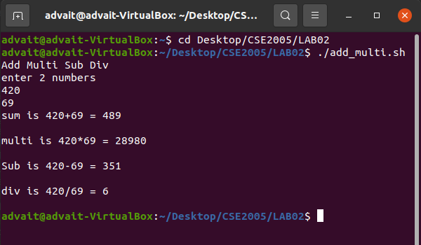
echo
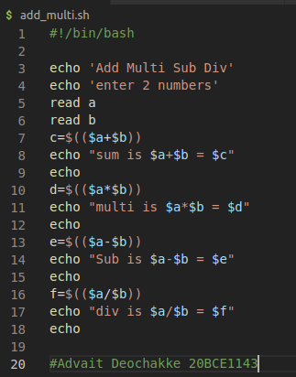

→Create and Kill Process

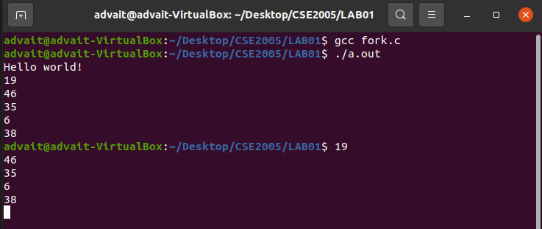
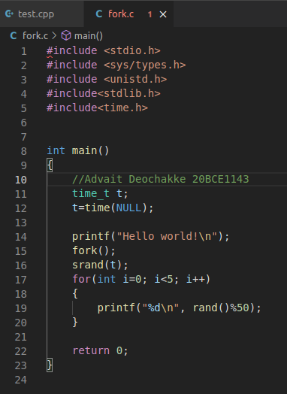

<next page>

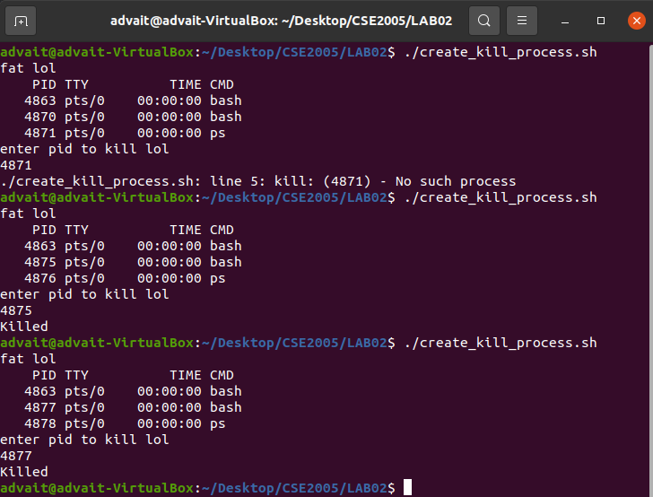
echo 'fat lol'
ps
echo 'enter pid to kill lol'
read a
kill -9 $a

<next page>

→I/O Sys Calls

1. cat> (filename) (create file) (Enter file contents line by line)

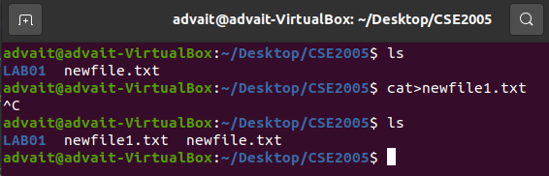

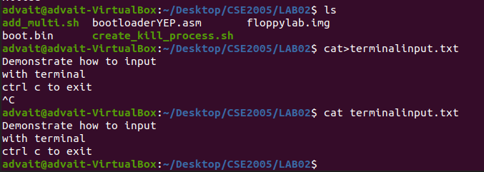
2. cat (filename) (show file contents)

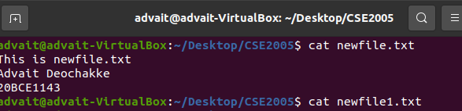

3. cat (file 1) >> (file 2) (copy file contents) (ctrl c ctrl v)

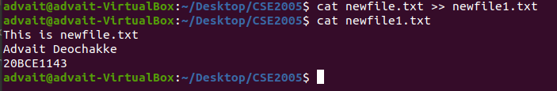

<next page>

→Bootloader

[BITS 16]
[ORG 0x7C00]

MOV SI, Stringer
CALL PrintString
JMP $

PrintCharacter:

MOV AH, 0x0E
MOV BH, 0x00
MOV BL, 0x07
INT 0x10
RET

PrintString:

next_character:
MOV AL, [SI]
OR AL, AL
JZ exit_function
CALL PrintCharacter
JMP next_character
exit_function:
RET

;Data
Stringer db 'Advait', 0 ;
TIMES 510 - ($ - $$) db 0
DW 0xAA55

<next page>

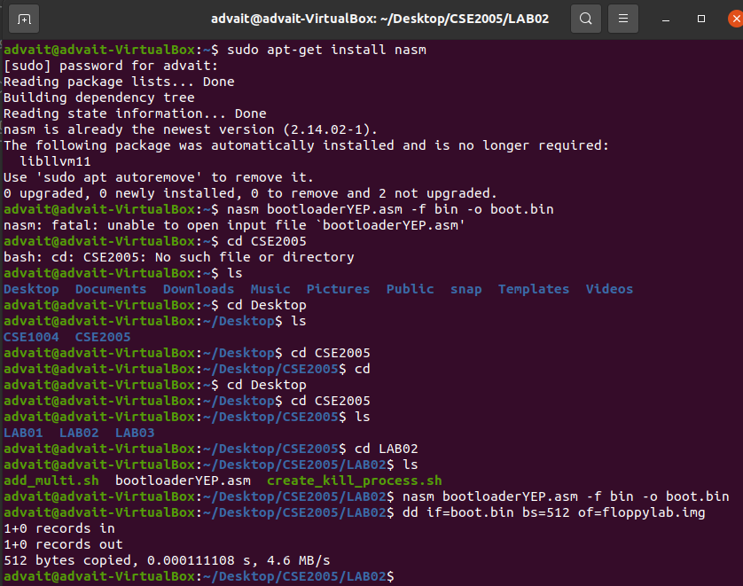

→ boot.bin and floppyimage.img disc image filename
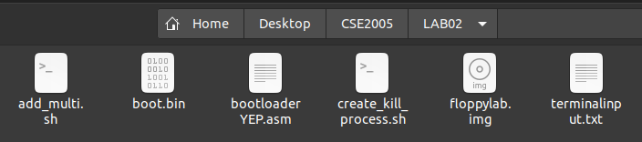

→ running on virtual box

