

CSE2005 OS – LAB 01
Advait Deochakke
20BCE1143

FCFS w/o Arrival, FCFS with Arrival, SJF(non-primitive), SRTF(primitive)

→ FCFS w/o Arrival

#include<iostream>

using namespace std;

struct process
{
int id=0;
int wait=0;
int burst=0;
int turnaround=0;
};

int main()
{
cout<<"Advait Deochakke\n20BCE1143\nEnter number of processes for FCFs: ";
int n;
int ttlwait=0, ttlturnaround=0;
cin>>n;
process arr[n];
for(int i=0; i<n; i++)
{
cout<<"\nEnter PiD: ";
cin>>arr[i].id;
cout<<"\nEnter Burst time: ";
cin>>arr[i].burst;
}
arr[0].wait=0;
arr[0].turnaround=arr[0].burst;

for(int i=1; i<n; i++)
{
for(int j=0; j<i; j++)
{
arr[i].wait=arr[i].wait+arr[j].burst;
}
arr[i].turnaround=arr[i].wait+arr[i].burst;
ttlturnaround=ttlturnaround+arr[i].turnaround;
ttlwait=ttlwait+arr[i].wait;

}

int avgturnaround, avgwait;
avgturnaround=ttlturnaround/n;
avgwait=avgturnaround/n;
cout<<"Avg waiting time is : "<<avgwait<<endl;
cout<<"Avg turnaround is : "<<avgturnaround<<endl;

cout<<"\n\nStats for each process: \n";
for(int i=0; i<n; i++)
{
cout<<"PiD: "<<arr[i].id<<", PWait: "<<arr[i].wait<<", PBurst: "<<arr[i].burst<<", PTurn: "<<arr[i].turnaround<<endl;
}

return 0;
}

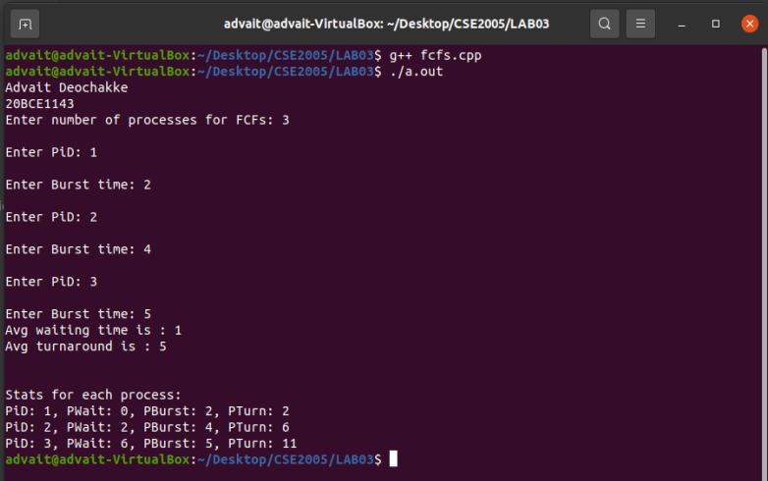

<next page>

→ FCFS with Arrival

#include<iostream>
#include<algorithm>

using namespace std;

struct process
{
int id=0;
int wait=0;
int burst=0;
int turnaround=0;
int arrival=0;
};

bool compareArrival(process p1, process p2)
{
return (p1.arrival<p2.arrival);
}

int main()
{
cout<<"Advait Deochakke\n20BCE1143\nEnter number of processes for FCFs: ";
int n;
int ttlwait=0, ttlturnaround=0;
cin>>n;
process arr[n];
for(int i=0; i<n; i++)
{
cout<<"\nEnter PiD: ";
cin>>arr[i].id;
cout<<"\nEnter Arrival time: ";
cin>>arr[i].arrival;
cout<<"\nEnter Burst time: ";
cin>>arr[i].burst;
}
sort(arr, arr+n, compareArrival);
arr[0].wait=0;
arr[0].turnaround=arr[0].burst;

for(int i=1; i<n; i++)
{
for(int j=0; j<i; j++)
{
arr[i].wait=arr[i].wait+arr[j].burst;
}
arr[i].turnaround=arr[i].wait+arr[i].burst;
ttlturnaround=ttlturnaround+arr[i].turnaround;
ttlwait=ttlwait+arr[i].wait;
}

int avgturnaround, avgwait;
avgturnaround=ttlturnaround/n;
avgwait=avgturnaround/n;
cout<<"Avg waiting time is : "<<avgwait<<endl;
cout<<"Avg turnaround is : "<<avgturnaround<<endl;

cout<<"\n\nStats for each process: \n";
for(int i=0; i<n; i++)
{
cout<<"PiD: "<<arr[i].id<<", PArrival: "<<arr[i].arrival<<", PWait: "<<arr[i].wait<<", PBurst: "<<arr[i].burst<<", PTurn: "<<arr[i].turnaround<<endl;
}
return 0;
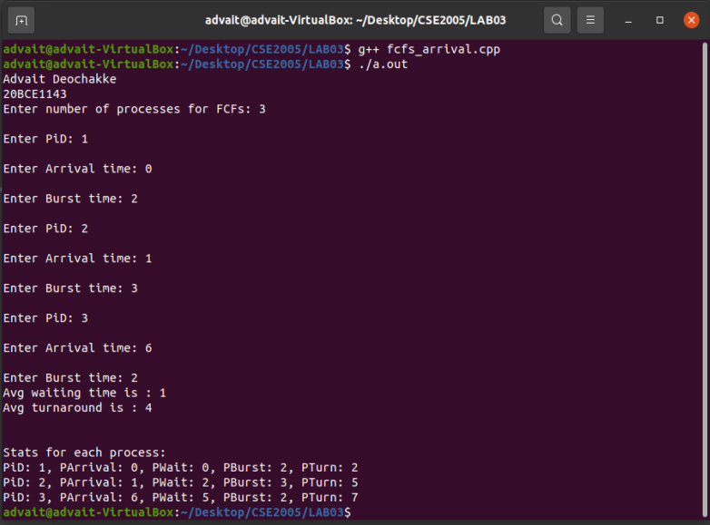
}

→ SJF (non primitive)

#include<iostream>
#include<algorithm>

using namespace std;

struct process
{
int pid;
int btime;
int waitime;
int turnover;
};

bool compareBurst(process p1, process p2)
{
return(p1.btime < p2.btime);
}

int main()
{
cout<<"Enter number of processes : ";
int no;
cin>>no;
process arr[no];

for(int i=0; i<no; i++)
{
cout<<"Enter the burst time for pid: "<<i<<": ";
arr[i].pid=i;
cin>>arr[i].btime;
}

sort(arr, arr+no, compareBurst);
int w=0;
int t=0;
for(int i=0; i<no; i++)
{
arr[i].waitime=w;
w=w+arr[i].btime;
arr[i].turnover=arr[i].waitime+arr[i].btime;
t=t+arr[i].turnover;
}

for(int i=0; i<no; i++)
{
cout<<"PiD: "<<arr[i].pid<<"; BurstTime: "<<arr[i].btime<<"; WaitTime: "<<arr[i].waitime<<"; TurnoverTime: "<<arr[i].turnover;
cout<<endl;
}

cout<<endl;
cout<<"Avg turnaround time: "<<t/no<<endl;

return 0;
}

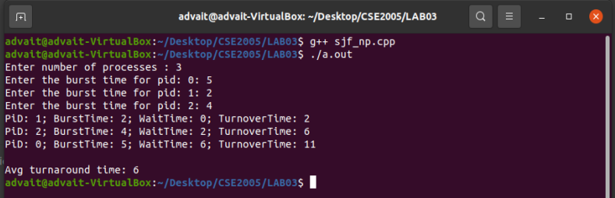
<without arrival, as given in lab manual. With arrival is also possible, as shown in next program>

<next page>

→ SRTF (Primitive)

#include<iostream>
#include<vector>
#include<algorithm>

using namespace std;

struct process
{
int pid;
int arrtime;
int burstime;
int remaintime;
int wtime=999;
int turnaroundtime;
int exitime;

};

bool compareArr(process p1, process p2)
{
return(p1.arrtime > p2.arrtime);
}

bool compareRem(process p1, process p2)
{
return(p1.remaintime > p2.remaintime);
}

int main()
{
int n;
int avgturnaround=0, avgwait=0;
cout<<"Enter no. of processes: ";
cin>>n;
int curtime=0, ttlexec=0;
vector<process> notinqueue, inqueue, completed;

for(int i=1; i<n+1; i++)
{
process a;
cout<<"Enter the arrival time for pid "<<i<<": ";
cin>>a.arrtime;
cout<<"Enter the burst time for pid "<<i<<": ";
a.pid=i;
cin>>a.burstime;
a.remaintime=a.burstime;
ttlexec=ttlexec+a.burstime;

notinqueue.push_back(a);

}
cout<<endl<<endl;

sort(notinqueue.begin(), notinqueue.end(), compareArr);

for(curtime; curtime<=ttlexec; curtime++)
{
int k1=999;
if(!notinqueue.empty())
k1=notinqueue.back().arrtime;

if(inqueue.empty())
{
//only takes one process per time cause im lazy sry, could use like while loop and update k1 inside
if(k1==curtime)
{
process a=notinqueue.back();
notinqueue.pop_back();
inqueue.push_back(a);
inqueue.back().remaintime--;
inqueue.back().wtime=0;
avgwait=avgwait+curtime;
if(inqueue.back().remaintime==0)
{
inqueue.back().exitime=curtime+1;
inqueue.back().turnaroundtime=inqueue.back().exitime-inqueue.back().arrtime;
avgturnaround=avgturnaround+inqueue.back().turnaroundtime;
process a=inqueue.back();
completed.push_back(a);
inqueue.pop_back();

}
}
}
else
{
if(k1==curtime)
{
process a=notinqueue.back();
notinqueue.pop_back();
inqueue.push_back(a);
}

sort(inqueue.begin(), inqueue.end(), compareRem);

if(!inqueue.empty())
{
inqueue.back().remaintime--;

}
if(inqueue.back().wtime!=999)
{
inqueue.back().wtime=curtime;
avgwait=avgwait+curtime;
}

if(inqueue.back().remaintime==0)
{
inqueue.back().exitime=curtime+1;
inqueue.back().turnaroundtime=inqueue.back().exitime-inqueue.back().arrtime;
avgturnaround=avgturnaround+inqueue.back().turnaroundtime;
process a=inqueue.back();
completed.push_back(a);
inqueue.pop_back();

}

}

}

avgturnaround=avgturnaround/n;
avgwait=avgwait/n;

cout<<"avg turnaround is: "<<avgturnaround;
cout<<"\navg wait is: "<<avgwait<<endl;

cout<<"final results: "<<endl;

sort(completed.begin(), completed.end(), compareArr);

for(int i=0; i<n; i++)
{
cout<<"Pid\tArrival Time\tBurst Time\tTurnaround Time\t\tExit Time";
cout<<completed.back().pid<<"\t\t"<<completed.back().arrtime<<"\t\t"<<completed.back().burstime<<"\t\t"<<completed.back().turnaroundtime<<"\t\t"<<completed.back().exitime;
completed.pop_back();

}

return 0;
}

<next page>

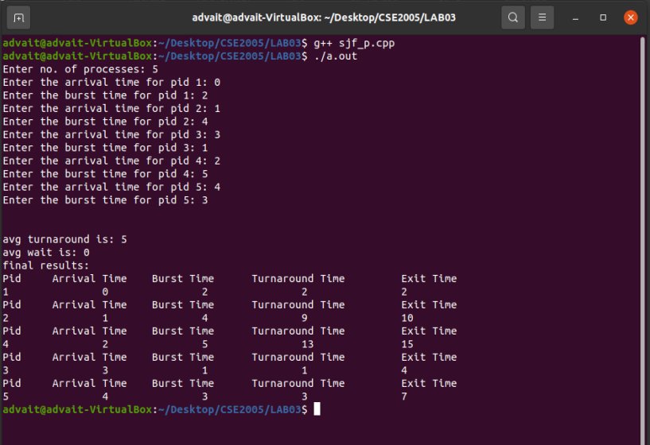

<to test the code, simply copy paste in a file, give it the .cpp extension, and run>
<copy pasted as easier to verify>

