

CSE2005 OS – LAB 01
Advait Deochakke
20BCE1143

Priority (non-primitive), Priority (Primitive), RoundRobin

→ Priority Scheduling (Non-Primitive)

#include<iostream>
#include<vector>
#include<algorithm>

using namespace std;

struct process
{
int pid;
int arrtime;
int burstime;
int remaintime;
int priority; //higher is more urgent
int wtime=999;
int turnaroundtime;
int exitime;

};

bool compareArr(process p1, process p2)
{
return(p1.arrtime > p2.arrtime);
}

bool compareRem(process p1, process p2)
{
return(p1.remaintime > p2.remaintime);
}

bool comparePri(process p1, process p2)
{
return(p1.priority < p2.priority);
}

int main()
{
int n;
int avgturnaround=0, avgwait=0;
cout<<"Enter no. of processes: ";
cin>>n;
int curtime=0, ttlexec=0;
vector<process> notinqueue, waitqueue, inqueue, completed;

for(int i=1; i<n+1; i++)
{
process a;
a.pid=i;
cout<<"Enter the arrival time for pid "<<i<<": ";
cin>>a.arrtime;
cout<<"Enter the burst time for pid "<<i<<": ";
cin>>a.burstime;
a.remaintime=a.burstime;
cout<<"Enter priorty (higher is more urgent): ";
cin>>a.priority;
ttlexec=ttlexec+a.burstime;

notinqueue.push_back(a);

}
cout<<endl<<endl;

sort(notinqueue.begin(), notinqueue.end(), compareArr);

for(curtime; curtime<=ttlexec; curtime++)
{
int k1=999;
if(!notinqueue.empty())
k1=notinqueue.back().arrtime;

if(inqueue.empty())
{
//only takes one process per time cause im lazy sry, could use like while loop and update k1 inside
if(k1==curtime)
{
process a=notinqueue.back();
notinqueue.pop_back();
inqueue.push_back(a);
inqueue.back().remaintime--;
cout<<"'"<<inqueue.back().pid<<"' ";
inqueue.back().wtime=0;
avgwait=avgwait+curtime;
if(inqueue.back().remaintime==0)
{
inqueue.back().exitime=curtime+1;
inqueue.back().turnaroundtime=inqueue.back().exitime-inqueue.back().arrtime;
avgturnaround=avgturnaround+inqueue.back().turnaroundtime;
completed.push_back(inqueue.back());
inqueue.pop_back();

}
}
}
else
{
if(k1==curtime)
{
process a=notinqueue.back();
notinqueue.pop_back();
waitqueue.push_back(a);
}

if(!inqueue.empty())
{
inqueue.back().remaintime--;
cout<<"'"<<inqueue.back().pid<<"' ";
}

if(inqueue.back().wtime!=999)
{
inqueue.back().wtime=curtime;
avgwait=avgwait+curtime;
}

if(inqueue.back().remaintime==0)
{
inqueue.back().exitime=curtime+1;
inqueue.back().turnaroundtime=inqueue.back().exitime-inqueue.back().arrtime;
avgturnaround=avgturnaround+inqueue.back().turnaroundtime;
process a=inqueue.back();
completed.push_back(a);
inqueue.pop_back();
sort(waitqueue.begin(), waitqueue.end(), comparePri);//for non-primitive
inqueue.push_back(waitqueue.back());
waitqueue.pop_back();
}
}
}

avgturnaround=avgturnaround/n;
avgwait=avgwait/n;

cout<<"\navg turnaround is: "<<avgturnaround;
cout<<"\navg wait is: "<<avgwait<<endl;

cout<<"final results: "<<endl;

sort(completed.begin(), completed.end(), compareArr);

for(int i=0; i<n; i++)
{
cout<<"Pid\tArrival Time\tBurst Time\tTurnaround Time\t\tExit Time\tPriority\n";
cout<<completed.back().pid<<"\t\t"<<completed.back().arrtime<<"\t\t"<<
completed.back().burstime<<"\t\t"<<completed.back().turnaroundtime<<"\t\t"<<
completed.back().exitime<<"\t\t"<<completed.back().priority<<"\n";
completed.pop_back();
}
return 0;
}

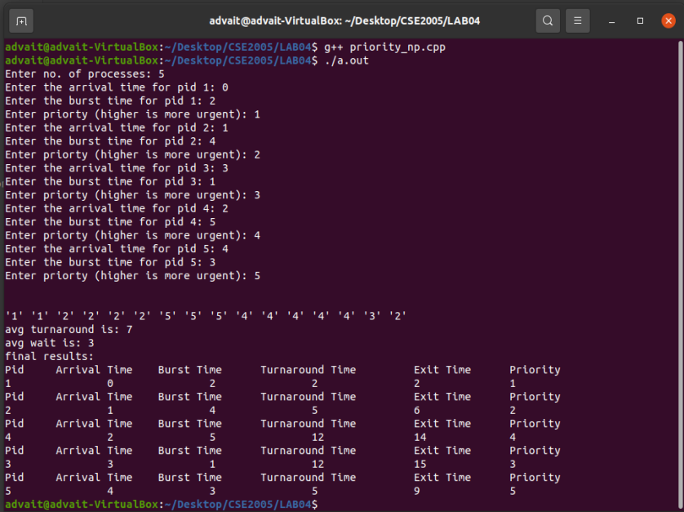

<next page>

→ Priority Scheduling (Primitive)

#include<iostream>
#include<vector>
#include<algorithm>

using namespace std;

struct process
{
int pid;
int arrtime;
int burstime;
int remaintime;
int priority; //higher is more urgent
int wtime=999;
int turnaroundtime;
int exitime;
};

bool compareArr(process p1, process p2)
{
return(p1.arrtime > p2.arrtime);
}

bool compareRem(process p1, process p2)
{
return(p1.remaintime > p2.remaintime);
}

bool comparePri(process p1, process p2)
{
return(p1.priority < p2.priority);
}

int main()
{
int n;
int avgturnaround=0, avgwait=0;
cout<<"Enter no. of processes: ";
cin>>n;
int curtime=0, ttlexec=0;
vector<process> notinqueue, inqueue, completed;

for(int i=1; i<n+1; i++)
{
process a;
a.pid=i;
cout<<"Enter the arrival time for pid "<<i<<": ";
cin>>a.arrtime;
cout<<"Enter the burst time for pid "<<i<<": ";
cin>>a.burstime;
a.remaintime=a.burstime;
cout<<"Enter priorty (higher is more urgent): ";
cin>>a.priority;
ttlexec=ttlexec+a.burstime;

notinqueue.push_back(a);

}
cout<<endl<<endl;

sort(notinqueue.begin(), notinqueue.end(), compareArr);

for(curtime; curtime<=ttlexec; curtime++)
{
int k1=999;
if(!notinqueue.empty())
k1=notinqueue.back().arrtime;

if(inqueue.empty())
{
//only takes one process per time cause im lazy sry, could use like while loop and update k1 inside
if(k1==curtime)
{
process a=notinqueue.back();
notinqueue.pop_back();
inqueue.push_back(a);
inqueue.back().remaintime--;
cout<<"'"<<inqueue.back().pid<<"' ";
inqueue.back().wtime=0;
avgwait=avgwait+curtime;
if(inqueue.back().remaintime==0)
{
inqueue.back().exitime=curtime+1;
inqueue.back().turnaroundtime=inqueue.back().exitime-inqueue.back().arrtime;
avgturnaround=avgturnaround+inqueue.back().turnaroundtime;
process a=inqueue.back();
completed.push_back(a);
inqueue.pop_back();

}
}
}
else
{
if(k1==curtime)
{
process a=notinqueue.back();
notinqueue.pop_back();
inqueue.push_back(a);
}

sort(inqueue.begin(), inqueue.end(), comparePri); //for primitive

if(!inqueue.empty())
{
inqueue.back().remaintime--;
cout<<"'"<<inqueue.back().pid<<"' ";
}
if(inqueue.back().wtime!=999)
{
inqueue.back().wtime=curtime;
avgwait=avgwait+curtime;
}
if(inqueue.back().remaintime==0)
{
inqueue.back().exitime=curtime+1;
inqueue.back().turnaroundtime=inqueue.back().exitime-inqueue.back().arrtime;
avgturnaround=avgturnaround+inqueue.back().turnaroundtime;
process a=inqueue.back();
completed.push_back(a);
inqueue.pop_back();
sort(inqueue.begin(), inqueue.end(), comparePri); //for primitive
}
}
}

avgturnaround=avgturnaround/n;
avgwait=avgwait/n;

cout<<"\navg turnaround is: "<<avgturnaround;
cout<<"\navg wait is: "<<avgwait<<endl;

cout<<"final results: "<<endl;

sort(completed.begin(), completed.end(), compareArr);

for(int i=0; i<n; i++)
{
cout<<"Pid\tArrival Time\tBurst Time\tTurnaround Time\t\tExit Time\tPriority\n";

cout<<completed.back().pid<<"\t\t"<<completed.back().arrtime<<"\t\t"<<
completed.back().burstime<<"\t\t"<<completed.back().turnaroundtime<<"\t\t"<<
completed.back().exitime<<"\t\t"<<completed.back().priority<<"\n";

completed.pop_back();
}

return 0;
}

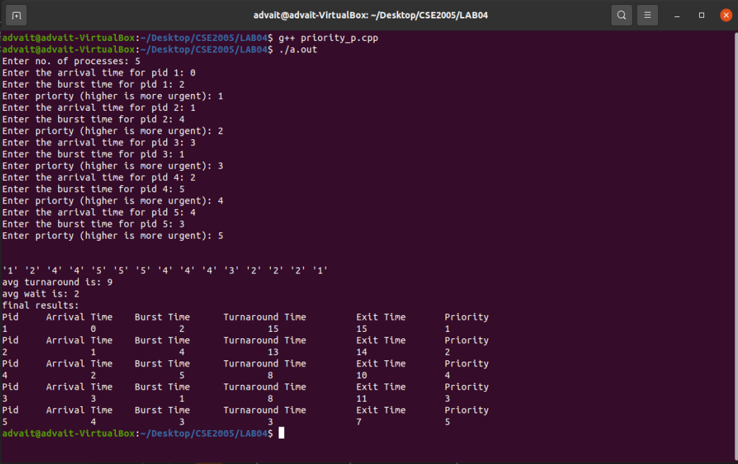

→ RoudRobin (Primitive by default)

#include<iostream>
#include<vector>
#include<algorithm>

using namespace std;

struct process
{
int pid;
int arrtime;
int burstime;
int remaintime;
int wtime=999;
int turnaroundtime;
int exitime;
};

bool compareArr(process p1, process p2)
{
return(p1.arrtime > p2.arrtime);
}

bool compareRem(process p1, process p2)
{
return(p1.remaintime > p2.remaintime);
}

int main()
{
int n;
int avgturnaround=0, avgwait=0;
int keeper=0;
cout<<"Enter no. of processes: ";
cin>>n;
int curtime=0, ttlexec=0;
vector<process> notinqueue, inqueue, robined, completed;

for(int i=1; i<n+1; i++)
{
process a;
a.pid=i;
cout<<"Enter the arrival time for pid "<<i<<": ";
cin>>a.arrtime;
cout<<"Enter the burst time for pid "<<i<<": ";
cin>>a.burstime;
a.remaintime=a.burstime;
//cout<<"Enter priorty (higher is more urgent): ";
//cin>>a.priority;
ttlexec=ttlexec+a.burstime;
notinqueue.push_back(a);
}
cout<<endl<<endl;

sort(notinqueue.begin(), notinqueue.end(), compareArr);

for(curtime; curtime<=ttlexec; curtime++)
{
keeper++;

int k1=999;
if(!notinqueue.empty())
k1=notinqueue.back().arrtime;

if(inqueue.empty())
{
//only takes one process per time cause im lazy sry, could use like while loop and update k1 inside
if(k1==curtime)
{
process a=notinqueue.back();
notinqueue.pop_back();
inqueue.push_back(a);
inqueue.back().remaintime--;
cout<<"'"<<inqueue.back().pid<<"' ";
inqueue.back().wtime=0;
avgwait=avgwait+curtime;
if(inqueue.back().remaintime==0)
{
inqueue.back().exitime=curtime+1;
inqueue.back().turnaroundtime=inqueue.back().exitime-inqueue.back().arrtime;
avgturnaround=avgturnaround+inqueue.back().turnaroundtime;
process a=inqueue.back();
completed.push_back(a);
inqueue.pop_back();
}
}
}
else
{
if(k1==curtime)
{
process a=notinqueue.back();
notinqueue.pop_back();
inqueue.push_back(a);
}

sort(inqueue.begin(), inqueue.end(), compareArr); //for primitive

if(!inqueue.empty())
{
inqueue.back().remaintime--;
cout<<"'"<<inqueue.back().pid<<"' ";
}

if(inqueue.back().wtime!=999)
{
inqueue.back().wtime=curtime;
avgwait=avgwait+curtime;
}

if(inqueue.back().remaintime==0)
{
inqueue.back().exitime=curtime+1;
inqueue.back().turnaroundtime=inqueue.back().exitime-inqueue.back().arrtime;
avgturnaround=avgturnaround+inqueue.back().turnaroundtime;
process a=inqueue.back();
completed.push_back(a);
inqueue.pop_back();
keeper=0;
}
else if(keeper==2)
{
robined.push_back(inqueue.back());
inqueue.pop_back();
keeper=0;
}

if(inqueue.empty())
{
int test1=robined.size();
for(int i5=0; i5<test1; i5++)
{
inqueue.push_back(robined.back());
robined.pop_back();
}
}
}
}

avgturnaround=avgturnaround/n;
avgwait=avgwait/n;

cout<<"\navg turnaround is: "<<avgturnaround;
cout<<"\navg wait is: "<<avgwait<<endl;

cout<<"final results: "<<endl;

sort(completed.begin(), completed.end(), compareArr);

for(int i=0; i<n; i++)
{
cout<<"Pid\tArrival Time\tBurst Time\tTurnaround Time\t\tExit Time\n";

cout<<completed.back().pid<<"\t\t"<<completed.back().arrtime<<"\t\t"<<
completed.back().burstime<<"\t\t"<<completed.back().turnaroundtime<<"\t\t"<<
completed.back().exitime<<"\n";

completed.pop_back();
}

return 0;
}
