x

**School of Computer Science and Engineering**

**J Component report**

**Programme : B.Tech**

**Course Title : Foundations of Data Analytics**

**Course Code : CSE3505**

**Slot : F1**

**Title: Analysis of vaccination rate and its effect on spread of coronavirus**

**Team Members: Advait Deochakke | 20BCE1143**

**Aryan Shah | 20BCE1490**

**Faculty: Dr. Sheik Abdullah A**

**Sign:**

**Date:**

**Index Page:**

|  |  |
| --- | --- |
| **Description** | **Page No.** |
| List of Figures | 3 |
| Abstract | 4 |
| Introduction | 5 |
| Literature review | 6 |
| Proposed methodology | 8 |
| Experimental results and discussion | 9 |
| Statistical analysis and interpretation | 11 |
| Visualization analysis | 14 |
| Conclusion | 17 |
| References | 18 |

**List of Figures:**

|  |  |
| --- | --- |
| **Fig. No.** | **Description** |
| **1** | Proposed methodology |
| **2** | Correlation Matrix |
| **3** | Naive Bayes Analysis (Cases vs Tests, based on HDI) |
| **4** | Random Forest Variable Importance |
| **5** | Random Forest Predictions vs Testing values |
| **6** | Fraction of Deaths in the Population attributes to Covid |
| **7** | Vaccination Rate based on GDP (PPP) |
| **8** | Cases vs Vaccinations chart for Gaussian LM |
| **9** | Deaths vs Vaccinations chart for Gaussian LM |

**Abstract:**

The Covid-19 pandemic has resulted in dramatic loss of life around the world and created unexpected public health challenges. Vaccination is currently the only means of slowing the spread of the virus in the community. The main focus is the collection of data on vaccination available on the Internet. These datasets are cleaned and normalized for data analysis. The motivation is to provide necessary information about immunizations worldwide, as well as model older people.

Figuring out quantitatively whether the increasing rate of vaccinated

individuals has had a definitive impact on the spread of novel

coronavirus. If there is a notable relation between the two, to what extent they are interconnected how we can predict the rate of infection to change as time goes past and more people are vaccinated.

The venture ambitions to convey the evaluation of various ongoing vaccination programs around the world by using the use of the inferences determined from the scraped records from the internet. The python libraries used inside the exploratory facts analysis consist of NumPy, Pandas, Matplotlib, Seaborn, and Plotly.

*Problem statement*

Whether there is a connection between vaccination rates and infection

Rates?

What is the extent of said connection, if it exists?

Can we predict the decrease in infection rates as vaccination rates decrease?

Whether there is a notable relation between the two, to what extent

they are interconnected, and how we can predict the rate of infection

to change as time goes past and more people are vaccinated.

How does the spread of Coronavirus fare today?

**Introduction:**

Covid-19 gripped the world in early 2020 and extensive research was conducted. Vaccinations were soon prepared, like the Moderna or Pfizer vaccine. Many people jumped at the chance to get these vaccines, and millions of people were vaccinated every day. Vaccine mandates, Mask mandates, and social distancing, combined with a prolonged period of social distancing and understanding from people has largely decreased infection rates.

As when the Covid-19 virus takes the arena in a shock. Covid-19 was declared as an endemic by using the world health organisation on 11th March 2020. For stopping the spread of the virus diverse international locations, ought to put into effect a complete lockdown. This lockdown even though help in slowing the speed of infection but became a first rate element in other adversaries like economic meltdown, activity loss, melancholy, and different low-budget and psychological problems. Scientists, academicians, and pharmaceutical research institutes labored tough toward developing a vaccine towards this virus. The Covid-19 vaccines are supposed to offer immunity against the virus. The COVID19 vaccines are broadly credited for their position in decreasing the spread, severity, and death as a result of a coronavirus. many countries have implemented phased distribution plans that prioritize the ones at the highest danger of complications, together with the elderly, and those at high chance of exposure and transmission, along with healthcare employees. seeing that most of the vaccines have been given emergency approvals there have been various misconceptions associated with them. With the span of time, the acceptability of vaccines has elevated. The nations which might be manufacturing these vaccines are exporting the same to the alternative international locations. in this project the dataset tracks the whole quantity of COVID-19 vaccinations administered in every usa, broken down by first and 2nd doses (in which country wide facts is available), and derived each day vaccination fees and population-adjusted figures.

Moreover, the pandemic has created a massive wealth of data due to the global-scale cooperation, creating opportunities for exercising various data analytics concepts.

**Literature review:**

The paper discusses the case in its infancy for Bangladesh, where limited awareness and various socio-economic factors, combined with very high population density can lead to explosive growth different from global trends recognized and evaluated by population density, GDP, HDI etc into account. Advanced models such as LASSO, RNN, GRU, and VAE are taken into use. We have focused on implementing short-term forecasting models where accuracy is more likely to be achieved. The paper uses algorithms and models which have successfully predicted curves for numerous other.

The Prophet algorithm made incredibly consistent and good predictions across 35 different periods of rounds. Due to the nature of Linear Regression, there were obvious unconformities during the period of 9 march 2020 through April 2020. The prediction is almost spot on 3rd algorithm onwards with the PR algorithm and Poly-MLR giving the best results in round 3 and 4 of the iterations after SVR prediction continued to be slightly off from actual. Later from the 5th to the 34th Prophet algorithm gives the best results and confirms correctly to the real-world data.

A majority Covid-related papers have been published in the past year or two dealing with modelling the spread, including models involving segmentation and compartmentalizing of infected populace into sections of Susceptible, Infected, and Recovered (SIR Models). The model, after careful calculation of the various responsible factors, gives a terrifyingly accurate prediction of cases per day. High Caution and Low Sense of Safety, an ideal state to prevent greater spread of the disease.

Contrary to our previous discussed works, the current paper accounts for predicting whether an individual is infected or not based on symptoms experienced and various different categorization techniques, the authors showcase the Bayes theorem of probability and how it related to classification-based Machine Learning Algorithms. The 3 base algorithms of Decision Tree, Linear Regression, and Naive Bayes showed close to a 95% accuracy with ~85% sensitivity, ~90% specificity. Whereas, Artificial Neural Network and Support Vector Machine show closer to 90% accuracy, with ~92% sensitivity and ~80% specificity.

Rather than using extremely advanced concepts or having revolutionary results, it shows the very foundation of machine learning and how it can be applied to day-to-day tasks. Machine learning model is presented using statistical visualization graphs to better predict the spread of theCOVID-19 pandemic. Data used in this study were collected from official data repositories such as the official website of Johns Hopkins University, WHO and Worldometer. The core idea is to use supervised machine learning algorithms for time series forecasting. Formulas were developed by WHO to calculate confirmed rates of change and mortality, patient recovery rates, and pandemic growth rates, etc.

To validate the performance of the proposed method, they used the root mean square error for each of his three attributes: confirmed cases, recovery, and death. They showed the final predictions of the proposed model for all attributes. They conducted a comparative study using state-of-art methods. Their findings predicted a sharp decline in his COVID-19 infections worldwide in the first week of September 2021.

This paper presents an overview and brief analysis of the leading machine learning predictive models for COVID-19. The paper presented a keyword-based network visualization, and the top keywords researchers focused on, including coronavirus, forecast, epidemic, humans, statistical analysis, quarantine, hospitalization, mortality, and weather. Additionally, this paper will help researchers identify key gaps in the research field and develop new machine learning models for predicting COVID-19 cases.

Extrapolation of epidemic impacts from early stages of growth is affected by model, data, and behavioural uncertainties. Although the complexity and methodologies vary, simple models can still be used as a reference during the early growth stages of the epidemic and provide the basis for more complex models of infection to understand the course of disease development. In combination with monitoring results from serological studies, it helps modelling researchers to accurately calibrate epidemiological models based on real-world situations. Various studies have been conducted on the impact of contact tracing and social isolation, but it has been argued that improved quarantine and reporting rates, as well as the wearing of face masks, are essential for epidemic prevention and control.

**Proposed methodology:**

Fig.1:

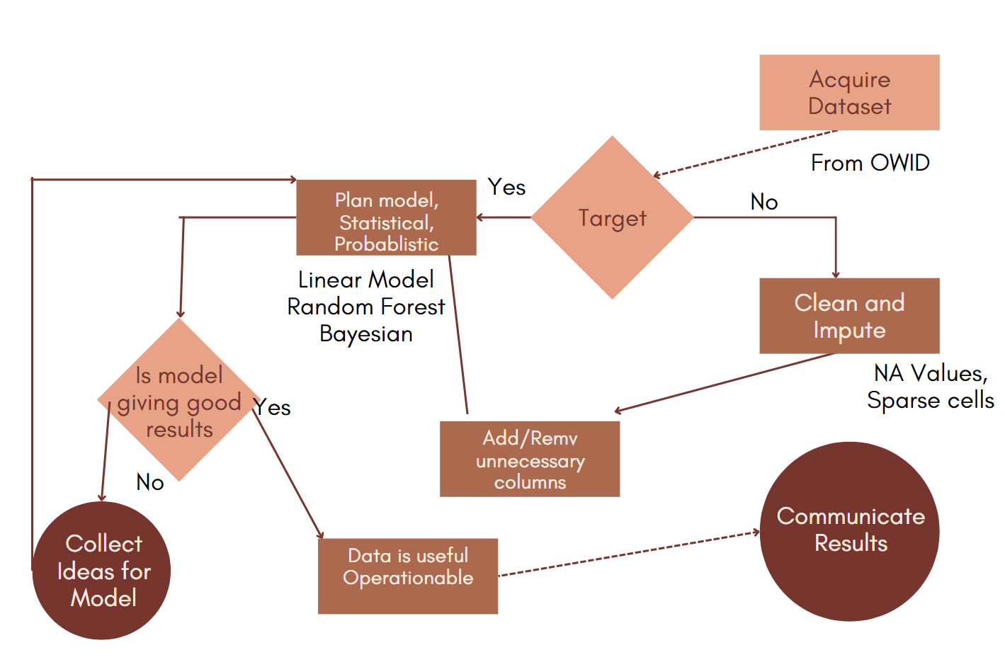

**Experimental results and discussion :**

Approach lies along the lines of co-relating vaccine rates by identifying weekly averages of increasing and cumulative vaccines (segregated by markers such as country, month, wave, etc – TBD) to the infection rate in that same category, and analyzing the processed data.

geom_smooth is used in the last few plot to highlight the trends and make them easier to see it uses various models such as "lm", "glm", "gam", "loess"

Loess : Local Polynomial Regression Fitting Description

Fit a polynomial surface determined by one or more numerical predictors, using local fitting. uses a t-based approximation. The memory usage of this implementation of loess is roughly quadratic in the number of points, with 1000 points taking about 10Mb.

glm : Fitting Generalized Linear Models Description

glm is used to fit generalized linear models, specified by giving a symbolic description of the linear predictor and a description of the error distribution.

A typical predictor has the form response ~ terms where response is the (numeric) response vector and terms is a series of terms which specifies a linear predictor for response. For binomial , the response can also be specified as a factor

The following is the process:

1) Identify the problem statement.

2) Identify the data from different sources and acquire the relevant data.

3) Process and clean the raw data.

4) Perform the exploratory analysis.

5) Generate the model by dividing the data into training and testing data.

6) Train the training dataset with the respective data set and validate the model, apply the same on the testing dataset.

7) Visualize the results and check for the accuracy.

**Full R Code:**

<https://github.com/Advait177013/FDA_JComp>

**Dataset:**

<https://ourworldindata.org/covid-vaccinations>

Dataset maintained by John Hopkins Uni. and Oxford University.

**Statistical analysis and interpretation**

Correlation Matrix for Income Groups

Fig.2:

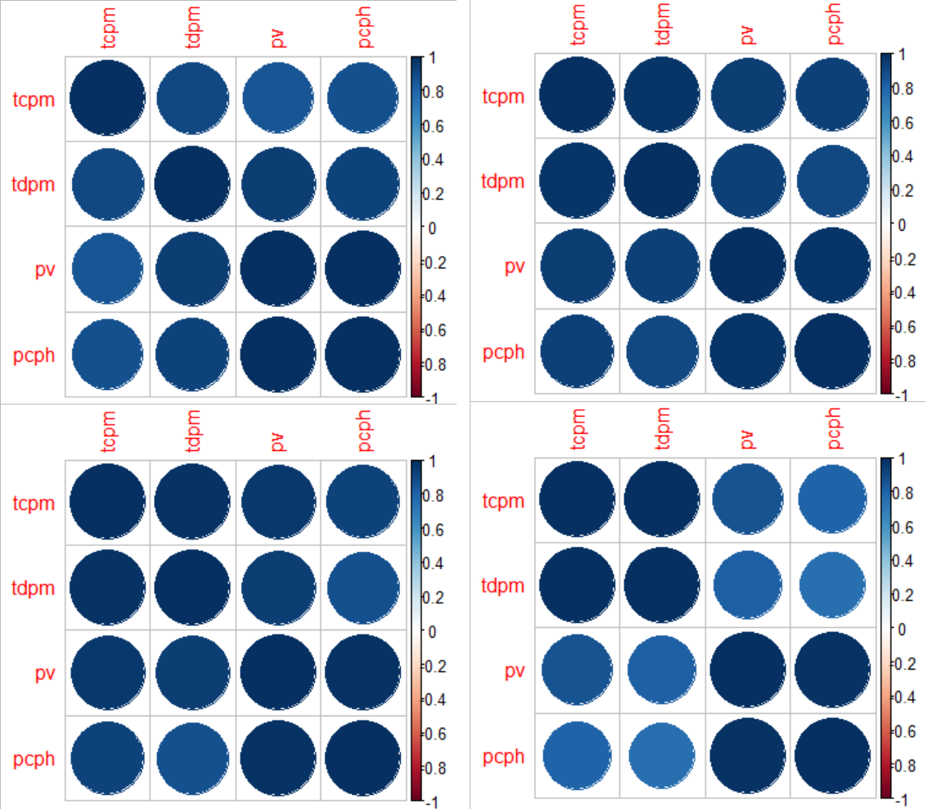

As we can see, correlation between variables tends to be high, signifying that they can be used to explain each other, thus validating the input criterion for our model.

**Naive Bayes probabilistic model and querying**

Fig.3

For high HDI countries, cases per million and tests per thousand

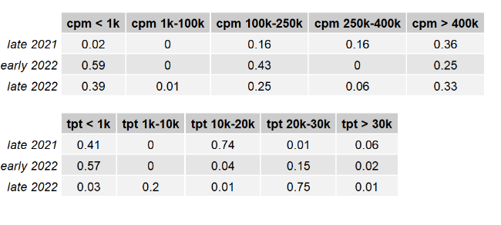

For low HDI countries, cases per million and tests per thousand

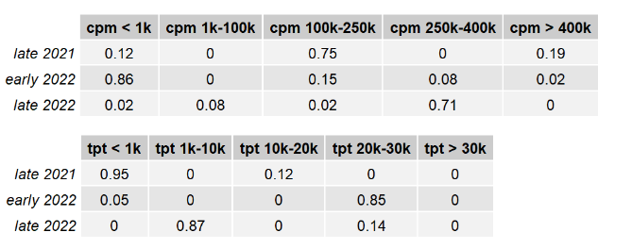

**Random Forest Prediction for Vaccinations based on available features**

Importance of Variables

Fig.4:

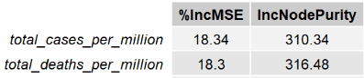

Fig.5:

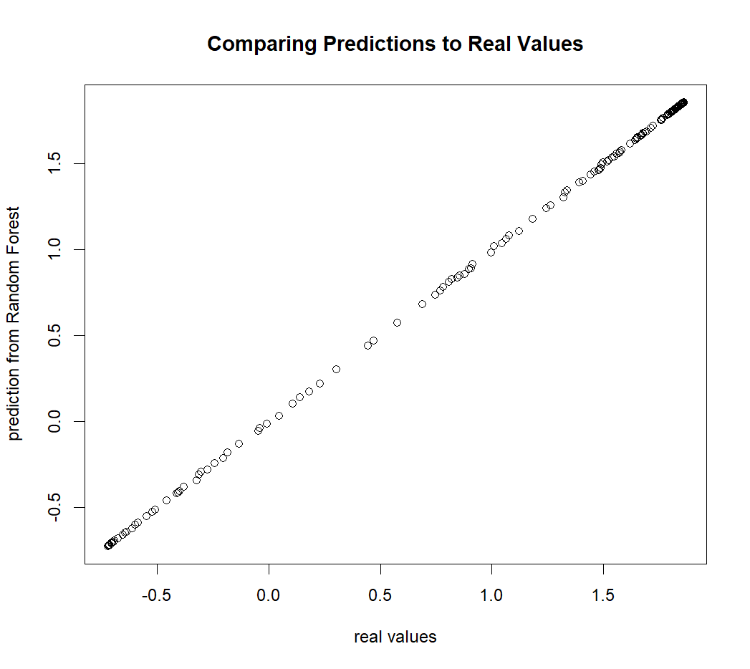

**Visualization analysis:**

**Fraction of deaths with respect to total population**

Fig.6:

September 2022

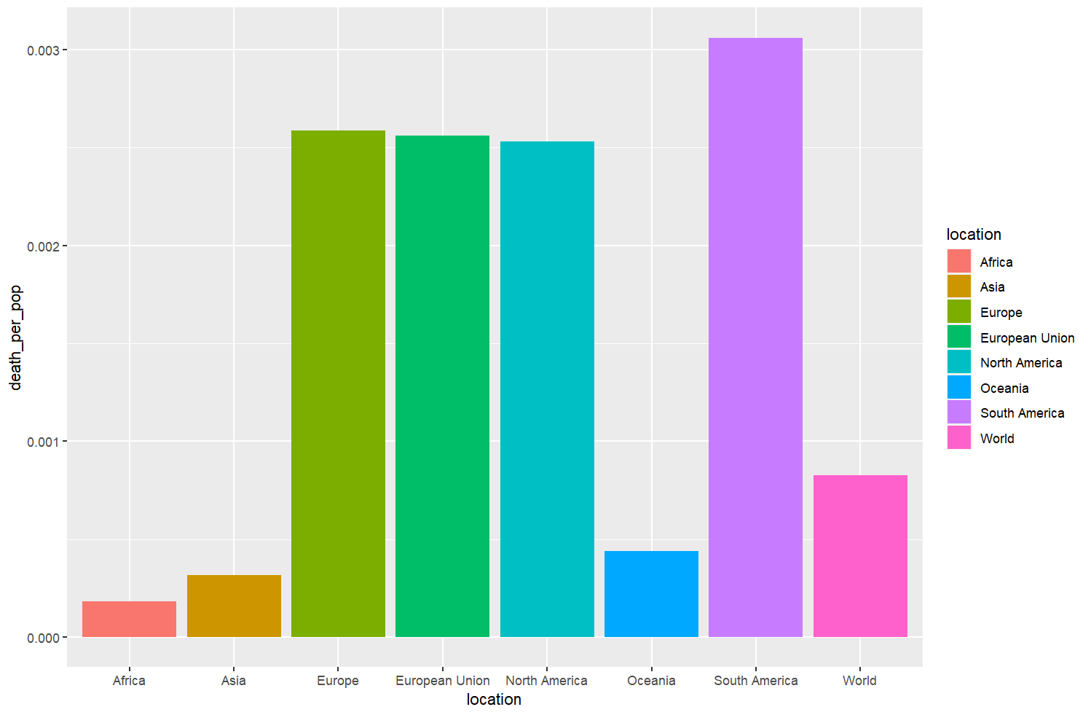September 2021

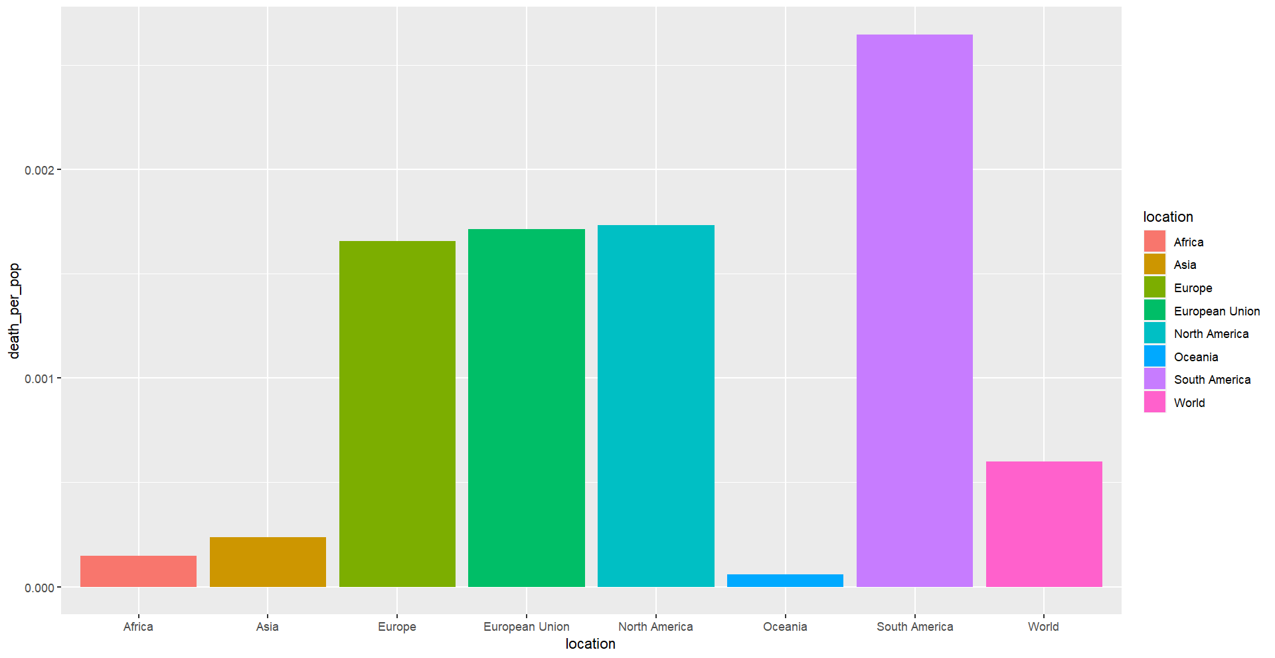

**Vaccination rate based on GDP (PPP)**

September 2022

Fig.7:

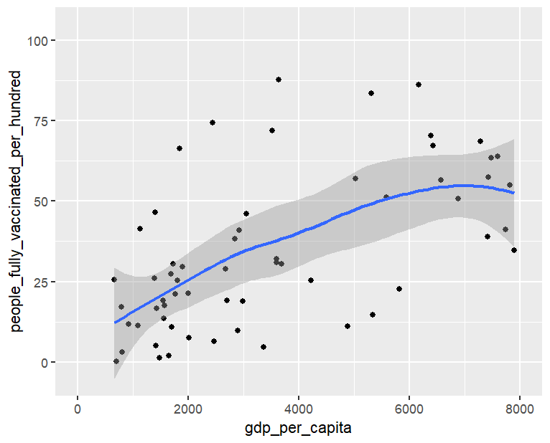

September 2021

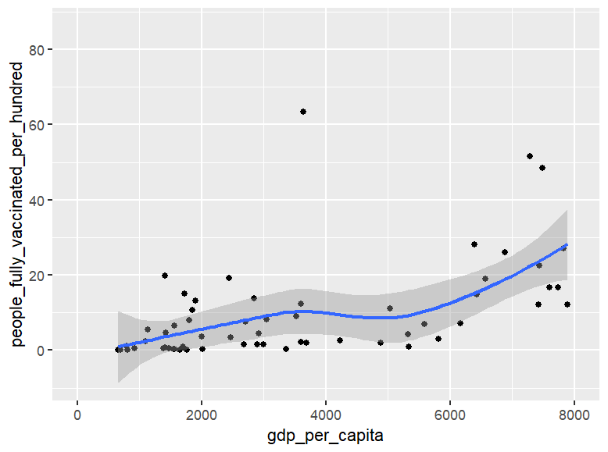

**Predicted vs Real values – Cases vs Vacc Gaussian Linear Model**

Fig.8:

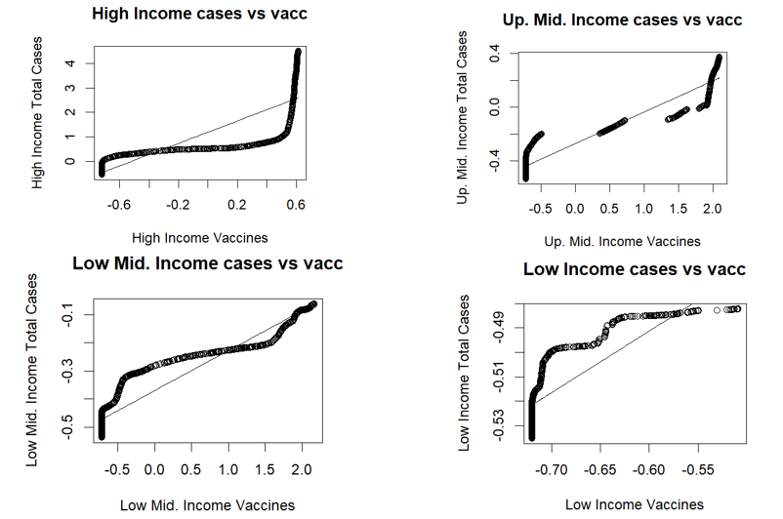

**Predicted vs Real values – Deaths vs Vacc Gaussian Linear Model**

Fig.9:

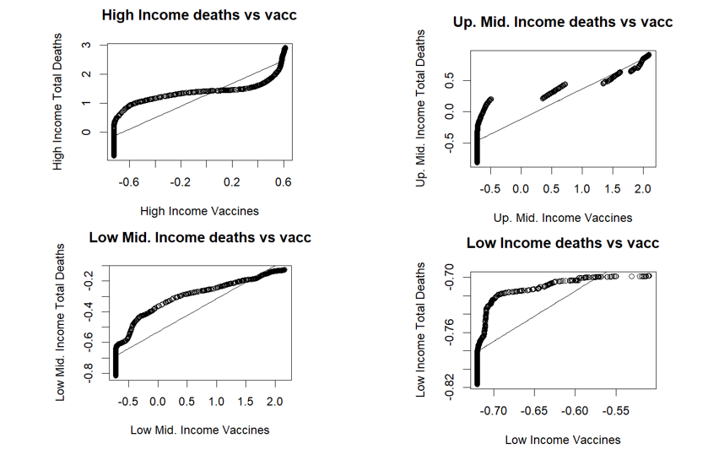

**Conclusion:**

We may confirm the existence of a relation between vaccination rates in a particular demographic, and their relation of the spread of COVID-19 in the same demographic.

We may find to what degree this relationship is, and hope to investigate into whether this is causation type of relationship between the former and the latter, or a co-relation type.

The project was successfully developed and found to perform well. In addition, the data entered by the user and the name of the patient's disease are saved in a database, which can be used as a record of the past and used for future treatment, contributing to the simplification of health management. In this we can use machine learning algorithms to show that diseases can be easily predicted using different parameters and models. New features can be added to this project to make it more productive, reusable, flexible, and hybrid.

**References**

1)Satu, M.S.; Howlader, K.C.; Mahmud, M.; Kaiser, M.S.; Shariful Islam, S.M.; Quinn, J.M.W.; Alyami, S.A.; Moni, M.A. Short-Term Prediction of COVID-19 Cases Using Machine Learning Models. Appl. Sci. 2021, 11, 4266. https://doi.org/ 10.3390/app11094266

2)Usherwood, T., LaJoie, Z. & Srivastava, V. A model and predictions for COVID-19 considering population behavior and vaccination. Sci Rep 11, 12051 (2021). <https://doi.org/10.1038/s41598- 021-91514-7>

3) Muhammad, L.J., Algehyne, E.A., Usman, S.S. et al. Supervised Machine Learning Models for Prediction of COVID-19 Infection using Epidemiology Dataset. SN COMPUT. SCI. 2, 11 (2021). <https://doi.org/10.1007/s42979-020-00394-7>

4) Malki, Zohair, et al. "The COVID-19 pandemic: prediction study based on machine learning models." Environmental science and pollution research 28.30 (2021): 40496-40506.

5) Rahimi, Iman, Fang Chen, and Amir H. Gandomi. "A review on COVID-19 forecasting models." Neural Computing and Applications (2021): 1-11.

6) Xiang, Yue, et al. "COVID-19 epidemic prediction and the impact of public health interventions: A review of COVID-19 epidemic models." Infectious Disease Modelling 6 (2021): 324-342.

7) Chu, Xu, et al. "Data cleaning: Overview and emerging challenges." Proceedings of the 2016 international conference on management of data. 2016.

8) Austin, Peter C., et al. "Missing data in clinical research: a tutorial on multiple imputation." Canadian Journal of Cardiology 37.9 (2021): 1322-1331

9) [Villavicencio, C.N.; Macrohon, J.J.E.; Inbaraj, X.A.; Jeng, J.-H.; Hsieh, J.-G. COVID-19 Prediction Applying Supervised Machine Learning Algorithms with Comparative Analysis Using WEKA. Algorithms 2021, 14, 201. <https://doi.org/10.3390/a14070201>]

10) <https://onlinelibrary.wiley.com/doi/10.1002/jmv.27609> Correlation between vaccine coverage and the COVID-19 pandemic throughout the world: Based on real-world data Chao Huang,Lijun Yang,Jia Pan,Xiaomei Xu,Rong Peng- ‘mass COVID-19 vaccination policy would protect the health and wellbeing of all, especially when the rate of vaccination passes 60%’

11)<https://doi.org/10.1016/j.msard.2022.104033> COVID-19 infection and vaccination against COVID-19 L. Pandit , A. Sudhir, C. Malli , A. D’Cunha - ‘vaccinations are safe and significantly mitigates the risk of severe infection’

12) <https://doi.org/10.1016/j.meegid.2021.104834> Predictive analysis of COVID-19 eradication with vaccination in India, Brazil, and U.S.A Deepa Chaturvedi , U. Chakravarty ’we have predicted the possible timescales for the end of the epidemic for different values of vaccination rates’