Fall 2021-2022
CSE3001: Software Engineering
J Component Review 2
Advait Deochakke – 20BCE1143

Full Implementation of J Component
------------------------------------------------------------------------------------------------------------------------

Login for Cashier/Admin:

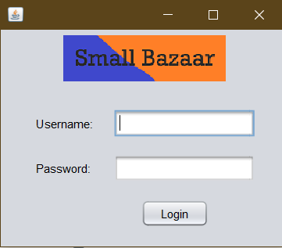

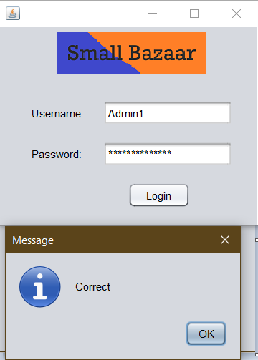
Admin login leads to Admin page, Cashier login leads to respective Cashier’s page

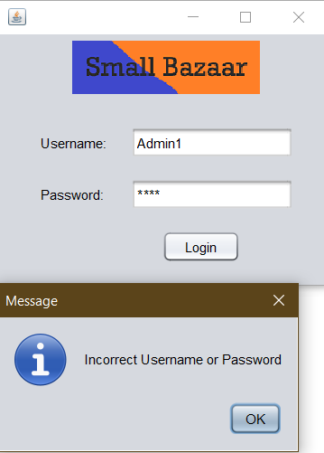

Cashier Page (shown earlier in partial implementation, refined now)

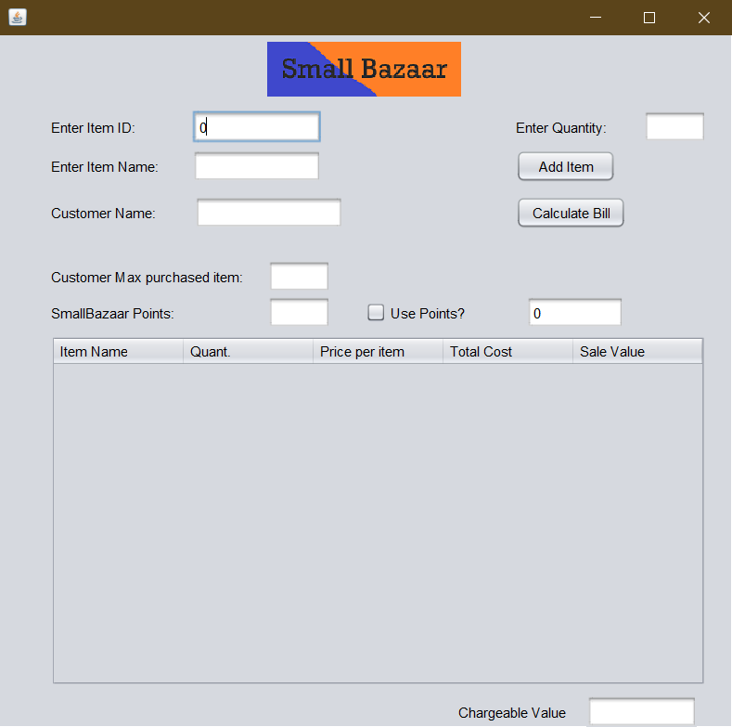
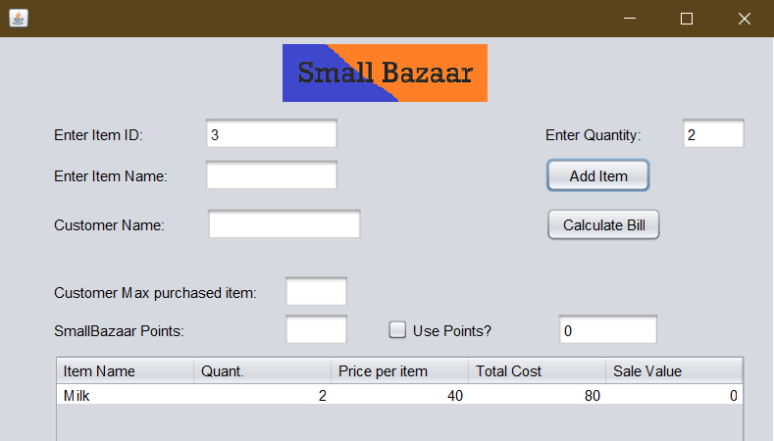
Adding items from either item ID (Possible placeholder for barcode scanner) , or item name

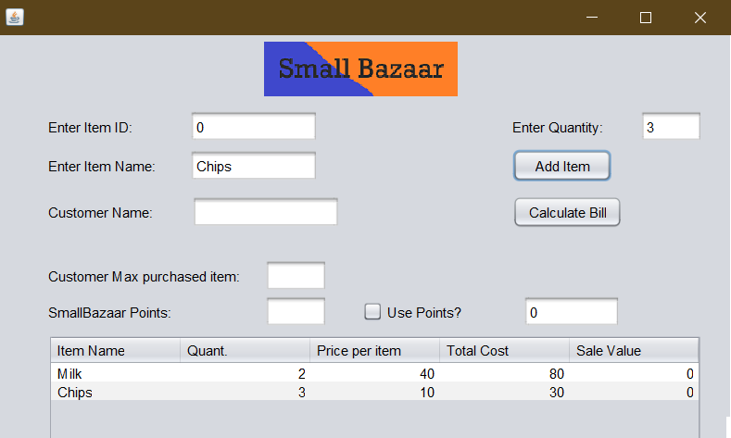

Billing
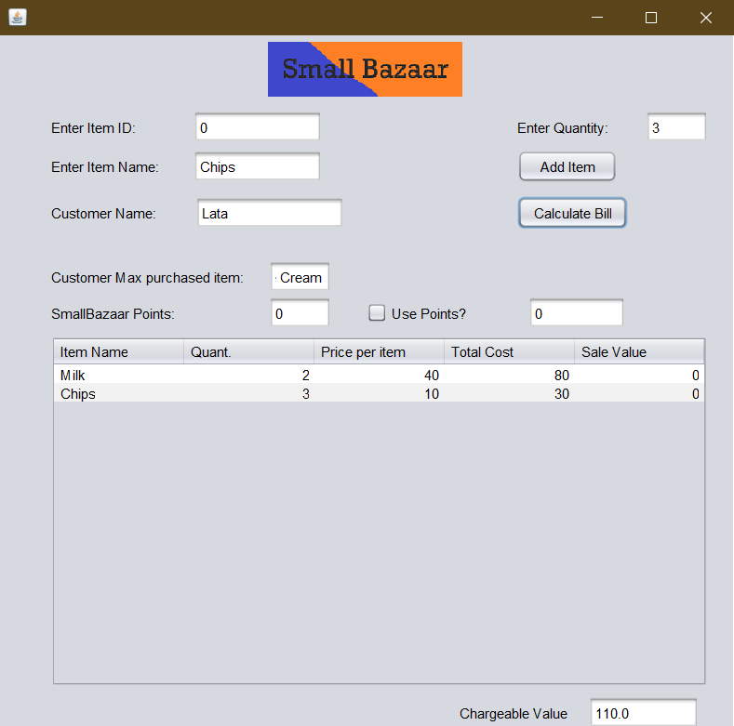

Sale

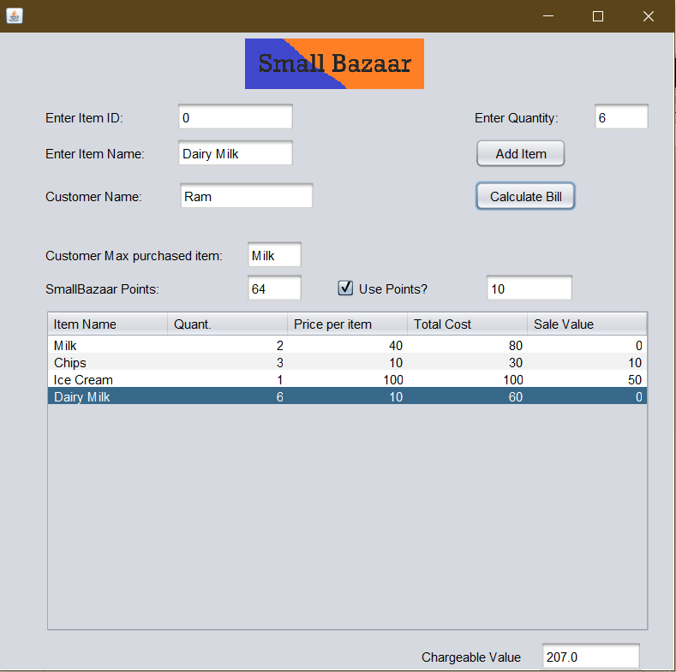

Customer Registration (In partial implementation documentation)

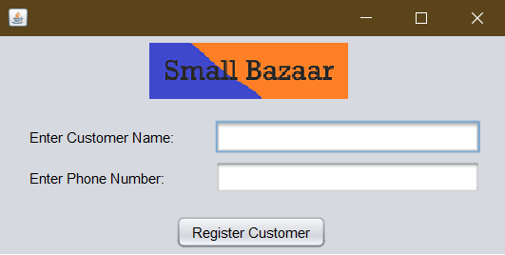

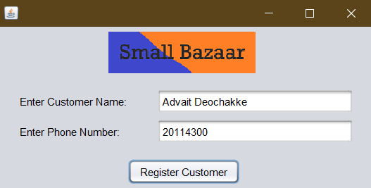

Report Generation (In Admin Page)

-> Admin Page

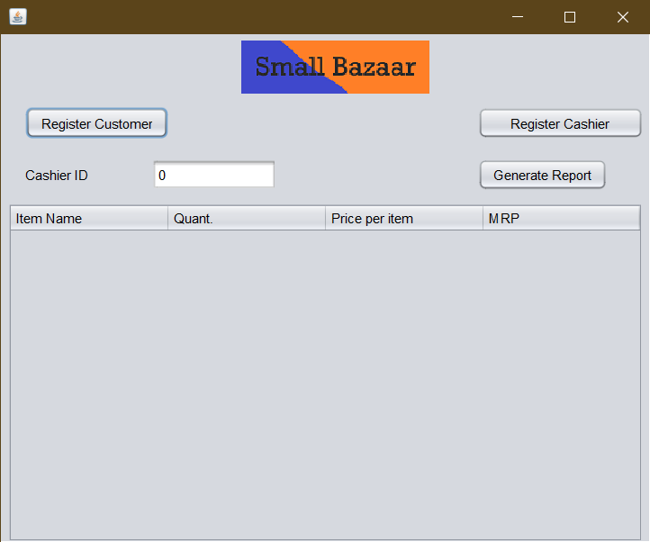

Report of Sales (As visible, the items in the earlier demonstration image have been added as sold)

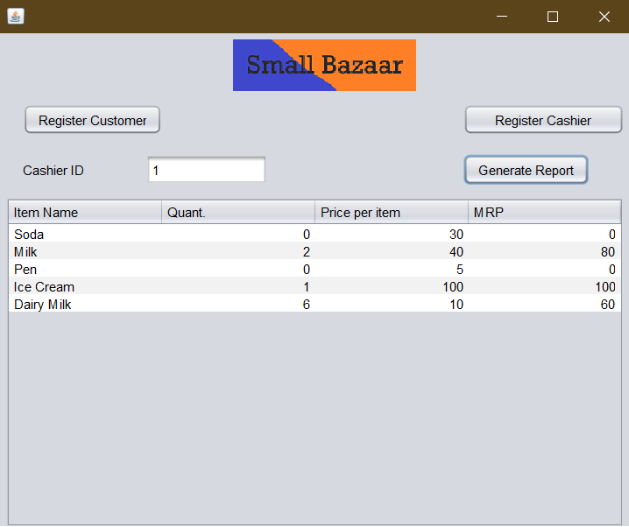

If no such Cashier exists

