| Program No: | 20 |
| --- | --- |
| Roll No: | 1510 |
| Title of Program: | Hashing |
| Objective: | Write 2 programs of hashing:   1. Linear Probe and Modulo Divison 2. Linear Probe and Digit Extraction |

**CODE:**

class HashTable

{

private Integer[] table;

private int size;

private int capacity;

public HashTable(int capacity){

this.capacity = capacity;

this.size = 0;

this.table = new Integer[capacity];

}//end of construtor

//Hash Function using modulo division

private int hash(int key)

{

return key%capacity;

}

//insert key into hash table

public void insert(int key)

{

if(size>=capacity)

{

System.out.println("Hash Table is full! Cannot insert " + key);

return;

}

int index = hash(key);

while(table[index] != null)

{

index = (index + 1)%capacity;

}

table[index] = key;

size++;

}

public void display()

{

for(int i=0; i<capacity; i++)

{

if(table[i] != null)

{

System.out.println("Index: " + i + table[i]);

}

else{

System.out.println("Index: " + i + ": null" );

}

}

}

public static void main(String[] args)

{

HashTable h = new HashTable(10);

//Sample key to insert

int[] keys = {25,52,45,78,98};

for(int i:keys)

{

h.insert(i);

}

h.display();

}

}// end of hashtable

**OUTPUT:**

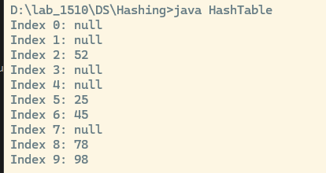

**CODE Digit Extraction and Linear Probe:**

/* Name: Advait Dhakad

Roll No: 1510

Unit 3: Hashing

Program: Digit Extraction and Linear Probe */

class HashTable_1

{

private Integer[] table;

private int size;

private int capacity;

public HashTable_1(int capacity){

this.capacity = capacity;

this.size = 0;

this.table = new Integer[capacity];

}//end of construtor

//Hash Function using modulo division

private int hash(int key)

{

return key%10;

}

//insert key into hash table

public void insert(int key)

{

if(size>=capacity)

{

System.out.println("Hash Table is full! Cannot insert " + key);

return;

}

int index = hash(key);

while(table[index] != null)

{

index = (index + 1)%capacity;

}

table[index] = key;

size++;

}

public void display()

{

for(int i=0; i<capacity; i++)

{

if(table[i] != null)

{

System.out.println("Index " + i + ": "+table[i]);

}

else{

System.out.println("Index " + i + ": null" );

}

}

}

public static void main(String[] args)

{

HashTable_1 h = new HashTable_1(10);

//Sample key to insert

int[] keys = {25,52,45,78,98};

for(int i:keys)

{

h.insert(i);

}

h.display();

}

}// end of hashtable

**OUTPUT:**

