





| Experiment No. 9 |
| --- |
| Program to manipulate arrays using Numpy |
| Date of Performace: 27/03/2024 |
| Date of Submission: 03/04/2024 |







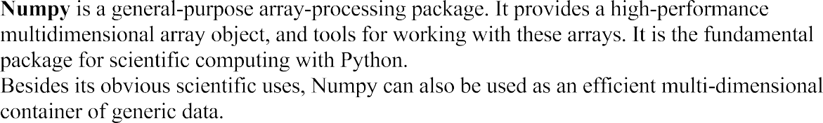









**Code:**

import numpy as np

l = []

n = int(input("Enter the number of elements: "))

for i in range(n):

l.append(int(input(f"{i}: ")))

arr = np.array(l)

a = int(input("Enter the element to find: "))

flag = False

for i in range(n):

if arr[i] == a:

print("Element Found at index ", i)

flag = True

break

if not flag:

print("Element not found")

s = 0

for i in arr:

s += i

print("The sum of the elements is: ", s)

**Output:**

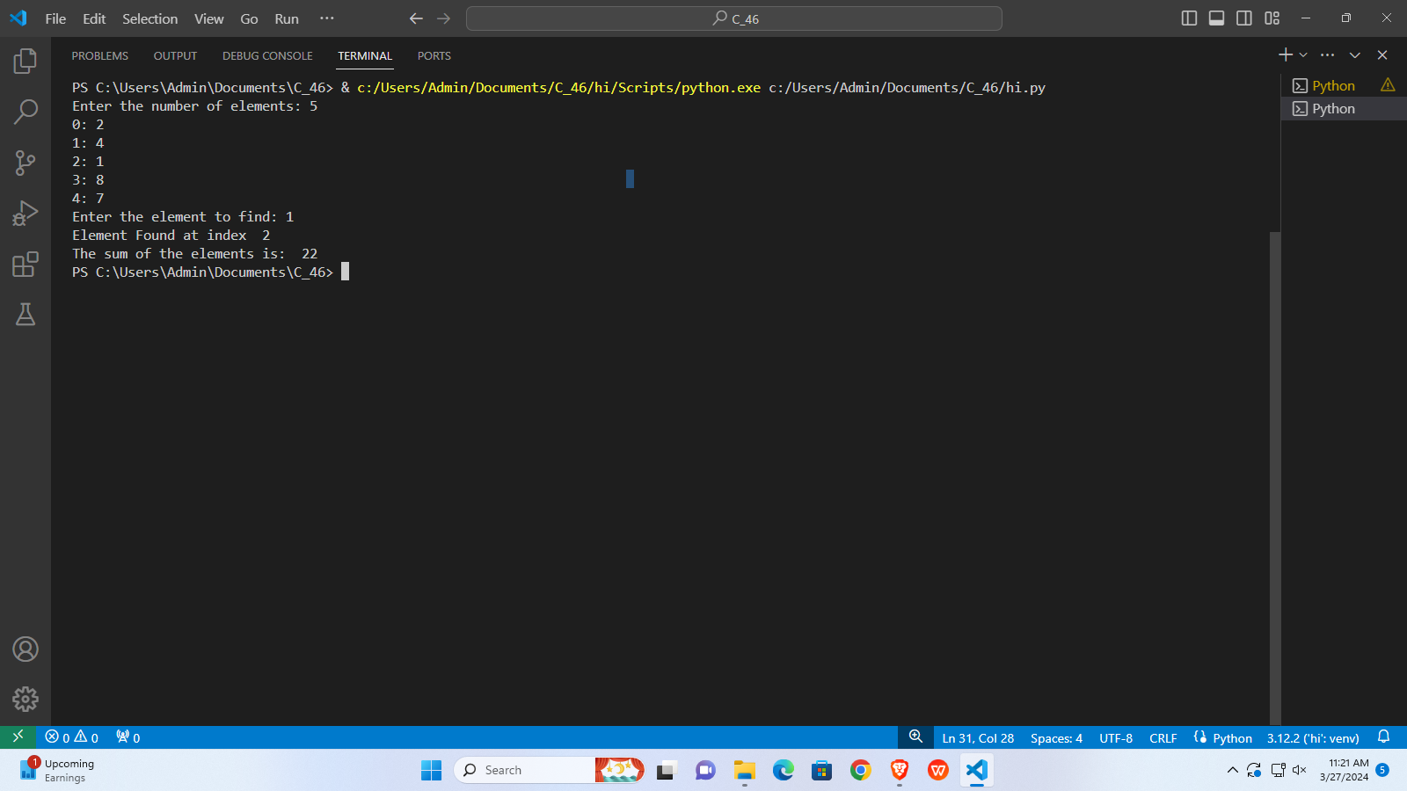

# Enter the number of elements: 5

# 0: 2

# 1: 4

# 2: 1

# 3: 8

# 4: 7

# Enter the element to find: 1

# Element Found at index 2

# The sum of the elements is: 22

**Conclusion:**

NumPy is a fundamental Python library for numerical computing. It provides support for large, multi-dimensional arrays and matrices, along with a collection of mathematical functions to operate on these arrays efficiently. NumPy's main object is the homogeneous multidimensional array. It is a table of elements (usually numbers), all of the same type, indexed by a tuple of non-negative integers. In NumPy, dimensions are called axes. NumPy arrays support advanced indexing techniques like slicing, boolean indexing, integer indexing, etc. NumPy integrates well with other Python libraries like SciPy (for scientific computing), Matplotlib (for data visualization), Pandas (for data manipulation and analysis), and more.