

| Experiment No. 11 |
| --- |
| Program to demonstrate manipulation using Pandas |
| Date of Performace: 10/04/2024 |
| Date of Submission: 17/04/2024 |





**Code:**

import pandas as pd

df = pd.read_csv("country_code.csv")

print("DataFrame Type:", type(df))

print("\nFirst 5 rows of the DataFrame:")

print(df.head())

print("\nBasic statistics of the DataFrame:")

print(df.describe())

print("\nInformation about the DataFrame:")

print(df.info())

**Output:**

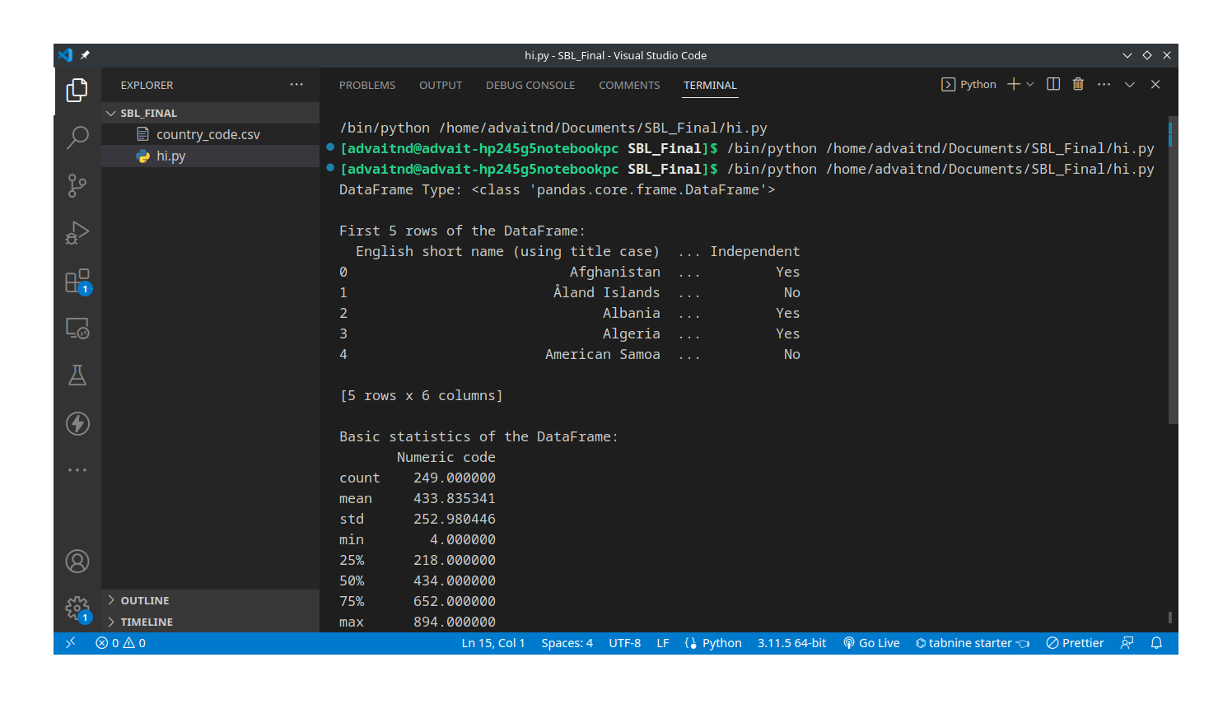

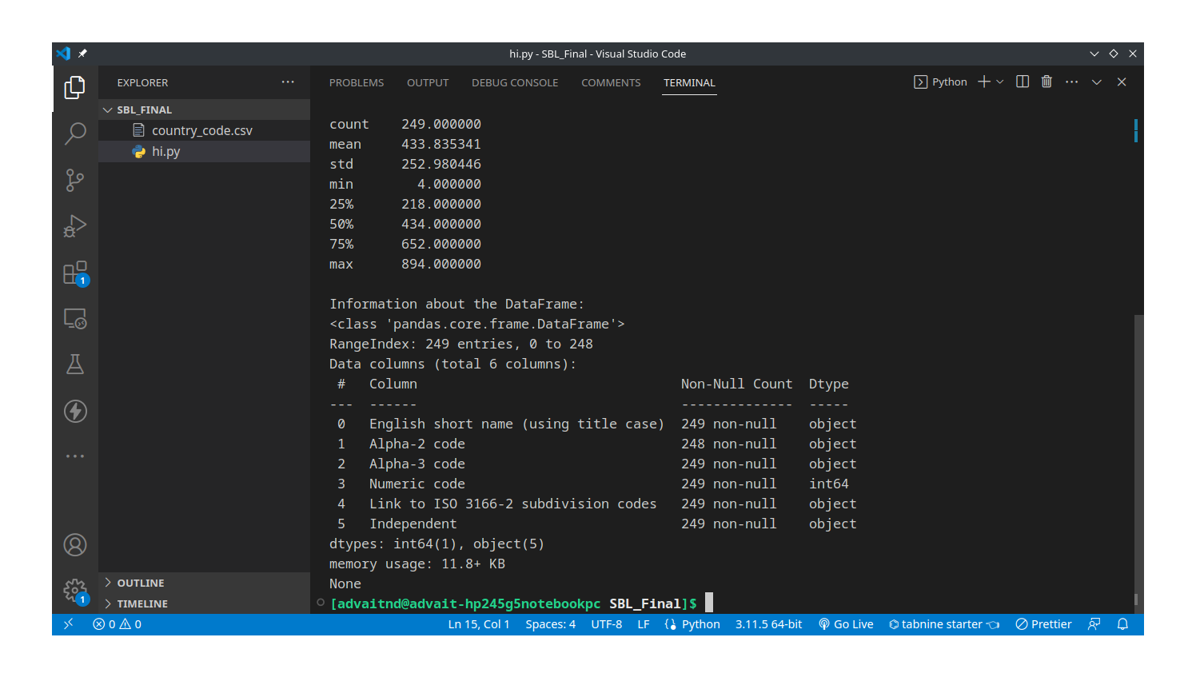

**Conclusion:**

Pandas is an open-source data manipulation and analysis library built on top of the Python programming language. Provides powerful data structures: primarily Series (1D) and DataFrame (2D), which are built on top of NumPy arrays. Offers tools for reading and writing data in various formats, including CSV, Excel, SQL databases, and more. Facilitates data manipulation tasks like filtering, sorting, grouping, merging, and reshaping datasets. Supports handling missing data through methods like dropna() and fillna(). Provides time series functionality for working with time-indexed data. Enables easy data visualization using integration with Matplotlib and Seaborn.





