**Q3.5.1**

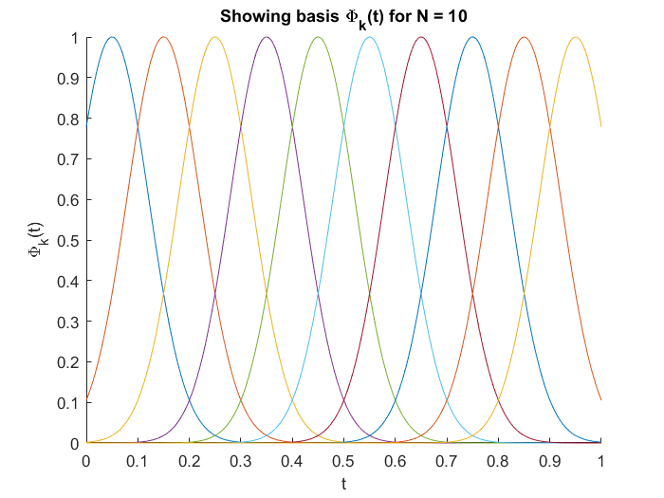**A close up of a piece of paper

Description generated with high confidence**

**Q 3.5.2**

**A screenshot of a cell phone

Description generated with very high confidence**

**Q 3.5.3**

**A close up of a map

Description generated with high confidenceA close up of a map

Description generated with very high confidence**

**A close up of text on a white background

Description generated with very high confidenceA close up of a piece of paper

Description generated with very high confidence**

**A screenshot of a social media post

Description generated with very high confidence**

**Q 3.6**

**A screenshot of a social media post

Description generated with very high confidence**

**A picture containing sky, text

Description generated with high confidence**

**A close up of a mans face

Description generated with high confidence**

**A screenshot of a cell phone

Description generated with high confidence**