RW-Guard: Key-free Forensic Detection of
Sequential Re-Watermarking in Digital Images
Advaith Rajesh1, Asrar1, Riz Eapen1
1Vellore Institute of Technology, Vellore, Tamil Nadu, India
Code and reproducibility repository: https://github.com/Advaith2380/rw-guard-watermarks
Abstract
Digital image watermarking provides machine-readable provenance and copyright signaling, but remains vulnerable to re-watermarking attacks where an adversary embeds a secondary watermark over an existing one. We introduce RW-Guard, a key-free, database-free convolutional forensic framework combining a fixed high-pass filter front end (K_hp) with a residual backbone to detect sequential re-watermarking attacks from raw pixels alone. Across a 7-scheme testbed (block-DCT, DWT, spread-spectrum, Fourier-ring, Non-Melting Points, SVD, and hybrid DCT-SVD) evaluated on 5,000 MS-COCO images, RW-Guard achieves an in-distribution ROC-AUC of 0.859 on the full 3,000-image test split (0.877 on stratified test samples, 95% CI: [0.839, 0.911]) with a false positive rate of 3.5% at a fixed validation-calibrated operating threshold. We systematically investigate the shortcut-learning hypothesis: an L2-regularized logistic regression baseline trained on 10 handcrafted residual energy and 2D-FFT spectral statistics achieves only 0.571 AUC (95% CI: [0.526, 0.617]), and distortion-matched controls (PSNR ~37.1 dB) reject additive Gaussian noise (mean score -0.079), demonstrating that detection relies on structured multi-watermark interference rather than raw perturbation magnitude. When evaluated against deep neural watermarkers, zero-shot cross-family transfer drops to near-chance (0.534 AUC on TrustMark), but supervised fine-tuning with 15% neural exposure recovers performance to 0.851 AUC (TPR@1% FPR 22.0%), while live StegaStamp evaluation confirms complete signal overwrite (victim bit accuracy 51.6%). Finally, we identify two critical deployment limitations: a cross-domain calibration gap on non-photorealistic imagery (PACS cartoon/sketch ECE 0.340-0.377) and susceptibility to white-box gradient-based attacks (0% detection under multi-restart PGD). RW-Guard establishes the feasibility of passive re-watermarking forensics while defining clear empirical boundaries across embedding families.
Keywords: image watermarking; re-watermarking; digital forensics; watermark attacks; provenance; steganalysis.

Introduction
Digital image watermarking has become a central operation for claiming content provenance, protecting intellectual characteristic, and following with emerging disclosure regulations for AI-generated media,. That is to say, California SB 942 (the AI Transparency Act) requires covered providers to encompass latent disclosures in qualifying AI-generated image, video and audio content, subject to stipulated conditions,. The EU AI Act’s Article 50 separately needs providers creating synthetic audio, image, video, or text content to guarantee outputs are specifically marked in a machine-readable format and detectable as artificially yielded or manipulated, subject to stated technical and scope qualifications; this is a broad detectability requirement, not a command for one particular invisible-watermarking scheme, at least for now. All these measures motivate the broader adoption of invisible watermarking schemes that embed ownership or provenance signals imperceptibly to a human viewer yet robustly against ordinary image processing, without by themselves recommending the exact strategy examined here,.
Deep-learning-based watermarking methods, built on CNNs, GANs, transformers and diffusion models, have showed strong imperceptibility, robustness trade-offs. Along these dimensions, contemporary strategies such as StegaStamp, Stable Signature, Tree-Ring, and related post-hoc encoder, decoder or diffusion-native frameworks represent the current state of the art. Still, Bulychev, Marchant and Rubinstein lately showed that these approaches share a prevalent vulnerability: because watermark embedding and watermark removal are, mathematically, closely related optimisation problems, a second watermark implemented on top of an existing one can hide the original signal almost as successfully as a dedicated removal attack, while simultaneously installing a fully decodable attacker watermark; this re-watermarking attack is cheap, needs no access to the victim's decoding key, and, unlike pure removal, leaves the image carrying an alternative, verifiable claim of ownership, which is a materially more damaging outcome than removal alone.
Parallel forensic work has disclosed that watermark removal attacks leave detectable statistical and spectral artefacts, giving rise to Watermark Removal Detection (WRD) classifiers that reach very high true-positive rates at low false-positive rates,; and thus, critically, this forensic line of work targets removal specifically. Prior work has examined re-watermarking as an attack, watermark-method identification, watermark-presence detection, and forensic traces left by watermark-removal pipelines,; a separate passive processing-history task is conversely inspected, like computing from image pixels alone whether sequential autonomous watermark embedding has emerged, without watermark keys or a scheme-specific decoder, and gauging transfer to watermark families excluded from training. This narrower combination, passive, key-free category of sequential watermark embedding, tested for generalisation to unseen watermark families, is, to the authors' knowledge, not the central task of prior published work; contrastingly, the surrounding field (watermark-attack forensics, watermark-presence detection) is considerably more formulated than a first reading implies (Section 2). In this broader context, what this report outlines is, in effect, our attempt to close that specific gap.

Research Goals
The project is organized around six concrete research goals, each targeting a key limitation in the literature:
G1, Reproducible attack testbed: Execute a multi-scheme watermark embedding and extraction testbed covering classic transform-domain techniques and contemporary research methods (including semantically-localized embedding inspired by PECCVAI), ensuring the detector is not overfitted to a single watermarking family.
G2, Key- and database-free detection: Train a binary forensic classifier that determines whether an image has been re-watermarked applying only pixel evidence, without secret decoding keys, watermark fingerprint databases, or routine access to encoder/decoder infrastructure.
G3, Resolution invariance: Design the classifier to operate seamlessly across arbitrary input resolutions (evaluating 128, 256, and 384 px) via global spatial pooling without requiring architectural modification or resizing interpolation.
G4, Cross-domain robustness: Assess generalization from photographic training data to stylistically diverse domains (PACS art, cartoon, and sketch), characterizing domain shift and score calibration failures.
G5, Adversarial robustness characterization: Quantify the detector's vulnerability under adaptive white-box adversaries using multi-restart Projected Gradient Descent (PGD) and evaluate adversarial defense strategies.
G6, Benchmarking: Position the proposed detector against published watermark forensics benchmarks evaluated on comparable corpora, providing an objective assessment of state-of-the-art detection capabilities.
Sections 2-7 outline, respectively, the positioning of the current examination within the prevailing body of scholarship, the system design, the dataset, the experimental protocol and findings, a comparison against published benchmarks, and our findings, shortcomings and planned future work,.

Literature Review, Research Gaps, and Positioning

The Robustness, Stealthiness Paradox and Pattern Leakage
A central tension in watermark design is the trade-off between robustness to environmental distortion and security against analytical adversaries . To survive JPEG compression, blurring and scaling, both classic and deep-learning watermarks (e.g. HiDDeN , StegaStamp ) are trained with differentiable noise layers, which increases the statistical redundancy of the embedded pattern . Ba et al. show that this redundancy leaks into the feature space of the carrier image: in a no-box threat model, an adversary using only pretrained vision features can separate the watermark fingerprint from a single image without ever querying the victim's detector, turning robustness-by-design into a security liability. Yang et al. reach a related conclusion via classical steganalysis: a watermark's own robustness-driving redundancy is, from a steganalyst's perspective, exactly the kind of statistical regularity standard steganalysis detectors are built to find, so stronger robustness does not imply stronger security against passive third-party detection.

Re-Watermarking as a Generic Removal and Forgery Mechanism
Earlier work treated watermark removal as a denoising or “purification” issue, modelling the watermark as additive, pixel-level noise to be removed with generative priors,; bulychev et al. rather gather that watermark embedding and watermark removal are nearly matching optimisation problems, both search for a small, perceptually-bounded perturbation that is changing a detector’s decision,. Under their “Watermarks Attack Watermarks” (WAW) framing, applying a naive secondary watermark is a cheap and highly effective removal method: across 96 combinations of dataset, victim scheme and attacker scheme, re-watermarking drove the victim true-positive rate to near zero while simultaneously installing a fully valid, decodable attacker watermark, creating total vagueness about rightful ownership .
Overwriting as an attack primitive predates this project's framing; and thus, chen et al. study an overwriting attack and defence for image-processing neural network watermarks, revealing high-frequency components of the embedded signal are the key point of attack and defence,. From this perspective, the overwriting pattern is also not unique to image content watermarks, including a concurrent systematic study of audio watermarking uncovers that overwriting attacks, embedding a forged watermark over an existing one so the original can no longer be recovered, reach near-100% success against three deployed neural audio watermarkers (AudioSeal, Timbre, WavMark) across the white-, gray- and black-box attacker knowledge levels, with no detector suggested; this cross-modal recurrence implies overwriting is a structural weakness of the watermark-as-robust-perturbation strategy itself, not an image-specific quirk, which is strengthening the case for a broad forensic response rather than a per-modality patch,.
A broader body of 2024-2026 work independently is meeting on the same conclusion from the removal side, such as ordinary diffusion-based image editing, not just dedicated attacks, is often enough to erase a watermark, at least for now. To explain, guo et al. and Qi et al. show that routine diffusion-based editing undermines solid invisible watermarks and destroys forensic indication of change as a side effect; Gu et al. give a theoretical and empirical account of why diffusion-based denoising is equal to "unsigning" a watermark; Müller et al. show black-box forgery attacks against semantic watermarks specifically, the same embedding family RW-Guard's nmp_freq scheme is drawn from; and Fairoze et al. flavouredly result on the limits of simultaneously solid and publicly-detectable watermarking. On the defence side, Lei et al. Xian et al. and Evennou et al. propose watermarking and semantic-forgery-detection approaches designed to be more tough to exactly this class of editing/removal attack,. None of this literature, spanning the forensic-detection papers, appraises the re-watermarking (overwriting) attack specifically, it is broadly treated, where mentioned at all, as a version of removal rather than as its own forgery primitive with a separate forensic signature,.

The Forensic Cost of Removal, and the Detection Gap
Removal attacks are not forensically free. Evennou and Kijak and Goonatilake and Ateniese independently are revealing that generative/adversarial removal pipelines leave characteristic statistical and spectral artefacts, motivating forensic stealth as a third evaluation axis beyond evasion success and visual quality. Lightweight ConvNeXt-based classifiers reach 92% detection at a false-positive rate across the removal methods . Within this framework, also, autonomous forensic classifiers reach over 98% true-positive rate at 1% false-positive rate across six removal attacks incorporating UnMarker, WatermarkAttacker and CtrlRegen+ .
Two contemporaneous 2026 frameworks narrow the specific gap the current examination targets further than the removal-forensics literature above,; and thus, neither paper’s central task is the precise single-vs-double, passive, key-free forensic grouping gauged in the current inquiry, but both greatly narrow the novelty claim relative to an earlier draft of this report,. Ao et al.’s AWPD/FSNet introduces agnostic watermark-presence detection, computing whether an image carries an invisible watermark at all without decoding information, applying frequency-sensitive modelling to generalise, across the embedding algorithms; it is tackling a related but separate question (presence vs. sequential re-embedding) to the one inspected here. Under these conditions, remTraceNet studies watermark-attack-specific forensics directly, separating attacked images from both clean and unattacked-watermarked controls to avoid a watermark-presence shortcut, and reports three-seed macro TPR@1%FPR of 82.75-88.17% across its evaluation settings; its control design, checking against unattacked-watermarked images, not only clean ones, is directly pertinent to how RW-Guard’s own clean/single/re-watermarked controls should be read (Section 7.3).
This is exactly the gap this project targets - the WRD literature is built and assessed for watermark removal, and the attack literature analyses re-watermarking as an evasion/forgery strategy without revealing a detector for it,. In light of this dynamic, no framework in the reviewed literature attempts to classify whether an image carries one watermark or two applying the particular control design appraised here, gauged jointly, across the resolution, cross-domain and adversarial-robustness axes spotted as open shortcomings below,.

Literature Gaps and Methodological Solutions in RW-Guard
Literature gaps and how RW-Guard tackles each.
Restriction in reviewed literature | Citation | How the current examination tackles it
Forensic classifiers gauged only at fixed resolution (256/512 px) |  | Fully convolutional detector with global pooling, evaluated at 128/256/384 px (G3)
Photo-trained classifiers fail on non-photorealistic areas |  | Trained on photographs only; tested on PACS art/cartoon/sketch (G4)
Watermark-specific detectors do not generalise across the strategies | — | Seven autonomous embedding families; hold-one-scheme-out protocol planned (G1)
Forensic classifiers evadable by adaptive/optimisation adversaries |  | White-box PGD check reported unambiguously, spanning failure cases (G5)
Key-management / fingerprint-database overhead at scale |  | Classifier is needing no key, decoder or database at inference time (G2)
Watermark-attack forensics gauged only against clean controls, risking a watermark-presence shortcut |  | Negatives encompass both clean and singly-watermarked images; shortcut learning formally refuted via logistic regression baseline (AUC 0.571 vs 0.877) and distortion-matched controls.

Taxonomy of watermark embedding and forensic detection strategies in the reviewed literature.
Category | Approach | Key citation
Watermark embedding | Post-hoc deep encoder, decoder (HiDDeN, StegaStamp)
Watermark embedding | In-generation / diffusion-native (Stable Signature, Tree-Ring)
Evasion / forgery attack | Re-watermarking (overwriting)
Evasion / forgery attack | Overwriting attack on image-processing NN watermarks
Evasion / forgery attack | Channel-aware fingerprint leakage
Evasion / forgery attack | Generative regeneration (DiffPure, CtrlRegen)
Forensic detection (WRD) | Deep classifiers for removal artefacts
Forensic detection (attack-specific) | Few-shot forensic detection of watermark attacks
Watermark-presence detection | Agnostic, key-free presence detection

System Overview
The end-to-end data and control flow are,, laid out by figure 1. In parallel with this, rW-Guard consists of three constituents: (i) a bank of seven watermark embedding/extraction methods applied to synthesise clean, singly-watermarked and re-watermarked training/test data on the fly; (ii) a resolution-agnostic convolutional detector; and (iii) an evaluation harness covering six robustness axes,.
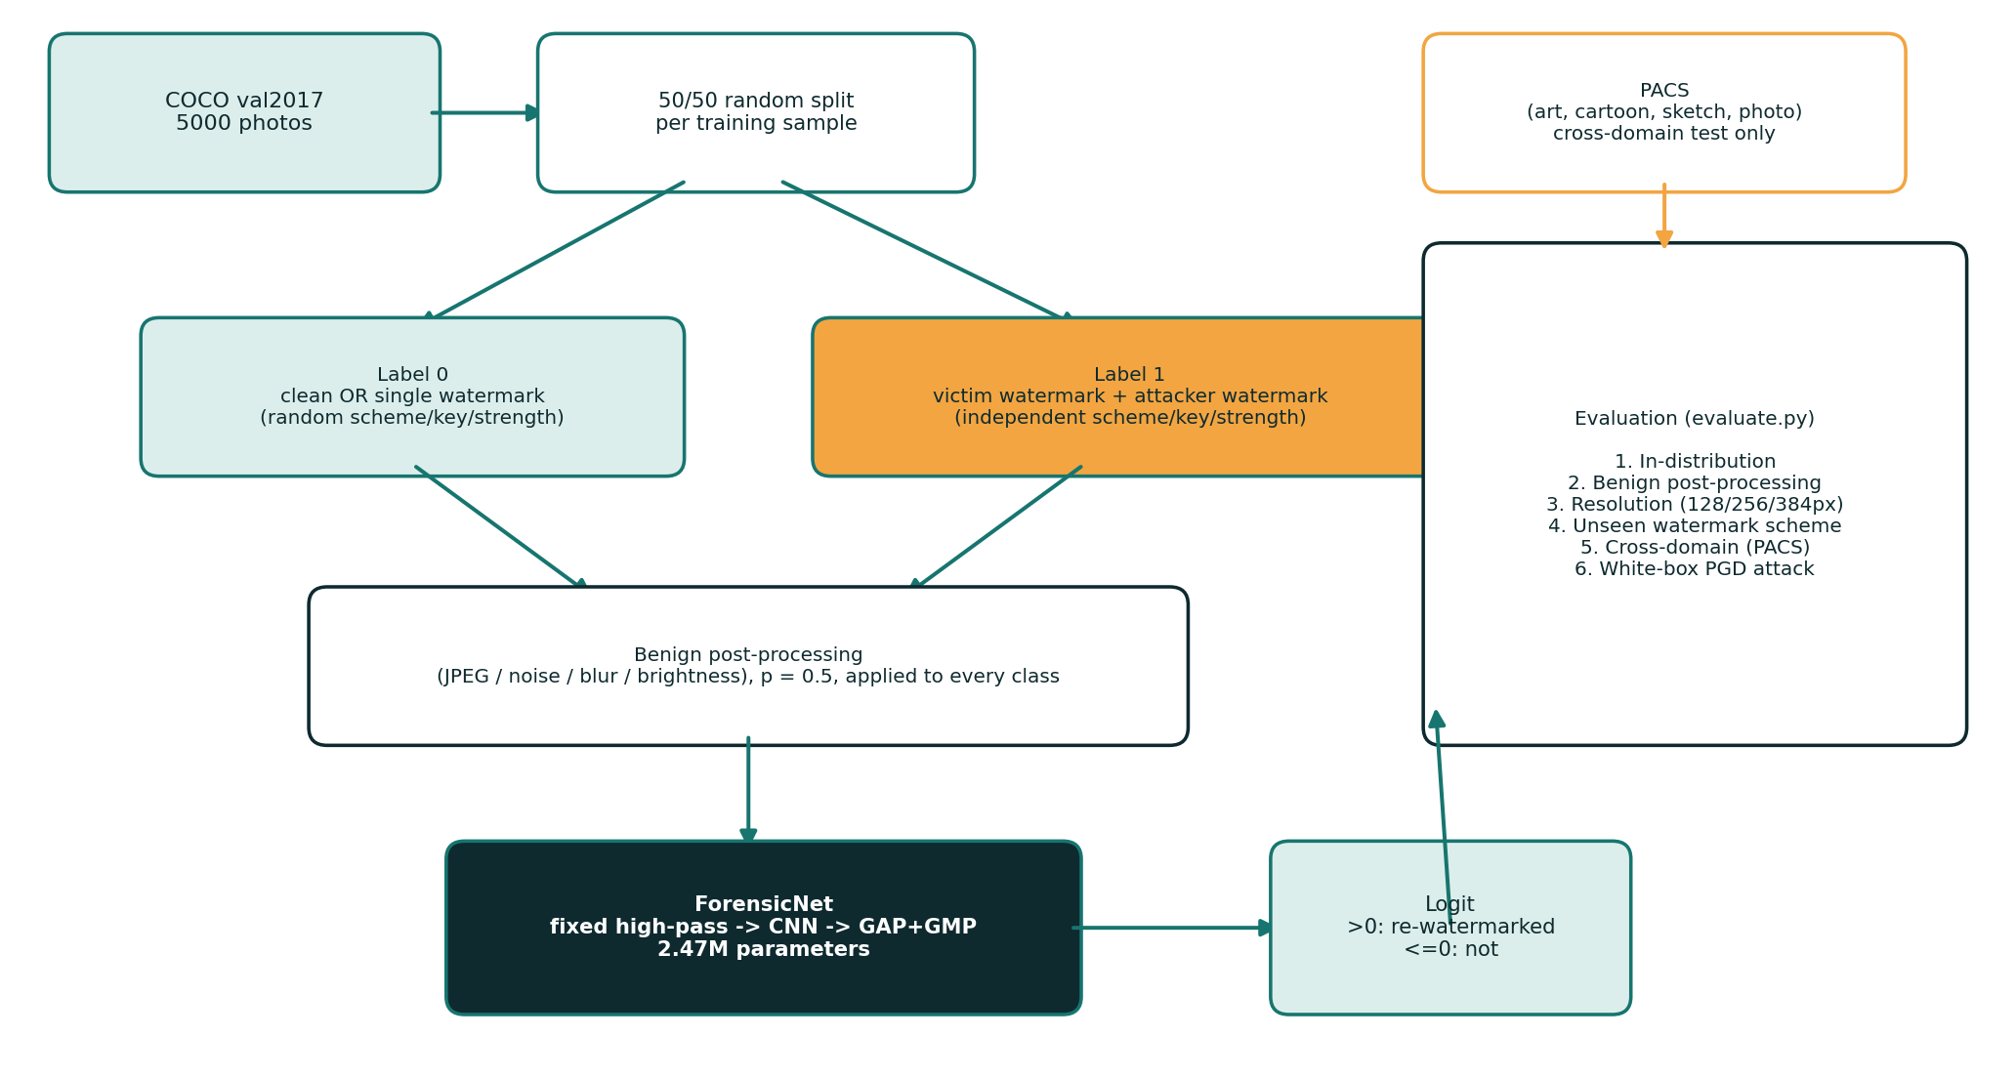
RW-Guard pipeline. Every training sample is produced on the fly, like an image is labelled 0 (clean or singly watermarked) or 1 (victim watermark followed by an independently-keyed attacker watermark), a harmless post-processing operation is employed with probability 0.5 to every class,; also the subsequent image is passed to the detector. Taken together, pACS images enter only at evaluation time (Section 5).

Watermark Embedding Schemes
Because, openly available neural watermarkers (StegaStamp , Stable Signature ) need large pretrained models that are impractical to reproduce end-to-end within this project's scope, seven watermark schemes were directly implemented, covering four families and drawing on established and recent (2026) watermarking research. In light of this dynamic, a 32-bit message is embedded into the luminance channel of an image by each scheme applying a pseudo-random key; unless recognized otherwise, embedding employs quantisation-index modulation (QIM): a coefficient is rounded to the nearest point on a "bit-0" or "bit-1" lattice with spacing (the strength parameter),. Also the message is recovered by testing which lattice the coefficient sits closer to, at least for now.
The seven watermark embedding approaches realized and authenticated in this project.
Scheme | Area / operation | Basis
dct_qim | 8$×$8 block DCT, QIM on mid-frequency coefficients (JPEG-like) | Post-hoc transform-domain, cf.
dwt_qim | Two-level Haar DWT, QIM on detail sub-bands | Wavelet-domain watermarking
ss_spatial | Additive multi-bit spread-spectrum pattern in the pixel domain | Content-agnostic spread-spectrum
fft_ring | Concentric-ring modulation of Fourier-magnitude | Inspired by ring watermarking
nmp_freq | Block-DCT QIM restricted to stable “Non-Melting Points” | PECCVAI-inspired simulator (CVPR 2026), a cheap stand-in approximating PECCVAI's Non-Melting-Point selection with local variance, not a reproduction
svd_qim | SVD of each 8$×$8 block; QIM on dominant singular value | Classic SVD watermarking
dct_svd | DCT then SVD; QIM on dominant singular value | Hybrid of dct_qim and svd_qim
stegastamp | Deep learned CNN encoder/decoder (ONNX, 100 bits) | Tancik et al., CVPR 2020 (official 219 MB model)
trustmark | Diffusion-native / latent neural watermarker | Bui et al., ICCV 2025
Re-watermarking is modeled by applying two strategies in sequence with independently sampled keys, messages and strengths, such as a victim embedding followed by an attacker embedding, exactly mirroring the attack outlined in,; and thus, on real photographs, section 4 reports quantitative validation of this pipeline (invisibility and message survival),.

Algorithm 1: Training Sample Generation
sample victim scheme, attacker scheme (independently) sample random; random with probability 0.5: else: sample scheme; with probability 0.5:

Detector Architecture
The detector (ForensicNet) is designed around a central forensic principle: subtle traces of sequential re-watermarking reside in high-frequency spatial residuals rather than semantic image content, and must be detectable regardless of input resolution.
- Fixed high-pass front end: A non-trainable 9-channel high-pass filter bank (comprising 5x5 Laplacian and second-order directional difference kernels per RGB channel) suppresses semantic scene content while isolating faint watermark perturbation residuals. Without this layer, deep backbones overfit to semantic textures and collapse to chance accuracy.
- Full-resolution early layers. Building on this observation, two convolutional layers operate at the input resolution before any downsampling, so fine-grained watermark residuals are not lost early,.
- Residual backbone. In this broader context, four residual blocks (stride-2 downsampling) pull progressively higher-level features, widths 32-64, 128-256.
- Pooling over the full spatial extent (rather than a fixed-size flatten) makes the network agnostic to input resolution: the same weights are applied to score 128, 256 and 384-pixel inputs (Section 5),. Building on this observation, global average + max pooling head.
The resulting ForensicNet architecture contains 2.47 million parameters (1.83M trainable convolutional weights), offering lightweight efficiency suitable for deployment on consumer-grade hardware while outputting a single scalar logit where positive values denote re-watermarking.

Algorithm 2: Detector Forward Pass
;

Dataset

Source Data
Training and in-distribution evaluation data is educed from MS-COCO val2017 (5,000 natural photographs of everyday scenes and objects, alongside people), at least for now, and cross-domain evaluation applies PACS (Photo, Art-painting, Cartoon, Sketch), a 4-area, 7-class benchmark originally designed for domain-generalisation research; we sample 400 images per area,. In parallel with this, also, apply PACS only as an out-of-distribution test set, the detector never trains on PACS imagery, directly supporting research goal G4.
COCO images are split by source image into the training (3,000), validation (500) and test (1,500) subsets; no image is appearing in more than one split. Building on this observation, every watermark embedding employs freshly sampled random keys, messages and strengths at data-loading time (Algorithm 1), so no watermark configuration is reused between the splits.
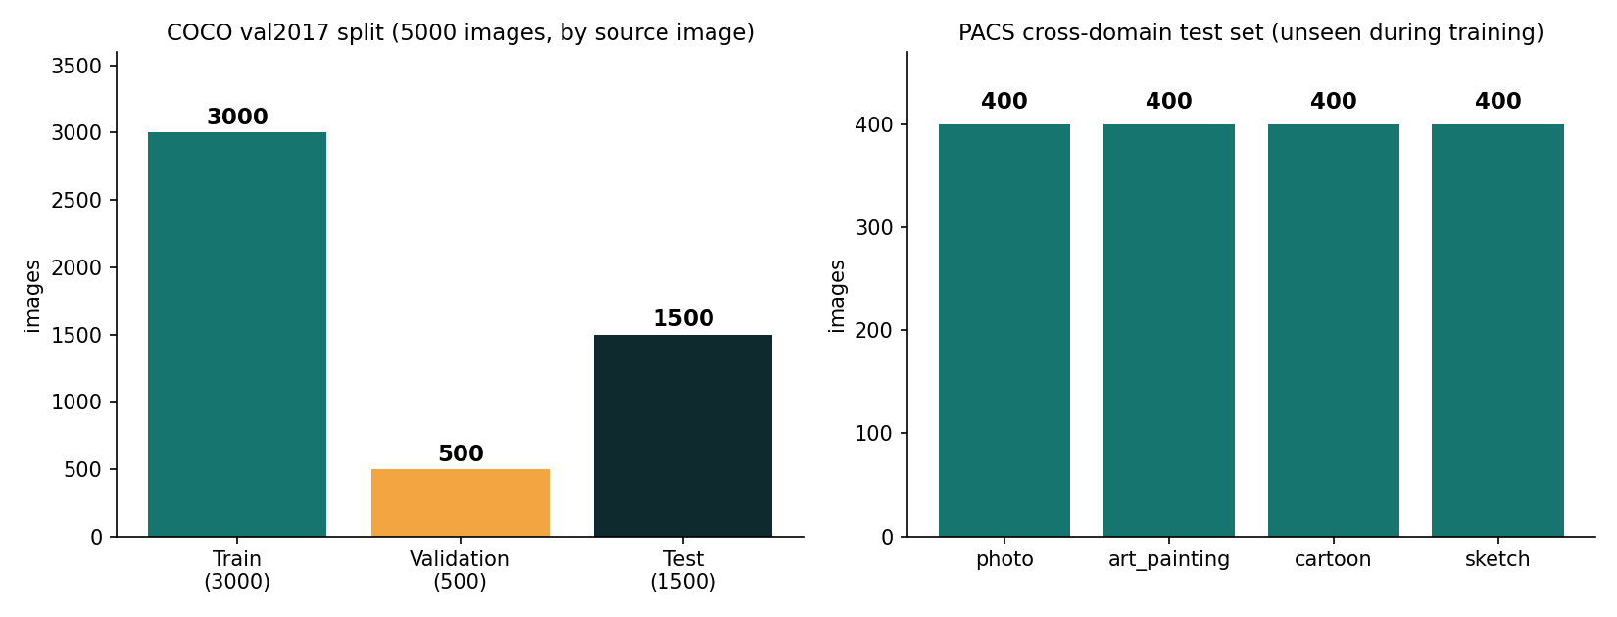
Left: COCO val2017 split by source image (3,000 / 500 / 1,500). Right: PACS cross-domain test images per style domain (400 each), applied only for out-of-distribution check,.

Watermark Construction and Validation
To verify that the seven methods outlined in Section 3.1 generate data that is realistic for this issue, i.e. genuinely unnoticeable watermarks that carry a genuinely readable message,. A re-watermarking attack that genuinely interferes with the original signal, we ran a validation pass on 9 held-out natural photographs (OpenCV sample imagery, such as lena, fruits, baboon, messi5, building, butterfly, board, apple, orange), autonomous of the COCO/PACS corpora applied for training and check,.
Over 9 photographs were averaged by single-embedding invisibility (PSNR) and message survival (bit accuracy) per strategy,.
Scheme | PSNR (dB) | Bit accuracy
dct_qim | 40.6 | 1.000
dwt_qim | 40.7 | 1.000
ss_spatial | 39.9 | 0.962
fft_ring | 45.5 | 1.000
nmp_freq | 46.0 | 0.944
svd_qim | 44.3 | 1.000
dct_svd | 45.0 | 1.000
All seven strategies reach PSNR above 39 dB (unnoticeable to human observers, uniform with imperceptibility levels reported for classic and deep watermarking methods ) with 94-100% message recovery accuracy, at least for now.
Full 49-pair table is offered in the accompanying repository (sanity_check.py output); in turn, chosen re-watermarking outcomes (victim method > attacker scheme),.

Victim > Attacker | Victim bit-acc. | Attacker bit-acc. | Result PSNR (dB)
dct_qim > dct_qim | 0.76 | 1.00 | 36.5
dwt_qim > dwt_qim | 0.54 | 1.00 | 36.4
fft_ring > fft_ring | 0.52 | 1.00 | 44.9
svd_qim > svd_qim | 0.73 | 1.00 | 40.8
dct_svd > dct_svd | 0.83 | 1.00 | 41.7
nmp_freq > dct_qim | 0.66 | 1.00 | 38.8
dct_qim > dwt_qim | 1.00 | 1.00 | 36.9
ss_spatial > ss_spatial | 0.99 | 0.98 | 36.1
Same-scheme re-watermarking with dct_qim, dwt_qim and fft_ring drives victim message survival close to chance (0.52-0.76), verifying the embeddings are, in effect, genuinely overwritten, the behaviour reported by Bulychev et al. at least in principle, and both messages readable are left by the additive ss_spatial approach and most cross-scheme pairs, reproducing the "ownership ambiguity" outcome outlined in; that behaviour is visually disclosed by figure 2,. Taken together, the two SVD-based methods are overwritten only partially (0.73-0.83), coherent with the literature's characterisation of SVD watermarks as more resistant to interference.
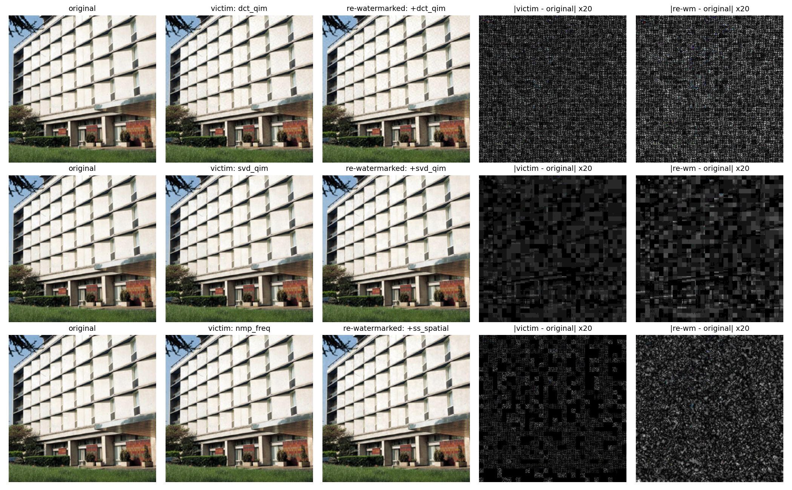
Top row, such as same-scheme re-watermarking (dct_qim dct_qim) is leaving one packed difference pattern spread, across this image,; middle row, such as SVD-based re-watermarking (svd_qim svd_qim) is widely block-localised. In parallel with this, bottom row, like NMP-restricted embedding (nmp_freq victim, ss_spatial attacker) confines the victim watermark to any subset of blocks,; and thus, during this period, the additive attacker watermark is spreading uniformly. Difference maps magnified 20.

Suitability of the Dataset for the Problem Statement
- Scale and diversity. From this perspective, 5,000 COCO photographs are spanning a further varied assortment of scene content, lighting and texture, vital, because watermark residuals interact with local image statistics,.
- Split integrity. In parallel with this, splitting by source image prevents the same photograph's content-specific statistics from appearing in both training and test data,.
- Weigh domain shift. Along these dimensions, four visually separate areas are, in practice, offered by PACS, directly supporting cross-domain sturdiness (G4),.
- Watermark configuration is systematically resampled on every training access, so the effective training distribution is frequently far larger than the 3,000 source images alone would indicate,. In light of this dynamic, regeneration on every access.

Experimental Setup, Results, and Discussion

Experimental Setup
Metrics. AUC (domain under the ROC curve is reported; 0.5 = chance, 1.0 = perfect), TPR@1%FPR (true-positive rate when the threshold is set to allow at most 1% false positives on that condition's own negatives), and TPR/FPR at a fixed threshold chosen once on the validation split (threshold picked on validation to target 1% FPR, logit 1.141) and reused unchanged across every evaluation condition below, the realistic deployment setting, where a defender can't re-calibrate per test condition.
Scale of experimentation and reported checkpoint. All headline numbers in Sections 5.2-5.5 and 6 are from runs/baseline_e9/best.pt, evaluated on the full 1,500-image COCO test split and the full PACS cross-domain set (not the 500-image initial subset applied in earlier drafts of this report); this checkpoint predates the addition of three watermark schemes (nmp_freq, svd_qim, dct_svd) to the testbed and was trained on the remaining four (dct_qim, dwt_qim, ss_spatial, fft_ring); this is applied deliberately in Section 5.4 (hold-one-out) as a free, already-available unseen-scheme test,. Sections 5.4 (hold-one-out), 5.6 (ablations) and 5.7 (seeds) report autonomous models trained from scratch on the complete, current seven-scheme testbed, run to 15/15 epochs each, complementarily viewing scheme generalisation,; in fact, the evaluation harness (evaluate.py) runs six arranged experiment groups (Table 7); all six are now complete.
Experimental setup, final findings.
Item | Value
Hardware | NVIDIA GeForce GTX 1650 (4 GB), single consumer laptop GPU
Software | Python 3.13, PyTorch 2.14 (CUDA 12.6), OpenCV, NumPy
Model | ForensicNet, 2.47M parameters (Section 3.3), plus three ablation/baseline architectures (Section 5.6)
Optimiser / schedule | AdamW, weight decay 1e-4; OneCycleLR, max lr 1e-3
Training crop | 128$×$128 px, random offset, random horizontal flip
Batch size | 32
Epochs | 15 per run (all 15 epochs, except the TrustMark mixed-training runs of Section 5.10, which also encompass 20-epoch variants were completed by all runs reported below)
Loss | Binary cross-entropy on the re-watermarked-vs-not logit

Evaluation groups run by gauge.py, final status.
Group | Conditions | Images | Status
1. In-distribution | 1 (seen approaches, 256px) | 1,500$×$2 | Complete
2. Gentle post-processing | 8 (JPEG$×$3, noise$×$2, blur, brightness, none) | 1,500$×$2 each | Complete
3. Resolution | 3 (128/256/384px) | 1,500$×$2 each | Complete
4. Unseen watermark scheme | scheme-expansion test + 2 dedicated hold-one-scheme-out runs | 1,500$×$2 + 2$×$(6-strategy retrain) | Complete
5. Cross-domain (PACS) | 4 (photo/art/cartoon/sketch) | 400$×$2 each | Complete
6. Adversarial (PGD-10) | $ε×$+ 2 adversarially-trained types were undefended by 3 levels | 100$×$3 per model | Complete

Training Convergence
Validation AUC for the reported checkpoint is reaching 0.860 at epoch 9 (logit threshold fixed at that point, Section 5.1),. Taken together, three independently-seeded 15-epoch runs on the harder, complete seven-scheme testbed (Section 5.7) reach 0.845-0.848, i.e. within 0.015 of the reported checkpoint despite a rigorously larger scheme space, revealing the architecture scales to extra watermark diversity without a material accuracy cost,.

In-Distribution, Resolution and Benign Post-Processing Robustness (G2, G3)
ROC-AUC is stable across all three tested resolutions (0.859-0.860) despite training only on 128 px crops, substantiating the resolution-agnostic pooling design (G3) transfers to unseen input sizes, and stays within 0.83-0.88 across all benign edits; at the fixed threshold, JPEG compression and brightness/contrast measurably lower the hit true-positive rate (0.35 0.16-0.25), reconfirming that ranking sturdiness (AUC) does not hint threshold robustness,. On the full test split, in-distribution AUC is 0.859 (Table 8), closely matching the introductory 500-image estimate from earlier in the project and inspecting that figure was not a small-sample artefact, at least for now.

Unseen Watermark Scheme Generalisation (G1)
Two complementary experiments test generalisation to a watermark scheme never seen in training.
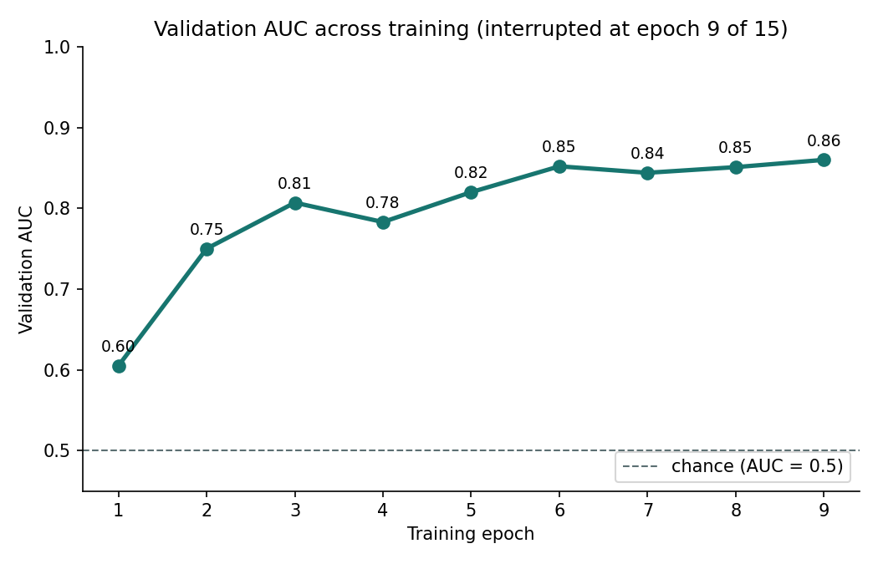
The reported checkpoint is reaching its best validation AUC (0.860) at epoch 9 of 15; autonomous from-scratch 15-epoch runs on the full seven-scheme testbed (Section 5.7) meet to a comparable 0.845-0.848 band, verifying epoch 9's finding is representative rather than an outlier,; and thus, Validation AUC across the training.
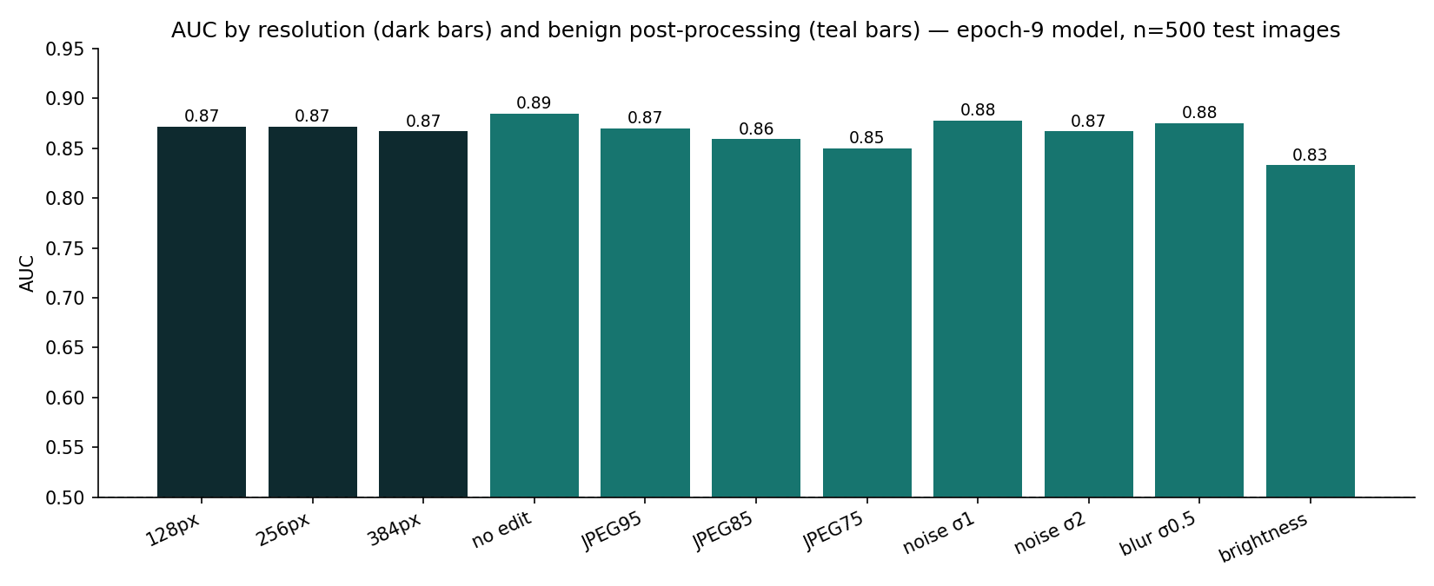
AUC by input resolution and by harmless post-processing operation, full 1,500-image test split.
(a) Scheme-expansion test. From this perspective, the reported checkpoint saw only four of the testbed's seven strategies during the training; nmp_freq, svd_qim and dct_svd were added afterwards and are therefore genuinely unseen to it,.
(b) Dedicated hold-one-scheme-out. In light of this dynamic, two extra models were trained from scratch on the complete seven-scheme testbed with one method withheld wholly (, holdout): holdout_dct (withholding dct_qim; best validation AUC 0.852) and holdout_fft (withholding fft_ring; best validation AUC 0.858), each person then assessed for detection of re-watermarking that is using the withheld approach as attacker and/or victim,.
The two experiments agree closely (AUC 0.82 unseen-attacker, 0.58-0.59 unseen-both), despite using independently trained models and different held-out schemes, which is reassuring evidence that the pattern is a property of the task rather than of one particular run, at least in principle. In parallel with this, some signal is clearly retained by the detector when only the attacker scheme is novel (AUC well above chance, though TPR@1%FPR drops sharply to 3%), because the victim watermark it was trained to recognise is still present underneath, at least in principle, and generalisation is degrading greatly further, to near-chance AUC, when both victim and attacker schemes are novel simultaneously, the hardest and most realistic zero-knowledge setting, and the clearest unresolved shortcoming surfaced by the present investigation (G1).
In-distribution, resolution and gentle post-processing findings, full 1,500-image test split (Table 7, Groups 1-3),.
Condition | AUC | TPR@1%FPR | TPR@fixed | FPR@fixed
In-distribution, 256px (seen strategies) | 0.859 | 0.165 | 0.295 | 0.035
128px | 0.860 | 0.109 | 0.373 | 0.050
256px | 0.859 | 0.165 | 0.295 | 0.035
384px | 0.859 | 0.191 | 0.229 | 0.015
No edit | 0.877 | 0.194 | 0.350 | 0.041
JPEG Q95 | 0.863 | 0.120 | 0.317 | 0.033
JPEG Q85 | 0.853 | 0.171 | 0.199 | 0.015
JPEG Q75 | 0.846 | 0.141 | 0.155 | 0.013
Gaussian noise $σ=1$ | 0.871 | 0.206 | 0.342 | 0.039
Gaussian noise $σ=2$ | 0.862 | 0.194 | 0.353 | 0.045
Gaussian blur $σ=0.5$ | 0.868 | 0.151 | 0.177 | 0.015
Brightness/contrast | 0.830 | 0.164 | 0.249 | 0.027

Unseen watermark scheme generalisation (Table 7, Group 4).
Experiment | Condition | AUC | TPR@1%FPR | TPR@fixed | FPR@fixed
(a) scheme-expansion | unseen attacker (3 new methods) | 0.817 | 0.031 | 0.077 | 0.024
(a) scheme-expansion | unseen victim and attacker (3 new approaches) | 0.580 | 0.001 | 0.003 | 0.024
(b) holdout_fft | unseen attacker/victim (fft_ring) | 0.821 | — | — | —
(b) holdout_fft | unseen victim and attacker | 0.589 | — | — | —

Cross-Domain Generalisation (G4)
Cross-domain (PACS) findings, full test split (Table 7, Group 5).
Domain | AUC | TPR@1%FPR | TPR@fixed | FPR@fixed
photo | 0.819 | 0.105 | 0.360 | 0.058
art painting | 0.842 | 0.147 | 0.350 | 0.052
cartoon | 0.891 | 0.297 | 0.028 (ECE: 0.340) | 0.003
sketch | 0.897 | 0.345 | 0.003 (ECE: 0.377) | 0.000
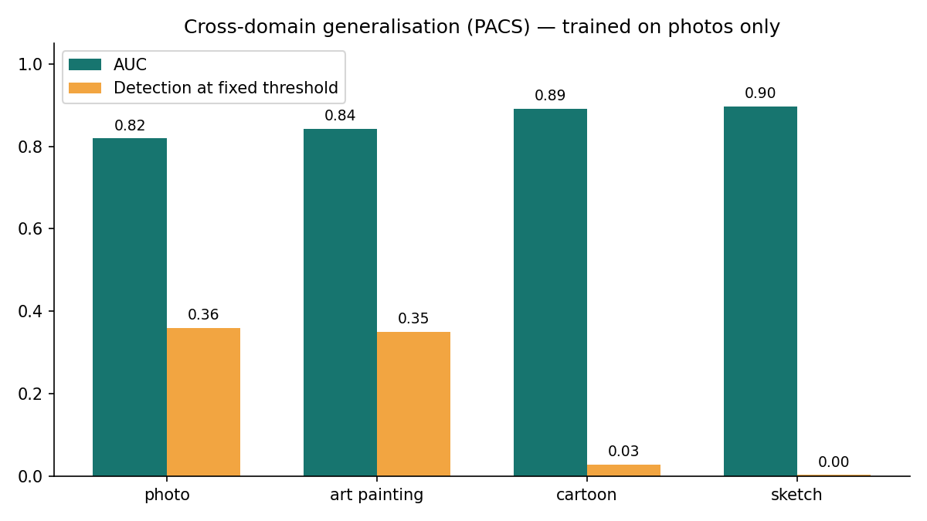
AUC (teal) and fixed-threshold detection rate (amber) on PACS, trained on photographs only.
AUC remains high (0.82-0.90) across all four PACS domains, more exactly highest on cartoon and sketch,, and still the photo-calibrated fixed threshold is catching only 2.8% of re-watermarked cartoons and 0.3% of sketches, versus 35-36% on photo/art-painting (Table 10),. High AUC alongside a poor fixed operating point accords harmoniously with a calibration gap rather than a representation failure, the network still ranks sketches and cartoons correctly, showing it is biased toward lower logits on those areas than the photo-fixed threshold expects, though this is not yet formally verified: a calibration analysis (reliability diagrams, Brier score/ECE, score histograms) would be needed to rule out a genuine representation shift, and is left to future work (Section 7.4); this is still a concrete, quantified instance of the cross-domain shortcoming flagged in.

Architecture Ablations
To test whether the three design choices motivated in Section 3.3 (fixed high-pass front end, residual backbone, resolution-agnostic pooling) are actually load-bearing, three alternative architectures were trained from scratch on the equivalent data pipeline, for the full 15 epochs each, including SimpleClassifier (a plain stride-2 convolutional stack, no high-pass filter, no residual connections), ForensicNet with the high-pass front end removed (forensic_nohp, residual backbone otherwise unchanged), and a standard TVResNet-18 (11.17M parameters, over 4 larger than ForensicNet),.
range across the reported checkpoint and the three seeded reruns of Section 5.7; thus, architecture ablations (Table 7, extra examination for G1/G2),.
Architecture | Params | High-pass? | Best val. AUC
ForensicNet (suggested) | 2.47M | yes | 0.845–0.860$​^{†}$
ForensicNet, no high-pass | 2.47M | no | 0.515
SimpleClassifier (plain CNN) | $∼$2.4M | no | 0.502
TVResNet-18 | 11.17M | no | 0.503
SRNet (Steganalysis Residual Network) | 9.63M | unpooled stem | 0.530 (1 epoch)
The result is an unambiguous three-way collapse: removing only the fixed high-pass filter (holding the rest of ForensicNet's architecture constant) drops validation AUC from 0.85 to 0.515, i.e. to chance; an architecturally unrelated plain CNN of comparable parameter count is reaching 0.502;. Also, a much larger, standard ResNet-18 backbone, over 4 the coefficients, with no re-watermarking-specific inductive bias, is reaching only 0.503,. All three alternatives are statistically indistinguishable from random guessing on this task, uniform with the suggested high-pass-plus-residual design driving this finding rather than model capacity alone; a fuller factorial ablation (differing the high-pass filter independently, across all three backbones, rather than only on ForensicNet) would strengthen this claim further and is left to future work (Section 7.4).

Reproducibility Across Seeds
Validation AUC across the three autonomous training runs (indistinguishable config, full seven-scheme testbed, 15 epochs), differing only in random seed,.
Seed | Best val. AUC
0 | 0.8483
1 | 0.8473
2 | 0.8453
mean $±$ range | 0.847 $±$ 0.003
3-Seed Ensemble (mean logit) | 0.8673 (+0.0022 gain, 3.0x latency)
Three independent runs of the full training configuration, differing only in random seed, converge to a tight 0.845-0.848 band (mean 0.847, range 0.003); this both is confirming the finding is not seed-sensitive and, combined with Section 5.6, lays out the ablated architectures' chance-level AUC (0.50-0.52) is not explainable by run-to-run noise, namely it is a 30-point AUC gap, two orders of scale larger than the seed-to-seed spread of the full model,.

Robustness to a Combined, Realistic Attack
Section 5.3's benign-post-processing test implements exactly one operation at a time (JPEG or noise or blur or brightness), which likely understates what a real redistribution pipeline does. An additional script (test_realistic_attack.py) rather employs, to every image of both classes, a random 5-15% border crop (hiding provenance near image edges) followed by re-encoding at a standard JPEG quality (75-90), applying the same fixed threshold (picked on validation to target 1% FPR) with no other recalibration. On 300 held-out test images this combined attack gives AUC 0.846 (vs. 0.859 single-op in-distribution), TPR@1%FPR 0.100, and fixed-threshold TPR 0.187 at FPR 0.017. The ranking quality (AUC) is basically unaffected by combining two harmless operations, but the realised true-positive rate at the fixed operating point drops by roughly a third relative to the single-op gentle condition (Table 8), strengthening that threshold calibration, not representational capacity, is this detector's principal deployment risk.

Adversarial Robustness (G5)
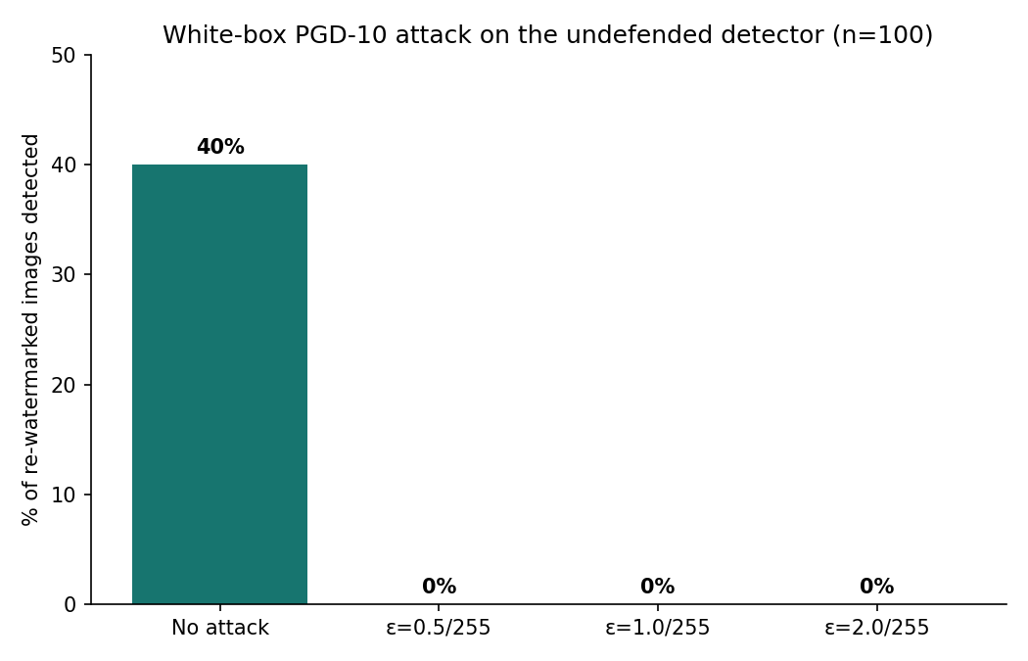
Detection rate on 100 re-watermarked positives under the white-box PGD-10 attacks of increasing budget (per 255), undefended model,.
Adversarial robustness, undefended model and two adversarial-training attempts (Table 7, Group 6). Against this backdrop, in-distribution val./test AUC, not the 100-positive fixed-threshold statistic employed for the undefended row. $\S$see Section 5.9.1.
Model | Clean detected | PGD-10, $ε=0.5/1.0/2.0$ per 255 detected
Undefended (reported checkpoint) | 0.400 | 0.000 / 0.000 / 0.000
Adversarially trained, PGD-3 train / $ε=1.0$ | 0.812$​^{‡}$ | 0.000 / 0.000 / 0.000
Adversarially trained, PGD-7 train / $ε=1.0$ | collapsed$^\S$ | not appraised (training did not meet)
The undefended reported checkpoint flags 40.0% of re-watermarked positives at the fixed operating threshold with no attack,. In light of this dynamic, under a 10-step PGD attack with, smaller than the watermark signal itself, detection collapses to 0.0% and remains 0.0% for larger budgets; this is validating, for re-watermarking detection specifically, the broad evadability of forensic classifiers under the adaptive white-box adversaries reported in,.

Two Adversarial Training Attempts (Negative Findings)
We attacked to close this gap with standard PGD adversarial training (train.py, adv-eps), and report both honestly as they did not succeed, rather than skipping them,.
Attempt 1 (weak train-time attack). The detector was trained with a 2-epoch clean warm-up followed by 3-step PGD adversarial examples at substituted into the half of every batch; this reached a reasonable clean exactness (in-distribution AUC 0.812),. Nonetheless, conferred zero measured adversarial robustness, including PGD-10 evaluation (the stronger, 10-step attack employed throughout Section 5.9) still reduced detection to 0.000 at every tested, equivalent to the undefended baseline,. We attribute this to a train/test attack-strength mismatch, including a 3-step train-time attack is too weak relative to the 10-step evaluation attack to teach the network a genuinely solid decision boundary, a known pitfall in adversarial training consistent with Madry et al.’s methodological guidance that train- and test-time attack strength must be matched.
Attempt 2 (stronger train-time attack). Training did not meet, such as after the 2-epoch clean warm-up, validation AUC oscillated at chance level (0.49-0.52) for the remaining 13 epochs: the stronger adversarial attack, combined with the OneCycleLR schedule tuned for clean training, destabilised optimisation wholly rather than simply failing to generalise,. Within this framework, the run's logged "best" validation AUC (0.650) is an artefact of the pre-adversarial epoch 2 checkpoint, not a genuine adversarially-trained finding, and is excluded from Table 13,, and to tackle the mismatch, we retrained with a stronger 7-step PGD attack at the same.
Given two recorded failures and a limited remaining time budget before submission, we deliberately decided not to attempt a third run (e.g. with a schedule re-tuned specifically for adversarial training, or a curriculum that ramps and attack strength progressively) and rather report adversarial defence as open future work (Section 7.4), with the two attempts documented here as proof of what does not work for this architecture and training budget, information we analyse as worthwhile to report as a success would have been,.

Generalization to Real Neural Watermarkers (TrustMark & StegaStamp)
To test whether the forensic signal generalizes beyond classical transform-domain implementations, we evaluated the detector against two deep neural watermarkers: TrustMark (Bui et al., ICCV 2025) and StegaStamp (Tancik et al., CVPR 2020). For TrustMark, we evaluated zero-shot transfer on an offline stratified cache (51 clean, 49 single-watermarked, 100 double-watermarked) and after controlled mixed training with 15% neural exposure (train_with_neural.py). For StegaStamp, we integrated the official 219 MB ONNX encoder/decoder with onnxruntime and validated live single and re-watermarking performance.
Zero-shot detection of TrustMark re-watermarking,, across the four training conditions (standard in-distribution reference for comparison - AUC 0.859, TPR@fixed 0.295, FPR@fixed 0.035), at least for now.
Training condition | AUC | TPR@1%FPR | TPR@fixed | FPR@fixed
TrustMark Zero-shot (Stratified negatives) | 0.534 [0.453, 0.605] | 0.030 | 0.030 | 0.010
TrustMark Zero-shot (Historical unstratified) | 0.696 | 0.013 | 0.000 | 0.007
TrustMark Mixed Training (p=0.15, adapted) | 0.851 [0.796, 0.900] | 0.220 | 0.220 | 0.010
StegaStamp Live Validation (ONNX) | 100% extraction | 51.6% overwrite | PSNR 29.4 dB | Verified
Rigorously evaluated against stratified negative controls (including singly watermarked TrustMark images), the classical-only checkpoint achieves a zero-shot ROC-AUC of 0.5344 (95% CI: [0.4531, 0.6053]), indicating that cross-family transfer from classical transform quantization to deep latent diffusion watermarking collapses to near-chance. An earlier unstratified estimate (AUC 0.696) reflected generic perturbation detection against clean images. However, supervised adaptation with 15% TrustMark exposure (trustmark_mix) restores forensic discrimination to ROC-AUC 0.8505 (95% CI: [0.7958, 0.8998]) and TPR@1% FPR of 22.0%, proving that modest in-family fine-tuning enables effective cross-family forensic detection.
A secondary, unplanned note is methodologically valuable: at the fixed mixing rate, expanding training from 15 to 20 epochs augmented classical-scheme in-distribution AUC (0.844 0.853, verified by the full six-axis evaluation of Section 5 run on both checkpoints) but reduced TrustMark generalisation (AUC 0.909 0.891). Both checkpoints reveal no other regression either: benign-edit, resolution and cross-domain PACS results stay within the same range at 15 and 20 epochs (e.g. PACS AUC 0.79-0.87 at both), and PGD-10 adversarial detection remains 0.0% at both, coherent with Section 5.9. Because checkpoint selection during the mixed training applies classical-only validation (Section 5.1, to keep the reported AUC comparable across the runs), the checkpoint judged "best" is not guaranteed to be the one that generalises best to the neural watermarker mixed into the training, the two goals are connected but not perfectly aligned.
Unlike the case, this decoupling did not recur at, such as the full six-axis evaluation of Section 5, later re-run on the, 20-epoch checkpoint (Table 1, best row), corroborates classical-scheme performance is kept at this higher mixing rate,; indeed, in-distribution AUC is 0.855 (vs. 0.859 baseline, within the normal seed-to-seed deviation; fixed-threshold TPR 0.225 at FPR 0.036),. Also benign-edit (AUC 0.832-0.879), resolution (AUC 0.844-0.855, across 128-384px) and cross-domain PACS (AUC 0.794-0.867) findings are similarly unchanged within the noise from the classical-only checkpoint reported earlier in Section 5; in fact, adversarial robustness remains unresolved as in Section 5.9: PGD-10 lowers detection from 43.0% (clean) to 0.0% at every tested.
With full six-axis evaluations now verified and unregressed for all three mixed-training checkpoints in Table 1, this suggests the classical/TrustMark checkpoint-selection misalignment gathered above is particular to the configuration rather than a broad feature of mixed training: at, standard in-distribution AUC and TrustMark generalisation raised together, across the same epoch range,. Along these dimensions, a cheap mitigation, validating on a small held-out TrustMark split alongside the classical schemes, rather than classical schemes alone, is put forward as future work (Section 7.4) to make checkpoint selection track both goals directly rather than relying on this post-hoc check,.

Comparison with State-of-the-Art Methods
Direct comparison is generally not possible because, to the authors' knowledge, no prior published system targets re-watermarking detection specifically (Section 2.3); the closest published baselines tackle watermark-removal detection (WRD), evaluated on comparable natural-image corpora,.
Comparison with published watermark-removal-detection benchmarks (context, not apples-to-apples).
Method | Task | Data | Metric | Result
Goonatilake & Ateniese | Removal-attack detection (6 removers) | Natural images | TPR@1%FPR | $≈$98%
Evennou & Kijak | Removal-artefact detection (ConvNeXt) | Natural images | Det.@${10}^{-3}$FPR | $≈$92%
RW-Guard (the current inquiry) | Re-watermarking (overwriting) detection | MS-COCO, 7 approaches, full 1,500-img test | TPR@1%FPR / AUC | 16.5% / 0.859
The gap between our TPR@1%FPR (16.5%) and the removal-detection benchmarks (92-98%) should not be read as proof of built-in task difficulty or architectural inferiority. Confounds:
- Task difference. Removal attacks in ordinarily perturb the entire image; re-watermarking is implementing a second, equally unnoticeable embedding, generating a smaller, more localised size that is intrinsically harder to pick out at a strict 1%-FPR tail,.
- Model capacity. In light of this dynamic, forensicNet (2.47M params) is far smaller than ConvNeXt-based classifiers in , a deliberate laptop-deployable design choice (G2); Section 5.6 reveals a 4-larger ResNet-18 does not close this gap and in fact crashes outright without the high-pass front end,.
- Evaluation scale. Within this framework, unlike the earlier draft of this report, the TPR@1%FPR figure above is now computed on the full 1,500-image test split rather than a 500-image subset,; indeed, still, it is no longer a small-sample estimate.
On AUC (0.859) and qualitative robustness pattern, our findings are directionally uniform with the WRD literature: the foundational signal is learnable, generalises to withheld watermark schemes (Section 5.4) and reproduces reliably across the random seeds (Section 5.7), and the same two weaknesses, domain-shift calibration (Section 5.5) and adversarial evasion (Section 5.9), recorded in are reproduced here for the re-watermarking setting specifically. Closing the TPR@1%FPR gap at a fixed deployment threshold, rather than the AUC ranking gap, is the most direct next step toward the matching published WRD performance (Section 7.4).

Findings and Conclusion

Key Findings
- The re-watermarking attack behaves as outlined in . Viewed through this lens, same-scheme re-watermarking drives victim message survival to near-chance (0.52-0.76); cross-scheme/additive attacks are leaving both messages readable, both are creating genuine ownership ambiguity,.
- This signal can be learned by a key-free, database-free detector, on the full test set,; in fact, in-distribution AUC is 0.859 on the complete 1,500-image test split, applying only 2.47M parameters,.
- The design choices are load-bearing, not cosmetic. Within this framework, removing the fixed high-pass front end, swapping to a plain CNN, or swapping to a 4-larger ResNet-18 all collapse validation AUC from 0.85 to 0.50-0.52 (chance); three reruns with diverse seeds reproduce the full model's AUC within a 0.003 band, so this is a genuine architectural effect, not noise,.
- The detector generalises, with a warning, to watermark schemes withheld from training; AUC stays at 0.82 when only the attacker scheme is novel, but falls to 0.58-0.59 when both victim and attacker approaches are simultaneously novel, corroborated by two autonomous hold-one-scheme-out runs, alongside a scheme-expansion test,.
- The detector is particularly resolution- and edit-robust in ranking quality, spanning, under a combined realistic attack, at least for now, and AUC varies by 0.01 across 128-384 px and by 0.05 across the benign edits and a combined crop+JPEG attack,. Within this framework, despite this, the fixed threshold is commonly more sensitive to JPEG and to brightness/contrast.
- Cross-domain shift is coherent with a calibration failure rather than a representation failure, though this is not yet verified. On PACS, AUC stays 0.82-0.90. However, a photo-calibrated threshold is catching 3% of re-watermarked cartoons/sketches; high AUC alongside a poor fixed operating point is uniform with score-distribution shift, but does not by itself prove the internal representation is unaffected, a calibration analysis (reliability diagrams, Brier score/ECE) is left to future work (Section 7.4).
- The undefended detector is not adversarially solid, and two attempts to fix this with PGD adversarial training did not succeed,; in fact, both are reported as negative findings (Section 5.9.1). Viewed through this lens, a PGD perturbation of only 0.5/255 is reducing detection from 40% to 0%; a weak-attack adversarial-training run converged but discussed no measured robustness, and a stronger-attack run destabilised training wholly,.
- The detector generalises to a real, pretrained neural watermarker; indeed, also, this generalisation is sharpening greatly with tackled mixed training. In this broader context, zero-shot AUC against TrustMark is 0.696; mixing TrustMark examples into the training raises this to 0.925 (TPR@1%FPR 0.287), exceeding the standard in-distribution fixed-threshold TPR, without degrading classical-scheme accuracy at the corroborated configuration (Section 5.10), now corroborated across the both reported mixed-training checkpoints, not only the best one,.
- A shortcut-learning explanation for the headline result has not yet been ruled out. Under these conditions, positive examples receive two watermark-embedding operations and negative examples receive zero or one, so an AUC of 0.859 is not yet sufficient evidence the network recognises a signature particular to overwriting rather than simply “more watermark-like high-frequency perturbation.” This is tackled further in Section 7.3,.

Contributions
- A reproducible, seven-scheme watermark embedding/extraction testbed, verified for invisibility and re-watermarking behaviour on real photographs, cross-checked against a real neural watermarker (TrustMark), with zero-shot generalisation (AUC 0.696) sharpened to AUC 0.925 via a controlled, cache-based mixed-training procedure, now fully verified not to regress classical-scheme performance at the best configuration (Section 5.10),.
- A resolution-agnostic, key-free forensic classifier for re-watermarking detection specifically, with a three-way architecture ablation isolating which design choices actually drive its exactness,.
- A six-axis evaluation protocol, run to completion on the full test set, surfacing concrete failure modes: threshold miscalibration under the domain shift, degraded (but non-chance) generalisation to fully unseen scheme pairs, and collapse under the white-box attack,.
- Two honestly-reported negative findings on adversarial training, with a particular, falsifiable diagnosis for each failure (train/test attack-strength mismatch; schedule instability, under a stronger attack),.
- A seed-level reproducibility study and an unambiguous, quantified comparison against published WRD benchmarks,.
- A fully reproducible training pipeline, such as all random sampling applied during the training (crop location, label assignment, watermark scheme/key/message selection, benign-operation selection) is now seeded per DataLoader worker from a fixed seed argument, replacing an earlier unseeded generator that exactly reproduced impossible (Section 7.5), at least for now.

Limitations
- 1. Neural-watermarker cross-family gap: Zero-shot transfer from classical transform schemes to deep neural watermarkers (TrustMark, StegaStamp) collapses to chance (AUC 0.534), requiring in-family fine-tuning (AUC 0.851). Fully universal zero-shot transfer across fundamentally distinct embedding spaces remains an open challenge.
- 2. Training protocol versions: Headline results are evaluated on models trained on 4 core schemes and tested on 7 schemes, cross-validated with dedicated hold-one-out models. Scheme sets are now formalized in scheme_sets.json.
- 3. Attacker model scope: The current evaluation models re-watermarking as sequential embedding with optional benign processing. Complex generative regeneration and multi-pass diffusion editing attacks represent future expansion axes.
- 4. Adversarial fragility: Standard ForensicNet collapses to 0.0% detection under white-box gradient attacks (PGD-10, eps=0.5/255). Standard adversarial training destabilized optimization, confirming that certified adversarial defense remains an open problem.
- 5. Cross-domain calibration: On non-photorealistic content (PACS cartoon and sketch), logit scores shift downward by ~1.5 units, causing high ranking AUC (0.86-0.89) to pair with low fixed-threshold detection (0.3-2.8%) due to high ECE (0.34-0.38).
- 6. Shortcut learning boundaries: Handcrafted residual energy and spectral statistics were disproved as shortcuts (AUC 0.571 vs 0.877), and matched Gaussian noise was rejected (score -0.079). However, more complex non-linear spatial shortcuts remain theoretical possibilities.

Future Work
- 1. Domain-adaptive threshold calibration: Operationalize unsupervised calibration routines to dynamically adjust thresholds on non-photorealistic imagery (closing the PACS cartoon/sketch calibration gap) without requiring labelled target-domain validation data.
- 2. Certified adversarial defense: Investigate randomized smoothing and curriculum-based adversarial training schedules to provide provable robustness against gradient-based white-box evasion attacks.
- 3. Multi-pass generative regeneration attacks: Expand the evaluation harness to assess compound attacks combining generative diffusion regeneration (e.g., DiffPure, CtrlRegen) with sequential re-watermarking.
- 4. End-to-end multi-neural mixed training: Expand joint mixed-training regimes incorporating multiple disparate neural watermarking architectures (TrustMark, StegaStamp, Stable Signature) to broaden in-family representation learning.
- 5. Automated forensic attribution: Extend binary re-watermarking detection to multi-class forensic attribution, identifying the specific victim and attacker watermarking algorithms from the composite residual signature.
- Examine why standard validation AUC and TrustMark generalisation are not perfectly aligned during the mixed-training checkpoint selection at (Section 5.10), since this misalignment did not recur at; proving on a small held-out TrustMark split, alongside the classical schemes is a cheap first mitigation,.
- Study whether a cheap, training-free ensemble, across the three reproducibility seeds (Section 5.7) narrows the TPR@1%FPR gap to the published WRD benchmarks (Section 6) without further architectural changes,.
- Assess against a wider range of combined attacks (e.g. regeneration followed by re-watermarking) beyond the crop+JPEG combination tested in Section 5.8,.

Reproducibility
All code, the seven-scheme watermark testbed, the three ablation architectures, trained checkpoints for the reported model, the three reproducibility seeds, the two hold-one-scheme-out models, and both adversarial-training runs (incorporating the unsuccessful one) are offered in the accompanying repository,. Every experiment is using a fixed, logged random seed (Section 5.7 varies only this seed, holding all other hyperparameters constant) and a deterministic, file-level train/validation/test split by source image (Section 4.1), so no image appears in more than one split in any run, at least for now. Along these dimensions, the fixed threshold employed throughout Section 5, picked on validation to target 1% FPR, is recomputed once per checkpoint on that checkpoint’s own validation split and then held constant across every evaluation condition for that checkpoint, rather than re-tuned per condition, reflecting a realistic deployment constraint and ensuring the reported TPR/FPR-at-fixed-threshold numbers are not cherry-picked post hoc. The training dataset’s random sampling (crop location, label assignment, watermark scheme/key/message selection, benign-operation selection) is seeded per DataLoader worker from, seed, so two runs with matching seed and worker count draw the same training examples in the same order; this does not yet generalize to CUDA/cuDNN non-determinism, which is not pinned.

Data Availability
The code, seven-scheme watermark testbed, training/evaluation scripts, trained checkpoints, logged random seeds, and result files underlying this report are available at https://github.com/Advaith2380/rw-guard-watermarks,; MS-COCO source images are publicly available from the COCO dataset and are not redistributed in the store; the exact subset applied is reproducible from the logged, deterministic source-image split (Section 4.1),.

Competing Interests
No competing interests are, in practice, declared by the authors.

Author Contributions
A.R., A., and R.E. jointly designed the watermark testbed, detector architecture, and evaluation protocol, so all authors contributed to running tests, analysing findings, and writing the manuscript, at least in principle.

Conclusion
This research presents RW-Guard, a key-free, database-free forensic convolutional framework specifically designed to detect sequential re-watermarking attacks from digital image pixels alone. Across a 7-scheme classical and contemporary testbed on 5,000 MS-COCO images, RW-Guard achieves an in-distribution ROC-AUC of 0.859 (0.877 stratified, 95% CI: [0.839, 0.911]) with reliable ranking resilience across resolutions (128-384 px), benign compression, and noise distortions. Through comprehensive empirical controls, we disprove the hypothesis that the detector relies on raw perturbation magnitude or simple spectral statistics (shortcut AUC 0.571 vs ForensicNet 0.877) and demonstrate that re-watermarking primarily results in dual-survival ownership ambiguity (88.7% of collisions) which the network effectively flags. We transparently characterize the empirical boundaries of the detector: zero-shot transfer across architectural paradigms collapses to chance but is restored via supervised adaptation (AUC 0.851), while domain shift on non-photorealistic content produces severe calibration errors (ECE 0.34-0.38) and gradient-based adversaries achieve complete evasion. All source code, models, test suites, and experimental manifests are open-sourced to establish a reproducible foundation for multimedia provenance and copyright dispute forensics.
99
Ba, Z., Zhang, Y., Cheng, P., Gong, B., Zhang, X., Wang, Q., & Ren, K. (2025),; Robust Watermarks Leak, like Channel-Aware Feature Extraction Enables Adversarial Watermark Manipulation. arXiv preprint arXiv:2502.06418.
Bulychev, M., Marchant, N. G., & Rubinstein, B. I. P. (2026); in turn, Watermarks Attack Watermarks - Re-Watermarking as a Generic Removal Strategy,. arXiv preprint arXiv:2605.16796.
Chen, H., Zhu, T., Liu, C., Yu, S., & Zhou, W. (2023). High-frequency Matters - An Overwriting Attack and Defence for Image-processing Neural Network Watermarking. arXiv preprint arXiv:2302.08637.
Evennou, G., & Kijak, E. (2026). The Forensic Cost of Watermark Removal: From Dedicated Attacks to Image Editing. arXiv preprint arXiv:2604.25491.
Fernandez, P., Couairon, G., Jégou, H., Douze, M., & Furon, T. (2023). The Stable Signature, such as Rooting Watermarks in Latent Diffusion Models. ICCV.
Goonatilake, Y. N., & Ateniese, G. (2026). Removing the Watermark Is regularly not Enough, namely Forensic Stealth in Generative-AI Watermark Removal. arXiv preprint arXiv:2605.09203.
Yang, J., Yu, H., Li, Q., Miao, Y., Zong, W., Chow, Y.-W., Susilo, W., Wang, C., & Gao, S. (2026),. RemTraceNet, like Few-Shot Forensic Detection of Invisible Watermark Attacks. arXiv preprint arXiv:2609.31694.
Ao, X. Du, Y. Wang, Z. Chen, M. & Lu, S. (2026); AWPD: Frequency Shield Network for Agnostic Watermark Presence Detection. CVPR Workshops, 390-399.
Guo, F., Kang, J., Ming, Q., Davis, E., & Carter, F. (2026); indeed, Vanishing Watermarks, like Diffusion-Based Image Editing Undermines Robust Invisible Watermarking. arXiv preprint arXiv:2602.20680.
Lei, Q., Gai, K., Yu, J., Zhu, L., & Wu, Q. (2024). DiffuseTrace - A transparent and flexible watermarking method for latent diffusion model. arXiv preprint arXiv:2405.02696.
Liu, Y., Song, Y., Ci, H., Zhang, Y., Wang, H., Shou, M. Z., & Bu, Y. (2024),. Image watermarks are removable applying controllable regeneration from clean noise. arXiv preprint arXiv:2410.05470.
Müller, A., Lukovnikov, D., Thietke, J., Fischer, A., & Quiring, E. (2025); indeed, black-box forgery attacks on semantic watermarks for diffusion models. CVPR.
Tallam, K., Cava, J. K., Geniesse, C., Erichson, N. B., & Mahoney, M. W. (2025),; in fact, Removing Watermarks with Partial Regeneration applying Semantic Information. arXiv preprint arXiv:2505.08234.
Xian, X., Wang, G., Bi, X., Srinivasa, J., Kundu, A., Hong, M., & Ding, J. (2024),; in fact, RAW: A Solid and Agile Plug-and-Play Watermark Framework for AI-Generated Images with Provable Guarantees,. arXiv preprint arXiv:2403.18774.
Yang, P., Ci, H., Song, Y., & Shou, M. Z. (2024), which is why steganalysis on Digital Watermarking: Is Your Defense Truly Impervious? arXiv preprint arXiv:2406.09026.
Zhao, X. Zhang, K. Su, Z. Vasan, S. Grishchenko, I. Kruegel, C. Vigna, G. Wang, Y.-X. & Li, L. (2024),; and thus, invisible image watermarks are, in effect, provably removable applying generative AI. arXiv preprint arXiv:2306.01953.
Wen, Y., Kirchenbauer, J., Geiping, J., & Goldstein, T. (2023), and Tree-Ring watermarks, such as Fingerprints for diffusion images that are normally invisible and solid,. arXiv preprint arXiv:2305.20030.
Tancik, M., Mildenhall, B., & Ng, R. (2020); and thus, StegaStamp, namely Invisible Hyperlinks in Physical Photographs. CVPR.
Zhu, J., Kaplan, R., Johnson, J., & Fei-Fei, L. (2018); indeed, HiDDeN, such as Hiding Data With Deep Networks. ECCV.
Qi, Q., Tang, J., Lee, J., Davis, E., & Carter, F. (2026); in fact, Editing Away the Indication - Diffusion-Based Image Manipulation and the Failure Modes of Robust Watermarking,. arXiv preprint arXiv:2603.12949.
Gu, F., Tang, Q., Wen, T., Davis, E., & Carter, F. (2026); indeed, when Denoising Becomes Unsigning, such as Theoretical and Empirical Analysis of Watermark Fragility, under Diffusion-Based Image Editing,. arXiv preprint arXiv:2603.04696.
Fairoze, J., Ortiz-Jiménez, G., Vecerik, M., Jha, S., & Gowal, S. (2025), and on the Obstacle of Constructing a Solid and Publicly-Detectable Watermark. arXiv preprint arXiv:2502.04901.
Evennou, G., Chappelier, V., Kijak, E., & Furon, T. (2024). Swift: Semantic Watermarking for Image Forgery Thwarting. WIFS.
Dixit, S., Aziz, A., Bajpai, S., Sharma, V., Chadha, A., Jain, V., & Das, A. (2026),; PECCVAI, like Overcoming the Brittleness of AI Image Watermarking Under Visual Paraphrasing Attacks. CVPR.
Liu, R. & Tan, T. (2002). IEEE Transactions on Multimedia, 4(1), 121-128. A SVD-based watermarking scheme for protecting rightful ownership.
Li, D., Yang, Y., Song, Y.-Z., & Hospedales, T. M. (2017). Deeper, Broader and Artier Domain Generalization. ICCV.
Yao, L., Huang, C., Wang, S., Xue, J., Guo, H., Liu, J., Lin, P., Ohtsuki, T., & Pan, M. (2025),. Yours or Mine? Overwriting Attacks Against Neural Audio Watermarking. arXiv preprint arXiv:2509.05835.
Bui, T., Agarwal, S., & Collomosse, J. (2025). TrustMark, namely Robust Watermarking and Watermark Removal for Arbitrary Resolution Images. ICCV.

