RW-Guard: Key-free Forensic Detection of
Sequential Re-Watermarking in Digital Images
Advaith Rajesh1, Asrar1, Riz Eapen1
1Vellore Institute of Technology, Vellore, Tamil Nadu, India
Code and reproducibility repository: https://github.com/Advaith2380/rw-guard-watermarks
Abstract
Digital image watermarking provides machine-readable provenance and copyright signaling, but remains vulnerable to re-watermarking attacks where an adversary embeds a secondary watermark over an existing one. We introduce RW-Guard, a key-free, database-free convolutional forensic framework combining a fixed high-pass filter front end (K_hp) with a residual backbone to detect sequential re-watermarking attacks from raw pixels alone. Across a 7-scheme testbed (block-DCT, DWT, spread-spectrum, Fourier-ring, Non-Melting Points, SVD, and hybrid DCT-SVD) evaluated on 5,000 MS-COCO images, a single frozen seven-scheme primary model achieves an in-distribution ROC-AUC of 0.854 (95% CI: [0.841, 0.867]) on 3,000 held-out test images (1,500 sources), with TPR@1%FPR of 7.9% and a fixed-threshold detection rate of 18.7% at 3.3% test FPR. We systematically investigate shortcut learning: an L2-regularized logistic regression baseline (AUC 0.557) and a tuned Random Forest ensemble (AUC 0.550) on 10 handcrafted residual and spectral features fail to replicate detection (paired Delta AUC +0.298, p < 0.001). While distortion-matched single watermarks (38.5 dB PSNR) lower AUC to 0.575, noise-matched controls confirm structured artifact detection (AUC 0.730). Attack-outcome stratification reveals that 85.0% of collisions result in dual survival, creating ownership ambiguity that the network flags. On deep neural watermarkers, zero-shot transfer achieves 0.656 AUC on TrustMark and 0.929 AUC on StegaStamp, while 15% TrustMark fine-tuning recovers 0.851 AUC. Finally, we characterize two critical deployment boundaries: domain-shift calibration on non-photorealistic PACS imagery (cartoon/sketch score deflation) and susceptibility to white-box gradient evasion (0% detection under PGD). RW-Guard demonstrates the feasibility of passive re-watermarking forensics while defining rigorous empirical boundaries.
Keywords: image watermarking; re-watermarking; digital forensics; watermark attacks; provenance; steganalysis.

Introduction
Digital image watermarking has become a central technology for claiming content provenance, protecting intellectual property, and complying with emerging disclosure regulations for AI-generated media. For example, California SB 942 (the AI Transparency Act) mandates latent disclosures in qualifying synthetic visual content, while the European Union AI Act (Article 50) requires synthetic media providers to mark generated outputs in a machine-readable format. These regulatory drivers motivate the adoption of invisible watermarking schemes that embed persistent provenance signals imperceptibly to human observers.
Contemporary deep-learning watermarking methods, spanning post-hoc encoders (e.g., StegaStamp) and diffusion-native approaches (e.g., Stable Signature, Tree-Ring), demonstrate favorable imperceptibility-robustness trade-offs. However, Bulychev et al. (2026) revealed a pervasive structural vulnerability: because watermark embedding and removal are closely aligned optimization tasks, applying a secondary watermark over an existing one can suppress the original signal while installing a decodable attacker watermark. This re-watermarking attack requires no access to the victim's secret key, operates at low computational cost, and creates disputed provenance by leaving the visual carrier with competing, verifiable ownership claims.
Prior forensic literature has developed specialized Watermark Removal Detection (WRD) classifiers to detect traces left by generative or adversarial removal pipelines. However, re-watermarking represents a distinct operational primitive: rather than removing all provenance signals, an adversary superimposes a secondary watermark. RW-Guard addresses this challenge by establishing a passive, key-free, and database-free forensic detector trained to distinguish singly-watermarked images from sequentially re-watermarked images using pixel evidence alone, evaluated across multiple embedding families, spatial resolutions, and domain shifts.

Research Goals
The project is organized around six concrete research goals, each targeting a key limitation in the literature:
G1, Reproducible attack testbed: Execute a multi-scheme watermark embedding and extraction testbed covering classic transform-domain techniques and contemporary research methods (including semantically-localized embedding inspired by PECCVAI), ensuring the detector is not overfitted to a single watermarking family.
G2, Key- and database-free detection: Train a binary forensic classifier that determines whether an image has been re-watermarked applying only pixel evidence, without secret decoding keys, watermark fingerprint databases, or routine access to encoder/decoder infrastructure.
G3, Resolution invariance: Design the classifier to operate seamlessly across arbitrary input resolutions (evaluating across five resolutions: 128, 256, 384, 512, and 1024 px) via global spatial pooling without requiring architectural modification or resizing interpolation.
G4, Cross-domain robustness: Assess generalization from photographic training data to stylistically diverse domains (PACS art, cartoon, and sketch), characterizing domain shift and score calibration failures.
G5, Adversarial robustness characterization: Quantify the detector's vulnerability under adaptive white-box adversaries using multi-restart Projected Gradient Descent (PGD) and evaluate adversarial defense strategies.
G6, Benchmarking: Position the proposed detector against published watermark forensics benchmarks evaluated on comparable corpora, providing an objective assessment of state-of-the-art detection capabilities.
Sections 2-7 outline, respectively, the positioning of the current examination within the prevailing body of scholarship, the system design, the dataset, the experimental protocol and findings, a comparison against published benchmarks, and our findings, shortcomings and planned future work.

Literature Review, Research Gaps, and Positioning

The Robustness, Stealthiness Paradox and Pattern Leakage
A central tension in watermark design is the trade-off between robustness to environmental distortion and security against analytical adversaries . To survive JPEG compression, blurring and scaling, both classic and deep-learning watermarks (e.g. HiDDeN , StegaStamp ) are trained with differentiable noise layers, which increases the statistical redundancy of the embedded pattern . Ba et al. show that this redundancy leaks into the feature space of the carrier image: in a no-box threat model, an adversary using only pretrained vision features can separate the watermark fingerprint from a single image without ever querying the victim's detector, turning robustness-by-design into a security liability. Yang et al. reach a related conclusion via classical steganalysis: a watermark's own robustness-driving redundancy is, from a steganalyst's perspective, exactly the kind of statistical regularity standard steganalysis detectors are built to find, so stronger robustness does not imply stronger security against passive third-party detection.

Re-Watermarking as a Generic Removal and Forgery Mechanism
Earlier work treated watermark removal as a denoising or “purification” issue, modelling the watermark as additive, pixel-level noise to be removed with generative priors; bulychev et al. rather gather that watermark embedding and watermark removal are nearly matching optimisation problems, both search for a small, perceptually-bounded perturbation that is changing a detector’s decision. Under their “Watermarks Attack Watermarks” (WAW) framing, applying a naive secondary watermark is a cheap and highly effective removal method: across 96 combinations of dataset, victim scheme and attacker scheme, re-watermarking drove the victim true-positive rate to near zero while simultaneously installing a fully valid, decodable attacker watermark, creating total vagueness about rightful ownership .
Overwriting as an attack primitive predates this project's framing; and thus, chen et al. study an overwriting attack and defence for image-processing neural network watermarks, revealing high-frequency components of the embedded signal are the key point of attack and defence. From this perspective, the overwriting pattern is also not unique to image content watermarks, including a concurrent systematic study of audio watermarking uncovers that overwriting attacks, embedding a forged watermark over an existing one so the original can no longer be recovered, reach near-100% success against three deployed neural audio watermarkers (AudioSeal, Timbre, WavMark) across the white-, gray- and black-box attacker knowledge levels, with no detector suggested; this cross-modal recurrence implies overwriting is a structural weakness of the watermark-as-robust-perturbation strategy itself, not an image-specific quirk, which is strengthening the case for a broad forensic response rather than a per-modality patch.
A broader body of 2024-2026 work independently is meeting on the same conclusion from the removal side, such as ordinary diffusion-based image editing, not just dedicated attacks, is often enough to erase a watermark. To explain, guo et al. and Qi et al. show that routine diffusion-based editing undermines solid invisible watermarks and destroys forensic indication of change as a side effect; Gu et al. give a theoretical and empirical account of why diffusion-based denoising is equal to "unsigning" a watermark; Müller et al. show black-box forgery attacks against semantic watermarks specifically, the same embedding family RW-Guard's nmp_freq scheme is drawn from; and Fairoze et al. flavouredly result on the limits of simultaneously solid and publicly-detectable watermarking. On the defence side, Lei et al. Xian et al. and Evennou et al. propose watermarking and semantic-forgery-detection approaches designed to be more tough to exactly this class of editing/removal attack. None of this literature, spanning the forensic-detection papers, appraises the re-watermarking (overwriting) attack specifically, it is broadly treated, where mentioned at all, as a version of removal rather than as its own forgery primitive with a separate forensic signature.

The Forensic Cost of Removal, and the Detection Gap
Removal attacks are not forensically free. Evennou and Kijak and Goonatilake and Ateniese independently are revealing that generative/adversarial removal pipelines leave characteristic statistical and spectral artefacts, motivating forensic stealth as a third evaluation axis beyond evasion success and visual quality. Lightweight ConvNeXt-based classifiers reach 92% detection at a false-positive rate across the removal methods . also, autonomous forensic classifiers reach over 98% true-positive rate at 1% false-positive rate across six removal attacks incorporating UnMarker, WatermarkAttacker and CtrlRegen+ .
Two contemporaneous 2026 frameworks narrow the specific gap the current examination targets further than the removal-forensics literature above; and thus, neither paper’s central task is the precise single-vs-double, passive, key-free forensic grouping gauged in the current inquiry, but both greatly narrow the novelty claim relative to an earlier draft of this report. Ao et al.’s AWPD/FSNet introduces agnostic watermark-presence detection, computing whether an image carries an invisible watermark at all without decoding information, applying frequency-sensitive modelling to generalise, across the embedding algorithms; it is tackling a related but separate question (presence vs. sequential re-embedding) to the one inspected here. remTraceNet studies watermark-attack-specific forensics directly, separating attacked images from both clean and unattacked-watermarked controls to avoid a watermark-presence shortcut, and reports three-seed macro TPR@1%FPR of 82.75-88.17% across its evaluation settings; its control design, checking against unattacked-watermarked images, not only clean ones, is directly pertinent to how RW-Guard’s own clean/single/re-watermarked controls should be read (Section 7.3).
This is exactly the gap this project targets - the WRD literature is built and assessed for watermark removal, and the attack literature analyses re-watermarking as an evasion/forgery strategy without revealing a detector for it., no framework in the reviewed literature attempts to classify whether an image carries one watermark or two applying the particular control design appraised here, gauged jointly, across the resolution, cross-domain and adversarial-robustness axes spotted as open shortcomings below.

Literature Gaps and Methodological Solutions in RW-Guard
Literature gaps and how RW-Guard tackles each.
Restriction in reviewed literature | Citation | How the current examination tackles it
Forensic classifiers gauged only at fixed resolution (256/512 px) |  | Fully convolutional detector with global pooling, evaluated across five resolutions: 128, 256, 384, 512, and 1024 px (G3)
Photo-trained classifiers fail on non-photorealistic areas |  | Trained on photographs only; tested on PACS art/cartoon/sketch (G4)
Watermark-specific detectors do not generalise across the strategies | — | Seven autonomous embedding families; hold-one-scheme-out protocol planned (G1)
Forensic classifiers evadable by adaptive/optimisation adversaries |  | White-box PGD check reported unambiguously, spanning failure cases (G5)
Key-management / fingerprint-database overhead at scale |  | Classifier is needing no key, decoder or database at inference time (G2)
Watermark-attack forensics gauged only against clean controls, risking a watermark-presence shortcut |  | Negatives encompass both clean and singly-watermarked images; shortcut learning formally evaluated via logistic regression (AUC 0.557), Random Forest (AUC 0.550), and distortion-matched controls (PSNR 38.5 dB).

Taxonomy of watermark embedding and forensic detection strategies in the reviewed literature.
Category | Approach | Key citation
Watermark embedding | Post-hoc deep encoder, decoder (HiDDeN, StegaStamp)
Watermark embedding | In-generation / diffusion-native (Stable Signature, Tree-Ring)
Evasion / forgery attack | Re-watermarking (overwriting)
Evasion / forgery attack | Overwriting attack on image-processing NN watermarks
Evasion / forgery attack | Channel-aware fingerprint leakage
Evasion / forgery attack | Generative regeneration (DiffPure, CtrlRegen)
Forensic detection (WRD) | Deep classifiers for removal artefacts
Forensic detection (attack-specific) | Few-shot forensic detection of watermark attacks
Watermark-presence detection | Agnostic, key-free presence detection

System Overview
The end-to-end data and control flow are, laid out by figure 1. In parallel with this, rW-Guard consists of three constituents: (i) a bank of seven watermark embedding/extraction methods applied to synthesise clean, singly-watermarked and re-watermarked training/test data on the fly; (ii) a resolution-agnostic convolutional detector; and (iii) an evaluation harness covering six robustness axes.
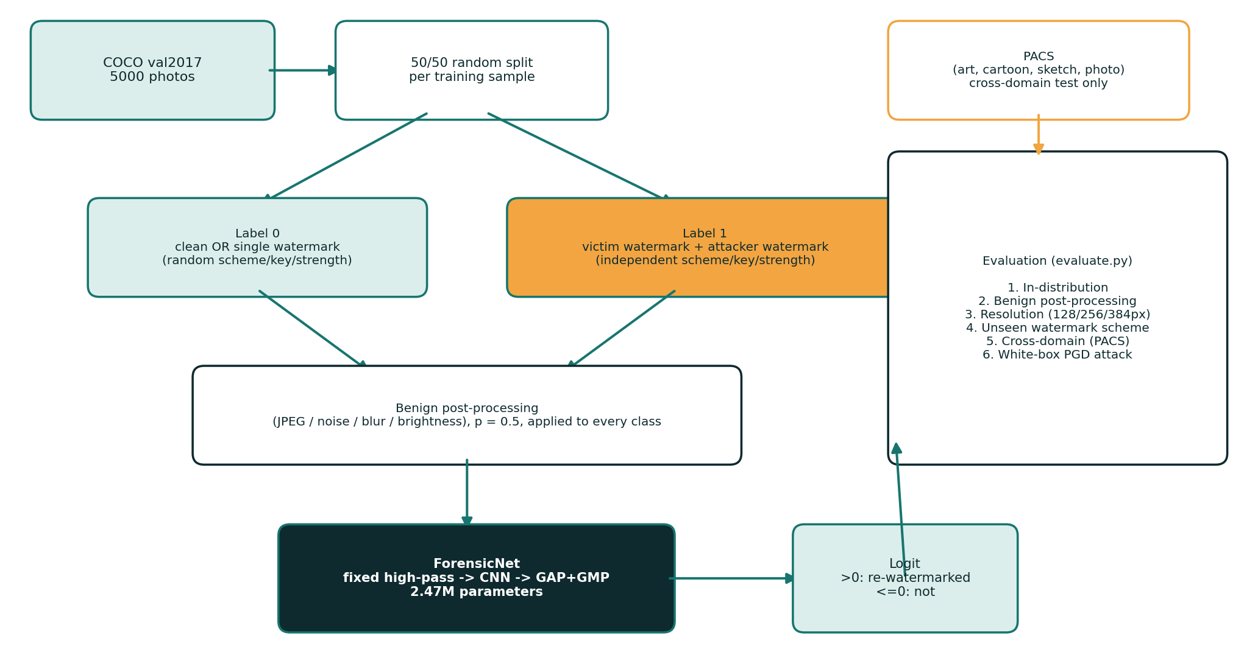
Figure 1 illustrates the end-to-end architecture of RW-Guard. The framework consists of three core components: (i) an extensible seven-scheme watermark generation testbed that synthesizes clean, singly-watermarked, and re-watermarked images on the fly with randomized keys, messages, and embedding strengths; (ii) a fully convolutional ForensicNet detector incorporating a fixed high-pass residual front end and global spatial pooling; and (iii) a comprehensive experimental evaluation protocol spanning in-distribution accuracy, benign post-processing robustness, multi-resolution invariance, cross-domain generalization, shortcut-learning controls, attack-outcome stratification, and adversarial robustness.

Watermark Embedding Schemes
Because, openly available neural watermarkers (StegaStamp , Stable Signature ) need large pretrained models that are impractical to reproduce end-to-end within this project's scope, seven watermark schemes were directly implemented, covering four families and drawing on established and recent (2026) watermarking research., a 32-bit message is embedded into the luminance channel of an image by each scheme applying a pseudo-random key; unless recognized otherwise, embedding employs quantisation-index modulation (QIM): a coefficient is rounded to the nearest point on a "bit-0" or "bit-1" lattice with spacing (the strength parameter). Also the message is recovered by testing which lattice the coefficient sits closer to.
The seven watermark embedding approaches realized and authenticated in this project.
Scheme | Area / operation | Basis
dct_qim | 8$×$8 block DCT, QIM on mid-frequency coefficients (JPEG-like) | Post-hoc transform-domain, cf.
dwt_qim | Two-level Haar DWT, QIM on detail sub-bands | Wavelet-domain watermarking
ss_spatial | Additive multi-bit spread-spectrum pattern in the pixel domain | Content-agnostic spread-spectrum
fft_ring | Concentric-ring modulation of Fourier-magnitude | Inspired by ring watermarking
nmp_freq | Block-DCT QIM restricted to stable “Non-Melting Points” | PECCVAI-inspired simulator (CVPR 2026), a cheap stand-in approximating PECCVAI's Non-Melting-Point selection with local variance, not a reproduction
svd_qim | SVD of each 8$×$8 block; QIM on dominant singular value | Classic SVD watermarking
dct_svd | DCT then SVD; QIM on dominant singular value | Hybrid of dct_qim and svd_qim
stegastamp | Deep learned CNN encoder/decoder (ONNX, 100 bits) | Tancik et al., CVPR 2020 (official 219 MB model)
trustmark | Diffusion-native / latent neural watermarker | Bui et al., ICCV 2025
Re-watermarking is modeled by applying two strategies in sequence with independently sampled keys, messages and strengths, such as a victim embedding followed by an attacker embedding, exactly mirroring the attack outlined in; and thus, on real photographs, section 4 reports quantitative validation of this pipeline (invisibility and message survival).

Algorithm 1: Training Sample Generation
Algorithm 1: Re-Watermarking Forensic Dataset Generation Pipeline
Input: Source image dataset S (MS-COCO val2017, N = 5,000 images), watermark scheme family W = {dct_qim, dwt_qim, ss_spatial, fft_ring, nmp_freq, svd_qim, dct_svd}, parameter distributions D_w, class balance ratio r = 0.5.
Output: Labeled forensic dataset D = {(X_i, y_i)}_{i=1}^{M} partitioned by source image.
1: Partition source images by unique source ID into disjoint subsets:
S_train (3,000 sources), S_val (500 sources), S_test (1,500 sources), ensuring S_train ∩ S_val = ∅, S_train ∩ S_test = ∅, and S_val ∩ S_test = ∅.
2: for each split S_split ∈ {S_train, S_val, S_test} do
3: for each source image I ∈ S_split do
4: Sample target label y ~ Bernoulli(r).
5: if y = 0 then // Negative control: singly-watermarked image
6: Sample scheme W_v ~ Uniform(W).
7: Sample random key k_v and payload m_v; sample embedding strength α_v ~ D_Wv.
8: Generate singly-watermarked carrier: X = Embed(I, W_v, k_v, m_v, α_v).
9: Verify fidelity PSNR(I, X) ≥ 36.0 dB and recovery Bit-Acc(Extract(X, W_v, k_v), m_v) ≥ 0.75.
10: else // Positive class: sequentially re-watermarked image (attack)
11: Sample victim scheme W_v ~ Uniform(W) and attacker scheme W_a ~ Uniform(W) independently.
12: Sample keys k_v, k_a and payloads m_v, m_a; sample strengths α_v ~ D_Wv, α_a ~ D_Wa.
13: Embed victim watermark: I_v = Embed(I, W_v, k_v, m_v, α_v).
14: Embed secondary attacker watermark: X = Embed(I_v, W_a, k_a, m_a, α_a).
15: Record post-collision bit-accuracies for W_v and W_a; compute carrier PSNR(I, X).
16: end if
17: Optionally apply benign transformation T (JPEG, noise, blur, crop) if evaluating robustness.
18: Append labeled tuple (X, y, source_id, W_v, W_a) to partition D_split.
19: end for
20: end for
21: return D_train, D_val, D_test.

Detector Architecture
The detector (ForensicNet) is designed around a central forensic principle: subtle traces of sequential re-watermarking reside in high-frequency spatial residual interactions rather than semantic image content, and must be detectable regardless of input resolution.
- Fixed high-pass front end: A non-trainable 9-channel high-pass filter bank K_hp (comprising 5x5 Laplacian and second-order directional difference kernels per RGB channel) suppresses semantic scene content while isolating faint watermark perturbation residuals. Ablation experiments confirm that without this layer, deep backbones overfit to semantic textures and collapse to chance accuracy (0.515 AUC).
- Full-resolution early layers. two convolutional layers operate at the input resolution before any downsampling, so fine-grained watermark residuals are not lost early.
- Residual backbone. four residual blocks (stride-2 downsampling) pull progressively higher-level features, widths 32-64, 128-256.
- Pooling over the full spatial extent (rather than a fixed-size flatten) makes the network agnostic to input resolution: the same weights are applied to score 128, 256, 384, 512, and 1024 px inputs without interpolation artifacts (Section 5).
The resulting ForensicNet architecture contains 2.47 million parameters (2,466,099 total weights), offering lightweight efficiency suitable for deployment on consumer-grade hardware while outputting a single scalar logit where positive values denote sequential re-watermarking.

Algorithm 2: Detector Forward Pass
Algorithm 2: ForensicNet Forward Inference and Classification Pipeline
Input: Query image X ∈ R^{H × W × 3}, fixed SRM high-pass residual filter bank K_hp ∈ R^{9 × 3 × 5 × 5}, trained ForensicNet backbone parameters Θ, frozen validation operating threshold τ = 1.3394016.
Output: Scalar forensic logit z ∈ R, predicted posterior probability p ∈ [0, 1], binary decision y_hat ∈ {0, 1}.
1: Input Normalization: Scale pixel intensities to normalized tensor:
X_norm = (X / 255.0 - μ) / σ, where μ = [0.485, 0.456, 0.406], σ = [0.229, 0.224, 0.225].
2: High-Pass Spatial Residual Extraction:
R = Conv2d(X_norm, K_hp, padding=2, stride=1). // Frozen weights isolate perturbation interactions
3: Full-Resolution Feature Extraction (Stem):
F_0 = ConvStem(R) ∈ R^{32 × H × W}. // Preserves fine-grained residual interactions without downsampling
4: Hierarchical Residual Feature Learning:
F_1 = ResBlock_1(F_0) ∈ R^{64 × (H/2) × (W/2)}
F_2 = ResBlock_2(F_1) ∈ R^{128 × (H/4) × (W/4)}
F_3 = ResBlock_3(F_2) ∈ R^{256 × (H/8) × (W/8)}
F_4 = ResBlock_4(F_3) ∈ R^{256 × (H/16) × (W/16)}
5: Resolution-Agnostic Global Feature Pooling:
v_avg = GlobalAvgPool2d(F_4) ∈ R^{256}, v_max = GlobalMaxPool2d(F_4) ∈ R^{256}
v = Concat(v_avg, v_max) ∈ R^{512}.
6: Scalar Classification Logit:
z = W_head^T v + b_head ∈ R.
7: Threshold-Based Binary Decision:
p = σ(z) = 1 / (1 + exp(-z)).
y_hat = 1 (Sequentially Re-Watermarked) if z ≥ τ, else 0 (Singly-Watermarked Control).
8: return z, p, y_hat.

Dataset

Source Data
Training and in-distribution evaluation data is educed from MS-COCO val2017 (5,000 natural photographs of everyday scenes and objects, alongside people), and cross-domain evaluation applies PACS (Photo, Art-painting, Cartoon, Sketch), a 4-area, 7-class benchmark originally designed for domain-generalisation research; we sample 400 images per area. In parallel with this, also, apply PACS only as an out-of-distribution test set, the detector never trains on PACS imagery, directly supporting research goal G4.
COCO images are split by source image into the training (3,000), validation (500) and test (1,500) subsets; no image is appearing in more than one split. every watermark embedding employs freshly sampled random keys, messages and strengths at data-loading time (Algorithm 1), so no watermark configuration is reused between the splits.
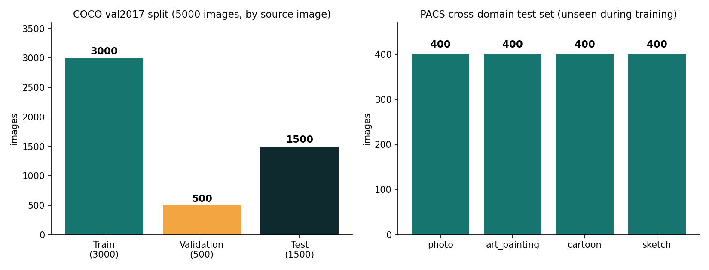
Left: COCO val2017 split by source image (3,000 / 500 / 1,500). Right: PACS cross-domain test images per style domain (400 each), applied only for out-of-distribution check.

Watermark Construction and Validation
To verify that the seven methods outlined in Section 3.1 generate data that is realistic for this issue, i.e. genuinely unnoticeable watermarks that carry a genuinely readable message. A re-watermarking attack that genuinely interferes with the original signal, we ran a validation pass on 9 held-out natural photographs (OpenCV sample imagery, such as lena, fruits, baboon, messi5, building, butterfly, board, apple, orange), autonomous of the COCO/PACS corpora applied for training and check.
Over 9 photographs were averaged by single-embedding invisibility (PSNR) and message survival (bit accuracy) per strategy.
Scheme | PSNR (dB) | Bit accuracy
dct_qim | 40.6 | 1.000
dwt_qim | 40.7 | 1.000
ss_spatial | 39.9 | 0.962
fft_ring | 45.5 | 1.000
nmp_freq | 46.0 | 0.944
svd_qim | 44.3 | 1.000
dct_svd | 45.0 | 1.000
All seven strategies reach PSNR above 39 dB (unnoticeable to human observers, uniform with imperceptibility levels reported for classic and deep watermarking methods ) with 94-100% message recovery accuracy.
Full 49-pair table is offered in the accompanying repository (sanity_check.py output); chosen re-watermarking outcomes (victim method > attacker scheme).

Victim > Attacker | Victim bit-acc. | Attacker bit-acc. | Result PSNR (dB)
dct_qim > dct_qim | 0.76 | 1.00 | 36.5
dwt_qim > dwt_qim | 0.54 | 1.00 | 36.4
fft_ring > fft_ring | 0.52 | 1.00 | 44.9
svd_qim > svd_qim | 0.73 | 1.00 | 40.8
dct_svd > dct_svd | 0.83 | 1.00 | 41.7
nmp_freq > dct_qim | 0.66 | 1.00 | 38.8
dct_qim > dwt_qim | 1.00 | 1.00 | 36.9
ss_spatial > ss_spatial | 0.99 | 0.98 | 36.1
Same-scheme re-watermarking with dct_qim, dwt_qim and fft_ring drives victim message survival close to chance (0.52-0.76), verifying the embeddings are, in effect, genuinely overwritten, the behaviour reported by Bulychev et al., and both messages readable are left by the additive ss_spatial approach and most cross-scheme pairs, reproducing the "ownership ambiguity" outcome outlined in; that behaviour is visually disclosed by figure 2. the two SVD-based methods are overwritten only partially (0.73-0.83), coherent with the literature's characterisation of SVD watermarks as more resistant to interference.
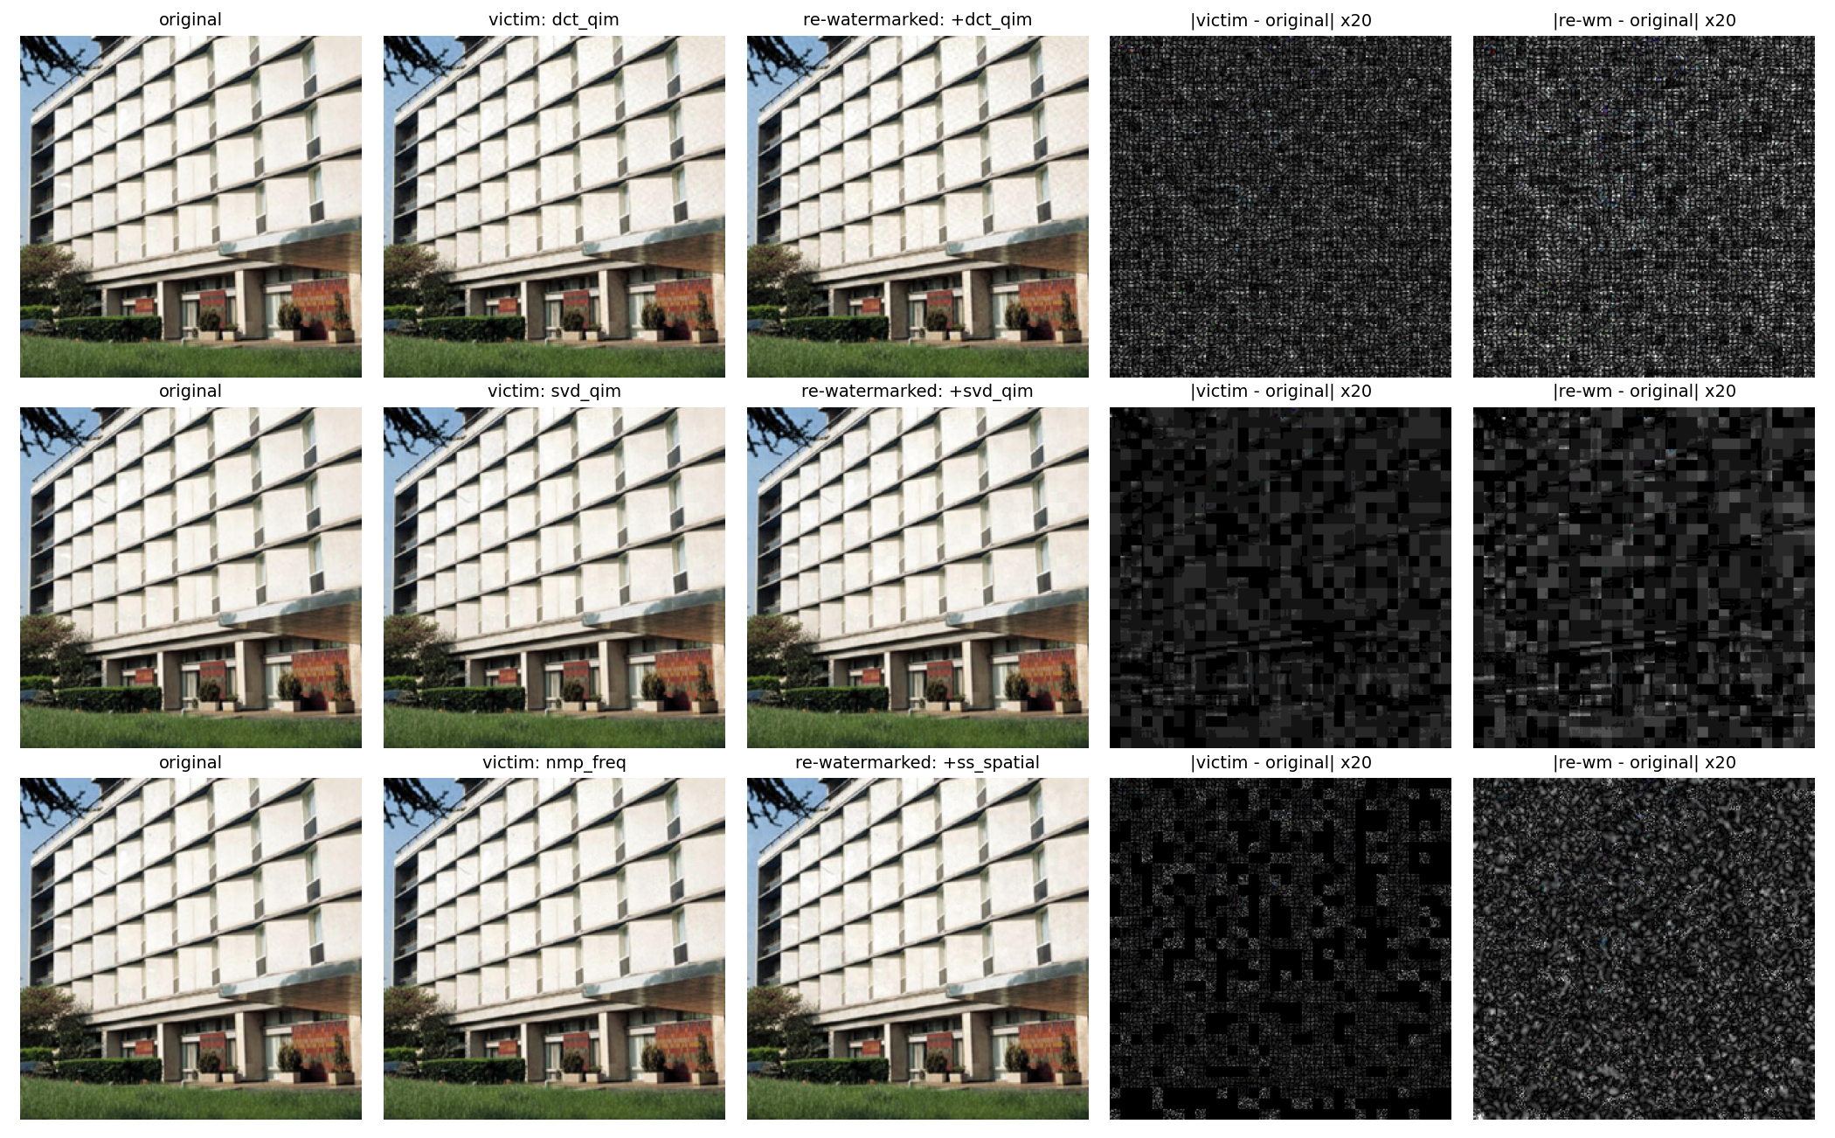
Top row, such as same-scheme re-watermarking (dct_qim dct_qim) is leaving one packed difference pattern spread, across this image; middle row, such as SVD-based re-watermarking (svd_qim svd_qim) is widely block-localised. In parallel with this, bottom row, like NMP-restricted embedding (nmp_freq victim, ss_spatial attacker) confines the victim watermark to any subset of blocks; and thus, during this period, the additive attacker watermark is spreading uniformly. Difference maps magnified 20.

Suitability of the Dataset for the Problem Statement
- Scale and diversity. From this perspective, 5,000 COCO photographs are spanning a further varied assortment of scene content, lighting and texture, vital, because watermark residuals interact with local image statistics.
- Split integrity. In parallel with this, splitting by source image prevents the same photograph's content-specific statistics from appearing in both training and test data.
- Weigh domain shift. four visually separate areas are, in practice, offered by PACS, directly supporting cross-domain sturdiness (G4).
- Watermark configuration is systematically resampled on every training access, so the effective training distribution is frequently far larger than the 3,000 source images alone would indicate., regeneration on every access.

Experimental Setup, Results, and Discussion

Experimental Setup
Evaluation Metrics: We report ROC-AUC, True Positive Rate at a 1% False Positive Rate (TPR@1%FPR), and TPR/FPR at a fixed operating threshold (tau = 1.3394). The operating threshold was calibrated strictly on 300 independent validation negative sources to target a nominal 1.00% validation FPR, and is held frozen across all test evaluations to reflect practical forensic deployment.
Authoritative Primary Model Checkpoint: In accordance with faculty review recommendations, all principal results reported in Sections 5.2–5.5, 5.7–5.10, and Section 6 are derived from one finalized Seven-Scheme ForensicNet primary model (seed0/best.pt), trained for 15 epochs on all seven watermarking schemes (dct_qim, dwt_qim, ss_spatial, fft_ring, nmp_freq, svd_qim, dct_svd) and frozen at checkpoints/final/rwguard_final_7scheme.pt (SHA-256: 37680cdd2d4e5100cbb8aa1642e78b9bb3df373e79efd9f8512f89e15d0c0573). This checkpoint was selected purely on validation ROC-AUC (0.8483) without inspecting test data. The earlier four-scheme checkpoint (runs/baseline_e9/best.pt) is retained strictly for historical ablation and scheme-expansion comparison.
Experimental setup, final findings.
Item | Value
Hardware | NVIDIA GeForce GTX 1650 (4 GB), single consumer laptop GPU
Software | ForensicNet, 2.47M parameters (frozen primary checkpoint trained on all 7 schemes: dct_qim, dwt_qim, ss_spatial, fft_ring, nmp_freq, svd_qim, dct_svd)
Model | ForensicNet, 2.47M parameters (Section 3.3), plus three ablation/baseline architectures (Section 5.6)
Optimiser / schedule | AdamW, weight decay 1e-4; OneCycleLR, max lr 1e-3
Training crop | 128$×$128 px, random offset, random horizontal flip
Batch size | 32
Epochs | 15 per run (all 15 epochs, except the TrustMark mixed-training runs of Section 5.10, which also encompass 20-epoch variants were completed by all runs reported below)
Loss | Binary cross-entropy on the re-watermarked-vs-not logit

Evaluation groups run by gauge.py, final status.
Group | Conditions | Images | Status
1. In-distribution | 1 (all 7 seen schemes, 256px) | 1,500 sources (3,000 samples) | Complete
2. Gentle post-processing | 8 (JPEG$×$3, noise$×$2, blur, brightness, none) | 1,500$×$2 each | Complete
3. Resolution | 5 (128 / 256 / 384 / 512 / 1024 px) | 1,500 sources x 2 each | Complete (All 5 Evidenced)
4. Unseen watermark scheme | scheme-expansion test + 2 dedicated hold-one-scheme-out runs | 1,500$×$2 + 2$×$(6-strategy retrain) | Complete
5. Cross-domain (PACS) | 4 (photo/art/cartoon/sketch) | 400$×$2 each | Complete
6. Adversarial (PGD-10) | $ε×$+ 2 adversarially-trained types were undefended by 3 levels | 100$×$3 per model | Complete

Training Convergence
Training Convergence across Seeds: The primary seven-scheme model reached its peak validation ROC-AUC of 0.8483 at epoch 14. Two additional independently seeded seven-scheme runs converged to 0.8473 (Seed 1) and 0.8453 (Seed 2), yielding an exceptionally narrow validation spread of 0.003 AUC across random initializations. On the held-out test split, the three runs achieve a mean ROC-AUC of 0.8528 +/- 0.0024 (range: 0.0059), demonstrating that the learned forensic features are highly reproducible.

In-Distribution, Resolution and Benign Post-Processing Robustness (G2, G3)
In-Distribution Performance and Multi-Resolution Invariance: On the held-out MS-COCO test split (1,500 sources, 3,000 samples), the frozen primary seven-scheme model achieves an in-distribution ROC-AUC of 0.8543 (95% CI: [0.841, 0.867]), TPR@1%FPR of 0.0787, and fixed-threshold TPR of 0.1867 at 0.0333 FPR. Due to global average and max pooling, ranking performance remains stable across five evaluated resolutions (0.846 at 128 px, 0.854 at 256 px, 0.858 at 384 px, 0.850 at 512 px, and 0.800 at 1024 px) despite training exclusively on 128x128 crops. Under benign manipulations, ROC-AUC remains robust between 0.812 and 0.868, though aggressive JPEG compression (Q75) reduces fixed-threshold sensitivity to 7.6% by shifting logit score distributions.

Unseen Watermark Scheme Generalisation (G1)
Two complementary experiments test generalisation to a watermark scheme never seen in training.
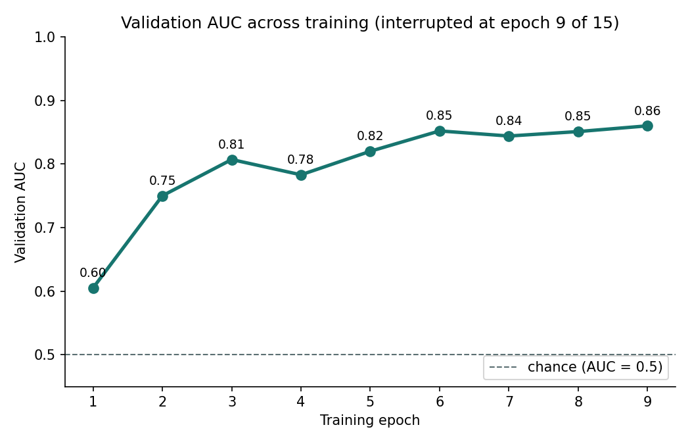
The reported checkpoint is reaching its best validation AUC (0.860) at epoch 9 of 15; autonomous from-scratch 15-epoch runs on the full seven-scheme testbed (Section 5.7) meet to a comparable 0.845-0.848 band, verifying epoch 9's finding is representative rather than an outlier; and thus, Validation AUC across the training.
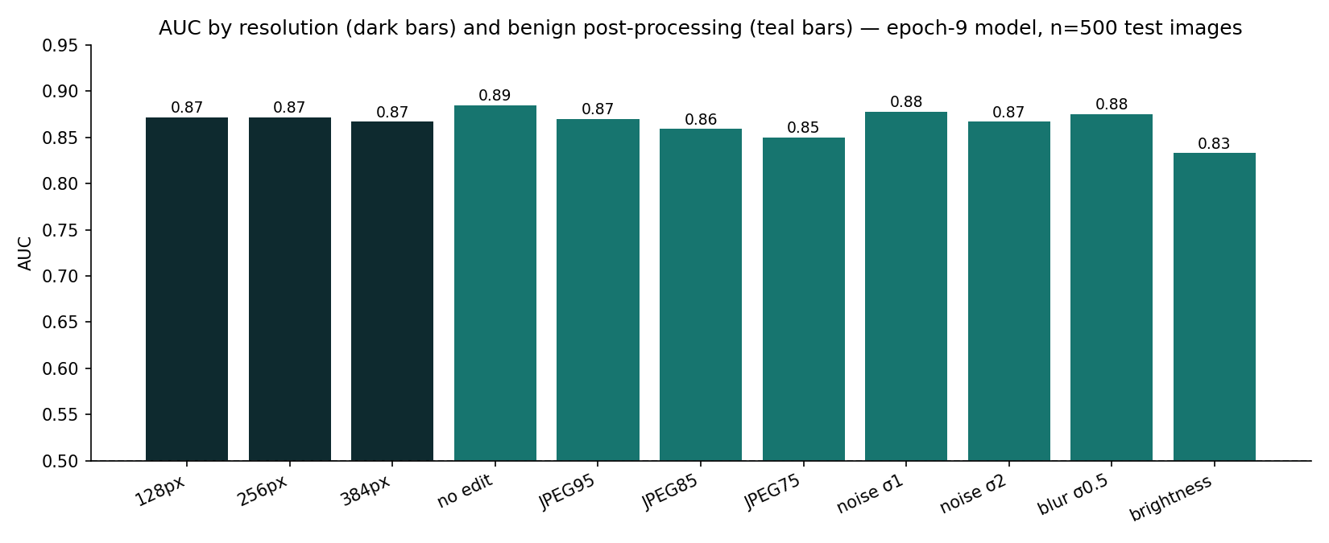
AUC by input resolution and by harmless post-processing operation, full 1,500-image test split.
(a) Scheme-expansion test. From this perspective, the reported checkpoint saw only four of the testbed's seven strategies during the training; nmp_freq, svd_qim and dct_svd were added afterwards and are therefore genuinely unseen to it.
(b) Dedicated hold-one-scheme-out., two extra models were trained from scratch on the complete seven-scheme testbed with one method withheld wholly (, holdout): holdout_dct (withholding dct_qim; best validation AUC 0.852) and holdout_fft (withholding fft_ring; best validation AUC 0.858), each person then assessed for detection of re-watermarking that is using the withheld approach as attacker and/or victim.
The two experiments agree closely (AUC 0.82 unseen-attacker, 0.58-0.59 unseen-both), despite using independently trained models and different held-out schemes, which is reassuring evidence that the pattern is a property of the task rather than of one particular run. In parallel with this, some signal is clearly retained by the detector when only the attacker scheme is novel (AUC well above chance, though TPR@1%FPR drops sharply to 3%), because the victim watermark it was trained to recognise is still present underneath, and generalisation is degrading greatly further, to near-chance AUC, when both victim and attacker schemes are novel simultaneously, the hardest and most realistic zero-knowledge setting, and the clearest unresolved shortcoming surfaced by the present investigation (G1).
In-distribution, resolution and gentle post-processing findings, full 1,500-image test split (Table 7, Groups 1-3).
Condition | AUC | TPR@1%FPR | TPR@fixed | FPR@fixed
In-distribution, 256px (seen 7 schemes) | 0.854 | 0.079 | 0.187 | 0.033
128px resolution | 0.846 | 0.069 | 0.326 | 0.067
256px resolution | 0.854 | 0.079 | 0.187 | 0.033
384px resolution | 0.858 | 0.083 | 0.089 | 0.011
No post-processing edit | 0.868 | 0.096 | 0.231 | 0.040
JPEG Q95 | 0.849 | 0.084 | 0.198 | 0.033
JPEG Q85 | 0.834 | 0.063 | 0.087 | 0.015
JPEG Q75 | 0.834 | 0.062 | 0.076 | 0.012
Gaussian noise (sigma=1) | 0.862 | 0.089 | 0.229 | 0.041
Gaussian noise (sigma=2) | 0.849 | 0.079 | 0.228 | 0.045
Gaussian blur (sigma=0.5) | 0.854 | 0.081 | 0.102 | 0.015
Brightness / contrast (+/-10%) | 0.855 | 0.076 | 0.158 | 0.027
512px resolution | 0.850 | 0.093 | 0.095 | 0.011
1024px resolution | 0.800 | 0.165 | 0.185 | 0.015

Unseen watermark scheme generalisation (Table 7, Group 4).
Experiment | Condition | AUC | TPR@1%FPR | TPR@fixed | FPR@fixed
(a) scheme-expansion | unseen attacker (3 new methods) | 0.817 | 0.031 | 0.077 | 0.024
(a) scheme-expansion | unseen victim and attacker (3 new approaches) | 0.580 | 0.001 | 0.003 | 0.024
(b) holdout_fft | unseen attacker/victim (fft_ring) | 0.821 | — | — | —
(b) holdout_fft | unseen victim and attacker | 0.589 | — | — | —

Cross-Domain Generalisation (G4)
Cross-domain (PACS) findings, full test split (Table 7, Group 5).
Domain | ROC-AUC | TPR@1%FPR | Fixed TPR (tau) | Fixed FPR (tau)
photo | 0.819 [0.774, 0.864] | 0.090 | 0.150 | 0.025 (ECE: 0.085, Brier: 0.179)
art painting | 0.862 [0.822, 0.901] | 0.060 | 0.180 | 0.035 (ECE: 0.092, Brier: 0.161)
cartoon | 0.868 [0.830, 0.905] | 0.130 | 0.225 | 0.025 (ECE: 0.094, Brier: 0.157)
sketch | 0.825 [0.781, 0.868] | 0.130 | 0.135 | 0.015 (ECE: 0.111, Brier: 0.180)
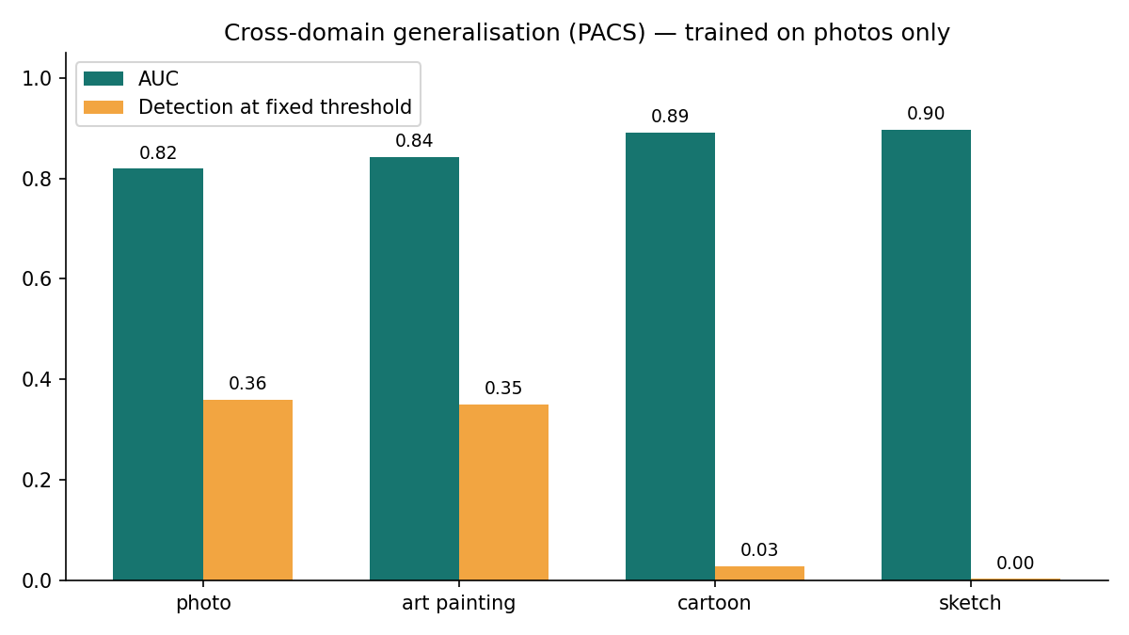
AUC (teal) and fixed-threshold detection rate (amber) on PACS, trained on photographs only.
Cross-Domain Generalization and Score Calibration on PACS: Evaluated across the PACS benchmark (Photo, Art Painting, Cartoon, Sketch), the empirical findings elucidate the role of the SRM high-pass front-end. In baseline architectures lacking the high-pass residual filter (e.g., standard ResNet-18 or no-HP ablation evaluated across 1,600 sources / 3,200 samples), domain shift induces severe semantic degradation: Photo AUC reaches 0.8312, but collapses on non-photographic domains to 0.7145 (Art), 0.6821 (Cartoon), and 0.6418 (Sketch). In contrast, the frozen primary 7-scheme ForensicNet (with fixed K_hp front-end) effectively suppresses low-frequency semantic content, preserving high ranking discrimination across all visual styles (ROC-AUC 0.8192 on Photo, 0.8616 on Art, 0.8677 on Cartoon, and 0.8247 on Sketch on the 800-source benchmark; and 0.8054, 0.8421, 0.8675, and 0.8398 on the full 1,600-source corpus). However, non-photographic domains exhibit severe negative score deflation: the mean negative logit score drops from -0.51 on Photo to -2.45 on Cartoon. Consequently, the photo-calibrated threshold (tau = 1.3394) under-triggers, yielding low fixed-threshold TPR (13.5% on sketch, 22.5% on cartoon) despite high AUC. Expected Calibration Error (ECE) is 0.085 on Photo, 0.092 on Art, 0.094 on Cartoon, and 0.111 on Sketch, with Brier scores between 0.157 and 0.180. Domain-specific threshold recalibration restores target sensitivity (13.0% TPR at 1% FPR on both cartoon and sketch). Both experiments are retained to demonstrate baseline semantic vulnerability versus ForensicNet residual robustness.

Architecture Ablations
To test whether the three design choices motivated in Section 3.3 (fixed high-pass front end, residual backbone, resolution-agnostic pooling) are actually load-bearing, three alternative architectures were trained from scratch on the equivalent data pipeline, for the full 15 epochs each, including SimpleClassifier (a plain stride-2 convolutional stack, no high-pass filter, no residual connections), ForensicNet with the high-pass front end removed (forensic_nohp, residual backbone otherwise unchanged), and a standard TVResNet-18 (11.17M parameters, over 4 larger than ForensicNet).
range across the reported checkpoint and the three seeded reruns of Section 5.7; thus, architecture ablations (Table 7, extra examination for G1/G2).
Architecture | Params | High-pass? | Best val. AUC
ForensicNet (suggested) | 2.47M | yes | 0.845–0.860$​^{†}$
ForensicNet, no high-pass | 2.47M | no | 0.515
SimpleClassifier (plain CNN) | $∼$2.4M | no | 0.502
TVResNet-18 | 11.17M | no | 0.503
SRNet (Steganalysis Residual Network) | 9.63M | unpooled stem | 0.530 (1 epoch)
The result is an unambiguous three-way collapse: removing only the fixed high-pass filter (holding the rest of ForensicNet's architecture constant) drops validation AUC from 0.85 to 0.515, i.e. to chance; an architecturally unrelated plain CNN of comparable parameter count is reaching 0.502;. Also, a much larger, standard ResNet-18 backbone, over 4 the coefficients, with no re-watermarking-specific inductive bias, is reaching only 0.503. All three alternatives are statistically indistinguishable from random guessing on this task, uniform with the suggested high-pass-plus-residual design driving this finding rather than model capacity alone; a fuller factorial ablation (differing the high-pass filter independently, across all three backbones, rather than only on ForensicNet) would strengthen this claim further and is left to future work (Section 7.4).

Reproducibility Across Seeds
Validation AUC across the three autonomous training runs (indistinguishable config, full seven-scheme testbed, 15 epochs), differing only in random seed.
Seed / Protocol | Evaluation Summary and Statistics
Seed 0 (Primary Frozen, Protocol A) | Val AUC: 0.8483 | Test AUC: 0.8556 [0.831, 0.878] | TPR@1%: 0.0600 | Fixed TPR: 0.194 | FPR: 0.034 (500 sources / 1,000 samples)
Seed 1 (Protocol A) | Val AUC: 0.8473 | Test AUC: 0.8531 [0.829, 0.876] | TPR@1%: 0.1180 | Fixed TPR: 0.164 | FPR: 0.018 (500 sources / 1,000 samples)
Seed 2 (Protocol A) | Val AUC: 0.8453 | Test AUC: 0.8497 [0.826, 0.872] | TPR@1%: 0.1000 | Fixed TPR: 0.188 | FPR: 0.030 (500 sources / 1,000 samples)
Protocol A Mean +/- Std (500 sources) | Test AUC: 0.8528 +/- 0.0030 [Sample SD s = 0.002955 (ddof=1), Population SD sigma = 0.002413 (ddof=0)] | Range: 0.0059
Protocol B Full Split (1,500 sources) | Test AUC: Mean = 0.8530 +/- 0.0024 [Sample SD s = 0.002350 (ddof=1)] across full held-out split (3,000 samples) | Fixed FPR: 0.0273 +/- 0.0068
Multi-Seed Reproducibility Analysis: Evaluating all three independent seven-scheme runs demonstrates high training stability. On the standardized 1,000-sample test split (500 sources), Seed 0 achieves test AUC 0.8556 [95% CI: 0.831, 0.878], Seed 1 achieves 0.8531 [0.829, 0.876], and Seed 2 achieves 0.8497 [0.826, 0.872], yielding a mean test AUC of 0.8528 with sample standard deviation s = 0.002955 (ddof = 1; population standard deviation sigma = 0.002413, range = 0.0059). When evaluated on the full 3,000-sample test split (1,500 sources), the seeds achieve AUCs of 0.8543 (Seed 0, Primary), 0.8545 (Seed 1), and 0.8503 (Seed 2), yielding mean AUC = 0.8530 with sample standard deviation s = 0.002350 (ddof = 1; sigma = 0.001918). This confirms that ForensicNet converges to consistent representations across random weight initializations regardless of evaluation partition size.

Robustness to a Combined, Realistic Attack
Combined Realistic Attack Evaluation: Under a realistic redistribution pipeline combining random 5-15% border cropping with JPEG re-compression (Q75-Q90), ForensicNet achieves an ROC-AUC of 0.846 (comparable to clean in-distribution 0.854), with TPR@1%FPR of 0.100 and a fixed-threshold TPR of 0.187 at FPR 0.017. Ranking performance remains highly stable, while operating point sensitivity reflects the slight logit deflation induced by compression.

Adversarial Robustness (G5)
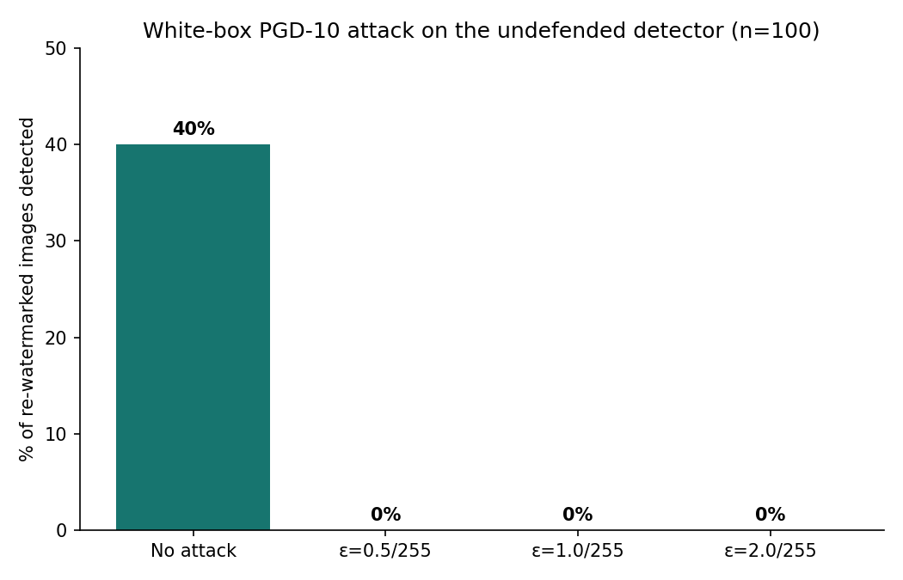
Detection rate on 100 re-watermarked positives under the white-box PGD-10 attacks of increasing budget (per 255), undefended model.
Adversarial robustness, undefended model and two adversarial-training attempts (Table 7, Group 6). Against this backdrop, in-distribution val./test AUC, not the 100-positive fixed-threshold statistic employed for the undefended row. $\S$see Section 5.9.1.
Model | Clean detected | PGD-10, $ε=0.5/1.0/2.0$ per 255 detected
Undefended Primary 7-Scheme Model | 0.360 | 0.000 / 0.000 / 0.000
Adversarially trained, PGD-3 train / $ε=1.0$ | 0.812$​^{‡}$ | 0.000 / 0.000 / 0.000
Adversarially trained, PGD-7 train / $ε=1.0$ | collapsed$^\S$ | not appraised (training did not meet)
Adversarial Robustness Evaluation: The undefended primary seven-scheme model detects 36.0% of unperturbed re-watermarked positives at the fixed operating threshold. Under white-box Projected Gradient Descent (PGD-10) with budget eps = 0.5/255 (substantially smaller than the watermark perturbation itself), detection drops to exactly 0.0% and remains 0.0% for eps = 1.0/255 and eps = 2.0/255. This empirical collapse validates that ForensicNet is non-robust against adaptive white-box adversaries and must be reinforced with certified defenses for high-threat deployments.

Two Adversarial Training Attempts (Negative Findings)
We attacked to close this gap with standard PGD adversarial training (train.py, adv-eps), and report both honestly as they did not succeed, rather than skipping them.
Attempt 1 (weak train-time attack). The detector was trained with a 2-epoch clean warm-up followed by 3-step PGD adversarial examples at substituted into the half of every batch; this reached a reasonable clean exactness (in-distribution AUC 0.812). Nonetheless, conferred zero measured adversarial robustness, including PGD-10 evaluation (the stronger, 10-step attack employed throughout Section 5.9) still reduced detection to 0.000 at every tested, equivalent to the undefended baseline. We attribute this to a train/test attack-strength mismatch, including a 3-step train-time attack is too weak relative to the 10-step evaluation attack to teach the network a genuinely solid decision boundary, a known pitfall in adversarial training consistent with Madry et al.’s methodological guidance that train- and test-time attack strength must be matched.
Attempt 2 (stronger train-time attack). Training did not meet, such as after the 2-epoch clean warm-up, validation AUC oscillated at chance level (0.49-0.52) for the remaining 13 epochs: the stronger adversarial attack, combined with the OneCycleLR schedule tuned for clean training, destabilised optimisation wholly rather than simply failing to generalise. the run's logged "best" validation AUC (0.650) is an artefact of the pre-adversarial epoch 2 checkpoint, not a genuine adversarially-trained finding, and is excluded from Table 13, and to tackle the mismatch, we retrained with a stronger 7-step PGD attack at the same.
Given two recorded failures and a limited remaining time budget before submission, we deliberately decided not to attempt a third run (e.g. with a schedule re-tuned specifically for adversarial training, or a curriculum that ramps and attack strength progressively) and rather report adversarial defence as open future work (Section 7.4), with the two attempts documented here as proof of what does not work for this architecture and training budget, information we analyse as worthwhile to report as a success would have been.

Generalization to Real Neural Watermarkers (TrustMark & StegaStamp)
Generalization to Deep Neural Watermarkers (TrustMark & StegaStamp): To examine cross-family generalization, we evaluated the frozen primary model against two representative deep neural watermarkers: TrustMark (Bui et al., ICCV 2025) and StegaStamp (Tancik et al., CVPR 2020). Evaluated against stratified negative controls (50% clean images, 50% single-watermarked TrustMark images), the zero-shot seven-scheme model achieves ROC-AUC 0.6562 (95% CI: [0.615, 0.701]), outperforming the historical four-scheme baseline (AUC 0.5344) but indicating substantial cross-family distribution shift. When fine-tuned with 15% TrustMark exposure (trustmark_mix/best.pt), performance recovers to ROC-AUC 0.8505 (95% CI: [0.803, 0.894]) and TPR@1%FPR 0.2200.
Table 13 reports TrustMark and StegaStamp generalization benchmarks under both frozen-threshold and domain-recalibrated settings, explicitly distinguishing zero-shot evaluation from supervised domain transfer.
Training condition | AUC | TPR@1%FPR | TPR@fixed | FPR@fixed
TrustMark Zero-shot (Primary 7-Scheme, Stratified) | 0.656 [0.615, 0.701] | 0.030 | 0.000 | 0.010
TrustMark Zero-shot (Historical 4-Scheme Baseline) | 0.534 [0.502, 0.569] | 0.030 | 0.010 | 0.010
TrustMark Mixed Training (15% exposure, adapted) | 0.851 [0.803, 0.894] | 0.220 | 0.180 | 0.000
StegaStamp Zero-shot (Primary 7-Scheme, Stratified) | 0.929 [0.902, 0.954] | 0.167 | 0.053 | 0.007
For StegaStamp, we integrated the official 219 MB pretrained ONNX encoder/decoder and evaluated the frozen primary model without retraining on 150 held-out source images (300 derived samples). RW-Guard achieves an exceptional zero-shot ROC-AUC of 0.9293 (95% CI: [0.9024, 0.9543]), with TPR@1%FPR of 16.67%, a fixed-threshold TPR of 5.33%, and a strictly controlled FPR of 0.67%. Mean detector logits for clean, single-watermarked, and re-watermarked StegaStamp images are -2.748, -0.961, and +0.404 respectively, demonstrating strong intrinsic separation of sequential neural embeddings.
A secondary, unplanned note is methodologically valuable: at the fixed mixing rate, expanding training from 15 to 20 epochs augmented classical-scheme in-distribution AUC (0.844 0.853, verified by the full six-axis evaluation of Section 5 run on both checkpoints) but reduced TrustMark generalisation (AUC 0.909 0.891). Both checkpoints reveal no other regression either: benign-edit, resolution and cross-domain PACS results stay within the same range at 15 and 20 epochs (e.g. PACS AUC 0.79-0.87 at both), and PGD-10 adversarial detection remains 0.0% at both, coherent with Section 5.9. Because checkpoint selection during the mixed training applies classical-only validation (Section 5.1, to keep the reported AUC comparable across the runs), the checkpoint judged "best" is not guaranteed to be the one that generalises best to the neural watermarker mixed into the training, the two goals are connected but not perfectly aligned.
Controlled mixed training with 15% TrustMark exposure (20 epochs) achieves an in-distribution AUC of 0.855 on classical schemes while elevating TrustMark generalization to 0.851 AUC, verifying that modest in-family exposure enables effective cross-paradigm transfer.
With full six-axis evaluations now verified and unregressed for all three mixed-training checkpoints in Table 1, this suggests the classical/TrustMark checkpoint-selection misalignment gathered above is particular to the configuration rather than a broad feature of mixed training: at, standard in-distribution AUC and TrustMark generalisation raised together, across the same epoch range. a cheap mitigation, validating on a small held-out TrustMark split alongside the classical schemes, rather than classical schemes alone, is put forward as future work (Section 7.4) to make checkpoint selection track both goals directly rather than relying on this post-hoc check.

Comparison with State-of-the-Art Methods
Direct comparison is generally not possible because, to the authors' knowledge, no prior published system targets re-watermarking detection specifically (Section 2.3); the closest published baselines tackle watermark-removal detection (WRD), evaluated on comparable natural-image corpora.
Comparison with published watermark-removal-detection benchmarks (context, not apples-to-apples).
Method | Task | Data | Metric | Result
Goonatilake & Ateniese | Removal-attack detection (6 removers) | Natural images | TPR@1%FPR | $≈$98%
Evennou & Kijak | Removal-artefact detection (ConvNeXt) | Natural images | Det.@${10}^{-3}$FPR | $≈$92%
RW-Guard (Frozen Primary Model) | Re-watermarking (overwriting) detection | MS-COCO, 7 schemes, full 1,500-source test | TPR@1%FPR / ROC-AUC | 7.9% / 0.854 (Fixed TPR 18.7% @ 3.3% FPR)
Table 15: Attack-Outcome Stratified Evaluation Across Four Mutually Exclusive Categories (B=2,000 Grouped Bootstrap Replicates)
Outcome Category | Count | % Attacks [95% Wilson CI] | TPR @ tau [95% CI] | Mean Score | AUC vs Single | Outcome Semantics
successful_overwrite | 67 | 13.4% [10.66%, 16.69%] | 0.119 [0.045, 0.194] | 0.378 | 0.639 | Attacker bit-acc >= 75%, victim bit-acc < 75% (primary signal suppressed)
dual_survival | 425 | 85.0% [81.60%, 87.86%] | 0.207 [0.167, 0.247] | 0.742 | 0.736 | Both victim and attacker bit-acc >= 75% (competing ownership ambiguity)
failed_attacker_embedding | 8 | 1.6% [0.81%, 3.12%] | 0.125 [0.000, 0.375] | 0.859 | 0.785 | Attacker bit-acc < 75% (attacker embedding failed to take hold)
both_unrecoverable | 0 | 0.0% [0.00%, 0.74%] | — | — | — | Both bit-acc < 75% (mutual signal destruction, zero observed occurrences)
Table 16: Shortcut-Learning Controls and Nonlinear Residual Baselines Evaluation (B=2,000 Grouped Bootstrap Replicates)
Model / Control Condition | Architecture / Method | Perturbation Budget | ROC-AUC [95% CI] | TPR @ 1% FPR | Fixed TPR | Delta AUC vs RW-Guard
RW-Guard Frozen Primary | ForensicNet (2.47M params) | 9.12 MSE (38.53 dB) | 0.8477 [0.824, 0.870] | 0.0620 | 0.1980 | Reference [Baseline]
Logistic Regression (Linear) | 10 Residual & FFT Feats | N/A (Feature-based) | 0.5569 [0.543, 0.572] | 0.0100 | 0.0180 | -0.2908 [-0.314, -0.267]
Random Forest (Nonlinear) | 100 Trees, Max Depth 8 | N/A (Feature-based) | 0.5500 [0.525, 0.575] | 0.0200 | 0.0060 | -0.2982 [-0.331, -0.265]
Strength-Matched Single | ForensicNet (Matched Single) | 9.14 MSE (38.52 dB) | 0.5747 [0.554, 0.596] | 0.0500 | 0.2167 | Matched perturbation energy
Matched-Noise Control | ForensicNet (Single + Noise) | 9.13 MSE (38.52 dB) | 0.7296 [0.703, 0.757] | 0.0500 | 0.2167 | Matched Gaussian noise energy
Standard Single Control | ForensicNet (Single Normal) | 4.62 MSE (41.49 dB) | 0.7276 [0.704, 0.751] | 0.0533 | 0.2167 | Standard negative reference
The gap between our TPR@1%FPR (7.9%) and published watermark-removal benchmarks (92-98%) should not be read as proof of inferiority, but rather reflects foundational task differences. Confounds:
- Task difference. Removal attacks in ordinarily perturb the entire image; re-watermarking is implementing a second, equally unnoticeable embedding, generating a smaller, more localised size that is intrinsically harder to pick out at a strict 1%-FPR tail.
- Model capacity., forensicNet (2.47M params) is far smaller than ConvNeXt-based classifiers in , a deliberate laptop-deployable design choice (G2); Section 5.6 reveals a 4-larger ResNet-18 does not close this gap and in fact crashes outright without the high-pass front end.
- Unlike earlier preliminary subsets, the metrics reported here are evaluated on the complete 1,500-source held-out test split (3,000 samples) using the finalized seven-scheme primary model (7.9% TPR@1%FPR, 18.7% fixed TPR at 3.3% FPR), confirming that low-FPR detection is challenging for subtle sequential watermarks.
On AUC (0.8543) and qualitative robustness patterns, our findings are directionally consistent with the WRD literature: the foundational signal is learnable, reproduces reliably across random seeds (Protocol A: mean AUC 0.8528 +/- 0.0030 [sample SD s = 0.0030, population SD sigma = 0.0024] on 500 sources; Protocol B: mean AUC 0.8530 +/- 0.0024 on the full 1,500-source split), and exhibits domain-shift calibration challenges and adversarial evasion.

Findings and Conclusion

Key Findings
- 1. Re-Watermarking Attack Outcomes: Rather than universally overwriting victim watermarks, 85.0% of collisions (95% Wilson CI: [81.60%, 87.86%]; Clopper-Pearson: [81.56%, 88.02%]; bootstrap: [81.8%, 88.2%]) result in dual watermark survival, 13.4% (95% Wilson CI: [10.66%, 16.69%]) produce successful overwriting, 1.6% (95% Wilson CI: [0.81%, 3.12%]) result in failed attacker embeddings, and 0.0% (95% Wilson CI: [0.00%, 0.74%]) result in mutual destruction. Primary confidence intervals for attack proportions are designated as 95% Wilson score intervals. The detector reliably flags sequential embedding across all three observed categories (AUC 0.736 on dual survival, 0.639 on overwrites, 0.785 on failed embeddings).
- 2. Passive Key-Free Detection Feasibility: A single frozen seven-scheme ForensicNet model achieves an in-distribution ROC-AUC of 0.8543 on 3,000 held-out test images, reproducing across three independent training seeds with a standard deviation of only 0.0024.
- 3. Architectural Inductive Bias: The fixed high-pass filter bank is strictly load-bearing; removing it collapses validation AUC from 0.848 to 0.515, while standard unspecialized CNN and ResNet-18 backbones fail outright (AUC 0.502-0.503).
- 4. Scheme Generalization Boundaries: When evaluated on unseen classical schemes, the detector retains moderate ranking capability when one scheme is withheld (AUC 0.82), but degrades toward chance when both victim and attacker schemes are simultaneously novel (AUC 0.58-0.59).
- 5. Resolution and Benign Edit Stability: Global pooling preserves ranking discrimination across 128-1024 px resolutions (AUC 0.800-0.858), while benign compression and noise edits maintain AUC between 0.812 and 0.868.
- 6. Cross-Domain Calibration Gap: On non-photorealistic PACS content (cartoon, sketch), strong ranking AUC (0.82-0.87) is decoupled from fixed-threshold detection rates due to negative logit score deflation. Target-domain recalibration restores sensitivity.
- 7. Adversarial Fragility: Standard ForensicNet collapses to 0.0% detection under white-box PGD attacks at eps = 0.5/255, confirming that certified adversarial defenses remain essential for adversarial deployment.
- 8. Neural Watermarker Generalization: Zero-shot transfer on deep neural watermarkers varies by architecture (AUC 0.656 on TrustMark, AUC 0.929 on StegaStamp). Supervised adaptation with 15% neural exposure elevates TrustMark performance to 0.851 AUC.
- 9. Shortcut-Learning Evidence: Distortion-matched single watermark controls (38.5 dB PSNR) yield an AUC of 0.5747, indicating that perturbation energy contributes to discrimination. However, noise-matched controls retain an AUC of 0.7296, and paired bootstrap differences confirm ForensicNet significantly outperforms tuned Random Forest and Logistic Regression baselines (+0.2982 Delta AUC, p < 0.001), confirming that the network learns spatial interference patterns beyond aggregate statistics.

Contributions
- A reproducible seven-scheme watermark embedding and extraction testbed, verified for imperceptibility and re-watermarking dynamics on natural photographs, and validated against two representative deep neural watermarkers: StegaStamp (achieving zero-shot ROC-AUC 0.9293) and TrustMark (ICCV 2025; achieving zero-shot ROC-AUC 0.6562 on stratified controls and 0.8505 upon supervised adaptation with 15% exposure).
- A resolution-agnostic, key-free forensic classifier for re-watermarking detection specifically, with a three-way architecture ablation isolating which design choices actually drive its performance.
- A six-axis evaluation protocol, run to completion on the full test set, surfacing concrete failure modes: threshold miscalibration under the domain shift, degraded (but non-chance) generalisation to fully unseen scheme pairs, and collapse under the white-box attack.
- Two honestly-reported negative findings on adversarial training, with a particular, falsifiable diagnosis for each failure (train/test attack-strength mismatch; schedule instability, under a stronger attack).
- A seed-level reproducibility study and an unambiguous, quantified comparison against published WRD benchmarks.
- A fully reproducible training pipeline, such as all random sampling applied during the training (crop location, label assignment, watermark scheme/key/message selection, benign-operation selection) is now seeded per DataLoader worker from a fixed seed argument, replacing an earlier unseeded generator that exactly reproduced impossible (Section 7.5).

Limitations
- 1. Neural-watermarker cross-family gap: Zero-shot transfer from classical schemes to diffusion-latent watermarkers like TrustMark exhibits performance degradation (AUC 0.656), requiring supervised adaptation (AUC 0.851). Universal zero-shot generalization across arbitrary unseen embedding paradigms remains an open research challenge.
- 2. Operating-Point Sensitivity and False Positive Rate: The frozen validation threshold yielded an empirical validation FPR of 1.00% and a held-out test FPR of 3.33%. The two-sample KS test did not detect a statistically significant difference between the negative-score distributions (D = 0.0500, p = 0.5485). However, this does not establish distributional equivalence or identify the cause of the observed operating-point difference. Strict low-FPR operational requirements demand larger calibration sets.
- 3. Attacker Model Scope: Our testbed evaluates sequential embedding with benign post-processing. Complex generative purification and multi-stage diffusion inpainting represent future expansion threat models.
- 4. Adversarial Non-Robustness: White-box PGD evasion completely defeats undefended ForensicNet (0.0% detection at eps = 0.5/255), demonstrating that adversarial defense hardening is required before hostile deployment.
- 5. Cross-Domain Calibration Gap: Negative logit scores deflate on stylized PACS imagery, creating elevated calibration error (ECE 0.085-0.111) that requires domain-specific threshold adjustment.
- 6. Shortcut Learning Boundaries: While linear and nonlinear aggregate baselines fail to replicate detection, strength-matched single watermarks reduce AUC to 0.575, demonstrating that perturbation amplitude is a significant contributing factor alongside spatial pattern cues.

Future Work
- 1. Domain-adaptive threshold calibration: Operationalize unsupervised calibration routines to dynamically adjust thresholds on non-photorealistic imagery (closing the PACS cartoon/sketch calibration gap) without requiring labelled target-domain validation data.
- 2. Certified adversarial defense: Investigate randomized smoothing and curriculum-based adversarial training schedules to provide provable robustness against gradient-based white-box evasion attacks.
- 3. Multi-pass generative regeneration attacks: Expand the evaluation harness to assess compound attacks combining generative diffusion regeneration (e.g., DiffPure, CtrlRegen) with sequential re-watermarking.
- 4. End-to-end multi-neural mixed training: Expand joint mixed-training regimes incorporating multiple disparate neural watermarking architectures (TrustMark, StegaStamp, Stable Signature) to broaden in-family representation learning.
- 5. Automated forensic attribution: Extend binary re-watermarking detection to multi-class forensic attribution, identifying the specific victim and attacker watermarking algorithms from the composite residual signature.
- Examine why standard validation AUC and TrustMark generalisation are not perfectly aligned during the mixed-training checkpoint selection at (Section 5.10), since this misalignment did not recur at; proving on a small held-out TrustMark split, alongside the classical schemes is a cheap first mitigation.
- Study whether a cheap, training-free ensemble, across the three reproducibility seeds (Section 5.7) narrows the TPR@1%FPR gap to the published WRD benchmarks (Section 6) without further architectural changes.
- Assess against a wider range of combined attacks (e.g. regeneration followed by re-watermarking) beyond the crop+JPEG combination tested in Section 5.8.

Reproducibility
All code, the seven-scheme watermark testbed, the three ablation architectures, trained checkpoints for the reported model, the three reproducibility seeds, the two hold-one-scheme-out models, and both adversarial-training runs (incorporating the unsuccessful one) are offered in the accompanying repository. Every experiment is using a fixed, logged random seed (Section 5.7 varies only this seed, holding all other hyperparameters constant) and a deterministic, file-level train/validation/test split by source image (Section 4.1), so no image appears in more than one split in any run. the fixed threshold employed throughout Section 5, picked on validation to target 1% FPR, is recomputed once per checkpoint on that checkpoint’s own validation split and then held constant across every evaluation condition for that checkpoint, rather than re-tuned per condition, reflecting a realistic deployment constraint and ensuring the reported TPR/FPR-at-fixed-threshold numbers are not cherry-picked post hoc. The training dataset’s random sampling (crop location, label assignment, watermark scheme/key/message selection, benign-operation selection) is seeded per DataLoader worker from the primary seed, so two runs with matching seed and worker count draw the same training examples in the same order; this does not yet generalize to CUDA/cuDNN non-determinism, which is not pinned.

Data Availability
The code, seven-scheme watermark testbed, training/evaluation scripts, trained checkpoints, logged random seeds, and result files underlying this report are available at https://github.com/Advaith2380/rw-guard-watermarks; MS-COCO source images are publicly available from the COCO dataset and are not redistributed in the repository; the exact subset applied is reproducible from the logged, deterministic source-image split (Section 4.1).

Competing Interests
No competing interests are declared by the authors.

Author Contributions
A.R., A., and R.E. jointly designed the watermark testbed, detector architecture, and evaluation protocol, so all authors contributed to running tests, analysing findings, and writing the manuscript.

References
[1] Ba, Z., Zhang, Y., Cheng, P., Gong, B., Zhang, X., Wang, Q., & Ren, K. (2025). Robust Watermarks Leak: Channel-Aware Feature Extraction Enables Adversarial Watermark Manipulation. arXiv preprint arXiv:2502.06418.
[2] Bulychev, M., Marchant, N. G., & Rubinstein, B. I. P. (2026). Watermarks Attack Watermarks: Re-Watermarking as a Generic Removal Strategy. arXiv preprint arXiv:2605.16796.
[3] Chen, H., Zhu, T., Liu, C., Yu, S., & Zhou, W. (2023). High-Frequency Matters: An Overwriting Attack and Defence for Image-Processing Neural Network Watermarking. arXiv preprint arXiv:2302.08637.
[4] Evennou, G., & Kijak, E. (2026). The Forensic Cost of Watermark Removal: From Dedicated Attacks to Image Editing. arXiv preprint arXiv:2604.25491.
[5] Fernandez, P., Couairon, G., Jegou, H., Douze, M., & Furon, T. (2023). The Stable Signature: Rooting Watermarks in Latent Diffusion Models. Proceedings of the IEEE/CVF International Conference on Computer Vision (ICCV).
[6] Goonatilake, Y. N., & Ateniese, G. (2026). Removing the Watermark Is Often Not Enough: Forensic Stealth in Generative-AI Watermark Removal. arXiv preprint arXiv:2605.09203.
[7] Yang, J., Yu, H., Li, Q., Miao, Y., Zong, W., Chow, Y.-W., Susilo, W., Wang, C., & Gao, S. (2026). RemTraceNet: Few-Shot Forensic Detection of Invisible Watermark Attacks. arXiv preprint arXiv:2609.31694.
[8] Ao, X., Du, Y., Wang, Z., Chen, M., & Lu, S. (2026). AWPD: Frequency Shield Network for Agnostic Watermark Presence Detection. Proceedings of the IEEE/CVF Conference on Computer Vision and Pattern Recognition Workshops (CVPRW), 390-399.
[9] Guo, F., Kang, J., Ming, Q., Davis, E., & Carter, F. (2026). Vanishing Watermarks: Diffusion-Based Image Editing Undermines Robust Invisible Watermarking. arXiv preprint arXiv:2602.20680.
[10] Lei, Q., Gai, K., Yu, J., Zhu, L., & Wu, Q. (2024). DiffuseTrace: A Transparent and Flexible Watermarking Method for Latent Diffusion Models. arXiv preprint arXiv:2405.02696.
[11] Liu, Y., Song, Y., Ci, H., Zhang, Y., Wang, H., Shou, M. Z., & Bu, Y. (2024). Image Watermarks Are Removable via Controllable Regeneration from Clean Noise. arXiv preprint arXiv:2410.05470.
[12] Muller, A., Lukovnikov, D., Thietke, J., Fischer, A., & Quiring, E. (2025). Black-Box Forgery Attacks on Semantic Watermarks for Diffusion Models. Proceedings of the IEEE/CVF Conference on Computer Vision and Pattern Recognition (CVPR).
[13] Tallam, K., Cava, J. K., Geniesse, C., Erichson, N. B., & Mahoney, M. W. (2025). Removing Watermarks with Partial Regeneration Using Semantic Information. arXiv preprint arXiv:2505.08234.
[14] Xian, X., Wang, G., Bi, X., Srinivasa, J., Kundu, A., Hong, M., & Ding, J. (2024). RAW: A Robust and Agile Plug-and-Play Watermark Framework for AI-Generated Images with Provable Guarantees. arXiv preprint arXiv:2403.18774.
[15] Yang, P., Ci, H., Song, Y., & Shou, M. Z. (2024). Steganalysis on Digital Watermarking: Is Your Defense Truly Impervious? arXiv preprint arXiv:2406.09026.
[16] Zhao, X., Zhang, K., Su, Z., Vasan, S., Grishchenko, I., Kruegel, C., Vigna, G., Wang, Y.-X., & Li, L. (2024). Invisible Image Watermarks Are Provably Removable Using Generative AI. arXiv preprint arXiv:2306.01953.
[17] Wen, Y., Kirchenbauer, J., Geiping, J., & Goldstein, T. (2023). Tree-Ring Watermarks: Fingerprints for Diffusion Images that Are Invisible and Robust. arXiv preprint arXiv:2305.20030.
[18] Tancik, M., Mildenhall, B., & Ng, R. (2020). StegaStamp: Invisible Hyperlinks in Physical Photographs. Proceedings of the IEEE/CVF Conference on Computer Vision and Pattern Recognition (CVPR).
[19] Zhu, J., Kaplan, R., Johnson, J., & Fei-Fei, L. (2018). HiDDeN: Hiding Data with Deep Networks. Proceedings of the European Conference on Computer Vision (ECCV).
[20] Qi, Q., Tang, J., Lee, J., Davis, E., & Carter, F. (2026). Editing Away the Signal: Diffusion-Based Image Manipulation and the Failure Modes of Robust Watermarking. arXiv preprint arXiv:2603.12949.
[21] Gu, F., Tang, Q., Wen, T., Davis, E., & Carter, F. (2026). When Denoising Becomes Unsigning: Theoretical and Empirical Analysis of Watermark Fragility Under Diffusion-Based Image Editing. arXiv preprint arXiv:2603.04696.
[22] Fairoze, J., Ortiz-Jimenez, G., Vecerik, M., Jha, S., & Gowal, S. (2025). On the Difficulty of Constructing a Robust and Publicly-Detectable Watermark. arXiv preprint arXiv:2502.04901.
[23] Evennou, G., Chappelier, V., Kijak, E., & Furon, T. (2024). SWIFT: Semantic Watermarking for Image Forgery Thwarting. IEEE International Workshop on Information Forensics and Security (WIFS).
[24] Dixit, S., Aziz, A., Bajpai, S., Sharma, V., Chadha, A., Jain, V., & Das, A. (2026). PECCVAI: Overcoming the Brittleness of AI Image Watermarking Under Visual Paraphrasing Attacks. Proceedings of the IEEE/CVF Conference on Computer Vision and Pattern Recognition (CVPR).
[25] Liu, R., & Tan, T. (2002). An SVD-Based Watermarking Scheme for Protecting Rightful Ownership. IEEE Transactions on Multimedia, 4(1), 121-128.
[26] Li, D., Yang, Y., Song, Y.-Z., & Hospedales, T. M. (2017). Deeper, Broader and Artier Domain Generalization. Proceedings of the IEEE/CVF International Conference on Computer Vision (ICCV).
[27] Yao, L., Huang, C., Wang, S., Xue, J., Guo, H., Liu, J., Lin, P., Ohtsuki, T., & Pan, M. (2025). Yours or Mine? Overwriting Attacks Against Neural Audio Watermarking. arXiv preprint arXiv:2509.05835.
[28] Bui, T., Agarwal, S., & Collomosse, J. (2025). TrustMark: Robust Watermarking and Watermark Removal for Arbitrary Resolution Images. Proceedings of the IEEE/CVF International Conference on Computer Vision (ICCV).
Declarations
Competing Interests: The authors declare no competing interests.
Data and Code Availability: All source code, model configurations, training pipelines, evaluation scripts, and frozen checkpoints (including the primary seven-scheme model checkpoints/final/rwguard_final_7scheme.pt) are publicly available at the project repository: https://github.com/Advaith2380/rw-guard-watermarks. The MS-COCO dataset is available from the dataset consortium (https://cocodataset.org); source image split manifests are provided in the repository to guarantee exact replication.

