Note to Kieran - QA reassessment 2026-10-26
Hey Kieran - I reran the full QA sweep (the five-agent persona-by-scenario pass from March, plus a live browser run of the real flows on a dev server against the prod DB with throwaway accounts). Your October 14 fixes all landed: landing copy, wordmark, bulk-invite wording, the roster "Setting up" badge, the context-aware relationship list and tooltip, "Reissue invite". Nice work, and the rebuild itself is in good shape: onboarding, the Today slider, the reviewer form and the AI prep are all genuinely strong.
Platform score is 7.50, down from 7.82 in March, and that drop is almost entirely five new things I'd want fixed before we put testers on it:
1. Coach notes leak to the client. Notes are labelled "Private - shapes AI insights" in the coach UI, but the latest one is quoted verbatim on the client's Today page as "Your coach" (and again in the week-6 micro-moment). I reproduced it live. individual/today/+page.server.ts:258-277.
2. The invite accept page can't be reached by the invitee. /coach/invite/[token] is under the coach-only layout, so a signed-out client bounces to /sign-in and a signed-in individual bounces to the role chooser. Acceptance only works through the email auto-link, which fires before the client has picked a role or seen your name, and never works if they sign up with a different address. coach/+layout.server.ts:8.
3. Insights, Ask, Scorecard and History fell out of the individual nav in the rebuild. All four pages work by URL.
4. The reviewer reminder cron re-mints a fresh request twice a week forever for any reviewer with an unused token, including expired ones, and reviewers have no opt-out (emails omit the preferences link, STOP only updates User rows, no Remove button). jobs/remind-stakeholder-feedback.ts:10-63, feedbackToken.ts:62-96.
5. The stacked-render flash is a Svelte effect loop. seenForm = form into $state proxies the object, so form === seenForm never matches and the page throws effect_update_depth_exceeded after every submit on coach onboarding. Your 303 fixed the skip path; send-invite still hits it. coach/onboarding/+page.svelte:117.
Second tier, all small: invited clients see the role chooser with no coach context; notes saved for a "Setting up" client vanish; alerts keep firing after a journey completes; the "Overdue" email can fire on day 1 of a week; reminder emails deep-link to the old 11-button check-in page instead of Today; a few invented stats in copy ("98% open rate", "top 20% of leaders").
Things I couldn't verify from here (my network blocks Vercel's IP range): Clerk live keys, Sentry DSN, Upstash (rate limiting is a no-op without it), and whether PUBLIC_APP_URL has a scheme (templates prepend https://).
Full report with file:line for everything, the per-domain reports and 27 screenshots: docs/qa-full-reassessment-2026-10-26.md, screenshots/qa5_*. Happy to re-test anything after your next pass. - Marc

The coach-note leak as it appears on the client's Today page (qa5_05):
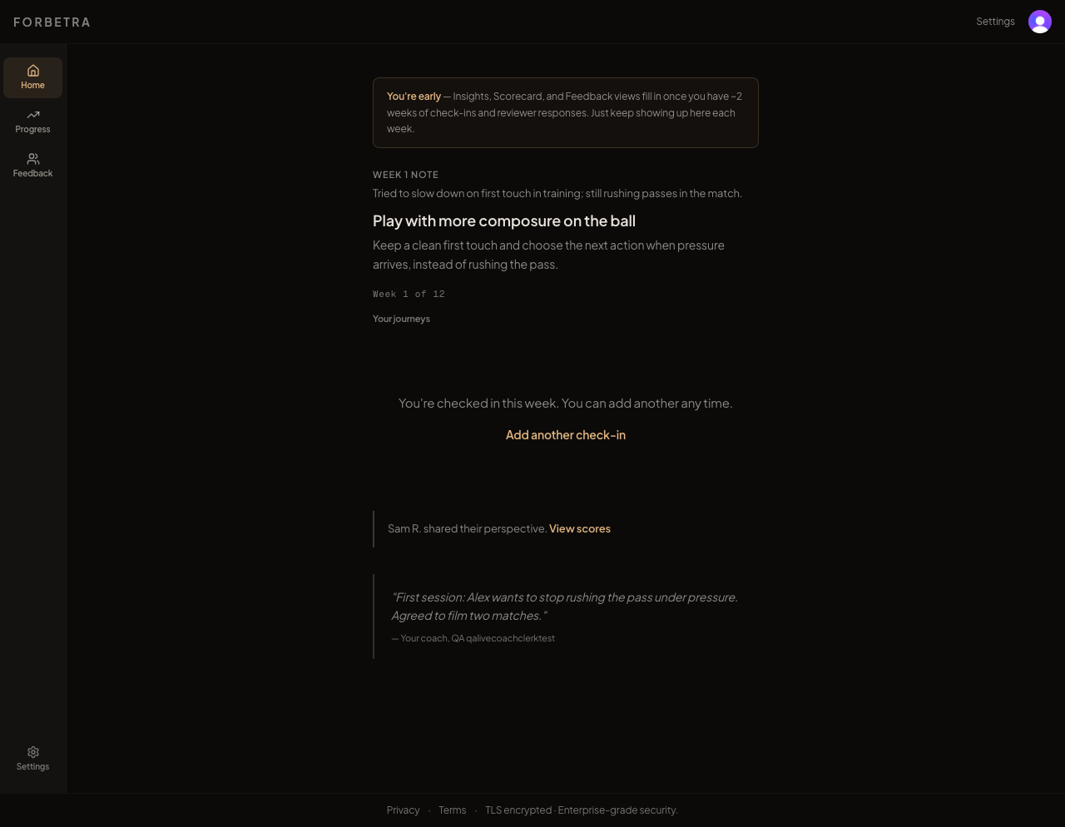
Today page showing the coach's private note attributed to "Your coach"

