Forbetra Full QA Reassessment - 2026-10-26
Rerun of the exhaustive persona-by-scenario QA (same method as the 2026-03-14 full assessment and reassessment) against main at 958913e, which includes Kieran's PR #26 (domain rebuild and rename), PR #27 (coach onboarding and invites) and PR #28 (October 14 tester-readiness fixes).
Two layers this time:
1. Code-based synthetic QA. Five parallel agents walked every persona x scenario in the UX evaluation framework (docs/ux-evaluation-framework.md) through the actual code paths: individual, coach, reviewer, admin/cross-role, API/jobs/backend. Every issue cites a file:line that was read.
2. Live browser walkthrough. Headless Chromium against a local dev server pointed at the production database, with throwaway Clerk test accounts (qa-live-coach, qa-live-ind-a, qa-live-ind-b, one reviewer). Email and SMS in mock mode. Screenshots in screenshots/qa5_01 through qa5_27. Test rows were deleted afterwards.
Static baseline: npm run check 0 errors / 3 warnings, npm test 132/132, npm run lint clean on code (only the October QA markdown files fail prettier).
Production could not be probed from this network. The AT&T Wi-Fi captive portal on Marc's connection intercepts TLS to Vercel's 76.76.21.x range and serves a secure-login.attwifi.com certificate for app.forbetra.com, so the Clerk-key and Sentry checks from October 14 remain unverified (see section 7). This is a local network artifact, not a Forbetra defect.

1. Platform score: 7.50 / 10 (-0.32 vs March reassessment)
Role | 2026-10-26 | 2026-03-14 reassess | 2026-03-14 full | Delta vs reassess
Individual | 7.41 | 7.91 | 6.43 | -0.50
Coach | 7.43 | 7.65 | 7.20 | -0.22
Reviewer | 7.75 | 8.17 | 7.01 | -0.42
Admin (coach weights) | 7.24 | 7.25 | - | -0.01
Platform | 7.50 | 7.82 | 6.81 | -0.32

Formula unchanged: Individual x 0.45 + Coach x 0.30 + Reviewer x 0.25.
The drop is not a regression in build quality. Most March fixes hold. Three things moved the number: the rebuild dropped Insights, Ask, Scorecard and History out of the individual nav; this pass traced the notification layer end to end and charged the reviewer reminder loop to the reviewer role; and two new trust defects (coach notes shown to the individual, unreachable invite accept page) landed with the new code.

Dimension breakdown
Dimension | Individual | Coach | Reviewer | Admin
FI First impression | 7.6 | 8.0 | 8.0 | 7.4
CP Clarity of purpose | 8.0 | 8.0 | 8.5 | 8.0
OE Onboarding ease | 8.2 | 6.5 | 8.3 | 6.6
CT Core task flow | 7.4 | 7.0 | 8.0 | 7.4
IA Information architecture | 6.3 | 8.0 | 8.0 | 7.6
FP Feedback and progress | 7.5 | 7.5 | 7.5 | 7.0
CL Cognitive load | 7.8 | 7.5 | 7.0 | 7.4
TC Trust and credibility | 5.8 | 7.0 | 6.5 | 6.6
EE Emotional engagement | 7.6 | 7.0 | 8.5 | 6.5
VP Value perception | 7.5 | 8.0 | 7.5 | 7.6

Worst: Individual TC 5.8 (coach "private" notes quoted to the individual; invented statistics in copy). Best: Reviewer CP 8.5 and EE 8.5 (the form and the reveal are the strongest surfaces in the product).

2. Issue summary
Domain | Critical | Major | Minor | Polish | Total
Individual journey | 2 | 9 | 14 | 6 | 31
Coach journey | 1 | 4 | 7 | 4 | 16
Reviewer journey | 0 | 5 | 12 | 5 | 22
Admin and cross-role | 0 | 5 | 13 | 9 | 27
API, jobs, backend | 2 | 11 | 12 | 6 | 31
Live walkthrough (new, not in the five reports) | 0 | 1 | 4 | 2 | 7
Raw total | 5 | 35 | 62 | 32 | 134

Several items were found independently by more than one agent (the reminder loop, reviewer opt-out, the role chooser for invited clients, the cross-coach prep leak, the per-request Clerk lookup). After dedup the list below has 5 Critical and 24 Major. March full assessment had 13 Critical / 53 Major.
Per-domain reports with every Minor and Polish item, the regression tables and the persona risk tables are appended in section 12.

3. Critical (5) - fix before any tester cohort
# | Issue | Evidence | Effort
C1 | Coach notes marked "Private - shapes AI insights" are shown to the client. The latest coach note is quoted verbatim on the individual's Today page as a coach nudge, and again in the week-6 check-in micro-moment. Confirmed live: the note "First session: Alex wants to stop rushing the pass under pressure..." appeared on qa-live-ind-a's Today page attributed to "Your coach" (screenshot qa5_05). | coach/session/[clientId]/+page.svelte:687 (label); individual/today/+page.server.ts:258-277, +page.svelte:420-428; individual/checkin/+page.server.ts:264-289 | S
C2 | The coach invite accept page is unreachable by the invited client. /coach/invite/[token] sits under the COACH/ADMIN-only layout. Confirmed live: a signed-out visitor is bounced to /sign-in with no return redirect (qa5_22); a signed-in individual is 303'd to the role chooser (qa5_23). Acceptance only happens via the sign-in auto-link when the Clerk email equals the invite email. A client who signs up with Google using a different address has no accept path at all, and the coach is told "accepted" the moment the matching user loads any page, before the client has picked a role or seen the coach's name. | coach/+layout.server.ts:8; coach/invite/[token]/+page.svelte:96-166; hooks.server.ts:48-122; routes/+page.server.ts:13-24 | S
C3 | Insights and Ask are unreachable in-app. Individual nav is Home / Progress / Feedback / Settings. Insights is linked only from emails; Ask only from Insights; History from nowhere; Scorecard only via a conditional Today nudge. Confirmed live: all four pages render fine by URL (qa5_09, qa5_11) and none has a nav entry. Regression of March Critical #5. | individual/+layout.svelte:17-21; today/+page.svelte:360-417 | S
C4 | Reviewer reminder cron turns one invite into a perpetual twice-weekly request. The job selects any reviewer holding any unused feedback token on an active journey (including expired ones) and, in reminder mode, mints a new token for the current week, which keeps the reviewer in next week's set. One unanswered invite yields 2 emails + 2 SMS per week for the rest of the journey, contradicting the welcome email's "Checking in does not send it automatically". No minimum token age either, so a 14:30 invite gets a 15:00 "reminder". Found independently by the reviewer and backend agents. | jobs/remind-stakeholder-feedback.ts:10-63; lib/server/feedbackToken.ts:62-96; emailTemplates.ts:152 | M
C5 | Reviewers cannot opt out and cannot be removed. Reviewer emails deliberately omit the preferences link; Twilio STOP updates User rows only, so a reviewer who texts STOP is still sent SMS from the app's perspective; the Reviewer model has no opt-out field; the reviewers page has no remove action. Combined with C4 this is unsubscribable automated messaging to third parties, and /sms-consent promises reviewers "1-2 messages per month". | emailTemplates.ts:51-64; api/webhooks/twilio/+server.ts:49-55; prisma/schema.prisma Reviewer; individual/reviewers/+page.server.ts (no remove action) | M

4. Major (24, deduplicated)

New in the October rebuild
# | Issue | Location | Effort
M1 | Coach onboarding throws `effect_update_depth_exceeded` after every form submit, which is the stacked-render flash from the Oct 13/14 notes. The effect at +page.svelte:117 does seenForm = form into $state, which wraps the object in a proxy, so form === seenForm is never true and the effect loops until Svelte aborts it. Reproduced live on both savePractice and sendInvite; the Invite step rendered above the dashboard (qa5_15). PR #28 only fixed the skip path (now a 303). | coach/onboarding/+page.svelte:116-129 | S
M2 | Coach-invited clients land on the Individual / Coach role chooser with no invite context; picking Coach strands them ("contact support", no link) and leaves a COACH user on the coach's roster. Confirmed live for qa-live-ind-b (qa5_23). | routes/+page.server.ts:13-24; routes/+page.svelte:251-316 | S
M3 | Coach notes written for a "Setting up" client (no journey yet) save with journeyId null and are never listed again. "Note saved", then gone. | coach/session/[clientId]/+page.server.ts:85-100, 206-216 | S
M4 | Alerts keep firing after a journey is COMPLETED: week number is uncapped and buildClientSummary never checks journey status, so finished clients show "needs attention" under the "Journey complete" banner. | lib/server/buildClientSummary.ts:322-346; domain/week.ts:9-20 | S
M5 | Two check-in UIs. Today uses the new RatingBar slider; every reminder email/SMS and the hub's "Add another check-in" deep-link to the legacy /individual/checkin page (11-button grid, "insights update within 24 hours"). Confirmed live (qa5_10). | emailTemplates.ts:231, 288; smsTemplates.ts:13, 18; individual/+page.svelte:215 | M
M6 | Reviewer management is split: the nav "Feedback" tab has a reduced add form (raw prisma.create, no relationship/cadence); the full form with the context-aware tooltip lives on /individual/reviewers, which is not in nav. | feedback/+page.server.ts:184-266; reviewers/+page.svelte:411-447 | M
M7 | Weekly insight is rendered as raw text although the prompt asks for markdown (bold markers and list bullets show literally on Today and Insights). | lib/server/ai/prompts.ts:25; today/+page.svelte:350-354 | S
M8 | Weekly synthesis targets the wrong week for most users: journey weeks start on the onboarding weekday, but the cron fires Sunday 20:00 UTC and synthesizes the current week at that moment. A Thursday starter gets Thu-Sun synthesized and Mon-Wed never. | jobs/generate-weekly-insights.ts:29-61; domain/week.ts:9-12 | M
M9 | A FAILED weekly synthesis is permanent: dedup ignores status, and the unique index makes in-app regeneration throw P2002 (500). | jobs/generate-weekly-insights.ts:34-46; generateInsight.ts:167-176; schema.prisma:319 | S
M10 | Journey completion flips status before the report exists; if report generation throws, the "Your growth report is ready" email still goes out and nothing can regenerate it. Starting a new journey from /individual/new-cycle completes the old one with no report and no email, outside a transaction. Live: /individual/new-cycle is reachable at week 1 of an active journey and offers "Start New Journey" with no warning. | jobs/complete-expired-cycles.ts:27-100; new-cycle/+page.server.ts:113-155 | S
M11 | "Overdue check-ins" email and SMS fire on journey days 0-2 of every week (anything except day 3), so the morning a week starts the user is told they are overdue, and the 2-per-week cap is spent before anything is actually overdue. | jobs/remind-overdue-prompts.ts:19, 38-56 | S
M12 | Base check-in nudge is skipped entirely for Wednesday and Thursday starters (day 3 falls on a weekend and isLocalWeekday drops it). | jobs/remind-base-reflections.ts:18, 34-38 | S
M13 | Redirect loop when a Clerk session exists but dbUser is null (missing email or DB create failure): requireAuth -> /onboarding -> requireRole -> requireAuth. Total lockout when it fires; only / has a retry UI. | lib/server/auth.ts:37-40; onboarding/+page.server.ts:104 | S
M14 | Streak milestone copy and thresholds assume days ("One week strong! 7 straight", "A full month" at 30) but the streak counts weeks; only 3 and 7 are reachable in a 12-week journey. | checkin/+page.svelte:24-31; emailTemplates.ts:587-617 | S
M15 | Invented or false claims in product copy: "top 20% of committed leaders on the platform", "Research shows it takes about 6 weeks", "98% open rate vs 20% for email" (seen live on the reviewer phone interstitial), "insights update within 24 hours" (they generate Sundays only). | checkin/+page.server.ts:212, 219; reviewers/+page.svelte:179-180; checkin/+page.svelte:207 | S

Carried over from March, still open
# | Issue | Location | Effort
M16 | AI cron jobs are still sequential with no maxDuration on any job route; at tester scale the Sunday job will hit the Vercel timeout mid-loop and silently skip the rest. March Critical #9. | jobs/generate-weekly-insights.ts:52-71; generate-coach-prep.ts:62-88; no config export on api/jobs/\* | M
M17 | ORG_ADMIN is unscoped: sees and edits every organization, and the OrgRole and UserRole enums share a name but are unrelated. March Major #11. | admin/organizations/+page.server.ts:7-112 | M
M18 | SMS consent is never captured or checked for individuals; Twilio START sets delivery to "both" even for users who never opted in. March Major #10. | individual/settings/+page.server.ts:42-70; sms.ts:31-52 | M

Other
# | Issue | Location | Effort
M19 | Cross-coach privacy: the session page shows the newest COACH_PREP by client regardless of author, and prep embeds the generating coach's private notes, so a second coach on the same client reads coach A's notes. Insight has no coachId. | session/[clientId]/+page.server.ts:40-44; generateInsight.ts:599-612; generate-coach-prep.ts:53-69 | M
M20 | Every authenticated request calls clerkClient.users.getUser() before any page load (Clerk round trip per SSR, Clerk rate-limit exposure). | hooks.server.ts:170-188 | M
M21 | Email and SMS templates build https://${PUBLIC_APP_URL}; the implementation doc tells you to set PUBLIC_APP_URL with a scheme, which would yield https://https://app.forbetra.com/... in every footer link. Depends on the prod env value (unverified, see section 7). | emailTemplates.ts:46-59; smsTemplates.ts:1-4; appUrl.ts | S
M22 | "Request a new link" recovery dead-ends when a newer link is already live: the individual's email points to /individual/reviewers, whose only action refuses with "Feedback already requested this week"; the reissue action lives only on /individual/feedback. Reviewer is told "has been notified" and nothing arrives. | stakeholder/invalid/+page.server.ts:57-62; reviewers/+page.server.ts:91-115; feedback/+page.server.ts:267-288 | S
M23 | Admin email edit on /admin/users/[id] is silently reverted by the Clerk sync in hooks on the user's next request. | admin/users/[id]/+page.server.ts:114-117; hooks.server.ts:318-320 | S
M24 | Demo tours and Preview panel point at pre-rename routes (/individual?tab=scorecard); four demo steps narrate a daily hub while landing on the Journeys board. Impersonation has no audit log, allows impersonating other admins, and "preview" entry points still write real data. | admin/demo/+page.svelte:71-198; admin/preview/+page.svelte:68-71; api/admin/impersonate/+server.ts | S-M

5. Live walkthrough - what I ran and what I saw
Local dev server (EMAIL_MODE=mock SMS_MODE=mock npm run dev) against the production Neon database; sign-in via Clerk sign-in tickets (scripts/qa-clerk-signin.ts). Desktop 1280px and mobile 390px. No horizontal overflow on any captured page at 390px.
Step | Result | Notes / screenshot
Coach sign-in, onboarding Welcome -> Your practice -> Invite | Works | Clean three-step flow; "Dashboard" nav item points at /coach/onboarding until setup completes. qa5_13, qa5_14
Save practice, then reload /coach/onboarding | Restarts at Welcome | Fields are prefilled from the DB but step state is not resumed (coach Minor #9).
Send invitation from onboarding | Works, with page error | Invite created, mock email logged, dashboard shows "0 active clients, 1 pending invite". Console: effect_update_depth_exceeded; Invite step rendered above the dashboard (M1). qa5_15
Individual A sign-in | Role chooser, then one-screen onboarding | Picking the "Play with more composure on the ball" example prefills goal and description. qa5_01-03
Baseline check-in on Today | Works | RatingBar is a real ARIA slider ("5, Steady"), shows "--" when unset, Save disabled until both set. No celebration after save; "You're early" banner. qa5_04, qa5_05
Coach invite acceptance | Silent | Individual A was marked "Accepted - Joined as QA ..." the moment they loaded a page after the invite existed. They never saw an accept screen or the coach's name. Same for Individual B, who was auto-accepted before choosing a role (C2, M2). qa5_16, qa5_23
Coach roster, session, analytics, settings | Work | Roster shows Week 1, Effort 7/10, Performance 4/10 and the "Setting up" badge for B. qa5_17-19
Add reviewer on /individual/reviewers | Works | Context-aware relationship list (Coach, Teammate, Trainer first) and sports tooltip (PR #28). URL becomes ?/addReviewer= after the non-enhanced POST. qa5_07
Generate feedback link | Works after a phone interstitial | Interstitial carries the "98% open rate vs 20% for email" claim (M15). Link still reads /stakeholder/feedback/<64 hex>.
Reviewer opens link, rates, comments, submits | Works, ~60 s | Welcome gate, two 11-button grids, collapsed comment, attribution copy, reveal of self vs reviewer scores. Revisiting the used link shows "You've already shared your perspective". qa5_24-27
Individual Feedback / Scorecard after reviewer response | Works | Feedback shows You 7 / Reviewers 6, gap +1 and -1 (qa5_08). Scorecard said "Well-aligned this week - you and your reviewers see eye-to-eye" before any reviewer had responded (new Minor).
Coach note + AI prep | Works | Prep streamed in ~20 s with headline, data points, starters, experiments, risk flags; markdown rendered. The same note saved three times was read as "the same action item repeated 3 times", which is a QA artifact but shows prep treats each note as a separate event.
Coach note visible to the individual | Confirmed | Note text appeared on Individual A's Today page attributed to "Your coach" (C1).
Archive client | Works | Native confirm "Archive this client?", toast, count update. Toast lifetime is 4 s in code (toasts.svelte.ts:13), not the ~2 s suspected on Oct 14. qa5_20
AI prep on an archived client | Allowed | Prep generated for Individual A after they were archived (backend Minor #14).
Legacy /individual/checkin, /individual/history, /individual/new-cycle | Reachable by URL | History header prints the goal title twice. New-cycle offers "Start New Journey" at week 1 of an active journey (M10). qa5_10, qa5_11

New items from the live pass that are not in the five agent reports:
Sev | Issue
Major | M1 above (effect loop on coach onboarding).
Minor | Scorecard "Well-aligned this week" copy renders when no reviewer has responded.
Minor | Coach onboarding restarts at Welcome on reload even after the practice is saved.
Minor | Non-enhanced forms leave ?/savePractice= and ?/addReviewer= in the address bar; a refresh re-POSTs.
Minor | Two "Settings" links (header and sidebar) both go to the legacy /settings redirect page; the mobile tab goes straight to /individual/settings.
Polish | History page header: "QA ... - Play with more composure on the ball · Play with more composure on the ball".
Polish | Duplicate skip links ("Skip to main content" and "Skip to content") on individual pages.

Screenshots
All captured on the local dev server against the production database on 2026-10-26. Desktop frames are 1280px wide; frames marked mobile are 390px.
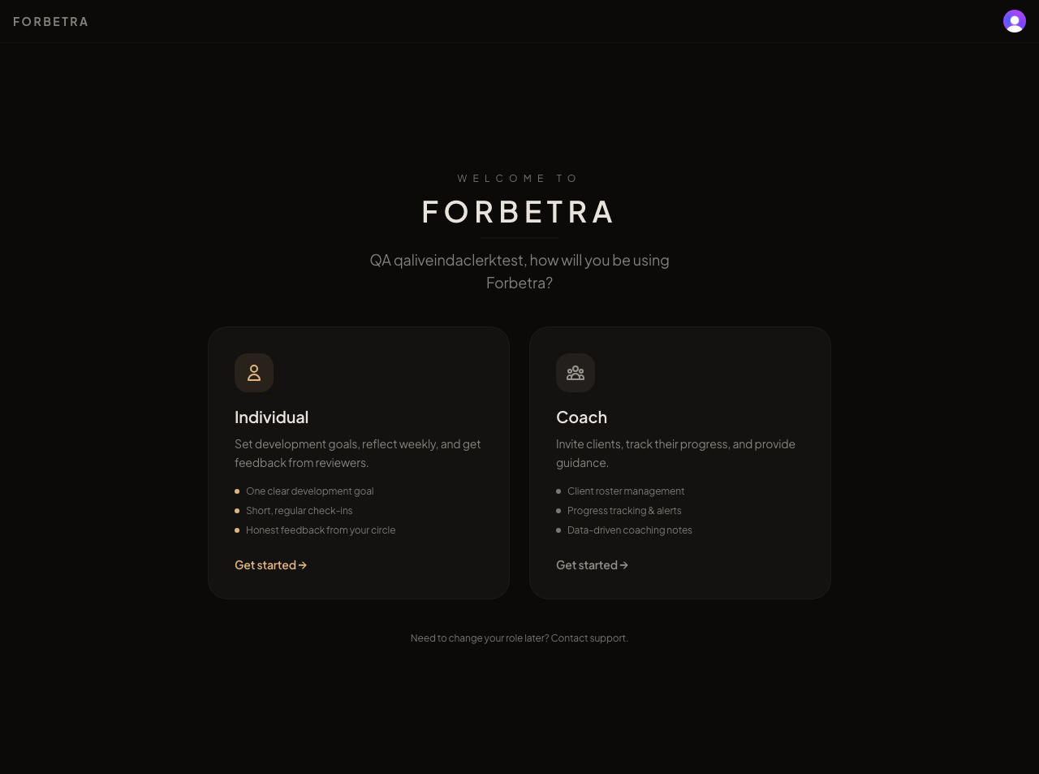
qa5_01 - Individual A after sign-in: the Individual / Coach role chooser
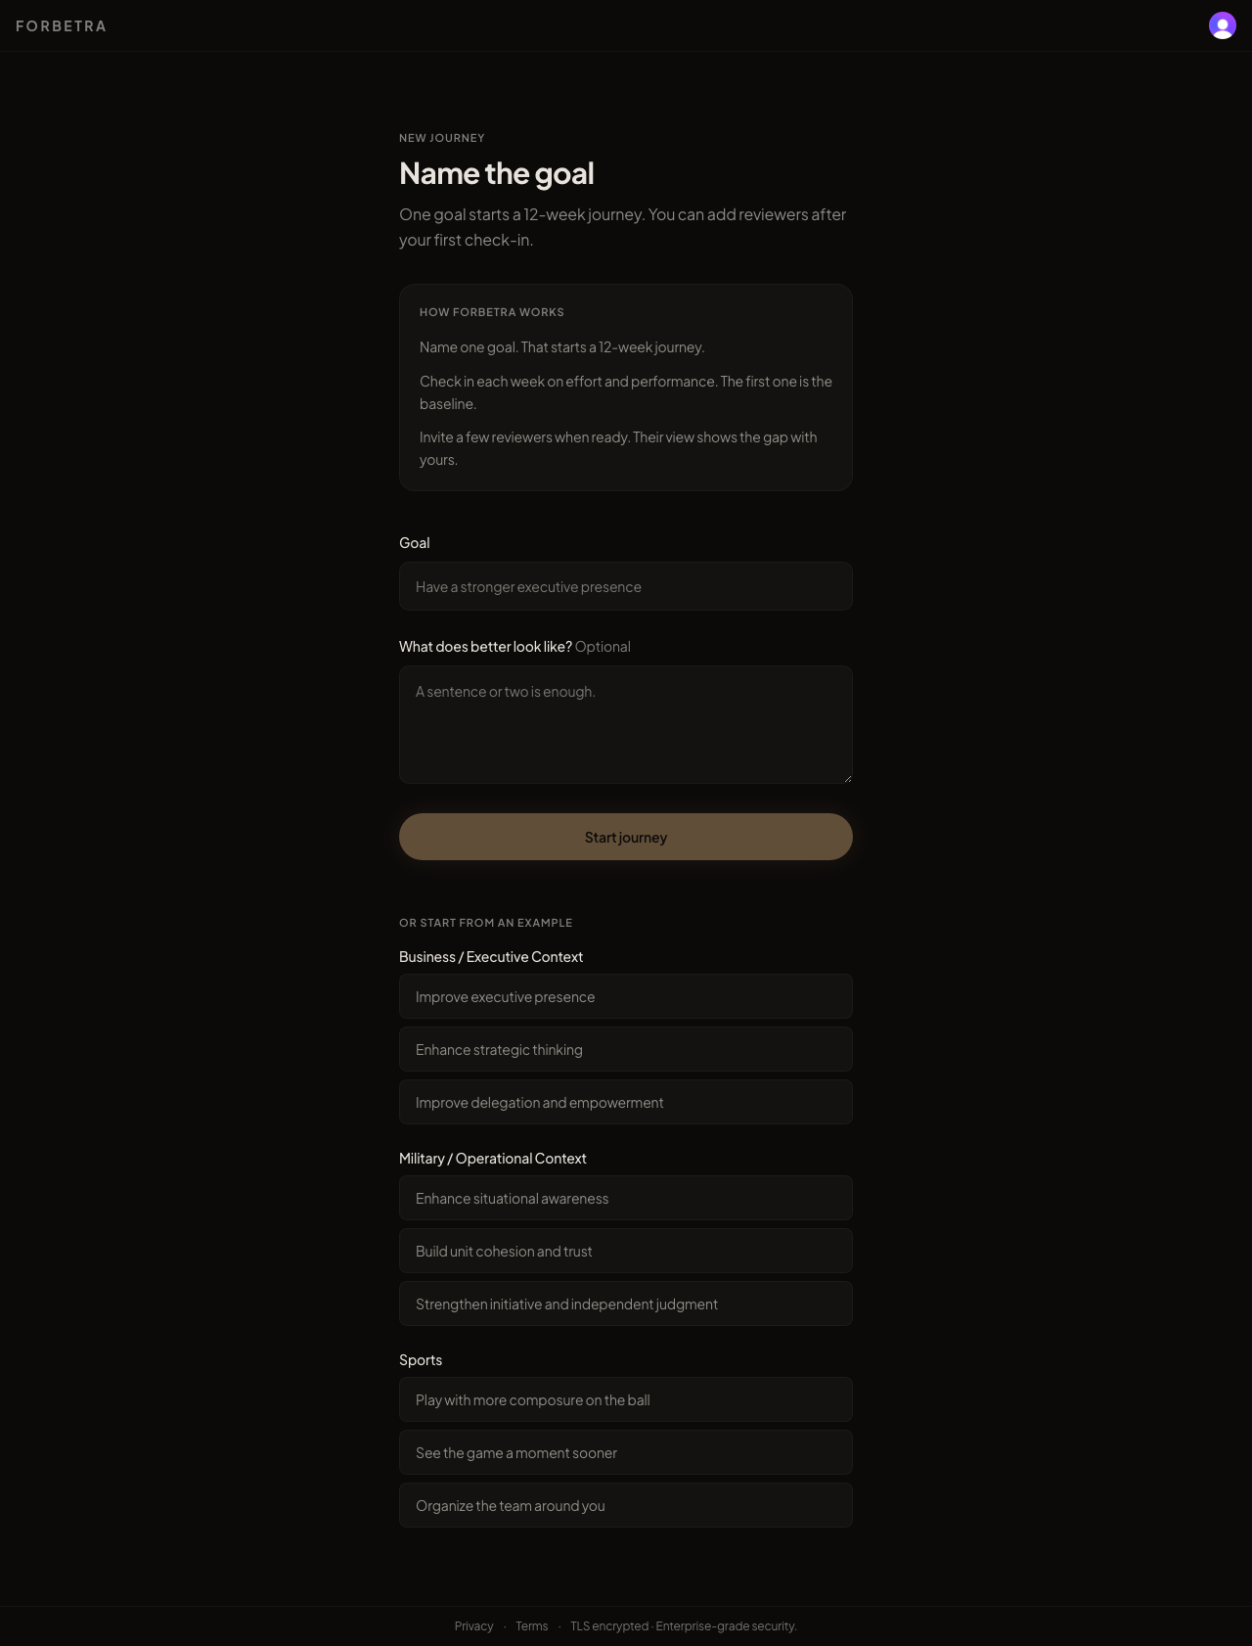
qa5_02 - Onboarding: one screen, name the goal, examples inline
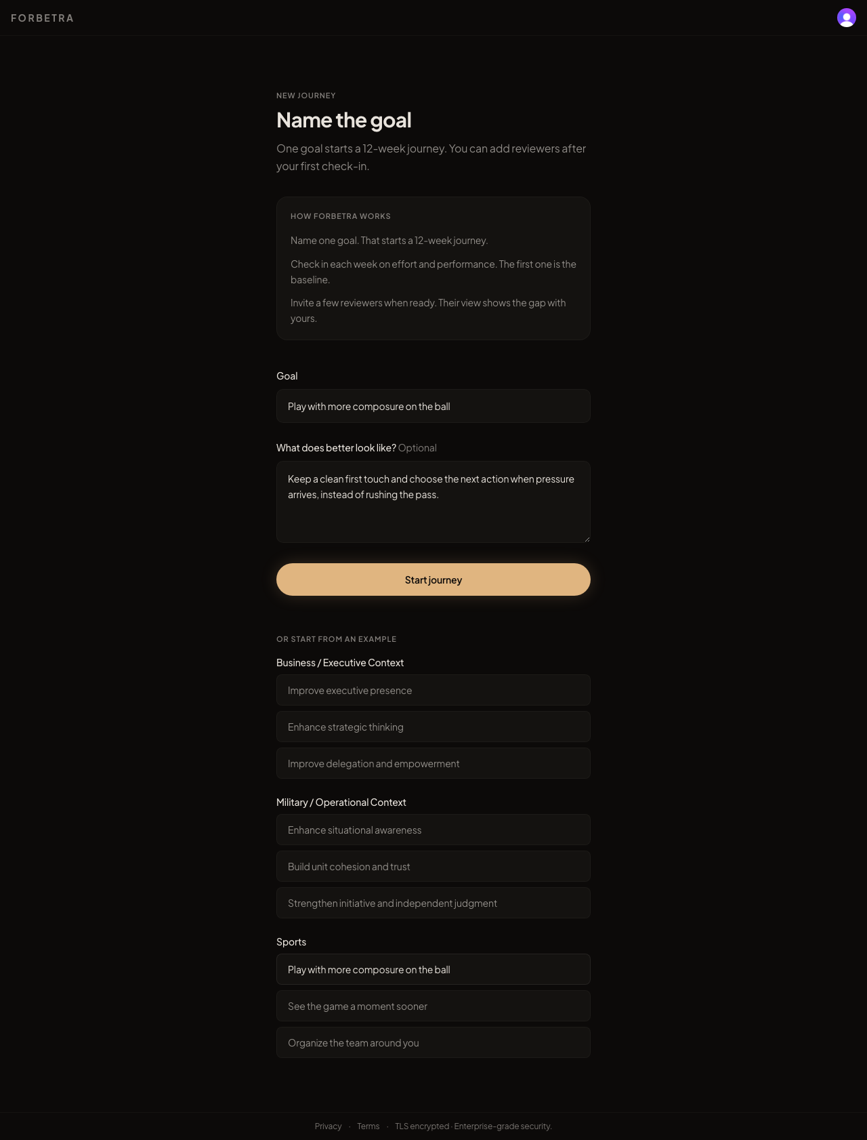
qa5_03 - Onboarding with the sports example prefilled
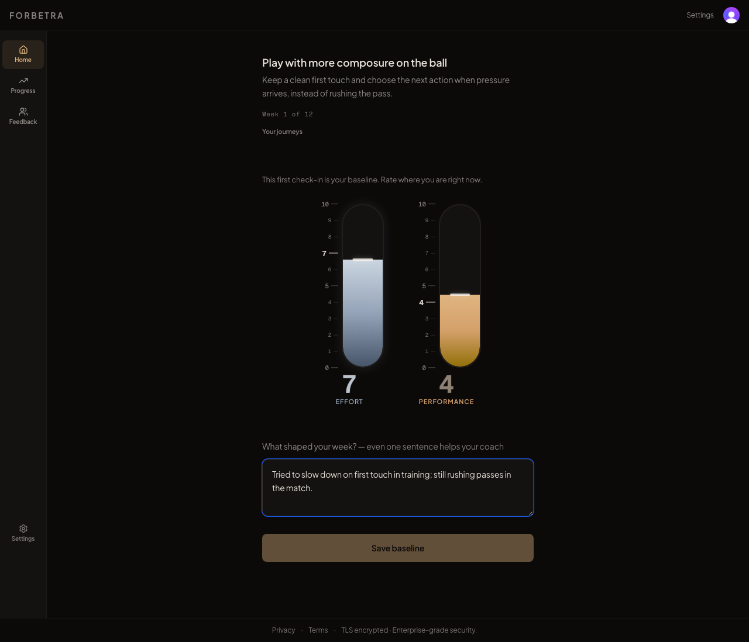
qa5_04 - Today: baseline check-in with the RatingBar slider set to 7 and 4
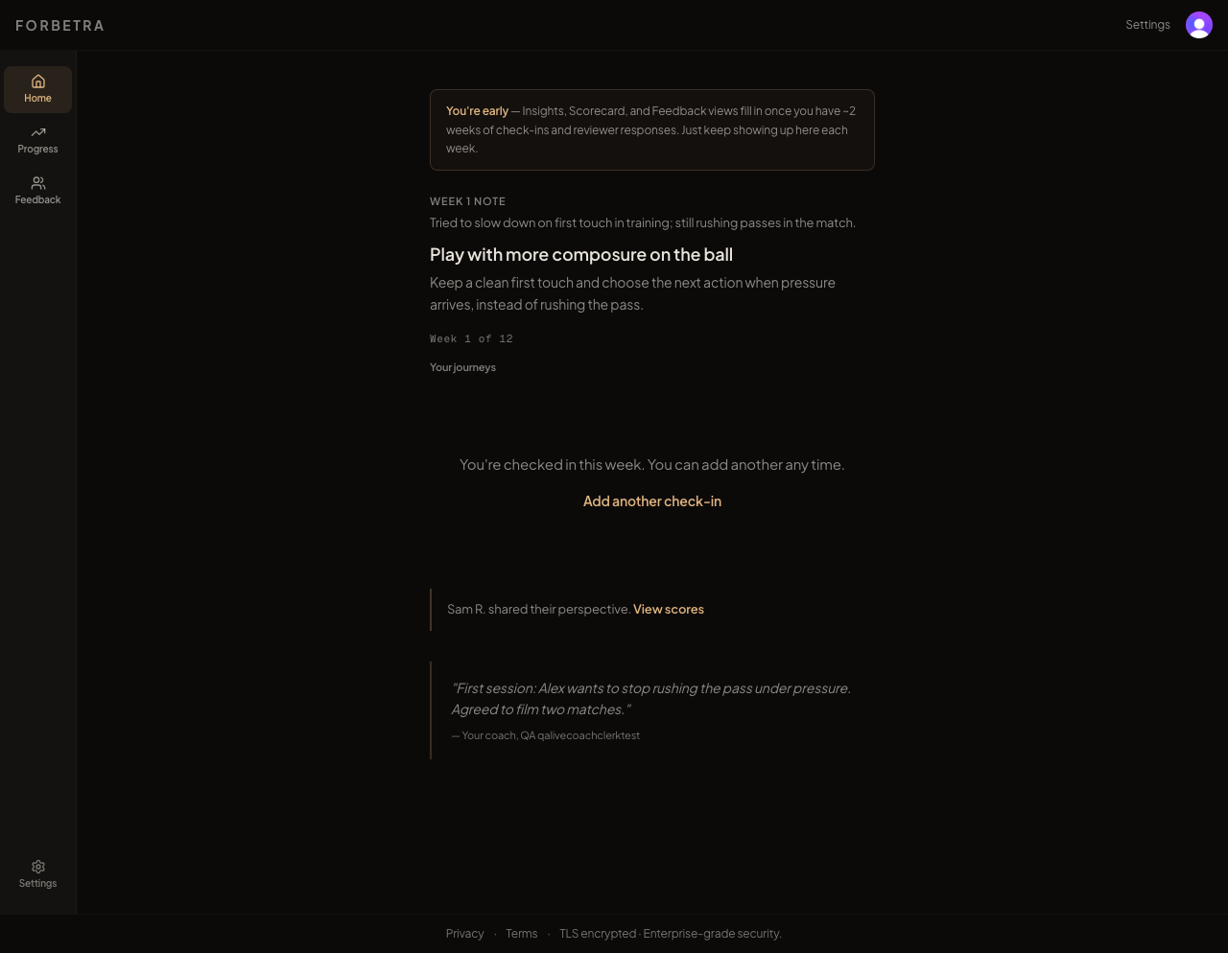
qa5_05 - Today after the coach saved a note: the "Private" coach note is quoted to the client (C1)
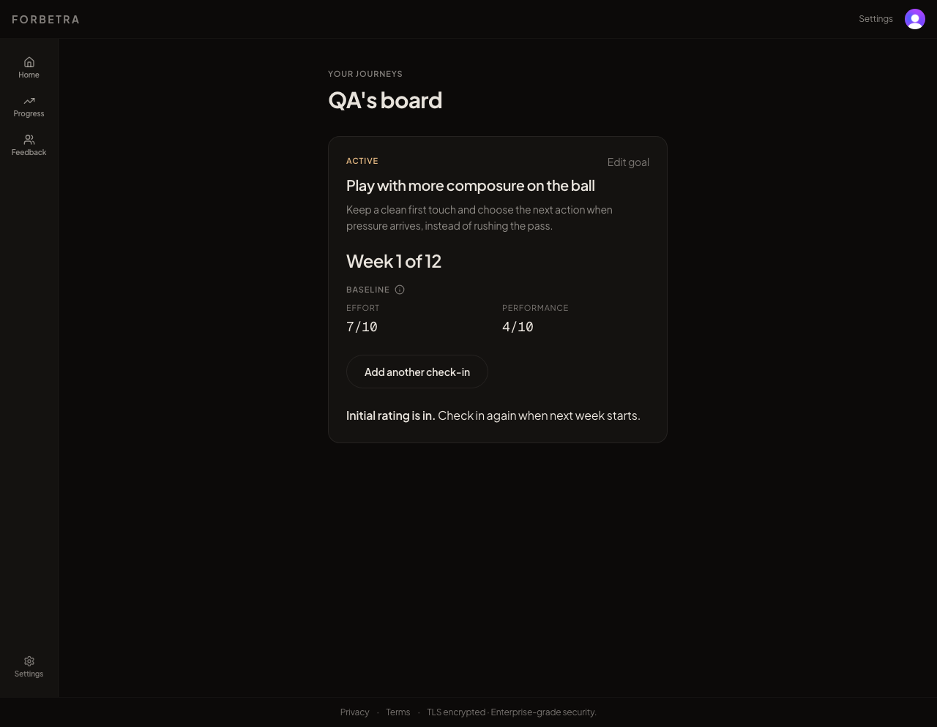
qa5_06 - Journeys board (/individual)
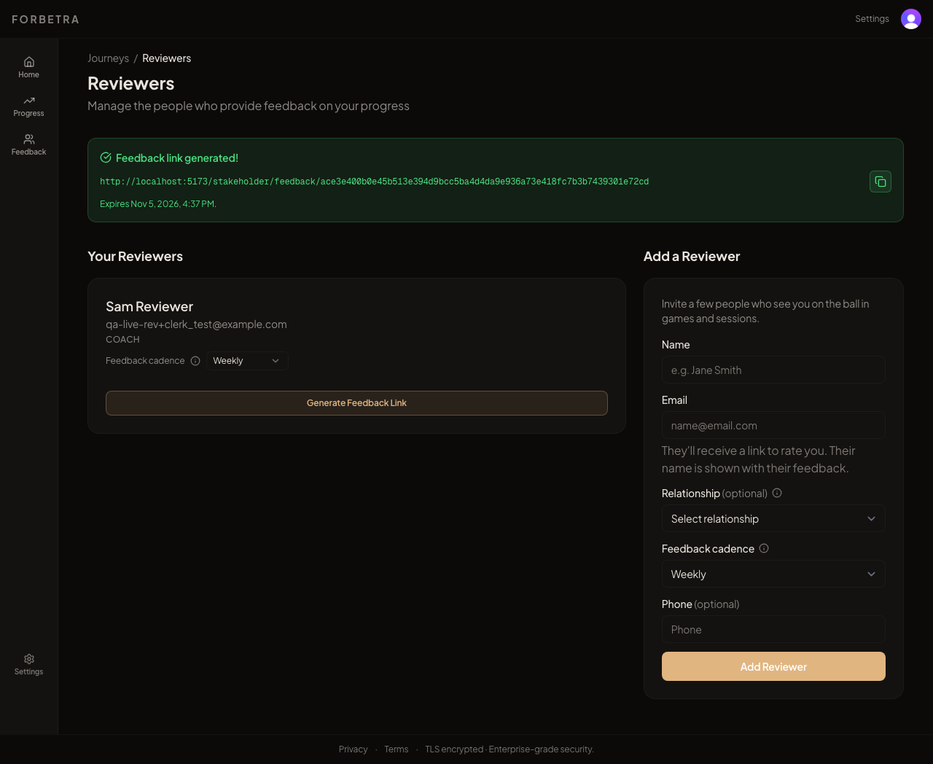
qa5_07 - Reviewers page with the context-aware relationship list and sports tooltip (PR #28)
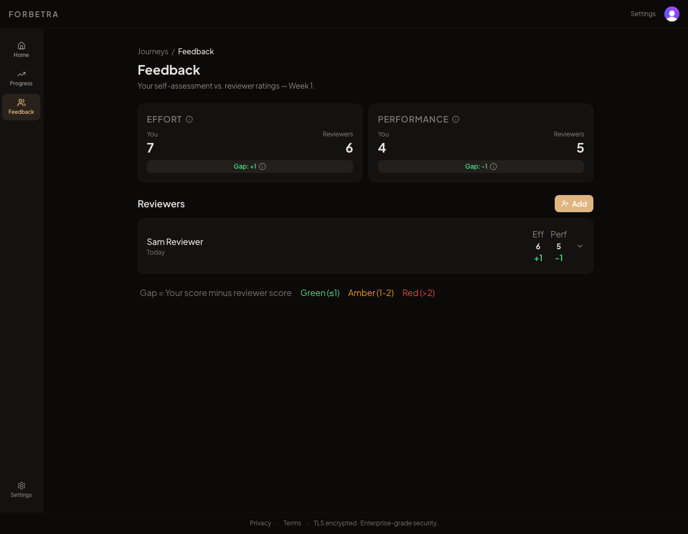
qa5_08 - Feedback page after the reviewer responded: You 7 / Reviewers 6
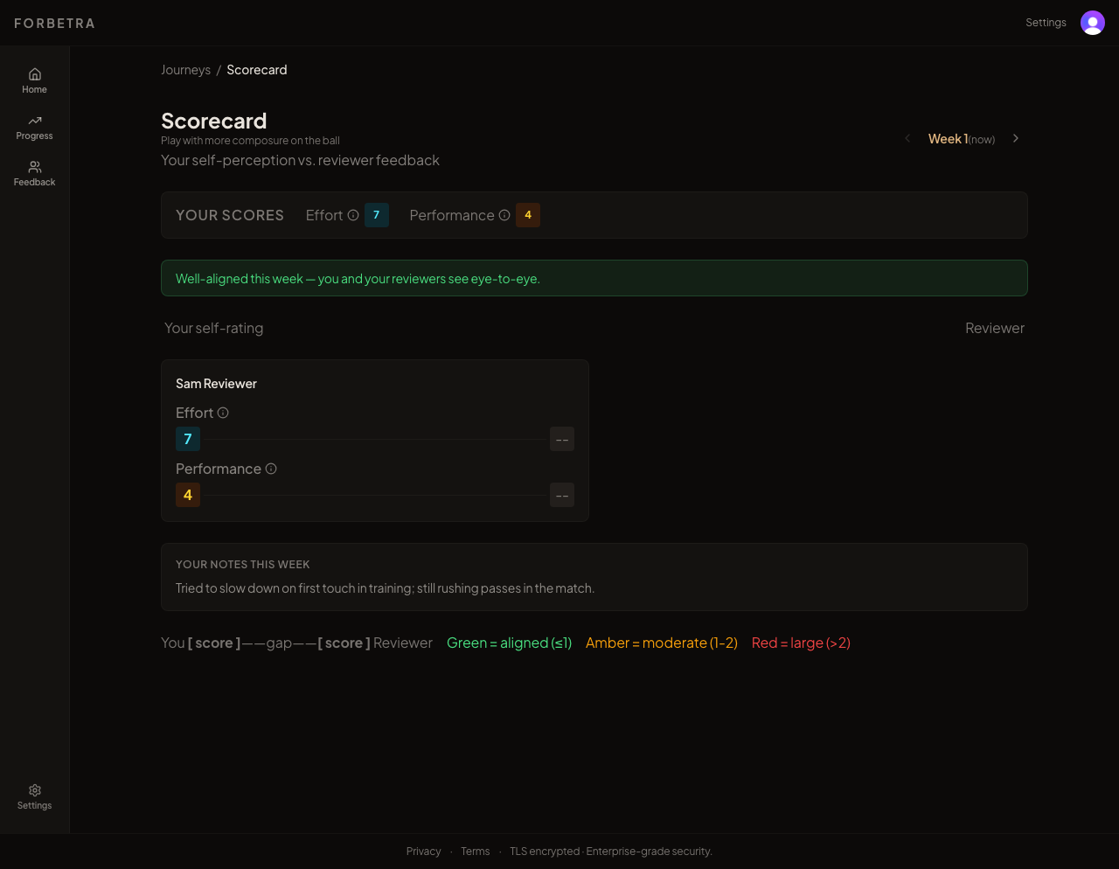
qa5_09 - Scorecard: "Well-aligned this week" shown before any reviewer had responded
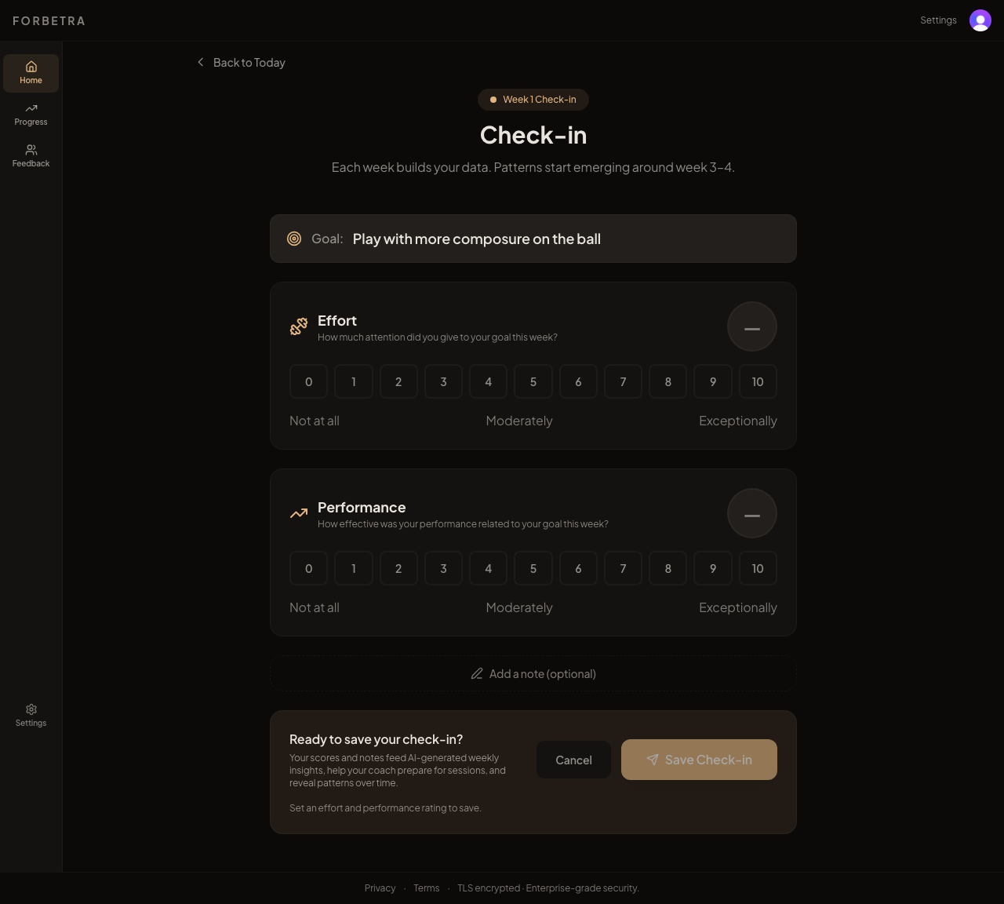
qa5_10 - Legacy /individual/checkin page that reminder emails still deep-link to (M5)
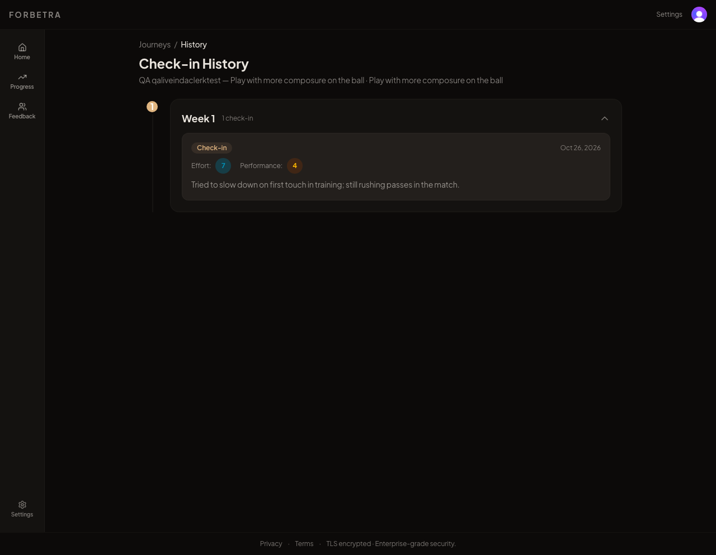
qa5_11 - History page: goal title printed twice in the header
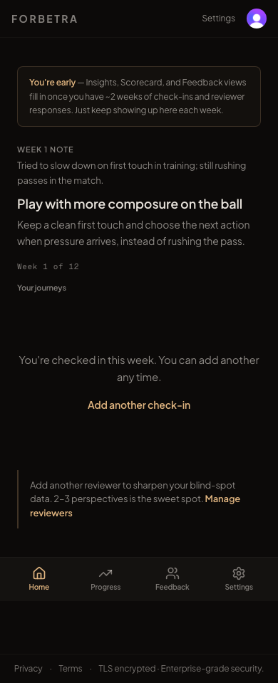
qa5_12 - Today at 390px (mobile): no horizontal overflow
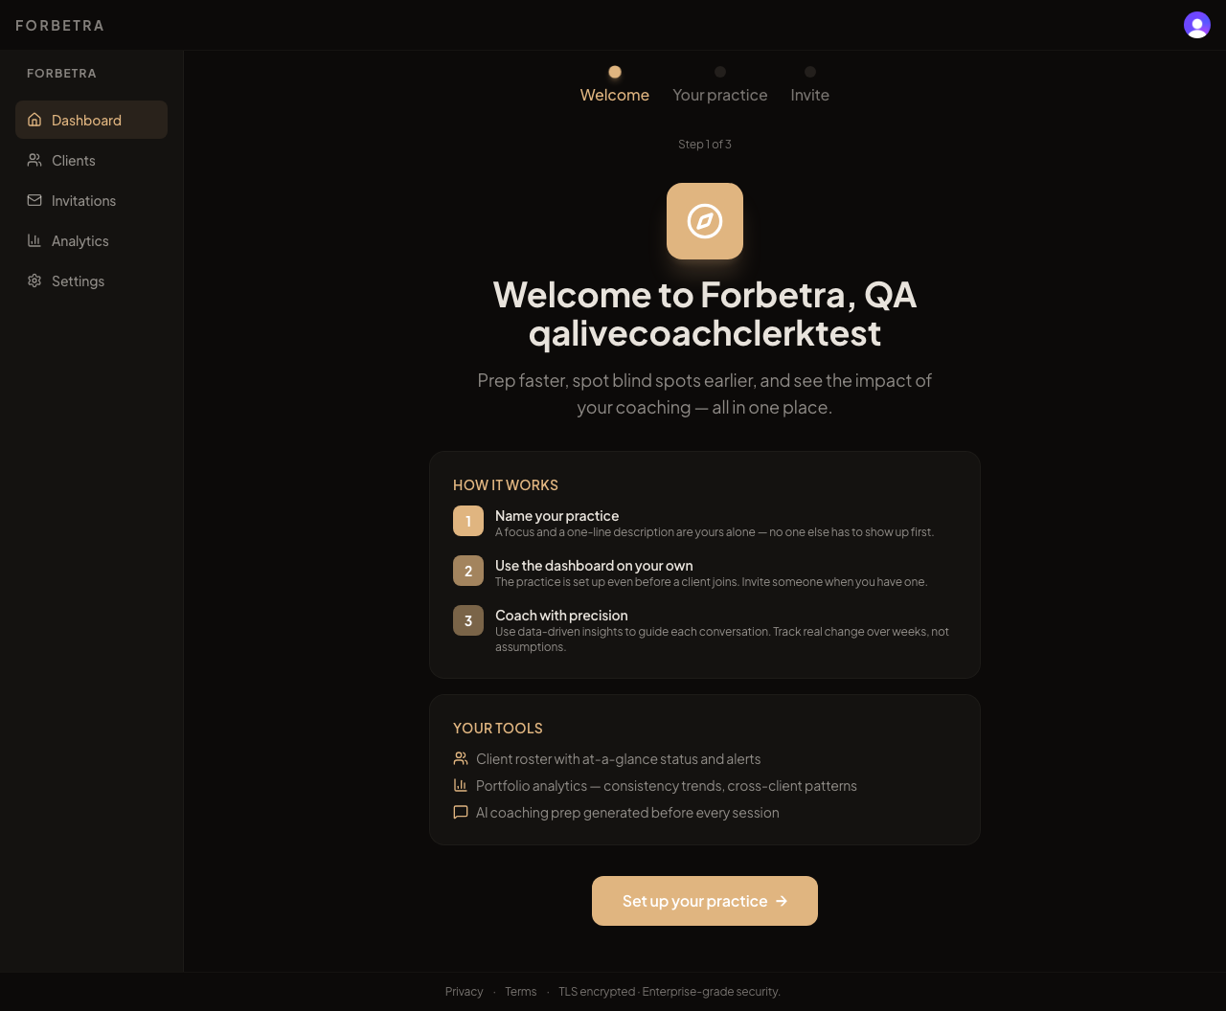
qa5_13 - Coach onboarding, step 1 of 3
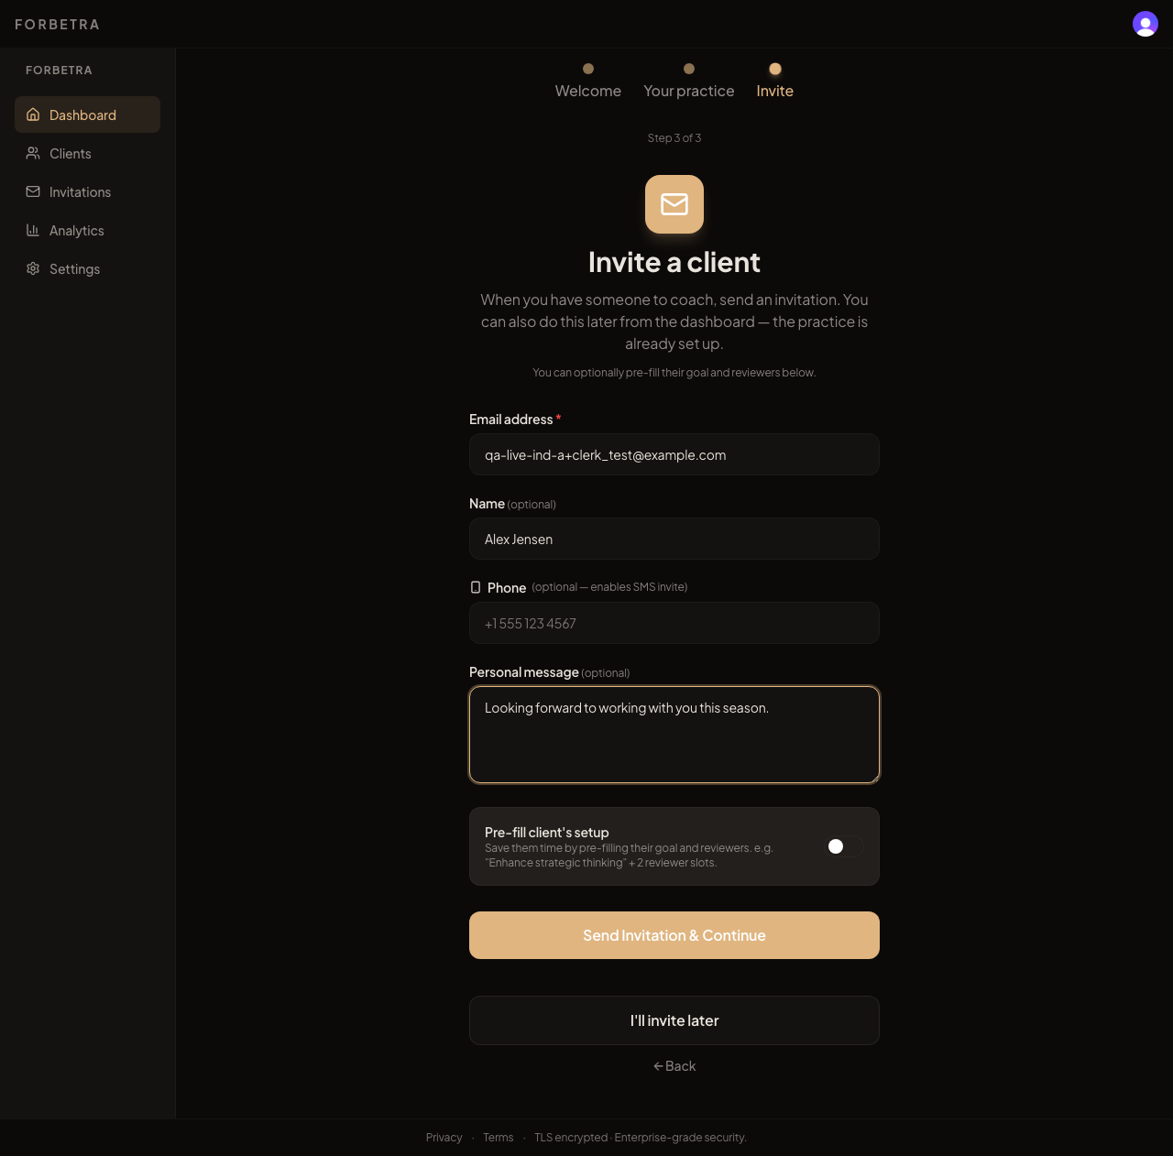
qa5_14 - Coach onboarding, invite step filled in
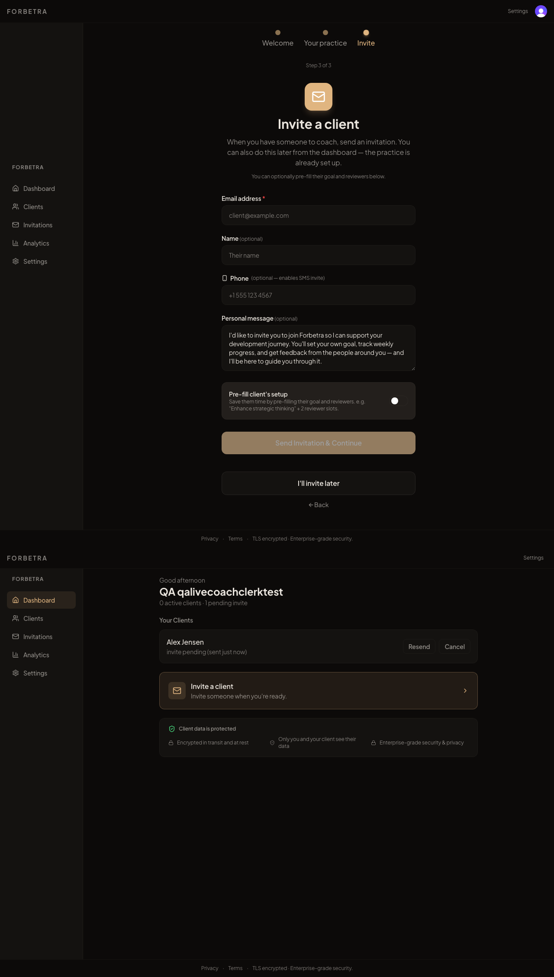
qa5_15 - After "Send Invitation": the Invite step rendered above the dashboard, with effect_update_depth_exceeded in the console (M1)
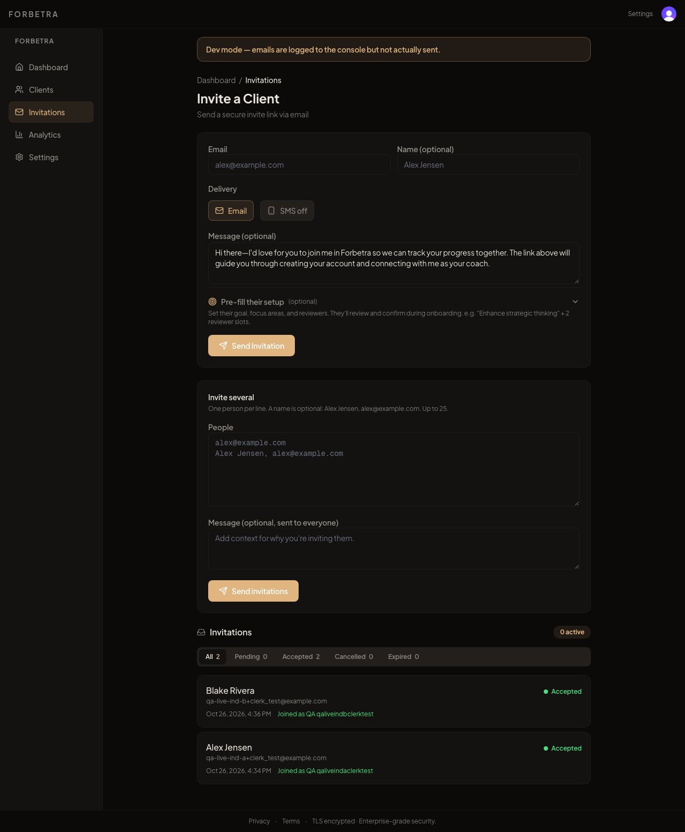
qa5_16 - Invitations page: Individual A shows Accepted although they never saw an accept screen (C2)
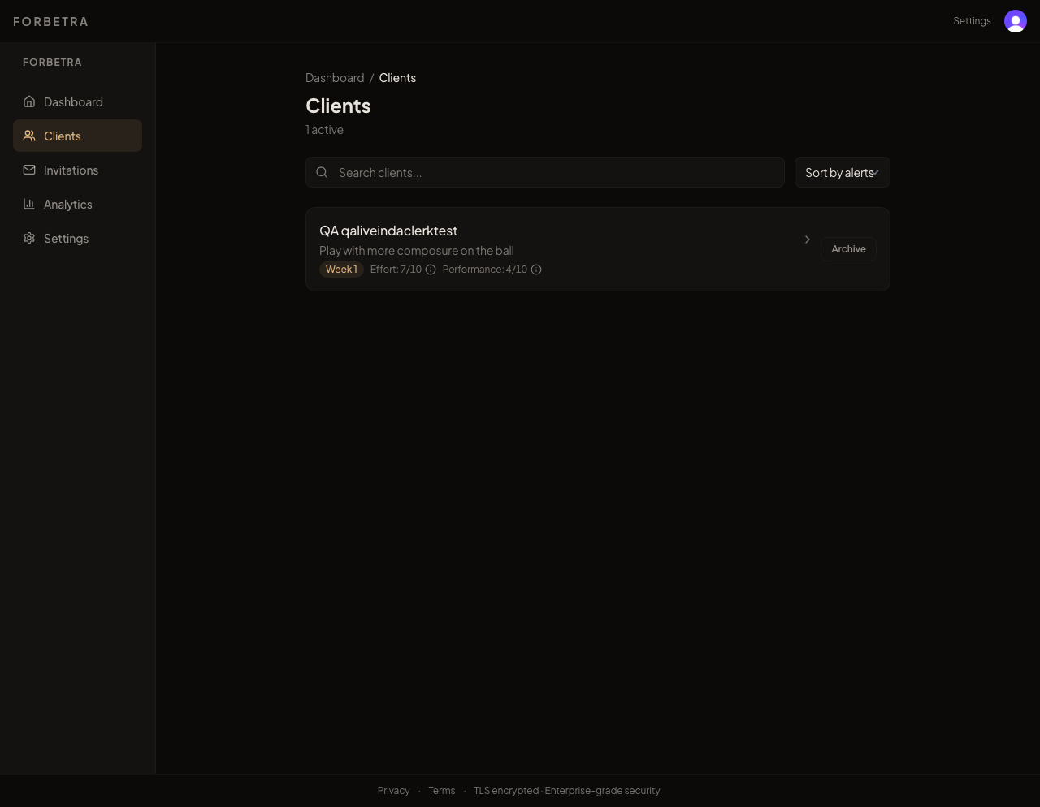
qa5_17 - Roster with the "Setting up" badge on the roster page (PR #28)
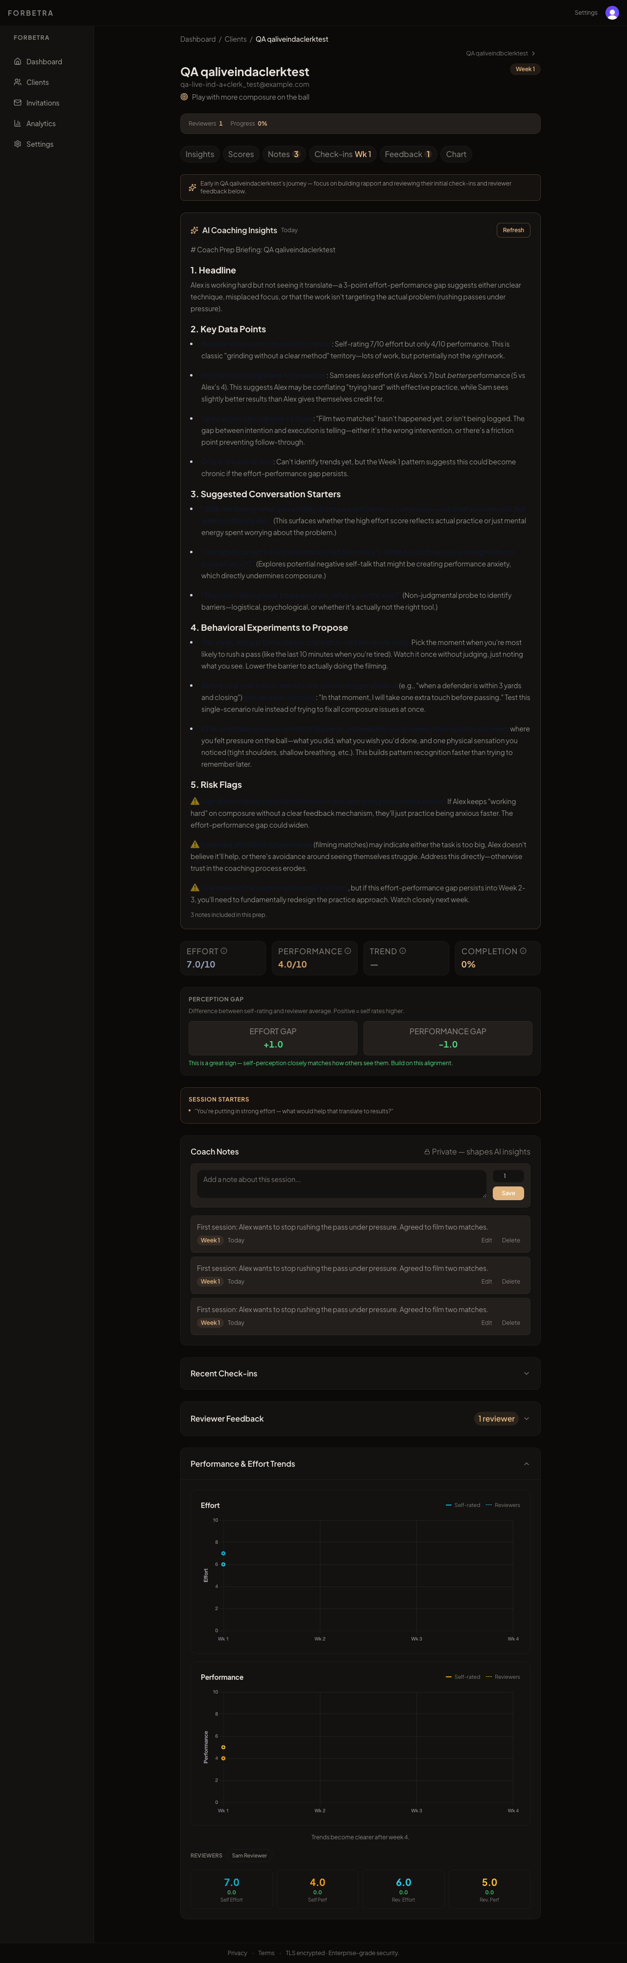
qa5_18 - Client session page: scores, prep, notes, trends
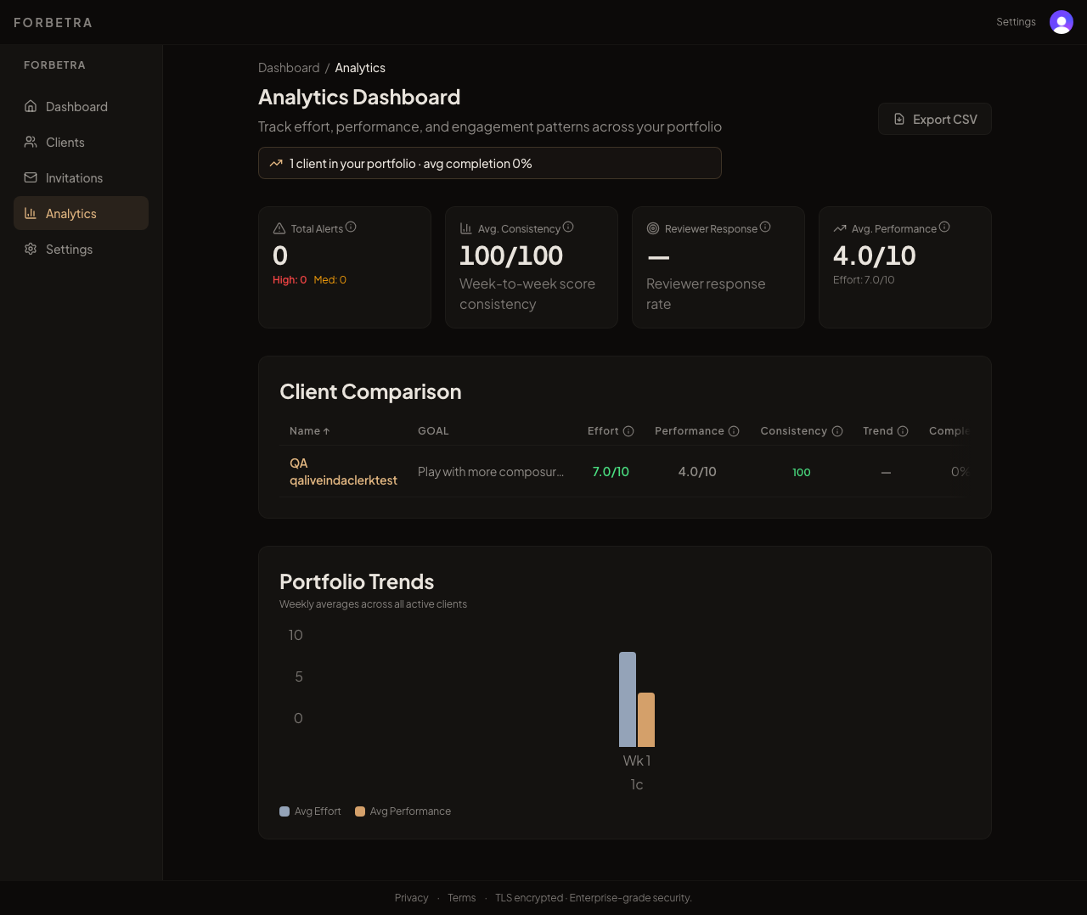
qa5_19 - Analytics dashboard with one client
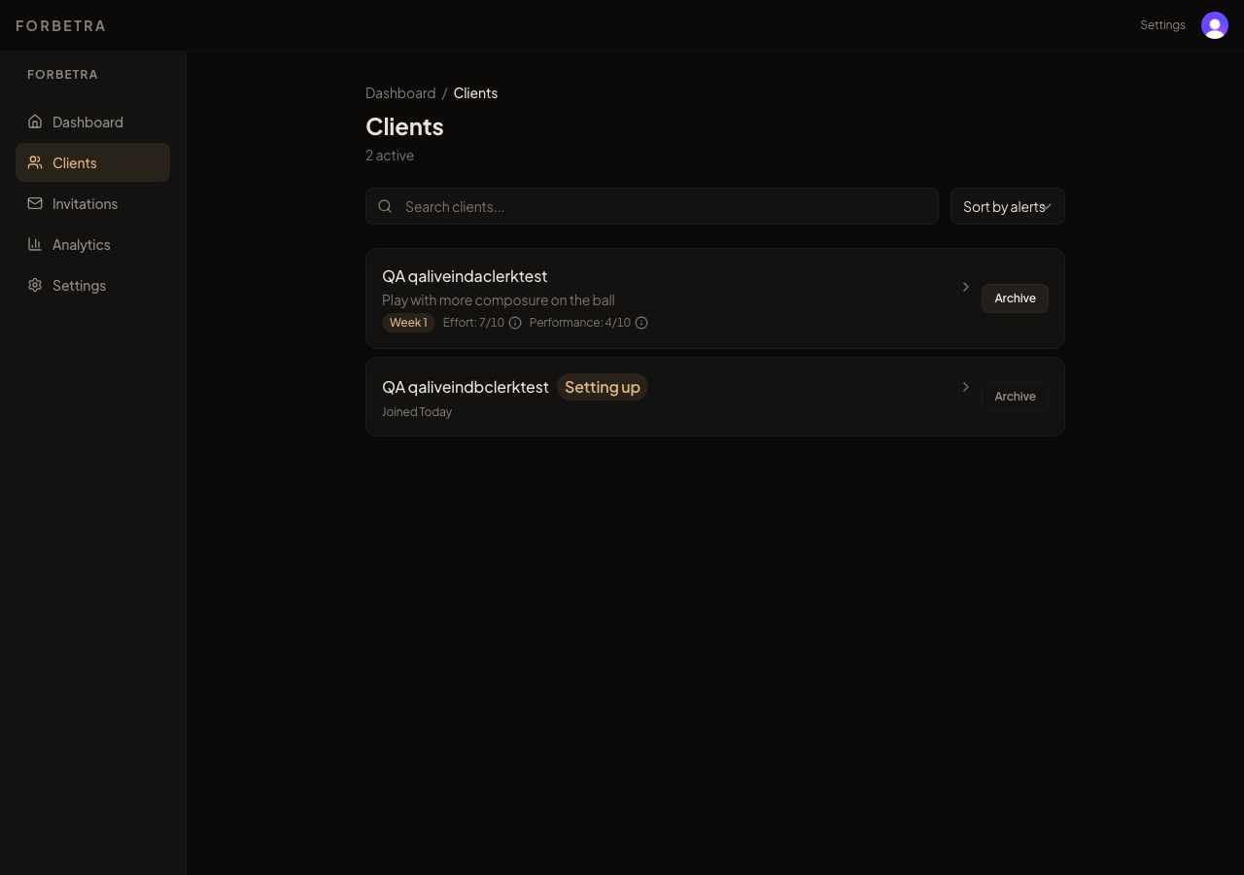
qa5_20 - Roster right after Archive: toast visible
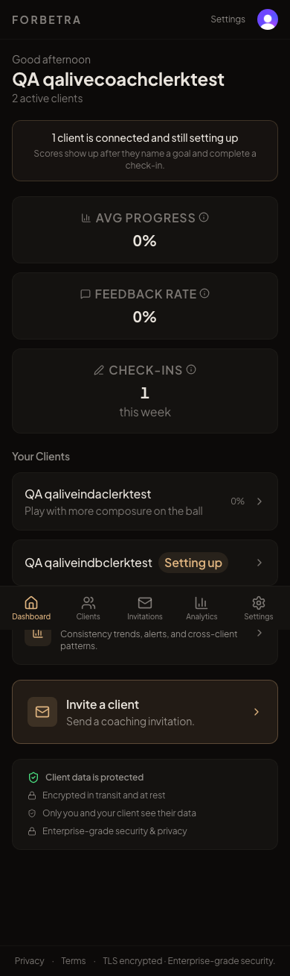
qa5_21 - Coach dashboard at 390px (mobile)
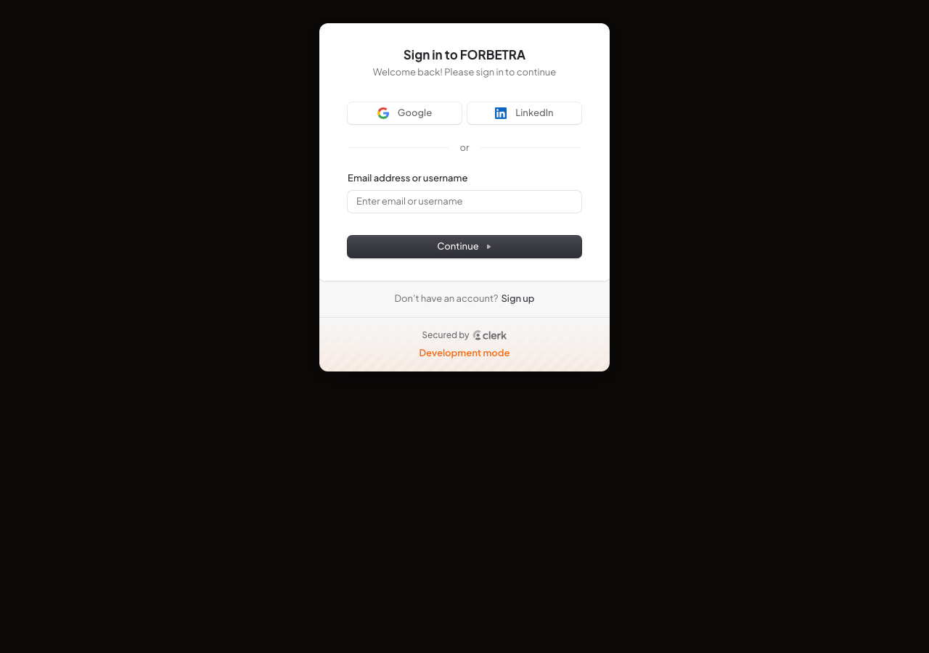
qa5_22 - Signed-out visitor opening a coach invite link lands on /sign-in with no return redirect (C2)
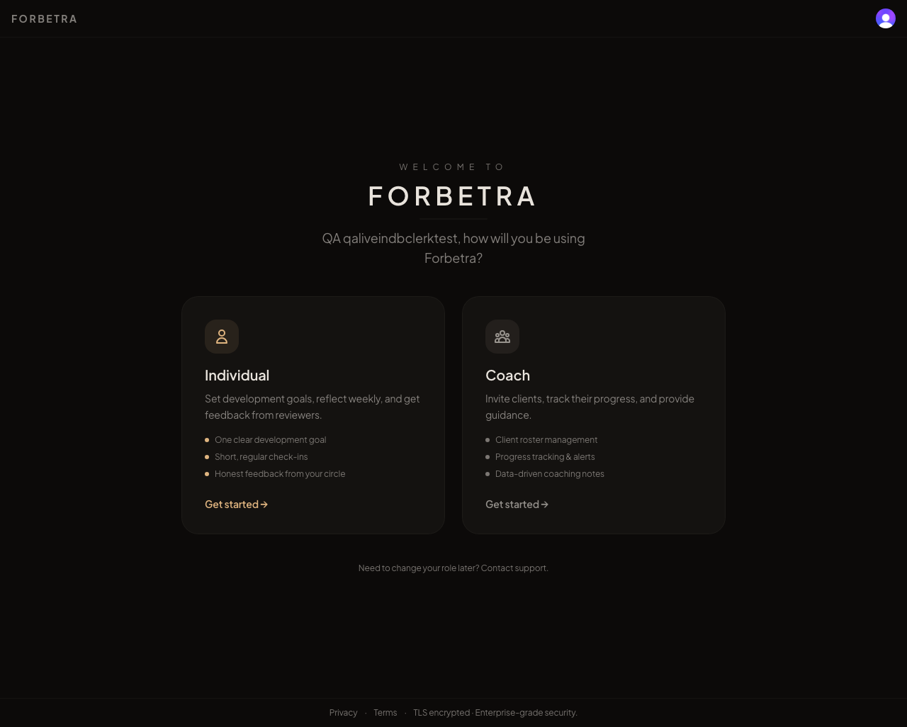
qa5_23 - Signed-in Individual B opening the same invite link is sent to the role chooser with no invite context (C2, M2)
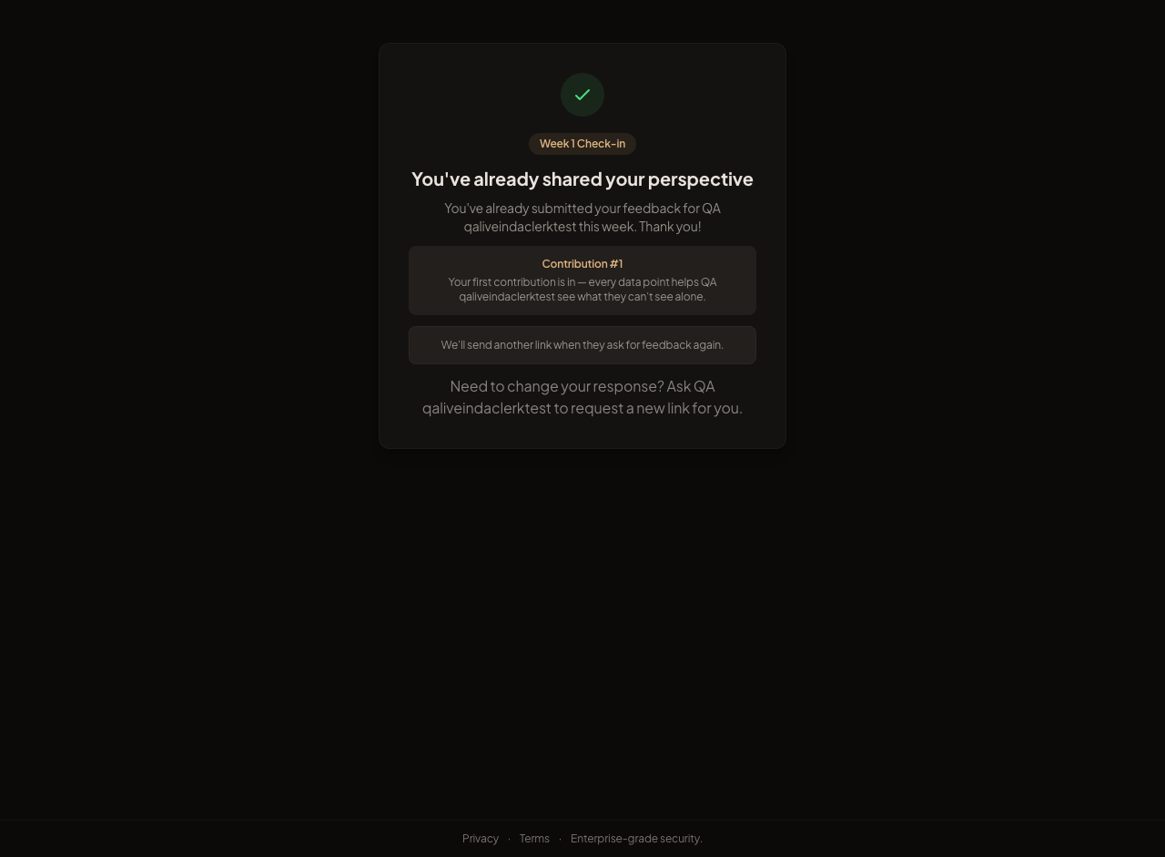
qa5_24 - Reviewer feedback link: welcome gate
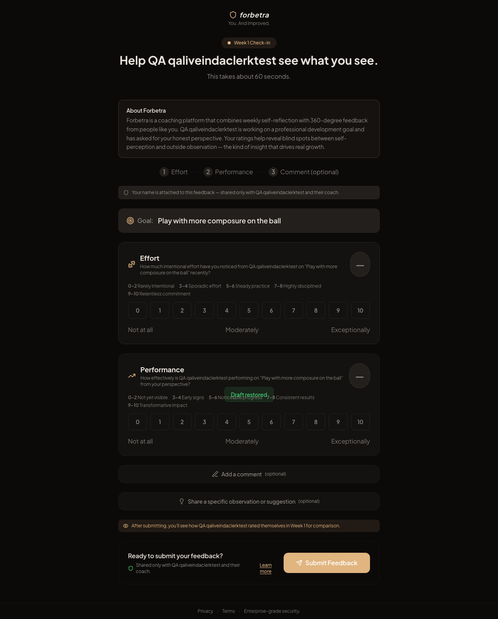
qa5_25 - Reviewer form: two 11-button grids, calibration guides, attribution copy
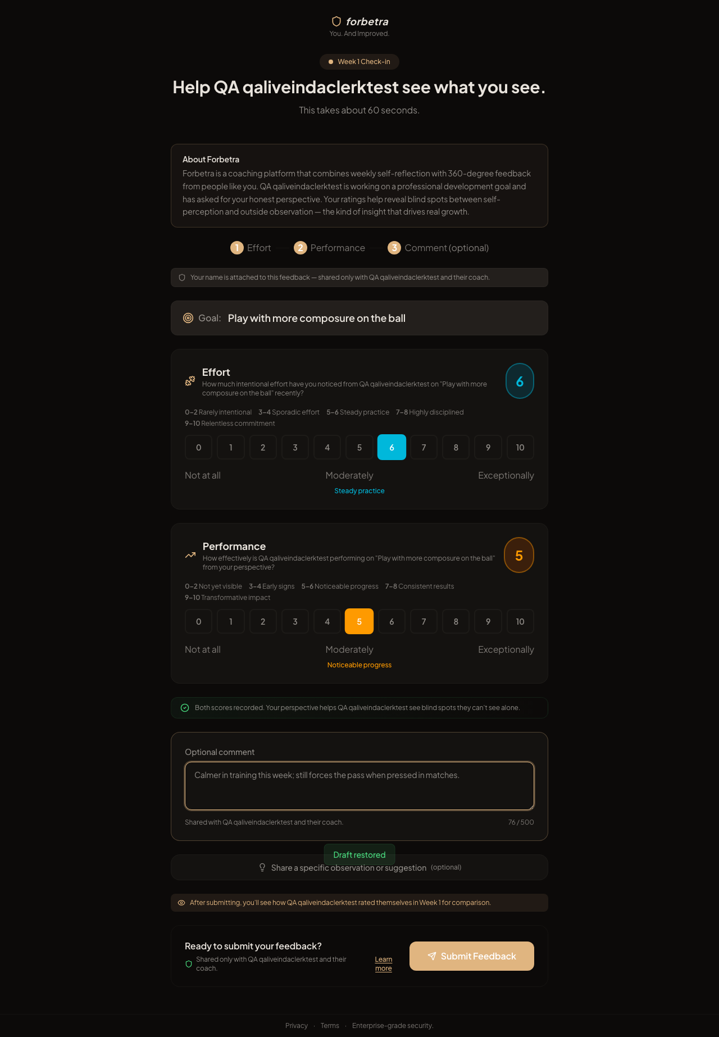
qa5_26 - Reviewer form filled: 6 / 5 plus a comment
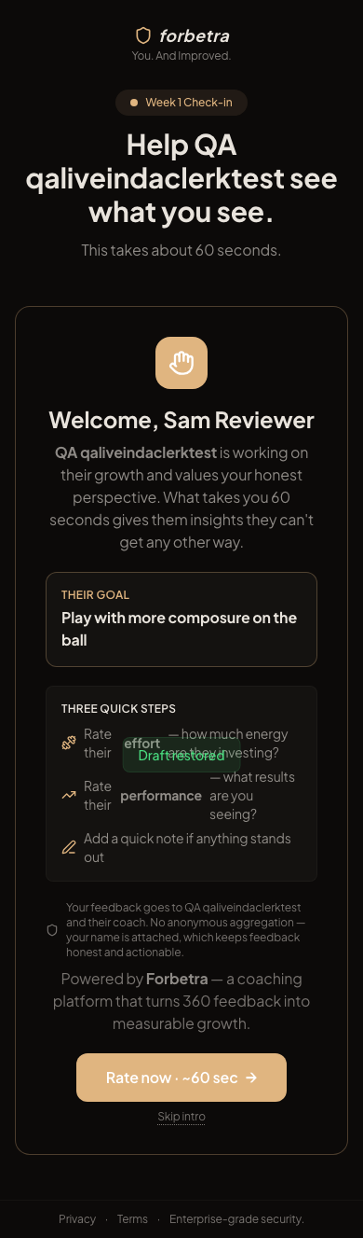
qa5_27 - Reviewer form at 390px (mobile)

6. Kieran's PR #28 - what landed (verified against October 14 notes)
October 14 item | Status | Evidence
F1 Landing bullet 3 workplace-only | Fixed | routes/+page.svelte:100-103 ("coaches, teammates, peers, managers"). Hero paragraph and meta description still say "professionals" (Polish).
F2 FORBETRA wordmark clips at 390px | Fixed in code | routes/+page.svelte:65-69 responsive type scale. Not visually verified on prod (network).
F3 Clerk sign-up requires Username | Unverified | Clerk dashboard setting; the local dev instance still shows "Email address or username".
Bulk-invite "Failed N" misleading | Fixed | invitations/+page.svelte:320-335 separates "Created N (email didn't go, copy links)" from "Failed N".
"Setting up" badge missing on /coach/roster | Fixed, confirmed live | roster/+page.svelte:160-165; qa5_17.
Relationship tooltip workplace-only | Fixed, confirmed live | reviewerRelationships.ts + reviewers/+page.server.ts:77-86; qa5_07. Unit tests added.
"Resend" on Cancelled / Expired rows | Mostly fixed | Label is "Reissue invite"; confirm dialog only on Cancelled, not Expired; success toast still says "resent".
"Client archived" toast fades too fast | Already 4 s in code | toasts.svelte.ts:13. Fine as is.
Baseline slider pins rest at 5 when unset | Fixed on Today | RatingBar shows "--" and "Tap or press arrow keys to set". The legacy /individual/checkin grid is unchanged.
Stacked-render flash on "I'll invite later" | Fixed for skip only | Skip is a 303 (onboarding/+page.server.ts:299). Send-invite path still loops and stacks (M1).
Native window.confirm for destructive actions | Still open | Confirmed live on Archive.
Settings link duplicated header + sidebar | Still open | Confirmed live.
B1 Clerk dev keys in prod, B2 Sentry DSN | Unverified | Network block; see section 7.

7. Cannot be verified from the repo or this network - please check
Item | Why it matters | Where to check
Clerk production keys (pk_live_ / sk_live_) and the Username requirement | "Development mode" badge on the first screen; dev-instance caps | Vercel env + Clerk dashboard. app.forbetra.com/sign-up HTML should not contain pk_test_.
SENTRY_DSN and VITE_SENTRY_DSN | Without them tester errors are invisible; hooks.server.ts:12-17 only inits when set | vercel env ls production
UPSTASH_REDIS_REST_URL / token | rateLimit.ts:34 returns true without them, which silently disables impersonation, feedback-form, AI endpoint and cron limiters | vercel env ls production
PUBLIC_APP_URL value | If it includes https://, every email footer link is https://https://... (M21) | vercel env ls production
SendGrid domain authentication for forbetra.com; Postmark sender | Invites land in spam otherwise; the From header has no display name (reviewer Minor #13) | SendGrid and Postmark dashboards
Vercel plan allows hourly crons | Two of nine schedules are hourly | Vercel project settings
Twilio inbound webhook URL | STOP/START keywords route to /api/webhooks/twilio only if the messaging service points there | Twilio console, messaging service MG3e4cfc...

8. Persona risk
Persona | Score | Risk | Key barrier
Maya Chen (Driven Director) | 7.6 | Low-Medium | Cannot find Insights or Ask; two check-in UIs read as unfinished; raw markdown in weekly insight.
James Okafor (Reluctant Leader) | 6.2 | High | Role chooser after his coach's invite; a red "Overdue" email the day after he starts; reminders land on the old page; his coach's private note can surface on his Today screen.
Priya Mehta (Eager Early-Career) | 7.5 | Low | No celebration on the Today check-in; milestone copy in the wrong unit; Scorecard hidden.
Sarah Williams (Digital-Native Coach) | 7.9 | Low | Her first client who signs up with a different email cannot accept.
Dr. Robert Kim (Traditional Coach) | 6.4 | High | A note for a new client vanishes; finished clients glow red; re-entering setup starts over; native confirms.
Amara Johnson (Scale-Focused Coach) | 7.0 | Medium | No multi-coach model and the one leak is private notes via shared prep; analytics counts archived clients.
Marcus Taylor (Willing Colleague) | 8.1 | Low | Welcome gate is a fourth tap; otherwise under 75 s.
Linda Park (Skeptical Manager) | 6.6 | Medium-High | Bare sender address, /stakeholder/ URL, privacy link hidden behind "Learn more", twice-weekly reminders she cannot stop.

Scenario completion
Code | Result | Where it breaks
I-1 Onboarding | Yes | Three hops; invitees see the role chooser.
I-2 Weekly check-in | Yes | Under 60 s on Today; reminders land on the legacy page.
I-3 Add reviewer + link | Partial | Two steps plus phone interstitial; nav tab points at the reduced form.
I-4 Insights + Ask | No from navigation | Pages work by URL only.
I-5 Scorecard | Partial | Entry depends on a conditional nudge.
I-6 New journey | Yes | Previous journey loses its report (M10).
I-7 Day-3 return | Yes | Day-1 "overdue" email may already have arrived (M11).
C-1 Coach onboarding + invite | Yes (coach side) | Client side is C2 / M2.
C-2 Monday roster review | Partial | False alerts on completed journeys (M4).
C-3 Session deep dive + prep + note | Partial | Note vanishes for "Setting up" clients (M3).
C-4 Analytics | Yes | Totals include archived clients.
C-5 Invite with prefill | Partial | Works only by email match.
S-1 First feedback | Yes | ~60-75 s, 4 taps.
S-2 Score reveal | Partial | Promised unconditionally; shown only when the individual checked in that week.
S-3 Return visit | Yes | Under 30 s; anchoring from prefilled scores.
S-4 Expired token | Partial | Recovery dead-ends when a newer link exists (M22).

9. Strengths (what the rebuild got right)
1. One-decision onboarding: name the goal, the baseline is the first check-in, examples inline. The cleanest first run the product has had.
2. RatingBar on Today: real ARIA slider with keyboard support, "--" when unset, value text ("5, Steady"), last-score marker.
3. Reviewer flow end to end: zero account, hashed single-use tokens, used-before-expired ordering, honest attribution copy, reveal with delta, draft autosave, fast return visit.
4. Coach invites: hashed tokens, transactional reissue, duplicate handling by outcome, bulk invite with per-line parsing and tests, email-failed link fallback everywhere.
5. Stage-aware empty states on every coach surface, plus the "Setting up" badge now on both dashboard and roster.
6. AI prep: streaming, freshness badge, "N notes since last prep", markdown rendered, rate-limited. Generated a genuinely useful briefing from one check-in, one reviewer response and one note.
7. Cascade deletes, impersonation gating, timezone-aware reminders, email provider failover, STOP footer on all 17 SMS templates: every March backend Critical except cron batching is closed.

10. Recommended fix order

Before any tester invite (all S except where noted)
1. C1 Stop quoting coach notes to the individual (remove the nudge source or add an explicit "share with client" flag on the note).
2. C2 Move /coach/invite/[token] out of the guarded layout; pass redirect= through sign-in; show the accept screen before auto-linking, or at least show the coach's name on first load.
3. M2 Skip the role chooser (or preselect Individual with the coach's name) when a pending or accepted coach invite matches the email.
4. C3 Put Insights, Scorecard and History back in the individual nav; the Insights -> Ask link already exists.
5. M1 Replace seenForm = form with $state.raw or compare on a form id; the stacked render goes away with it.
6. C4 + C5 (M): remind only on open, unexpired, individual-requested tokens with a minimum age, and never mint new ones; add a reviewer opt-out token to reviewer emails, honor STOP for reviewer phones, add Remove reviewer.
7. M11 + M12 Fix the overdue-day logic and the weekday gate on the base nudge.
8. M3 + M4 Persist notes without a journey; gate alerts on journey.status === 'ACTIVE'.
9. M5 Point reminder emails/SMS and "Add another check-in" at /individual/today; retire the legacy page or restyle it.
10. M15 Delete the invented statistics.
11. Section 7 env checks (Clerk live keys, Sentry, Upstash, PUBLIC_APP_URL, SendGrid auth, Vercel plan, Twilio URL).

Next sprint
M6 reviewer form consolidation, M7 markdown for weekly insight, M8/M9/M10 synthesis week + FAILED recovery + journey rollover, M13 redirect loop guard, M14 milestone units, M16 cron maxDuration + batching, M19 coachId on Insight, M20 cache the Clerk lookup, M21 baseUrl scheme handling, M22 reissue from the reviewers page, M23 admin email edit, M24 demo/preview targets.

Later
M17 ORG_ADMIN scoping, M18 SMS consent capture, the Minor/Polish lists in the per-domain reports, native confirm dialogs, the 11-button reviewer grids, terminology seams in URLs and job names (/stakeholder/, new-cycle, cycle/extend, stakeholder-impact).
Estimated platform score after the "before testers" list: about 8.3. After the next-sprint list: about 8.8.

11. Draft note to Kieran
Hey Kieran - I reran the full QA sweep (the five-agent persona-by-scenario pass from March, plus a live browser run of the real flows on a dev server against the prod DB with throwaway accounts). Your October 14 fixes all landed: landing copy, wordmark, bulk-invite wording, the roster "Setting up" badge, the context-aware relationship list and tooltip, "Reissue invite". Nice work, and the rebuild itself is in good shape: onboarding, the Today slider, the reviewer form and the AI prep are all genuinely strong.
Platform score is 7.50, down from 7.82 in March, and that drop is almost entirely five new things I'd want fixed before we put testers on it:
1. Coach notes leak to the client. Notes are labelled "Private - shapes AI insights" in the coach UI, but the latest one is quoted verbatim on the client's Today page as "Your coach" (and again in the week-6 micro-moment). I reproduced it live. individual/today/+page.server.ts:258-277.
2. The invite accept page can't be reached by the invitee. /coach/invite/[token] is under the coach-only layout, so a signed-out client bounces to /sign-in and a signed-in individual bounces to the role chooser. Acceptance only works through the email auto-link, which fires before the client has picked a role or seen your name, and never works if they sign up with a different address. coach/+layout.server.ts:8.
3. Insights, Ask, Scorecard and History fell out of the individual nav in the rebuild. All four pages work by URL.
4. The reviewer reminder cron re-mints a fresh request twice a week forever for any reviewer with an unused token, including expired ones, and reviewers have no opt-out (emails omit the preferences link, STOP only updates User rows, no Remove button). jobs/remind-stakeholder-feedback.ts:10-63, feedbackToken.ts:62-96.
5. The stacked-render flash is a Svelte effect loop. seenForm = form into $state proxies the object, so form === seenForm never matches and the page throws effect_update_depth_exceeded after every submit on coach onboarding. Your 303 fixed the skip path; send-invite still hits it. coach/onboarding/+page.svelte:117.
Second tier, all small: invited clients see the role chooser with no coach context; notes saved for a "Setting up" client vanish; alerts keep firing after a journey completes; the "Overdue" email can fire on day 1 of a week; reminder emails deep-link to the old 11-button check-in page instead of Today; a few invented stats in copy ("98% open rate", "top 20% of leaders").
Things I couldn't verify from here (my network blocks Vercel's IP range): Clerk live keys, Sentry DSN, Upstash (rate limiting is a no-op without it), and whether PUBLIC_APP_URL has a scheme (templates prepend https://).
Full report with file:line for everything, the per-domain reports and 27 screenshots: docs/qa-full-reassessment-2026-10-26.md, screenshots/qa5_*. Happy to re-test anything after your next pass. - Marc

12. Appendix - per-domain agent reports
The five reports follow verbatim.

Forbetra QA rerun 2026-10-26 - Individual journey
Scope: personas I-1 Maya Chen, I-2 James Okafor, I-3 Priya Mehta; scenarios I-1 to I-7; routes /onboarding (+ initial-ratings, complete), /individual (hub), /individual/today, /checkin, /reviewers, /feedback, /insights, /ask, /scorecard, /progress, /history, /focus-areas, /journey/[cycleId], /new-cycle, /settings, /stakeholders redirect, the individual layout nav, hooks.server.ts + src/lib/server/auth.ts role resolution, and the emails/SMS an individual receives. Code-based walkthrough at main 958913e; every line cited was read.

1. Role score card (Individual weights)
Dim | Score | Weight | Note
FI | 7.6 | 8% | Today/hub/onboarding are coherent; the legacy /individual/checkin page is a different visual system and is where every reminder lands.
CP | 8.0 | 10%
OE | 8.2 | 12%
CT | 7.4 | 15%
IA | 6.3 | 10% | Insights, Ask and History have no in-app entry; Scorecard only via a conditional nudge; reviewer management split across two pages; Settings has three entry points with two targets.
FP | 7.5 | 10%
CL | 7.8 | 10%
TC | 5.8 | 8% | Coach notes labelled "Private" in the coach UI are quoted to the individual; several invented statistics and a false "insights update within 24 hours" promise.
EE | 7.6 | 10%
VP | 7.5 | 7%

Weighted Individual score: (7.6x.08)+(8.0x.10)+(8.2x.12)+(7.4x.15)+(6.3x.10)+(7.5x.10)+(7.8x.10)+(5.8x.08)+(7.6x.10)+(7.5x.07) = 7.41 (prior 2026-03-14 reassessment: 7.91; delta -0.50, driven by the IA regression and the coach-note leak).

2. Issues
Counts: Critical 2, Major 9, Minor 14, Polish 6 = 31.
# | Sev | Issue | Location | Effort | Personas
1 | Critical | Coach notes are labelled "Private - shapes AI insights" with a lock icon in the coach UI, yet the latest note is quoted verbatim to the individual as a "coach nudge" on Today and again in the week-6 check-in micro-moment. Coach trust and individual trust both break the first time a candid note surfaces. | coach/session/[clientId]/+page.svelte:687 (label); individual/today/+page.server.ts:258-277 and +page.svelte:420-428; individual/checkin/+page.server.ts:264-289 | S | All; James most (his coach referred him)
2 | Critical | /individual/ask and /individual/insights are unreachable in-app. Nav has Home/Progress/Feedback only; the only link to Ask is on Insights; Insights is linked only from emails. Regression of the 03-14 Critical #5. | individual/+layout.svelte:17-21; insights/+page.svelte:448-464 (sole Ask link); emailTemplates.ts:215, 325 (only Insights links) | S | Maya, Priya
3 | Major | Redirect loop when a Clerk session exists but event.locals.dbUser is null (hook falls through on missing email or DB create failure): requireAuth -> /onboarding -> requireRole -> requireAuth -> /onboarding. Only / has a retry UI. Low frequency, total lockout when it fires. | lib/server/auth.ts:37-40; onboarding/+page.server.ts:104; hooks.server.ts:190-194, 308-312 | S | All
4 | Major | Two different check-in UIs. Today uses RatingBar; /individual/checkin is the old page (11-button grid, "Midpoint CheckIn", "insights update within 24 hours"). Every reminder email/SMS and the hub's "Add another check-in" deep-link to the old page, so the weekly habit is trained on the UI the product moved away from. | emailTemplates.ts:231, 288; smsTemplates.ts:13, 18; individual/+page.svelte:215; today/+page.svelte:336; checkin/+page.svelte:451-476, 587, 207 | M | All
5 | Major | Scorecard is reachable only through the Today nudge, which requires >= 4 feedback rows and is suppressed whenever a reviewer responded in the last 7 days (new-feedback nudge wins). History has no in-app link at all. Scenario I-5 cannot be started from navigation. | today/+page.svelte:360-417 (priority chain); today/+page.server.ts:325; individual/+layout.svelte:17-21 | S | Maya, Priya
6 | Major | Reviewer management is split: the nav "Feedback" tab has an add form (name/email/phone, raw prisma.create) while relationship, cadence and the context-aware tooltip live only on /individual/reviewers, which is not in nav and not linked from Feedback. | feedback/+page.server.ts:184-266; feedback/+page.svelte:362-429; reviewers/+page.server.ts:157-222; reviewers/+page.svelte:411-447 | M | James, Maya
7 | Major | A coach-invited individual still gets the "How will you be using Forbetra? Individual / Coach" screen on first / visit because goal count is 0; the invite accept action returns success with no redirect to /onboarding. Choosing Coach by mistake breaks the coach link and the only recovery is "Contact support". | routes/+page.server.ts:13-24; routes/+page.svelte:314-316; coach/invite/[token]/+page.server.ts:233-235 | S | James
8 | Major | Streak milestones count consecutive weeks, but copy and thresholds assume days: "One week strong! 7 straight", "Two weeks of consistency!" at 14, "A full month" at 30; only 3 and 7 are reachable in a 12-week journey. | checkin/+page.svelte:24-31; emailTemplates.ts:587-617, 628; submitCheckIn.server.ts:15, 67 | S | Priya
9 | Major | Weekly insight is rendered as raw text although the prompt asks for markdown, so **bold** and list markers show literally on Today and Insights. | lib/server/ai/prompts.ts:25; today/+page.svelte:350-354; insights/+page.svelte:198-200 | S | All
10 | Major | "Overdue Check-ins" (red header) email and SMS can fire on day 1 or 2 of a journey week: any weekday except day 3, no check-in yet this week, up to 2 per week. Nothing is overdue until the week ends. | jobs/remind-overdue-prompts.ts:38-56; emailTemplates.ts:270-291; smsTemplates.ts:17-19 | S | James
11 | Major | Invented or false claims in product copy: "top 20% of committed leaders on the platform", "Research shows it takes about 6 weeks", "98% open rate vs 20% for email", "your coach and AI insights update within 24 hours" (insights generate Sundays 20:00 UTC only). | checkin/+page.server.ts:212, 219; reviewers/+page.svelte:179-180; checkin/+page.svelte:207; jobs/generate-weekly-insights.ts:1-6 | S | Maya, James
12 | Minor | Settings has three entry points and two targets: desktop sidebar and header go to /settings (redirect page with spinner), mobile tab goes straight to /individual/settings. | individual/+layout.svelte:61, 99; routes/+layout.svelte:100-107; routes/settings/+page.svelte:18-34 | S | All
13 | Minor | requireAuth redirects to /sign-in without the destination, so email deep links (scorecard shift alert, "Manage reviewers") land on /individual/today after sign-in. | lib/server/auth.ts:32; sign-in/+page.svelte:5; emailTemplates.ts:771, 663 | S | All
14 | Minor | The primary Today check-in ignores the streak and milestone the action returns; celebration exists only on the legacy page. | today/+page.svelte:19-24, 326-342; submitCheckIn.server.ts:95-103 | S | Priya
15 | Minor | Welcome email is sent after the goal is saved but says "Complete your onboarding to set up your first goal". | onboarding/+page.server.ts:223-233; emailTemplates.ts:96-102 | S | All
16 | Minor | Feedback page empty state says "that's normal in week 1" regardless of week. | feedback/+page.svelte:186-197 | S | Maya
17 | Minor | "Request Feedback" stays enabled while an open link exists and returns the error "Feedback already requested from X this week"; "Send a new link" sits beside it. | feedback/+page.svelte:322-353; lib/server/feedbackToken.ts:62-79 | S | James
18 | Minor | New journey wizard: step 3 "Settings" contains no settings; "Start with a new goal" promises "fresh goal and focus areas" but collects none; continuing while a journey is still ACTIVE silently marks it COMPLETED with no confirmation. | new-cycle/+page.svelte:58-59, 268, 510-523; new-cycle/+page.server.ts:143-146 | M | Maya
19 | Minor | Between endDate and the daily 01:00 UTC completion cron, Today shows "Week 13 of 12"; isOverdue is computed and never rendered. | today/+page.server.ts:298; today/+page.svelte:219-222; jobs/complete-expired-cycles.ts:25-34 | S | All
20 | Minor | The feedback link shown to the individual still contains /stakeholder/feedback/... (terminology seam from the rename). | lib/server/feedbackToken.ts:98; reviewers/+page.svelte:89 | M | Maya
21 | Minor | "What shaped your week? - even one sentence helps your coach" is shown to individuals without a coach; coachName is available to the page. | today/+page.svelte:279-283; today/+page.server.ts:283 | S | Maya, Priya
22 | Minor | Legacy check-in a11y: <label for="effort-score"> and for="progress-score" reference no element; aria-valuetext is set on a plain div. | checkin/+page.svelte:420, 503, 438-440, 521-523 | S | All
23 | Minor | Settings name edit can silently revert: the hook rewrites the DB name from Clerk on every request; if the warn-only Clerk sync fails, the saved name is lost on the next request. | hooks.server.ts:181, 322-324; settings/+page.server.ts:72-81 | S | All
24 | Minor | Feedback-page add form uses prisma.reviewer.create and reports "You already have a reviewer with that email" for a reviewer attached to an older goal; the Reviewers page upserts instead. | feedback/+page.server.ts:223-232, 254-260; reviewers/+page.server.ts:200-222 | S | Maya
25 | Minor | Insights and Progress both host the AI journey report; the journey-complete email points at /individual/insights while Today's "View Report" points at /individual/progress; Insights says "Complete 3+ check-ins to unlock" but gates on any data. | insights/+page.svelte:204-335, 353-367; progress/+page.svelte:136-224; emailTemplates.ts:325; today/+page.svelte:165-170 | S | Maya
26 | Polish | Journey story page uses a text-danger class that does not exist in app.css; negative deltas lose their color. | journey/[cycleId]/+page.svelte:95 | S | Priya
27 | Polish | First journey label is server-built as "Name - Goal title" (em dash) while later defaults are "Journey 2"; shows on the hub and History. | onboarding/+page.server.ts:204; new-cycle/+page.server.ts:49; individual/+page.svelte:277 | S | Maya
28 | Polish | Quick-start copy prints the raw ISO date: "12 weeks starting 2026-10-26". | new-cycle/+page.svelte:115 | S | Maya
29 | Polish | Today's "You're early" banner promises "Insights, Scorecard, and Feedback views", two of which have no nav entry. | today/+page.svelte:185-195 | S | Priya
30 | Polish | Settings page title is "Profile & Notifications" while every entry point says "Settings"; activeCycle is loaded and unused. | settings/+page.svelte:55, 77; settings/+page.server.ts:11-17, 29 | S | All
31 | Polish | Em dashes remain throughout UI copy despite the 10-13 "em-dash fix" (Today banner, note prompt, coach nudge, check-in micro-moments). | today/+page.svelte:190, 280, 426; checkin/+page.server.ts:158-163 | S | -

3. Regression check (prior Critical/Major in this domain)
2026-03-14 full assessment:
- C5 Ask unreachable: Still open (regressed). The Insights -> Ask bridge exists (insights/+page.svelte:448-464) but Insights itself left the nav (individual/+layout.svelte:17-21).
- C6 Scorecard no nav entry: Still open. Only the conditional Today nudge (today/+page.svelte:374-387).
- C7 Dashboard no nav entry: No longer applicable. /individual/dashboard is a 308 to /individual/today (dashboard/+page.server.ts:7-9).
- C8 New-cycle not linked from complete state: Fixed. today/+page.svelte:171-176 and individual/+page.svelte:228-235.
- C12 Template sidebar hidden on mobile: No longer applicable. Templates render inline below the form (onboarding/+page.svelte:147-171).
- M1 No Insights -> Ask link: Fixed on the page (insights/+page.svelte:449) but moot while Insights is unreachable.
- M4 "Step 1 of 2" indicator: No longer applicable. Single-screen onboarding.
- M8 Disabled form instead of "not available": No longer applicable. Check-in is always available (checkin/+page.server.ts:91-93).
- M9 isLocked always false: No longer applicable by design. Multiple check-ins per week are intended (submitCheckIn.server.ts:17).
- M10 Feedback link never exposed: Fixed. reviewers/+page.svelte:82-109 shows the link with copy button and expiry.
- M15 Terminology reviewer/stakeholder/rater: Mostly fixed. Residual: /stakeholder/ in the user-visible link (feedbackToken.ts:98); emails say "feedback provider" (emailTemplates.ts:136); "rater" survives only in identifiers.
- M16 AI report plain text: Fixed for the journey report (insights/+page.svelte:275; progress/+page.svelte:179 use renderMarkdown); Still open for weekly insight (issue 9).
2026-03-14 reassessment:
- C1 "Step 1 of 3" with 2 steps: No longer applicable.
- C2 Notes maxlength mismatch: Fixed. UI 500 (checkin/+page.svelte:595; today/+page.svelte:287) within schema 1000 (validation/reflection.ts:14).
- C3 History and Stakeholders unreachable from sidebar: Partial. Reviewers reachable from hub and Today nudges (individual/+page.svelte:207, 252; today/+page.svelte:391, 405); History still has no link.
- M3 No hub empty state after onboarding: Fixed. Baseline framing on Today (today/+page.svelte:237-243) and hub (individual/+page.svelte:196-200).

4. Verified from PR #26-#28 in this domain
Landed:
- Rename in routes and copy: /individual/reviewers, /individual/checkin, /individual/today, /individual/journey/[cycleId]; "Goal", "Journey", "Reviewer", "Focus area" throughout individual pages and all individual emails/SMS.
- /individual/stakeholders is a 308 that preserves the query string (stakeholders/+page.server.ts:4-6).
- Domain layer used by onboarding, check-in and feedback token paths (domain/index.ts; onboarding/+page.server.ts:6-8; submitCheckIn.server.ts:5).
- Goal shown on the check-in page (checkin/+page.svelte:311-318); live <3-char goal error (onboarding/+page.svelte:27-29); baseline sliders explained in text (RatingBar.svelte:291).
- Reviewer prompts and relationship options adapt to the goal's template context, with tooltip (reviewers/+page.server.ts:77-86; +page.svelte:416, 427).
- Settings link hidden during onboarding (routes/+layout.svelte:23-28, 100).
- Email and SMS deliverables carry STOP text on every SMS template (smsTemplates.ts, all 16).
Partial:
- Internal names still say cycle: route folder new-cycle, param [cycleId], form fields cycleLabel/cycleMode/cycleStartDate, cycleSummary, cycleCompleted templates. Not user-visible except the /stakeholder/ link (issue 20) and /individual/new-cycle in the address bar.
- Em-dash fix did not reach Today, check-in micro-moments or the server-built journey label (issues 27, 31).
- The old check-in page was not retired; it remains the reminder target (issue 4).

5. Strengths
1. Onboarding is one decision. "Name the goal" with a three-line "How Forbetra works" and inline examples; the baseline is simply the first check-in (onboarding/+page.svelte:61-78, 147-171; today/+page.svelte:237-243).
2. Today shows one ambient nudge at a time in a fixed priority order, so James never sees a wall of cards (today/+page.svelte:358-417).
3. RatingBar has real keyboard and ARIA slider support plus a last-score marker (RatingBar.svelte:152-173, 240-249, 266-268).
4. Feedback link is visible, copyable, shows expiry, and the token layer refuses duplicate requests per reviewer per week while allowing reminders (reviewers/+page.svelte:82-109; feedbackToken.ts:45-79).
5. Week and reminder math is timezone-aware, and the overdue cap persists in Postgres when Redis is absent (preferences.ts:114-120; week.ts:9-12; notificationCap.ts:18-27).
6. Journey completion is a real moment: first-half vs second-half self and gap deltas with a single headline move (today/+page.server.ts:149-255; +page.svelte:62-179).

6. Persona risk
Persona | Score | Abandonment risk | Key barrier
Maya Chen (Driven Director) | 7.6 | Low-Medium | Cannot find Insights or Ask from the app; two check-in UIs read as unfinished; raw markdown in weekly insight.
James Okafor (Reluctant Leader) | 6.2 | High | Role-selection screen after his coach's invite; a red "Overdue" email the day after he starts; reminders land on the old 11-button page; his coach's "private" note could surface on his Today screen.
Priya Mehta (Eager Early-Career) | 7.5 | Low | No celebration on the Today path; milestone copy in the wrong unit; Scorecard hidden until four feedback rows exist.

7. Scenario completion
Code | Result | Where it breaks or stalls
I-1 First-time onboarding | Yes | sign-up -> / role selection -> /individual/today -> /onboarding -> Today baseline. Three hops; invitees see role selection they should not (issue 7). /onboarding/initial-ratings and /complete are redirects to Today.
I-2 Weekly check-in | Yes | Under 60 s on Today. From a reminder email the user lands on the legacy page instead (issue 4).
I-3 Add reviewer + feedback link | Partial | Works, but it is two steps (add, then "Generate Feedback Link") with a phone interstitial, and the nav tab points at the reduced Feedback form (issues 6, 17).
I-4 Insights + Ask | No from navigation | Both pages work once reached; neither is linked in-app (issue 2). Reachable only from a reviewer-feedback or journey-complete email.
I-5 Scorecard + gap | Partial | Page works; entry depends on the Today nudge conditions (issue 5).
I-6 New journey, same goal | Yes | Quick-start one click; appears only once the daily cron has marked the journey COMPLETED (issue 19 window).
I-7 Day-3 return, baseline done | Yes | Today shows "You're checked in this week" plus the add-a-reviewer nudge; no reminder is sent because hasCheckInForWeek is true (remind-base-reflections.ts:43-48).

Forbetra QA rerun 2026-10-26 - Coach journey
Scope: personas C-1 Sarah Williams, C-2 Dr. Robert Kim, C-3 Amara Johnson; scenarios C-1..C-5; routes /coach, /coach/onboarding, /coach/roster, /coach/session/[clientId], /coach/analytics, /coach/invitations, /coach/invite/[token], /coach/settings, coach layout, src/lib/server/coachInvites.ts, src/jobs/generate-coach-prep.ts, /api/insights/coach-prep, coach-facing email and SMS templates.
Method: static walk of every +page.server.ts load/action -> +page.svelte -> components -> server utils -> Prisma, plus npx vitest run (19 files, 132 tests pass) and npm run check (0 errors, 3 warnings; one is in the coach domain). git is unusable on this machine (Xcode license prompt), so PR #27/#28 claims were verified against the checked-out tree, not against diffs. No browser run; anything marked "not timed/not seen in browser" is code-verified only.

1. Role score card (Coach weights)
Dim | Score | Weight | Weighted | Note
FI | 8.0 | 8% | 0.64
CP | 8.0 | 10% | 0.80
OE | 6.5 | 12% | 0.78 | Coach-side onboarding is clean, but the client accept page is unreachable for clients (C1) and onboarding re-entry restarts at Welcome.
CT | 7.0 | 15% | 1.05 | Roster, session, analytics flow well; the invite-to-accept chain (the coach's first core task) only works by email coincidence.
IA | 8.0 | 12% | 0.96
FP | 7.5 | 10% | 0.75
CL | 7.5 | 8% | 0.60
TC | 7.0 | 8% | 0.56
EE | 7.0 | 7% | 0.49
VP | 8.0 | 10% | 0.80
Coach weighted |  |  | 7.43 | 2026-03-14 reassessment: 7.65. Down 0.22 because a Critical in the new invite-accept page and two Majors in the new roster states were found; the fixed items from March all hold.

2. Issues
# | Severity | Issue | Location | Effort | Personas
1 | Critical | /coach/invite/[token] sits inside the COACH/ADMIN-only layout. A signed-out client who clicks the emailed link is 307'd to /sign-in with no return redirect; a signed-in INDIVIDUAL is 303'd to /. The page's own "Sign in", "Create account" and "Accept invitation" CTAs, the coach message, practice description and the email-mismatch error are unreachable by the intended audience (only a COACH/ADMIN can render the page, which is why the 10-13 "coach opens own link" check passed). Acceptance only happens via the hooks auto-link when the Clerk primary email equals the invite email; a client who signs up with another address (Google OAuth with a personal address is the common case) has no accept path at all. | src/routes/coach/+layout.server.ts:8; src/lib/server/auth.ts:32,54; src/routes/coach/invite/[token]/+page.svelte:96-106,154-166; src/hooks.server.ts:48-72 | S (move the route out of the guarded layout or short-circuit the layout load for /coach/invite/) | All three (every client they invite)
2 | Major | Coach notes written for a "Setting up" client (no journey) are saved with journeyId: null, then never shown: the load returns [] when there is no journey and later filters on journeyId = journey.id. The coach sees "Note saved", the note disappears, and it never resurfaces after the client starts a journey. The 10-14 pass confirmed the Notes form is the only thing visible on that page, so this is the first thing a coach does there. | src/routes/coach/session/[clientId]/+page.server.ts:85-100,206-216; +page.svelte:704-706 | S | Robert (trust), Sarah
3 | Major | Alerts keep firing after a journey is COMPLETED. currentWeekNumber is uncapped and buildClientSummary gates alerts on journey && currentWeek with no status check, so every finished client accrues "Missing: this week and last week check-ins" (high) and a falling "Check-in completion" alert each week. The dashboard flags them "needs attention", the nav badge counts them, and the session page shows the "Journey complete - well coached" banner directly above the red alerts. | src/lib/server/buildClientSummary.ts:322-346; src/lib/server/domain/week.ts:9-20; src/routes/coach/clientData.ts:84-96; src/routes/coach/session/[clientId]/+page.svelte:240-274 | S (require journey.status === 'ACTIVE' for alerts) | All; breaks C-2 triage
4 | Major | Invited client lands on the generic Individual/Coach role chooser. The hooks auto-link marks the invite accepted and emails the coach "X accepted your invitation" on the client's first authenticated request, before the client has chosen a role or seen the coach's name; the chooser has no invite context. If the client picks Coach, the coach's roster contains a COACH user and the notification was false. | src/hooks.server.ts:74-122; src/routes/+page.server.ts:13-24,56-98; src/routes/+page.svelte:164-315 | M | All (via their clients); Robert's clients
5 | Major | Multi-coach privacy: the session page loads the newest COACH_PREP for the client regardless of author, and Insight has no coachId. Prep context embeds the generating coach's private notes (coachNotes where coachId), so a second coach linked to the same client (CoachClient allows it; two invites from two coaches do it) reads a prep built from coach A's "Private - shapes AI insights" notes. Edge today, but it is the exact shape of Amara's 3-coach practice. | src/routes/coach/session/[clientId]/+page.server.ts:40-44; prisma/schema.prisma:301-317; src/lib/server/ai/generateInsight.ts:608-612; src/jobs/generate-coach-prep.ts:45-56 | M | Amara
6 | Minor | Reissue semantics half-landed: "Reissue invite" label is correct and Cancelled rows confirm, but Expired rows reissue a fresh 30-day token with no confirm, and the success toast still reads "Invitation resent to X" for a reissue. | src/routes/coach/invitations/+page.svelte:828-835,855-861,134-142 | S | Sarah, Amara
7 | Minor | Onboarding keeps its own copy of the invite logic instead of issueCoachInvite; the reuse branch drops the pre-fill payload and onboarding pre-fill reviewers carry no relationship. Drift will widen. | src/routes/coach/onboarding/+page.server.ts:160-240 vs src/lib/server/coachInvites.ts:175-332 | S | Sarah, Amara
8 | Minor | Analytics and dashboard alert totals and averages include archived clients, while the nav badge excludes them, so three numbers disagree after an archive. | src/routes/coach/analytics/+page.server.ts:32-53; src/routes/coach/+page.server.ts:84; src/routes/coach/+layout.server.ts:11 | S | Amara
9 | Minor | Onboarding re-entry restarts at Welcome even when the practice step is already saved (currentStep initialises from form only); a coach who leaves after step 2 repeats steps 1-2. Sidebar is visible during onboarding, so wandering off is easy. | src/routes/coach/onboarding/+page.svelte:29,97-113; src/routes/coach/+layout.svelte:14-24 | S | Robert
10 | Minor | Session page shows the Generate/Refresh prep button for any goal, but the API requires an ACTIVE journey; for a completed journey the click yields "No active journey found for this client" with no hint. | src/routes/coach/session/[clientId]/+page.svelte:407-459; src/routes/api/insights/coach-prep/+server.ts:37-51 | S | All
11 | Minor | Coach invitation email has no trust/privacy sentence (the reviewer invite got one in March) and no sender-verification cue beyond the coach's name. | src/lib/notifications/emailTemplates.ts:461-512 | S | Robert's clients
12 | Minor | ADMIN on /coach/invitations sees every coach's invites, and a resend goes out under the admin's name as coachName. | src/routes/coach/invitations/+page.server.ts:33-39,274-285; src/lib/server/coachInvites.ts:118-119 | S | Admin only
13 | Polish | Visible copy "Total client self-checkIns submitted this week" (camelCase in UI). | src/routes/coach/+page.svelte:171 | S | All
14 | Polish | Native window.confirm for archive, cancel and reissue; no loading/disabled state on the dashboard Resend/Cancel buttons. | src/routes/coach/roster/+page.svelte:222; src/routes/coach/invitations/+page.svelte:234,799,831; src/routes/coach/+page.svelte:252-276 | M | Robert
15 | Polish | Redundant role="row" on <tr> (svelte-check warning). | src/routes/coach/analytics/+page.svelte:447 | S | -
16 | Polish | Invite page says "signed in as a admin" for ADMIN role (mostly unreachable; see #1). | src/routes/coach/invite/[token]/+page.svelte:120-128 | S | -

Counts: Critical 1, Major 4, Minor 7, Polish 4.

3. Regression check (prior Critical/Major, coach domain)
Prior finding | Status | Evidence
03-14 Critical #1: completion % shows ~6500% | Fixed | buildClientSummary.ts:166-167 returns 0-100; dashboard Math.round(c.goal.journey.completion) at coach/+page.server.ts:105,121; session Math.round(...completion)}% at session/[clientId]/+page.svelte:306,555.
03-14 Critical #9: dashboard empty when all on track | Fixed | healthyClients built at coach/+page.server.ts:112-122, rendered at coach/+page.svelte:353-402; "All clients on track" banner at :102-124.
03-14 Major #17 / reassessment Major #1: no edit/delete for coach notes | Fixed | editNote/deleteNote actions session/[clientId]/+page.server.ts:219-258; inline edit and two-step delete +page.svelte:750-845, ownership check :231,251.
03-14 Major #18: no portfolio metrics on dashboard | Fixed | Avg Progress / Feedback Rate / Check-ins grid coach/+page.svelte:139-181.
Reassessment Major #2: AI prep rendered as plain text | Fixed | renderMarkdown with tag allow-list src/lib/utils/markdown.ts:1-45, used at session/[clientId]/+page.svelte:471-475.
Reassessment Major #12: missing CoachNote indexes | Fixed | prisma/schema.prisma:258-260.
Framework #3: session view too long, no filters | Fixed | Jump-nav session/[clientId]/+page.svelte:338-393; check-ins and feedback collapsed by default :857-995.
Framework #5: prefill hidden in accordion | Partially fixed | Still a collapsed toggle (invitations/+page.svelte:498-516, onboarding/+page.svelte:518-545) but now with helper copy and an example; acceptable.
Framework #8: analytics lacks export/comparison | Fixed | CSV export analytics/+page.svelte:134-167; sortable comparison table :296-528.
Framework #10: no adaptive empty states | Fixed | Dashboard coach/+page.svelte:280-312,408-442; roster roster/+page.svelte:114-142; analytics analytics/+page.svelte:530-564.
Reassessment Major #14: reviewer/stakeholder/rater terminology | Fixed in coach UI | Coach surfaces say "reviewer" throughout; residue is internal only (allReflections, cycleEnd, candidateCycleIds, earlyInCycle) plus the "self-checkIns" string in #13.

4. Verified PR #27 / #28 claims (coach domain)
Claim | Status | Evidence
Coach onboarding rewrite: Welcome -> Your practice -> Invite, practice-first | Landed | onboarding/+page.server.ts:57-96 (savePractice validation), +page.svelte:171-380.
Onboarding skip is a 303 redirect (stacked-render flash) | Landed in code | onboarding/+page.server.ts:285-300 throws redirect(303, '/coach'); the skip form has no use:enhance (+page.svelte:632-639) so it is a full-page POST and the browser follows the redirect. The invite-success path still uses goto('/coach') inside an $effect (+page.svelte:116-129). Not seen in a browser.
Shared coachInvites.ts (cancel/resend/issue) | Landed, partially adopted | Used by /coach/invitations and the dashboard; onboarding still carries its own copy (#7). Tokens are sha256-hashed, the Token row is cleaned on cancel/reissue, all in transactions (coachInvites.ts:41-55,87-112,222-281).
Bulk invite up to 25 | Landed | src/lib/coachBulkInvites.ts:1-44 (cap, dedupe, three line formats), invitations/+page.server.ts:201-258; unit tests coachBulkInvites.test.ts pass.
Bulk-invite "Created N / Failed N" wording | Landed | invitations/+page.svelte:320-335: "Created N invites. Email didn't go - copy the links below" separated from "Sent N. Skipped N. Failed N." with per-row reasons.
Email-failed link copy (single, resend, bulk, onboarding) | Landed | sendEmail throws only after primary and fallback both fail (email.ts:126-162), so emailFailed is reliable; link blocks at onboarding/+page.svelte:409-440, invitations/+page.svelte:267-319,352-377, coach/+page.svelte:217-240.
Archive flow: confirm, toast, "Show archived", empty state | Landed | roster/+page.server.ts:61-77; roster/+page.svelte:12-20,101-110,114-142,217-233.
"Client archived" toast lifetime | Landed in code | toasts.svelte.ts:13 default 4000 ms with Dismiss (ToastContainer.svelte:29-33). Not timed in a browser.
"Setting up" badge on dashboard and on /coach/roster | Landed | Dashboard coach/+page.svelte:361-366; roster roster/+page.svelte:160-165 (!archived && !goal?.journey).
Accepted-but-no-goal copy on dashboard and session page | Landed | coach/+page.svelte:125-137; session/[clientId]/+page.svelte:225-229; prep, scores and chart hidden without a goal.
"Reissue invite" label + confirm when reactivating a cancelled invite | Landed, incomplete | Label invitations/+page.svelte:855-861; confirm only for status === 'cancelled' (:828-835); toast wording unchanged (#6).
Expired tab | Landed | invitations/+page.svelte:152-158,84-93.
Coach opens own invite link warning | Landed | invite/[token]/+page.svelte:110-119. This is the only audience that can reach the page (#1).
Landing copy, wordmark, reviewer relationship options | Not in scope | Not verified here.

Jobs and emails: /api/jobs/coach-prep -> generateCoachPrepInsights (src/jobs/generate-coach-prep.ts:11-94) skips clients without an active journey and dedupes on a 7-day window per individual+journey; cron Mondays 07:00 UTC (vercel.json). It writes insights only, no email, matching CLAUDE.md. Coach-facing templates: coachInvitation, coachClientAccepted, coachReviewerFeedbackReceived (emailTemplates.ts:461-583) plus SMS twins (smsTemplates.ts:67-74,104), all escaped and footer-linked to /coach/settings. notifyCoachClientAccepted honours deliveryMethod (notifyCoach.ts:22-48).

5. Strengths
1. Invite plumbing is solid: hashed tokens, Token-table cleanup, transactional reissue, duplicate handling by outcome (pending / accepted / sent) rather than exceptions (coachInvites.ts:175-332).
2. Session prep streams over SSE with a freshness badge and a "N notes added since last prep - Refresh" nudge (session/[clientId]/+page.svelte:40-47,416-441); rate-limited 5/min (api/insights/coach-prep/+server.ts:11).
3. Perception gap and conditional session starters computed from real data (session/[clientId]/+page.svelte:561-676).
4. Stage-aware empty states everywhere: no clients, pending invites, setting up, all archived, no score data (dashboard, roster, analytics).
5. Analytics table has aria-sort, keyboard-activatable rows, sticky name column, mobile swipe hint and CSV export (analytics/+page.svelte:296-528).
6. Coach notes are scoped by coachId in every query and in the prep context (clientData.ts:46-51, generateInsight.ts:608-612); COACH_PREP insights are never returned to the individual (individual/insights/+page.server.ts:286, individual/today/+page.server.ts:35).

6. Persona risk
Persona | Score | Abandonment risk | Key barrier
C-1 Sarah Williams | 7.9 | Low | Her first client who signs up with a different address cannot accept (#1); she will field "the link does nothing" replies and has no fix besides cancel-and-reinvite.
C-2 Dr. Robert Kim | 6.4 | High | A note he writes for a new client vanishes (#2); finished clients glow red (#3); re-entering setup starts over (#9); native confirm dialogs. Each one reads as "the software lost it".
C-3 Amara Johnson | 7.0 | Medium | No multi-coach practice model, and the one place it leaks is private notes via shared prep (#5); analytics counts archived clients (#8); no filters beyond sort; bulk invite and CSV are the right shape.

7. Scenario completion
Code | Result | Where it breaks
C-1 Coach onboarding + invite first client | Yes (coach side) | Completes in 3 steps; "I'll invite later" is a clean 303. The client-side tail is #1/#4.
C-2 Monday roster review + identify at-risk client | Partial | Triage works for active journeys; any client whose journey ended is a false "needs attention" (#3, buildClientSummary.ts:322).
C-3 Pre-session deep dive + AI prep + add note | Partial | Works for an active journey. Note vanishes for a "Setting up" client (#2); Generate errors with no guidance for a completed journey (#10).
C-4 Analytics review + sort + identify trends | Yes | Sort, trends, CSV all function; totals include archived clients (#8).
C-5 Invite new client with prefilled data | Partial | Send and prefill storage work; prefill is applied at onboarding/+page.server.ts:68-93 by email match. Acceptance page is unreachable for the client (#1); works only when the sign-up email equals the invite email, then via the role chooser (#4).

Forbetra QA rerun 2026-10-26 - Reviewer journey (formerly Stakeholder)
Scope: personas S-1 Marcus Taylor, S-2 Linda Park; scenarios S-1..S-4. Code walked read-only at main 958913e: /stakeholder/feedback/[token] (+page.server.ts, +page.svelte, +error.svelte), /stakeholder/invalid, /stakeholder/+error.svelte, src/lib/server/feedbackToken.ts, tokenHash.ts, rateLimit.ts, notificationCap.ts, src/lib/validation/feedback.ts, src/lib/server/domain/{feedback,reviewer,week}.ts, src/lib/notifications/{emailTemplates,smsTemplates,smsKeywords,sms,email}.ts, src/routes/api/webhooks/twilio/+server.ts, src/jobs/remind-stakeholder-feedback.ts, src/jobs/send-stakeholder-impact-summaries.ts, src/hooks.server.ts, root +layout.svelte, prisma/schema.prisma (Token/Reviewer/Feedback), /privacy, /sms-consent, and the individual-side reviewers/+page.server.ts and feedback/+page.server.ts actions that close the recovery loop. npx svelte-check --threshold warning was run today; the two radiogroup warnings at +page.svelte:1035 and :1122 are still present.
All paths cited are relative to /Users/marcsagal/Dropbox/Projects/Forbetra/src/ unless they start with prisma/ or docs/.

1. Role score card (Reviewer weights)
Dim | Weight | Score | Note
FI | 12% | 8.0 | Consistent brand header, tagline and card system on form, invalid and error pages.
CP | 15% | 8.5 | "Help X see what you see", "about 60 seconds", three-step list and goal card on first load; a reviewer knows what is asked within 5 seconds (+page.svelte:332-394).
OE | 8% | 8.3 | Zero account, zero Clerk contact (see section 4); one interstitial tap before the form.
CT | 20% | 8.0 | 4 taps first time, 1 tap on return with prefilled scores; two 11-button grids on mobile (6+5 rows, 44px targets).
IA | 5% | 8.0 | Single-column, linear; optional fields collapsed by default.
FP | 10% | 7.5 | Rich post-submit state, but reveal is promised unconditionally and the invalid page cannot say why the link failed.
CL | 15% | 7.0 | First visit stacks welcome, "About Forbetra", step indicator, attribution banner, goal card, focus areas, two calibration guides, two optional expanders, a reveal teaser and a submit panel; the 11-point scales from the 2026-03 baseline are unchanged.
TC | 10% | 6.5 | Privacy link hidden behind a toggle, no terms link, bare sender address, /stakeholder in every URL, reminders with no reviewer opt-out, STOP not reflected in app state, SMS consent page frequency does not match code.
EE | 3% | 8.5 | Reveal with delta vs last rating, contribution counter, welcome-back trend box, thank-you email and monthly impact summary (+page.svelte:454-459, 782-888).
VP | 2% | 7.5 | Reviewer sees the self-rating comparison and their own trend; nothing beyond that.

Weighted reviewer score: 7.75 (0.96 + 1.275 + 0.664 + 1.60 + 0.40 + 0.75 + 1.05 + 0.65 + 0.255 + 0.15).
Context on the delta vs the 2026-03-14 reassessment (8.17): the form itself improved. The drop comes from the notification layer, which this pass traced end to end (reminder loop, reviewer opt-out, STOP handling, consent-page claims). The 2026-03 passes scored those as backend items and did not charge them to the reviewer role.

2. Issues
No Critical issues: every scenario can be completed. Five Major, twelve Minor, five Polish.
# | Sev | Issue | Location | Effort | Persona
1 | Major | Reminder job keeps minting fresh links and emailing + texting every reviewer up to 2x per week for the life of the journey. It selects any reviewer with an unused FEEDBACK_INVITE token, including expired ones from weeks ago, and uses that as the anchor, so a reviewer invited once in week 2 is still reminded in week 20 even though the individual never asked again. The reminder path bypasses the open-token check. The reminder copy "Any earlier link still works" is false when the anchor is expired, and the welcome email's "If a request is still open, you may also get a reminder" is false in general. | jobs/remind-stakeholder-feedback.ts:10-19, 43-46, 55, 58-63; lib/server/feedbackToken.ts:72-79; lib/notifications/emailTemplates.ts:145, 349; smsTemplates.ts:50 | M | Both; Linda flags as spam
2 | Major | Reviewers have no way to stop reminder emails. Reviewer templates deliberately omit the preferences link (emailFooter(null)), and there is no unsubscribe token or "stop reminding me" action; the only exit is asking the individual to delete them. Combined with #1 this is a CAN-SPAM and deliverability risk. | lib/notifications/emailTemplates.ts:51-64, 185, 355, 389; no reviewer opt-out route exists under routes/stakeholder/ | M | Linda
3 | Major | STOP from a reviewer's phone is not honored in app state. The Twilio webhook updates only User.deliveryMethod; Reviewer has no opt-out field, so trySendSms(reviewer.phone, ...) continues for invites, reminders, thank-yous and monthly summaries. The webhook still replies "You will no longer receive Forbetra texts". Mitigation: a Twilio messaging-service opt-out list will usually reject the send, but the app records nothing and smsSent reporting on the individual side becomes misleading. | routes/api/webhooks/twilio/+server.ts:49-55; prisma/schema.prisma:197-222; senders at lib/server/feedbackToken.ts:128, routes/stakeholder/feedback/[token]/+page.server.ts:344-350, jobs/send-stakeholder-impact-summaries.ts:131-138 | S-M | Both
4 | Major | Reviewer SMS is sent without the reviewer's consent and at a frequency the consent page does not disclose. The individual types the reviewer's phone and a welcome SMS goes out immediately; afterwards invite + up to 2 reminders/week + thank-you + monthly summary can exceed 15 texts/month. /sms-consent promises "1-2 messages per month for reviewers" and "Users must actively choose SMS delivery and enter their phone number before any text messages are sent". | routes/individual/reviewers/+page.server.ts:219, 239-248; routes/sms-consent/+page.svelte:69-70, 96-98; jobs/remind-stakeholder-feedback.ts:55 | M | Linda
5 | Major | "Request a new link" recovery breaks when a newer link is already live. The individual's notification email points to /individual/reviewers, whose only action is generateFeedback; createFeedbackToken refuses with "Feedback already requested from X this week" when an open token exists. The reissueFeedback action that expires old links lives only on /individual/feedback. The reviewer was told "the person who invited you has been notified" and then nothing arrives. Plausible because #1 keeps issuing reminder tokens with 10-day expiry, so clicking an older email while a newer one is live is common. | routes/stakeholder/invalid/+page.server.ts:13, 57-62; lib/notifications/emailTemplates.ts:662, 679-681; lib/server/feedbackToken.ts:62-79; routes/individual/reviewers/+page.server.ts:91-115; routes/individual/feedback/+page.server.ts:267-288 | S | Both
6 | Minor | Privacy policy link is only reachable after clicking "Learn more" inside the submit panel; the welcome interstitial (Linda's 10-second decision point), the "About Forbetra" box, the already-submitted page, the invalid page and both error pages have no privacy or terms link. | routes/stakeholder/feedback/[token]/+page.svelte:397-409, 1312-1347; routes/stakeholder/invalid/+page.svelte; routes/stakeholder/+error.svelte | S | Linda
7 | Minor | Pre-submit teaser promises "After submitting, you'll see how X rated themselves in Week N" unconditionally, but the reveal only renders when the individual has a check-in in that week; otherwise the reviewer gets "hasn't logged a Week N check-in yet". Broken promise on the one delight moment. | +page.svelte:1278-1286, 715-719; +page.server.ts:405-423 | S | Both
8 | Minor | Already-submitted page says "Need to change your response? Ask X to request a new link for you", but no edit path exists: createFeedbackToken refuses once feedback is recorded for the week and submitFeedback throws on duplicates. | +page.svelte:273-276; lib/server/feedbackToken.ts:45-60; lib/server/domain/feedback.ts:22-29 | S | Both
9 | Minor | Validation message says "write an observation" but typing in the "Specific behavior you've observed" field does not satisfy it; client checks notes only, server refine checks comment only. A reviewer who fills the structured field and no score is blocked with a message that tells them they already did the thing. | +page.svelte:64-69, 1290-1299; lib/validation/feedback.ts:26-35 | S | Marcus
10 | Minor | First visit shows the welcome interstitial, then the form repeats the same orientation in an "About Forbetra" box. Marcus needs 4 taps (Rate now, effort, performance, submit) against a stated 3-tap tolerance; the welcome gate is the extra tap. | +page.svelte:36, 355-433, 769-780 | S | Marcus
11 | Minor | Invalid page cannot distinguish expired from unknown links; all three failure redirects carry no reason, so copy hedges "may have expired or already been used". A reviewer with a 12-day-old email gets no confirmation that waiting longer was the cause. | +page.server.ts:73, 105, 126; routes/stakeholder/invalid/+page.svelte:31-35 | S | Both
12 | Minor | a11y: role="alert" wraps the entire invalid page including the recovery form, so screen readers announce the form as an alert and the inputs sit inside a live region. The two radiogroup warnings (a11y_interactive_supports_focus) at lines 1035 and 1122 remain; roving tabindex on the buttons makes keyboard use work, but the group itself fails the lint and some AT. | routes/stakeholder/invalid/+page.svelte:16-19; +page.svelte:1035-1041, 1122-1128 | S | Linda (desktop keyboard)
13 | Minor | Sender identity is a bare address with no display name (from: this.fromEmail); default noreply@forbetra.com, and .env.example points SENDGRID_FROM_EMAIL at a thewinningmind.com personal address. Outlook shows the raw address, not "Forbetra". | lib/notifications/providers/sendgrid.ts:31-36; lib/notifications/email.ts:18; .env.example:16 | S | Linda
14 | Minor | Rate limiting on feedback submit and on the recovery form is a no-op unless Upstash env vars are set; the recovery form then allows unlimited "X requested a new link" email + SMS to the individual from any visitor. .env.example ships these blank. Verify prod env. | lib/server/rateLimit.ts:29-34; routes/stakeholder/invalid/+page.server.ts:29-38; +page.server.ts:183-186 | S | n/a (abuse)
15 | Minor | Terminology seam the reviewer sees: every link and address bar reads /stakeholder/feedback/... and /stakeholder/invalid after the Reviewer rename; "Week N Check-in" badge uses the individual's action word on the reviewer's page. | lib/server/feedbackToken.ts:98; routes/stakeholder/*; +page.svelte:243, 322 | M | Linda
16 | Minor | Copy assumes a coach exists: "goes to X and their coach", "already informing their next session". Coach notification only fires if a coachClient row exists; self-serve individuals have none. | +page.svelte:400-403, 721-724, 935-937, 1311; +page.server.ts:354-366 | S | Both
17 | Minor | Return visits prefill last week's scores and invite "tap Submit if things look about the same". Fast, but a 4th-visit reviewer can submit without reading the scale; the rating history then shows anchored repeats, which is what the coach relies on. Design decision worth revisiting rather than a bug. | +page.svelte:39-40, 982-988 | S | Marcus
18 | Polish | Preview banner is fixed top-4 right-4 and overlaps the brand header below ~400px; preview URL is public (no auth), harmless but sample data. | +page.svelte:292-308; +page.server.ts:28-69 | S | n/a
19 | Polish | Delta copy reads "Last time you rated effort 7 - same as this week." (backwards). | +page.svelte:553-568, 631-646 | S | Marcus
20 | Polish | Already-submitted page omits the brand header and tagline every other reviewer page has. | +page.svelte:224-278 | S | Linda
21 | Polish | HELP replies with the generic "reply STOP to opt out or START to resume" and no support contact; no CHECK IN keyword exists anywhere, so any non-STOP/START reply gets the same generic line. | routes/api/webhooks/twilio/+server.ts:36-39; lib/notifications/smsKeywords.ts:1-2 | S | Both
22 | Polish | Draft autosave is keyed by token, so a draft started from the invite email is not restored when the reviewer opens the reminder email's different link. | +page.svelte:33, 155-181 | S | Marcus

3. Regression check (2026-03-14 Critical/Major items in this domain)
Prior item | Status | Evidence
C#2 Double reminder emails (remind-prompts also ran reviewer reminders) | Fixed | routes/api/jobs/remind-prompts/+server.ts and jobs/remind-overdue-prompts.ts contain no reviewer reminder call; only routes/api/jobs/remind-feedback/+server.ts:4 runs it, scheduled weekdays 15:00 UTC in vercel.json:23-26.
C#4 Expired-but-submitted shows "invalid" | Fixed | Load checks usedAt/existing feedback before expiry (+page.server.ts:110-127); action checks usedAt before expiresAt (:236-245).
C#10 Invite email has no trust language | Fixed | emailTemplates.ts:179 ("secure coaching platform... shared only with X and their coach, never sold"). No privacy link in the email, see #6.
C#11 "Return to Forbetra" dead end on invalid page | Fixed | Replaced by "Request a new link" form that notifies the individual (invalid/+page.svelte:45-51, invalid/+page.server.ts:18-79). Loop gap remains, see #5.
M Reviewer reminder has no dedup (Mon-Fri spam) | Partially fixed | Capped at 2 per 7 days via allowNotification (remind-stakeholder-feedback.ts:55, DB fallback in notificationCap.ts:18-27), but the loop never ends and re-anchors on expired tokens (#1).
M No privacy policy link on feedback page | Partially fixed | Link exists but only inside the "Learn more" toggle (+page.svelte:1340-1346); absent elsewhere (#6).
M Terminology reviewer/stakeholder/rater | Partially fixed | Reviewer-visible copy uses "reviewer"/"feedback provider"/"participant" consistently; URLs still say stakeholder (#15).
M N+1 in remind job | Fixed | Single findMany with include (remind-stakeholder-feedback.ts:10-38).
M 8 of 12 SMS templates missing STOP | Fixed | Every template in smsTemplates.ts ends with "Reply STOP to opt out".
M No SMS consent verification before sending | Still open for reviewers | #3 and #4.
M Feedback link never exposed in UI (individual side) | Fixed | routes/individual/reviewers/+page.svelte:5, 77-86 shows the generated link with copy affordance.
Baseline M#2 11-button scale cognitive burden | Still open | Two 11-button grids (+page.svelte:1042-1061, 1129-1148).
Baseline Minor#6 Comment prompt too vague | Fixed | Structured observation + suggestion prompts (+page.svelte:1216-1265).

4. Verified from PR #26-#28 in this domain
- PR #26 domain layer is wired in: submitFeedback + DuplicateFeedbackError (domain/feedback.ts), weekNumberForDate/isReviewerDue (domain/week.ts), upsertReviewer (domain/reviewer.ts); the route imports them (+page.server.ts:11-16). Reviewer, Journey, Goal, FocusArea models in prisma/schema.prisma:197-243; Feedback unique on (reviewerId, journeyId, weekNumber).
- Job functions renamed (remindReviewerFeedback, sendReviewerImpactSummaries) but file names, cron paths (/api/jobs/stakeholder-impact) and the public route (/stakeholder/...) kept the old noun. Landed partially.
- Token hygiene: SHA-256 hash at rest (tokenHash.ts), 64-hex sanitize before DB lookup (+page.server.ts:21-24), plaintext only in the URL, reissueFeedbackToken expires old links (feedbackToken.ts:134-150), used-before-expired ordering on both load and action.
- Recovery: /stakeholder/invalid has the request form with per-email (3/24h) and per-IP (10/h) limits and an enumeration-safe generic response (invalid/+page.server.ts:12-38). Limits depend on Upstash (#14).
- Reviewer welcome email now says a check-in does not auto-send a request and "No account creation required" (emailTemplates.ts:135-152).
- Zero-auth confirmed: hooks.server.ts:164-167 sets dbUser = null and resolves when there is no Clerk session; no +layout.server.ts under routes/stakeholder/; root +layout.svelte:18, 63-64 hides the signed-in header on /stakeholder paths; /privacy has no server load. A reviewer never meets Clerk on form, success, already-submitted, invalid, error or privacy pages.
- PR #27/#28 changed nothing on the reviewer-facing form; the context-aware relationship options and tooltip live on the individual's reviewers page (routes/individual/reviewers/+page.server.ts:77-86).

5. Strengths
1. Zero-account, zero-Clerk path end to end, including recovery and legal pages (section 4).
2. Token lifecycle is correct and defensive: hex-only sanitize, hashed storage, used-before-expired on both load and action, duplicate-feedback path marks the token used (+page.server.ts:21-24, 121-127, 236-245, 262-266).
3. Reveal is the right hook and is well built: own score vs self-score, delta vs last rating, average across multiple check-ins (+page.svelte:498-674).
4. Honest attribution copy, repeated at welcome, form and submit panel, states that the reviewer's name is attached rather than pretending anonymity (+page.svelte:400-403, 930-938, 1309-1337).
5. Return visit is genuinely fast: welcome-back trend box, contribution count, prefilled scores, one-tap submit (+page.svelte:782-893, 982-988).
6. Draft autosave with 4-hour TTL and a "Draft restored" toast (+page.svelte:33-34, 154-211).

6. Persona risk
Persona | Score | Abandonment risk | Key barrier
Marcus Taylor (Willing Colleague, iPhone) | 8.1 | Low | Welcome interstitial adds a 4th tap on first visit; first-visit page is long to scroll past; validation message mismatch (#9) if he writes only a structured note. Completes in roughly 60-75 s, under the 90 s target.
Linda Park (Skeptical Manager, Outlook + Chrome) | 6.6 | Medium-High | First 10 seconds: raw sender address, /stakeholder/feedback/<64 hex> link, no privacy link on the welcome screen. After week 2: twice-weekly reminders she cannot stop (#1, #2), plus unsolicited texts if the individual entered her number (#4). Likely outcome is a spam flag, which hurts delivery for every other reviewer.

7. Scenario completion
Code | Scenario | Result | Where it breaks or stalls
S-1 | First feedback from email click | Yes | 4 taps, ~60-75 s. Stall points: welcome gate (+page.svelte:355-433) then the duplicate "About Forbetra" box (:769-780).
S-2 | Score reveal after submit | Partial | Works when the individual has a check-in in that week (+page.server.ts:405-423). If not, the pre-submit promise (+page.svelte:1283) is broken and the reviewer gets the "hasn't logged a check-in" fallback (:715-719).
S-3 | Return visit, 4th time | Yes | Welcome-back box, "Contribution #4", prefilled scores, one tap. Under 30 s. Risk is anchoring (#17), not completion.
S-4 | Expired / used / invalid token | Partial | Malformed and unknown tokens redirect to /stakeholder/invalid; used tokens and expired-but-submitted show "already shared" correctly. Recovery form sends the individual an email, but if a newer link is already live the individual's page refuses to issue another and the reviewer waits for nothing (#5). Page cannot say which failure happened (#11).

Forbetra QA rerun 2026-10-26 - Admin and Cross-Role
Scope: /admin and every subroute, /api/admin/impersonate, role resolution (src/hooks.server.ts, src/lib/server/auth.ts), Clerk webhook, /settings redirect, /sign-in, /sign-up, landing /, legal pages, root layout, terminology and token consistency, ORG_ADMIN scoping. Read-only code walk at main 958913e. No admin persona exists in the framework; Admin is scored on Coach weights. Cross-role findings are marked [X].

1. Admin score card (Coach weights)
Dim | Score | Weight | Note
FI | 7.4 | 8% | Token-driven and consistent across 12 admin pages; the Demo page's HR card uses light-palette hardcoded colors on a dark-only theme (demo/+page.svelte:224-225).
CP | 8.0 | 10% | Every page has a title plus one-line purpose.
OE | 6.6 | 12% | No admin orientation at all; the two orientation tools (Demo, Preview) point at pre-rename routes and narrate pages that no longer exist at those paths.
CT | 7.4 | 15% | Role change, delete, impersonate all work. Email edit on users/[id] silently reverts (see #2). Users list has no pagination and is oldest-first.
IA | 7.6 | 12% | Sidebar is sane for ADMIN. ORG_ADMIN sees 10 nav items that all bounce back to Organizations.
FP | 7.0 | 10% | Form banners on success/error; "View as" opens a new tab with no confirmation in the originating tab; Insights "N shown" counts only the latest 50 rows.
CL | 7.4 | 8% | Native confirm() for deletes, one form per row; fine for an operator.
TC | 6.6 | 8% | Impersonation has no audit trail and the "preview" entry points write real data; ORG_ADMIN is unscoped; email edits do not stick.
EE | 6.5 | 7% | Stat cards and recent activity, nothing more. Acceptable for admin.
VP | 7.6 | 10% | Impersonation + Preview + Demo are genuinely useful for supporting testers (tester-readiness N5).

Weighted Admin = 0.592 + 0.800 + 0.792 + 1.110 + 0.912 + 0.700 + 0.592 + 0.528 + 0.455 + 0.760 = 7.24 (2026-03-14: 7.25). Flat: cascade deletes, rate limiting, settings redirect and security headers landed, but the rename left the Demo/Preview surfaces stale and the ORG_ADMIN and impersonation trust gaps are unchanged.

2. Issues
Severity order: Critical, Major, Minor, Polish. [X] = cross-role. All locations read in this pass.
# | Sev | Issue | Location | Effort | Persona(s)
1 | Major | ORG_ADMIN is unscoped: load returns every organization, createOrg/addMember/removeMember accept any orgId or memberId with no membership check, and an ORG_ADMIN can grant OrgRole ORG_ADMIN to any user. Also OrgRole.ORG_ADMIN and UserRole.ORG_ADMIN share a name but are unrelated; granting the org role gives zero admin access. | src/routes/admin/organizations/+page.server.ts:7,33,58,101,112; prisma/schema.prisma OrgRole/UserRole | M | Admin, ORG_ADMIN
2 | Major | Admin email edit on user detail is silently reverted. The action writes email to Prisma only; hooks.server.ts syncs email from Clerk on the user's next request (existingUser.email !== primaryEmail -> updates.email). Admin sees "User updated." and the change disappears when the user next loads a page. | src/routes/admin/users/[id]/+page.server.ts:114-117; src/hooks.server.ts:318-320 | S | Admin
3 | Major | Demo tours and Preview panel use pre-rename routes. /individual?tab=scorecard and /individual?tab=progress have no tab handling (/individual is now the Journeys board, "Today" lives at /individual/today; scorecard and progress are their own routes). Four steps narrate the daily hub ("Single-focus header, Primary action card, Streak badge") while landing on the Journeys board. Preview "Individual Hub" and users/[id] "Individual Hub" have the same stale target. | src/routes/admin/demo/+page.svelte:71,107,129,146,198; src/routes/admin/preview/+page.svelte:68-71; src/routes/admin/users/[id]/+page.svelte:85-90; src/routes/individual/+page.svelte:51 (title "Journeys") | S | Admin (sales demo), C-3
4 | Major | Impersonation has no audit log (no console or DB record of who viewed whom), no restriction on impersonating other ADMIN users, and the "preview" entry points are not read-only: the onboarding action only widens the role gate when ?preview=true and still creates a real goal/journey for the impersonated user; the hub/insights/coach previews have no preview flag at all, so any form the admin submits is a real write as that user. | src/routes/api/admin/impersonate/+server.ts:9-38; src/hooks.server.ts:141-154; src/routes/onboarding/+page.server.ts:149-150; src/routes/individual/checkin/+page.server.ts:23-24 | M | Admin; every impersonated user (TC)
5 | Major [X] | Coach-invited clients get the role-selection screen. / shows role selection for any INDIVIDUAL with zero goals, including users auto-linked to a coach by linkPendingCoachInvites. Picking "Coach" flips the role in Prisma and Clerk; the coach's roster keeps them as "Setting up" forever and the invite page then refuses them ("Only individual accounts can accept a coach invitation. Please contact support."). The page says "Need to change your role later? Contact support." with no link. | src/routes/+page.server.ts:13-25,73-85; src/routes/+page.svelte:251-316; src/routes/coach/invite/[token]/+page.server.ts:137-140; src/hooks.server.ts:49-55 | S | I-2 James, C-1/C-3 coaches, Admin (support load)
6 | Minor | Admin Settings still gated ['COACH','ADMIN'] at page level (prior Major #7). The admin layout blocks COACH on GET, but form actions do not run layout loads, so a COACH can POST to /admin/settings (only updates their own name/phone/timezone, so impact is low). | src/routes/admin/settings/+page.server.ts:9,24; src/routes/admin/+layout.server.ts:6-11 | S | Admin
7 | Minor | ORG_ADMIN experience: sidebar shows Dashboard, Demo, Preview, Users, Goals, Reviewers, Coaches, Insights (all redirect back to Organizations); root header hides Settings for ORG_ADMIN and there is no settings page for that role (cannot set name/phone/timezone). | src/routes/admin/+layout.svelte:18-33; src/routes/+layout.svelte:99; src/routes/settings/+page.server.ts:8-10 | S | ORG_ADMIN
8 | Minor [X] | ADMIN who opens /coach directly (or whose impersonation cookie expired mid-preview) is redirected 307 into coach onboarding because the coach guard allows ADMIN and the admin has no clients. | src/routes/coach/+page.server.ts:10-19; src/routes/coach/+layout.server.ts:8 | S | Admin
9 | Minor | Reviewers (8 columns) and Insights (7 columns) tables sit in overflow-hidden wrappers with no horizontal scroll and no card fallback; columns are clipped below ~900px. Users and Coaches pages handle this correctly. | src/routes/admin/reviewers/+page.svelte:46; src/routes/admin/insights/+page.svelte:93 | S | Admin on tablet/phone
10 | Minor | Insights page: type filter omits JOURNEY_REPORT (enum has 5 types, filter lists 4); stat cards aggregate all rows while the table and "N shown" cover only the latest 50, so filters undercount. | src/routes/admin/insights/+page.server.ts:9-12; src/routes/admin/insights/+page.svelte:73-78,89; prisma/schema.prisma enum InsightType | S | Admin
11 | Minor | Demo "For HR / Corporate" card uses hardcoded light-palette classes (bg-violet-50, text-violet-500, bg-white/60) on a dark-only token theme; light background with text-text-secondary (light rgba) subtitle is near-illegible. | src/routes/admin/demo/+page.svelte:224-225,265-267; src/app.css:8-73 | S | Admin
12 | Minor [X] | Landing page still carries the legacy indigo/blue palette: from-accent to-blue-600 CTA gradient, rgba(99,102,241) glows and hover shadows, cyan radial, while the token system is warm amber on stone. First screen every role sees is off-system. | src/routes/+page.svelte:52,126,204,266 | S | All roles (FI)
13 | Minor [X] | /sign-in and /sign-up render a bare Clerk widget: no Forbetra header or wordmark (root header is inside SignedIn), no footer or Privacy/Terms links (footer requires data.dbUser), redirect query param is passed to Clerk unvalidated, and requireAuth redirects to /sign-in without a redirect param so deep links (reminder emails, reviewer invites) land on / after login. | src/routes/sign-in/+page.svelte:5,13-16; src/routes/sign-up/+page.svelte:5,13-16; src/routes/+layout.svelte:63-113,136-146; src/lib/server/auth.ts:30-33 | S | All roles, S-2 Linda (TC)
14 | Minor | Users page loads every user with no pagination, ordered createdAt: 'asc' so the newest tester is at the bottom; search/filter are client-side. Fine at 50 users, not at 500. | src/routes/admin/users/+page.server.ts:13-24 | M | Admin
15 | Minor | Impersonation cookie is session-wide: "View as" opens a new tab but the cookie also swaps every other non-admin tab the admin has open (an admin using /coach as a coach sees the impersonated user's data). Closing the preview tab without "Stop" leaves the swap active for 4h. | src/routes/api/admin/impersonate/+server.ts:7,29-35; src/routes/admin/users/+page.svelte:10-21; src/hooks.server.ts:144-148 | S | Admin
16 | Minor [X] | Every authenticated request calls clerkClient.users.getUser() (Clerk Backend API round trip) before any page load, for all roles. Adds latency to every SSR and exposes the app to Clerk backend rate limits under load. | src/hooks.server.ts:174 | M | All roles
17 | Minor | Clerk webhook: the global webhook:clerk 30/min limit runs before signature verification, so unauthenticated junk POSTs can starve legitimate Clerk events (Svix will retry, but deletes lag). Separately, admin-initiated deletes remove the Prisma row first and then Clerk, so the resulting user.deleted webhook always logs "Manual reconciliation may be required" (P2025) as noise. | src/routes/api/webhooks/clerk/+server.ts:44-46,65-73; src/routes/admin/users/+page.server.ts:99-105 | S | Admin (ops)
18 | Minor [X] | Terminology seams survive in URLs, API and job names after PR #26: /stakeholder/feedback/[token] and /stakeholder/invalid (the URL reviewers actually click), /individual/new-cycle, /individual/journey/[cycleId], /api/cycle/extend, /api/insights/cycle-report, /api/jobs/complete-cycles, /api/jobs/stakeholder-impact, /api/onboarding/suggest-subgoals; CSS tokens --color-rater-1..5; admin internals activeCycleCount, cycleStatus. UI copy itself is clean (zero user-facing "stakeholder/objective/subgoal/rater" strings in .svelte). | find src/routes -type d listing; src/app.css:69-73; src/routes/admin/+page.server.ts:17; src/routes/admin/preview/+page.server.ts:65-66 | M | S-2 Linda (URL), devs
19 | Polish | "View as" on an ADMIN or ORG_ADMIN target is a no-op loop: / redirects them to /admin\*, where impersonation is suspended, so the admin sees their own admin view with no explanation. | src/hooks.server.ts:141-145; src/routes/+page.server.ts:38-44 | S | Admin
20 | Polish [X] | Two <h1> per page: root header renders <h1>Forbetra</h1> and every page renders its own h1. | src/routes/+layout.svelte:87 | S | All roles (a11y)
21 | Polish | Root <main> adds p-4 for admin routes, so the admin sidebar is inset 16px from the viewport edge and page content gets p-4 + p-6. | src/routes/+layout.svelte:118; src/routes/admin/+layout.svelte:35-37 | S | Admin
22 | Polish | Sidebar brand says "Forbetra CMS"; the root header "Admin" link goes to /admin/users rather than the dashboard. | src/routes/admin/+layout.svelte:41; src/routes/+layout.svelte:92 | S | Admin
23 | Polish | Preview buttons on user detail ("Onboarding Flow", "Check-in / Ratings", "Individual Hub") render for COACH and ADMIN targets too; clicking them bounces through role redirects. | src/routes/admin/users/[id]/+page.svelte:66-92 | S | Admin
24 | Polish [X] | Landing copy is context-neutral in bullet 3 (PR #28) but the hero paragraph and meta description still say "professionals" / "professional growth". | src/routes/+page.svelte:30,35,72-73 | S | Sports/military testers
25 | Polish | Dead code on landing: the signed-in "Welcome back ... operating as ROLE" block (with a /individual "View dashboard" link) is unreachable because load redirects every role. | src/routes/+page.svelte:320-392 | S | -
26 | Polish | Webhook secret read once at module scope (process.env.CLERK_WEBHOOK_SECRET); rotation needs a redeploy. Low impact on Vercel since env changes need a redeploy anyway. | src/routes/api/webhooks/clerk/+server.ts:11 | S | Admin (ops)
27 | Polish [X] | Docs drift: CLAUDE.md still lists a "Stakeholder" role, "Cycle completion" job and individual/stakeholders; /sms-terms links /individual/settings for every role (coaches get bounced to /coach). | CLAUDE.md User Roles + Cron table; src/routes/sms-terms/+page.svelte:63 | S | Devs, coaches

Counts: Critical 0, Major 5, Minor 13, Polish 9. Total 27.

3. Regression check (prior Critical/Major in this domain)
Prior finding | Status | Evidence
Critical: user.deleted webhook fails, no cascade deletes | Fixed | prisma/schema.prisma: every User relation now has onDelete: Cascade (Goal:101, GoalChange:131, Journey:165, CheckIn:190, Reviewer:212, CoachNote:254-255, Token:276, CoachClient:293-294, Insight:316, CoachInvite:341, OrganizationMember:376) or SetNull where appropriate. Webhook prisma.user.delete (clerk/+server.ts:65) succeeds.
Critical: no rate limiting on impersonate | Fixed | impersonate/+server.ts:15 rateLimit('impersonate:${admin.id}', 10, 60_000). Note rateLimit.ts:34 is a no-op without Upstash env vars.
Critical: impersonation cookie unsigned, escalation vector | Fixed by design | hooks.server.ts:145 honors the cookie only when event.locals.dbUser?.role === 'ADMIN'; a forged cookie on a non-admin session does nothing.
Critical: webhook secret stale on rotation | Still open, downgraded to Polish (#26) | clerk/+server.ts:11
Critical: admin user deletion misses ObjectiveChange + OrganizationMember | Fixed | Schema cascades cover GoalChange and OrganizationMember; the manual deleteMany chain in users/+page.server.ts:64-100 is now redundant but harmless.
Major: role escalation via Clerk publicMetadata | No longer applicable | publicMetadata is not client-writable in Clerk; hooks.server.ts:183-188 reads it and restricts to ALLOWED_ROLES. Both writers (admin pages, selectRole) are server-side.
Major: ORG_ADMIN can modify any organization | Still open (#1) | organizations/+page.server.ts:7,33,58,101
Major: terminology inconsistency reviewer/stakeholder/rater | Mostly fixed in UI; open in routes/API (#18) | zero user-facing legacy strings in .svelte; route dirs listed in #18
Major: settings redirect falls through for STAKEHOLDER/ORG_ADMIN | Fixed | settings/+page.server.ts:8-17; STAKEHOLDER no longer exists in UserRole enum.
Major: admin settings allows COACH | Still open, downgraded to Minor (#6) | settings/+page.server.ts:9,24; layout gate at admin/+layout.server.ts:6
Major: no security headers | Mostly fixed | vercel.json headers: X-Frame-Options DENY, nosniff, Referrer-Policy, HSTS preload, Permissions-Policy. No CSP.
Major: debug endpoints open in production | Fixed | api/debug/email/+server.ts:23-27 requires x-debug-key matching DEBUG_EMAIL_KEY; unset key denies all.

4. Verified fixes from PR #26-#28 in this domain
- PR #26 rename landed in all admin UI: nav "Goals & Journeys", "Reviewers" (admin/+layout.svelte:23-24); dashboard cards "Goals", "Active Journeys", "Check-ins", "Reviewers" (admin/+page.svelte:35-57); goals/[id] shows "Focus Areas", "Journey", "Reviewers"; /individual/stakeholders 308-redirects to /individual/reviewers preserving the query string (stakeholders/+page.server.ts:5). Partial: Demo and Preview targets were not updated (#3); route/API/job names were not renamed (#18).
- PR #26 domain layer: admin pages use weekNumberForDate from $lib/server/domain consistently (admin/+page.server.ts:83, users/[id]:80, goals/[id]:59).
- PR #28 landing: hero wordmark is responsive (text-3xl ... md:text-5xl with scaled tracking, +page.svelte:65-69); bullet 3 is context-neutral ("coaches, teammates, peers, managers", :100-103). Partial: paragraph and meta still workplace-framed (#24).
- PR #27 coach invites: admin Coach Assignments page reads CoachInvite with accepted/cancelled/expired/pending states (coaches/+page.svelte:109-131) and archivedAt on relationships (:62-72); matches the archive flow.
- Clerk webhook signature verification via Svix unchanged and correct (clerk/+server.ts:16-41).
- Reviewer preview no longer tries to rebuild a URL from a hashed token; it correctly uses the /stakeholder/feedback/preview?preview=true sample path (preview/+page.server.ts:74-86, +page.svelte:84).
Not verifiable from code: the 2026-10-14 tester-readiness items about Clerk DEV keys in prod and the Clerk sign-up form's required Username are Clerk dashboard/env configuration, not repository state.

5. Strengths
1. Every admin gate is server-side: admin/+layout.server.ts:6 requires ADMIN or ORG_ADMIN, each page load and each form action repeats requireRole (map in section 8); nothing relies on client-side hiding.
2. Impersonation is structurally safe: cookie honored only for ADMIN sessions, never on /admin or /api/admin routes, 4h TTL, httpOnly + secure + sameSite lax, admin's own lastSeenAt is stamped before the swap (hooks.server.ts:130-154).
3. Full Prisma cascade strategy closes the deletion hole that was the top Critical in March.
4. Legal pages are complete and cross-linked (Privacy, Terms, SMS Consent, SMS Terms all link each other and carry a contact email); the landing page links all four before account creation (+page.svelte:137-156).
5. Design tokens are used almost everywhere: zero hardcoded palette classes in all admin pages except Demo (#11); the only other offenders are scorecard (16), CorrelationView (6), GapLensView (2), landing (2).
6. Demo tours re-impersonate per step, clear the cookie on Stop and return to /admin/demo (DemoTourOverlay.svelte:14-43); the mechanism is right even though the paths are stale.

6. Persona risk
No admin persona exists; risk is assessed for the operator (Marc as support admin) plus the cross-role personas this domain touches.
Persona | Score | Abandonment risk | Key barrier
Admin operator (Marc) | 7.2 | Low (captive) | Demo/Preview land on wrong pages (#3); email fix does not stick (#2); no record of who was impersonated (#4).
ORG_ADMIN (pilot sponsor) | 5.8 | High | Sees every org and can edit all of them (#1); nav full of dead links, no settings (#7). Not shippable to a real customer admin.
James Okafor (I-2, referred by coach) | 6.9 | Medium | Role-selection trap after auto-link (#5); legacy-palette landing and bare sign-in reduce "this is legit" signal (#12, #13).
Linda Park (S-2) | 7.6 | Medium | URL she clicks still says /stakeholder/ (#18); no brand or privacy link on sign-in if she ever lands there (#13). Legal pages themselves are good.
Amara Johnson (C-3) | 7.4 | Low | Admin-run demo mis-narrates the individual experience she is being sold (#3).

7. Scenario completion
Framework scenarios are role-specific; this domain owns the admin and cross-role steps.
Code | Scenario | Result | Break point
A-1 | Sign in as ADMIN, land on dashboard, find a tester by email | Yes | None. / -> /admin (+page.server.ts:38-40); Users search works client-side. Newest users are at the bottom (#14).
A-2 | Change a user's role and have it stick | Yes | Prisma + Clerk publicMetadata both updated (users/+page.server.ts:136-146).
A-3 | Fix a user's email from admin | No | Reverted by hooks.server.ts:318-320 on the user's next request (#2).
A-4 | Impersonate a stuck tester, see their hub, stop | Partial | Works; "Individual Hub" button opens the Journeys board not Today (#3); no audit record (#4); other open tabs swap too (#15).
A-5 | Run the "For Leaders" demo end to end | Partial | Steps 1 and 5 land on the Journeys board; ?tab=scorecard is ignored (#3).
A-6 | ORG_ADMIN manages only their org | No | No scoping exists (#1).
A-7 | Delete a user (admin) and confirm Clerk + DB both clean | Yes | users/+page.server.ts:64-112; webhook logs a spurious reconciliation error (#17).
A-8 | Clerk-side user deletion propagates | Yes | Cascades in schema; webhook delete succeeds.
X-1 | Any role hits legacy /settings | Yes | settings/+page.server.ts routes ADMIN, COACH, INDIVIDUAL, ORG_ADMIN.
X-2 | New coach-invited client signs in and reaches onboarding without choosing a role | No | Role selection shown; wrong pick strands them (#5).
X-3 | Unauthenticated user reads Privacy/Terms/SMS pages from landing | Yes | +page.svelte:137-156; all four pages render without auth.
X-4 | Deep link (email) -> sign-in -> back to the deep link | Partial | Only coach/invite passes redirect=; requireAuth drops the destination (#13).

8. Admin page gate inventory
All gates are in +page.server.ts / +layout.server.ts (server-side). The layout gate at src/routes/admin/+layout.server.ts:6-11 applies to every page below; page-level gates are listed because form actions bypass layout loads.
Route | Gate | Dev-only | Notes
/admin | ADMIN, ORG_ADMIN (ORG_ADMIN redirected) | No | +page.server.ts:8-12
/admin/users | ADMIN (load + action) | No | users/+page.server.ts:11,34
/admin/users/[id] | ADMIN (load + action) | No | users/[id]/+page.server.ts:12,92
/admin/coaches | ADMIN | No | coaches/+page.server.ts:6
/admin/goals | ADMIN | No | goals/+page.server.ts:6
/admin/goals/[id] | ADMIN | No | goals/[id]/+page.server.ts:8
/admin/reviewers | ADMIN | No | reviewers/+page.server.ts:6
/admin/insights | ADMIN | No | insights/+page.server.ts:6
/admin/organizations | ADMIN, ORG_ADMIN (load + 3 actions) | No | organizations/+page.server.ts:7,33,58,101; unscoped (#1)
/admin/preview | ADMIN | No | preview/+page.server.ts:6
/admin/demo | ADMIN | No | demo/+page.server.ts:6
/admin/seed | ADMIN; if (!dev) throw error(404) on load and action | Yes | seed/+page.server.ts:10-11,29-30; nav entry also dev-gated (admin/+layout.svelte:28)
/admin/settings | COACH, ADMIN (load + action) | No | settings/+page.server.ts:9,24; over-permissive (#6)
/api/admin/impersonate | ADMIN via locals.realUser ?? locals.dbUser (POST + DELETE) | No | impersonate/+server.ts:10-13,41-44
/api/webhooks/clerk | Svix signature; no session | No | clerk/+server.ts:16-41
/api/debug/email, /api/debug/sms | x-debug-key header must equal DEBUG_EMAIL_KEY | No | debug/email/+server.ts:23-27

Impersonation lifecycle: start = POST /api/admin/impersonate from Users, User detail, Preview, Demo; exit = "Stop" button in the root banner (+layout.svelte:38-41,65-77, visible on every non-/stakeholder page while realUser is set), Demo "stop" (DemoTourOverlay.svelte:37-43), target user deleted (hooks.server.ts:149-152), or 4h cookie expiry. Who can impersonate whom: any ADMIN, any user including other ADMIN/ORG_ADMIN (#19), no audit (#4).

Forbetra QA rerun 2026-10-26 - API, Cron Jobs, and Backend
Scope: every route under src/routes/api/**, every job in src/jobs and vercel.json, src/lib/server/domain/*, src/lib/notifications/*, src/lib/server/ai/*, prisma/schema.prisma, plus the server actions those systems depend on (feedbackToken.ts, coachInvites.ts, hooks.server.ts, settings/reviewers/check-in/new-cycle/feedback-token page servers). Read-only code walk at main 958913e. No persona scoring per the brief; npm test/npm run check not rerun (both reported green by the caller).
Repo root: /Users/marcsagal/Dropbox/Projects/Forbetra. All paths below are relative to src/ unless noted.

1. Severity summary
Severity | Count
Critical | 2
Major | 11
Minor | 12
Polish | 6
Total | 31

Prior backend count (2026-03-14 reassessment): 4 Critical / 17 Major / 15 Minor. Net: most prior Criticals are fixed (cascade deletes, double reminders, STOP footers, debug gating, impersonation rate limit), but PR #26's reminder redesign introduced a new perpetual auto-request bug that is worse than the double-send it replaced.

2. Issues table
Critical first. Every location was read in this pass.
# | Sev | Issue | Location | Effort | Persona(s) hit
1 | Critical | Reviewer reminder cron auto-sends a brand-new feedback request every week, twice a week, to any reviewer holding ANY unused FEEDBACK_INVITE token on an active journey - for the rest of the journey. Selection is tokens.some({usedAt: null, journey ACTIVE}); each reminder calls createFeedbackToken(..., 'reminder'), which (a) skips the "already requested this week" guard for reminders and (b) mints a new token for the CURRENT week even when the individual never asked. That new unused token keeps the reviewer in next week's selection set. One unanswered invite (or one reminder sent while the original was later used) puts the reviewer on a 2 email + 2 SMS per week treadmill for up to 16 weeks. Also: no minimum token age, so an invite sent at 14:30 gets a "reminder" at 15:00 the same day. Contradicts the welcome email promise "You'll receive a feedback request when they ask for one. Checking in does not send it automatically." | jobs/remind-stakeholder-feedback.ts:10-19, 42-63; lib/server/feedbackToken.ts:62-79, 85-96; lib/notifications/emailTemplates.ts:152 (the promise) | M | S-1 Marcus, S-2 Linda, I-3 (reviewer churn blamed on the individual)
2 | Critical | No reviewer opt-out path and no reviewer removal. individual/reviewers has add/cadence/generate actions only - no remove. Reviewer has no optOut/removedAt field. Twilio STOP updates User rows only, so a reviewer who texts STOP keeps receiving SMS from the app's perspective (Twilio Advanced Opt-Out will block at the carrier layer, but the app records nothing and keeps attempting sends). Reviewer emails deliberately omit the preferences link (emailFooter(null)), so there is no unsubscribe mechanism at all. Combined with #1 this is unsubscribable automated email+SMS to third parties. | routes/individual/reviewers/+page.server.ts:91-277 (no remove action); prisma/schema.prisma:197-222; routes/api/webhooks/twilio/+server.ts:49-55; lib/notifications/emailTemplates.ts:148,185,355,389,453; lib/notifications/sms.ts:58-70 (no opt-out check) | M | S-2 Linda, S-1 Marcus, I-3
3 | Major | AI cron jobs are still fully sequential with no maxDuration/config export on any job route, so Vercel's default function timeout applies. One AI call per journey (weekly insights), per coach-client (coach prep), per expired journey (journey report). At tester scale (10-30 journeys) the Sunday job will hit the limit mid-loop; everything after the cutoff is silently skipped and not retried. | jobs/generate-weekly-insights.ts:52-71; jobs/generate-coach-prep.ts:62-88; jobs/complete-expired-cycles.ts:49-118; routes/api/jobs/*/+server.ts (no config export); svelte.config.js:12 | M | I-4, C-3
4 | Major | Weekly synthesis targets the wrong week for most users. Journey weeks run from the start weekday (day of onboarding), but the cron fires Sunday 20:00 UTC and synthesizes currentWeekNumber at that moment. For a journey started Thursday, Sunday is day 3 of the week: Thu-Sun check-ins are synthesized, Mon-Wed check-ins never are. Only Sun/Mon starters get a near-complete week. The check-in micro-moment promises "Your AI insight for this week will be ready Sunday evening." | jobs/generate-weekly-insights.ts:29-32,61; lib/server/domain/week.ts:9-12; routes/onboarding/+page.server.ts:205-211 (start = now); routes/individual/checkin/+page.server.ts:166 | M | I-1 Maya, I-2 James, I-3 Priya
5 | Major | A FAILED weekly synthesis is permanent. Cron dedup set is built from all WEEKLY_SYNTHESIS rows regardless of status, so a row marked FAILED (Anthropic outage, timeout) blocks regeneration for that journey+week forever. The in-app path cannot recover either: insight.create sits outside the try/catch and the DB unique index (userId, journeyId, weekNumber, type) makes the create throw P2002 -> unhandled 500. | jobs/generate-weekly-insights.ts:34-46; lib/server/ai/generateInsight.ts:167-176; prisma/schema.prisma:319; routes/api/insights/hub-summary/+server.ts:85 | S | I-4
6 | Major | Journey completion flips status to COMPLETED before the report exists; if generateCycleReport throws, the journey is never revisited (job filters status: 'ACTIVE') and the "Your growth report is ready" email/SMS still go out pointing at a report that does not exist. The on-demand regen endpoint requires an ACTIVE journey, so the user has no way to produce it. | jobs/complete-expired-cycles.ts:27-34, 59-100; routes/api/insights/cycle-report/+server.ts:15-29 | S | I-6, I-4
7 | Major | Starting a new journey from /individual/new-cycle closes the previous ACTIVE journey with a raw updateMany({status:'COMPLETED'}) - no JOURNEY_REPORT, no completion email - and because the cycle-report API only serves ACTIVE journeys, that journey can never get a report. The three writes (deactivate goal, complete journeys, create) are not in a transaction. | routes/individual/new-cycle/+page.server.ts:113-155; routes/api/insights/cycle-report/+server.ts:19-22 | S | I-6 Maya, James
8 | Major | Overdue reminder fires on journey days 0-2 of every week (anything except day 3), i.e. the morning the new week starts the user is told "You have overdue check-ins" when nothing is overdue. The 2-per-rolling-7-days cap is consumed on the first two eligible weekdays, so days 4-6 (actually overdue) get nothing. Net weekly pattern: two false "overdue" messages, one base nudge, silence when it matters. | jobs/remind-overdue-prompts.ts:19, 38-56; lib/server/notificationCap.ts:11-28 | S | I-2 James, I-7
9 | Major | Base check-in nudge is skipped for Wed/Thu starters. It only fires on journey day 3 AND a local weekday; Wed start -> day 3 = Sat, Thu start -> Sun, both dropped by isLocalWeekday. Roughly 2 of 7 onboarding weekdays produce users who never get the weekly nudge. | jobs/remind-base-reflections.ts:18, 34-38; lib/notifications/preferences.ts:70-73 | S | I-2, I-7
10 | Major | hooks.server.ts calls clerkClient.users.getUser() on every authenticated request (not cached, not conditional). Adds a Clerk round-trip to every page load and SSR fetch, and exposes the app to Clerk API rate limits (the tester-readiness doc already flagged Clerk dev-instance caps). Any Clerk hiccup degrades to the fallback branch and can silently drop role updates. | hooks.server.ts:170-188, 377-394 | M | All signed-in roles
11 | Major | Template baseUrl double-scheme bug: emailTemplates.ts and smsTemplates.ts build https://${PUBLIC_APP_URL}. docs/EMAIL_NOTIFICATIONS_IMPLEMENTATION.md:96 documents PUBLIC_APP_URL=https://app.forbetra.com, which yields https://https://app.forbetra.com/settings in EVERY email footer "Manage notification preferences" link and in any template called without appUrl. Same code also falls back to VERCEL_URL (preview URL) on preview deploys, contradicting appUrl.ts, which was fixed for exactly this. Conditional on the prod env value (not verifiable from repo). | lib/notifications/emailTemplates.ts:46-59, 541, 576; lib/notifications/smsTemplates.ts:1-4; lib/server/appUrl.ts:2-9 | S | All email recipients
12 | Major | SMS consent is never captured or checked. Settings accept `deliveryMethod=sms | bothwith no consent checkbox or timestamp;sendSmshas no opt-out lookup; Twilio START setsbotheven for users who hademailand never opted in. Prior Major #10 still open./sms-consent` is a static page only. | routes/individual/settings/+page.server.ts:42, 61-70; lib/notifications/sms.ts:31-52; routes/api/webhooks/twilio/+server.ts:49-54; prisma/schema.prisma:61-78 (no consent field) | M | I-_ with phone, S-_ with phone
13 | Major | COACH_PREP leaks across coaches. The prompt embeds the generating coach's private notes (coachNotes where coachId), but the session page shows the newest COACH_PREP by clientId only, and the cron dedups per individual (${userId}:${journeyId}), so a second coach on the same client sees coach A's prep (with A's notes) and never gets their own from the cron. Low frequency, high sensitivity. | lib/server/ai/generateInsight.ts:599-602 (coachNotes where coachId) ; routes/coach/session/[clientId]/+page.server.ts:40-44; jobs/generate-coach-prep.ts:53-56, 69 | S | C-1, C-2
14 | Minor | /api/insights/coach-prep verifies the CoachClient row but ignores archivedAt; an archived client can still have prep generated and charged. | routes/api/insights/coach-prep/+server.ts:23-34 | S | C-3
15 | Minor | Settings accept arbitrary timezone, notificationTime, deliveryMethod strings; invalid timezone silently falls back to UTC and bad time to 09:00, so reminders arrive at the wrong hour with "Profile updated." shown. | routes/individual/settings/+page.server.ts:40-42, 61-70; lib/notifications/preferences.ts:25-33, 75-81 | S | I-2, I-7
16 | Minor | /api/cycle/extend has no caller in the UI (dead endpoint), no journey-status check (extends COMPLETED journeys), no cumulative cap (12 weeks per call, unlimited calls), and request.json() is unguarded (malformed body -> 500). | routes/api/cycle/extend/+server.ts:15-41 | S | I-6
17 | Minor | /api/insights/ask hardcodes claude-sonnet-4-5-20250929 (ignores ANTHROPIC_MODEL_ID), uses no prompt caching on a multi-KB system prompt, and does not validate messages[].role/content (non-string content throws on .length -> 500). | routes/api/insights/ask/+server.ts:16-33, 157-165 | S | I-4
18 | Minor | /api/insights/hub-summary has no UI caller, picks the newest journey with no status filter (returns "No active journey" copy for completed ones), and would P2002 whenever the cron already produced the week (see #5). | routes/api/insights/hub-summary/+server.ts:20-33, 85 | S | I-4
19 | Minor | Clerk webhook: secret read at module top-level (prior Critical #10, still open, downgraded because Vercel env changes already require a redeploy); returns 204 even when the Prisma delete fails, so Clerk never retries and orphans go unnoticed. | routes/api/webhooks/clerk/+server.ts:11, 64-77 | S | Admin
20 | Minor | Rate limiting is a silent no-op without Upstash (return true), which also disables the cron 1/min guard, impersonation limiter, feedback-form IP limiter and AI endpoint limiters. .env.example still claims an in-memory fallback exists. Prod env not verifiable from repo. | lib/server/rateLimit.ts:24-34; .env.example (Upstash comment) | S | Ops
21 | Minor | addReviewer does not validate the email format (only non-empty) and has no rate limit; an authenticated individual can fire welcome emails/SMS at arbitrary addresses. | routes/individual/reviewers/+page.server.ts:156-248 | S | I-3
22 | Minor | Used feedback token leaves sibling tokens for the same week unused (reminders mint extra links by design), so hasPendingInvite on the reviewers page stays true after the reviewer already submitted, and the stale tokens feed issue #1. | lib/server/feedbackToken.ts:72-79; routes/stakeholder/feedback/[token]/+page.server.ts:270-273; routes/individual/reviewers/+page.server.ts:48-50, 63 | S | I-3, S-3
23 | Minor | Terminology drift in backend seams: /api/jobs/stakeholder-impact, /stakeholder/feedback/[token], /stakeholder/invalid, job files remind-stakeholder-feedback.ts / complete-expired-cycles.ts (exporting completeExpiredCycles), resolveJob and suggestFocusAreasHandler glob shims that hide missing modules (suggest handler silently returns []), alias route /api/onboarding/suggest-subgoals, cycleLabel/activeCycle/cycleMode field names, cycle/extend. | routes/api/jobs/resolveJob.ts:4-5; routes/api/onboarding/suggestFocusAreasHandler.ts:6-12; routes/api/jobs/stakeholder-impact/+server.ts:5-6; routes/individual/new-cycle/+page.server.ts:62, 84-85 | M | Dev/maintainer
24 | Minor | generate-coach-prep picks goals[0] with take: 1 and no orderBy; with two active goals (possible via onboarding re-run) the chosen journey is nondeterministic. | jobs/generate-coach-prep.ts:24-27, 63 | S | C-3
25 | Minor | newJourneySchema.journeyStartDate default is computed once at module load (new Date() inside .default(...)), so a warm lambda serves a stale default for days. Latent today because new-cycle always posts a string. | lib/validation/onboarding.ts:25-30 | S | I-6
26 | Polish | allowNotification consumes a cap slot before wantsEmail/wantsSms/phone checks, so SMS-only users without a phone burn their weekly overdue budget on no-ops. | jobs/remind-overdue-prompts.ts:46-56 | S | I-2
27 | Polish | Check-in accepts PAUSED/PLANNED journeys (only COMPLETED is rejected) and has no double-submit guard; multiple rows per week are by design but a double-click creates two identical rows. | routes/individual/submitCheckIn.server.ts:17-28, 58-64 | S | I-2
28 | Polish | generateCheckInInsight is exported but never called (dead path). | lib/server/ai/generateInsight.ts:401-465 | S | -
29 | Polish | Insight unique index uses nullable weekNumber; Postgres treats NULLs as distinct, so COACH_PREP/JOURNEY_REPORT are not deduped by the index (the 7-day createdAt window is doing that work). Worth a comment or a partial index. | prisma/schema.prisma:319; jobs/generate-coach-prep.ts:40-56 | S | -
30 | Polish | CLAUDE.md drift: says SendGrid is primary (code prefers Postmark when both keys exist and EMAIL_PROVIDER is unset), lists src/lib/prompts/ (does not exist; prompts live in lib/server/ai/prompts.ts). | lib/notifications/email.ts:28-39; CLAUDE.md Stack and Project Structure | S | Dev
31 | Polish | /api/insights/[id]/feedback and /api/cycle/extend call request.json() without try/catch (500 instead of 400 on malformed body). | routes/api/insights/[id]/feedback/+server.ts:10; routes/api/cycle/extend/+server.ts:15 | S | -

3. Regression check (prior Critical/Major in this domain)
Prior item | Status | Evidence
C2 Stakeholders get double reminder emails daily (remind-prompts also ran stakeholder reminders) | Fixed, but superseded by #1 | routes/api/jobs/remind-prompts/+server.ts:4 runs only remindOverduePrompts
C3/C4/C5 Clerk user.deleted fails, no cascade strategy | Fixed | prisma/schema.prisma:101,130-131,147,165-166,189-190,212-215,237-238,254-256,276-278,293-294,316-317,341-342,375-376; migration prisma/migrations/20260928120000_baseline/migration.sql:382-463 (every FK has ON DELETE CASCADE or SET NULL). prisma.user.delete in routes/api/webhooks/clerk/+server.ts:65-67 can now succeed
C4 Expired-but-submitted token shows "invalid" | Fixed | routes/stakeholder/feedback/[token]/+page.server.ts:121-127 checks submitted state before expiry
C7 Impersonation cookie unsigned | No longer an escalation vector | Cookie is only honored when the live Clerk session resolves to an ADMIN (hooks.server.ts:143-153), and admin routes always ignore it. Cookie itself is still a raw userId (routes/api/admin/impersonate/+server.ts:29-35); signing would be hygiene, not a fix
C8 8 of 12 SMS templates missing STOP | Fixed | All 17 templates in lib/notifications/smsTemplates.ts end with "Reply STOP to opt out" (lines 9,14,18,23,35,40,45,50,59,64,69,73,78,88,96,101,114)
C9 AI cron jobs risk Vercel timeout | Still open | Issue #3
C10 Webhook secret at module top-level | Still open, downgraded to Minor | Issue #19
C13 No rate limit on impersonation API | Fixed | routes/api/admin/impersonate/+server.ts:15-17 (10/min per admin)
M Stakeholder reminder no dedup (Mon-Fri spam) | Partially fixed, then regressed | Cap of 2 per 7 days exists (jobs/remind-stakeholder-feedback.ts:55) but the job now creates requests nobody asked for (#1)
M Debug endpoints reachable in prod | Fixed | routes/api/debug/email/+server.ts:31-36, routes/api/debug/sms/+server.ts:25-30 (403 in production) plus DEBUG_EMAIL_KEY header
M Role escalation via Clerk publicMetadata | No longer applicable | publicMetadata is only writable with the backend secret key; hooks.server.ts:182-188 whitelists roles. Acceptable as designed
M Email failover not implemented | Fixed | lib/notifications/email.ts:97-124, 138-160 (SendGrid<->Postmark fallback, both directions)
M Null reminderDays users never reminded | No longer applicable | Field removed; reminders keyed on journey day + notificationTime (jobs/remind-base-reflections.ts:34-38)
M Timezone-ignorant reminders | Fixed | lib/notifications/preferences.ts:49-88; both reminder jobs use isUsersNotificationHour/isLocalWeekday
M No SMS consent verification | Still open | Issue #12
M Missing composite index on Insight | Fixed | prisma/schema.prisma:319-322
M Missing indexes on CoachNote | Fixed | prisma/schema.prisma:258-260
M N+1 in remind-stakeholder-feedback | Fixed | Single findMany with nested include (jobs/remind-stakeholder-feedback.ts:10-38); createFeedbackToken still does ~5 queries per reminded reviewer, acceptable
M No response body on cron endpoints | Fixed | lib/server/cronAuth.ts:42-51 returns JSON status plus job counters
M Admin delete misses ObjectiveChange/OrgMember | Fixed | GoalChange and OrganizationMember cascade (schema.prisma:131, 376)
M Terminology inconsistency | Still open in backend seams | Issue #23

4. Verified fixes from PR #26-#28 in this domain
Landed and verified by reading:
- Domain layer lib/server/domain/*: weekNumberForDate/currentWeekNumber timezone-aware (week.ts:9-20); isReviewerDue biweekly cadence (week.ts:23-26); submitFeedback double-guards duplicates (app check + P2002 catch, feedback.ts:22-51) backed by @@unique([reviewerId, journeyId, weekNumber]) (schema:240); dedupeFeedback/weeklyGap with tests (gap.ts, gap.test.ts); startJourney computes endDate from lengthWeeks (journey.ts:21-41); replaceFocusAreas hard-replaces with ordering (goal.ts:15-34).
- Tokens hashed at rest for feedback and coach invites, raw value only in URL (lib/server/tokenHash.ts, feedbackToken.ts:87, coachInvites.ts:9-10); 32-byte random; invite accept flow binds email and marks Token used (routes/coach/invite/[token]/+page.server.ts:181-225); pending invites auto-linked at first sign-in (hooks.server.ts:48-123).
- Cron auth: constant-time compare, accepts CRON_SECRET or JOB_SECRET_TOKEN, per-path 1/min limiter, JSON result with counters (lib/server/cronAuth.ts).
- NotificationCap DB fallback when Upstash is absent (lib/server/notificationCap.ts, migration 20261009160000_notification_cap).
- Twilio inbound STOP/START webhook with signature validation against both request URL and canonical URL, CSRF bypass scoped to that path only (routes/api/webhooks/twilio/+server.ts:19-34, hooks.server.ts:28-44). Partial: updates User only (issue #2).
- Prompt caching on the shared system message and env-overridable model id in generateInsight.ts:27-36 and suggestSubgoals.ts:3. Partial: /api/insights/ask not covered (#17).
- Streaming insight generation persists partial content on client disconnect and marks FAILED with error metadata (generateInsight.ts:216-330).
- Sentry server init guarded by SENTRY_DSN (hooks.server.ts:12-17); security headers in vercel.json.
- Coach invites (PR #27): single/bulk issue, cancel, reissue with new token and cancelledAt: null, 30-day TTL, email-failure fallback returns inviteUrl (lib/server/coachInvites.ts). PR #28's confirm-before-reactivate is UI-side; the server still silently reactivates (coachInvites.ts:95-102), which is fine given the UI confirm.
Partially landed / not landed:
- Reminder dedup: cap exists, but the job's selection + reminder-token minting creates the perpetual request loop (#1).
- Reviewer STOP/opt-out: only User rows (#2).
- AI cron batching/timeout: not landed (#3).

5. Reliability and security assessment
Auth and access (good): every /api route is behind requireRole/requireAuth, cron bearer auth, Svix, or Twilio signature. Coach endpoints verify CoachClient; individual endpoints scope by dbUser.id; insight feedback checks ownership. Impersonation requires an ADMIN Clerk session and is excluded on /admin and /api/admin. Debug endpoints are hard-off in production. CSRF: SvelteKit's origin check is replaced by an equivalent custom hook that only exempts the Twilio path.
Input validation (fine, with gaps): Zod schemas cover check-in, reviewer feedback, onboarding and new journey (lib/validation/*). Gaps: settings fields (#15), reviewer email (#21), ask message shape (#17), several unguarded request.json() calls (#31).
Data integrity (good): cascade/SetNull rules are complete; unique constraints on Feedback and Insight hold the invariants the domain layer relies on. Hot queries are indexed (Journey.status, Insight.[type,status], Token.[reviewerId], CoachInvite.[email], NotificationCap.[key,createdAt]). Remaining risk is #5 (unique index + FAILED rows) and #7's non-transactional journey rollover.
Notifications (mixed): email failover works; SMS templates are TCPA-footed; timezone and notification-hour gating works. The reminder scheduling logic is where the real defects are (#1, #8, #9) and third-party opt-out is absent (#2, #12). The baseUrl double-scheme (#11) depends on how PUBLIC_APP_URL is set in Vercel - check it before testers go out.
Cron/serverless (weak): sequential AI loops with no maxDuration (#3); week-boundary mismatch makes the Sunday synthesis wrong for most users (#4); FAILED insights are sticky (#5, #6). Rate limiting is only real if Upstash is configured (#20).
AI (acceptable): model id is overridable; prompt caching on the big system prompt; failures are recorded with status/metadata; suggestFocusAreas degrades to []. PII sent to the model: individual name (email as fallback in coach prep), reviewer names, raw check-in notes, reviewer comments/observations, coach notes. No emails/phones except the coach-prep name fallback (generateInsight.ts:688). Reasonable for the product; worth a line in the privacy policy.
Clerk coupling (weak): per-request getUser (#10). Webhook only handles user.deleted and swallows failures (#19).

6. Strengths
1. Cascade strategy is complete and matches the migration; the Clerk delete webhook and admin delete can no longer fail on FK constraints.
2. Token hygiene: 256-bit random, SHA-256 at rest, single-use, expiry-after-submitted ordering, reissue expires old links, constant-time cron secret compare.
3. Email layer: real two-way provider failover with mock mode, consistent escapeHtml, CAN-SPAM address in every footer.
4. Domain feedback invariants enforced twice (app + DB unique) with a typed DuplicateFeedbackError that the token page turns into a friendly "already submitted" state.
5. Insight lifecycle is observable: PENDING -> GENERATING -> COMPLETED/FAILED with error metadata, prompt hash and model id recorded; cron handlers return counters.
6. Reminder time gating is timezone-correct and the overdue cap survives without Redis via NotificationCap.

7. Scenario completion (backend-touching scenarios only)
Code | Result | Where it breaks
I-2 Weekly check-in | Yes | Saves; multiple per week allowed by design (#27)
I-3 Add reviewer + generate link | Partial | Link generation works; reviewer then enters the auto-request loop (#1) and cannot be removed (#2)
I-4 Review AI insights + ask | Partial | Works when the cron succeeded; wrong-week synthesis (#4); a FAILED week is unrecoverable (#5)
I-6 Start new journey | Partial | Journey starts; previous journey loses its report and completion email (#7)
I-7 First return visit (day 3) | Partial | Base nudge arrives on day 3 only if it is a weekday (#9); "overdue" copy may already have arrived on days 0-2 (#8)
C-3 Generate AI prep | Yes | Works; cross-coach leak only with two coaches on one client (#13)
S-1 First feedback from email | Yes | Token page, submit, thank-you, coach notify all trace cleanly
S-3 Return visit (4th time) | Partial | Submission works; reviewer has likely received unrequested reminders by then (#1)
S-4 Expired token | Yes | Expiry vs submitted ordering fixed; recovery form rate-limited and non-enumerable

