**Group By Queries in Access:**

So far we’ve merely filtered our data to get answers to our questions, but most of the time you’ll want to ask a question that requires you to summarize either all of your data or part of it. This is where you need to do what’s called a group by query. It’s essentially the same thing as a pivot table in Excel, but is immensely more powerful and flexible.

Open up the Hunting database we worked with last class. Remember we asked it to show us how many accidents occurred in Jackson County? Wouldn’t it be great to see all the counties and how many there were in each one?

Let’s step back a minute and talk about when we would need a group by query:

Typically the records in your database will each represent one thing (1 hunting accident, 1 baseball player, 1 crime incident, 1 campaign finance donation) and you may want to count them or summarize them or “group” them and compare the groups.

So questions that might require a group by query would be like:

Hunting accidents -- Which county had the greatest number of accidents? Or How many victims were women, compared to how many were men?

Baseball salaries – Which team paid the most in salaries last year? Or What are the average salaries for each position?

Crime incidents – What type of crime occurred most often last year? Did they occur more often at night than during the day?

Campaign finance – Which donor gave the most money? Or which candidate received the most money? Or which candidate received the greatest number of contribution checks?

I’ve underlined the key words that should tip you off that you might need a group by query to get the answer. Notice how many of these questions ask you for one thing in your answer – i.e. “which team paid the post”. Although you’re asking a question that implies you need just one thing in your answer, you really will need to see ALL the teams to put them in order based on the total money they paid out. Then whichever team lands at the top of your list, is the answer to your question.

Before we do a group by query, let’s look at some of the FUNCTIONS in Access that we are going to use as part of our group by queries.

The main ones that you will find yourself using are:

COUNT

SUM

AVG

The COUNT function will count the number of records. The SUM will total all the values in whatever field you’ve selected. And the AVG function will average all the values in whatever field you’ve selected. NOTE: Access does not have a built-in median function (one of my dislikes about Access!)

Let’s put these into action in the Hunting database, just to see how they work.

Remember that the Hunting database is one record for each person injured or killed in a hunting accident in Wisconsin between 1987 and 1994.

So we can use the COUNT function to count how many injuries/deaths there were, by using this query:

SELECT COUNT(*)  
FROM DEER

This query will return one number (87) because that’s all the query asked for. It doesn’t ask to see any of those records. Notice that I put an asterisk inside the parentheses. The COUNT function doesn’t require us to specify a particular column (unlike the SUM and AVG functions). You can do that, however I’d advise against it. If you did put a column name in there instead of the asterisk, it will only count the records where that column has a value (it will ignore the NULL or blank values).

This database doesn’t have a good field for using the SUM function (a dollar field is what you’ll use it for most often). But the AVERAGE function works the same way. So let’s find out the average age of the victims (the field VAGE in the hunting database)

SELECT AVG(VAGE)  
FROM DEER

This query also returns one number. In this case, it’s 30.8. In other words, the average age of the victims was about 31 years.

The two queries we just run generated numbers based on all the records in the database.

Let’s say we want to count the number of accidents in each county. In other words, we want one record for each county, showing the number of accidents in each. For this, we’ll use the COUNT function, along with a group by.

Let’s try this one out first and then we’ll explain how it works. Here’s the SQL syntax:

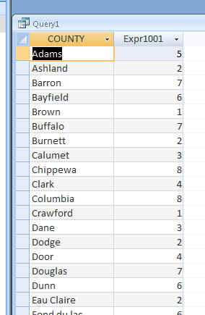SELECT COUNTY, COUNT(*)  
FROM DEER  
GROUP BY COUNTY

To the right is a picture of the first few records from our answer.

You’ll see that we got 64 records back – that’s the number of counties in Wisconsin.

You’ll also see that we only have 2 columns in our answer. Notice that our SELECT line only has two columns – the name of the county and the result of the COUNT.

Here’s what Access just did: Because we did NOT have a where clause, it looked at all the records in our database and then it divvied them up into virtual “piles”; all the Adams county ones in a pile; all the Ashland county ones in another, etc.

Then it went through and counted the number of records in each “pile” and returned that number in our second column.

Notice that “county” (the name of the column) appears in BOTH the SELECT line and the GROUP BY line. Why? That’s one of the hard and fast rules of SQL. Whatever criteria (or field) you are using to dictate your groups or “piles” must appear in both the Group By and the Select lines. AND …you can’t have any other fields in the select line (only a function like COUNT or SUM or AVG)

It returned the answer in alphabetical order by the county field (the first field) because that’s the default when you don’t include an ORDER BY statement.

So if we wanted to adjust this query so that we see which county had the MOST accidents, simply add an ORDER BY, like this:

SELECT COUNTY, COUNT(*)  
FROM DEER  
GROUP BY COUNTY  
ORDER BY 2 DESC

Why does it say ‘ORDER BY 2 DESC’?

We could say “ORDER BY COUNT(*) DESC”, but Access allows us to use a little shortcut here and just refer to the column number – the column in our answer. In this case, the name of the county is column one (it’s the first item in our SELECT line) and the COUNT result is our second column. So we want the answer to be displayed largest to smallest, according to that COUNT. You can use this shortcut anytime you use ORDER BY. It doesn’t need to be a group by query.

What if we want to create our “piles” based on more than one criteria? For example, what if I wanted to see the number of accidents in each county that were self-inflicted and the number that were second person. A cross-tab query would be a fancier way to do this, but let’s just see what happens when we put these two things together in a regular group by query:

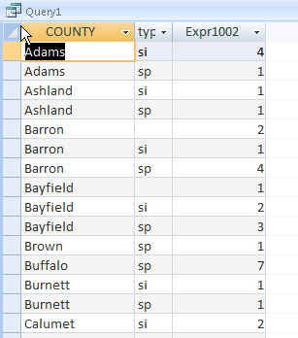SELECT COUNTY, TYPE, COUNT(*)  
FROM DEER  
GROUP BY COUNTY, TYPE  
ORDER BY 1

You’ll see now we have more than 1 record for each county. In the case of Barron County, we have 3 – because there were 2 records where the TYPE field was not filled in, 1 where the injury was self-inflicted and 4 where it was a second person.

Probably one of the most confusing things for a newbie learning Access is this idea that with a group by query you can’t see everything in one swoop.

I’ve had reporters flummoxed by this because they want to find out which county had the most accidents, but they also want to be able to see – at the same time –whether the majority of them were self-inflicted or not.

The problem is that the query we just ran won’t give you both answers at the same time. Notice that if you sort this last query by the COUNT field, you’ll end up with Buffalo County at the top – but this isn’t showing ALL the accidents in Buffalo; it’s only showing the 7 that were second-person.

You either need to run the two queries separately or get into more sophisticated queries (like a cross tab query). As a beginner, I’d recommend you stick with simple queries and just constantly remind yourself that each group by query is only going to tell you one thing.

The best way to approach Group By queries is to first draft your question, then think about what you expect the answer to look like.

Let’s try out another question….

Which county had the most fatal accidents?

Let’s deconstruct our question. First, we’re asking it to ONLY look at fatal accidents. So that means we need to filter our data – in other words, use a WHERE statement.

Second, we’re asking for the name of a county. And in order to see which county had the MOST, we need to see all the counties in a list. So we’re going to need the field COUNTY in our SELECT line.

Finally, we want a number for each county – so we need to COUNT the records. And because we’re counting, we need to use GROUP BY. And we’ll need an ORDER BY putting the records in descending order by the COUNT field so we can quickly see which county had the most fatal accidents.

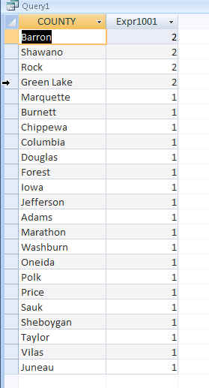So that means our SQL would look like this:

SELECT COUNTY, COUNT(*)  
FROM DEER  
WHERE INJURY= “FATAL”  
GROUP BY COUNTY  
ORDER BY 2 DESC

The best way to learn Group By queries is to practice, practice, practice. So here are some other questions, then go ahead and try some of your own.

1. What was the most common wound?
2. What were the most common types of self-inflicted wounds?
3. What was the most common cause of hunting accidents?
4. Which brand of gun is involved in the most hunting accidents?
5. What is the average age of victims in self-inflicted accidents?
6. What is the average age for the shooters in butt-injury accidents?
7. On which date did the most accidents occur? After getting this answer, then run a query to find out where those accidents occurred. Which county(s) had the most on that date?

Created by MaryJo Webster  
@MaryJoWebster  
Mjwebster71@gmail.com