**[](http://www.bls.gov/home.htm)**

**2015 Reporter’s Guide to Using QCEW Data**

This document provides single page tip sheets on using BLS Quarterly Census of Employment and Wages (QCEW) data to provide information and help on topics such as:

* [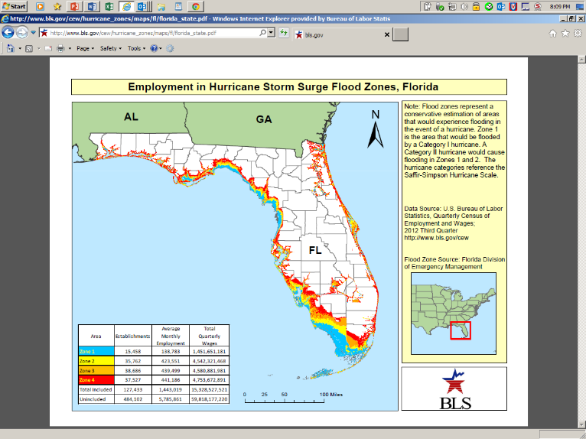](http://www.bls.gov/cew/hurricane_zones/maps/fl/florida_state.pdf)Quick read on an unfamiliar location
* Local incidence of an industry
* Local concentration of an industry
* Local reflection of national trends
* Employment and wages in hurricane flood zones
* QCEW Data Viewer: county, MSA, state, and national data by industry
* QCEW Open Data Access: Create your own data app or database

**Quick read on an unfamiliar location**

QCEW publishes industry employment and wage series for every county in the country. This may make it seem that QCEW data can be difficult to work with under deadline due to the huge number of series available (over a thousand NAICS industries for each and every county). Because of this, QCEW is constantly working to improve the user experience.

After Hurricane Katrina, the [**QCEW County High Level Spreadsheet**](http://www.bls.gov/cew/doc/layouts/cty_high_level_layout.htm) was developed to help reporters get a quick read on an unfamiliar location. [Available here](http://www.bls.gov/cew/datatoc.htm), it provides industry detail at the QCEW Supersector levels and higher level for each county, MSA, state, and for the nation. Restricting the industry detail to QCEW Supersector Levels and above results in a manageable number of industries for users in a hurry.

[**The QCEW State and County Map Application**](http://beta.bls.gov/maps/cew/US?period=2014-Q2&industry=1013&pos_color=blue&neg_color=orange&Update=Update&chartData=3&ownerType=5&distribution=Quantiles) was developed to provide the same high level information in a web application with data maps and sortable tables. It is a fully vetted product. It is listed under the beta directory to increase its exposure.

[**QCEW Data Viewer**](http://www.bls.gov/cew/apps/table_maker/v3/table_maker.htm#type=10&year=2014&qtr=2&own=5&area=22071&supp=0) is a web application that provides tabular access to all QCEW data for 2012 to the present. It provides much more industry detail than the high level spreadsheet or the map application.

[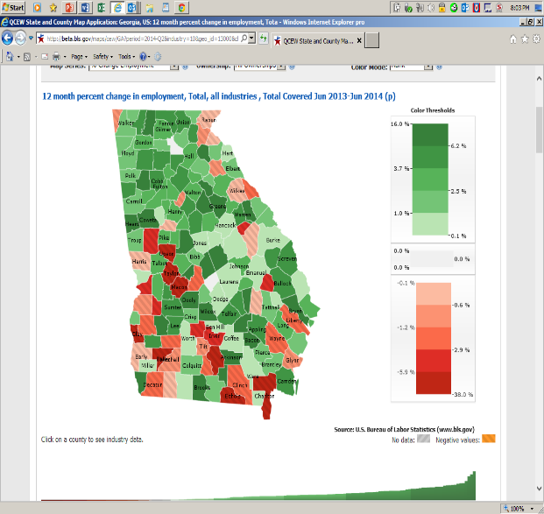](http://beta.bls.gov/maps/cew/GA?period=2014-Q2&industry=10&geo_id=13000&chartData=3&distribution=Quantiles&pos_color=green&neg_color=red&showHideChart=show&ownerType=0)

**[](http://www.bls.gov/home.htm)**

QCEW Publications Contact:

David Hiles

[hiles_d@bls.gov](mailto:hiles_d@bls.gov)

202-691-6561

[qcewinfo@bls.gov](mailto:qcewinfo@bls.gov) back to Table of Contents

**Local incidence of an industry**

***Where are the fertilizer plants?*** QCEW received this question after the April 2013 explosion in West, Texas.

QCEW publishes establishment counts (as well as employment and wages) at the finest level of industry detail (NAICS 6-digit) for every county. Comparable data are available at the MSA, State and national levels. QCEW publishes this detail for over 3,000 counties. All levels of industry detail are available, from NAICS 6-digit up to total, all industries.

The best tool for accessing QCEW data is the **QCEW Data Viewer**.

To see the complete list of counties where an industry exists, check the box labeled “*Show records with suppressed employment and wages.*” There were 914 fertilizer manufacturing establishments in the second quarter of 2014. Click [here](http://www.bls.gov/cew/apps/table_maker/v3/table_maker.htm#type=1&year=2014&qtr=2&own=5&ind=32531&supp=1) to see a QCEW Data Viewer table of the counties with these establishments.

**[](http://www.bls.gov/home.htm)**QCEW Publications Contact:

David Hiles

[hiles_d@bls.gov](mailto:hiles_d@bls.gov)

202-691-6561

[qcewinfo@bls.gov](mailto:qcewinfo@bls.gov) back to Table of Contents

**Local concentration of an industry**

***Where is industry X concentrated? How dependent is my area on industry Y?*** QCEW can answer this question via the use of Location Quotients (LQ). This is made possible by the great amount of industry detail published by QCEW at the county, MSA, state, and national levels.

**Location Quotients Express Local Concentration**

A location quotient (LQ) is a ratio that expresses an industry’s share of local jobs as compared to the national total. For example, a LQ of 1.0 indicates that the local industry has a normal concentration, that is, a concentration that matches the U.S. total. A LQ of 2.0 indicates that the industry has twice the share of local jobs compared to the national economy. A LQ of 0.5 shows that the local industry has only half the share of jobs as it does at the national level.

Use the QCEW Data Viewer to compare location quotients for any industry or location.

--Area by [industry](http://www.bls.gov/cew/apps/table_maker/v3/table_maker.htm#type=10&year=2014&qtr=1&own=5&area=17031&supp=0):

--Industry by [location](http://www.bls.gov/cew/apps/table_maker/v3/table_maker.htm#type=1&year=2014&qtr=2&own=5&ind=511&supp=0):

Try sorting the examples below by LQ:

Taney County, MO (Branson)

<http://www.bls.gov/cew/apps/table_maker/v3/table_maker.htm#type=10&year=2014&qtr=2&own=5&area=29213&supp=0>

Oil and Gas Extraction

<http://www.bls.gov/cew/apps/table_maker/v3/table_maker.htm#type=1&year=2014&qtr=2&own=5&ind=211&supp=0>

**[](http://www.bls.gov/home.htm)**QCEW Publications Contact:

David Hiles

[hiles_d@bls.gov](mailto:hiles_d@bls.gov)

202-691-6561

[qcewinfo@bls.gov](mailto:qcewinfo@bls.gov) back to Table of Contents

**Local reflection of national trends**

***What is the most local (county) incidence of the recovery? Is it evenly spread, is it concentrated in specific metropolitan areas, in the financial areas, or in the high tech areas?***  QCEW can provide data to support this line of reporting.

QCEW publishes industry employment and wage totals for the nation and every county, MSA, and state. It is not a survey but a quarterly census.

Comparative trend analysis is the most challenging task for QCEW users. The QCEW program provides comprehensive files on the BLS site going back to 1975. These files are provided by year. Users combine these files to create a series. QCEW provides sample code for converting these files into SAS and Access formats. QCEW also provides files in a format designed for users who wish to load QCEW data into their own SQL database.

[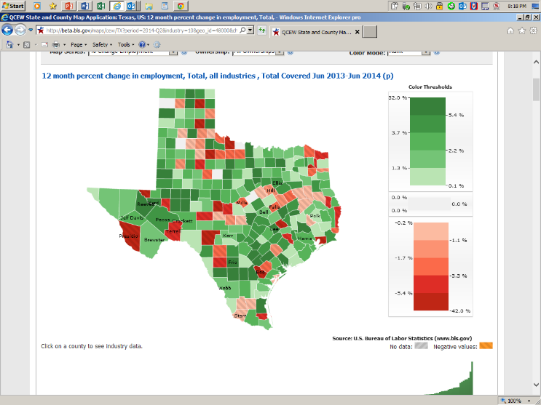](http://beta.bls.gov/maps/cew/TX?period=2014-Q2&industry=10&geo_id=48000&chartData=3&distribution=Quantiles&pos_color=green&neg_color=red&showHideChart=show&ownerType=0)

Guide to QCEW Data Sources:

<http://www.bls.gov/cew/dataguide.htm>

QCEW Downloadable Data File Access:

<http://www.bls.gov/cew/datatoc.htm>

**[](http://www.bls.gov/home.htm)**QCEW Publications Contact:

David Hiles

[hiles_d@bls.gov](mailto:hiles_d@bls.gov)

202-691-6561

[qcewinfo@bls.gov](mailto:qcewinfo@bls.gov) back to Table of Contents

**Employment and wages in hurricane flood zones**

The Quarterly Census of Employment and Wages (QCEW) program has created a set of [maps and data](http://www.bls.gov/cew/hurricane_zones/maps.htm) for hurricane flood zones on the Gulf and Atlantic Coasts. Where permitted by State regulations, maps include dots indicating the location of business and government establishments. This product is the combination of geocoded BLS establishment data and flood zones created by the U. S. Corps of Engineers and State emergency management authorities. For more information, see the [evacuation zone FAQ page](http://www.bls.gov/cew/hurricane_zones/hcat_faqs.htm).

Maps and Data:

<http://www.bls.gov/cew/hurricane_zones/maps.htm>

Evacuation Zone FAQ Page:

<http://www.bls.gov/cew/hurricane_zones/hcat_faqs.htm>

[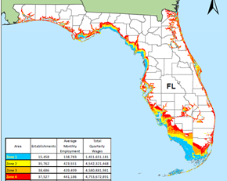](http://www.bls.gov/cew/hurricane_zones/maps/fl/florida_state.pdf)The summarized data are presented for each zone. If a Category I storm is experienced, the subject establishments are represented by the Category I sums. The Category II sums represent the establishments which are not in zone I but are in zone II. To get a total for establishments subject to a Category II storm, users should add the Category I and II values.

**[](http://www.bls.gov/home.htm)**

QCEW Publications Contact:

David Hiles

[hiles_d@bls.gov](mailto:hiles_d@bls.gov)

202-691-6561

[qcewinfo@bls.gov](mailto:qcewinfo@bls.gov) back to Table of Contents

**QCEW Data Viewer: county, MSA, state, and national data by industry**

The [QCEW Data Viewer](http://www.bls.gov/cew/apps/data_views/data_views.htm#tab=Tables) provides point and click access to 100% of QCEW data for 2012 forward. Data are presented in sortable tables. For example, see [here](http://www.bls.gov/cew/apps/table_maker/v3/table_maker.htm#type=10&year=2014&qtr=2&own=5&area=13067&supp=0) for a detailed industry table for Cobb County, GA. By default, these tables do not display suppressed series. Users can override this default.

BLS is working on adding data back to 1975, a multi-year comparison feature, data graphics, and other features.

**Based on an open data access resource**

The underlying data files used by the QCEW Data Viewer products are provided in CSV form as part of the QCEW open data access resource. BLS has released [documentation](http://www.bls.gov/cew/opendata.htm) of the underlying CSV data file naming convention, record layout, and directory structure.  The CSV files are available on the BLS web.  Applications can directly address these open data files through URLs.

Here is the link to the CSV data underlying the Cobb County example above:

<http://www.bls.gov/cew/data/api/2014/2/area/13067.csv>

**[](http://www.bls.gov/home.htm)**

QCEW Publications Contact:

David Hiles

[hiles_d@bls.gov](mailto:hiles_d@bls.gov)

**202-691-6561**

[qcewinfo@bls.gov](mailto:qcewinfo@bls.gov) back to Table of Contents

**QCEW Open Data Access: Create your own data app or database**

[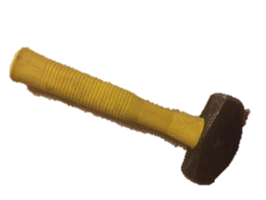](http://www.bls.gov/cew/apps/table_maker/v3/table_maker.htm#type=1&year=2014&qtr=2&own=5&ind=332216&supp=1)QCEW data for 2012 forward are available in an open data access resource. This resource is open to third party programmers, developers, and organizations. BLS provides links [here](http://www.bls.gov/cew/opendata.htm) to QCEW open data access documentation as well as to sample code in several languages. BLS is working to extend the data available in this facility back to 1975.

**Industry, Area, and Establishment Size Slices**

QCEW open data files are [sliced](http://www.bls.gov/cew/doc/access/csv_data_slices.htm) by industry, by area, and by establishment size-class. An **industry** slice contains all the records associated with the industry for a single time period. An **area** slice contains all the records associated with the area for a single time period. A **size** slice contains all records published within a specific establishment size class for the first quarter of a specified year. Slices are named and ordered into directories using a [RESTful](http://www.drdobbs.com/web-development/restful-web-services-a-tutorial/240169069) approach. All slices contain pre-calculated location quotients. For more information on location quotients, please see the location quotients [page](http://www.bls.gov/cew/doc/info/location_quotients.htm).

**Code Examples/Direct Access**

QCEW data slices can be directly accessed from various programming languages. BLS has provided [simple examples](http://www.bls.gov/cew/doc/access/data_access_examples.htm) in several languages. This removes the need to download files.

**QCEW Data Viewer**

[QCEW Data Viewer](http://www.bls.gov/cew/apps/data_views/data_views.htm#tab=Tables) is the newest tool currently available at BLS for QCEW data users. It takes the open data access files as its input.

**[](http://www.bls.gov/home.htm)**QCEW Publications Contact:

David Hiles

[hiles_d@bls.gov](mailto:hiles_d@bls.gov)

202-691-6561

[qcewinfo@bls.gov](mailto:qcewinfo@bls.gov) back to Table of Contents