**Open Refine Exercise**

Created March 2013

You’re going to need a data file called “Franken.xlsx.” These are all contributions to the Al Franken for Senate committee during the 2008-09 election cycle.

You’ll need to have Open Refine installed on your computer: <http://openrefine.org/>

1. Launch Refine. This will open up a new window in your web browser

**A little housekeeping, first:**

We need to do one housekeeping task because the data we’re working with is rather large. Notice in your address bar it should say “127.0.0.1:3333” or something like that. Edit that by adding “/preferences” to the end of the URL.

On the Preferences page that pops up, click the Edit button to change the Facet limit. Change it to 5000. Then you can hit the back button to go back to your project.

1. Back to the project…. you’ll get the choice to “Create Project”, “Open Project” or “Import Project.”

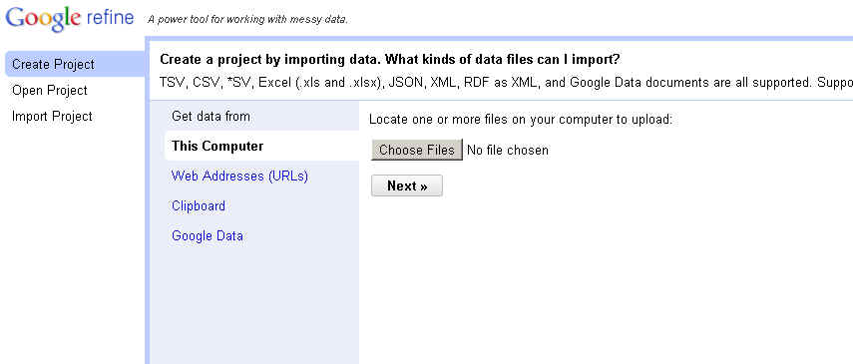

We’re going Choose “Create Project”. Then click “Choose Files” button and navigate to the “Franken.xlsx” data file. Then hit “next”

It will give you a preview of your data and (at the bottom of the page), various options. We’re going to leave the defaults. Then click “Create Project” in the upper right corner.

1. 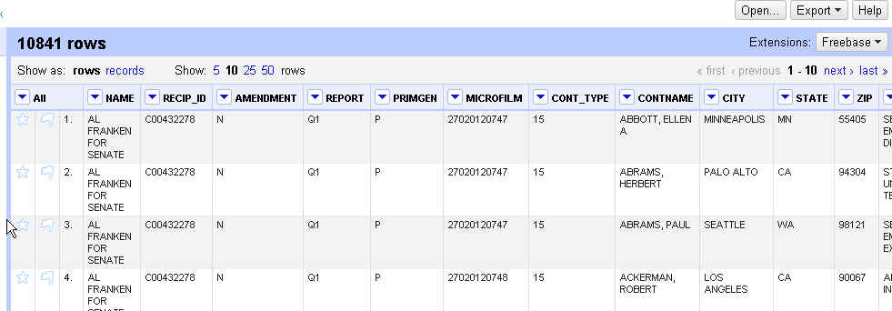Now you’ll see your data – or at least just the first 10 rows.

1. 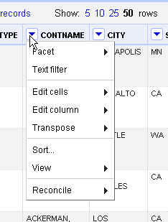We’re going to start with some **simple data cleanup** that you would likely need to do on any dataset. Notice that there are pull-down menus next to each column name. Click the one next to CONTNAME and you’ll see the various cleanup tools we have.

Hover over “Edit Cells” and then “Common Transformation”

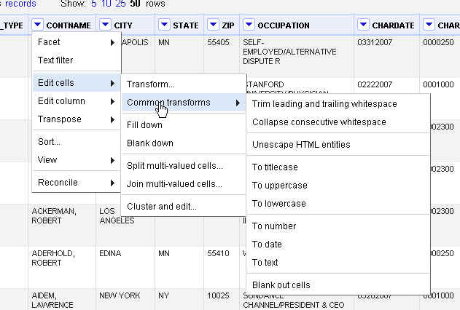

There are lots of great options here, including trimming leading and trailing whitespace, collapsing extra whitespaces in the middle of the data string, turning everything to uppercase. Those are my favorites. Let’s run each of those on CONTNAME.

1. Then repeat those three transformations on CITY, STATE, ZIP, OCCUPATION
2. Next we’re going to start **standardizing data**. The best practice for this is to do the work in a new column, so that you retain the original column of data (in case of errors).

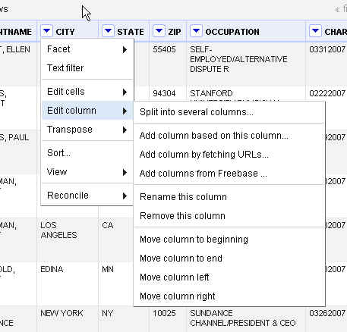

Click on the pull-down for the City field and choose “Edit Column” and then “Add column based on this column”

In the pop-up box, give your new column a name…I’m going to call mine “City_New”

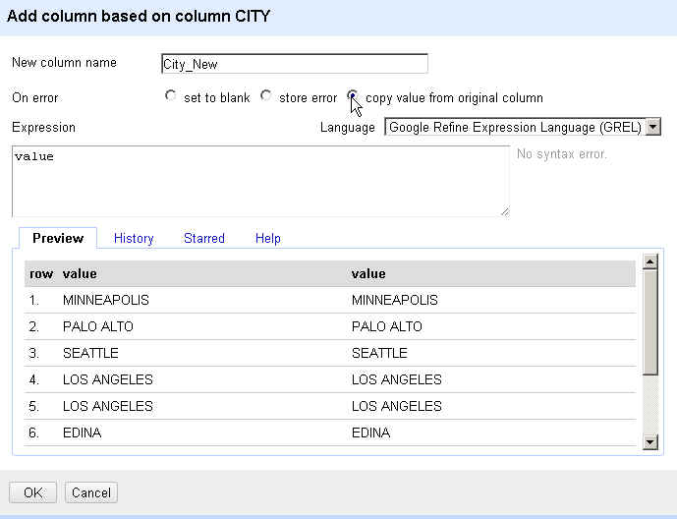And then choose “copy value from original column”

Hit OK.

1. 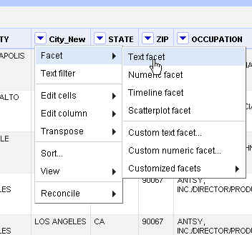Now go to that new column – “City_New” – and from the pull-down menu choose “Facet” and “Text Facet”

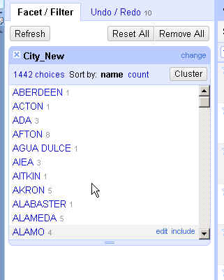It will add a little box on the left side of the screen showing the various city names that show up in this field.

Go to the bottom of that list of cities and you’ll see that we have one blank record. Hover to the right of (blank) and choose “Edit” (you can see it in this picture to the right)

Change that record to “Unknown”

1. Close the Facet box for the city_new field. Then let’s repeat all those steps for the State field.

First, create a new field called “state_new” (just like in step 5)

Then do a text facet on this new field. This time you’ll see that we have a lot of blank fields. Select “Include” and it will display just those records. You’ll see that we have some records that can obviously be fixed because they have the city name. Fix the ones you can (i.e. Minneapolis, Los Angeles, etc). There are quite a few that are obviously in other countries or you don’t know where they are. Leave those blank.

Then go back to the Facet box and choose to Edit the remaining blank ones. Change them all to “ZZ”

1. In order to standardize the names, I think it would be best to do the city and state together because there are situations where there are cities with the same – or similar – names that are in different states. So first, we need to **merge the city and state together into one field.**

Note: the next step requires that all of your records in those two fields have valid data (no nulls). So that cleanup we did in step 7 was crucial to making this work.

Select either one of your new columns and choose to “add column based on this column”

In the box that comes up (like the one below), give you new column a name – “CityState”

And in the Expression box type the following:

Cells[“City_New”].value + “, “ +cells[“State_New”].value

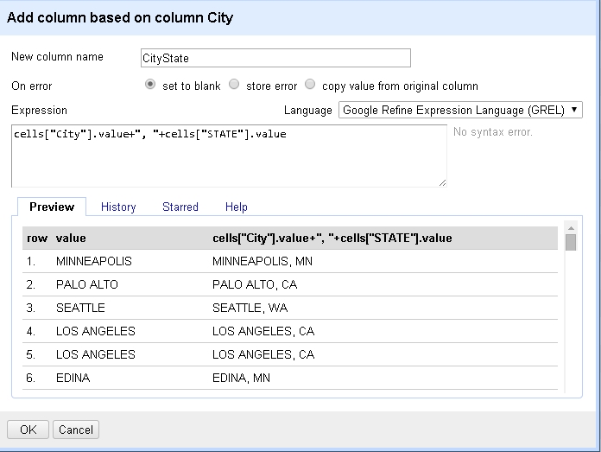

Note: the names of your city_new and state_new columns (inside those quote marks) are case sensitive. So notice in my code I have a capital letter on the start of each word – because that’s how I typed it when I created those fields. If you typed yours differently, you’ll need to match to how your fields are listed.

Then push the OK button at the bottom of the box.

1. Now we can do a text facet on that new CityState field and start cleaning up our inconsistent data.

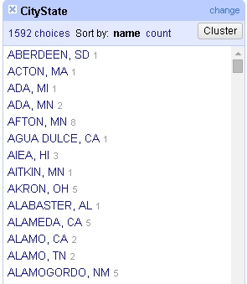

Once you have this facet box, hit the Cluster button and it will give you several options for grouping data together.

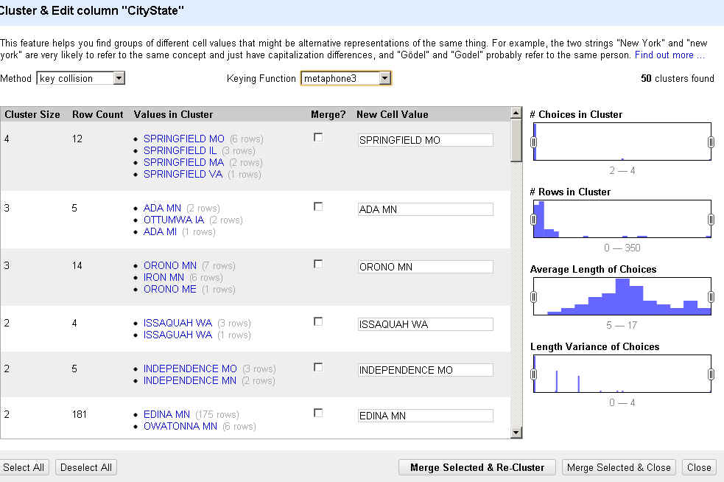Notice that the Cluster & Edit box that comes up has “method” and “keying function” menus – these allow you to change which algorithm Refine will use for trying to find matches. You’ll see that some return no results, others return results that seem too drastic (i.e. matching Ada, MN with Ottumwa, IA). You have to try each of the methods until you find something that seems to work on your data.

For this one, I think the “nearest neighbor” method might be most fruitful. Notice that some of the matches are ones we don’t want to merge – i.e. Andover MN and Andover MA (unless we have reason to question that single one from Massachusetts as possibly being wrong?)

But farther down you’ll see that it found two variations of Greensboro, NC and Pacific Palisades CA.

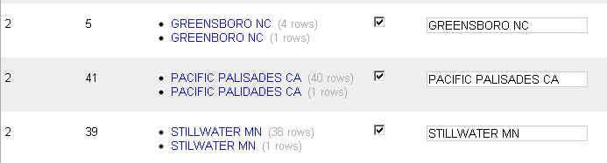To fix those, put a checkmark in the box next to the one(s) you want to fix and then make sure the text box on the right side has the correct spelling that you want.

You might need to do some outside research or look back at your original data to make sure you’re not screwing something up. For example, the data has “Lincoln NE” (2 records) and “Lincoln NM” (1 record). I know there is a Lincoln NE, but is there a city called Lincoln in New Mexico? Might be worth checking out. Typing NM instead of NE is an easy data entry error.

Once you’ve gone through them all and settled on which ones to merge, push the “Merge Selected & Re-Cluster” button. This will give you a chance to review any of the ones that you did NOT merge. Maybe you’ll find one you missed. When all finished, hit either “Merge Selected & Close” or simply the “Close” button (if you don’t have any others to merge)

You can keep trying the various methods to keep finding matches.

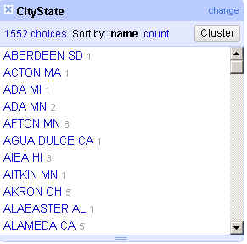

When you’re done, you’ll notice that the original 1,586 variations in the CityState column have been whittled down. I got mine down to 1,552 choices.

1. Now let’s repeat all those steps for the Occupation field.

First, create a new column based on that column.

Then, do a text facet and cluster. Try out the various methods and merge and cluster as needed to clean up the data as much as possible.

1. You might find that this field should be split into “employer” and “occupation” (splitting it on the slash), and then cleaning up the two fields separately, might work better.

To do that, select the new occupation column and choose “Edit column” and “split into several columns”

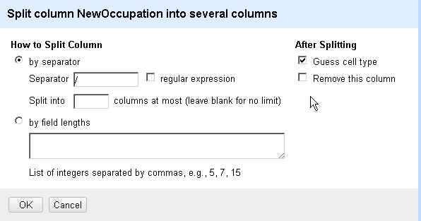In the box that comes up, put the slash “/” in the separator box and uncheck the box that says “remove this column”

**Converting dates:**

In this data we have a field called “chardate” that is the original date, as it came through from the FEC. It shows the dates as “MMDDYYYY” – and is formatted as text.

We want to convert that to “MM/DD/YYYY”

To start with, make a copy of the “chardate” field and we’ll work on that copy.

Go to that new column and choose Edit Cells>>Transform. It will bring up this dialog box.

In the expression box type:

toString(toDate(value), “MM/DD/YYYY”

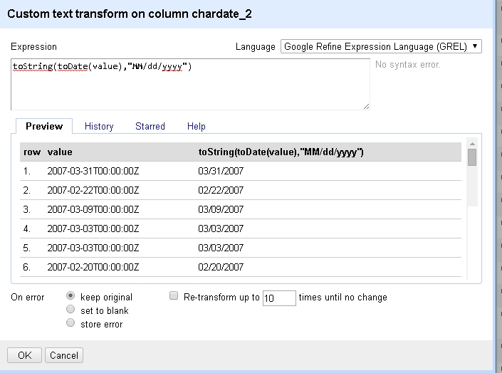

You might have noticed under Edit Cells that there is also a transformation option “To date”

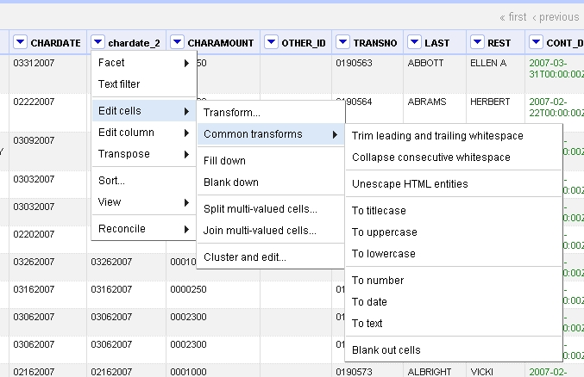

It will give you dates that look like this:

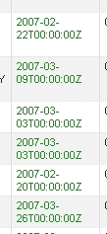

Yes, ugly. But you can fix that by simply running the transform (with the “toDate” function) that we ran above and it will be fixed.

**More help/tutorials:**Using Refine to Clean Messy Data: <http://www.propublica.org/nerds/item/using-google-refine-for-data-cleaning>

Open Refine Cheat Sheet: <https://docs.google.com/document/d/1kRoK6oDtgRO-g1KAHBMaAFPFOEGYsr5p5kpllRIn_og/edit>

Refine Tutorial by David Huynh: <http://davidhuynh.net/spaces/nicar2011/tutorial.pdf>

*MaryJo Webster  
St. Paul Pioneer Press*[*mwebster@pioneerpress.com*](mailto:mwebster@pioneerpress.com) *651-228-5507  
@mndatamine*