How many bridges are “structurally deficient”?

--did a pivot table, filtered on “DefStat” as “S.D.” and counted the number of records

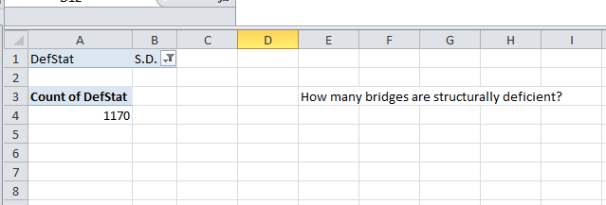

Check to make sure there aren’t records listed some other way:

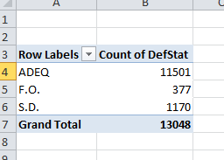

What kinds of sufficiency ratings do these structurally deficient bridges have?

--Pivot Table, filtered on DefStat=”S.D.” and counted the number of records with each SuffRate (sufficiency rating). It shows that there are some with really high sufficiency ratings, but why are they labeled as structurally deficient?

