Access: Running Crosstab queries

Use the Bridges Inspection database to follow along.

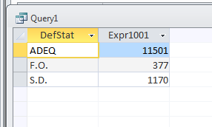

Group by queries in Access are great if you just have one variable that you want to summarize, like this:

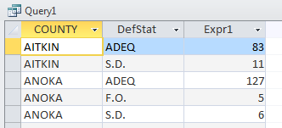But what if you want to see how many bridges have each of these deficiency designations by what county they are in.

If you run a group by query with that, you end up with multiple rows for each county.

This is a situation where you want to have one row for each county and separate columns showing how many bridges fall into each of those deficiency categories.

To do that, you need a Crosstab query. Luckily, Access has a Wizard that walks you through setting up a Crosstab query. You don’t need to know SQL to do this one.

First, a couple pieces of advice:

* Crosstab queries work best if at least one of the variables has a small number of potential values. In this example, the Deficiency Status field only has 3 potential values. The County field that we are going to cross it against has 87 values. That works really well. You’ll always want to make that “small” variable the columns.
* There may be times that your data table is not set up properly to feed the right data into your crosstab query – or maybe you want to base the crosstab on a subset of your data. In those situations, you might first has to create a regular Select query and save it. Then you can base your crosstab query on the saved query.

This example is simple enough that we can base it off the table itself.

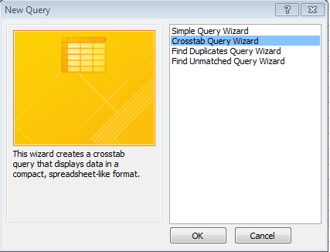Go to the Create ribbon and choose “Query Wizard”

In the box that comes up, choose “Crosstab Query Wizard”

Hit OK.

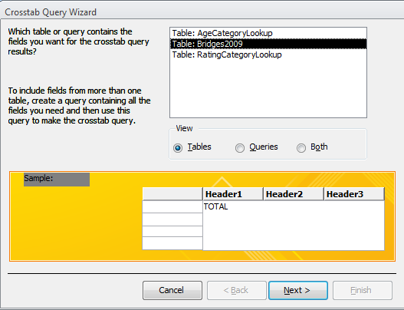The next screen asks you to specify which table or query you want to base your query on. For this one, choose “Table: Bridges2009”

Hit Next.

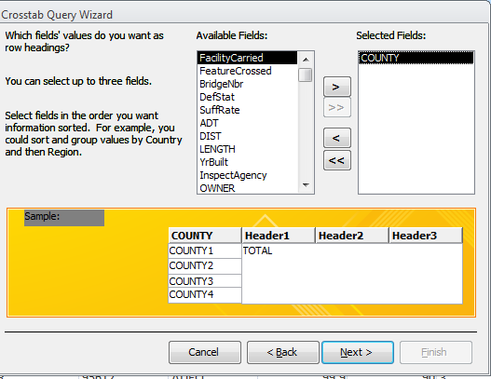Then it’s going to ask what field(s) you want to dictate the rows. Usually you will just choose one field here, but it’s possible to choose more than one. Think of this like the Group By set up. We’re determining how to group the records. In this case, we want the “County” field because we want each row in our answer to represent one county.

Choose “County” and push the > symbol to move it over to the “Selected Fields” box.

Hit Next.

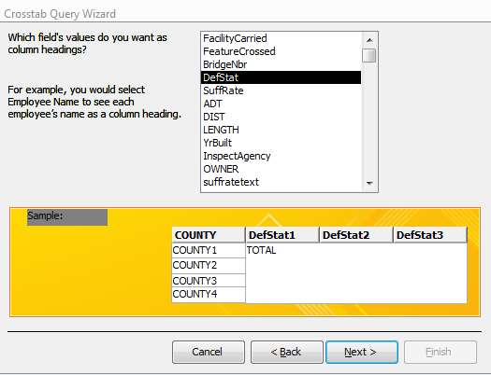Then you choose what field you want for your columns. Here you can only choose one field. In this case we want “DefStat” – which contains the deficiency status codes.

Hit Next.

Next, we need to specify what values we want to display in the cells. In this case, we just want to count the number of bridges that fall into each deficiency status, in each county. To do that you can choose any field from the list of fields and set “Count’ as the function.

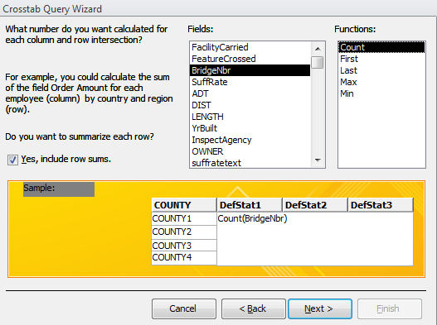To make it a little easier to understand, I’m going to choose “BridgeNbr” as the field that it’s going to count.

You’ll notice that there’s a little checkbox on this screen “Yes, include row sums”. If you leave this checked, it will add a total column for each row (this would be the total number of bridges in each county). In this case, this is quite useful. Other times, you might not need it.

Hit Next.

The final screen gives you a chance to name your query (all cross tab queries are automatically saved in your database).

Then hit Finish.

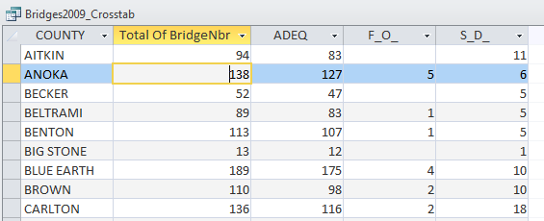

Created by MaryJo Webster  
@MaryJoWebster  
[mjwebster71@gmail.com](mailto:mjwebster71@gmail.com)  
January 2016