**Make Table Queries in Access**

You can make a new table in Access from part (or all) of an existing table. In this example, we’re going to pull out a subset of data and make that into a new table.

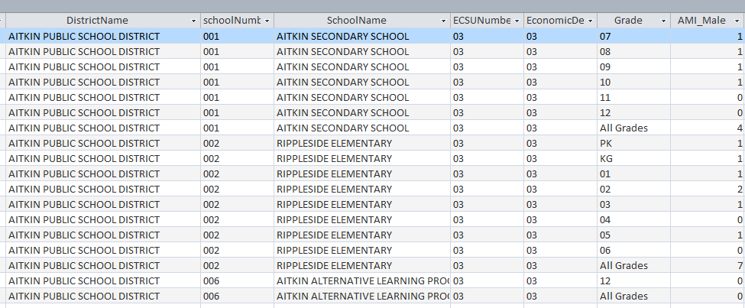Our existing data is in a table called “EnrollRace”. This shows enrollment at each public school in Minnesota, broken down by race and there are separate records for each grade. Plus there is a record that lists the figures for “all grades” combined.

Having the “all grades” records in a separate table will make our analysis a bit easier. I also want to only include elementary schools .

Step 1:  
Start a new query, put the EnrollRace table in the query

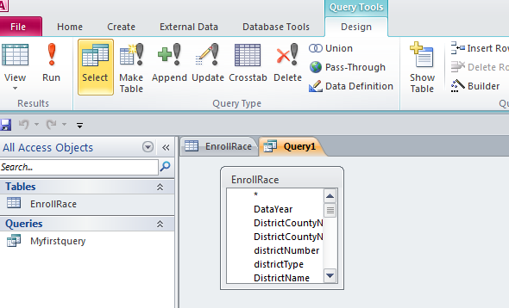Step 2:  
In the ribbon menu at the top, you’ll see buttons for different query types. Right now our query is a Select query. We need to change it to a Make Table query.

Step 3:

After selecting the “Make Table” button, it will launch a little dialog box asking you to give you new table a name. The default is that it will create this in the “current database.” But you could have it put it in another Access database, if you want.

Name your new table. I’m going to call this “ElemEnroll”

Step 4:  
Fip to the SQL view and you should see the beginning of your syntax like this:  
SELECT INTO ElemEnroll  
FROM EnrollRace;

We need to build this out. Let’s include all the fields by putting an asterisk in the SELECT line  
SELECT * into ElemEnroll

Then we need to tell it which records to pull – remember we only want elementary schools and the ones where the grade field indicates “all grades.” So we’ll need to use a WHERE clause to do that. The field called schoolclassification indicates which ones are elementary schools with the code “10”. Be sure to delete the semi-colon after “EnrollRace”

SELECT * into ElemEnroll  
FROM EnrollRace  
WHERE schoolclassification=”10” and grade= “All grades”

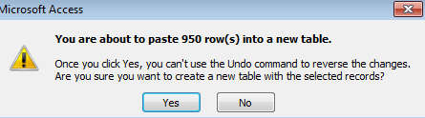Step 5:  
Run the query. It will give you this little message. Click Yes.

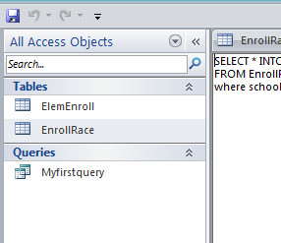Step 6:   
It will look like nothing has happened, but if you look at your list of tables on the left, you’ll now see a new table there.

By @MaryJoWebster  
Feb 2016