Easy Calculations in Excel

(2007 and newer)

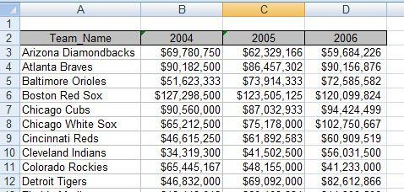Any time you have a list of numbers that require some sort of calculation like *percent change from one year to the next,*

*percent of total, average* or just a *simple total*, it’s easier to put the figures into Excel and let the computer do the tough stuff for you. Excel is also extremely helpful when *comparing a list of numbers* to find out which one is the biggest, which is the smallest, etc.

This tipsheet will use total Major League Baseball payrolls for 2004, 2005 and 2006 to show how to calculate percent change

from year to year, percent of total, average payroll and how to sort the list to compare the teams.

Here’s a sample of what the data looks like when we start out.

**TERMS**:

* **Columns** contain “categories” of data and are vertical
* **Rows** contain “individual records” and are horizontal
* A **cell address** consists of a letter followed by a number, i.e. “B4”
* The **active cell** is the cell with the darker border. Click on a cell to make it active.
* Each Excel file is described as a **workbook**, which can contain multiple **worksheets**.
* The **formula bar**, which is located in the menu bar, is similar to the address bar in a web browser.

Here you can view and edit formulas that you’ve created in the worksheet.

# Percent Change:

To do this properly, it’s crucial to have last year’s total and this year’s total lined up side by side (as shown above). It’s possible to do this if the numbers are in other configurations, but it’s much more difficult.

In the first blank column on the right (in this case Column E), create a new column header called “PctChange”. Then in the cell just below the header (in this case, cell E3) we’re going to create a formula that we can use to generate a percent change for all the teams — and it only needs to be typed once!

The formula is straight out of middle school math:

New value minus Old Value, divided by Old Value.

But with Excel, you set up a formula using the cell addresses – not the actual numbers. So in this case, the Arizona Diamondbacks 2005 payroll is in cell **C3** and their 2006 payroll is in D**3**.

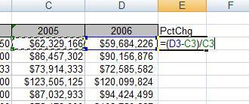So here’s the formula: = **(D3-C3)/C3**

When you are finished typing the formula, press the **Enter** key and you will see the result. It will probably be shown as decimals or maybe even as

currency — we’ll change it to a percent value later.

Now to apply the formula to the other teams, you need to put your cursor back on the Diamondback’s result and put your cursor over the lower right corner of the cell – where you will find a very small black square known as the “fill handle”. (**Note**: when you move your cursor to different positions around cell E3 you will find your cursor changes shape.)

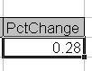***Notice the black square in the lower right corner (a.k.a. “fill handle”)

When the cursor changes to a thin black cross, push down on your left mouse button and drag or “copy” the cell down through the subsequent cells until you

reach the end of the list.

## Formatting the column:

When column E is filled in with values for each of the teams listed, be sure that all of those numbers are the top menu bar changes appearance and it will give you formatting and alignment options. Note on this screen capture where it says “Currency” – that is a pull-down menu where you can change the format of the highlighted cells to percentage. Then you can use the buttons just below (that have zeros and arrows) to increase or decrease the number of decimals that are displayed.

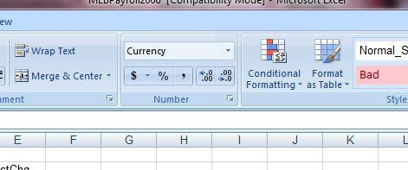

## Sorting the List:

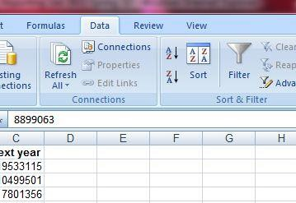To easily determine which team had the largest payroll increase and largest decrease, we need to sort the list. Put your cursor somewhere in the middle of your data area or text (you’ll see a black box around whatever cell you landed in — this is the “active cell”.) Then go to **Data** on the menu bar and choose **Sort…**

This will bring up a dialog box where you can choose which column you want to sort by. In this case, we want the list to go from highest percent change to lowest. So we would choose (from the pull-down menu in the left box called “sort by”) the “**PctChange**” column and set it to go descending under the Order pull-down menu. (Note: If the pull-down menu doesn’t show actual

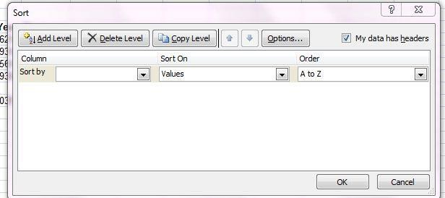field names, but instead says “Column A”, etc,

check the checkbox in upper right that says “My data has headers.”)

# Percent of Total:

We may want to know what percent of all MLB money spent on payroll is made up by the Yankees’ monstrous payroll. Here’s how to do that.

First, we need to calculate a total payroll for all teams combined. To do that, go to the bottom of column D (where the 2006 data is stored) and leave one blank line, then start a new formula on the next line to sum the figures. Instead of typing in all of the numbers in the list (like you would on a calculator), we’re going to add up all the numbers within a particular “range”. We use what’s called a **Sum** function.

Start the formula with an Equal sign, then within parentheses, indicate the range by typing the cell where the first value is located (in this case the list starts in D3) and then type a **colon** and the cell address where the last value is located. After you type this formula and press the **Enter** key you will see a total.

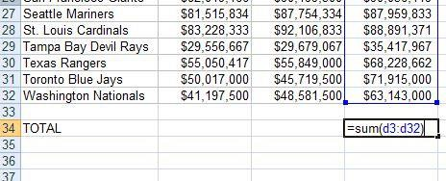

Now to do the percent of total for each team, go to the first blank column on the right (in this case, the F column) and create a new header called “PctTotal”. In the cell just below your new header, we’ll do the formula for percent total.

Again it’s middle school math:

Team Payroll divided by Total League Payroll.

Our first team’s payroll for 2006 is located in cell **D3**. Our total league payroll is in **D32**. This time we need to add something special to the formula to tell it to always use cell D32 for the total number – even when we copy down the formula to other teams. **Note**: If you don’t do this, Excel will use cell D33 for the second team, D34 for the third team, etc., and you won’t get the correct answers!

To “lock” the formula on a particular cell, you put dollar signs ($) around the column letter.

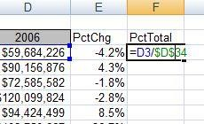Here’s what it looks like:

Now copy down the formula (get your thin black cross tool) like we did before and highlight the answers so that the formatting menu comes back at the top. Change the results to Percentage.

You can also re-sort the list so that you can see which team accounts for the biggest chunk of the total money spent on payroll in the MLB.

# Averages:

Calculating averages is similar to how we totaled the payroll list earlier. This time we’re going to use the **Average** function. We’ll calculate the average payroll for 2004 (later we’ll do the other years).

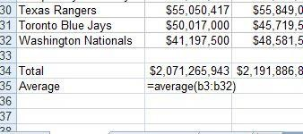On the row just below your total MLB payroll, create a line for averages and start a new formula in the B column on that line. Here’s what the formula looks like:

After pushing enter, put your cursor in the lower right corner of the answer and get the thin black cross. This time copy the formula to the RIGHT so that you get an answer in the C column too. If you put your cursor on the new answer in the C column, you’ll see that Excel accurately guessed that you wanted to do an average on C3:C32 instead.

To see, put your cursor on your new answer, then look at the top of the Excel page in the white bar (a.k.a. “formula bar”). Here’s what the original formula looks like in the formula bar:

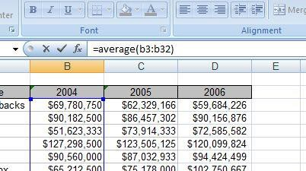

# Rank:

Instead of simply sorting your results to put them in “order”, this is a more sophisticated way to rank your records and to account for ties.

=RANK(This Number, $Start Range$:$End Range$, Order)

This Number should be the cell where your data starts.

Start Range should be the cell where your data starts. Anchor with dollar signs. End Range should be the last cell of your data. Anchor with dollar signs.

Order is either a 1 (smallest value will get assigned #1) or a 0 (largest value will get assigned

#1).

Example: =RANK(B2,$B$2:$B$100,1)

# Per Capita or other Rates:

Per person or per capita rates are used to level the playing field. They’re often used to compare dissimilar places or events: crimes in cities with different populations, deaths from various diseases, etc. Also used for very big or very small numbers to make them easier to understand.

In Excel, if you wanted to calculate the per capita (or per person) for a list of cities with the number of murders in each city, you need a separate column/field that lists the population of each city.

Then in a new field you would use this formula:

=murders/population

Most likely, though, this will yield a very small number like 0.03. So you need to bring it up to something that readers will understand. To do that you multiple by a set number such as 1,000 or 10,000 or 100,000, like this:

=(murders/population)*10000

# Shortcuts and other useful tricks

**To highlight your block of data** (to sort or copy): Push Control-Shift-Asterisk (*) at the same time. The cursor must be somewhere inside the chunk of data. (only works in Windows)

**To check the four corners of your highlighted data chunk**: While the data is highlighted, push Control-Period (.) at the same time, and repeat four times. Each time you push the keys it will go to a different corner of the data. This is useful for making sure you have highlighted the full chunk (and nothing extraneous) before sorting or copying.

**Freeze Panes**: To lock your field names in place so that you can always see them when you scroll down the page. Place your cursor in the cell just below the row that you want to lock into place, and all the way to the left of the page. Then go to View menu and select “Freeze Panes.” It gives you several options, such as freezing the top row or freezing the far left column.

**To return to the top of your data**: Push Control and Home keys at the same time.

**Paste Special:** Use this function when you want to get rid of the formulas behind a column or row of data (until you get rid of the formulas, that row will be dependent on the other rows/columns used to calculate the formulas). Highlight the row(s) or column(s) that have the formulas. Copy the data using Ctrl-C or the copy button. Then put your cursor where you want to paste the data (best choice is to put it in a new column or row) and right-mouse click, then choose “Paste Special.” A little box will come up: Under the Paste section at the top, choose “Values”. Then say OK.

**To set all of your columns to the appropriate width:** Highlight all of your data by putting your cursor in the empty grey box in the left corner between the A & 1.

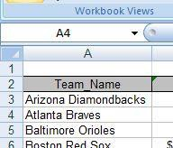

Then put your cursor in the grey, directly on the line between the A & B (or any two columns) and your cursor will change to more of a line. Then, double-click with your mouse and all of the columns on the page will widen or shrink to the maximum necessary width.

The same trick works for widening the rows (1, 2, 3, etc). When the data is highlighted, just put your cursor between the 1 & 2 (or any two rows) and double-click.

**Hide columns**: You can hide columns to get them out of your way or to avoid printing them by highlighting the columns you want (click on the letter at the top of the column) and right-mouse clicking to choose “Hide columns”. The columns will disappear. To get them back, highlight the two columns on either side of the ones that are missing and right-mouse click and choose “Unhide columns.”

**Worksheets**: You can toggle between different worksheets in an Excel workbook using the tabs in the lower left corner that have default names of “Sheet 1”, “Sheet 2”, etc. To change the name, double-click on the “Sheet 1” and it will turn black. Then you can start typing to give it a new name. To add a new worksheet, you’ll see a little button to the right of the tabs that gives you the option to add a new worksheet. You can move worksheets around so they appear in a different order, by clicking on the named tab with your mouse, holding down and dragging it in whatever direction you would like.

*Created by @MaryJoWebster*

[*Mjwebster71@gmail.com*](mailto:Mjwebster71@gmail.com)

*Updated: August 2015*