Importing to Access

MaryJo Webster

Revised: Jan 2016

Data to import: PCDogs.txt

Step One:

The data you want to import: What format is it in? Where is it stored?

--Be sure the data is on your computer (not on a CD or some other portable storage device or in a Zip file) and make sure the “read-only” property is turned off. (To do this, right click on the icon when the file is closed and choose “properties”; There is a check- box in the left corner for read-only that should be unchecked).

--Is it a text-file (.txt) or a Dbase file (.dbf) or an Excel file (.xls) or comma-separated value (.cvs)? Any of these three formats will import easily into Access. You might get a text file that has an extension other than .txt — you might want to type the extension into Google and see if you can find out what it is. Oftentimes, it is truly a text file and you can make a copy of it, then rename the copy with a .txt extension. (see end of this document for more guidance on file types)

Step Two:

Create a blank Access database. Consider this a “shell” that will house all your tables, queries, etc. To do this, open Access, choose “Blank Access Database” from the menu. Access will ask you to name it and select where you want to save it. (Pick a spot on your computer or network that will be easy to remember and give it a name that will broadly define what you’re going to house there).

Step Three:

The import process will go a little differently depending on the format of your file (whether it’s text, CVS, Dbase or Excel). If you have Dbase or Excel, it’s basically a one- step process. The other two options will take a little more work on your part.

From within your new Access database, choose the Ribbon menu “External Data”

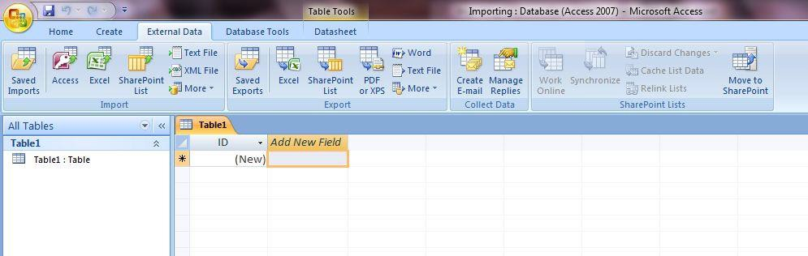

You’ll see that there are lots of options including to get something from another Access database, from Excel, from a SharePoint List, Text File, XML File and a “more” option.

For this exercise, let’s import a tab-delimited text file called “PCdogs” that is the dog license database for the portion of River Falls, Wis., that is located in Pierce County. (there is a separate file for those in St. Croix County)

Go to the External Data ribbon and choose “Text file”

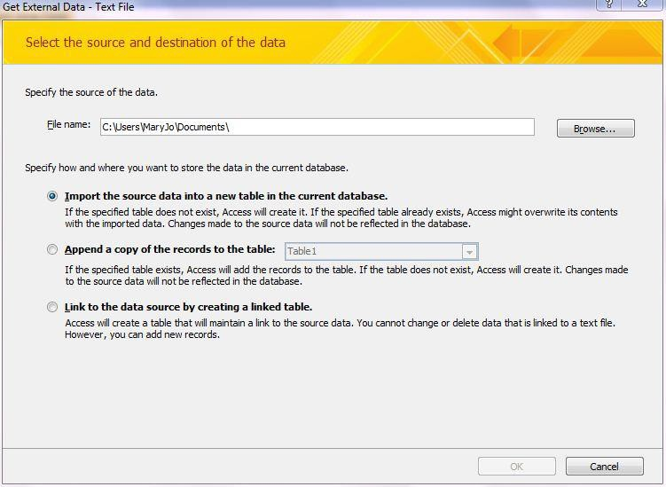

This first screen will ask you to locate the source of your data. Click on the Browse button to find it on your computer.

Then choose one of the radio buttons – either to import into a new table or to append to an existing table. The third option is to link to data stored elsewhere – something you won’t find much need for.

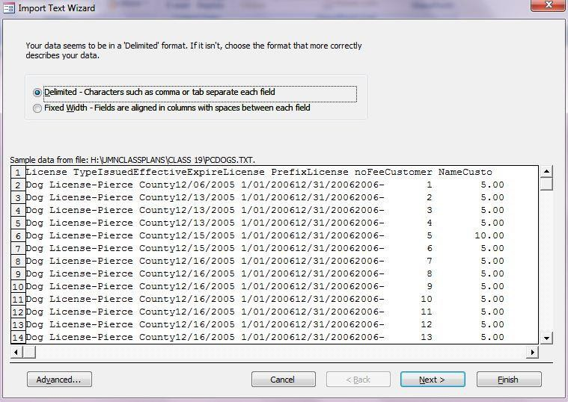

The second screen asks if the data is delimited or fixed-width. Delimited means that the columns are separated by some character that serves as a delimiter – this is typically a comma, tab, semi-colon, or pipe. Fixed-width means each column has a set number of bytes. The exact number for each column would be reflected in the data’s record layout.

For PCDogs, the data is delimited. So choose that and say Next.

The third screen asks for several key things:

What is the delimiter? In this case it is a tab.

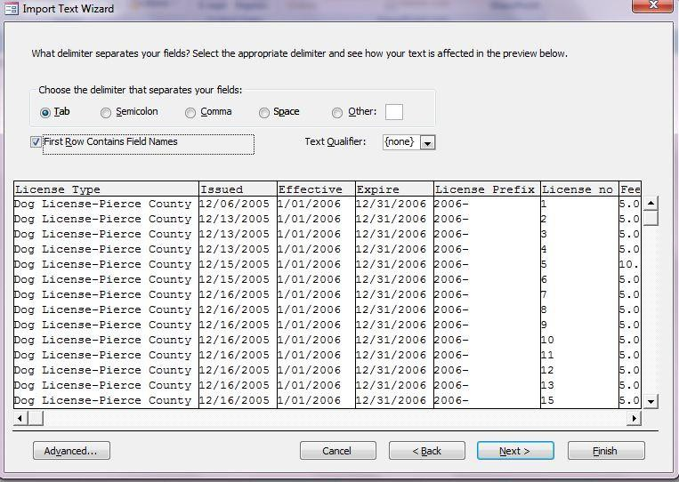Check the box that says “First row contains field names” because our data includes the headers in the top row.

It also asks if there are “text qualifiers.” This would be quotes or single quotes around any data that is designated as text. These are often used when there is a comma as the delimiter and some of the data contains a comma that is part of the actual data. For example a field that says “101 Main St., River Falls”. We don’t have text qualifiers in PCDogs, so we’ll leave that set to “none” and hit the Next button.

The fourth screen gives you a chance to change the field headers and set the data types for each field. Access will guess at the data types, but sometimes it can be wrong.

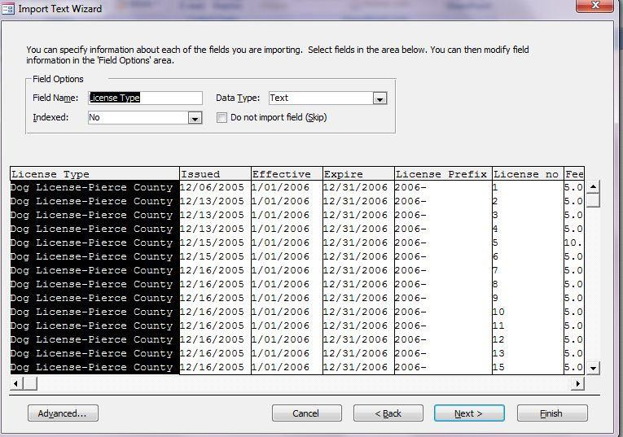For example, it will think zip codes are numbers. You will always want to set a zip code field to text because there are some zip codes in the US that start with zero – if it’s set to number, it will drop the leading zero.

You also want to set any ID number fields to text – especially if they contain leading zeros. General rule of

thumb, is that if it’s a field containing numbers that you would never do any math on, then set it as Text.

In this wizard, you can go from one field to the next simply by clicking on a field in the display window. Then it will allow you to edit the name and change the data type in the area just above the data display.

In PCDogs, look at the field called “License Prefix.” Access is guessing that it’s a number field.

But notice that it has dashes. If we leave this as a number field, Access will not import the contents of this field – the field will be there, but all the rows will be blank. So we need to change this to Text. General rule of thumb is that a number field cannot have any non-numeric characters (dashes, letters, symbols, etc)

As you scroll across the fields in PCDogs, you’ll notice there are a whole bunch of fields on the far right that don’t have a header name and don’t seem to have any content. This is common, especially when the data comes from an Excel file (this data was originally in Excel and I converted it to text for the sake of this exercise). I think this happens when somebody has content in those fields and later deletes it.

In this case, we have all these fields that will be blank. But in the wizard we can check the box that says “do not import field (skip)” for each of these fields. When finished, click Next.

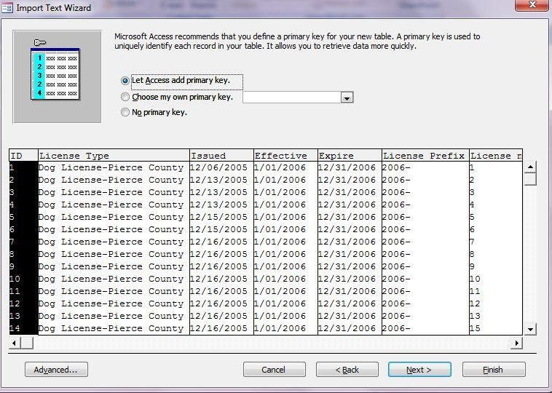The fifth screen asks if you want to add or choose a “primary key.” This would be a unique ID number. If you choose to add one, Access will add a new field on the far left and give each record a number, starting from 1. If your data already has a unique ID field (perhaps one that the agency provided), you can choose that from the pull-down list. Or you can simply go without and choose “No Primary Key.” The database will work just fine without one. There are lots of good reasons

– especially when you are a newbie to Access – to have a unique ID

field on each record. So I’d recommend adding one here.

The sixth screen asks you to name the new table.

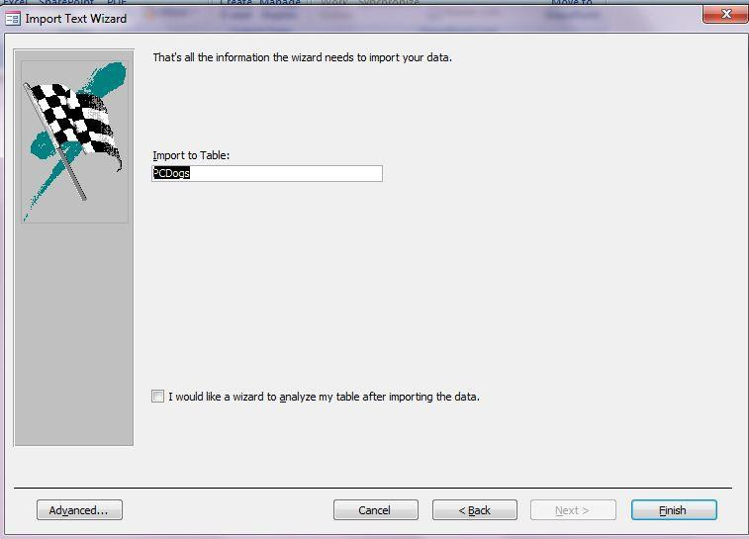

The 7th screen allows you to save your import procedure.

Also note on this screen shot that it’s giving me a message that I had “import errors” and it’s telling me that there’s a table in my database showing me what errors occurred.

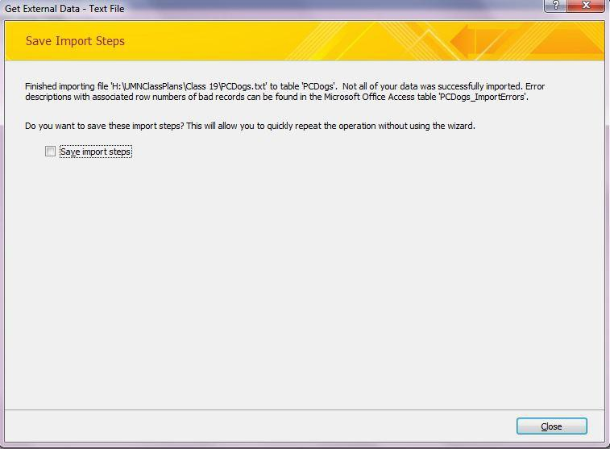These errors are because I didn’t set the license prefix field as “text” so the table shows each record number and then tells me that the field called “license prefix” had a problem. It doesn’t specify what the problem was – just that the import failed.

If you don’t have any errors, you’ll still get a similar screen – it will simply say the import is complete and was successful.

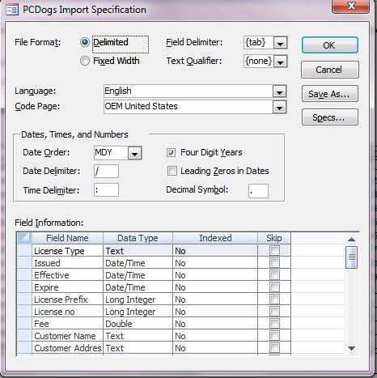If you’re worried at all about the consistency and quality of the data, you should import every field as a Text format (even if you later want it stored as a date or number). If you choose date or number for a field during an import, and one or more of your records has text in it (perhaps one record says “NA” where information was not available), that field will be empty on your imported table. It’s better to retain that information, so that you can deal with it (particularly if it’s just a typo…maybe someone accidentally put a letter in between two numbers). If you do import everything as Text, you will need to convert your fields later to the appropriate format.

**Advanced:**

If you have multiple files with the same structure that you need to import, either at one time or repeatedly over the course of time, you should use the Advanced button in the Wizard.

Here you can set the field names, widths (if fixed-width), types and other parameters. When finished choose “Save As” and this will save the specifications (it will ask you to name the specs).

The next time you need to import using these specs, go to the advanced button once you’re in the Wizard and choose “Specs” and you can choose those specs that you saved. Once you have chosen them, it will apply it to your new data file.

**File Types:**

Text files (.txt, .tab, .csv, .asc) – basic text files.

Microsoft Access (.mdb) – this is the “shell” that you created to store your information. You can import a table from one “shell” to another by choosing this file type in the import process.

Dbase III, 5, or IV (.dbf) – These are various versions of Dbase tables. Usually choosing Dbase IV will work for any version of Dbase. If it doesn’t, try one of the others.

Microsoft Excel (.xls or .xlsx) –Excel document.

HMTL documents (.html, .htm) – Access allows importing of HTML web pages, however this is more complicated and they won’t go directly into a table necessarily.

You can also import files from Outlook (like your address book), Lotus Notes or Paradox. The ODBC databases option requires more advanced set up, but would allow you to link to data tables stored on a remote server.

NOTE: Importing an Excel file or a file that has a .csv extension on it does NOT let you set the field types (date, text, etc). Sometimes this can pose a problem. For example, let’s say your data has an ID number that has a leading zero on it (i.e. “00310246”), the import process might treat it as numeric and when it comes in, it will strip off the leading zero(s). If this is happening, the only course of action is to open the file in Excel and save it as a .txt file (not a .csv). If it’s a .csv file you can just rename the file and change the extension to .txt instead of .csv.

**Data Types (most commonly-used):**

Text –Use for anything with alpha digits or to preserve leading zeros, such as on zips. Limited to 255 bytes.

Integer – use this if you have a field with single-digit numbers and no decimal places. Long Integer – use this for longer numbers, without decimal places.

Double – Use this for any numbers with decimal places (you can set the places once the table is imported)

Memo – This is used for long text fields that have more than 255 bytes

Currency – This will give you a dollar sign and two decimal places

Date/Time – This has many options for how the date and/or time appears. On the import it won’t give you any options, but will merely pull the information in as it appears in your data file. Once in the table, you can adjust the appearance.

Yes/No – Use this if you want a check box for a yes or no answer. Memo – Use this for a very long block of text (more than 254 bytes).

Hyperlink – With this format, a web address will be stored as a hyperlink and clicking on it from your data table will launch that site through your web browser.