Excel: Pivot Tables

You have a powerful summary tool with a Pivot Table. It’s much like a Totals, Group By or Summary query in a database manager, but it allows even more flexibility. This is one of the best tools you will find in Excel, although many beginners find it intimidating. But it shouldn’t be. It’s the best way, using Excel, to summarize large amounts of data.

You can follow along using data called “MLBPayrolls2009_2011.xls”

In that Excel file, there are two worksheets (look in the lower left corner) – one called “MLB Payrolls” and the other called “Twins-Brewers.” Click on “Twins-Brewers” and you’ll see that there is one record for each player on each of those two teams in the year 2011.

We need to use Pivot Tables if we want to ask questions such as: How much did each team spend on their payrolls in 2011? What’s the average pay for each position?

Before we start a Pivot Table, let’s do a little housekeeping. Make sure your data doesn’t have any blank rows or blank columns in the middle of it. Make sure all columns are labeled (this is crucial) and ideally you want simple and short labels. Make sure any “total” rows or notes are separate from your data – make sure that there is a blank row separating your data from these totals or notes or any other extraneous information that you don’t want tallied up in the totals or averages we are going to generate with a Pivot Table.

To start a Pivot Table, you need to make sure your cursor is somewhere inside your data (alternatively, you can highlight your data, including the headers), then go to the INSERT ribbon and choose “Pivot Table” (it’s on the far left)

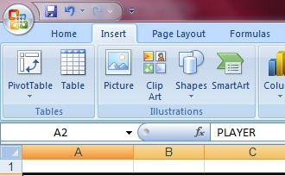

It will bring up a dialog box called “Create Pivot Table” and it will first ask you to

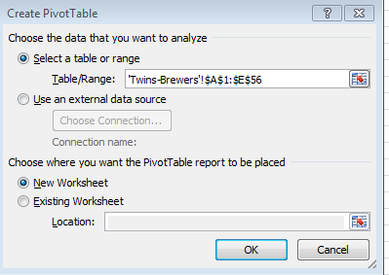confirm the location of your data. The default should be “select a table or range” and you’ll see that it is using cell addresses and the name of the worksheet to identify where your data is stored.

At the bottom of the dialog box it asks where you want the new pivot table stored. The default is in a new worksheet, which I recommend.

**Next** it will bring up the new worksheet and give you a blank canvas on the left like this (depending on your version of Excel, it might say “Drop Data Items Here” instead of “Value fields”):

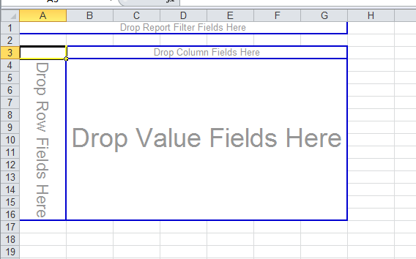

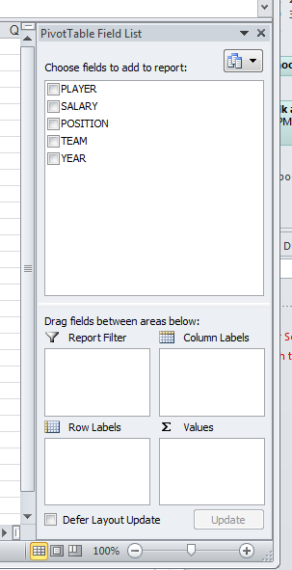Then on the right side will be a menu-like section with the various options for building your pivot table. Looks like this:

In the top box you’ll see your column labels (this is a big reason why you should ALWAYS label your columns!). Any columns that are not labeled simply won’t show up here.

At the bottom are four boxes that you can use to set up your pivot table. I’m going to refer to them quite often --Report Filter, Column Labels, Row Labels, Values

**Helpful hint:** As you’re working, the Field List and the four boxes on the right side of the screen might suddenly disappear on you. To get them back, simply click anywhere inside the Pivot Table results. (That pane vanishes if you click in any blank space in your worksheet)

There are two ways to design a Pivot Table – either using those four areas in the lower section, or by dragging items into the designer area.

I tend to use the four areas in the lower section, so that’s what I’ll show you here.

Let’s start with a simple Pivot Table. The data in the examples is player-by-player salary data for two baseball teams. It includes each player’s position and salary. I want to know the average salary for each position.

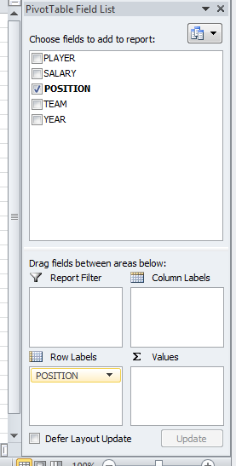To do that, click on Position in the list of fields and drag it into the “Row labels” box in the lower section.

Then you’ll notice that the list of various positions (catcher, outfielder, etc) are now in the designer.

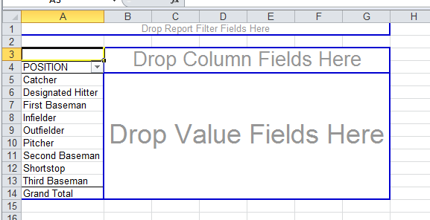

That’s exactly what we want. We want our answer to be a list of the positions – with just one row for each position – and then we want to show an average salary next to each one.

To do that, we need to put the salary in the “drop value fields here” section.

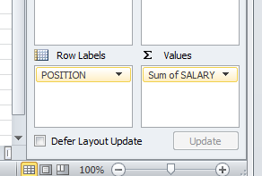So click on salary from the list of fields and drag that to the “values” section

Notice that it says “Sum of Salary”

But we want to calculate the average salary.

So click on “sum of salary” and you’ll get a menu – choose “Value Field Settings.  
 That will bring up this dialog box, where you can change it from Sum to Average.

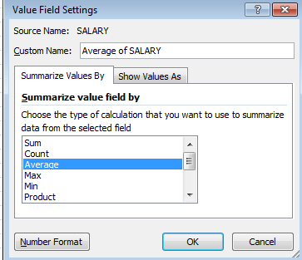

To sort your results:

Click on the first number in your answer and then up in the Menu bar (or the ribbons) you’ll see Pivot Table Tools- Options. In there are sorting options.

If you want to format your results – like convert this to Currency format – just highlight the cells you want to format and right-mouse click and choose “Format Cells”

MORE THAN ONE VALUE:

You can set up your Pivot Table to have more than one “value field.” In our example, we currently have the average salary by position. But we could add other values – such as the total salaries by position or the number of players in each position.

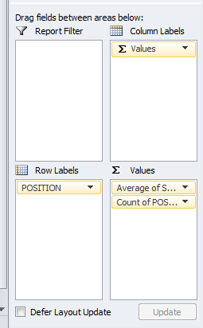

Let’s add the number of players. Since our data has one row for each player, we simply need to tell Excel to “count” the number of records by position. You can drag any column (from your list of columns/fields) into the Values section to do this count. I’m going to select “Position” and it automatically guesses that I want “Count of Position” (If I’m going to count, I prefer to choose a field that is text, rather than numbers, so that Excel doesn’t assume I want to “sum”)

Now you’ll have another column in your Pivot Table

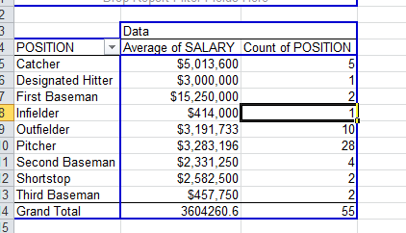

FILTERING A PIVOT TABLE:

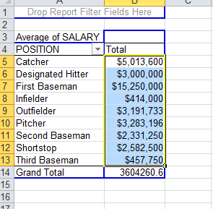Pivot Tables also allow you to filter your data and build a Pivot Table on just a sub-set of your data.

There are a couple different ways to filter.

1. Filter which “row” values are returned. For example, in the Pivot Table we just built showing average salaries by position, we might only want to see a couple of the positions. To do that, click on the little pull-down menu next to Position (in the Pivot Table result) and you’ll get a menu that allows you to uncheck whichever values you don’t want.
2. 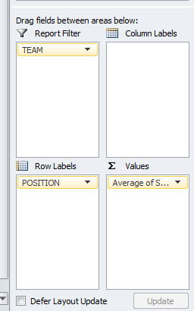If you want to filter on some other value that is not displayed in your data, you can do that using the “Report Filter” box in the lower right. For example, here we might want to filter to just the Twins. To do that, drag the “Team” field down to the Report Filter box.

Then you’ll notice a new element appeared above your Pivot Table.

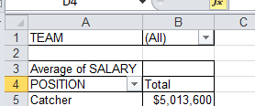

Notice that it says “(All)” – if you click that pull-down menu there, you’ll get a list of the various options. In this case, we can click “Twins” and it will change our Pivot Table to the average salaries by position for only players on the Twins team. Or we can choose “Brewers” and get that team’s averages. Or you can check the box that says “Select Multiple Items” and you can keep or ditch more than one (that option doesn’t work well with this example since we only have two teams…but imagine if this was for the whole MLB)

CROSS-TABULATION:

Another really useful way to use Pivot Tables is to generate a cross-tabulation. This is where you take two variables (or columns) in your data and generating summary data.

For example, in our baseball data we could leave “Position” in the Row Labels section, but then put “Team” in the “Column Labels” section and we end up with the average salaries by position, listed separately for each team (and then it also nicely gives you the overall averages for both teams combined)

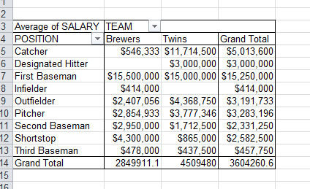

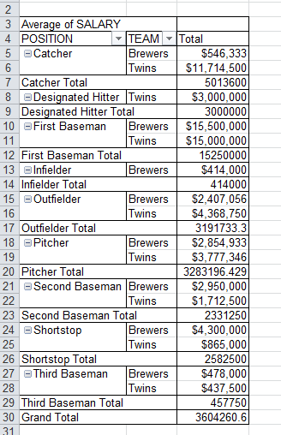You can also put more than one variable in the Row Labels section and it will kind of group your data. It depends what order you list the variables. So for example, if you move “Team” to the Row Labels (instead of the Column Labels), it will automatically fall below Position (which is already in our Row Labels area)

You’ll get this:

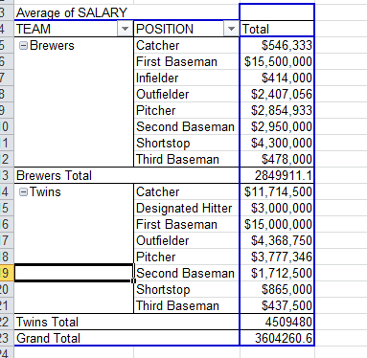But if you go into the Row Labels area and drag Position down – so it’s below Team – you’ll end up with a different look.

**Some other tutorials:**

Microsoft Office – [Create a PivotTable and analyze your data](https://support.office.com/en-za/article/Create-a-PivotTable-and-analyze-your-data-7810597d-0837-41f7-9699-5911aa282760?ui=en-US&rs=en-ZA&ad=ZA)

[Microsoft Excel Pivot Table Tutorial for Beginners](https://www.youtube.com/watch?v=peNTp5fuKFg) by Jon Flynn

[Excel Campus – Introduction to Pivot Tables, Charts and Dashboards in Excel](https://www.youtube.com/watch?v=9NUjHBNWe9M)

Created by:

@MaryJoWebster

Created: September 2015

- 4 -