QGIS basics:

**How to bring in an existing shapefile:**

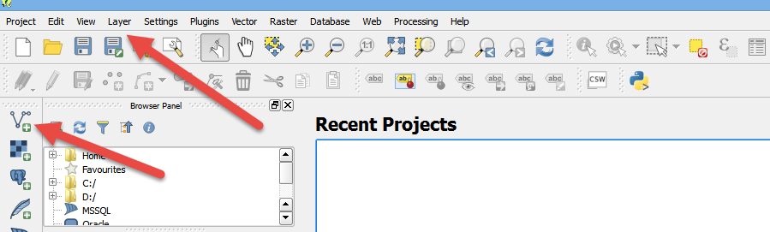Either use the “Add vector layer” button at the top of the buttons that run along the left side. Or go to the Layer menu and choose “Add layer” and then “Add vector layer”

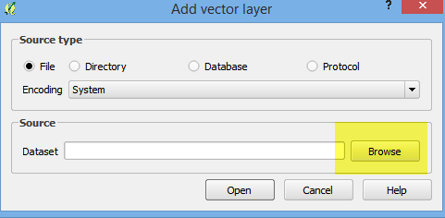On the next screen, push the Browse button to navigate to the folder where your shapefile is stored (and remember a shapefile consists of multiple files that work together. They must NOT be in a zipped or compressed folder)

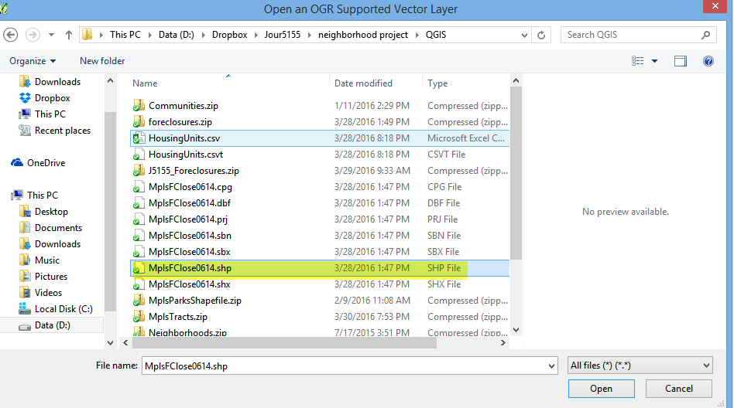When you find the layer, click on the file that has the .shp extension and then click the Open button.

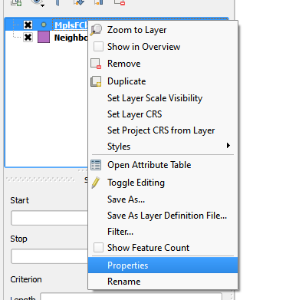Right-mouse click on the name of your layer (in the layers panel along the left) to get to key menus that you’ll use often. The main one is Properties.

Under properties, you’ll find various tabs along the left – General, Style, Labels, Fields, etc.

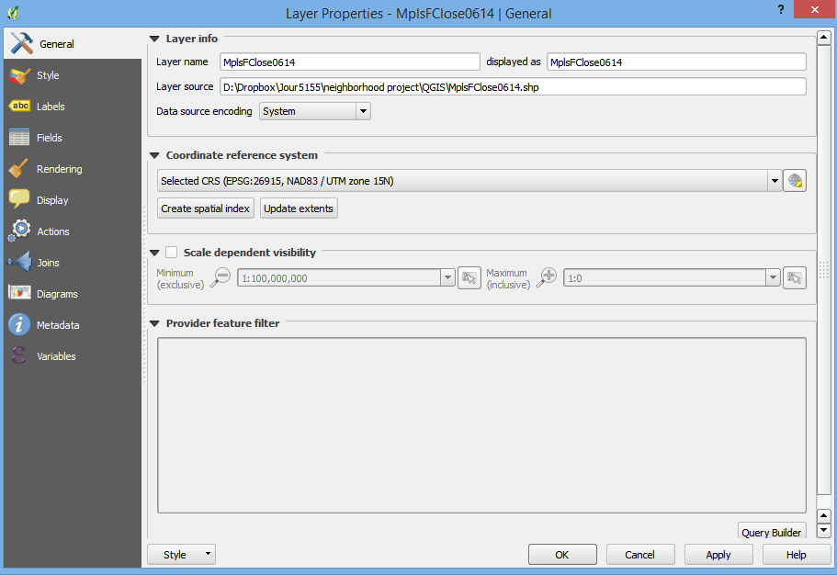

The previous image is showing the info that you can find under the General tab. This includes the folder where this shapefile is stored and the Coordinate Reference System. It’s important to know the CRS of your layers because your layers need to have the same CRS if you are going to do a spatial join, such as counting how many points fall inside each polygon. More about how to change a CRS later.

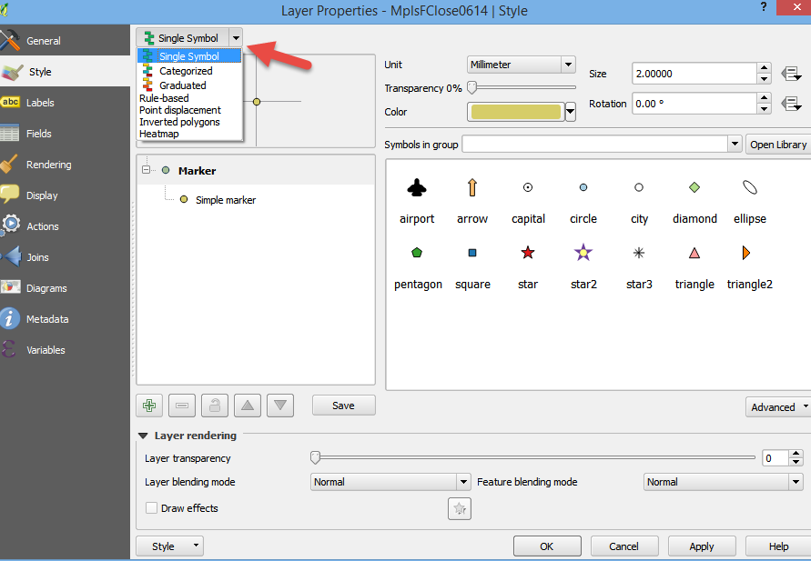Under the Style tab is where you go to change how your map is displaying – colors, etc. Click on the pull-down menu at the top to choose where it’s a single symbol (in other words, that all the points or polygons in that layer are styled the same), or categorized based on a field in your shapefile or Graduated colors (also based on a field in your shapefile). You can also choose a heatmap or some other options here.

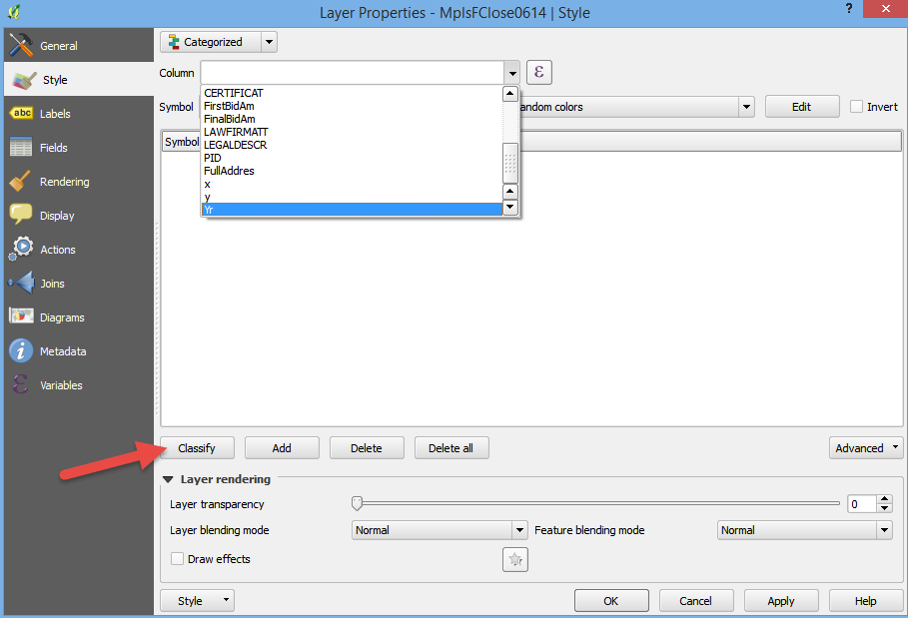If you choose Categorized or Graduated, you get a new screen that lets you pick which column to base it on. After choosing the column, it’s not quite obvious what to do next. You need to push the “Classify” button in order for it to set up the symbols it will use.

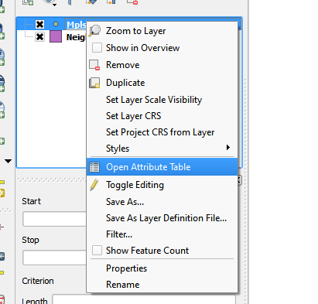Let’s close out of Properties.

Another useful thing is to right-mouse click on the layer again and this time choose “open attribute table.”

The attribute table is just a data table – one row for each item in your shapefile. In this case, we have a shapefile of points where sheriff’s sales occurred (foreclosures), so our attribute table is showing one record for each sheriff’s sale. And then we can also see all the various attributes – or fields of information – that we have about each sale.

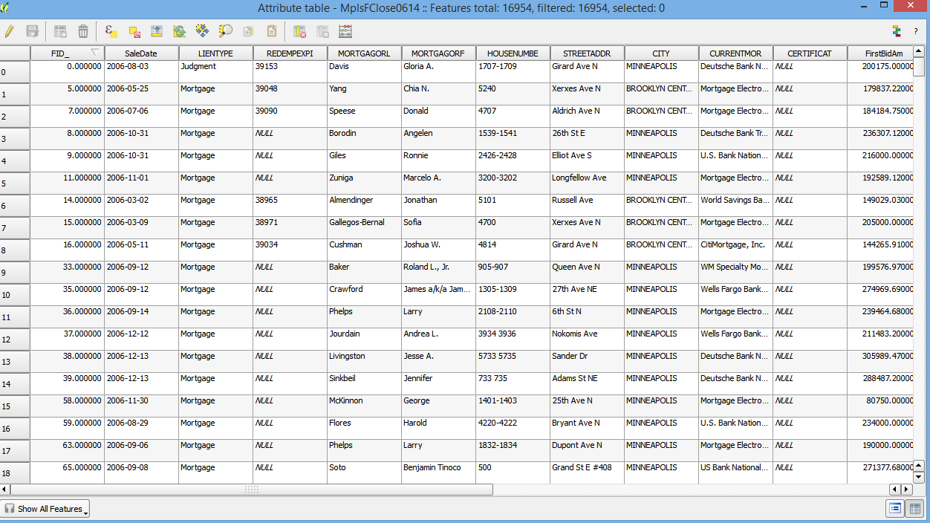

**How to add and edit a new field to our attribute table:**

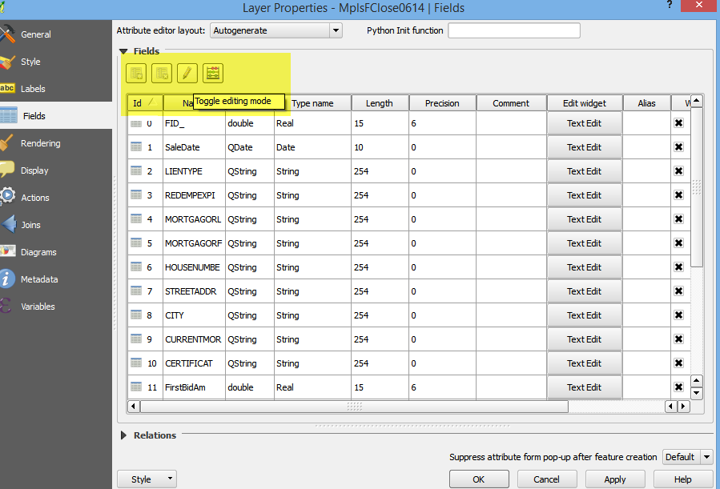First, go to Properties and click on the Fields tab. At the top you’ll see some buttons, including one that looks like a pencil (it’s call “Toggle editing mode.”) Click the pencil button to turn on editing. That will then enable the button on the left that lets you add a new column.

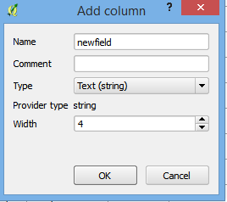Name your new column and set the type (string, number, date, etc) and the width.

The hit OK.

And then turn OFF the toggle editing button.

And say Yes when it asks if you want to save your changes.

Exit from properties.

Then right-mouse click on the layer and go to the Attribute Table.

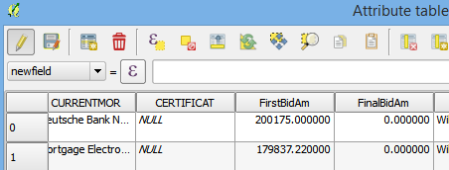In the upper left corner, you’ll see the pencil editing button again. Turn that on and a pull-down menu will appear just below it. That pull-down will contain a list of all the fields in your table, including your new field (most likely at the very end of the list). Choose the new field.

Then click the sigma button that is to the right of the equal sign. This will bring up an interface where you can write a little expression to dictate what to populate in the field. This is the same as running an Update query in Microsoft Access or some other SQL-based software.

In the middle area, open up the spot where it says “Fields of Values.” Here you’ll see a list of the fields in your table. In the left side pane, we’re going to write an expression that tells it how to populate our new field. You can truly do just about anything --have it transfer a value from another field; have it do some math between two or more fields, etc.

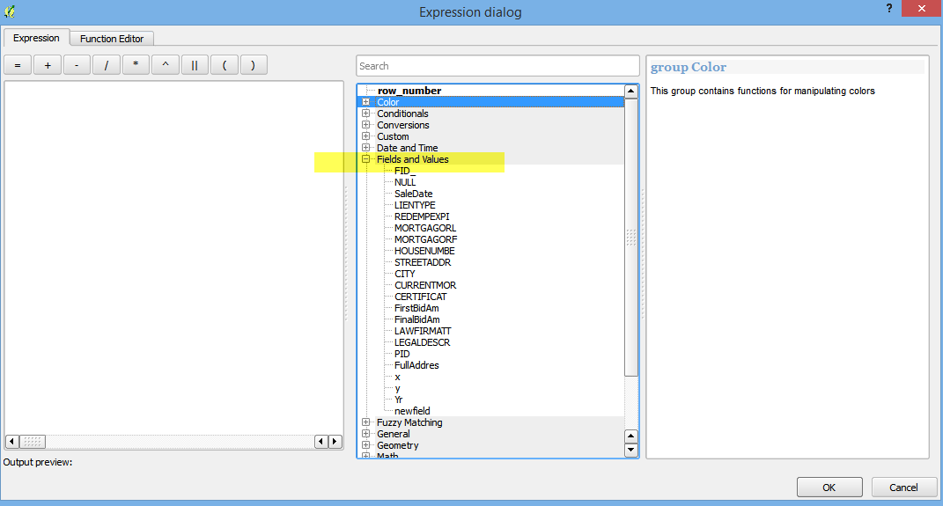

I’m going to have it pull just the year out of the SaleDate field. In this case, the left-most four digits of the Sale Date are the year. So I’ll have it do a string function.

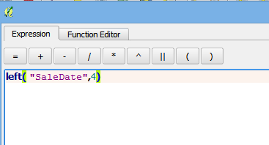You can find a list of potential string functions in the middle section where it says “String”. Double-click on “Left” and it will pop that into the pane on the left side of the screen. Then go to the Fields and Values and double-click “Sale Date”. Then you just need to add a comma and the number 4, and close the parentheses.

Hit the OK button to close the expression builder and you’ll be back to the table.

You’ll see your formula in the bar at the top. Next to it, push the button that says “Update all” in order to have it update the records.

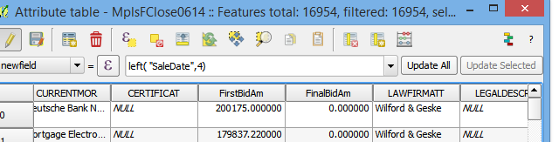

**Bringing a .csv data file into QGIS (without geometry):**

It’s quite common that we have some data – such as Census data – that we want to put into a map. But the data itself doesn’t have any geometry (no latitude, longitude) and isn’t a shapefile. We can bring it in, as long as it has a field that we can join or match to an existing shapefile.

For example, I have a small data file with the number of housing units in each area of Minneapolis (known as “communities”). My data just has two fields – the name of the community and the number of housing units.

I also have a shapefile with the community polygons and that also has a field with the name of the community (I also made sure the community names are spelled the same in each file)

QGIS is a little picky though about data coming in. Two key things:

1. It really only likes comma-separate values (.csv) files
2. 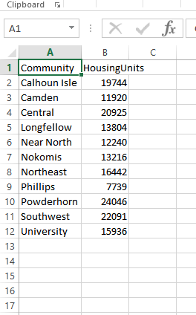You need to have a sister file, called a CSVT file, that tells QGIS the field types for each of your columns

So here’s my .csv file:

You can see I have a text field and an integer field.

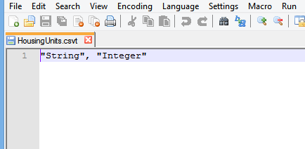Open a text editor – such as Notepad or Notepad++ -- and list the field types in the same order as they appear in your csv file, separated by commas. Use “string” for text fields, “integer” for numeric fields that don’t have decimals and “real” for numeric fields that have decimals and “date” for date fields.

Save this file so that the name of the file exactly matches your csv file, but make the extension .csvt

Make sure this file is in the same directory as your .csv file.

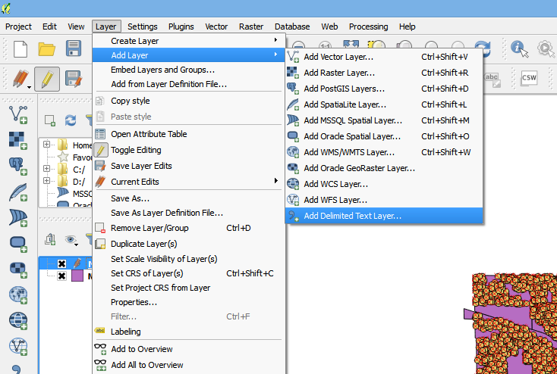In QGIS, go to the Layer menu and choose “Add Layer” and then choose “Add delimited text layer”

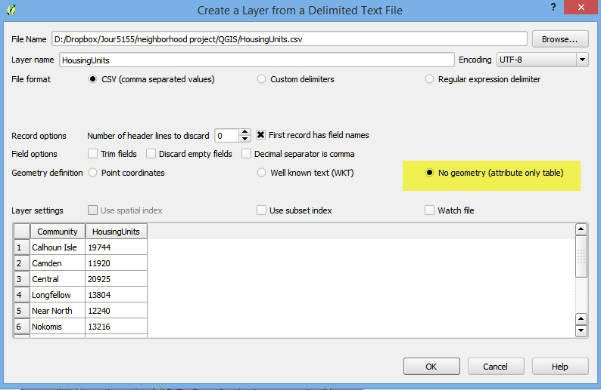Browse to your .csv file and then you’ll need to adjust a couple settings. The main thing is that you want to make sure the “no geometry” radio button is selected. Also make sure it has an X next to “first record has field names” . You’ll see a preview of your data at the bottom.

Click OK and you’ll see the text layer show up in the layer pane on the left.

**How to join the text layer to a shapefile:**

In this case, I want to join the housing units to a polygon shapefile I have called Communities.

So I’m going to right-mouse click on Communities and go to Properties. Then under the Join tab, look for the little green plus sign in the lower left corner.

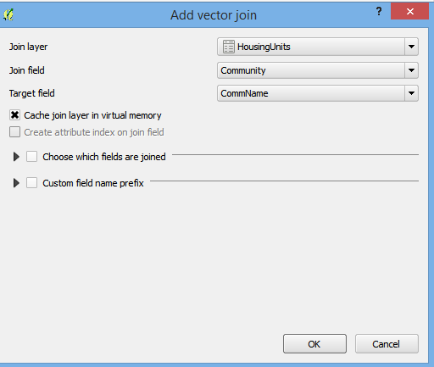In the “add vector join” box that comes up choose your text file as the “join layer” and then tell it which field in the text file matches to your shapefile (in this case, the field is called “community”) and then tell it which field in your shapefile matches (in this case, it’s called “CommName”)

Then click OK to exit that box. Then click OK on the Properties tab.

Now if you go look at the Attribute Table for the Communities shapefile, you should see the new field from the Housing Units csv file.

**How to change the CRS of a file:**

It’s pretty simple. You just need to save a new version of it and set the CRS as part of the save process.

Right-mouse click on your shapefile and choose “Save As”

In the dialog box that comes up, click Browse to tell it where to save the new shapefile and give it a name.

Then click on the World image next to the CRS pull-down to pick a different CRS.