DRAFT - IT Project Timeline (2-Month Delivery + Ongoing Services)

Total project duration: 2 months

Total agreement duration: 14 months

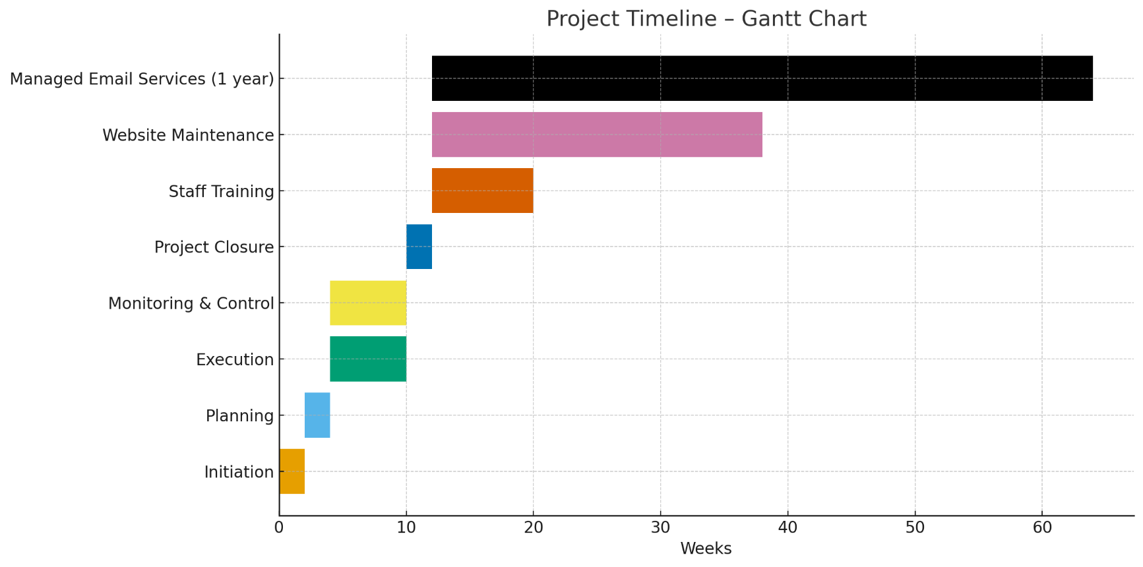

Month 1 – Initiation & Planning

Weeks 1–2: Initiation
- Conduct project kick-off meeting with the client.
- Confirm project objectives:
  - Construction of a simple website.
  - Implementation of Managed Email Services.
- Identify key stakeholders.
- Prepare and approve the Project Charter.

Weeks 3–4: Planning
- Gather all website functional requirements.
- Prepare initial website design (sitemap and wireframes).
- Develop implementation plan for Managed Email Services.
- Prepare detailed planning documents:
  - Schedule
  - Budget
  - Resource plan
  - Quality plan
  - Risk register
  - Communications plan
- Obtain formal approval for the project plan.

Month 2 – Execution

Weeks 5–8
Website Development
- Build the website structure, layout and navigation.
- Develop core pages
- Upload initial content provided by the client.
Managed Email Services
- Configure new email system.
- Conduct migration
- Set up devices and email clients.
- Perform initial functional testing.

Months 2–3 – Monitoring & Control (Runs in Parallel)

Weeks 5–10
- Hold weekly progress check-ins with the client.
- Review development milestones:
  - Website prototype
  - Email system testing
- Manage change requests.
- Perform quality checks on development and configuration.
- Apply system adjustments as required.

Month 3 – Project Closure

Weeks 11–12
Website
- Conduct final testing
- Apply final changes and obtain client approval.
- Launch the website.
Managed Email Services
- Conduct final user validation.
- Deliver configuration documentation.
Project Closure Activities
- Handover of deliverables.
- Final meeting and acceptance sign-off.
- Post-implementation review and lessons learned.

Post-Project Services

1. Website Maintenance – 6 Months (Months 4–9)
- Monthly monitoring and updates.
- Minor content updates.
- Technical maintenance, backups and security patches.
- Monthly status reports.

2. Staff Training (Three 4-Hour Sessions, Flexible Scheduling) – Months 4–6
- Session 1: Basic CMS use (editing content, uploading images).
- Session 2: Intermediate content management (new pages, layout adjustments).
- Session 3: Website upkeep, best practice and security awareness.

3. Managed Email Services – 12-Month Ongoing Service (Months 4–15)
- Ongoing technical support.
- Monitoring and incident resolution.
- Adjustments to configuration as required.
- Quarterly performance reports.

FINAL - IT Project Timeline (3-Month Delivery + Ongoing Services)

Total project duration: 3 months

Total agreement duration: 15 months

Month 1 – Initiation & Planning

Weeks 1–2: Initiation
- Conduct project kick-off meeting with the client.
- Confirm project objectives:
  - Construction of a simple website.
  - Implementation of Managed Email Services.
- Identify key stakeholders.
- Prepare and approve the Project Charter.

Weeks 3–4: Planning
- Gather all website functional requirements.
- Prepare initial website design (sitemap and wireframes).
- Develop implementation plan for Managed Email Services.
- Prepare detailed planning documents:
  - Schedule
  - Budget
  - Resource plan
  - Quality plan
  - Risk register
  - Communications plan
- Obtain formal approval for the project plan.

Month 2 – Execution

Weeks 5–8
Website Development
- Build the website structure, layout and navigation.
- Develop core pages
- Upload initial content provided by the client.
Managed Email Services
- Configure new email system.
- Conduct migration
- Set up devices and email clients.
- Perform initial functional testing.

Months 2–3 – Monitoring & Control (Runs in Parallel)

Weeks 5–10
- Hold weekly progress check-ins with the client.
- Review development milestones:
  - Website prototype
  - Email system testing
- Manage change requests.
- Perform quality checks on development and configuration.
- Apply system adjustments as required.

Month 3 – Project Closure

Weeks 11–12
Website
- Conduct final testing
- Apply final changes and obtain client approval.
- Launch the website.
Managed Email Services
- Conduct final user validation.
- Deliver configuration documentation.
Project Closure Activities
- Handover of deliverables.
- Final meeting and acceptance sign-off.
- Post-implementation review and lessons learned.

Post-Project Services

1. Website Maintenance – 6 Months (Months 4–9)
- Monthly monitoring and updates.
- Minor content updates.
- Technical maintenance, backups and security patches.
- Monthly status reports.

2. Staff Training (Three 4-Hour Sessions, Flexible Scheduling) – Months 4–6
- Session 1 - Core CMS Operations: Introduction to the content management system (CMS), including how to update text, replace or upload images, manage menus, and publish changes safely.
- Session 2 - Extended Content & Structural Updates: Creating new pages, adjusting layouts or page sections, managing reusable components, optimising media, and ensuring consistency with the site’s design standards.
- Session 3 - Ongoing Maintenance & Security Best Practice: Routine upkeep tasks, performance checks, backup awareness, plugin/theme updates, basic troubleshooting, and key security practices to protect the website over time.

3. Managed Email Services – 12-Month Ongoing Service (Months 4–15)
- Ongoing technical support.
- Monitoring and incident resolution.
- Adjustments to configuration as required.
- Quarterly performance reports.

