BSBXCS402 Assessment Task 2 - Project Portfolio V3 | ICT60220

Manuel Perez

28/05/2026

Section 1: Cyber security awareness and practices

Jotform: Cybersecurity Awareness Survey

Access Code: MIC_AD_of_IT2026
Section A - Password Habits
Q1 – One Choice
How often do you update your work account passwords?
- Only when required by the system
- Every 6 months
- Every 3 months
- Every month or more frequently
- I have never updated them

Q2 - Likert Scale
I use a unique and strong password for each of my work accounts and systems.

Section B - Phishing Awareness
Q3 - Multiple Choice
Which of the following would make you suspicious of an incoming email?
- The sender's domain does not match the company it claims to be from
- The email contains an urgent request for credentials or MFA codes
- The email contains an unexpected attachment or shortened link
- The email requests that you bypass a normal approval process
- None of the above

Q4 - Likert Scale
I feel confident identifying a phishing email or a suspicious link before clicking on it.
Q5 - Open-Ended (opinion)
In your opinion, what is the biggest gap in how the organisation currently handles phishing threats or suspicious communications?

Section C - Device and System Security
Q6 - One Choice
When you leave your workstation unattended, even briefly, what do you typically do?
- Lock the screen immediately
- Log out completely
- Leave it open if I plan to return soon
- I have no specific routine

Q7 - Likert Scale
I apply software and security updates on my work device promptly, without delaying or dismissing them.

Section D - Incident Reporting
Q8 - One Choice
If you suspected a cybersecurity incident had occurred on your workstation or account, what would you do first?
- Report it immediately to the IT or security team
- Inform my direct manager first
- Try to investigate or resolve it myself
- Wait to see if the issue resolves on its own

Q9 - Likert Scale
I know exactly how and where to report a cybersecurity incident within this organisation.

Section E - Policy Knowledge
Q10 - One Choice
Have you read and understood the organisation's cybersecurity policy?
- Yes, I have read it recently
- Yes, but it was a long time ago
- I have only read parts of it
- No, I have not read it

Q11 - Likert Scale
The cybersecurity training I have received so far is sufficient to handle threats relevant to my role.

Section F - Organisational Gaps (Opinion)
Q12 - Open-Ended
What one improvement would you suggest to strengthen cybersecurity awareness or practices in your workplace? Please be as specific as possible.

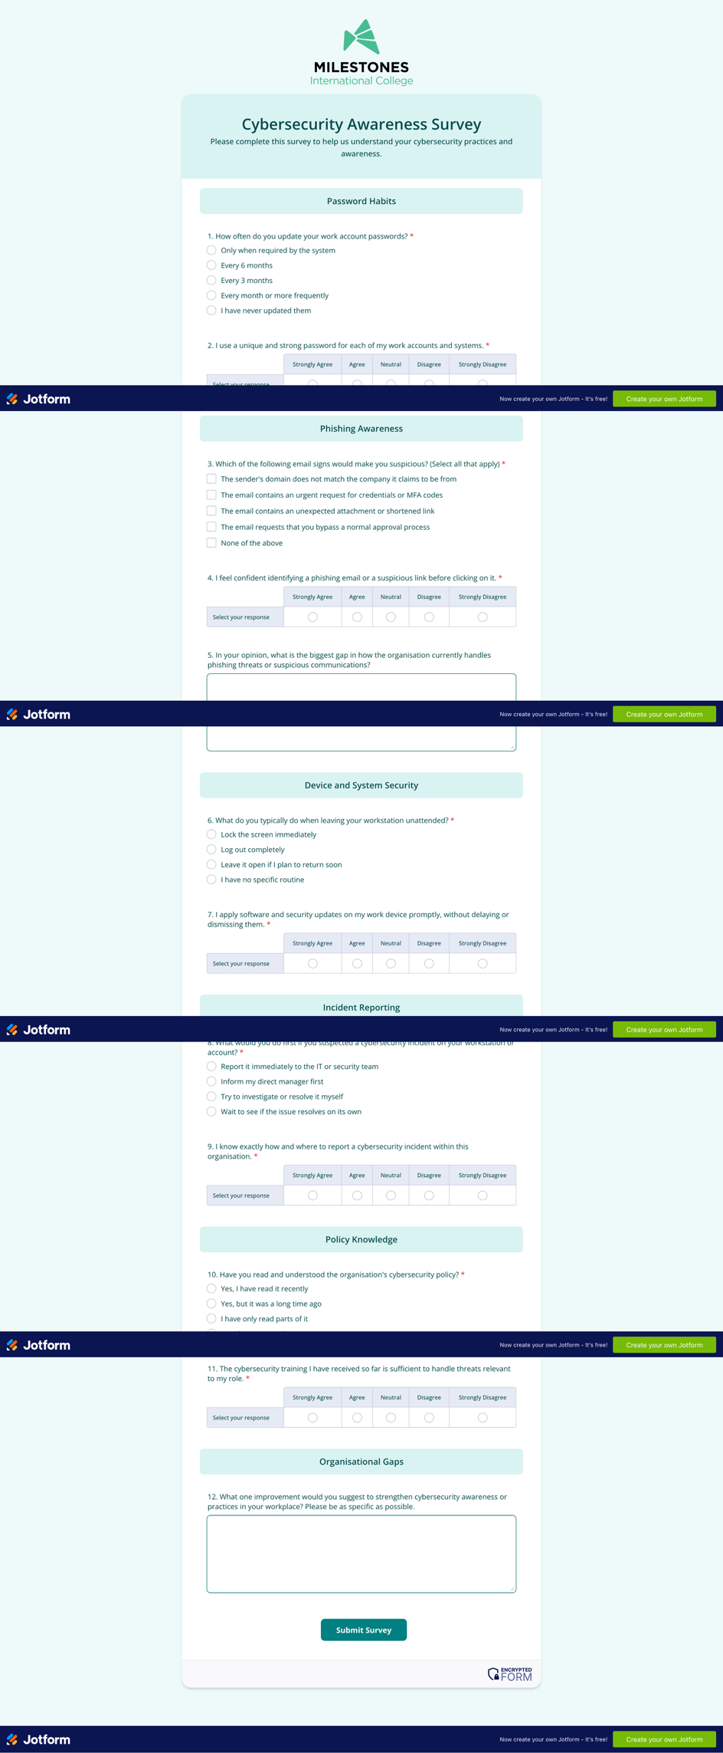

How the Survey Has Been Made Secure

This survey is administered via Jotform, utilising an enterprise-grade framework to ensure data confidentiality, integrity, and compliance with cybersecurity best practices.

- Data Encryption in Transit: All communications between respondents and Jotform servers are secured using HTTPS and TLS 1.3 (the current industry standard). This provides forward secrecy, eliminates legacy protocol vulnerabilities, and mitigates Man-in-the-Middle (MitM) interception or protocol downgrade attacks.

- End-to-End Encryption (E2EE): Leveraging Jotform Encrypted Forms 2.0, submissions are encrypted directly on the user’s device prior to transmission using RSA 2048-bit asymmetric encryption. The data remains unreadable to third parties and can only be decrypted using a private key held exclusively by the authorised form owner.

- Anonymity and Data Minimisation: To reduce the risk of a data breach, the survey is anonymous by design. No Personally Identifiable Information (PII)—such as names, emails, or employee IDs—is collected, strictly adhering to data minimisation principles.

- Access Control and Data Lifecycle: Access to the administration dashboard and collected response data is restricted to authorised personnel via secure credentials. All data will be permanently purged from the servers upon completion of the analysis phase.

Also, Jotform follows and meet high-security standards, including HIPAA, SOC 2, PCI Level 1, and GDPR.

Key Findings And Trends Regarding Cyber Security Awareness And Practices

The survey was administered to six participants within the organisation and covered five core areas: password habits, phishing awareness, device security, incident reporting, and policy knowledge. The findings reveal a workforce with pockets of strong practice, but with consistent and measurable gaps in areas that represent the highest cybersecurity risk.
Password Management
The most significant trend identified in this area is a reactive approach to credential security. Half of the respondents only update their passwords when forced by the system, and two individuals admitted to not using unique passwords across accounts, with one explicitly attributing this to fatigue caused by managing multiple system accesses. This pattern indicates the absence of a structured credential management tool or enforced rotation policy, and it creates a direct vulnerability to credential stuffing and account compromise.
Phishing Awareness
Confidence in identifying phishing threats is low to moderate across the group. Only two participants felt confident detecting a suspicious email before clicking, while three remained neutral and one strongly disagreed. Notably, one participant did not identify any of the listed phishing indicators as suspicious, which represents a critical individual risk. Staff identified process-bypass requests and unexpected attachments as the most recognisable red flags, but awareness of domain spoofing and MFA-harvesting attempts was considerably lower. Participants themselves identified the lack of dedicated phishing training, slow or ineffective filtering tools, and the use of personal devices for work access as the main organisational gaps.
Device and System Security
This was the strongest area across the survey. The majority of participants lock their screen immediately when leaving their workstation, and five of the six respondents apply software updates promptly without delay. These results suggest a positive baseline culture around physical and endpoint hygiene, though one participant acknowledged leaving their workstation open when planning to return shortly, which remains a risk in shared or open-plan environments.
Incident Reporting
A clear and concerning trend emerged in this section. Three of the six participants would report a suspected incident to their direct manager rather than the IT or security team, and one participant would attempt to investigate or resolve the issue independently. This behaviour can delay the containment of a threat and, in serious cases, destroy forensic evidence. While four participants indicated they know how to report an incident, two remained neutral, suggesting that the reporting channel exists but has not been communicated consistently or tested in practice.
Policy Knowledge and Training
This area produced the most critical findings. Only two participants have read the cybersecurity policy recently, three have only read parts of it, and one has not read it at all. This means the majority of staff are operating without a full understanding of their obligations. This is compounded by the training results, where half of the respondents consider the training they have received to be insufficient or outdated for their role. Participants suggested that training would be more effective if delivered through realistic simulations, simpler language, and gamified formats, with three respondents specifically requesting internal phishing simulations as a practical learning tool.
Overall Trend
The overarching trend identified across the survey is a gap between technical controls that exist in policy and the actual awareness and behaviour of staff. Where processes have been made visible and reinforced through daily use, such as screen locking and software updates, compliance is high. Where processes are less visible, less practiced, or poorly communicated, such as incident reporting channels, policy reading, and phishing response, significant gaps remain. These findings directly informed the development of the cybersecurity policies and procedures included in this portfolio.

