Progress Report

Project Details

Manuel Sergio Perez Espitia
16/11/2025

Milestone International College MIC - ICTICT608 - Case Study – IT BIZ SOLUTIONS

Project name | Grow Management Consultants
Location | 59 Farr St, Rockdale, NSW-2216, Australia
Duration | 3 months + 1 year (15 months + ongoing services)
Reporting period | Progress Week 4
Report compiled by | Manuel Perez
Date submitted | 17/11/2025

Summary

In summary, the project is progressing as expected. Activities began after the draft proposal was submitted. Of the initial services Simple Website Construction, Staff Training, and Managed Email Services Grow Management Consultants requested the termination of the Staff Training service and the addition of Website Maintenance for the next six months following the project's completion. Finally, we received the results of the survey, and overall, our client's perception is between good and excellent.

Activities & Outputs
Activity | Initial client consultation and needs assessment
Status | Achieved
Objective | To identify issues with the current website, the need for an upgrade, and the requirements for improved email communication systems as outlined by Paul Burns.
Activity | A background investigation was conducted to understand the client's needs.  The client's needs were analyzed, and the most suitable services were selected.  The client's existing Service Level Agreements (SLAs) were reviewed.  A proposal was submitted to the client outlining the selected services.  A detailed cost estimate was presented.  Finally, a timeline was created with the project schedule.
Progress | phase 1 - week 0
Outputs created | A profile was created based on the client's background and SLAs.  A service package tailored to the client was developed.  An agreement was sent to the client.  A timeline with the activity schedule was sent.
Activity | Draft proposal, agreement and SLA
Status | Achieved
Objective | To define the initial project scope, including a simple website build, one year of managed email services, and six months of website maintenance.
Activity | Versions 1.0 of the proposal, agreement, and SLA updates were completed. They were reviewed and approved by the client.
Progress | phase 1 - week 0
Outputs created | The client agreed to start the project
Activity | Confirmation of project objectives and client expectations
Status | Achieved
Objective | phase 1 - week 0
Activity | To ensure that both the client and the project team share a clear, consistent, and formally agreed understanding of the project’s objectives, scope, deliverables, timelines, and expectations before progressing to the next phases of work.
Progress | Clarification of core project deliverables  The client confirmed the three primary objectives: a simple modern website, a 12-month managed email service, and six months of website maintenance provided directly by IT Biz Solutions.  Alignment meeting to validate expectations and timelines  A formal meeting was held with the client to review timelines, scope boundaries, and the expected pace of delivery, ensuring all parties shared the same understanding of the project schedule.  Adjustment of proposal and SLA based on client feedback  Following concerns about staff workload, the client requested removal of internal staff training from the scope. The proposal and SLA were updated accordingly, incorporating a six-month post-launch maintenance period.  Confirmation of communication and approval processes  The client approved the reporting cycle, communication channels, and decision-making points, establishing clear expectations for progress updates and approvals.  Formal sign-off of updated project scope  The refined project scope including deliverables, constraints, responsibilities and post-project services was documented and formally approved by the client.
Outputs created | Client Communication and Approval Record
Activity | Collection of website content and business information
Status | Challenges
Objective | To gather text, images and business resources from the client and the Administration Assistants to support the structure and content of the new website.
Activity | phase 2 week 1-2
Progress | The administrative assistants, who help gather information and were originally going to maintain the website, are overloaded. As a result, the process of obtaining the graphics is experiencing delays; however, the overall progress of the project is on schedule.
Outputs created | No action has been initiated; the client is expected to catch up on this activity.
Activity | Delivery of Training Sessions
Status | Achieved
Objective | To provide initial training to the administrative staff and assess their capability to maintain the website as originally requested by the client.
Activity | phase 1 to phase 3 - week 0 - 4
Progress | 4 out of 8 sessions were completed. The client requested changes to the agreement
Outputs created | Four sessions were billed and the SLA was updated. Website maintenance service was added, which has a duration of six months.
Activity | Review of initial client feedback and approval of homepage
Status | Achieved
Objective | To incorporate early feedback from the client and confirm that the homepage design meets expectations before advancing with the remaining pages.
Activity | phase 2 week 1-2
Progress | Development progress is going well; the home page received client approval.
Outputs created | The team designated by the team is focused on the tasks of collecting images for the activity of Collection of website content and business information
Activity | Completion of full website design
Status | Achieved
Objective | To finalise the full website layout, content structure and initial visual design.
Activity | phase 3 week 3-4
Progress | Finalisation of the site map and navigation flow  The complete site map was finalised, defining all primary and secondary navigation paths to ensure a clear and intuitive user experience.  Approval of wireframes for all key pages  Wireframes for the homepage, service pages, contact page and secondary content pages were created and approved by stakeholders.  Design of the visual style guide  A full visual style guide colour palette, typography, iconography and spacing rules was completed and endorsed for use across the entire website.  Layout design for desktop and mobile views  Responsive layouts for all major screens were designed and validated, ensuring visual consistency across devices.  Image and media asset selection  All required imagery and media elements were selected, edited and incorporated into the final design files.  Branding alignment review  A full review and alignment check was conducted to ensure all page designs complied with Grow Management Consultants’ branding guidelines.  Stakeholder design review and approval  A final design review session was held with stakeholders, and all page designs were formally signed off.
Outputs created | The full website design package was finalised, including page structure, content layout, and visual wireframes. This allowed the project to move into the planning and development phases.
Activity | Definition of managed email services structure
Status | Achieved
Objective | To design the architecture of the managed email service using elements from previous similar projects to accelerate delivery.
Activity | phase 3 week 3-4
Progress | Identification of email service requirements  The client’s operational needs, number of users, mailbox size requirements and security expectations were fully documented and confirmed.  Selection of the managed email platform  The final email platform (hosting environment, protocols, and integration method) was selected based on reliability, security and compatibility with the client’s systems.  Configuration standards established  Standard configurations for mailboxes, aliases, forwarding rules, spam filtering, security settings and backups were defined and approved.  Access and authentication model defined  The authentication method (password policy, two-factor authentication, and admin access levels) was established to align with security best practices.  Email domain and DNS requirements documented  Required DNS updates were identified and prepared for implementation.  Service management workflows created  Processes for account creation, user changes, password resets and incident management were documented for ongoing operational support.  Service scope and limitations clarified  The boundaries of the 12-month managed service including support hours, escalation method and maintenance windows were finalised and communicated.
Outputs created | The email service structure was fully defined, enabling configuration work to begin in Phase 5. This structure was incorporated into the updated SLA.
Activity | Development of the detailed schedule for website build
Status | Achieved
Objective | To establish the sequence of activities and timeframe required to deliver the website within the agreed deadlines.
Activity | phase 4 week 5
Progress | Breakdown of all website components and deliverables  A full list of required pages, assets, features and technical tasks was created to define the complete scope of the website build.  Allocation of timelines for each development phase  Timeframes were assigned to content creation, front-end development, back-end configuration, testing and deployment, ensuring a structured weekly schedule.  Dependency mapping and sequencing of tasks  Key dependencies such as design approval, content delivery and infrastructure readiness were identified and integrated into the schedule to avoid bottlenecks.  Assignment of responsibilities to each team member  Development, design and QA responsibilities were allocated to specific team roles, ensuring accountability and clarity.  Incorporation of stakeholder review checkpoints  Review milestones were added to the schedule, including prototype demonstrations, design validations and pre-launch approvals.  Risk buffer and contingency time added  Contingency periods were included for potential delays such as slow content delivery, additional revisions or technical issues.  Final schedule approval meeting conducted  The full schedule was presented to stakeholders, revised based on feedback and formally approved for commencement of development.
Outputs created | A comprehensive build schedule was delivered and approved by stakeholders, providing clear timelines for development, prototyping, testing, and implementation.
Activity | Internal role allocation and content planning completion of website
Status | Achieved
Objective | To confirm team responsibilities and finalise content preparation before commencing the development phase.
Activity | phase 4 week 5
Progress | Assignment of internal roles for CMS management  Specific responsibilities were allocated to team members, including content editing, media management, quality assurance and publishing oversight.  Definition of content ownership and approval workflow  A clear process for drafting, reviewing and approving website content was established, ensuring that each page had an assigned content owner.  Completion of the website content matrix  A detailed content matrix was finalised, listing all pages, required text sections, images, metadata and responsible contributors.  Coordination with the design team for content alignment  Final content requirements were aligned with approved wireframes and design layouts to ensure accuracy and consistency across all pages.  Collection and organisation of final text and media assets  All final content, including written copy, images, documents and graphics, was collected, standardised and stored in the shared project repository.  Verification of content compliance with branding and tone guidelines  All content was reviewed for brand alignment, ensuring consistency in tone, terminology and visual identity across the entire website.  Stakeholder confirmation of content readiness  A final review session was held with stakeholders to confirm that all content was complete, approved and ready for integration into development.
Outputs created | CMS roles were assigned, and all content requirements were finalised. This ensured the team was prepared for full development in Phase 5.
Activity | Update of proposal, agreement and SLA based by client request
Status | Achieved
Objective | To reflect the client’s request for IT Biz Solutions to manage the website for the next six months and to remove staff training as an operational requirement.
Activity | phase 5 week 6-8
Progress | The client requested to terminate the "Staff training" service due to work overload, so website maintenance will be handled by us through the "website maintenance" service for 6 months.
Outputs created | The "Staff training" service has been completed and the "Website maintenance" service has been added. The agreement and SLA have been updated and sent to the client. The client has been billed for the training sessions conducted.
Activity | Components of website development
Status | In progress
Objective | To fully build the website according to the approved structure and design.
Activity | phase 5 week 6-8
Progress | Completed Tasks: Backend framework setup, Homepage build and styling, Global navigation and footer implementation  Development of internal content pages  Several subpages are currently in construction, with text and image placeholders being replaced using the final content provided by the client’s Administration Assistants.  Integration of media assets  Images, banners, and icons are being optimised and integrated into their respective sections, including About Us, Services and Contact pages.
Outputs created | Development of all website pages is underway. Updates to the proposal, agreement and SLA were completed to reflect the removal of training services and the addition of a 6-month maintenance service.
Activity | Configuration and deployment of managed email services
Status | In progress
Objective | To implement the managed email system, leveraging efficiencies from previous project configurations.
Activity | phase 5 week 6-8
Progress | Migration from the old system was done and now The hosting environment and core email service platform were configured, using optimised settings based on previous successful deployments.
Outputs created | Initial configuration has been completed and tested. Final deployment will occur during implementation (Weeks 11–12).
Activity | Prototype reviews with the client
Status | In progress
Objective | To validate the functionality and layout of the website and email system with the client before proceeding to testing.
Activity | phase 5 week 6-8
Progress | The homepage prototype was shown to the client, incorporating approved design, content placement, and basic navigation, now we are waiting feedback to ensure consistency across devices.  Documentation of agreed changes  Notes of client approvals, requested revisions, and decisions are being compiled to update the project schedule and SLA where necessary.
Outputs created | First website prototypes were presented to the client for review and refinement. Feedback is being implemented progressively during development.
Activity | Functional and compatibility testing
Status | Not started
Objective | To ensure the website and email system operate correctly across different devices and environments.
Activity | phase 6 week 9-10
Progress
Outputs created
Activity | Stakeholder review meetings
Status | In progress
Objective | To gather formal feedback from the client and internal stakeholders and identify any changes required.
Activity | phase 3 to phase 7 week 3-12
Progress | Weekly project status reviews with stakeholders address the most important issues for project progress. A survey is also conducted every eight weeks to evaluate the quality of our services.
Outputs created | We received feedback from the first survey, and the overall survey results indicate that our clients' perception is between good and excellent.
Activity | Corrections and system refinements
Status | Not started
Objective | To apply improvements and resolve issues prior to the final handover.
Activity | phase 6 week 9-10
Progress
Outputs created
Activity | Website launch and activation of email services
Status | Not started
Objective | To deploy the website and activate the managed email service for operational use.
Activity | phase 7 week 11-12
Progress
Outputs created
Activity | Delivery of final documentation and support materials
Status | Not started
Objective | To provide manuals, credentials, configurations, and all final project documentation.
Activity | phase 7 week 11-12
Progress
Outputs created
Activity | Handover and project close-out
Status | Not started
Objective | To formally transfer ownership of the deliverables to the client, complete administrative tasks, and close the project.
Activity | phase 7 week 11-12
Progress
Outputs created

Results

Survey Result
Client Feedback - Link: https://form.jotform.com/253182778722869
The results are as follows:
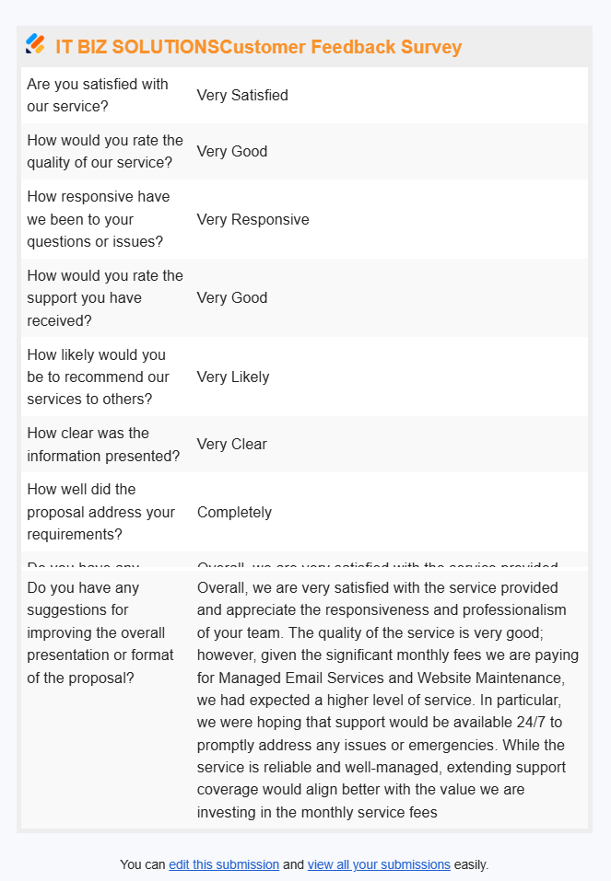
We received feedback from the first survey, and the client is happy overall, but excellence would be achieved by enhancing support coverage, reinforcing value, and proactively engaging to prevent any service gaps.
Based on the survey results, we are exploring ways to offer 24/7 service for critical infrastructure to small businesses, such as Managed Email Services and Website Maintenance. We are also considering extending our standard support hours.

Agreement and SLA Updated
Four weeks after the project began, the client formally requested via email that the Staff Training be discontinued due to the team's excessive workload. They requested a new proposal that included website maintenance services for six months.
This would give the client time to restructure the team's functions, or they could leave the maintenance to us. Finally, the client has been billed for the training sessions conducted.

Progress
The Week 4 report confirms that the Staff Training service was formally closed at 50% completion due to SLA changes and is now recorded as 100% complete for reporting purposes. Meanwhile, the Simple Website construction, which is 34% complete, is progressing as planned, with the homepage approved and all necessary content compiled despite the client team's internal workload. The client is satisfied with the progress and looks forward to the upcoming website launch.

The Managed Email Services are ahead of schedule at 40% complete, with setup accelerated by reusing previous work. The system is expected to be ready for management review in two weeks. The client has expressed confidence in the progress of all project components.
Finally, the chart shows Website Maintenance as not yet started, as the agreement takes effect after the project's completion.
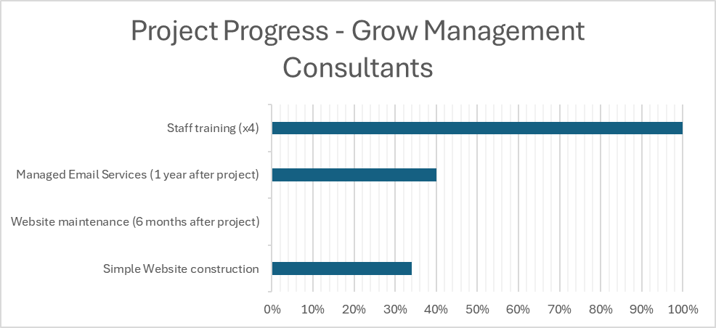

Budget
The initial budget was $9,600 as detailed in the following table:
Service | Fee | Monthly Fee | First Year
Simple Website construction | $ 5,000 | $ - | $ -
Staff training | $ 600 | $ - | $ -
Managed Email Services (1 year after project) | $ 1,600 | $ 200 | $ 2,400
Total First Year | $ 9,600

Following the SLA update, which included the Website maintenance service for 6 months and the completion and payment of 4 sessions of the Staff training service, the final budget is $11,700 for the first year of the agreement, as detailed in the following table:
Service | Fee | Monthly Fee | First Year
Simple Website construction | $ 5,000 | $ - | $ -
Website maintenance (6 months after project) | $ - | $ 400 | $ 2,400
Managed Email Services (1 year after project) | $ 1,600 | $ 200 | $ 2,400
Staff training (x4) | $ - | $ 300 | $ 300
Total First Year | $ 11,700

