Client Feedback
The results are as follows:
- Are you satisfied with our service? Client Response – Very Satisfied
- How would you rate the quality of our service? Client Response – Very good
- How responsive have we been to your questions or issues Client Response – Very responsive
- How would you rate the support you have received Client Response – Very good
- How likely would you be to recommend our services to others – Very Likely
- How clear was the information presented? – Very Clear
- How well did the proposal address your requirements? – Complety
- Do you have any suggestions for improving the overall presentation or format of the proposal? Overall, we are very satisfied with the service provided and appreciate the responsiveness and professionalism of your team. The quality of the service is very good; however, given the significant monthly fees we are paying for Managed Email Services and Website Maintenance, we had expected a higher level of service. In particular, we were hoping that support would be available 24/7 to promptly address any issues or emergencies. While the service is reliable and well-managed, extending support coverage would align better with the value we are investing in the monthly service fees

Link: https://form.jotform.com/253182778722869

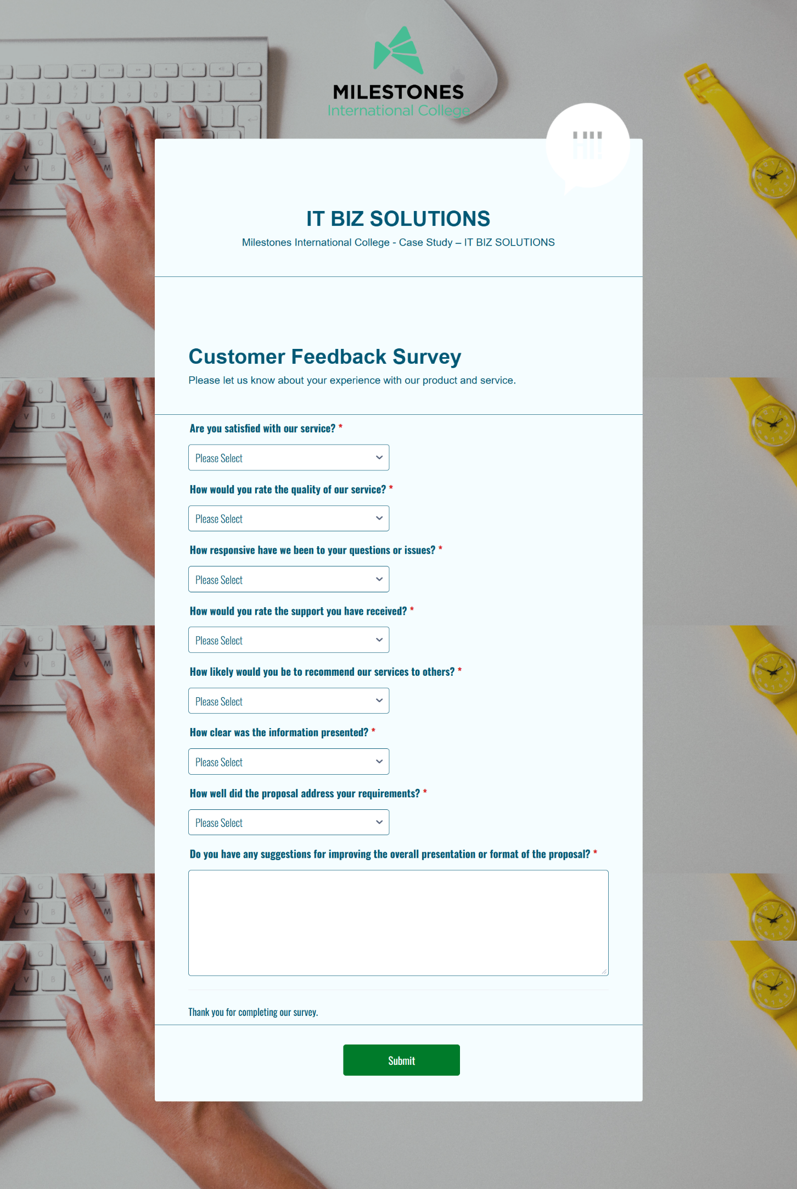

Response:

