The Gog We Trust



Second Assignment Report

<Mohammad Ghaderi>

<401222104>

Introduction:

In this assignment we are going to program a weather app that it has only one input and it's a name for the city that you want to know it's weather information.

* Well I think this assignment has three objectives:

1. First getting to know what git is(at least understand it basically)
2. In this assignment we used API to make a URL to send a request to the weather site to get the information in the String format then extract the data we need(Getting know what API is.).
3. Learn how to write a report.

* The approach which I have used(without considering GUI) was only write some simple functions for extracting things we need (for example: extract the temperature from the data that site gave to us.)

Design and Implementation:

This program is written by Java programming language.

The whole idea is that when the user input the city name we will make URL with our API_Key witch is different for everybody.

After that user input the city name and URL is maked we will send a request to the weather site(<https://www.weatherapi.com/>)

And it will send back a String witch has all the data of weather and some other information about the city in itself.

We will extract information which is interested to us (Like temperature) by "JsonObject".

And for this extracting information I have written 9 functions(Regardless of Main function and GUI.)

Functions which has been used are:

1. currentLocation function will extract the location that user entered.

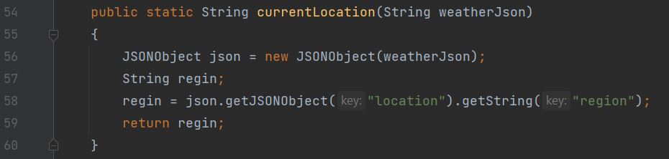

1. localTime function will extract and return the date and time of the current location that user entered:

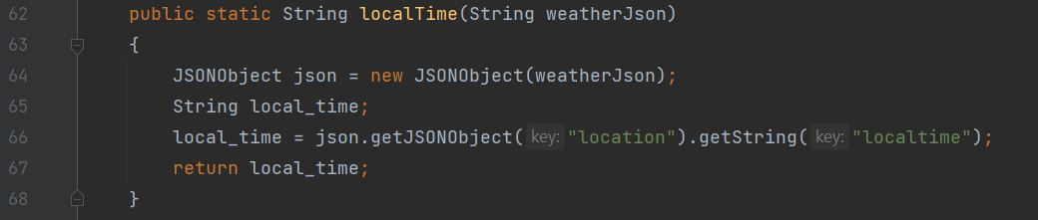

1. getTemperature function will extract and return the temperature (in celsius) from the "Json String" that weather site gave to us :

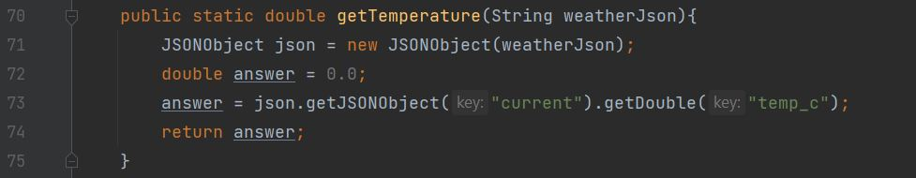

1. getFeelsLikeTem function will extract and return the temperature that feels like in the current location:

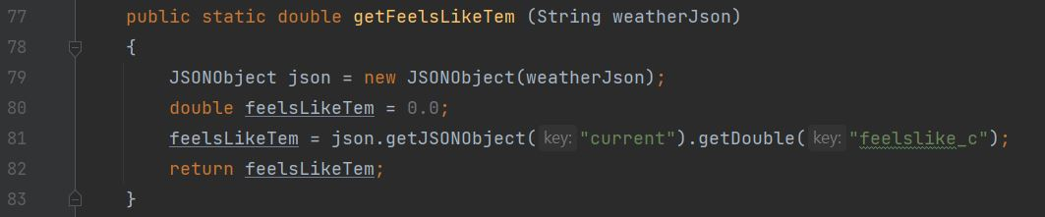

1. getHumidity function will extract and return the humidity in the current location which user entered:

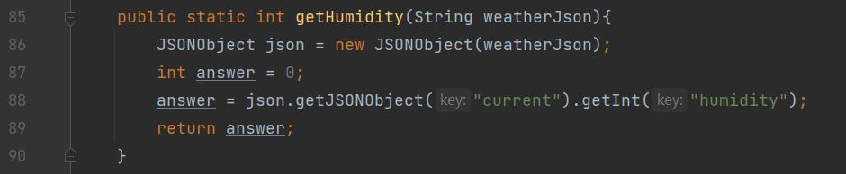

1. getWindSpeed function will extract and return wind's speed in the current location which user entered:

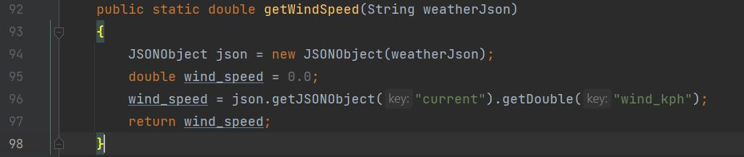

1. getWindDirection function will extract and return wind's direction in the current location which user entered:

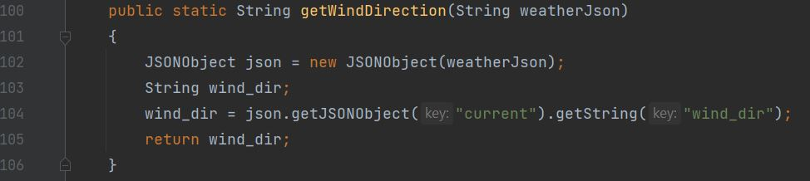

1. callAllFunctions function will call all the functions we have written even those functions that are for GUI.

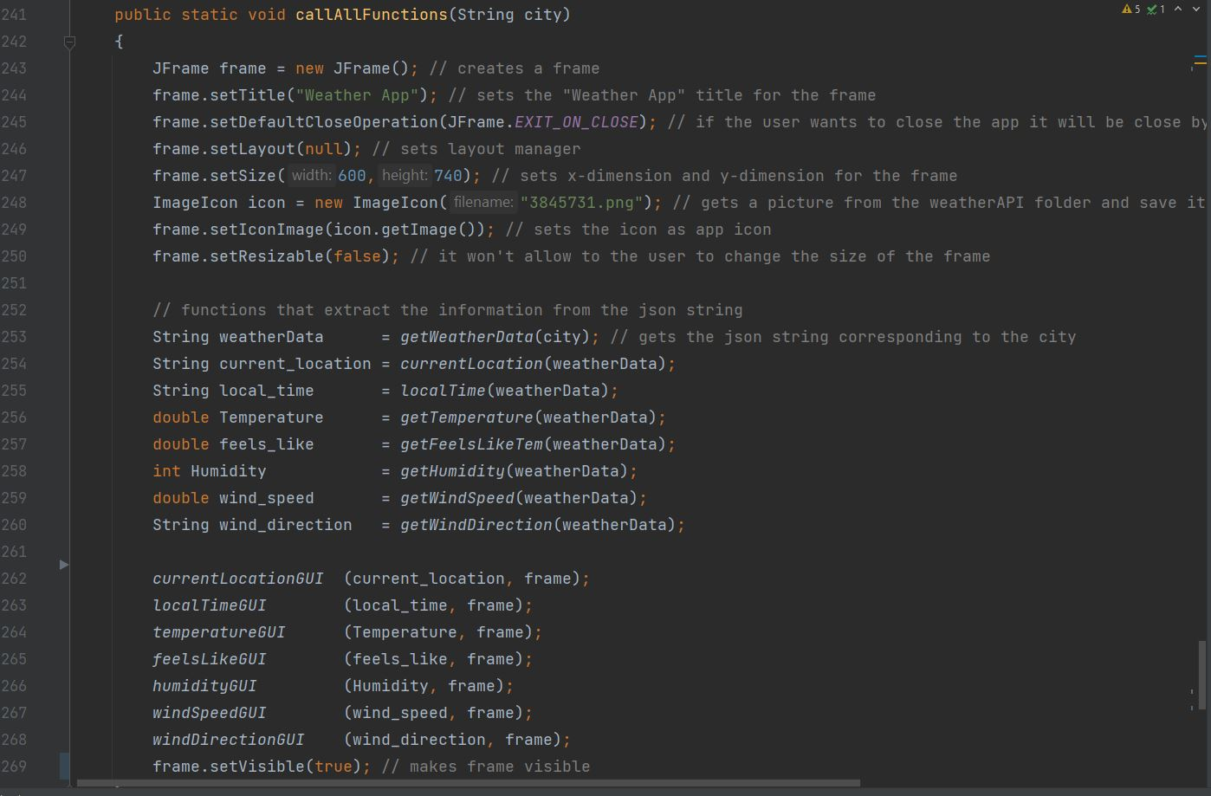

1. invaliInput function will return and make a graphical panel and display it to the user when the city name that user has entered in not find and invalid!

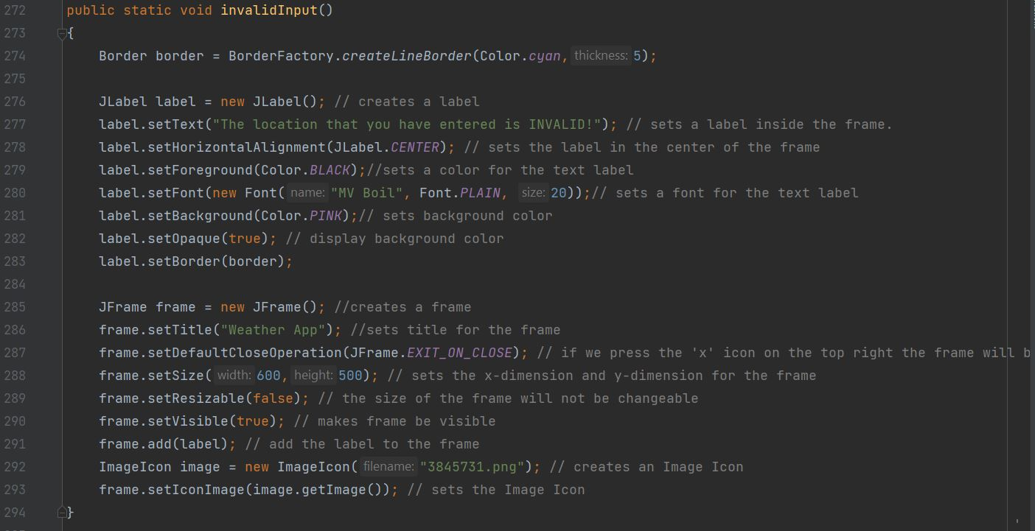

An overview on other functions:

1. getWeatherData function:

What this function dose is that make an URL and the API-key that you get from your account on weather site the city name .

After that this function will send a request to the weather site and then get a "json string" as a response.

It’s the same "json string" that we were talking about in a few pages back.

If the city name was incorrect then this function will return a null string.

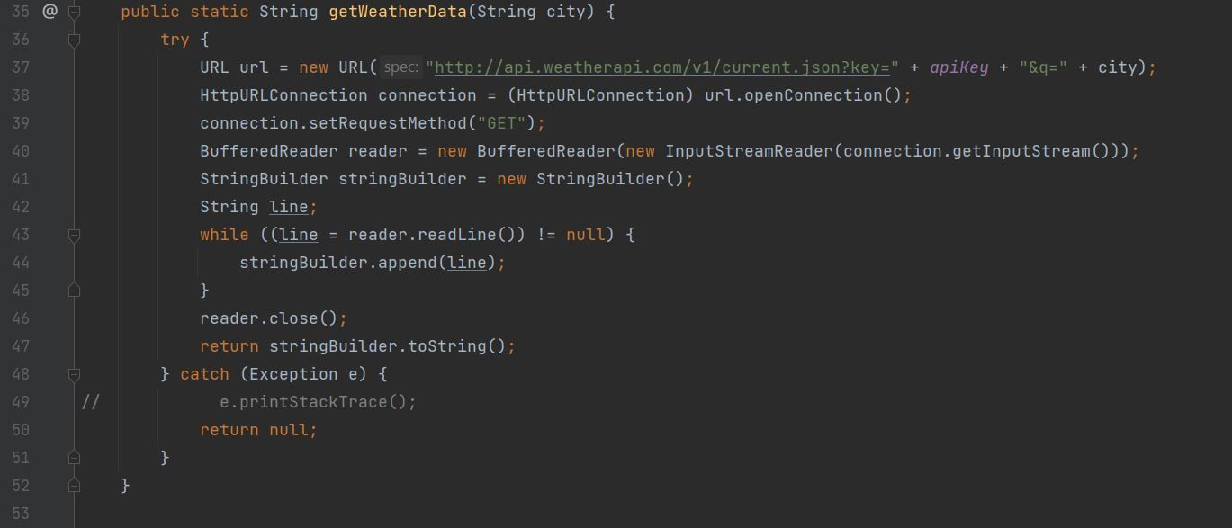

1. GUI functions:

We have 7 functions that help us to show our information in graphical frame.

Here I will explain the first one of these functions because all of these 7 functions are the same:

currentLocationGUI function:

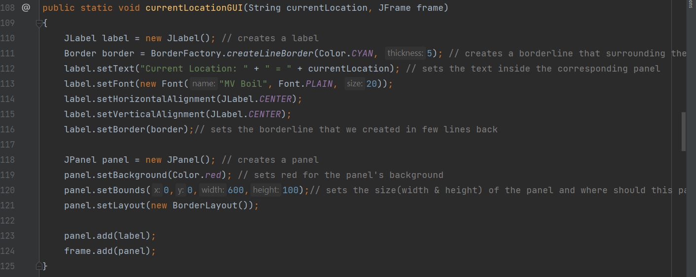

1. What JLabel do?

JLabel helps us to make a label here.

With labels we can set texts,pictures and borderlines in the graphical panel we are going to display to the user.

1. What Border do?

With border here we can make a borderline that we can choose it's color and thickness.

1. What JPanel do?

Well with JPanel we can make a graphical panel and show label in it.