I’ll try to cover those ideas and answer those questions in this article.

What’s GitFlow?

GitFlow is a branching model for Git, created by Vincent Driessen. To ensure quality and consistencies of code, it split branches into two types: main branches with strict access to it and other branches that revolve around the main branches.

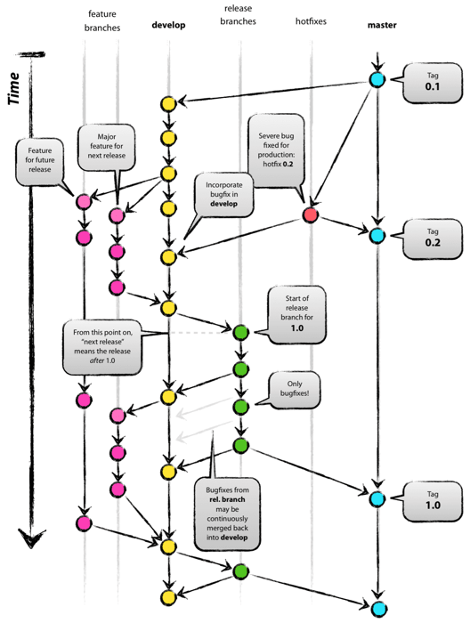

Graph of GitFlow

How to contribute in GitFlow?

* In GitFlow we have two main branches to contribute on, The main branch and the development branch.
* The main branch in also known as the release branch and is only responsible for the releases versions.
* The development branch is is responsible for receiving contributions related to the releasing.
* To add a new feature we have to create a new feature branch then start work which will be represented in a series of commits after this we have to open a pull request to merge the changes into the main branch.
* To add a normal fix we follow the same steps as mentioned in adding a new feature.
* To add a HotFix create a branch from the release branch add commits to it and after the work is done merge this branch to the release and develop branch.

How to review in GitFlow?

* All commits added to feature, Fix and HotFix branches should be merged to the main and develop branches.
* Merging always done through a pull request.
* All sub branches should be reviewed before merged to main and develop branches.

How to release in GitFlow?

Create a release branch starting from develop branch

Contribute to the release branch, May add a fix.

When the release branch is stable and reviewed you can merge it back to the develop and main branches to be released.

What are short live branches?

Release branches

Fix and HotFix branches

Feature branches

What are long live branches?

Develop branch

Main branch

What are the pros?

Let’s talk about the pros first. Forcing developers to make pull requests means we have complete control on changes made to our system, obviously improving the quality of code released into production. Every developer is unique, everyone does not have the same skills and styles when they code, this system will help to ensure every code has more or less the same style and also gives feedback to developers.

What are the cons?

The cons is also about the pull request itself, it slows down the development pace by a lot. Often the developers that will review the code has an assignment for themselves, this means you usually have to wait for your code to be reviewed.