Study On Command Line Text Editors

Study of a terminal based text editor such as Vim or Emacs. (By the end of the
course, students are expected to acquire following skills in using the editor: cursor
operations, manipulate text, search for patterns, global search and replace) Basic Linux
commands, familiarity with following commands/operations expected
1. man
2. ls, echo, read
3. more, less, cat,
4. cd, mkdir, pwd, find
5. mv, cp, rm ,tar
6. wc, cut, paste
7. head, tail, grep, expr
8 chmod, chown
9. Redirections & Piping
10. useradd, usermod, userdel, passwd
11. df,top, ps
12 ssh, scp, ssh-keygen, ssh-copy-id
Here is a list of basic Linux commands students are expected to know. You may take
this set as a starting point and explore each of them.

1. pwd
Use the pwdcommand to find out the path of the current working directory (folder)
you’re in. The command will return an absolute (full) path, which is basically a path of
all the directories that starts with a forward slash (/). An example of an absolute path is
/home/username.

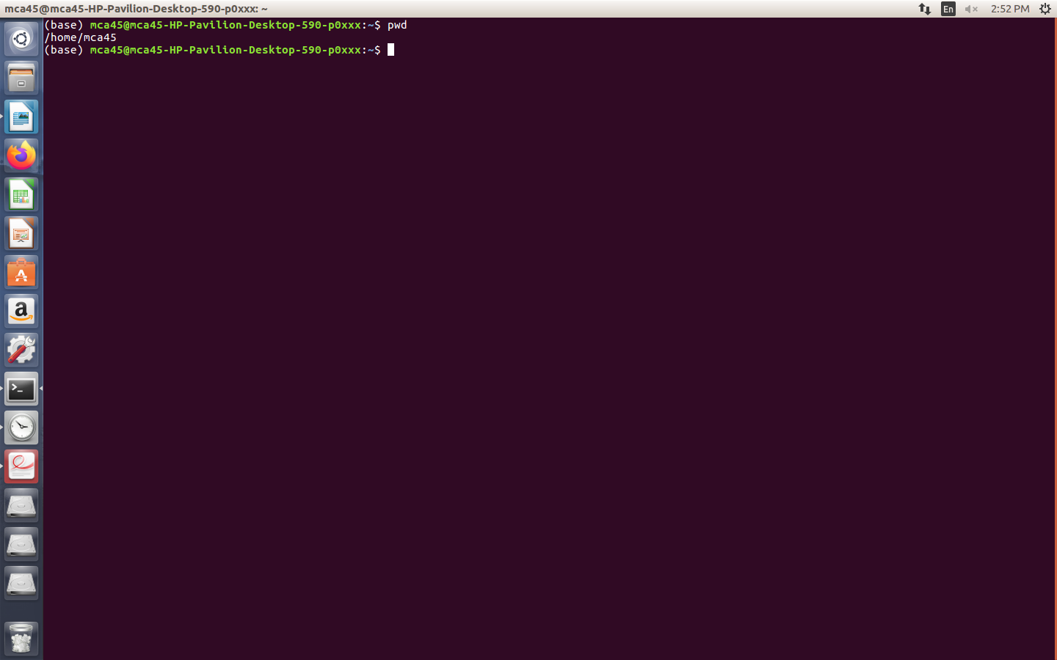

2. cd
To navigate through the Linux files and directories, use the cd . It requires either the
full path or the name of the directory, depending on the current working directory that
you’re in.
Let’s say you’re in /home/username/Documents and you want to go to Photos, a
subdirectory of Documents. To do so, simply type the following command: cd
Photos.
Another scenario is if you want to switch to a completely new directory, for
example,/home/username/Movies. In this case, you have to type cd followed by
the directory’s absolute path: cd /home/username/Movies.
There are some shortcuts to help you navigate quickly:
● cd ..(with two dots) to move one directory up
● cd to go straight to the home folder
● cd- (with a hyphen) to move to your previous directory
On a side note, Linux’s shell is case sensitive. So, you have to type the name’s
directory exactly as it is.

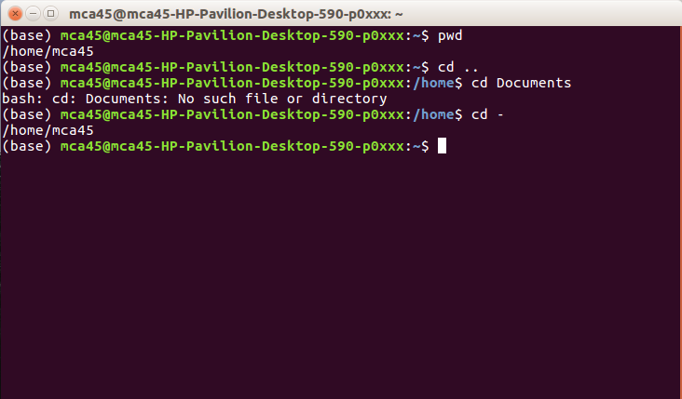
3. ls
The lscommand is used to view the contents of a directory. By default, this
command will display the contents of your current working directory.
If you want to see the content of other directories, type lsand then the directory’s path.
For example, enter ls /home/username/Documents to view the content of
Documents.
There are variations you can use with the lscommand:
● ls -R will list all the files in the sub-directories as well
● ls -a will show the hidden files
● ls -al will list the files and directories with detailed information like the permissions,
size, owner, etc.
● ls -t lists files sorted in the order of “last modified”
● -r option will reverse the natural sorting order. Usually used in combination with
other switches such as ls -tr. This will reverse the time-wise listing.
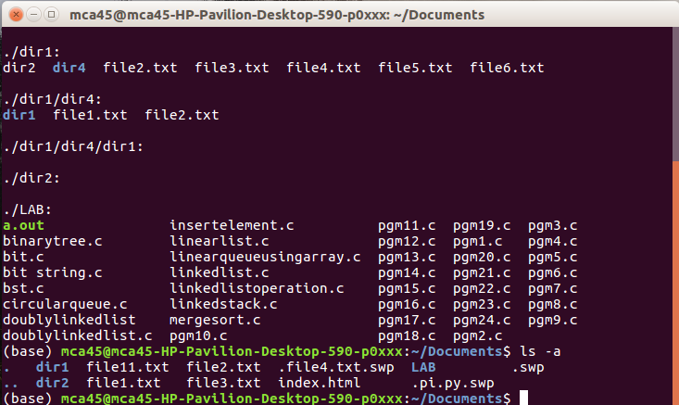

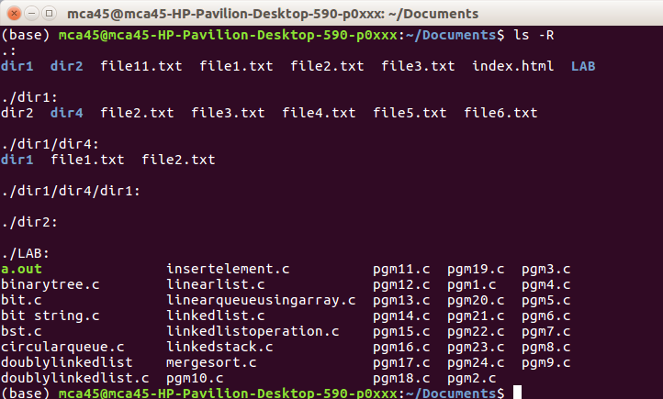

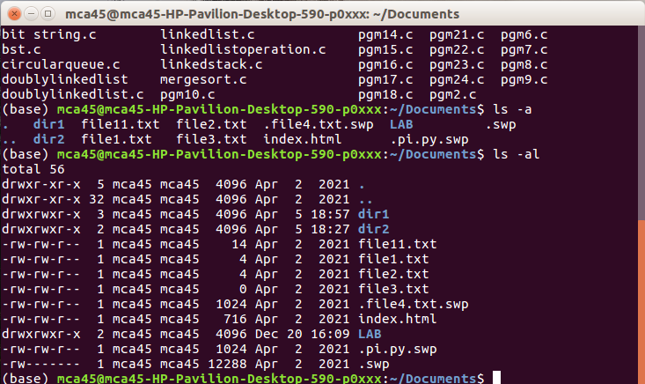

4. cat
cat(short for concatenate) is one of the most frequently used commands in Linux. It is
used to list the contents of a file on the standard output stdout . To run this command,
type cat followed by the file’s name and its extension. For instance: cat file.txt.
Here are other ways to use the cat command:
● cat> filename creates a new file
● cat filename1 filename2>filename3 joins two files (1 and 2) and stores the
output of them in a new file (3)
● to convert a file to upper or lower case use,
cat filename | tr a-z A-Z>output.txt

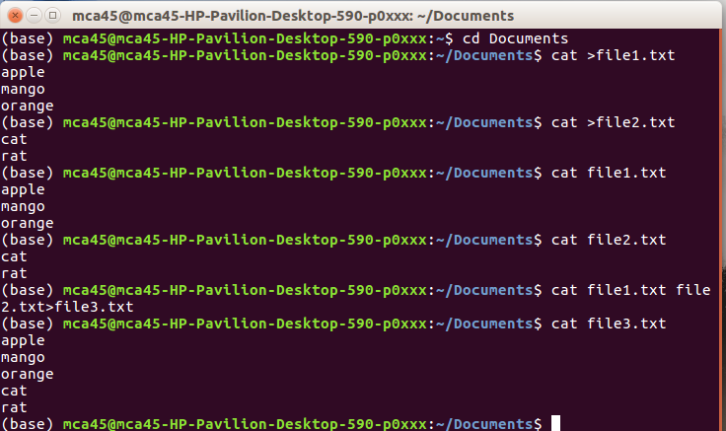

5. cp
Use the cp command to copy files from the current directory to a different directory. For
instance, the command cp scenery.jpg /home/username/Pictures would create a copy
of scenery.jpg (from your current directory) into the Pictures directory.
● cp -i will ask for user’s consent in case of a potential file
overwrite.
● cp -p will preserve source files’ mode, ownership
and timestamp.
● cp -r will copy directories recursively.
● cp -u copies files only if the destination file is not existing or the source file is newer

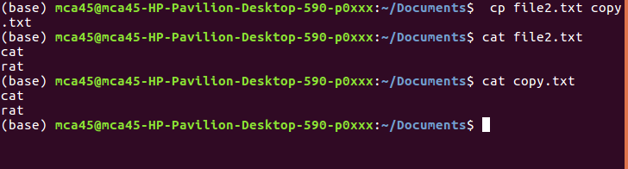

6. mv
The primary use of the mv command is to move files, although it can also be
used to rename files.
The arguments in mv are similar to the cp command. You need to type mv, the file’s
name, and the destination’s directory.
To rename files, the Linux is mv oldname.extnewname.ext

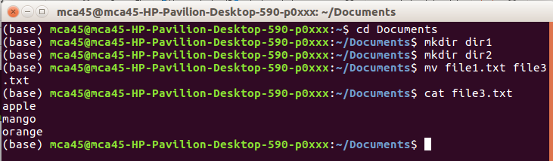
7. mkdir
Use mkdircommand to make a new directory — if you type mkdir Music it
will create a directory called Music.
There are extra mkdircommands as well:
● To generate a new directory inside another directory, use this Linux basic
command mkdir Music/Newfile
● use the p (parents) option to create a directory in between two existing directories.
For example, mkdir dir1

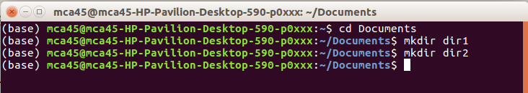

8. rmdir
If you need to delete a directory, use the rmdircommand. However, rmdir only allows
you to delete empty directories.

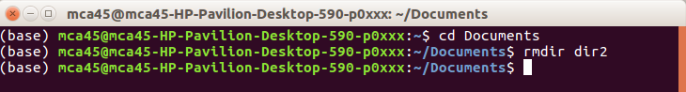

9. rm
The rmcommand is used to delete directories and the contents within them. If you only
want to delete the directory — as an alternative to rmdir — use rm -r.
Note: Be very careful with this command and double-check which directory you are
in. This will delete everything and there is no undo.

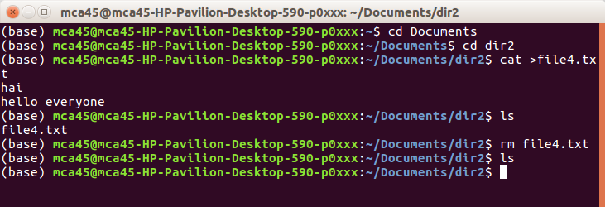

10. touch
The touch command allows you to create a blank new file through the Linux
command line. As an example, enter touch /home/username/Documents/Web.html
to create an HTML file entitled Web under the Documents directory.
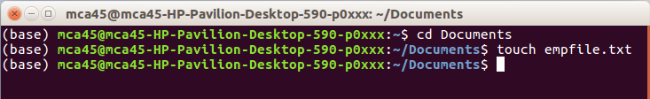

11. locate
You can use this command to locate a file, just like the search command in Windows.
What’s more, using the -i argument along with this command will make it case-
insensitive, so you can search for a file even if you don’t remember its exact name.
To search for a file that contains two or more words, use an asterisk (*). For example,
locate -i school*note command will search for any file that contains the word “school”
and “note”, whether it is uppercase or lowercase.

12. find
Similar to the locate command, using find also searches for files and directories.
The difference is, you use the find command to locate files within a given
directory.
As an example, find /home/ -name notes.txt command will search for a file called
notes.txt within the home directory and its subdirectories.
Other variations when using the find are:
● To find files in the current directory use, find . -name notes.txt
● To look for directories use, / -type d -name notes. Txt

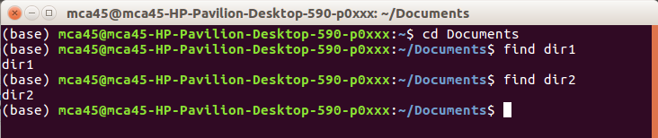

13. grep
Another basic Linux command that is undoubtedly helpful for everyday use is grep.
It lets you search through all the text in a given file.
To illustrate, grep blue notepad.txt will search for the word blue in the notepad file.
Lines that contain the searched word will be displayed fully.
Useful for command line use as well. Usually output of a previous command is piped
into the grep command. For example ls -l | grep “kernel”

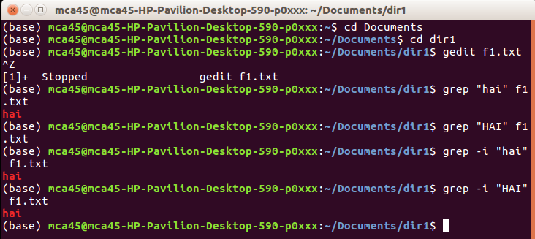

14. sudo
Short for “SuperUser Do”, this command enables you to perform tasks that require
administrative or root permissions. You must have sufficient permissions to use this
command.
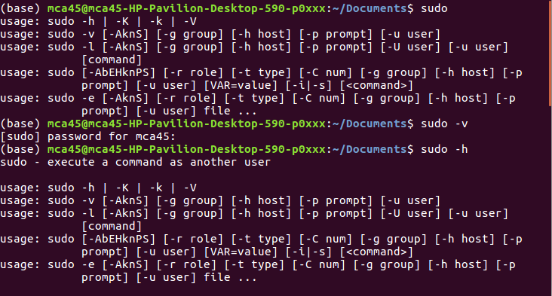

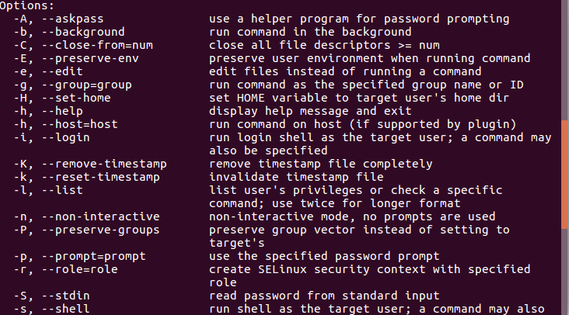

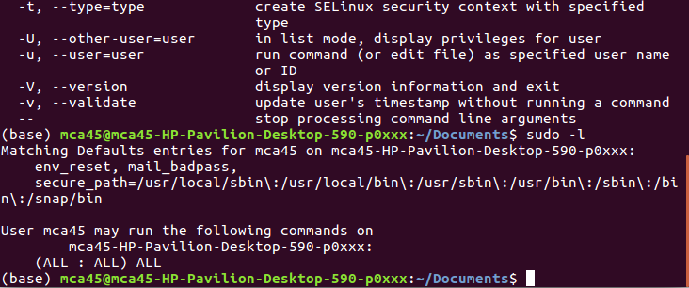

15. df
Use dfcommand to get a report on the system’s disk space usage, shown in
percentage and KBs. If you want to see the report in megabytes, type df -m.

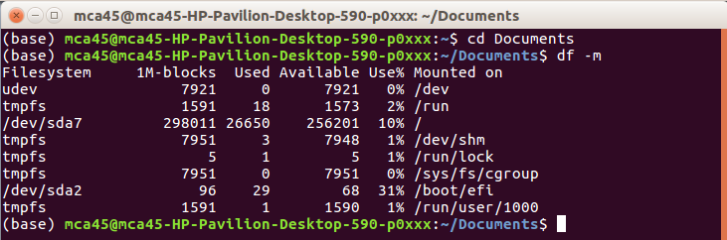

16. du
If you want to check how much space a file or a directory takes, the du (Disk
Usage) command is the answer. However, the disk usage summary will show disk
block numbers instead of the usual size format. If you want to see it in bytes,
kilobytes, and megabytes, add the -h argument to the command line.

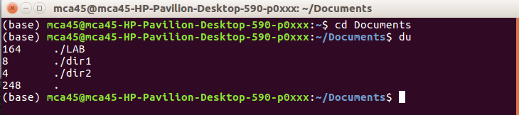

17. head
The head command is used to view the first lines of any text file. By default, it will
show the first ten lines, but you can change this number to your liking. For example, if
you only want to show the first five lines, type head -n 5 filename.ext. ( Read the
manual )

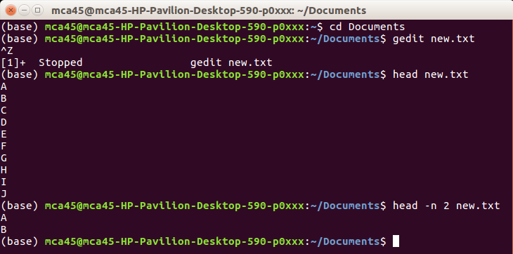

18. tail
This one has a similar function to the head command, but instead of showing the first
lines, the tail command will display the last ten lines of a text file. For example, tail -
n filename.ext.

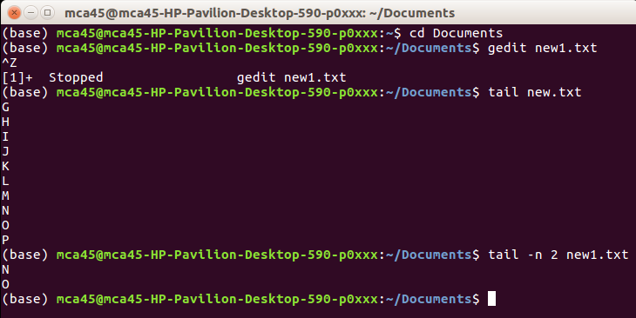
19. diff
Short for difference, the diff command compares the contents of two files line by line.
After analyzing the files, it willoutput.

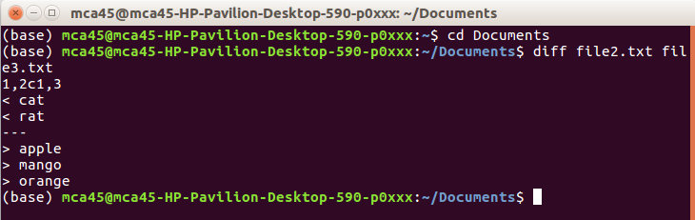

20. tar
The tar command is the most used command to archive multiple files into a
tarball— a common Linux file format that is similar to zip format, with compression
being optional.
This command is quite complex with a long list of functions such as adding new files
into an existing archive, listing the content of an archive, extracting the content from
an archive, and many more. Read some tutorial on net.

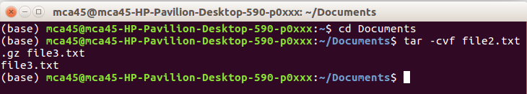

21. chmod
chmodis another Linux command, used to change the read, write, and execute
permissions of files and directories. Read about permissions and how to manipulate
them .

22. chown
In Linux, all files are owned by a specific user. The chowncommand enables you to
change or transfer the ownership of a file to the specified username. For instance,
chown linuxuser2 file.extwill make linuxuser2 as the owner of the file.ext.
it the lines that do not match. Programmers often use this command when they need to
make program alterations instead of rewriting the entire source code.
The simplest form of this command is diff file1.ext file2.ext
Ps command will display all current processes along with their process ids (PID) .
Read manuals for various options.

24. Kill
If you have an unresponsive program, you can terminate it manually by using the kill
command. It will send a certain signal to the misbehaving app and instructs the app
to terminate itself.
There is a total of sixty-four signals that you can use, but people usually only
use two signals:
● SIGTERM (15) — requests a program to stop running and gives it some time to
save all of its progress. If you don’t specify the signal when entering the kill command,
this signal will be used.
● SIGKILL (9) — forces programs to stop immediately. Unsaved progress will be lost.
Besides knowing the signals, you also need to know the process identification number
(PID) of the program you want to kill. If you don’t know the PID, simply run the
command ps ux. After knowing what signal you want to use and the PID of the
program, enter the following syntax:
kill [signal option] PID.
You can issue kill -9 PID

25. ping
Use the ping command to check your connectivity status to a server. For
example, by simply entering ping google.com, the command will check whether
you’re able to connect to Google and also measure the response time.
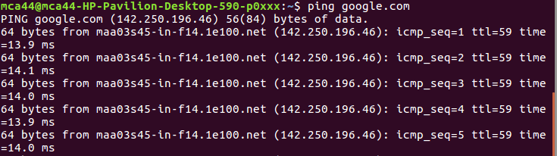

26. wget
The Linux command line is super useful — you can even download files from the
internet with the help of the wgetcommand. To do so, simply type wgetfollowed by
the download link.

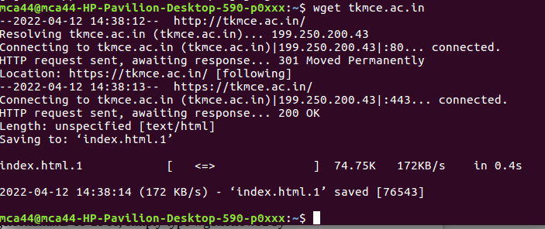

27. uname
The unamecommand, short for Unix Name, will print detailed information about your
Linux system like the machine name, operating system, kernel, and so on.

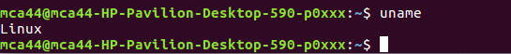

28. top
As a terminal equivalent to Task Manager in Windows, the top command will display a
list of running processes and how much CPU each process uses. It’s very useful to
monitor system resource usage, especially knowing which process needs to be
terminated because it consumes too many resources.
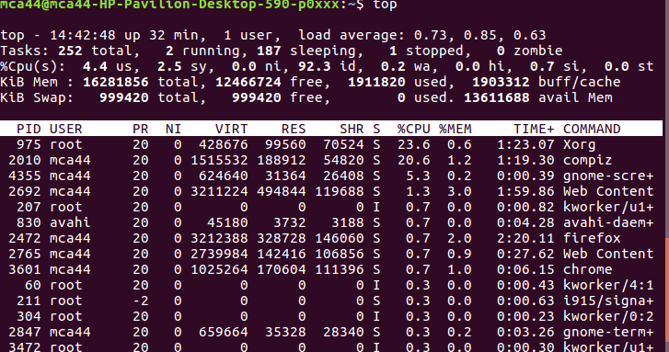

29. history
When you’ve been using Linux for a certain period of time, you’ll quickly notice that
you can run hundreds of commands every day. As such, running history command is particularly useful if you want to review the s you’ve entered before.

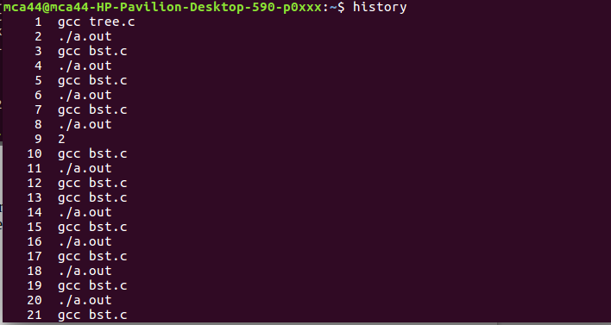

30. man
Confused about the function of certain Linux commands? Don’t worry, you can easily
learn how to use them right from Linux’s shell by using the man command. For
instance, entering man tail will show the manual instruction of the tail command.
Use the command: man man to start learning about man utility.

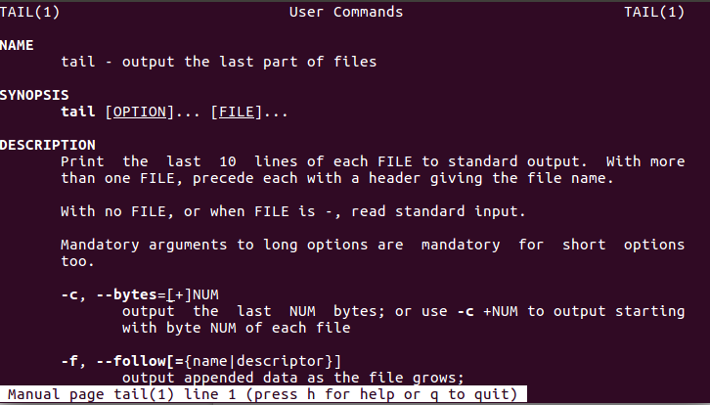

31. echo
This command is used to move some data into a file. For example, if you want to add
the text, “Hello, my name is John” into a file called name.txt, you would type echo
Hello, my name is John >> name.txt

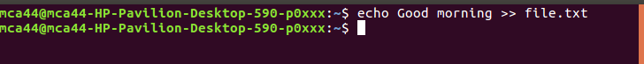

32. zip, unzip
Use the zip command to compress your files into a zip archive, and use the unzip
command to extract the zipped files from a zip archive. ( This program should be
installed , some distributions may not have them. You can also look at gzip and bzip
commands)

33. hostname
If you want to know the name of your host/network simply type hostname. Adding a -I to the end will display the IP address of your network.
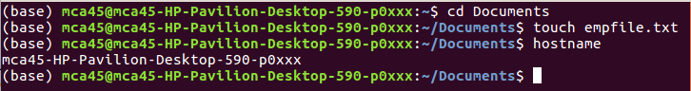

34. useradd, userdel
( This is available only to system admins) Since Linux is a multi-user system, this
means more than one person can interact with the same system at the same time.
useraddis used to create a new user, while passwdis adding a password to that user’s
account. To add a new person named John type, useradd John and then to add his
password type, passwd 123456789.
To remove a user is very similar to adding a new user. To delete the users account
type, userdelUserName

