q1
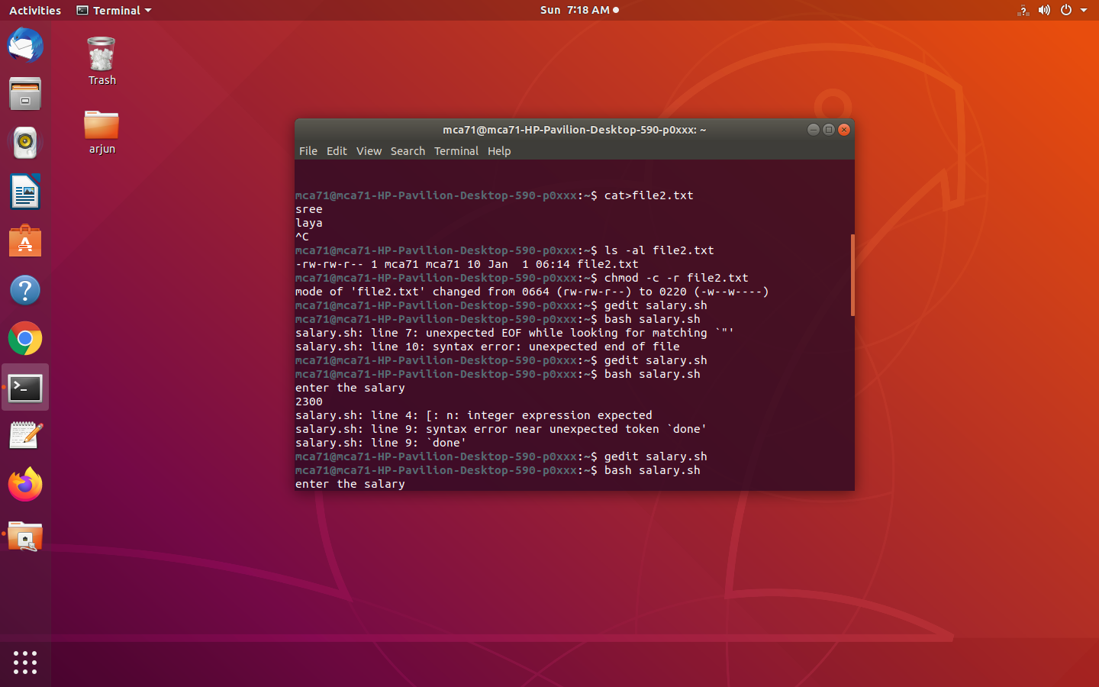

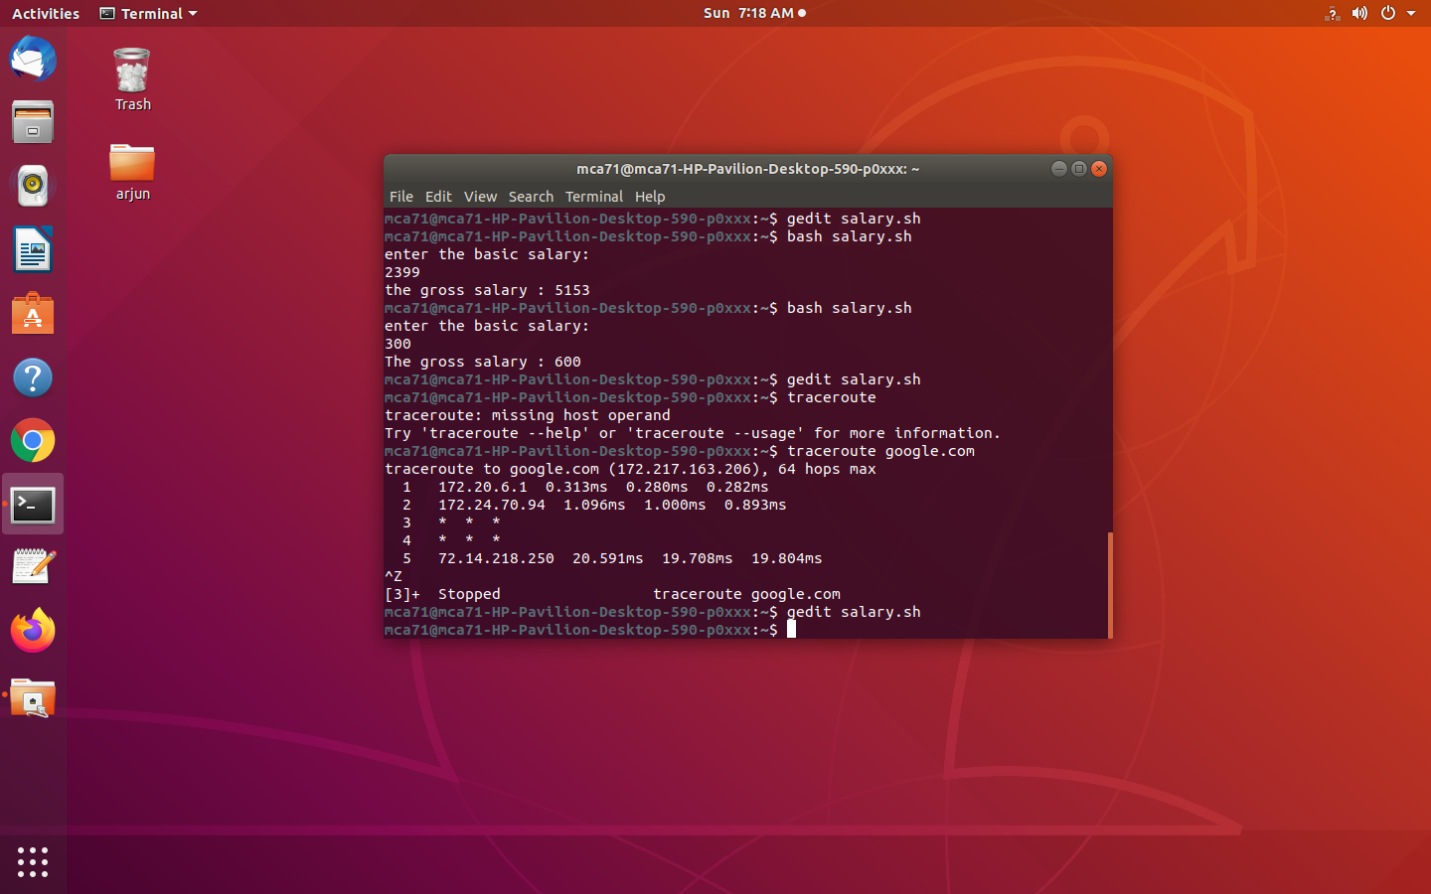
q2

q3

Schellscript
#!/bin/bash
echo "enter the basic salary:"
read bsal
if [ $bsal -lt 1500 ]
then
gsal=$((bsal+((bsal/100)*10)+(bsal/100)*90))
echo "The gross salary : $gsal"
fi
if [ $bsal -ge 1500 ]
then
gsal=$(((bsal+500)+(bsal/100)*98))
echo "the gross salary : $gsal"
fi

