|  |  |  |
| --- | --- | --- |
|  |  |  |

Naming System Model - Design

Version 1.0

|  |  |
| --- | --- |
|  |  |
| Domain Lead | Vasu Vuppala |
| Design Team | Vasu Vuppala |
|  |  |

Revision History

|  |  |  |  |
| --- | --- | --- | --- |
| Version | Date | Author | Description |
| 01.0 | 8/22/12 |  | Initial version |
|  |  |  |  |
|  |  |  |  |
|  |  |  |  |
|  |  |  |  |
|  |  |  |  |

Table of Contents

1 Introduction 5

1.1 Definitions, Acronyms, and Abbreviations 5

2 Database Design 5

2.1 Conceptual Model 5

2.1.1 Concepts, Entities, Objects 5

2.1.2 Relationships 6

2.1.3 Conceptual Diagram 6

2.2 Physical Model 7

2.2.1 Relational Model 7

2.2.2 Table Description 8

3 References 10

Appendix A – Notation 11

List of Figures and Tables

Figure 1 Conceptual Model 7

Figure 2 Physical Model 8

Table 1 Definition, Acronyms, and Abbreviations 5

# Introduction

Facility of Rare Isotope Beam (FRIB) Naming System uniquely identifies every piece of equipment in FRIB facility, and the equipment’s controls signals.

## Definitions, Acronyms, and Abbreviations

Table 1 Definition, Acronyms, and Abbreviations

|  |  |
| --- | --- |
| Item | Description |
|  |  |
|  |  |
|  |  |
|  |  |
|  |  |
|  |  |
|  |  |

# Database Design

FRIB Naming System divides FRIB Facility into following categories: System, Subsystem, and Devices. Signal names are attached to the devices. Signal names are divided into Signal Type, Signal Domain, and Signal Suffix. Refer to [1] for details on FRIB Naming System.

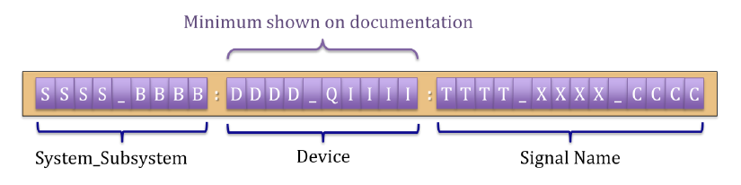

## Conceptual Model

### Concepts, Entities, Objects

FRIB facility is divided into

* System:
  + Definition: Name of a FRIB System
* Subsystem:
  + Definition: Name of a FRIB System
  + Examples: Quadrupole, cavity, BPM
* Device Type:
  + Definition: Name of a Device Type
* Signal Type
  + Definition: Name of a signal Type.
* Signal Domain
  + Definition: Name of the domain a signal belongs to.
* Signal Suffix
  + Definition: The suffix added to a signal name.

### Relationships

* A Subsystem may be restricted to a certain System. Some Subsystems are generic and may go with any System.
* A device may be restricted to a certain Subsystem.
* A signal may be restricted to a certain device.

### Conceptual Diagram

Figure 1 shows the entity types (or classes) and the relationships among them. The notation used in the figure is described in Appendix A – Notation. Some of the attributes of Element Type Properties and Element Properties are shown to clarify the difference between the two.

Figure 1 Conceptual Model

## Physical Model

### Relational Model

Figure 2 Physical Model

### Table Description

1. System: Each row represents an Element.

|  |  |
| --- | --- |
| **Attribute** | **Description** |
|  |  |
|  |  |
|  |  |
|  |  |
|  |  |
|  |  |
|  |  |
|  |  |
|  |  |
|  |  |
|  |  |

|  |  |
| --- | --- |
| **Attribute** | **Description** |
| element_id [P] | The Element |
| Install_device_id [P] | The Install Device |
| Index | The slice number or the composite number |

1. Device_Type: Each row represents an

|  |  |
| --- | --- |
| **Attribute** | **Description** |
| element_type_id [P] | Unique identifier |
| Name |  |
| description |  |

1. Signal_Type: Each row represents an

|  |  |
| --- | --- |
| **Attribute** | **Description** |
| Element_type_prop_id [P] | Unique identifier |
| Element_type_id | The element type |
| Name |  |
| Description |  |

1. Signal_domain: Each row represents the

|  |  |
| --- | --- |
| **Attribute** | **Description** |
| Element_id | The element |
| Element_type_prop_id | The Element Type Property |
| Value | The value of the property |

1. Signal_domain: Each row represents the

|  |  |
| --- | --- |
| **Attribute** | **Description** |
| Element_id | The element |
| Element_type_prop_id | The Element Type Property |
| Value | The value of the property |

1. Signal_suffix: Each row represents the

|  |  |
| --- | --- |
| **Attribute** | **Description** |
| Element_id | The element |
| Element_type_prop_id | The Element Type Property |
| Value | The value of the property |

1. Fnc_name: Each row represents the

|  |  |
| --- | --- |
| **Attribute** | **Description** |
| Element_id | The element |
| Element_type_prop_id | The Element Type Property |
| Value | The value of the property |

### Example

# References

1. FRIB Naming System Document, FRIB-T10500-PR-000001, FRIB Portal.

# Appendix A – Notation

Notation Example:



1. E2[1..m] - E3[0..n] means:
   1. An instance of E2 can be related to 0 or more instances of E3
   2. An instance of E3 can be related to 1 or more instances of E2
2. E2[1..1] - E3[0..n] means:
   1. An instance of E2 can be related to 0 or more instances of E3
   2. An instance of E3 can be related to exactly one instance of E2
3. E2[3..6] - E3[2..5] means:
   1. An instance of E2 can be related to 2 to 5 instances of E3
   2. An instance of E3 can be related to 3 to 6 instances of E2