Type Title of Project in Full

Type Your Name Here
Student ID
SRH University
Course number: Name
Instructor: Esteban Pozo
Due Date: June 20, 2026

Abstract

This is where you will insert the abstract of your paper. The abstract is a very brief summary of your paper. The abstract should be one double-spaced paragraph that is NOT indented. It is usually no more than 150-250 words long. Tell your reader the purpose of your paper in the abstract and describe the main points of your paper. It is usually easiest to write your abstract after you’ve written the rest of your paper.

Keywords: word 1, word 2, etc.

(An abstract is optional for student papers. Please check with your instructor to see whether an abstract should be included in your paper.)

Contents

Abstract 2
Introduction 4
Task 1 5
Subtitle 5
Task 2 5
Subtitle 5
Task 3 6
Subtitle 6
Task 4 6
Subtitle 6
References 7
Annex 8

Introduction
This will be the body of your paper. Each new paragraph is indented one tab. The entire body of your paper will be double-spaced. This includes the “References” page at the end. Don’t forget that you’ll need to include an in-text citation every time you quote, paraphrase, or summarize an outside source of information. This is very important. Each item that you include an in-text citation for must also be listed in your reference list. (Author, Year, page number)
For images proceed as follows:
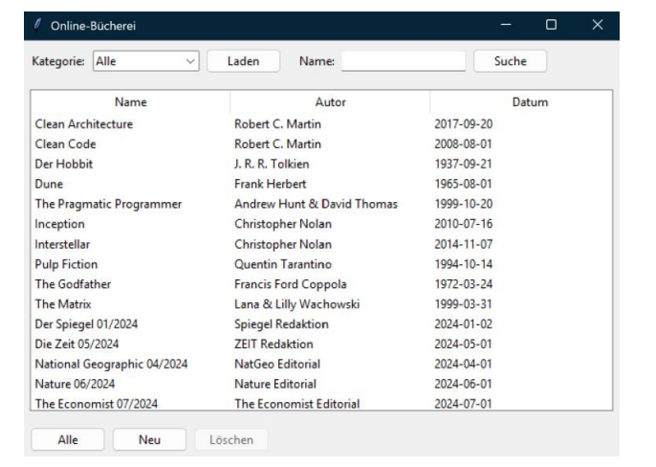
Figure 1. This is an image (Author, Year, page number)
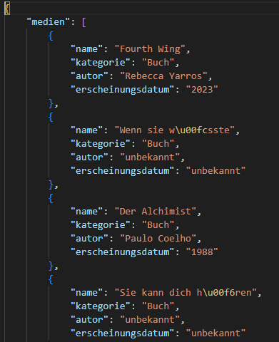
Figure 2. JSON file sample

For tables proceed as follows:
Table 1. This is a table (Author, Year, page number)

Task 1

Subtitle
Your text goes here

Task 2

Subtitle
Your text goes here

Task 3

Subtitle
Your text goes here

Task 4

Subtitle
Your text goes here

References
Author, A. A., Author B. B., & Author, C. C. (year). Title of article. Title of Journal, volume(issue), page-page. doi:x.xxxx/xxxx-xxxx.xx.x.xxx
Author, D.D. (year, Month day). Title of article. Title of Newspaper, https://newspaper.homepage
Author, E.E., & Author, F.F. (year). Title of book. Publisher.
Author, G.G., & Author, H.H. (year, Month day). Title of document. https://www.xxxxxxx

Your references will be listed alphabetical by author’s last name. They will not be indented the same way as the body of your paper. Each reference will have a “hanging indent,” like this paragraph is written. This guide shows how to create different types of reference entries: https://national.libguides.com/apa_7th/reference

Annex

