Advantzware CRM ZoHo Accounts

1. Log into crm.zoho.com and navigate to My Account by clicking on the far right tool icon.

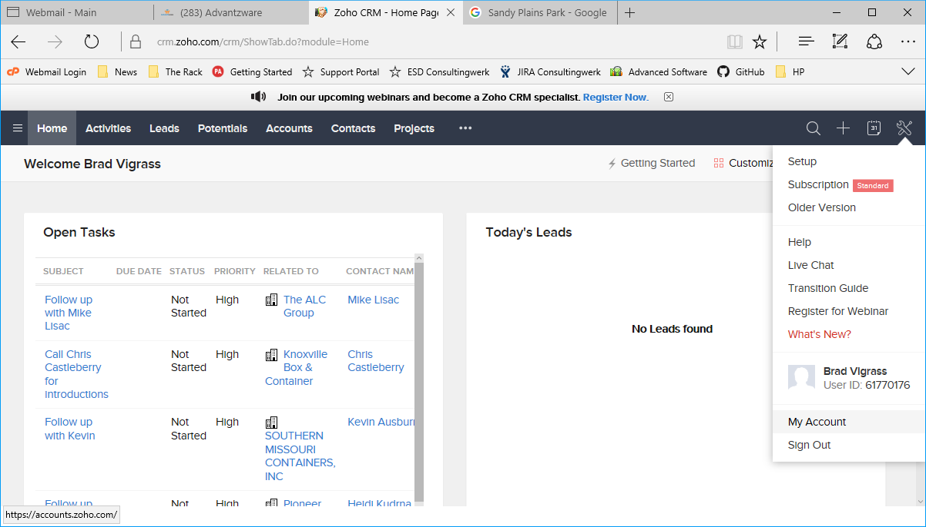

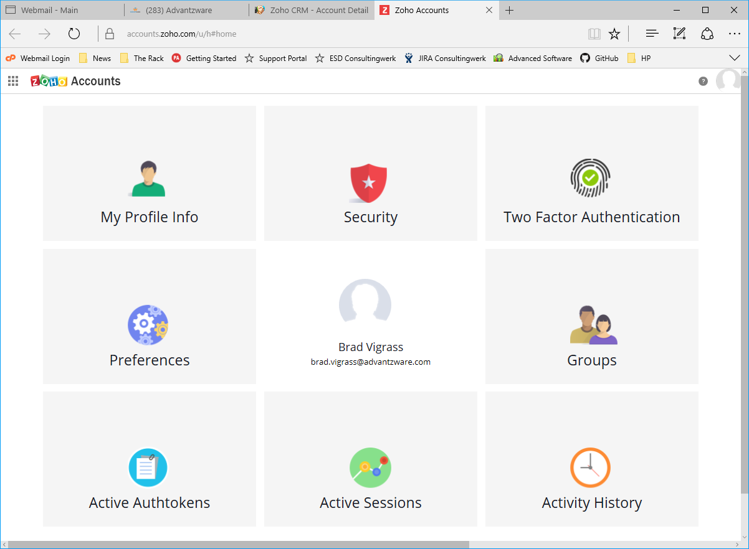

1. Select “Active Authtokens”.
2. Locate an Authtoken whose “Scope” has access to “crmapi”. Copy this value by highlighting the value and copy it into the system clipboard either by typing CTRL-C …

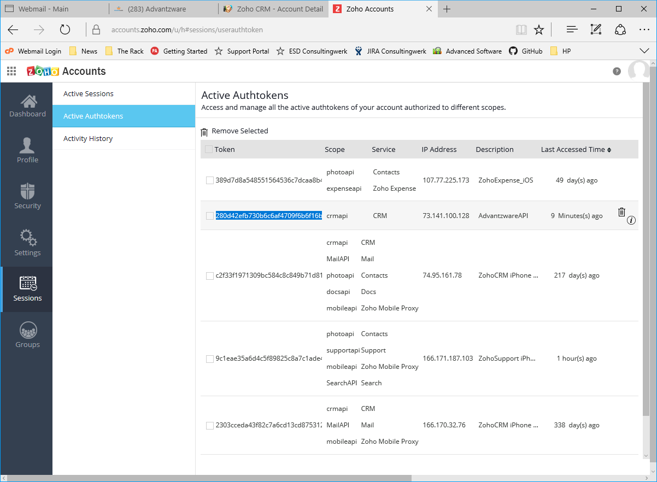

1. Or right mouse click over the highlighted text and select Copy.

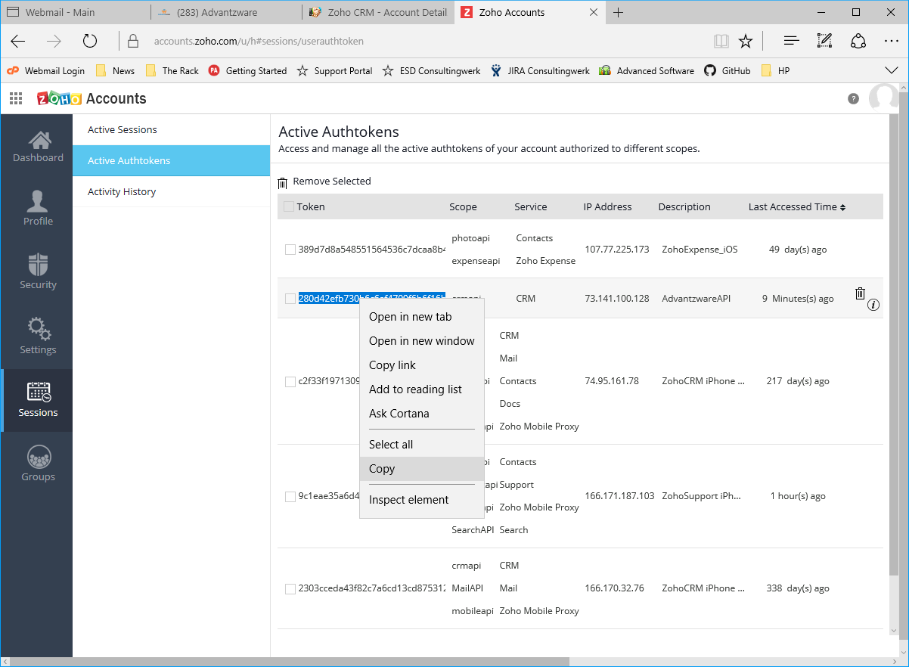

1. Navigate to Advantzware’s Customer Maintenance (A-F-1).

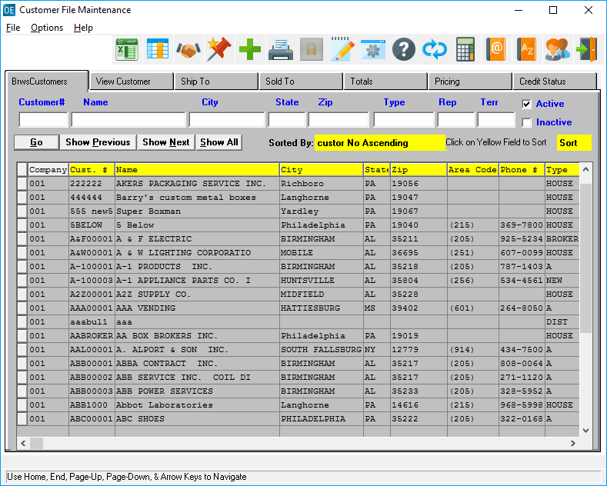

1. Click the “CRM” icon , which will invoke the ZoHo CRM interface. If this is the first time attempting to access CRM, the following Error will popup. This is necessary to Auto Create the N-K-1 value “CRMAuthToken”.

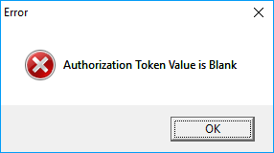

1. Locate “CRMAuthToken” in Advantzware’s Sytem Control Parameters (N-K-1).

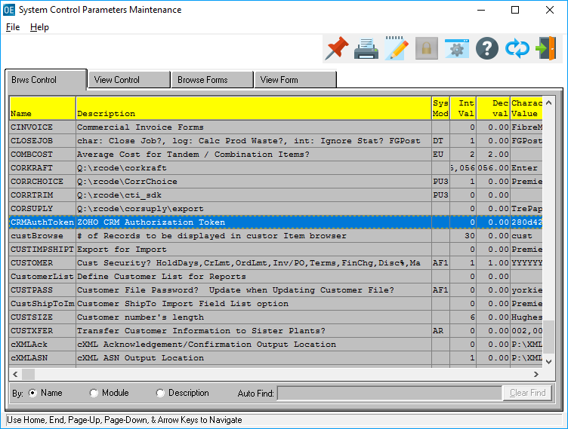

1. Perfrom a Paste “CTRL-V” to enter the ZoHo AuthToken value from the CRM ZoHo session.

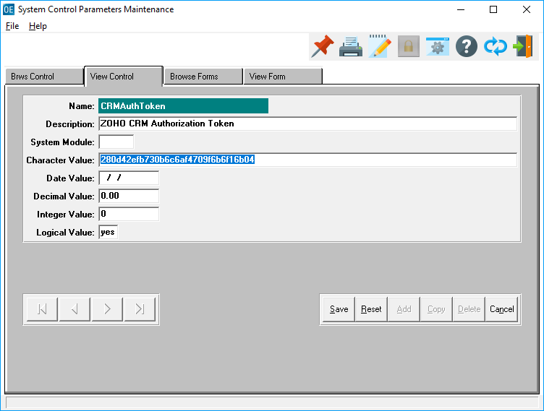

1. Navigate to Accounts within the CRM ZoHo session.

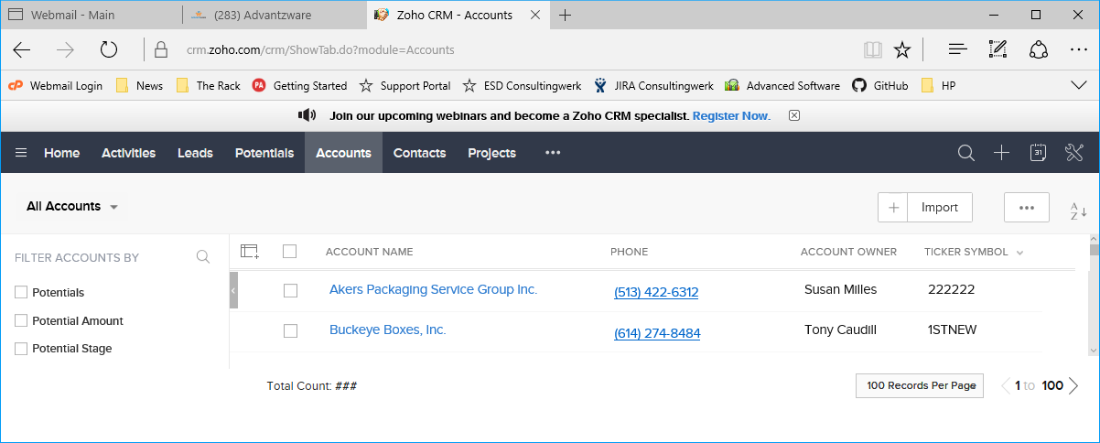

1. Select a CRM ZoHo Account that is to be uploaded into Advantzware. A Customer Code value needs to be entered into “Ticker Symbol” field. This value is this Account’s (Customer’s) designated Customer Code. In this example, Buckeye Boxes, Inc. has been selected. Click “Edit” and scroll down to the “Ticker Symbol” field. In this case, Buckeye’s Customer Code is entered as “Buckeye”. Note: this value needs to be unique because the CRM interface matches the “Ticker Symbol” value against those found in Advantzware. A match will indicate it is an update from CRM. A unique value indicates it is potentially a new Account to be Added to Advantzware.

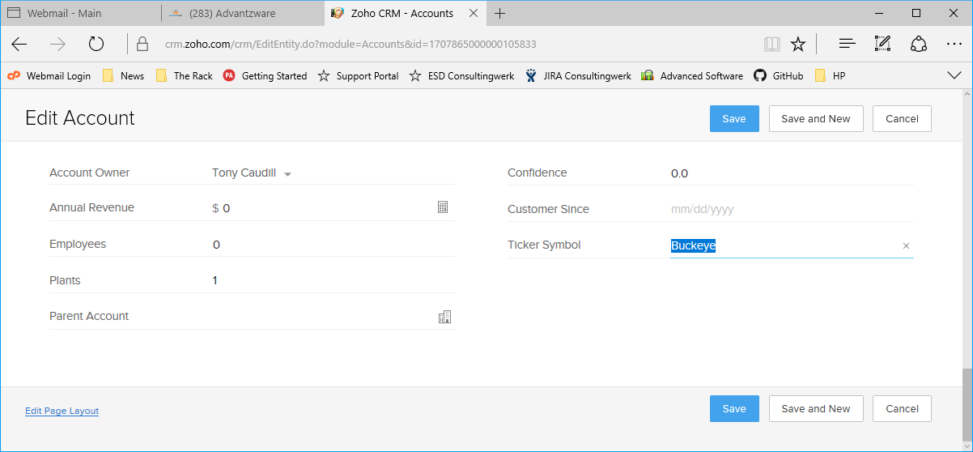

1. Repeat the above step 9 for any and all Accounts (Customers) which are to be uploaded into Advantzware.
2. Return to Customer Maintenance (A-F-1) and click the “CRM” icon  which will make a Web Service call to the CRM API. Any Accounts found with a “Ticker Symbol” not blank will be presented for review. Left columns will show the CRM Accounts. The Right columns show Advantzware Customers as they currently exist.

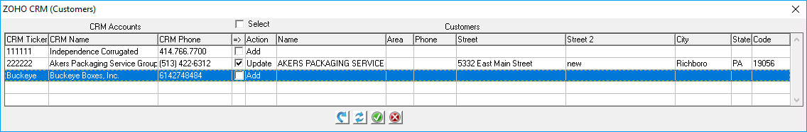

1. Any records returned where the Ticker Symbol matches an existing Customer will be presented as a potential “Update” and have the “Update” Action pre-checked. Any CRM Accounts without a matching Customer will appear as a potential “Add” Action, but will not be pre-checked.
   1.  Apply Selected Actions – will allow a preview of the CRM Account values applied to the Customer fields (this does not update any data in Advantzware).

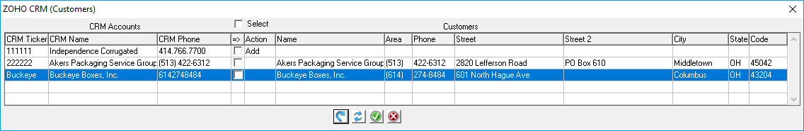

* 1.  Reset – will cause the process to reload the CRM process. This is useful if the above Apply Selected Action was done and the preview of any records is not desired.

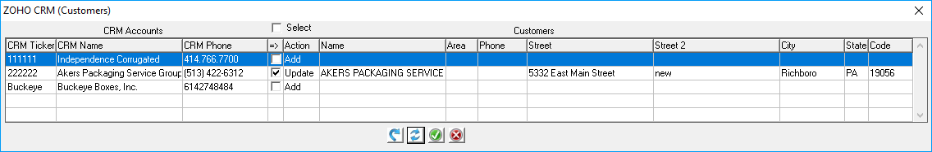

* 1.  Save Selected Actions – this process will apply any selections and/or previously applied previews to the Advantzware Customers. A Apply Selected Actions does NOT need to be performed prior to a Save Selected Actions. If an Apply has been performed, anything updated to the right columns will update to Advantzware. Or simply select any Update and/or Add to apply those selections to Advantzware.

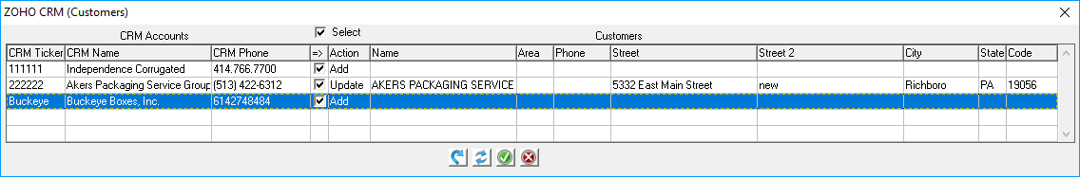

Note: clicking “Select” directly above the “Action” column will toggle selections On/Off accordingly.

* 1.  Cancel – this will close/exit the CRM interface.

Advantzware CRM ZoHo Contacts

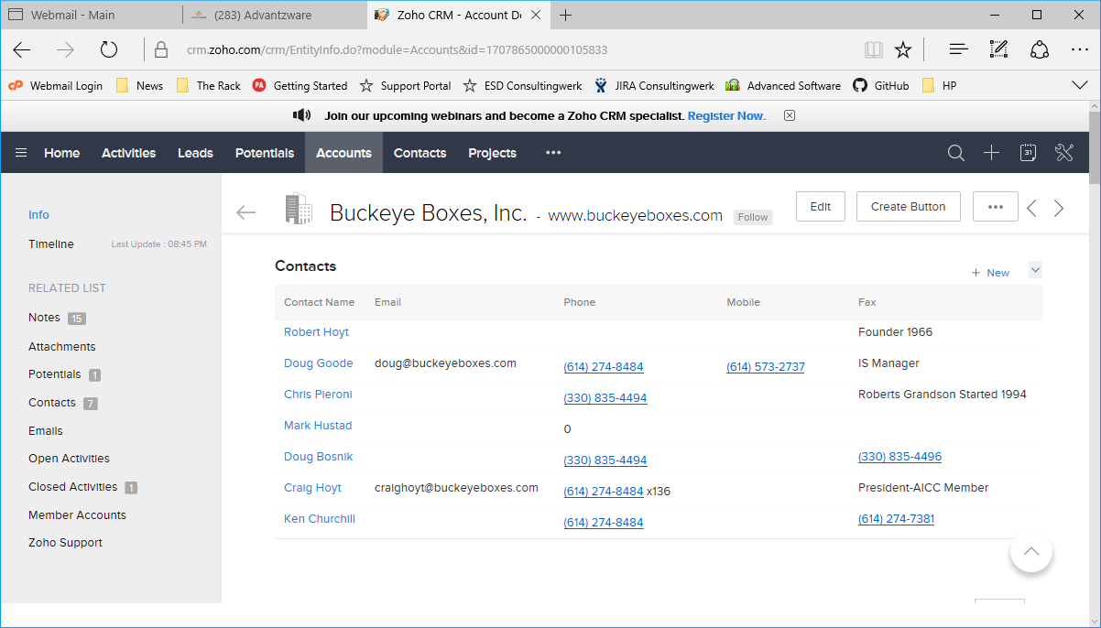

1. Locate the desired Customer whose Contacts are to be uploaded from CRM.

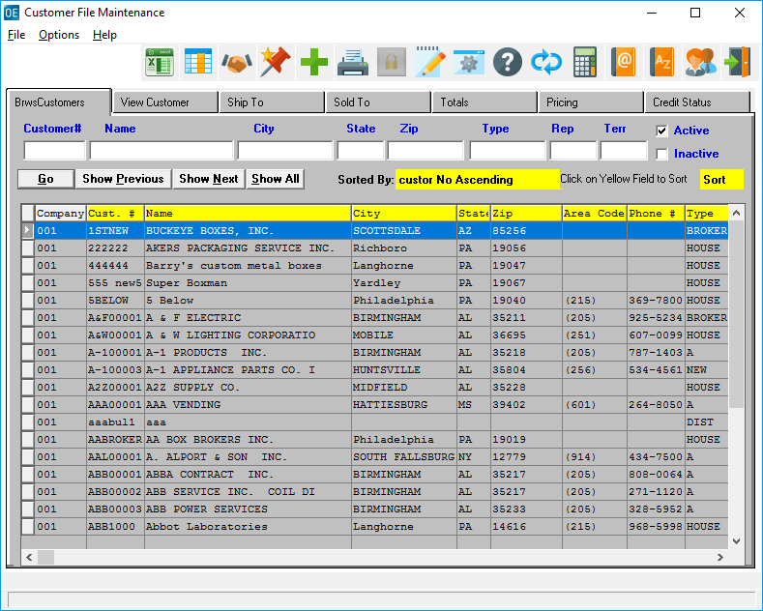

1. Click the Phone Info. Icon  which will access a Customer’s Contacts.

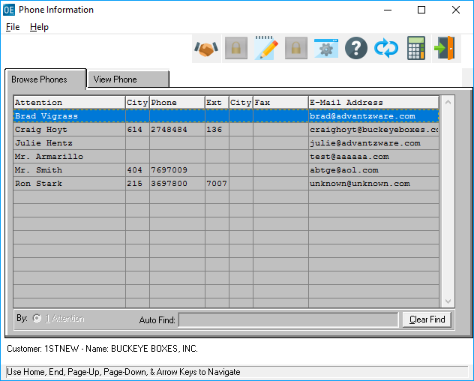

1. Select the CRM icon  , which will invoke the ZoHo CRM interface. If this is the first time accessing the CRM process, see step 5 above.

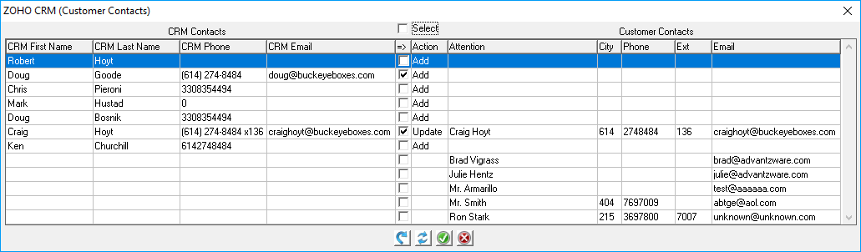

1. The key aspect of CRM Contacts is that is looks for matching “email” values. Those that match are auto selected as potential updates. If no email match is located, it is flagged as a potential add, but will only be auto selected if an email value exists, otherwise blank email records will not be auto selected, but can be manually selected for addition to Advantzware. CRM Contacts are rendered on the Left side and any existing Customer Contacts are located in the right side columns.
   1.  Apply Selected Actions – will allow a preview of the CRM Contact values applied to the Customer Contact fields (this does not update any data in Advantzware).

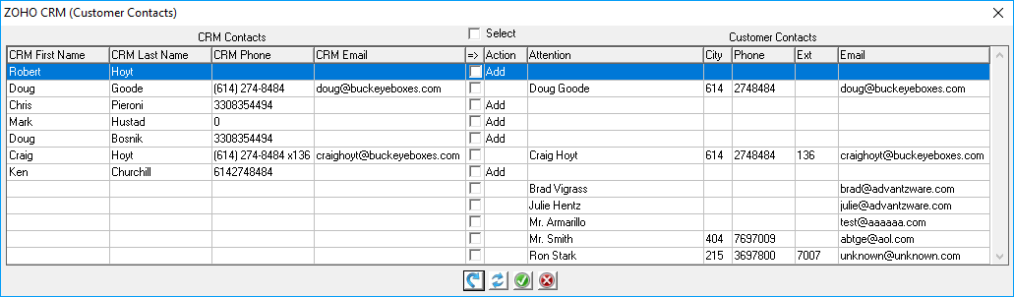

* 1.  Reset – will cause the process to reload the CRM process. This is useful if the above Apply Selected Action was done and the preview of any records is not desired.

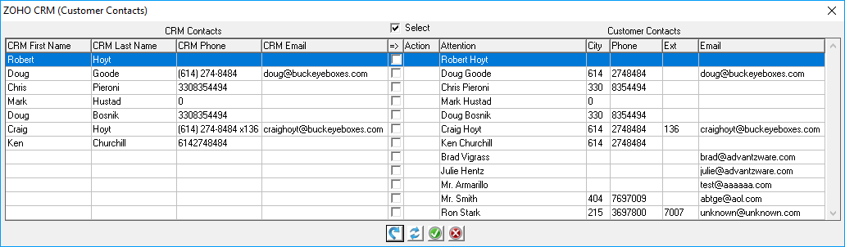

* 1.  Save Selected Actions – this process will apply any selections and/or previously applied previews to the Advantzware Con. A Apply Selected Actions does NOT need to be performed prior to a Save Selected Actions. If an Apply has been performed, anything updated to the right columns will update to Advantzware. Or simply select any Update and/or Add to apply those selections to Advantzware.

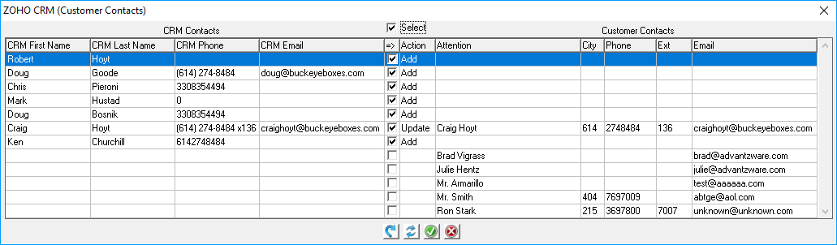

Note: clicking “Select” directly above the “Action” column will toggle selections On/Off accordingly.

* 1.  Cancel – this will close/exit the CRM interface.

Advantzware Open Analytics (AOA) – auto upload CRM Accounts (Customers)

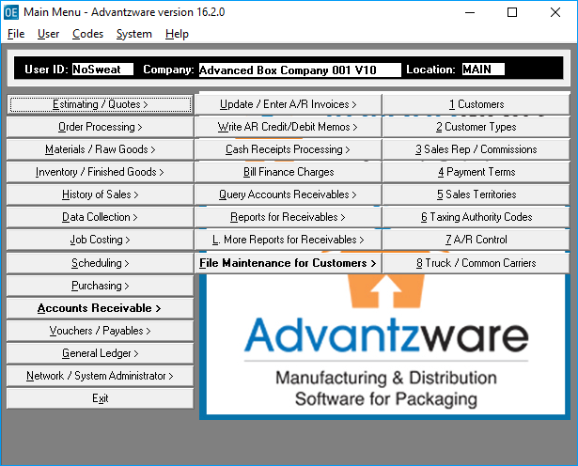

1. From anywhere within the Advantzware System, type CTRL-ALT-R to invoke the AOA Launcher.

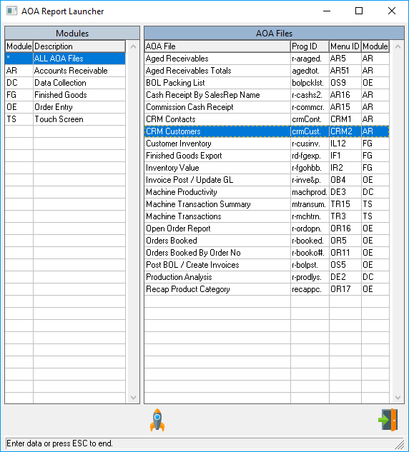

1. Click the Launch Icon  after selecting CRM Customers or double click CRM Customers to run the parameter screen.

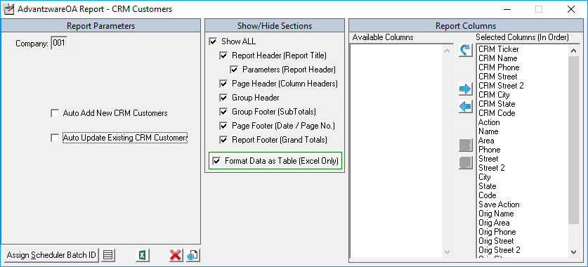

1. Selecting either Auto Add New CRM Customers and/or Auto Update Existing CRM Customers will perform the functions selected by silently adding and/or updating CRM Accounts (Customers) from the CRM into the Advantzware System.

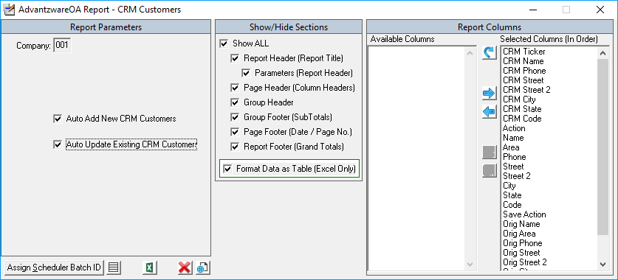

NOTE: See Advantzware Open Analytics (AOA) documentation for instructions on how to navigate AOA Parameter Screens. Any AOA module can be entered into our AOA Scheduler for executing during off hours on a periodic basis, daily, weekly and/or monthly… as frequently as desired.

Advantzware Open Analytics (AOA) – auto upload CRM Contacts (Customer Contacts)



1. From anywhere with the Advantzware System, type CTRL-ALT-R to invoke the AOA Launcher.

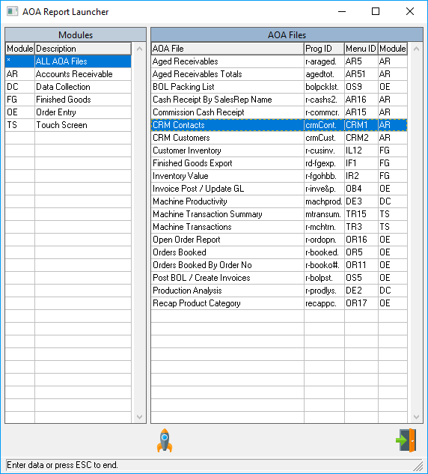

1. Click the Launch Icon  after selecting CRM Contacts or double click CRM Contacts to run the parameter screen.

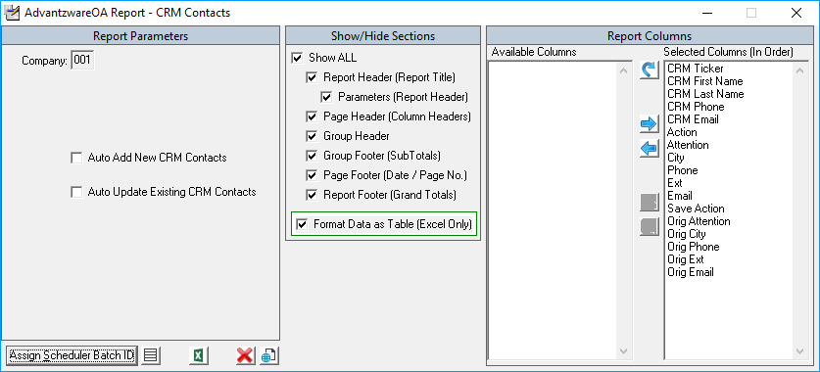

1. Selecting either Auto Add New CRM Contacts and/or Auto Update Existing CRM Contacts will perform the functions selected by silently adding and/or updating CRM Contacts (Customer Contacts) from the CRM into the Advantzware System.

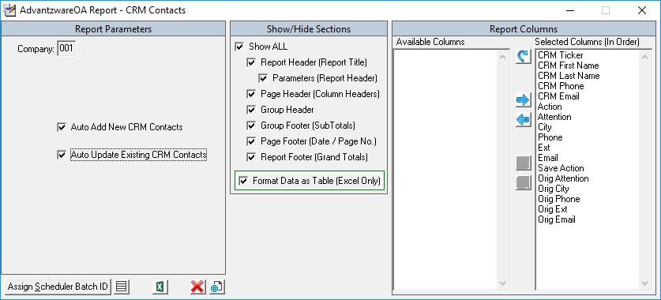

NOTE: See Advantzware Open Analytics (AOA) documentation for instructions on how to navigate AOA Parameter Screens. Any AOA module can be entered into our AOA Scheduler for executing during off hours on a periodic basis, daily, weekly and/or monthly… as frequently as desired.