**Requirements for API Inbound Setup and How to Test**

Last update date: **31st-July-2019 |** Version: **1.3**

**Setup**

**Step 1: Database Tables and Initial Configuration Data Required**

1. Ensure that the database tables APIInbound, APIInboundDetail and APIInboundEvent are available in ASI database
2. Ensure that the database tables APIInbound and APIInboundEvent have initial configuration data

**Step 2: Programs Required**

The latest code changes for API Inbound **must be** available in the repository and the same is required to be compiled in the targeted environment using the “fsInstaller”.

The “fsInstaller” compiles the code base and copies the compiles program to “Programs” folder.

**Step 3: Java Folder Setup**

* A folder named “java”(under Programs\api\node) will be created as the result of “fsInstaller” installer run.
* **Open Client Java OpenAPI** is required to enable making AppServer calls and running Progress procedures from a java class. Progress provides the required libraries as part of Progress OpenEdge installation. A java archive file named **o4glrt.jar** can be located under Progress Installation Folder as below:

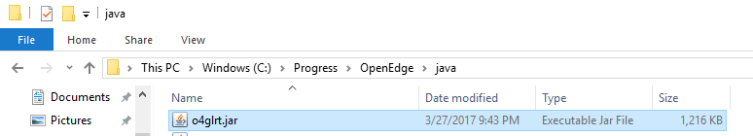

* Copy the required java packages from **<Progress Installation Folder>\java** into the folder Programs\api\node\java following the below steps:
* Go to the path **<Progress Installation Folder>\java** and extract the contents from **o4glrt.jar** into Programs\api\node\java folder and verify that the following sub-folders are available under Programs\api\node\java 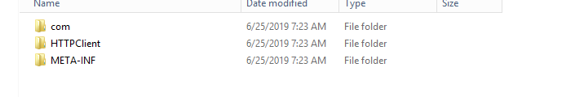
* Compile java programs as per the steps given below:
* Java programs “RequestDispatcherAS.java” and “RequestDispatcher.java” (under Programs\api\node\java) will be created as result of “fsInstaller” installer run as shown in below screenshot.

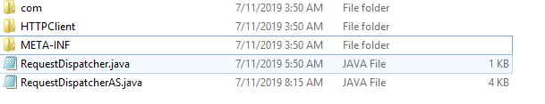

* Open command prompt
* Change current directory to Programs\api\node\java
* Execute below commands to compile java programs

|  |
| --- |
| **<Progress Installation Folder>**\jdk\bin\javac RequestDispatcher.java  **<Progress Installation Folder>**\jdk\bin\javac RequestDispatcherAS.java |

**Note:** If the java programs are compiled successfully, then files “RequestDispatcherAS.class**”** and **“**RequestDispatcher.class**”** should get generated in the same folder Programs\api\node\java as highlighted in the screen shot below:

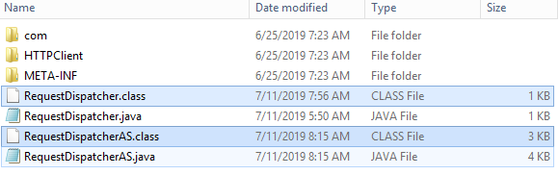

* **Once the .class files are generated, delete the .java files (“RequestDispatcherAS.java” and “RequestDispatcher.java”) from Programs\api\node\java folder.**
* Make sure “logs” folder under Programs\api\node\java is available. A CSV file will be generated with the failed requests data which can be later imported into APIInboundEvent table and processed further when AppServer/Progress Layer is down.

**Step 4: AppServer Setup for Development and Test Environments**

**Please note – this broker is ONLY required for Development and Test Environments – this is assumed that there is an existing AppServer broker available in Prod environment and the same can be used in node start program – please refer to the steps in this document under Node Server Setup section for more details.**

* Open Management Console
* Create new App Server broker **Advantzware_API**, if not already available

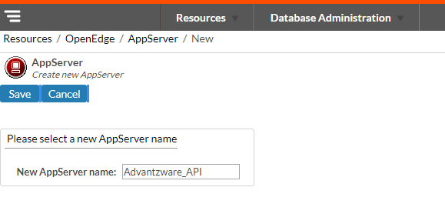

* After creation of AppServer broker **Advantzware_API**, click on “**Configuration**” to setup the AppServer.

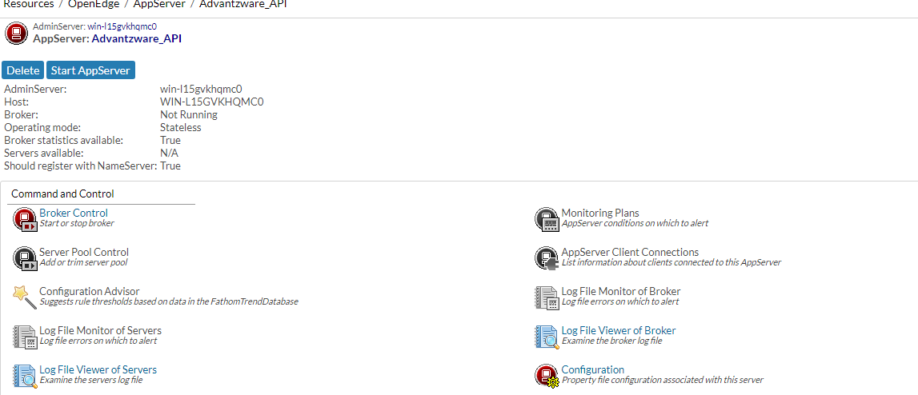

* Create a .pf file to setup the databases (ASI and AUDIT) and server start up parameters

-s to 200 and -strictEntityResolution to 0 to setup in **Advantzware_API** broker

A Sample code for .pf file creation is shown below:

The tags <path> , <asi-db-name> and <audit-db-name> are to be replaced with the appropriate values.

|  |
| --- |
| -db <path>\Prod\<asi-db-name>.db  -H localhost  -S 2821  -ld ASI  -cpinternal ISO8859-1  -cpstream ISO8859-1  -cpcoll Basic  -cpcase Basic  -d mdy  -numsep 44  -numdec 46  -db <path>\Audit\<audit-db-name>.db  -H localhost  -S 2831  -ld AUDIT  -cpinternal ISO8859-1  -cpstream ISO8859-1  -cpcoll Basic  -cpcase Basic  -d mdy  -numsep 44  -numdec 46  -s 200  -strictEntityResolution 0 |

* Go to the **Broker** tab to setup **“Operating Mode”** as **“Stateless”** as shown below

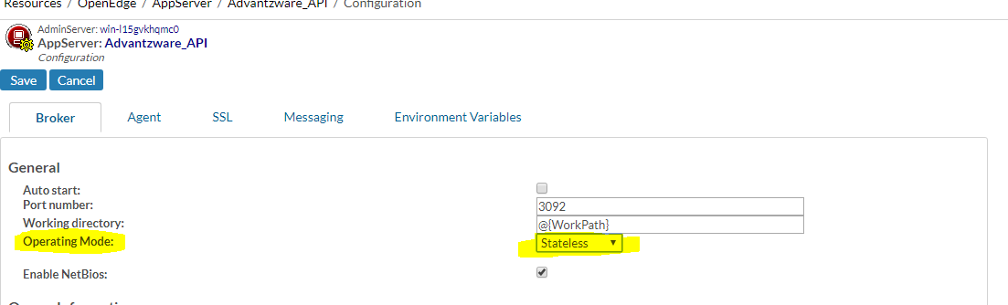

* Go to the **Agent** tab to setup the server startup parameters and the PROPATH
* Setup .pf file in the **server startup parameters** field and application’s PROPATH in the **PROPATH** field

Sample setup of AppServer startup parameters and the PROPATH is shown below

Add the below path to the PROPATH field as shown below:

C:\Asigui\Environments\Devel\Programs

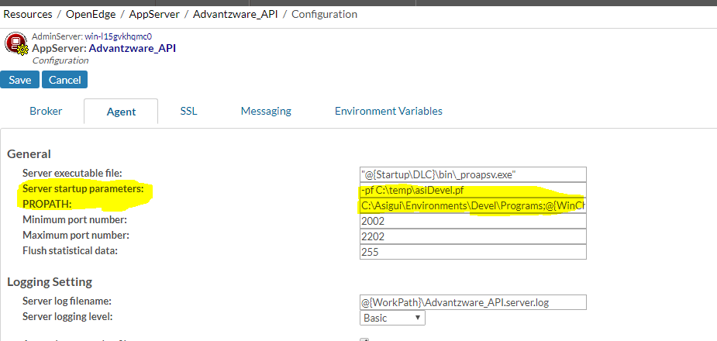

* Now, save the configuration and start the AppServer **Advantzware_API**.
* If the AppServer starts without any issues, we can see its status as **“Running”** as shown in the screen shot below.

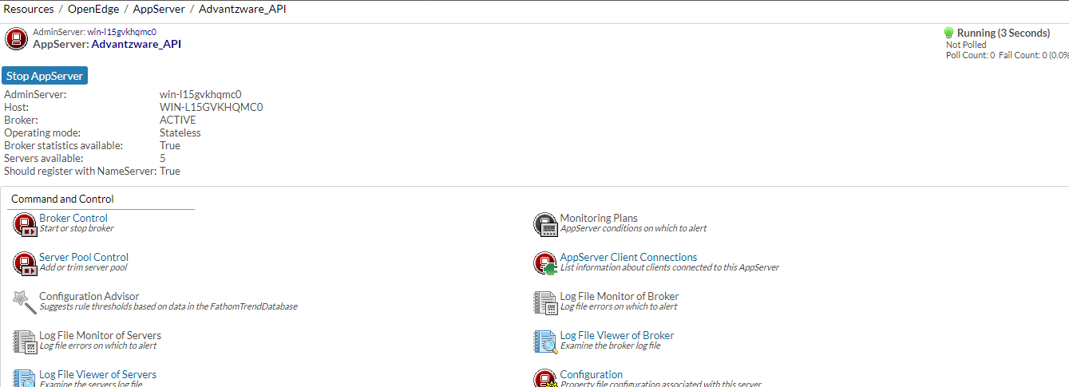

**Step 5: Progress Programs Folder Setup**

* A Folder named “inbound” (under Programs\api) will be created as result of “fsInstaller” installer run. This is where the Inbound API specific programs are available as compiled code

**Step 6: Node Server Setup**

1. **Install Node Server by using the link below:**

<https://nodejs.org/en/>

**Note:** If Node Server is installed successfully, then its icons should appear in windows search as shown below.

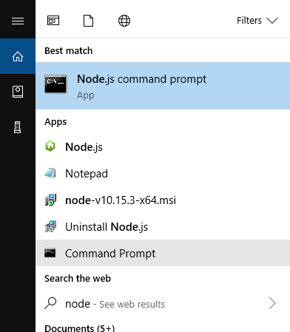

1. **Add NODE_PATH in environment variables:**

NODE_PATH: <path where node is installed>\node_modules

**Example**: C:\Program Files\nodejs\node_modules

1. **Install Required Node modules:**

* Open command prompt
* Run below commands in the same order as given below:

|  |
| --- |
| npm install --save express  npm install --save body-parser  npm install --save express body-parser body-parser-xml  npm install --save node-jre  npm install --save csv-write-stream  npm install --save fs  npm install --save xml  npm install --save xmldom |

1. **Update the following constants as below:**

* Open program Programs\api\node\config.js
* Config.js has a JSON string with key-value pair
* Value for the key **appServerURL** should be updated with AppServer broker name as configured in the Step 4.

Sample code is shown below

|  |
| --- |
| "appServerURL":"AppServer://localhost:5162/<AppServer broker name>", |

* Value for the key **DLC** should be updated with <Progress Installation Folder> and this should have \\ to escape backslash.

Sample code is shown below

|  |
| --- |
| "DLC":"<Progress Installation Folder>", |

* Value for the keys **authUsername** and **authPassword** are used while calling the API Inbound routes. **This is an ASI user.**

Sample is shown below

|  |
| --- |
| "authUsername":"<username>", |
| "authPassword":"<password>" |

Below screenshot shows code for constants **appServerURL**, **DLC** , **authUsername** and **authPassword** inPrograms\api\node\config.js

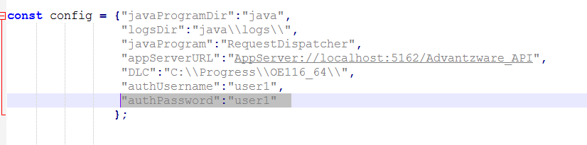

1. **Start JSON Node Server:**

* Open command prompt.
* Change current working directory to Programs\api\node folder
* Run below command

|  |
| --- |
| node InboundAPIStartJSON.js >> node.server.JSON.log |

**Note:** If Node starts without any errors, “node.server.JSON.log” file will have the text as shown below.

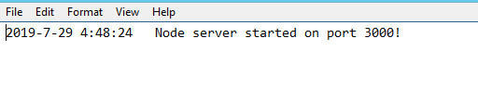

1. **Start XML Node Server:**

* Open command prompt.
* Change current working directory to Programs\api\node folder
* Run below command

|  |
| --- |
| node InboundAPIStartXML.js >> node.server.XML.log |

**Note:** If Node starts without any errors, “node.server.XML.log” file will have the text as shown below.

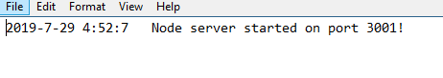

**How to test Inbound APIs**

1. Inbound API “**getinventory**”:

* Postman Setup
* Launch Postman
* Select request type as **POST**
* Enter “http://localhost:3000/api/getinventory” as API URL
* Go to “Authorization” tab and enter username and password as provided in the Node program (Programs\api\node\config.js)

In the **Step 6.4**

* Go to “Body” tab
* Enter below sample **JSON** text as request data

|  |
| --- |
| {  "Requestedby":"Premier",  "Company": "001",  "WareHouseID":"mAIN",  "LocationID":"fLOOR",  "InventoryStockID":"104041C",  "PrimaryID":"10107 32",  "ItemType":"FG"  } |

* Select “raw” and “JSON” as data type as shown below

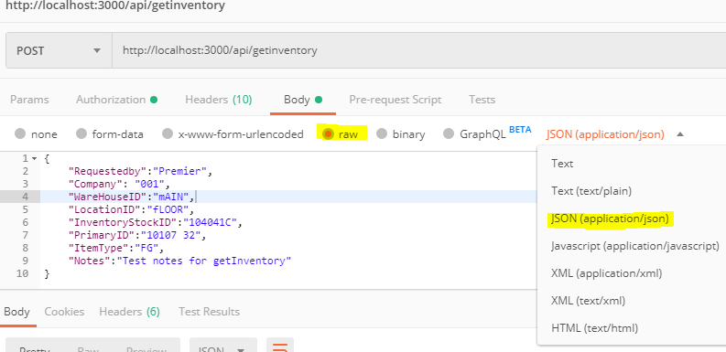

* Now click on **Send** button to call API “getinventory”
* If API “getinventory” call is successful, then below JSON text is returned as the response

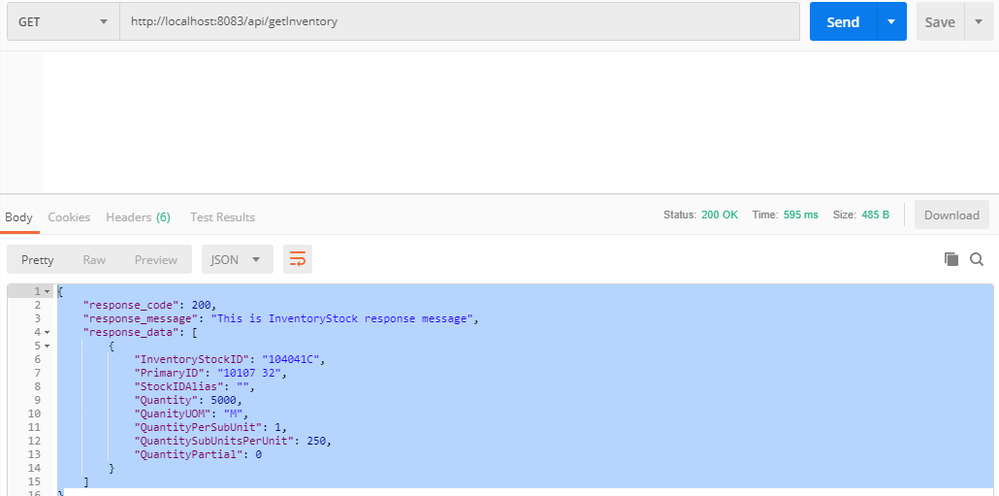

1. Inbound API “**cxmlorder**”:

* Setting up “System Control Parameter “ for “cXMLOrder”
* Go to “System Control Parameters” (N-K-1) screen
* Search for name “cXMLOrder”. Here, we are assuming that “cXMLOrder” is already created
* Create new form (sys-ctrl-shipto) by following below steps

1. Select radio button “Customer”
2. Enter “Customer/Vendor ID” field for which we tag the customer name
3. Enter customer name in “Business Form Name” field. Customer name should be same as “Identity” tag value in request XML provided by customer
4. Check “Logical Value” toggle box

Find the below sample form created for customer “amazon” linked to Customer ID “ATT1000”

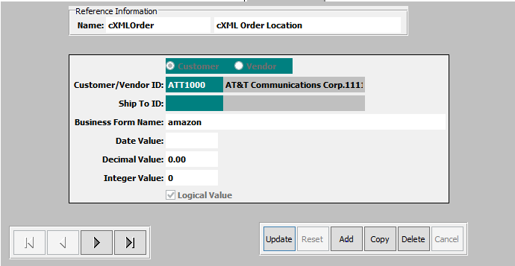

* Modify “XML request data” provided by customer as below.
* Modify “SupplierPartID” tag value in request XML with any valid item for the customer. Make sure the items are linked to customer ID provided in “cXMLOrder” System Control Parameter setup
* Modify “orderID” attribute in “OrderRequestHeader” tag with a unique value for each call
* Remove “DOCTYPE” tag from the request XML
* Setup Postman
* Launch Postman
* Select request type as **POST**
* Enter “http://localhost:3001/api/cxmlorder” as API URL
* Go to “Authorization” tab and enter username and password as provided in the Node program (Programs\api\node\config.js) in the **Step 6.4**
* Go to “Body” tab and paste modified request XML”
* Select “raw” and “Text” as data type as shown below

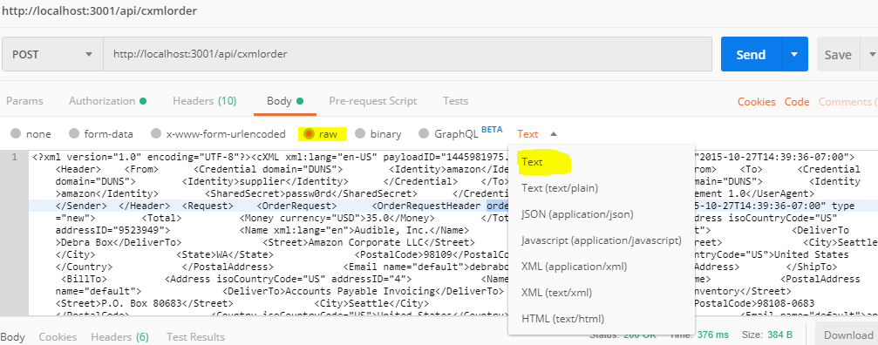

* Now click on **Send** button to call API “cxmlorder”
* If API “cxmlorder” call is successful, then below XML is returned as the response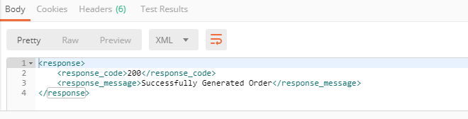
* Order created can be checked in **“Order Entry” (O-U-1)** screen as show below

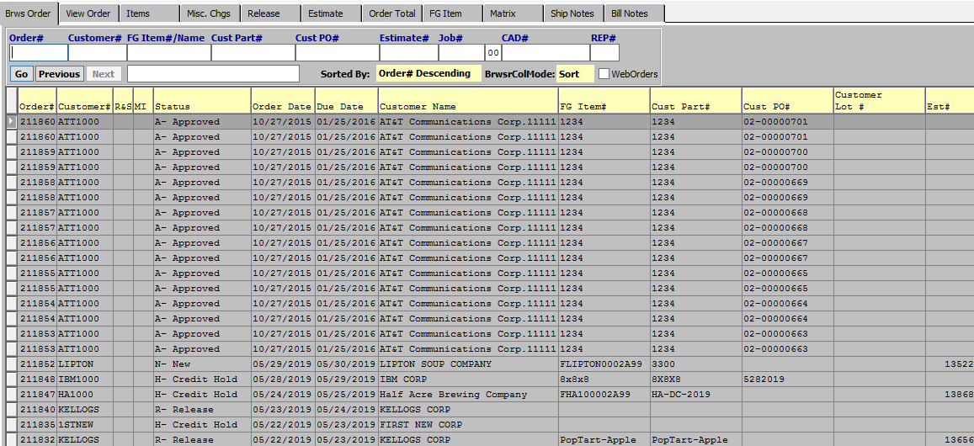

1. Inbound API “**createInventorystockaliasforpo**”:

* Postman Setup
* Launch Postman
* Select request type as **POST**
* Enter “http://localhost:3000/api/createInventorystockaliasforpo” as API URL
* Go to “Authorization” tab and enter username and password as provided in the Node program (Programs\api\node\config.js) in the **Step 6.4**
* Go to “Body” tab
* Enter below sample **JSON** text as request data

|  |
| --- |
| {  "Requester":"Premier",  "Company":"001",  "PONo":101944,  "POLine":1,  "PrimaryID":"COLSCOPUITEM",  "ItemType":"FG",  "Quantity":1000.1,  "QuantityPerSubUnit":1000.0,  "StockIDAlias":"FG00",  "RequesterNotes":"Test notes for createInventoryStockAliasForPO"  } |

* Select “raw” and “JSON” as data type as shown below

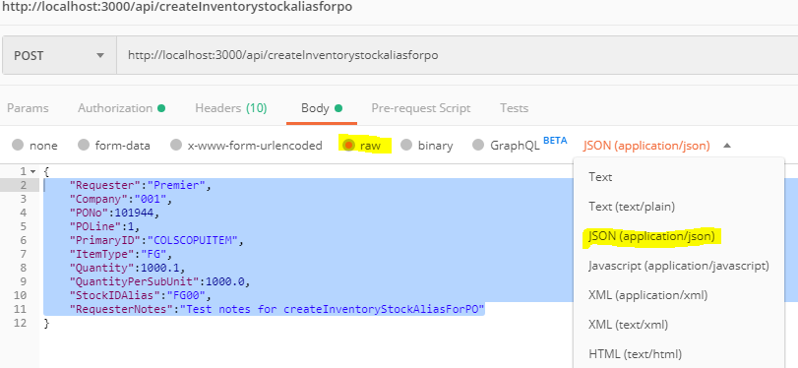

* Now click on **Send** button to call API “createInventorystockaliasforpo”
* If API “createInventorystockaliasforpo” call is successful, then below JSON text is returned as the response

