ADVANCED SOFTWARE SERVICES, INC
SYSTEM ADMINISTRATION

Title Page Title Page

Table of Contents 1 System Listing – Parameter Listing 34
Function Keys 2 System – Program Master List 35
User Font and Color Settings 3 System Listings – User Group List 36
Users Menu Structure 4 Stsem Listings – User List 37
Address Information – (Browse) 5 System Listing – Audit Trail List 38
Address Information – (View) 6 System Listing – Tracking Usage List 39
Notes Search – (Browse) 7
Notes Search – (View) 8
Phone Information – (Browse) 9
Phone Information – (View) 10
State and Province Abbreviation – (Browse) 11
State and Province Abbreviation – (View) 12
Title Codes – (Browse Titles) 13
Title Codes – (View Titles) 14
Zip Codes – (Browse) 15
Zip Codes – (View) 16
State List – List Request 17
Title Codes List 18
Zip Codes List 19
System – Spool Requests 20
System Configurations 21
System – Parameter Files- (Browse) 22
System – Parameter Files – (View) 23
System – Select Table to Audit 24
System – Access Security Menu 25
System – Misc. Fields Layout Design 26
System – Program Master - (Browse) 27
System – Program Master – (View) 28
System – User Groups – (Browse) 29
System – User Groups – (View) 30
System – Users – (Browse) 31
System – Users – (View) 32
System – Zip Code Loader 33

ADVANCED SOFTWARE SERVICES, INC
FUNCTION KEYS

The following describes the standard function buttons, which can be activated with the mouse or the alternate key on your keyboard.

BRWS = The browser folder is a list of records in the file. This is functionally equivalent
to the find option of our standard package.

VIEW = View folder records provides the ability to ADD, CHANGE, DELETE and UPDATE
an individual records.

This effectively replaces the find feature of our legacy Foldware and Corrware products.

SORT BY = The selections at the bottom of the browser which will sort the list in alphabetic order.

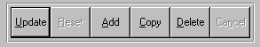

Update = Updating the current record.
Reset = Reset the current record.
Add = Add a record.
Copy = This will copy the existing record.
Delete = Delete the current record displayed on the screen. To delete an individual field, double
click on the field and press the regular delete key on the keyboard.
Cancel = Canceling the information that was entered.
Save = Save the record.


 |  |  |  |  |  |  |  |  |  |  |  |  |  |  |  |  |  |  | First – Takes you to the first record
 |  |  |  |  |  |  |  |  |  |  |  |  |  |  |  |  |  |  | Previous – Takes you back one record at a time
 |  |  |  |  |  |  |  |  |  |  |  |  |  |  |  |  |  |  | Next – Moves forward one record
 | First |  |  | Previous |  |  |  |  | Next |  |  | Last |  |  |  |  |  |  | Last – Last current record
 |  |  |  |  |  |  |  |  |  |  |  |  |  |  |  |  |  |  |  |  | F2 – Search for a record
 |  |  |  |  |  |  |  |  |  |  |  |  |  |  |  |  |  |  |  |  | F3 – List a record
 |  |  |  |  |  |  |  |  |  |  |  |  |  |  |  |  |  |  |  |  | F4 – Add notes to a record
 |  |  |  |  |  |  |  |  |  |  |  |  |  |  |  |  |  |  |  |  | F5 – Misc. fields
F2 |  |  | F3 |  | F4 |  | F5 |  |  | F6 |  |  | F7 |  |  | F8 | F9 | F12 |  |  | F6 – Browse the records
 |  |  |  |  |  |  |  |  |  |  |  |  |  |  |  |  |  |  |  |  | F7– View the records
 |  |  |  |  |  |  |  |  |  |  |  |  |  |  |  |  |  |  |  |  | F8 – Phone Information
 |  |  |  |  |  |  |  |  |  |  |  |  |  |  |  |  |  |  |  |  | F9 – Addressees
 |  |  |  |  |  |  |  |  |  |  |  |  |  |  |  |  |  |  |  |  | F12 – Exit the screen

ADVANCED SOFTWARE SERVICES, INC
USER FONT AND COLOR SETTINGS

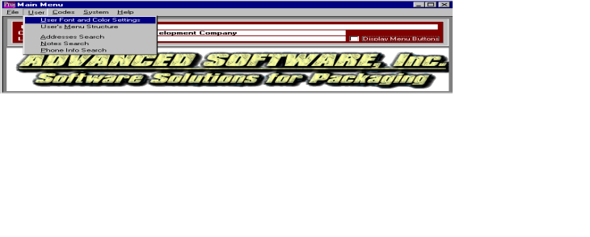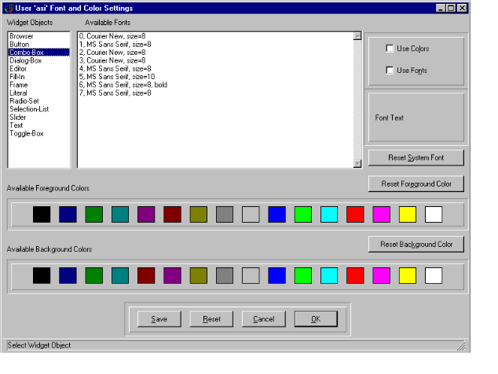

USER FONT AND COLOR SETTINGS

This selection allows the user to make custom changes to the font and color settings. The user can change any objects or screen color, or font style. Select an object from the Widget Object box, and then click on the desired foreground and background color. You may also choose a font style from the Available Font selection.

For these changes to take effect, you must check the Use Fonts and Use Colors checkbox and click the save button. If you do not check the Use Fonts checkbox, the fonts will not change. Changes made to the colors and fonts will only change for that user. No other user will be affected.

ADVANCED SOFTWARE SERVICES, INC
USER’S MENU STRUCTURE
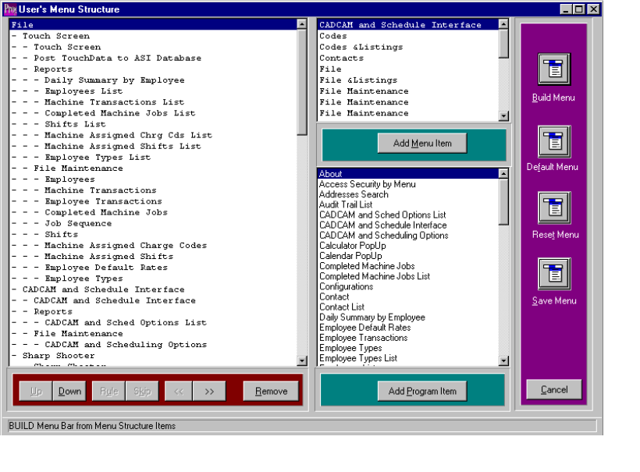

USER MENU STRUCTURE

This selection allows the user to customize their drop down menus. This does not customize the buttons on the main menu. The user will be able to add or remove items from their menu. For example, if a user does not use a particular option, they can remove that option from the menu. They can also move an option to a different menu. For example, if the user would like Zip Codes Loader on the Codes menu instead of the System menu, they can move that option.

To add a Menu item or Program Item to the user’s menu, first highlight the item in the users menu that you would like the new item to go below. Then select a menu item from the top right selection list, or Program Item from the bottom right selection list. Once an item is highlighted, click Add Menu Item, or Add Program Item. That item will then appear in the users menu structure.

To move an item, highlight the desired selection and use the Up or Down buttons at the bottom of the screen to move the selection to the new place. The dashes in front of each selection represent what menu that selection is on. For example, the word File has no dash in front of it. This means, this selection will appear in the menu bar on the main menu screen. The word Touch Screen is directly under the word file and has one dash in front. This means, Touch Screen is the first option on the File menu. When you see the word RULE, this places a solid line across the drop down menu list. When you see the word SKIP, this places a blank line in the drop down menu list. To change the menu placement, use the << and >> buttons at the bottom of the screen. These buttons remove or add dashes to the selected item.

To delete an item from the menu, highlight the desired selection and click Remove. This will remove that option from the menu.

After the user makes the desired changes, you must click on the Build Menu button. This button is located on the right side of the screen. Once you click the Build Menu button, click on the Save Menu. This will save your custom menu.

The Default Menu button will change the menu back to the pre-designed menu created by Advanced Software Inc.

The Reset Menu button will change the menu back to whatever it was the last time it was saved. For example, if you already created your custom menus and went into the Menu Structure to make changes. While you are making those changes, decide you no longer wanted the changes, you can click on the reset button. This will erase any changes you made in this session.

ADVANCED SOFTWARE SERVICES, INC
ADDRESS INFORMATION
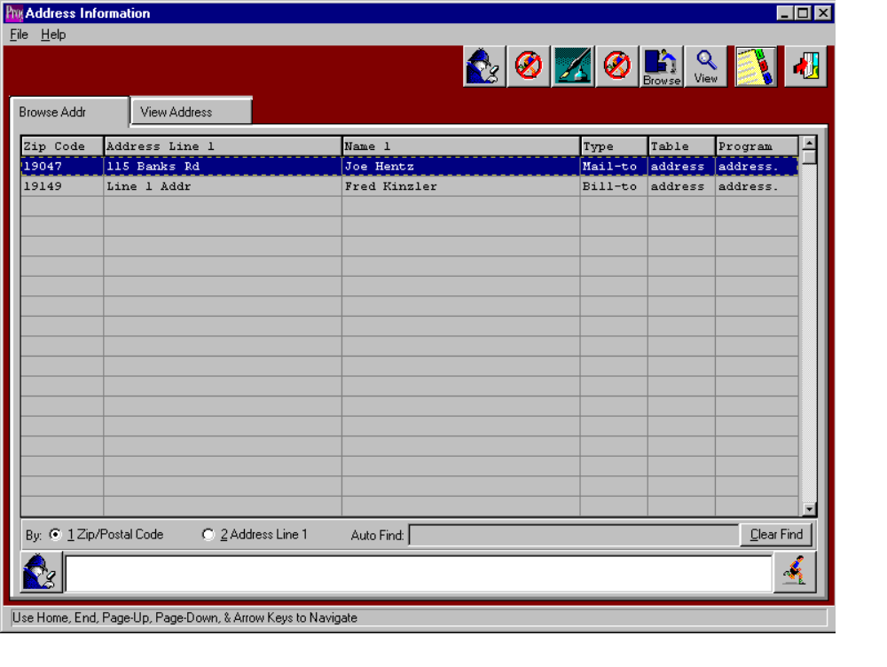

ADDRESS INFORMATION

The Address Information browser can be sorted by Zip Code or by Address Line 1. The browser shows the users zip code, address line 1, name, type, table and program. The icons at the top of the browser provide additional capabilities. The icon with the fountain pen provides notes for each address. Each note, records the users initials, date, description of the note and a full-page of text for each note. Unlimited notes may be defined for each address. The browse icon will provide immediate access to the browser by address. The icon with the 3 tabs provides immediate access to the phone information for a particular address.

ADVANCED SOFTWARE SERVICES, INC
ADDRESS INFORMATION
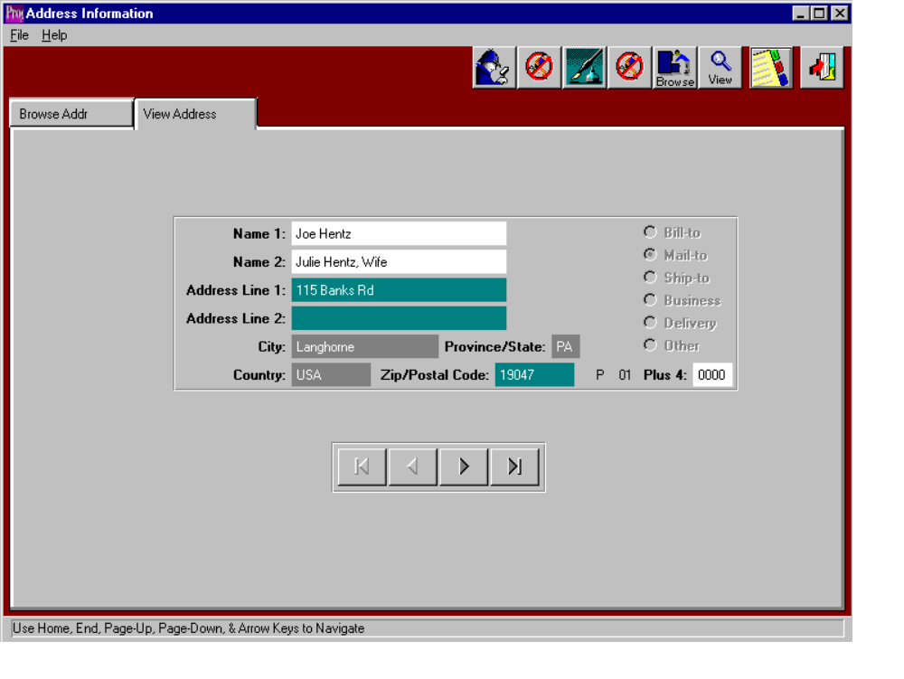

VIEW ADDRESS

The view address screen allows you to view the details of each address. You cannot change, add or delete any information from this screen. Use the arrow keys at the bottom of the screen to view the next or previous address. The icons at the top of the browser provide additional capabilities. The icon with the fountain pen provides notes for each address. Each note, records the users initials, date, description of the note and a full-page of text for each note. Unlimited notes may be defined for each address. The browse icon will provide immediate access to the browser by address. The icon with the 3 tabs provides immediate access to the phone information for a particular address.

ADVANCED SOFTWARE SERVICES, INC
NOTES SEARCH
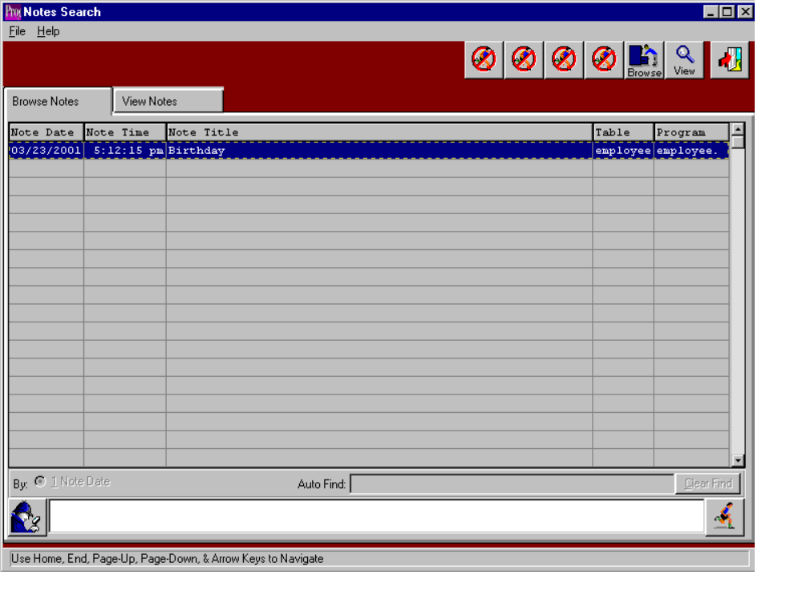

NOTES SEARCH - BROWSER

This selection shows all notes listed in the system. The notes are from every module. The note date, time, and user is recorded on each note. The browser shows the note date, time, title, table, and program where the note exists. To view a note, you may double click on the selected note or click the View Notes tab. You may also search notes by keywords or phases, using the text box at the bottom of the screen. By typing the keywords, using commas to separate words and phrases, and clicking on the search button (the button with the man holding the magnify glass).

ADVANCED SOFTWARE SERVICES, INC
NOTES SEARCH
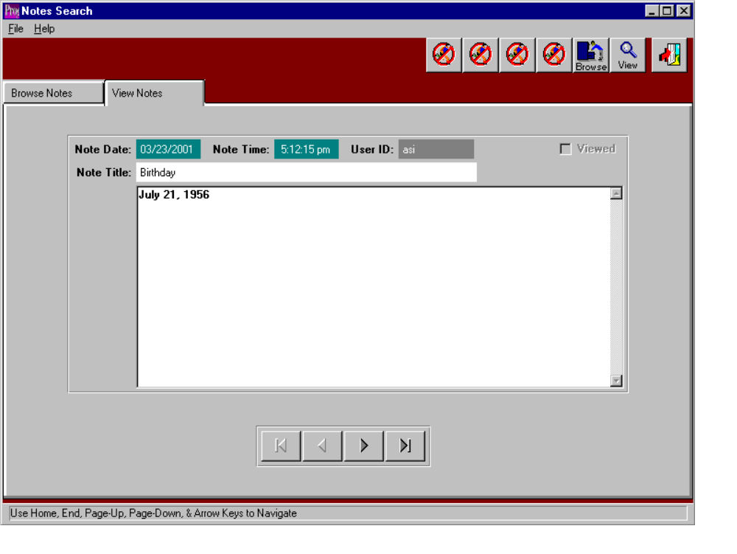

VIEW NOTES

The view notes screen allows you to view the text of each note. You cannot change, add or delete any information from this screen. Use the arrow keys at the bottom of the screen to view the next or previous note. The icons at the top of the browser provide additional capabilities. The browse icon will provide immediate access to the browser by note date.
ADVANCED SOFTWARE SERVICES, INC
PHONE INFORMATION
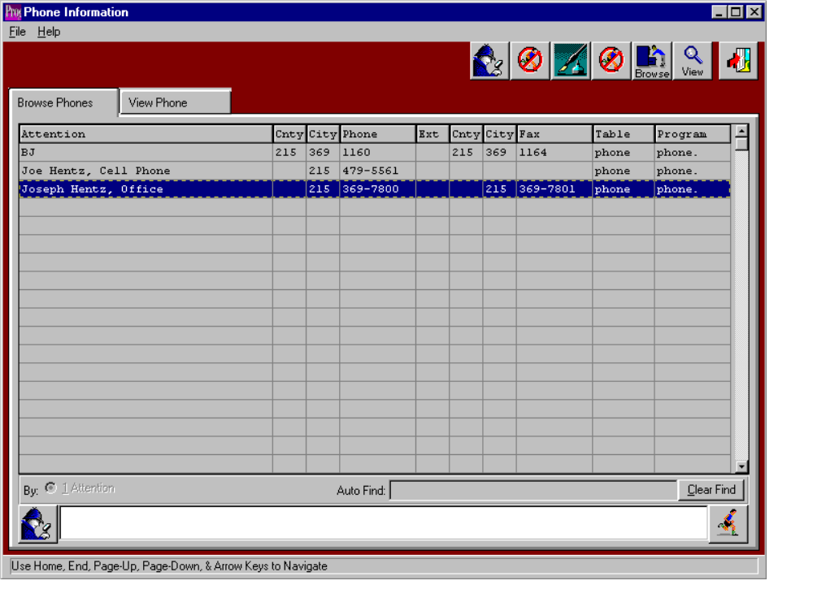

PHONE INFORMATION – BROWSER

This selection shows all phone information listed in the system. The browser shows the attention line, county code, area code, phone number, extension, fax county code, fax area code, fax number, table and program where the record exists. To view phone information, you may double click on the selected phone information or click the View Phone tab. You may also search phone information by keywords or phases, using the text box at the bottom of the screen. By typing the keywords, using commas to separate words and phrases, and then clicking on the search button (the button with the man holding the magnify glass). The icons at the top of the browser provide additional capabilities. The icon with the fountain pen provides notes for each record. Each note, records the users initials, date, description of the note and a full-page of text for each note. Unlimited notes may be defined for each record. The browse icon will provide immediate access to the browser by phone.

ADVANCED SOFTWARE SERVICES, INC
PHONE INFORMATION
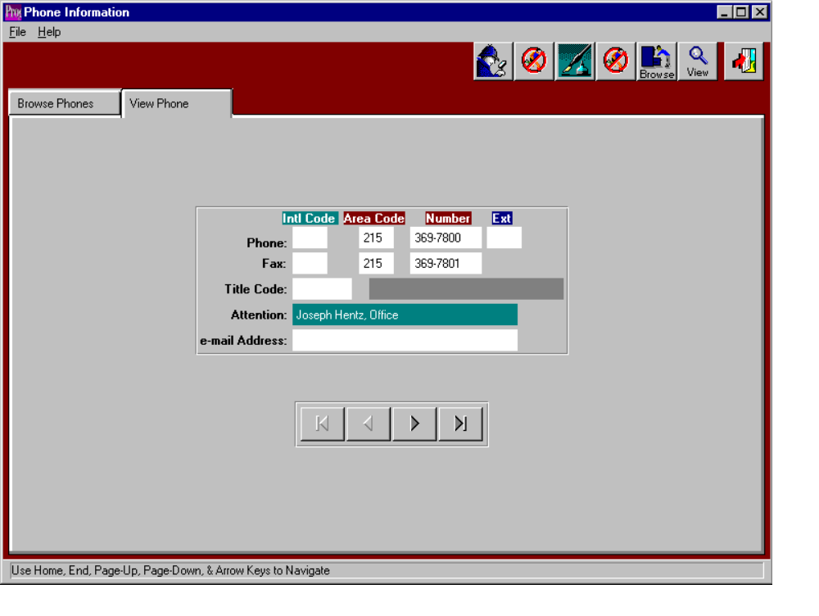

PHONE INFORMATION – VIEW

The view phone screen allows you to view the information of each listing. You cannot change, add or delete any information from this screen. Use the arrow keys at the bottom of the screen to view the next or previous phone record. The icons at the top of the browser provide additional capabilities. The browse icon will provide immediate access to the browser by phone. The icon with the fountain pen allows you to view any notes for the phone record selected.
ADVANCED SOFTWARE SERVICES, INC
STATE AND PROVINCE ABBREVIATION
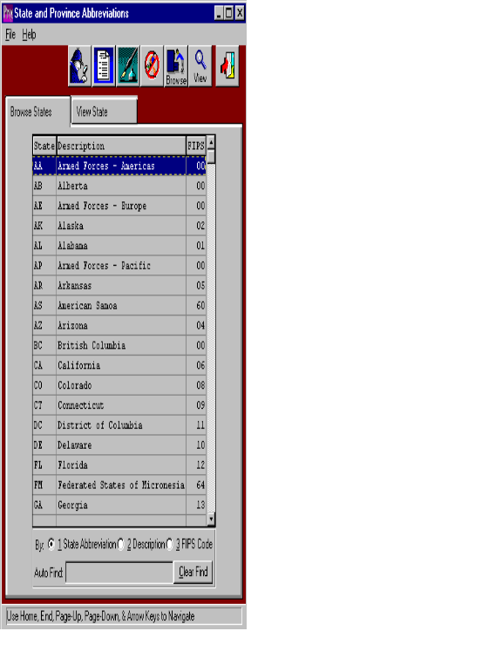

STATE AND PROVINCE ABBREVIATION – BROWSER

This selection shows all valid state and province abbreviation listed in the system. The browser shows the state abbreviation, description, and FIPS code. To view a state, you may double click on the selected state or click the View State tab. The icons at the top of the browser provide additional capabilities. The icon with the fountain pen allows you to view the notes for each state. Each note, records the users initials, date, description of the note and a full-page of text for each note. Unlimited notes may be defined for each state. The browse icon will provide immediate access to the browser by state. The icon with the corner of a page folded over allows you to print a list of the state and province abbreviations.

ADVANCED SOFTWARE SERVICES, INC
STATE AND PROVINCE ABBREVIATION

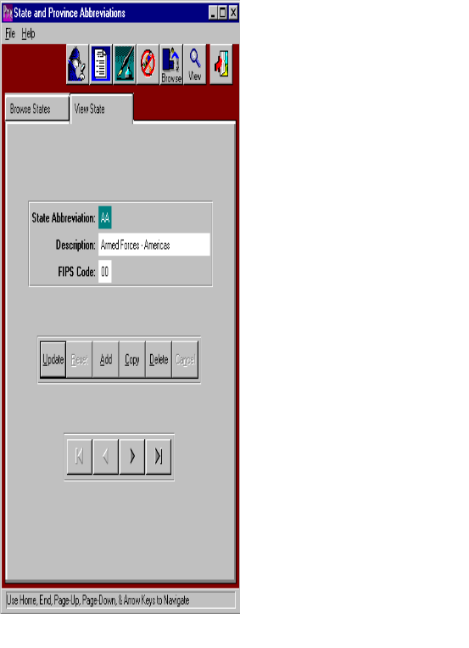

STATE AND PROVINCE ABBREVIATION – VIEW

The view phone screen allows you to view the information of each listing. You may copy, change, add or delete any information from this screen. Use the arrow keys at the bottom of the screen to view the next or previous state. The icons at the top of the screen provide additional capabilities. The browse icon will provide immediate access to the browser by state. The icon with the fountain pen allows you to view any notes for the state record selected. The icon with the corner of a page folded over allows you to print a list of the state and province abbreviations.
ADVANCED SOFTWARE SERVICES, INC
TITLE CODES
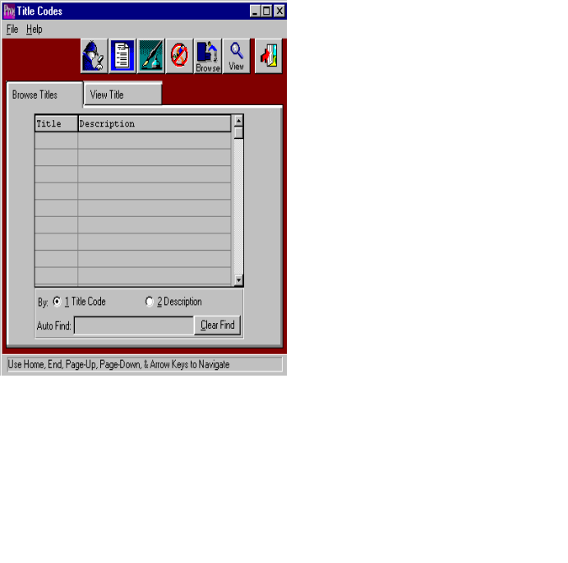

TITLE CODES – BROWSER

This selection shows all valid job title codes listed in the system. The browser shows the title and description. You may sort to browser list by Title Code or by Description by clicking on the desired sort option at the bottom of the screen. To view a title, you may double click on the selected job title or click the View Title tab. The icons at the top of the browser provide additional capabilities. The icon with the fountain pen allows you to view the notes for each title. Each note, records the users initials, date, description of the note and a full-page of text for each note. Unlimited notes may be defined for each title. The browse icon will provide immediate access to the browser by title. The icon with the corner of a page folded over allows you to print a list of the job titles.
ADVANCED SOFTWARE SERVICES, INC
TITLE CODES
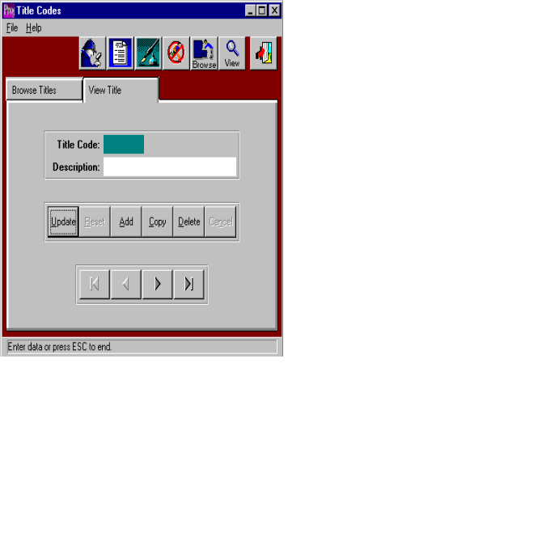

TITLE CODES – VIEW

The view Title screen allows you to view the information of each job title. You may copy, change, add or delete any information from this screen. Use the arrow keys at the bottom of the screen to view the next or previous title. The icons at the top of the screen provide additional capabilities. The browse icon will provide immediate access to the browser by title. The icon with the fountain pen allows you to view any notes for the title record selected. The icon with the corner of a page folded over allows you to print a list of the job title codes and descriptions.

ADVANCED SOFTWARE SERVICES, INC
ZIP CODES
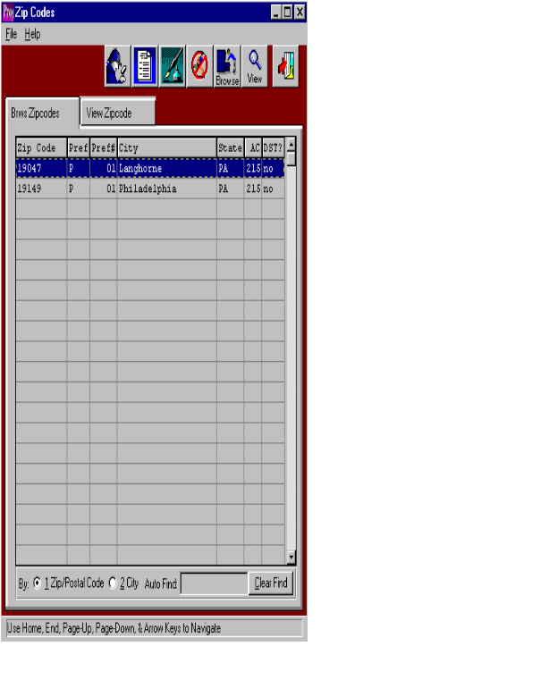

ZIP CODES – BROWSER

This selection shows all valid zip codes listed in the system. The browser shows the zip code, preference type, preference number, city, state, area code, and daylight savings. You may sort to browser list by Zip/Postal Code or by City by clicking on the desired sort option at the bottom of the screen. To view a zip code, you may double click on the selected zip code or click the View Zip Code tab. The icons at the top of the browser provide additional capabilities. The icon with the fountain pen allows you to view the notes for each zip code. Each note, records the users initials, date, description of the note and a full-page of text for each note. Unlimited notes may be defined for each zip code. The browse icon will provide immediate access to the browser by zip code. The icon with the corner of a page folded over allows you to print a list of the zip codes.
ADVANCED SOFTWARE SERVICES, INC
ZIP CODES
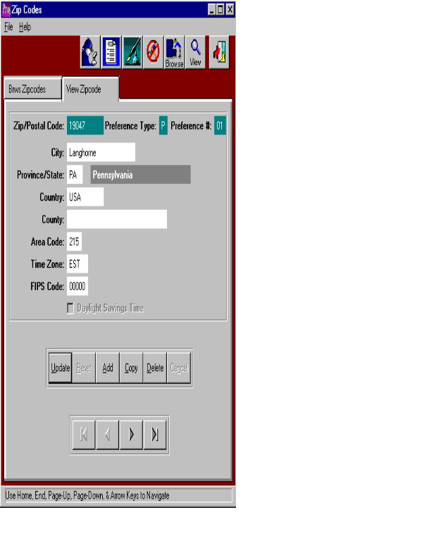

ZIP CODES – VIEW

The view Zip Code screen allows you to view the information of each zip code. You may copy, change, add or delete any information from this screen. Use the arrow keys at the bottom of the screen to view the next or previous zip code. The icons at the top of the screen provide additional capabilities. The browse icon will provide immediate access to the browser by zip code. The icon with the fountain pen allows you to view any notes for the record selected. The icon with the corner of a page folded over allows you to print a list of the zip codes.
ADVANCED SOFTWARE SERVICES, INC
STATE LIST –LIST REQUEST

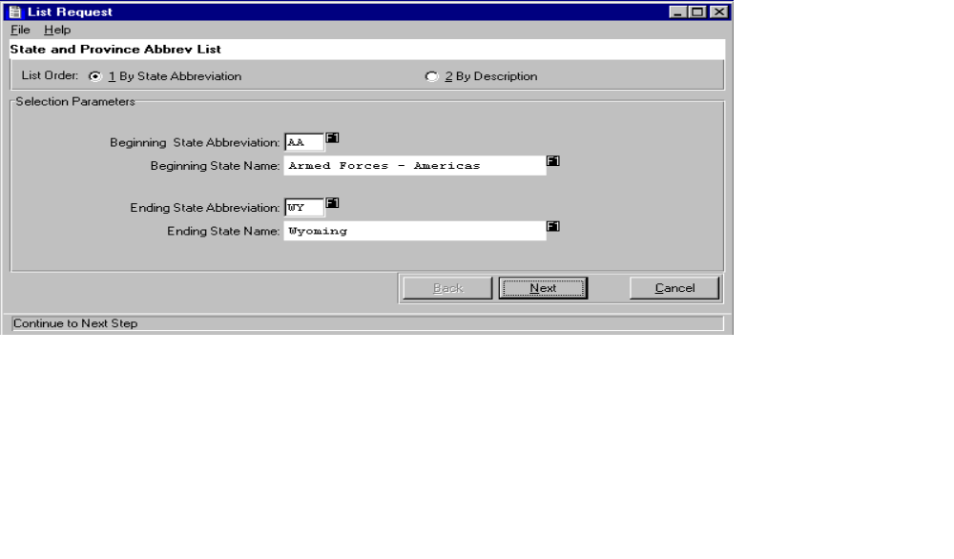

STATE ABBREVIATION – LIST REQUEST

This selection allows the user to print a list of state and province abbreviations. You may sort the list by State Abbreviation or by description. You may print a complete list or choose a range of states. You may also choose an output device. You may print list to a printer, the screen, or a disk file. You may also choose to spool this report to print at a later time or date. After clicking printer as an output device, click the spool checkbox. A field for a date and time will appear. Enter the date and time you would like this report to run.

ADVANCED SOFTWARE SERVICES, INC
TITLE CODES LIST
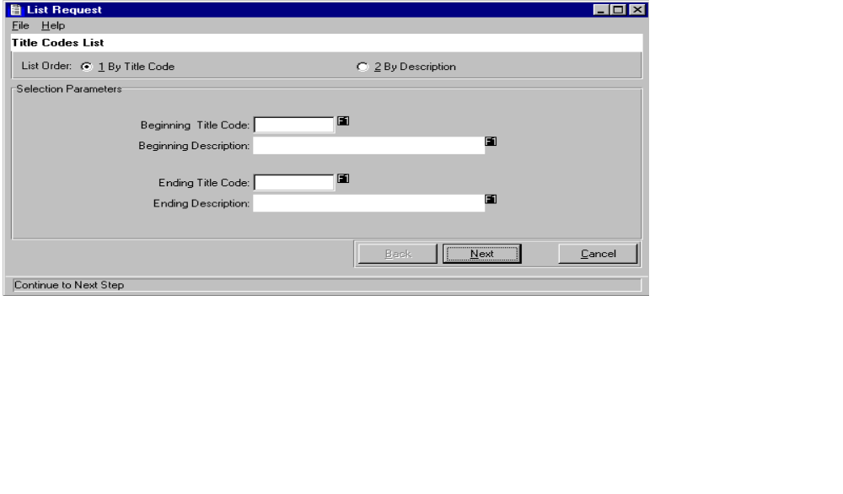

TITLE CODE – LIST REQUEST

This selection allows the user to print a list of job title codes. You may sort the list by title Code or by description. You may print a complete list or choose a range of titles. You may also choose an output device. You may print list to a printer, the screen, or a disk file. You may also choose to spool this report to print at a later time or date. After clicking printer as an output device, click the spool checkbox. A field for a date and time will appear. Enter the date and time you would like this report to run.
ADVANCED SOFTWARE SERVICES, INC
ZIP CODES LIST
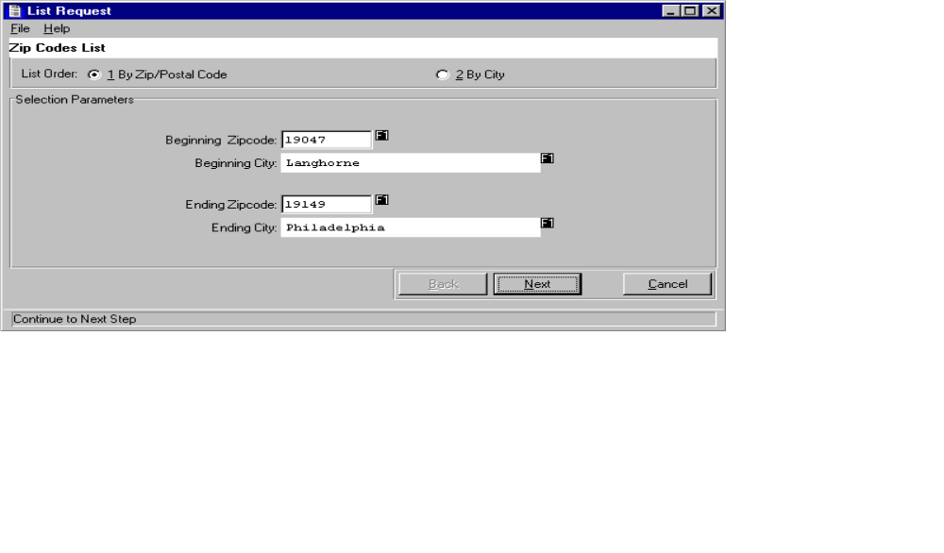

ZIP CODE – LIST REQUEST

This selection allows the user to print a list of zip codes. You may sort the list by zip code or by City. You may print a complete list or choose a range of zip codes. You may also choose an output device. You may print list to a printer, the screen, or a disk file. You may also choose to spool this report to print at a later time or date. After clicking printer as an output device, click the spool checkbox. A field for a date and time will appear. Enter the date and time you would like this report to run.

ADVANCED SOFTWARE SERVICES, INC
SYSTEM – SPOOL REQUESTS

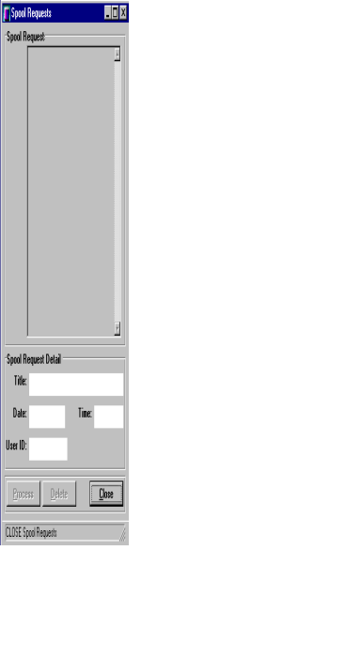

SYSTEM – SPOOL REQUESTS

This selection shows you any print jobs set to print at a later time. When you print from any module in this system, you can choose to print the report at a later time. When you select printer from the output device and place a check in the spool check box, a date and time will appear. The user will than enter the date and time they would like the report to print.

Once the report is sent to the spool request, it will print at that time. You may process the report at any time, simply by clicking the process button at the bottom of the screen. You may also choose to delete this print job, by clicking the delete button at the bottom of the screen. You may not, however, modify this print job in any way.

SHUT DOWN SPOOL REQUEST MONITOR

This selection disables the spool request option. If you choose to disable the spool request monitor, users may still spool print jobs. They will not print until you restart the spool request monitor. Once the spool request is running, it will check the spooled jobs and process any job prior to the current date and time.

ADVANCED SOFTWARE SERVICES, INC
SYSTEM – CONFIGURATIONS
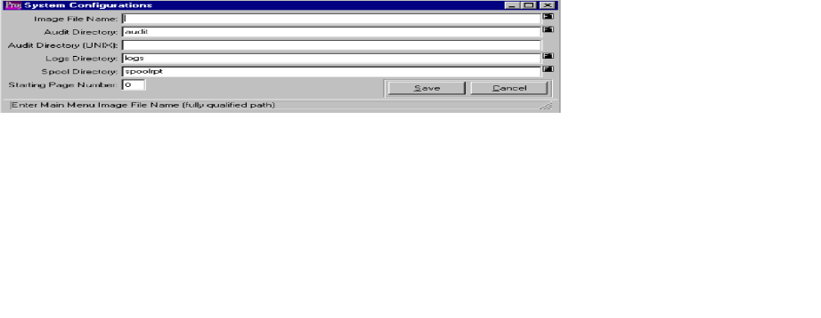

CONFIGURATIONS

This selection allows you to select your personal directories. To make any changes click on the update button. When selecting a directory, the user must type in a fully qualified path. The user may change the audit, log, or spool directory.

ADVANCED SOFTWARE SERVICES, INC
SYSTEM – PARAMETER FILES
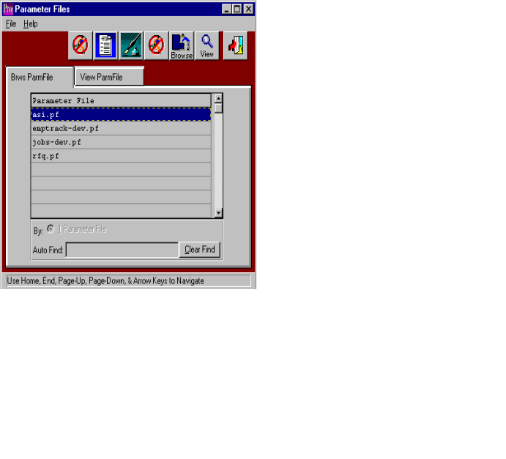

PARAMETER FILES - BROWSER

This selection shows all parameter files in the system. The browser shows the file name. To view a file, you may double click on the selected file or click the View ParmFile tab. The icons at the top of the browser provide additional capabilities. The icon with the fountain pen allows you to view the notes for each file. Each note, records the users initials, date, description of the note and a full-page of text for each note. Unlimited notes may be defined for each file. The browse icon will provide immediate access to the browser by file name. The icon with the corner of a page folded over allows you to print a list of the parameter files.
ADVANCED SOFTWARE SERVICES, INC
SYSTEM – PARAMETER FILES
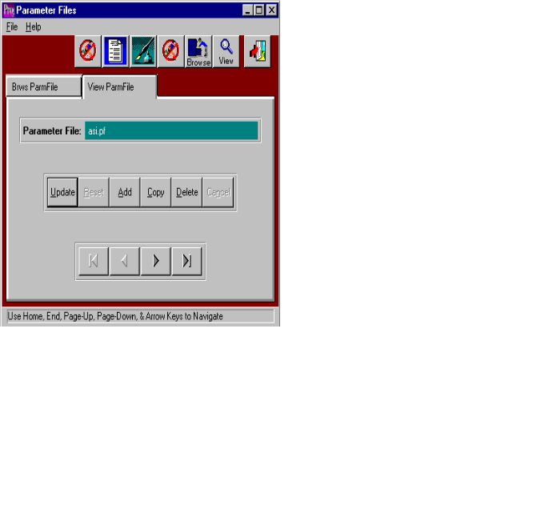

PARAMETER FILE – VIEW

The view ParmFile screen allows you to view the information of each file. You may copy, change, add or delete any file from this screen. Use the arrow keys at the bottom of the screen to view the next or previous parameter file. The icons at the top of the screen provide additional capabilities. The browse icon will provide immediate access to the browser by file name. The icon with the fountain pen allows you to view any notes for the record selected. The icon with the corner of a page folded over allows you to print a list of the parameter files.

ADVANCED SOFTWARE SERVICES, INC
SYSTEM – SELECT TABLE TO AUDIT

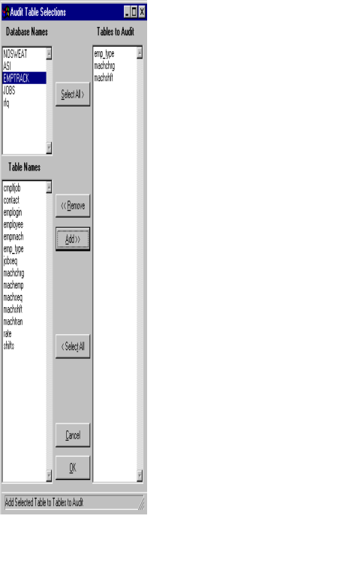

SELECT TABLE TO AUDIT

This selection allows the user to selection tables, or menu, they would like to audit. By selecting a table name from the list, the system will track the user, date and time any changes were made. To print this report, the user must go to the Audit Trail List, found in the System Listing option in the System menu. By using this selection you may audit the users going into different areas of the system.

ADVANCED SOFTWARE SERVICES, INC
SYSTEM – ACCESS SECURITY BY MENU

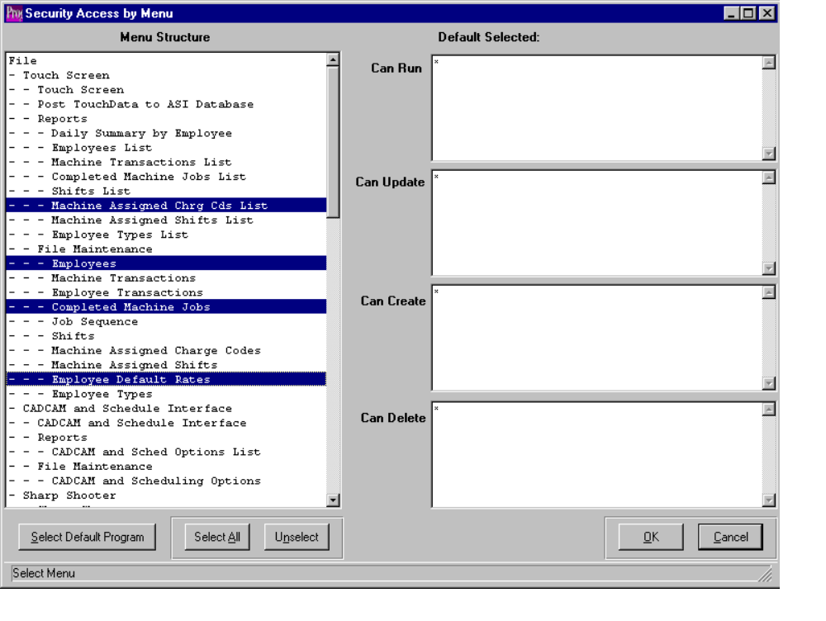

ACCESS SECURITY BY MENU

This security program allows the administrator to define which users or groups may have access to specific programs. If the user id or group name is not defined for the programs selected, then the user will be not be able to run, update, create, or delete that program. . An * gives rights to all users so this code is not recommended.

To secure a program, simply highlight the program from the menu structure list. To highlight each program, simply click each program or press the SELECT ALL button to highlight all programs. Once the programs are highighed, press the SELECT DEFAULT PROGRAM to display current users with access rights. I would recommend the SELECT ALL followed by the SELECT DEFAULT PROGRAM to set the security rights for the president, owner and individuals with complete access rights to the entire system. You must choose the indented most program name rather than the heading. For example, the File Maintenance Menu option can not be secured, but rather each program indented under file maintenance should be highlighted. After highlighting the desired programs by clicking each program name, you MUST click the button called Select Default Program. Thereafter, on the right side of the window, previously secured user and group names for each program will be displayed. Please note, the Select Default Program button must be clicked, otherwise modifications to the user and group names entered will not be saved. After selecting the programs, click on the security option Can Run, Can Update, Can Create or Can Delete, then enter the user names or user groups. Enter an (*) to allow all users access to the highlighted program. You must click the save button to save the settings. The Select All button will highlight every program; therefore this should be run first to add security to system administration and giving access to every program. Next, individual programs should be updated to individual access rights.

PLEASE NOTE: There are two ways to set security in the Advantzware software: Access Security by Menu as well as the Program Master. The Access security by menu allows selecting a range of programs. The Program Master allows selecting individual program for applying security. We recommend the SELECT ALL button followed by the SELECT DEFAULT PROGRAM to set the security rights for the president, owner and individuals with complete access rights to the entire system by typing their user ID on the Can Run, Can Update, Can Delete and Can Create blocks. Next, access the program master to set individual access rights by menu selection.
ADVANCED SOFTWARE SERVICES, INC
SYSTEM – MISC. FIELDS SCR LAYOUT DESIGN

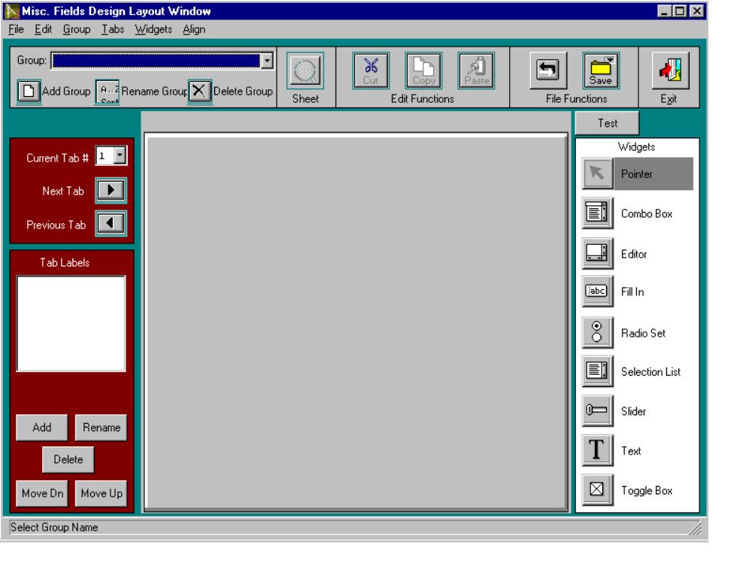

MISC. FIELDS SCREEN LAYOUT DESIGN

ADVANCED SOFTWARE SERVICES, INC
SYSTEM – PROGRAM MASTER
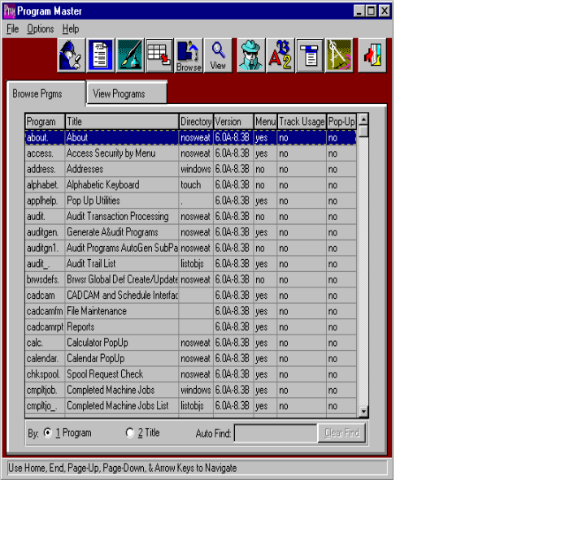

PROGRAM MASTER - BROWSER

This selection shows all the program names for each menu option. The browser shows the program name, menu title, directory, and version. Also shows if the selection appears on a menu, if it’s tracked for usage, and if it’s a pop up screen. To view a program, you may double click on the selected file or click the View Program tab. The icons at the top of the browser provide additional capabilities. The icon with the fountain pen allows you to view the notes for each program. Each note, records the users initials, date, description of the note and a full-page of text for each note. Unlimited notes may be defined for each program. The browse icon will provide immediate access to the browser by program name. The icon with the corner of a page folded over allows you to print a list of the program files. The icon of the man will provide immediate access to the security by menu screen. The icon of the letters will provide immediate access to the set font and colors screen. The icon of the drop-down menu will provide immediate access to the users menu structure screen.
ADVANCED SOFTWARE SERVICES, INC
SYSTEM – PROGRAM MASTER
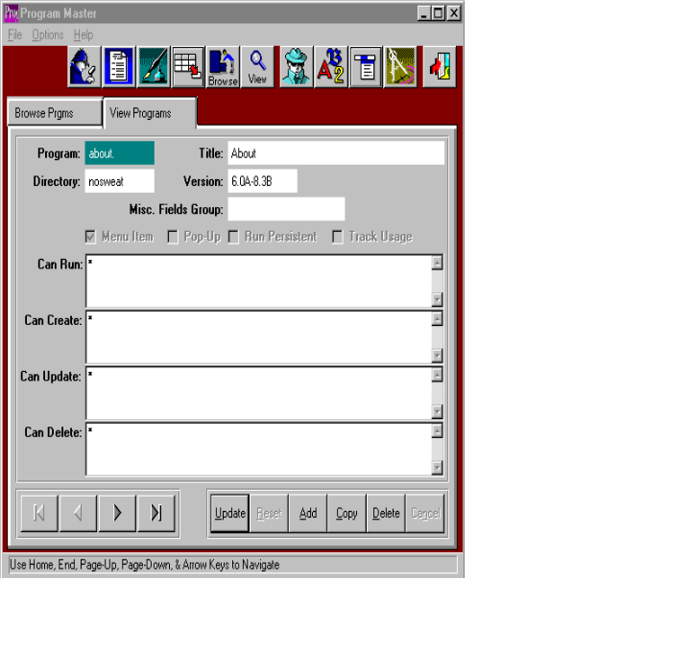

PROGRAM MASTER – VIEW

The view Program screen allows you to view the information of each program. You may copy, change, add or delete any program from this screen. You may also change the security for each program through this screen. Use the arrow keys at the bottom of the screen to view the next or previous program file. The icons at the top of the screen provide additional capabilities. The browse icon will provide immediate access to the browser by program name. The icon with the fountain pen allows you to view any notes for the program selected. The icon with the corner of a page folded over allows you to print a list of the program files. The icon of the man will provide immediate access to the security by menu screen. The icon of the letters will provide immediate access to the set font and colors screen. The icon of the drop-down menu will provide immediate access to the users menu structure screen.

ADVANCED SOFTWARE SERVICES, INC
SYSTEM – USER GROUPS

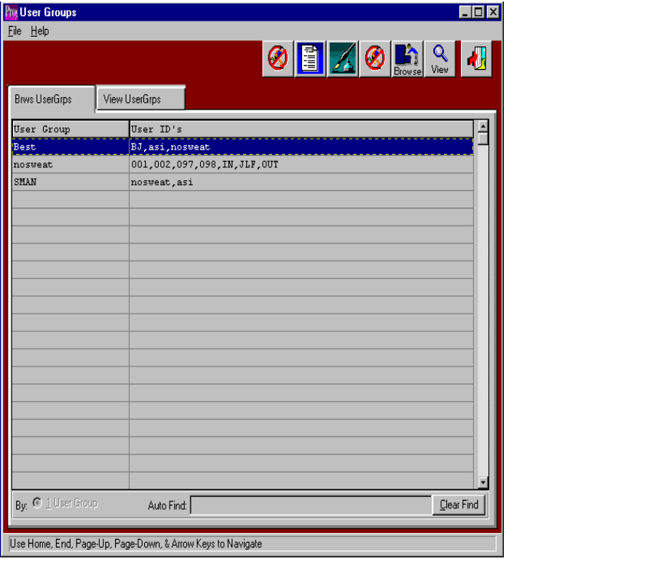

USER GROUPS – BROWSER

This selection shows all the user groups. The browser shows the user group, and user ID’s. To view a program, you may double click on the selected file or click the View Program tab. The icons at the top of the browser provide additional capabilities. The icon with the fountain pen allows you to view the notes for each user group. Each note records the users initials, date, description of the note and a full-page of text for each note. Unlimited notes may be defined for each user group. The browse icon will provide immediate access to the browser by user group. The icon with the corner of a page folded over allows you to print a list of the user groups.
ADVANCED SOFTWARE SERVICES, INC
SYSTEM – USER GROUPS
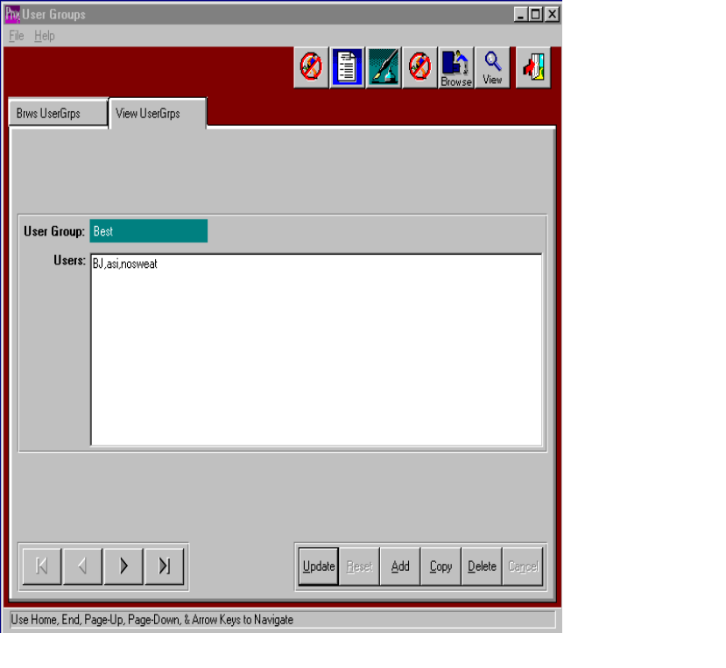

USER GROUPS – VIEW

The view UserGrps screen allows you to view the information of each user group. You may copy, change, add or delete any user group from this screen. Use the arrow keys at the bottom of the screen to view the next or previous user group. The icons at the top of the screen provide additional capabilities. The browse icon will provide immediate access to the browser by user group. The icon with the fountain pen allows you to view any notes for the user group selected. The icon with the corner of a page folded over allows you to print a list of the user groups.

ADVANCED SOFTWARE SERVICES, INC
SYSTEM – USERS
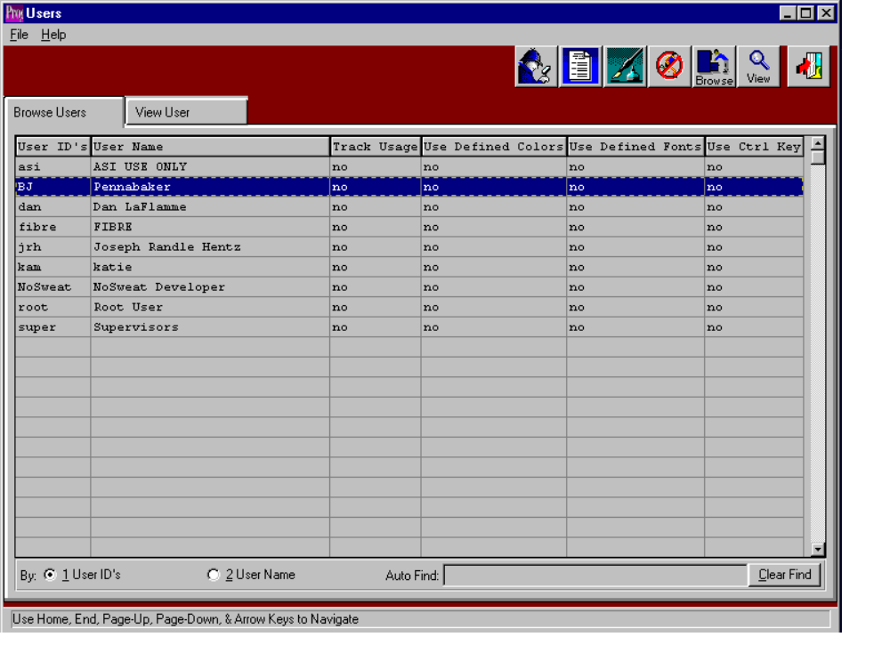

USERS – BROWSER

This selection shows all the users. The browser shows the user ID’s and user name. The browser also shows if the users usage is tracked, if the user is using defined colors, defined fonts, and control keys. To view a program, you may double click on the selected file or click the View User tab. The icons at the top of the browser provide additional capabilities. The icon with the fountain pen allows you to view the notes for each user. Each note records the users initials, date, description of the note and a full-page of text for each note. Unlimited notes may be defined for each user. The browse icon will provide immediate access to the browser by user. The icon with the corner of a page folded over allows you to print a list of the users.
ADVANCED SOFTWARE SERVICES, INC
SYSTEM – USERS
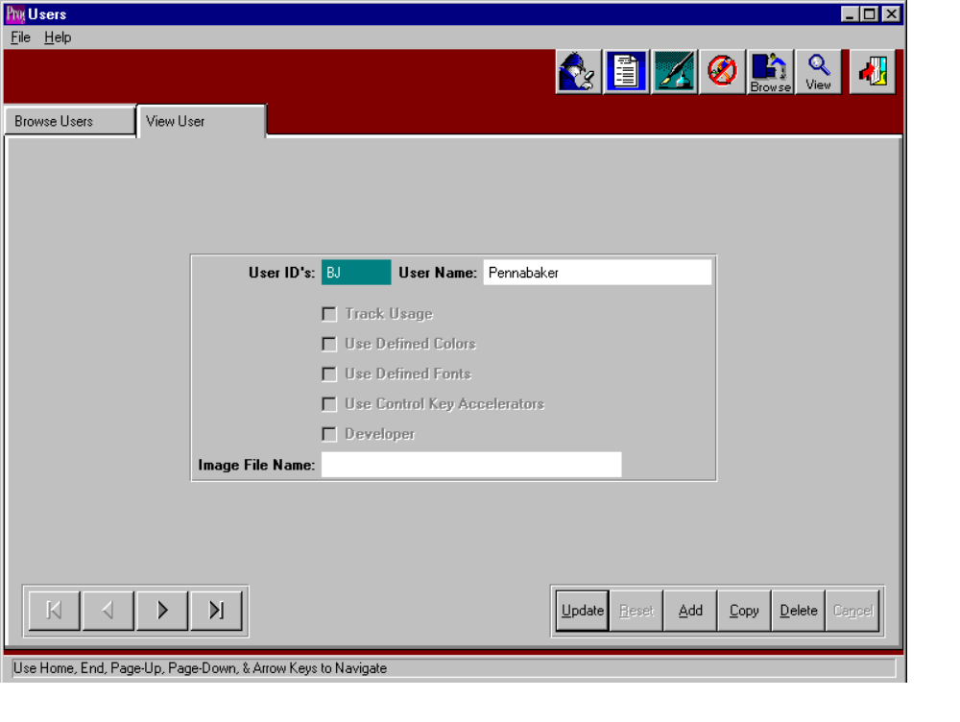

USERS – VIEW

The View User screen allows you to view the information of each user. You may copy, change, add or delete any user from this screen. Use the arrow keys at the bottom of the screen to view the next or previous user. The icons at the top of the screen provide additional capabilities. The browse icon will provide immediate access to the browser by user. The icon with the fountain pen allows you to view any notes for the user selected. The icon with the corner of a page folded over allows you to print a list of the users.

ADVANCED SOFTWARE SERVICES, INC
SYSTEM – ZIP CODE LOADER

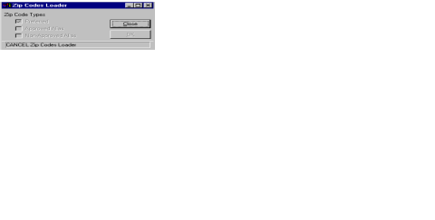

ZIP CODE LOADER

ADVANCED SOFTWARE SERVICES, INC
SYSTEM LISTINGS – PARAMETER FILES LISTING

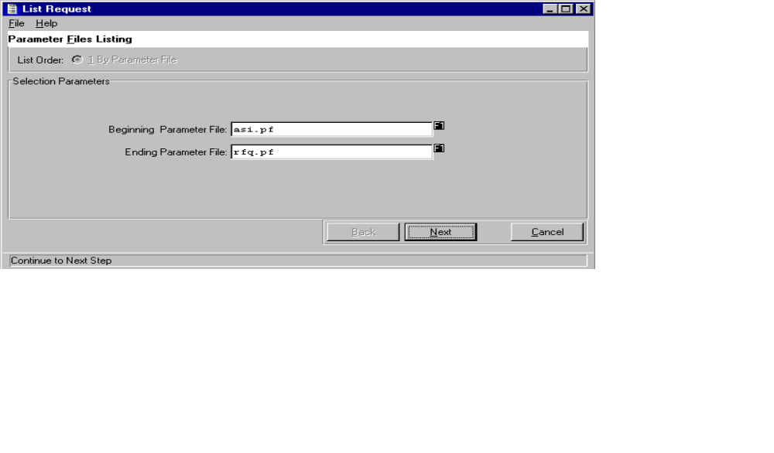

SYSTEM LISTING - PARAMETER FILES LISTING

This selection allows the user to print a list of parameter files. You may print a complete list or choose a range of parameter files. You may also choose an output device. You may print list to a printer, the screen, or a disk file. You may also choose to spool this report to print at a later time or date. After clicking printer as an output device, click the spool checkbox. A field for a date and time will appear. Enter the date and time you would like this report to run.
ADVANCED SOFTWARE SERVICES, INC
SYSTEM – SYSTEM LISTINGS – PROGRAM MASTER LIST
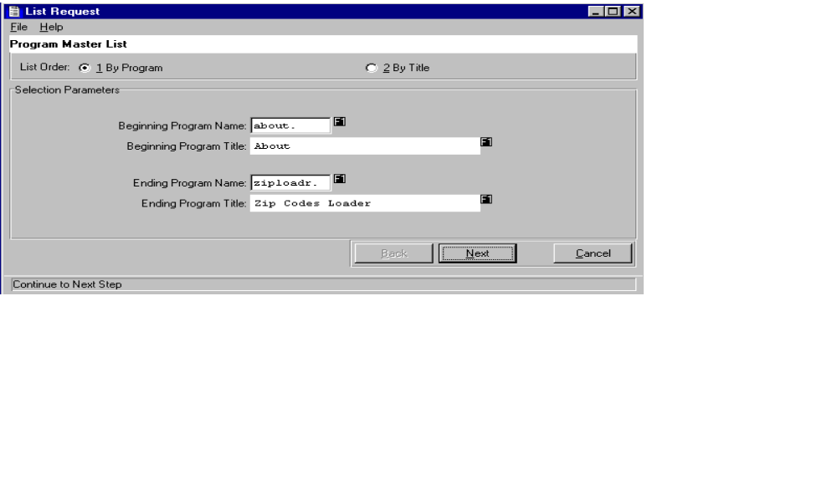

SYSTEM LISTING – PROGRAM MASTER LIST

This selection allows the user to print a list of programs. You may print a complete list or choose a range of programs. You may also choose an output device. You may print list to a printer, the screen, or a disk file. You may also choose to spool this report to print at a later time or date. After clicking printer as an output device, click the spool checkbox. A field for a date and time will appear. Enter the date and time you would like this report to run

ADVANCED SOFTWARE SERVICES, INC
SYSTEM – SYSTEM LISTINGS – USER GROUP LIST
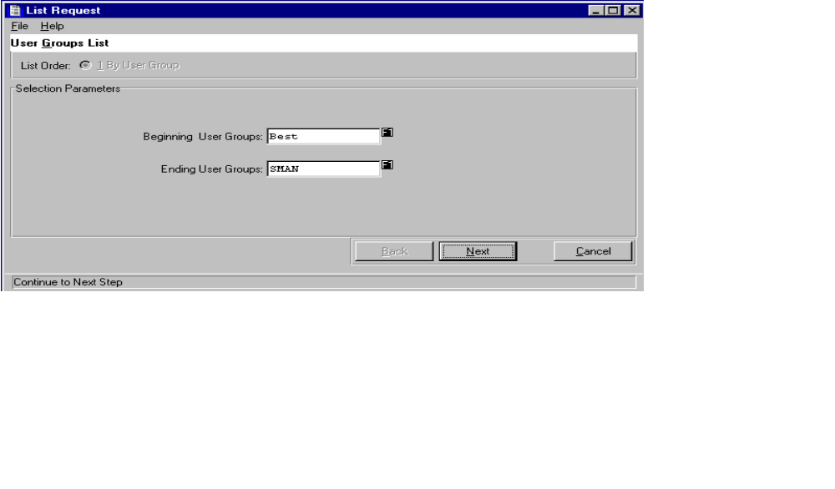

SYSTEM LISTINGS – USER GROUP LIST

This selection allows the user to print a list of user groups. You may print a complete list or choose a range of user groups. You may also choose an output device. You may print list to a printer, the screen, or a disk file. You may also choose to spool this report to print at a later time or date. After clicking printer as an output device, click the spool checkbox. A field for a date and time will appear. Enter the date and time you would like this report to run.

ADVANCED SOFTWARE SERVICES, INC
SYSTEM – SYSTEM LISTINGS – USER LIST
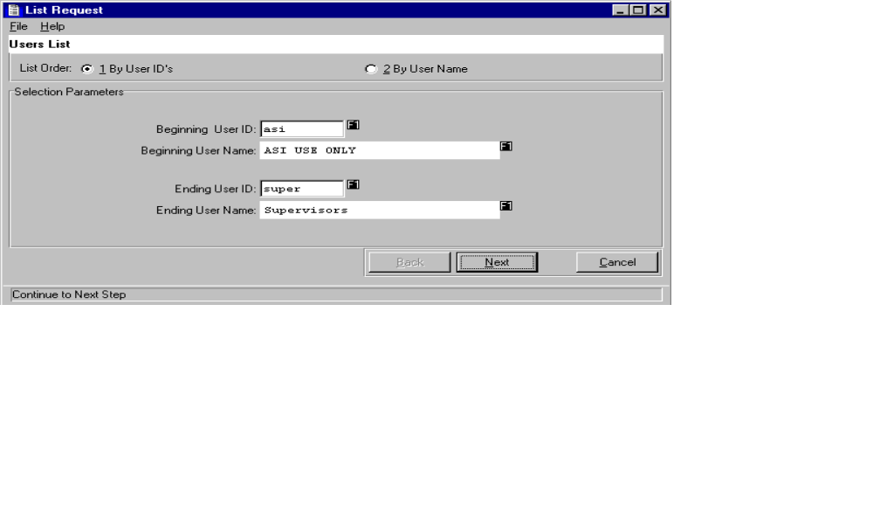

SYSTEM LISTING – USER LIST

This selection allows the user to print a list of users. You may print a complete list or choose a range of users. You may also choose an output device. You may print list to a printer, the screen, or a disk file. You may also choose to spool this report to print at a later time or date. After clicking printer as an output device, click the spool checkbox. A field for a date and time will appear. Enter the date and time you would like this report to run.
ADVANCED SOFTWARE SERVICES, INC
SYSTEM – SYSTEM LISTINGS – AUDIT TRAIL LIST
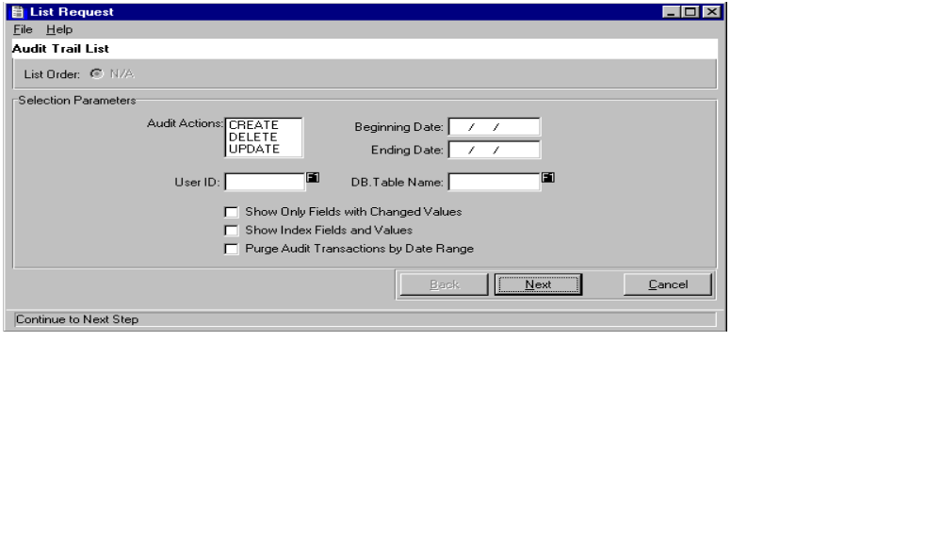

SYSTEM LISTINGS – AUDIT TRAIL LIST

This selection allows the user to print a list of audit trails. You may print a complete list or choose a range of audit trails. You may choose to print one action; create, delete, or update. You may also choose an output device. You may print list to a printer, the screen, or a disk file. You may also choose to spool this report to print at a later time or date. After clicking printer as an output device, click the spool checkbox. A field for a date and time will appear. Enter the date and time you would like this report to run.
ADVANCED SOFTWARE SERVICES, INC
SYSTEM – SYSTEM LISTINGS – TRACK USAGE LIST
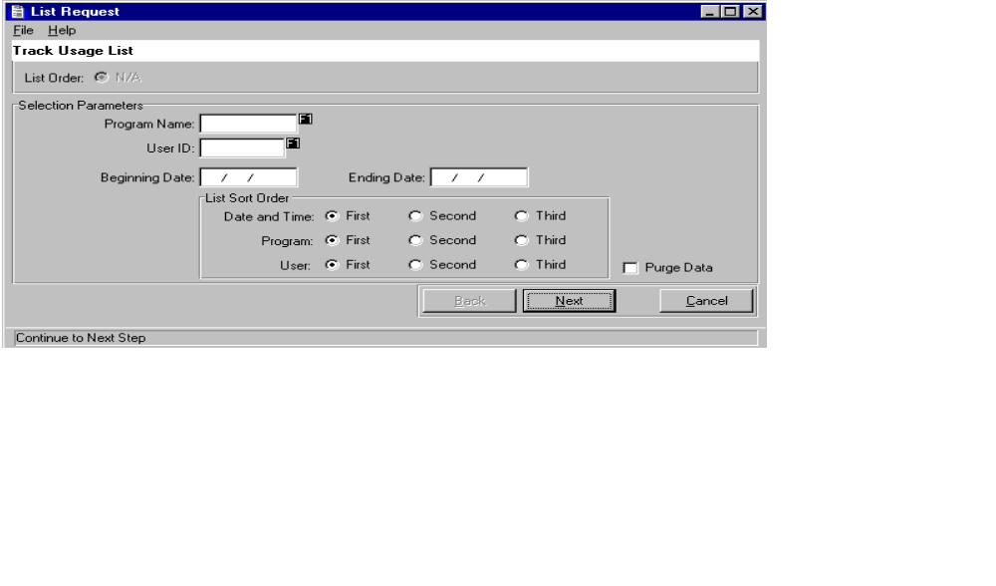

SYSTEM LISTINGS – TRACK USAGE LIST

This selection allows the user to print a list of track usage. You may print a complete list or choose a range of user groups. You may also select a sort order. You can choose an output device. You may print list to a printer, the screen, or a disk file. You may also choose to spool this report to print at a later time or date. After clicking printer as an output device, click the spool checkbox. A field for a date and time will appear. Enter the date and time you would like this report to run.

