ADVANCED SOFTWARE SERVICES, INC
REQUEST FOR QUOTE USER MANUAL

Title Page

Table of Contents 1
Function Keys 2
Request For Quotation Overview 3
Browse Part Number 4
View RFQ 5
RFQ Item 6
Size Folder 7
Item Specification 8
Materials 9
Printing 10
Shipping 11
File Maintenance 12
Request For Quote Control Printing 13

ADVANCED SOFTWARE SERVICES, INC
FUNCTION KEYS

The following describes the standard function keys:

BRWS = The browser is a list of RFQ in the file. This is functionally equivalent
to the find option of our standard package.

VIEW = View RFQ provides the ability to ADD, CHANGE, DELETE and UPDATE
an individual RFQ.

This effectively replaces the find feature of our legacy Foldware and Corrware products.

SORT BY = The selections at the bottom of the browser which will sort the list in alphabetic order.

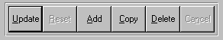

Update = Updating the current RFQ.
Reset = Reset the current RFQ.
Add = Add a RFQ.
Copy = This will copy the existing RFQ.
Delete = Delete the current RFQ displayed on the screen. To delete an individual field, double
click on the field and press the regular delete key on the keyboard.
Cancel = Canceling the information that was entered.
Save = Save the RFQ.


 |  |  |  |  |  |  |  |  |  |  |  |  |  |  |  |  | First – Takes you to the first record
 |  |  |  |  |  |  |  |  |  |  |  |  |  |  |  |  | Prev – Takes you back one record at a time
 |  |  |  |  |  |  |  |  |  |  |  |  |  |  |  |  | Next – Moves forward one record
 | First |  |  |  | Prev |  |  | Next |  |  | Last |  |  |  |  |  | Last – Last current record
 |  |  |  |  |  |  |  |  |  |  |  |  |  |  |  |  | F2 – Search for a RFQ record
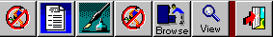 |  |  |  |  |  |  |  |  |  |  |  |  |  |  |  |  | F3 – List a RFQ record
 |  |  |  |  |  |  |  |  |  |  |  |  |  |  |  |  | F4 – Add notes to a RFQ record
 |  |  |  |  |  |  |  |  |  |  |  |  |  |  |  |  | F5 – Misc. fields
F2 |  | F3 | F4 |  |  | F5 |  |  | F6 |  |  | F7 |  |  | F12 |  | F6 – Brows the RFQ records
 |  |  |  |  |  |  |  |  |  |  |  |  |  |  |  |  | F7– View the RFQ records
 |  |  |  |  |  |  |  |  |  |  |  |  |  |  |  |  | F12 – Exit the screen

REQUEST FOR QUOTATION OVERVIEW

The request for quotation module provides the ability to enter specifications for one or more jobs without knowing how the estimate will be created. When a customer sends a request for a quotation for one or more boxes, this program allows sales people or customer service representatives the ability to enter detailed information about the customer’s requirements for the items to be manufactured. Once the data has been entered the information can be transferred to any estimate format in seconds. If a request for quotation has many items defined, the items may be transferred to multiple estimates or may be combined together on one estimate as a combination job or as a corrugated set. This transfer logic will allow one RFQ record for several items to create both single item estimates as well as a combination estimates in seconds. In addition the user has the ability to select which items they would like to transfer to the estimate.

This module is completely integrated with the Advantzware database information such as the customer, style, shipping carrier, raw materials, colors, blank dimensions, destination and more. Therefore, when an existing customer or part number is entered, the data from Advantzware will transfer directly to the new request for quote. For brand new items, the information may be added as if creating a brand-new item. Once the data has been entered, this may be transferred to an estimate then the finished good item may be created automatically. Once the estimate has been created in Advantzware, the estimate number is transferred back to the request for quotation file.

ADVANCED SOFTWARE SERVICES, INC
BROWSE PART NUMBER

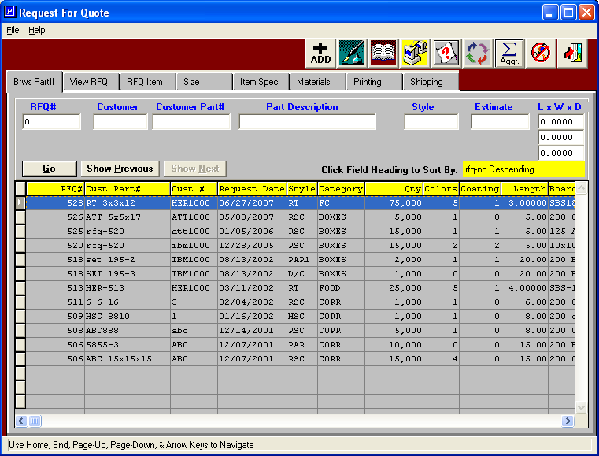

BROWSE PART NUMBER

This module has two browsers to help find a particular part number. The customer part number browser shows all the items in alphabetic order listing the customer part number as the primary sort option. To sort by the customer number, simply click the customer number field at the bottom of the browser and the list will be resorted in customer number order. This browser shows each part number for all request for quotes showing the part number, the request date, the style, the product category, the quantity requested, number of colors, number of coatings, blank length, width and depth. The icons at the top of the browser provide additional capabilities. The icons with the fountain pen provide notes for each RFQ record. Each note records the user initials, date, and description of the note and a full-page of text for each note. Unlimited notes may be defined for each record. The browse icon will provide an immediate access to the browser by customer part number. The view icons provides a list as a quick reference list.

ADVANCED SOFTWARE SERVICES, INC
VIEW REQUEST QUOTE

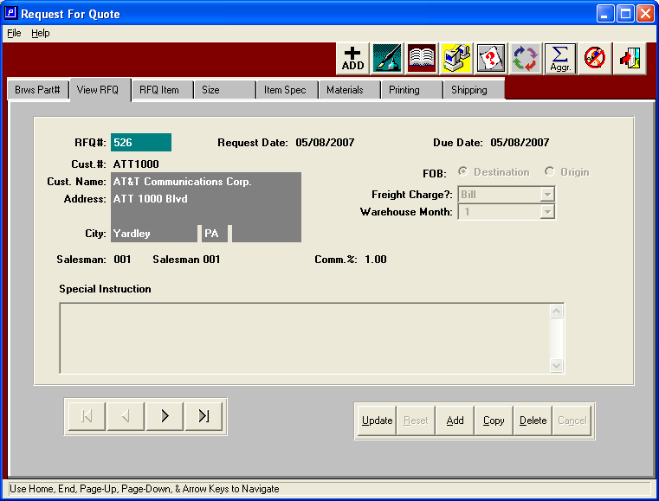

VIEW REQUEST QUOTE

To add, change, delete, or view a request for quotation, the folder called VIEW RFQ must be selected. To add a new request, click the ADD button or press alternate and letter A together. When adding, the number is assigned by the program. To move from field to field, as with all Windows-based programs, the TAB key should be utilized. The request date will default to today's date and due date may be change as the customer requests. The function key number one or F1 key provides a look up to find an existing or future date by utilizing an electronic calendar. The customer may be an existing customer defined in the Advantzware database or may be a temporary customer defined as TEMP. The temporary customer allows the user to change the Company name, address, city, state and zip code. When selecting an existing customer, the name, address, ship to address, freight payment method, an additional information will transfer immediately. The freight on board, charge method, warehouse months, salesman and special instructions may be changed or added as required. The ENTER key or the SAVE key are used to save the new request for quotation and begin to update or at the information for the new boxes on the RFQ item folder.

ADVANCED SOFTWARE SERVICES, INC
REQUEST FOR QUOTE ITEM

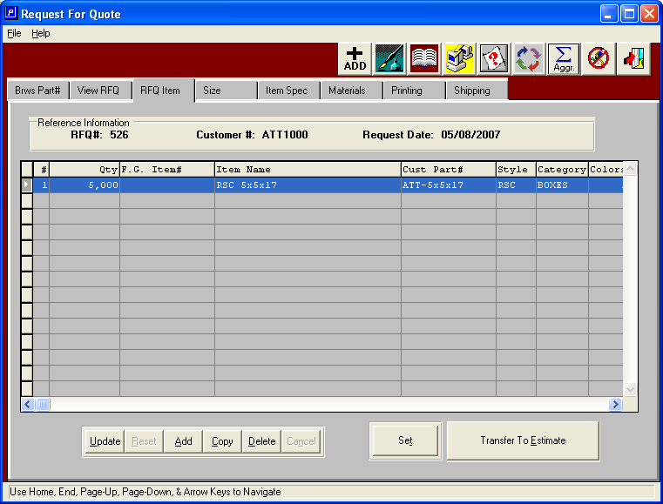

REQUEST FOR QUOTE ITEM

The RFQ item line is the only information required to create a request for quotation, however additional folders allow adding more detail specifications for the item. The RFQ item screen allows the user to add, change, delete, copy and transfer request for quotations. When adding a new item, multiple quantities may be added by pressing the F1 function key. On the quantity field Likewise the F1 Key will provide a look up for the finished good item number, customer part number, style, product category and board material. The TAB key should be used to move from one field to the next field, whereas the SHIFT TAB key will move back one field at a time. The ENTER key will act to save the item's record whether or not all the information for all the fields have been added or left blank. When pressing the F1 key to search for any information, a browser pertaining to that field will display, which will allow you to sort on various fields shown on the browser. To select a item from the browser list, simply double click with your mouse or use the arrow keys to select an item then press the enter key.

When creating locations for existing items which have been previously manufactured or previously estimated, the finished good item number or the customer part number will import all the specifications defined in the estimate immediately after entering the item number including the blank dimensions, board materials, ink colors, shipping carrier, packing materials and more. If the item number does not exist, the user can enter the information and later transfer this to a new estimate.

ADVANCED SOFTWARE SERVICES, INC
SIZE FOLDER

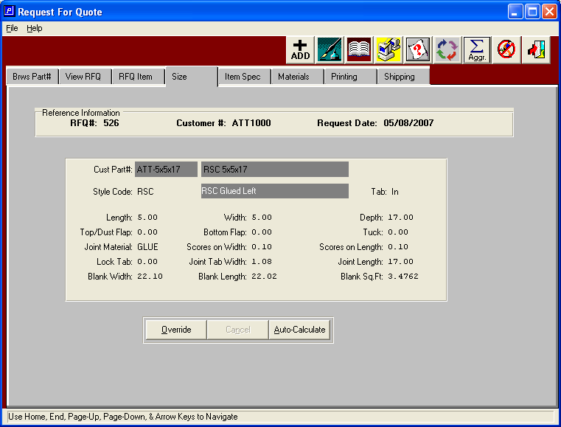

SIZE FOLDER

The size folder works exactly like the blank dimensions, which are calculated in the estimating program. Once the style code has been defined along with the carton's length, width and depth, the program will import the joint or glue lap material; default carton dimensions and immediately calculates the blank width, blank length and blank square inches. Update or change any dimensions for the box, simply press the UPDATE key, then change any dimension including the blank length or blank width. If you want the program to utilize the formulas defined in the style file to calculate the blank length and width, press the AUTO CALCULATE button. When finished updating the record, press the SAVE Key or the ENTER Key.

ADVANCED SOFTWARE SERVICES, INC
ITEM SPECIFICATION

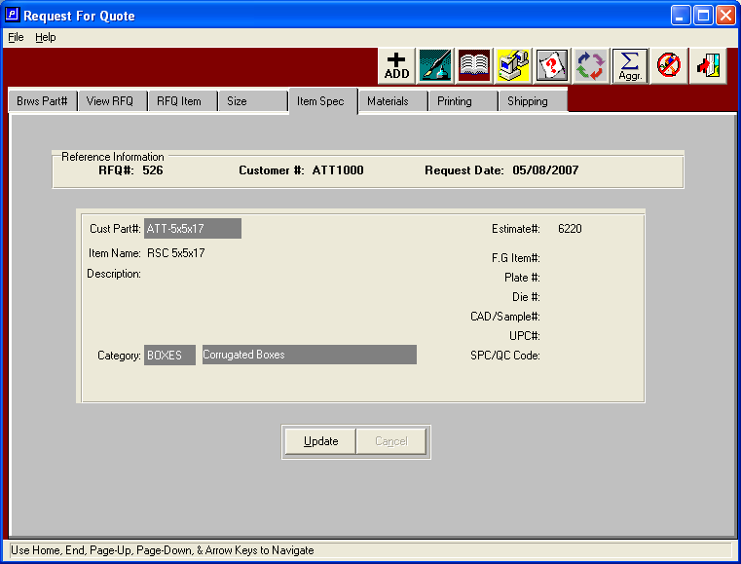

ITEM SPECIFICATION

The item specification folder allows definition of item specific information such as the item name part, description, product category, finished good item number, plate number, die number, CAD number, UPC number and quality control number. This information will import automatically when an existing part number has been entered on the item folder, otherwise this information may be added at any time for a brand-new item which is to be quoted. To update this information, press the update button and tab to the field or use your mouse to click in the field.
ADVANCED SOFTWARE SERVICES, INC
MATERIALS

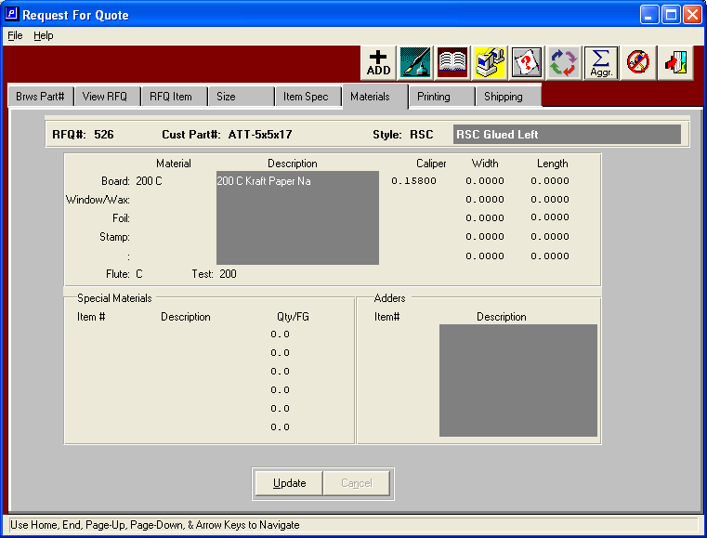

MATERIALS

The materials folder is a screen that concentrates all the materials required for an item, including paper board, tape, staples, window film, wax, foil stamping, lamination and miscellaneous materials. The dimensions of each material may be defined in this area, otherwise the estimating person may make the appropriate changes later. When pressing the F1 button on each material field, a browser pertaining to that particular material will show a list of all the existing material in the Advantzware database. Each browser provides different sort options for the fields listed on the browser screen. Any changes made to this screen will transfer are to the estimate. When finished updating, press the enter key or the save key.

ADVANCED SOFTWARE SERVICES, INC
PRINTING

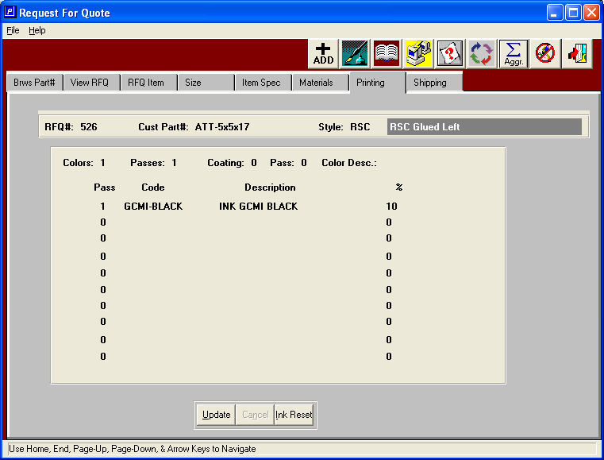

PRINTING

The printing folder will list all the ink colors and coatings for each part number as well as the coverage percentage for each material. When creating a new item, the number of colors entered on the item folder will automatically create a separate ink color on this screen. Likewise, existing part numbers will import the items colors and coatings from the original estimate as defined in the finished goods item file in the Advantzware database. The ink and coatings material defined in the control file will be utilized as a default material shown on this screen. To update with actual ink material defined in the Advantzware database, press the F1 key, which will then show a browser of all available ink material. To select a material from the browser screen, use the arrow key to move to on change color then press the enter key, otherwise you may use your mouse to select the item and double click the highlighted material. When finished updating, press the enter key or the save key.
ADVANCED SOFTWARE SERVICES, INC
SHIPPING

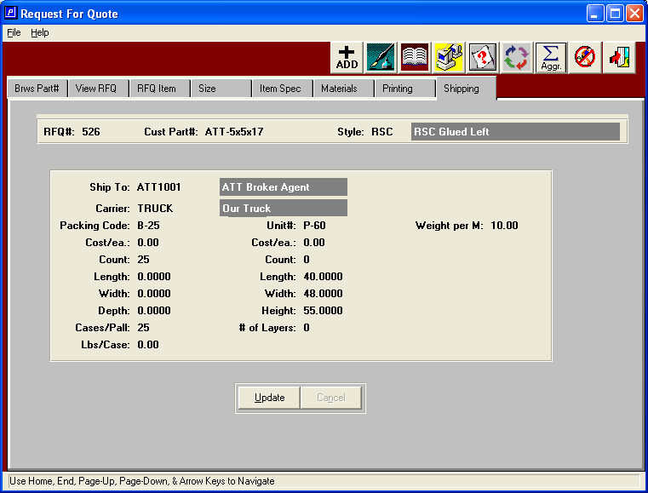

SHIPPING

The shipping folder defines in the common carrier or trucking company for shipping the finished goods as well as defining the packing information such as quantity per bundle, quantity per corrugated case, number of bundles or cases per pallet and the total quantity per pallet. The packing material including the bundle, corrugated case and pallet size will transfer from the customer file or the control file respectively. The length, width and depth will transfer from the raw material file in the advantzware for database; otherwise this may be entered directly on this screen. The system will automatically calculate the quantity per pallet or this may be manually entered.

The UPDATE button provides the ability to change the packing material while simultaneously calculating the quantity per pallet and number of bundles or cases per pallet. The number of boxes packed per case for bundle may be calculated by either a predetermined quantity or by the predetermined weight limit of the bundle or corrugated case. The customer may specify the exact number of boxes per bundle or per case and how many of these units per pallet. Likewise the customer may specify a pallet size which limits the height of the shipping pallet so that the boxes will fit in their storage racks. Therefore, the number of boxes per pallet multiplied by the number of bundles or cases per pallet equal the total quantity per pallet. When utilizing corrugated cases to pack the boxes, a maximum weight per case may be used so that the total number of boxes per case is determined by calculating the total weight for the total quantity estimated which is divided by the weight per case.

The UPDATE button allows the manual entry of the quantity per case or quantity per bundle and the number of bundles or cases per pallet, which yields the total quantity per pallet.

ADVANCED SOFTWARE SERVICES, INC
FILE MAINTENANCE
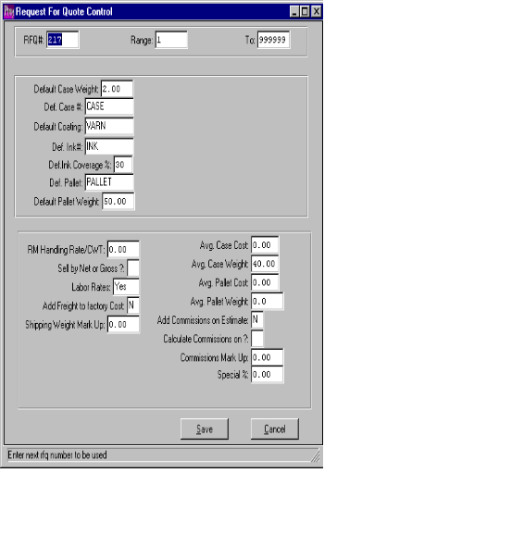

FILE MAINTENANCE

The control file maintenance screen provides default information when adding new part numbers into the request for quotation module. This screen is very similar to the estimating control file defined in Advantzware. The user may define the starting request for quotation number and a valid range of numbers to be utilized by the system. Likewise materials such is corrugated cases, bundles, inks, coatings and pallet may be defined in this file. To save the information added to this file press the SAVE button or press the ENTER key. When entering an item part number that exists in the Advantzware database, the data control file will not be used because the data will transfer directly from the estimate file from the Advantzware database.

ADVANCED SOFTWARE SERVICES, INC
REQUEST FOR QUOTE CONTROL PRINTING

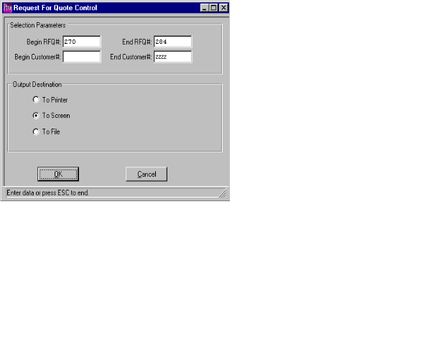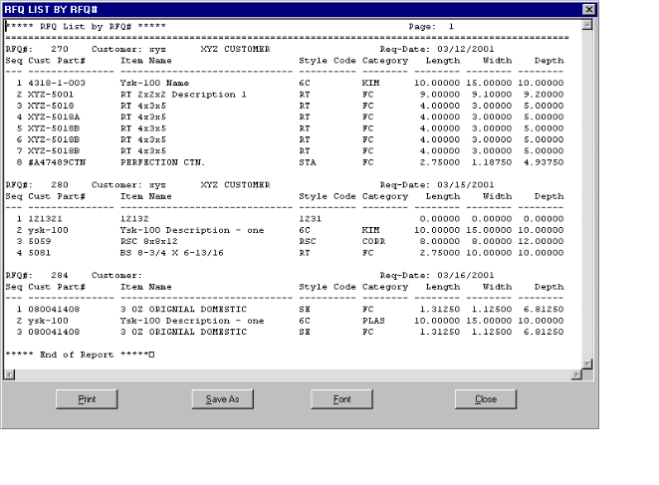

REQUEST FOR QUOTE CONTROL PRINTING

To print one or more request for quotations, press the reports menu selection and enter the customer range or the request for quote number range, then press the NEXT button to print the request for quotation report. When printing the report for many quotations, the report will list each item's customer part number, the item name, the style of the box, the product category, the carton length, width and depth, as well as the customer code, customer name and the required date. When printing this report you should select the font size of eight characters per inch. When printing a single request for quotation, more detail information will print then when printing range of quotes together.

