ADVANCED SOFTWARE SERVICES, INC
SYSTEM ADMINISTRATION DOCUMENT
SECURITY OVERVIEW

Title Page

System – Access Security Menu 25 from System Administration Manaul
System – Misc. Fields Layout Design 26 from System Administration Manaul
System – Program Master - (Browse) 27 from System Administration Manaul
System – Program Master – (View) 28 from System Administration Manaul
System – User Groups – (Browse) 29 from System Administration Manaul
System – User Groups – (View) 30 from System Administration Manaul
System – Users – (Browse) 31 from System Administration Manaul
System – Users – (View) 32 from System Administration Manaul

PLEASE NOTE: There are two ways to set security in the Advantzware software: Access Security by Menu as well as the Program Master. The Access security by menu allows selecting a range of programs. The Program Master allows selecting individual program for applying security. Once the program or programs are highlighted for security, the user id’s or group names must be entered on the Can Run, Can Update, Can Delete and Can Create. ALL MUST BE DEFINED THE SAME. An * gives rights to all users so this code is not recommended.

We recommend the SELECT ALL button followed by the SELECT DEFAULT PROGRAM to set the security rights for the president, owner and individuals with complete access rights to the entire system by typing their user ID on the Can Run, Can Update, Can Delete and Can Create blocks. Next, access the program master to set individual access rights by menu selection.

ADVANCED SOFTWARE SERVICES, INC
SYSTEM – ACCESS SECURITY BY MENU

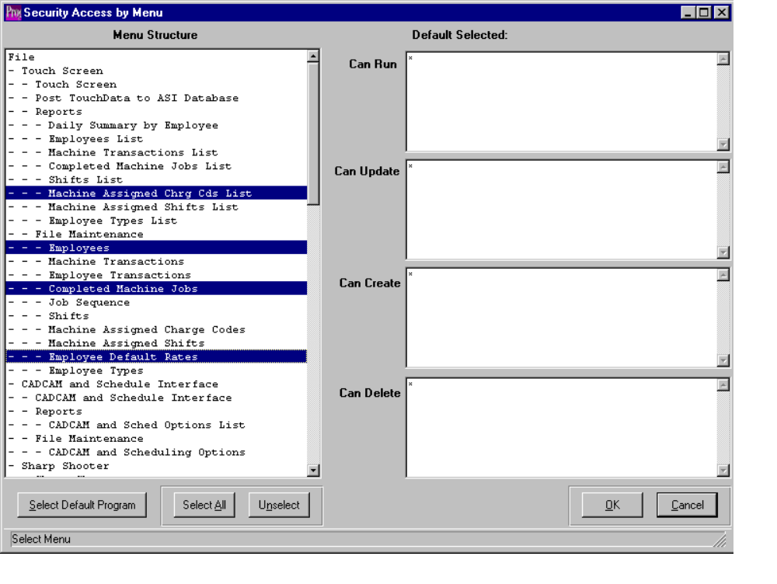

ACCESS SECURITY BY MENU

This security program allows the administrator to define which users or groups may have access to specific programs. If the user id or group name is not defined for the programs selected, then the user will be not be able to run, update, create, or delete that program. . An * gives rights to all users so this code is not recommended.

To secure a program, simply highlight the program from the menu structure list. To highlight each program, simply click each program or press the SELECT ALL button to highlight all programs. Once the programs are highighed, press the SELECT DEFAULT PROGRAM to display current users with access rights. I would recommend the SELECT ALL followed by the SELECT DEFAULT PROGRAM to set the security rights for the president, owner and individuals with complete access rights to the entire system. You must choose the indented most program name rather than the heading. For example, the File Maintenance Menu option can not be secured, but rather each program indented under file maintenance should be highlighted. After highlighting the desired programs by clicking each program name, you MUST click the button called Select Default Program. Thereafter, on the right side of the window, previously secured user and group names for each program will be displayed. Please note, the Select Default Program button must be clicked, otherwise modifications to the user and group names entered will not be saved. After selecting the programs, click on the security option Can Run, Can Update, Can Create or Can Delete, then enter the user names or user groups. Enter an (*) to allow all users access to the highlighted program. You must click the save button to save the settings.

The Select All button will highlight every program; therefore this should be run first to add security to system administration and giving access to every program. Next, individual programs should be updated to individual access rights.

ADVANCED SOFTWARE SERVICES, INC
SYSTEM – PROGRAM MASTER

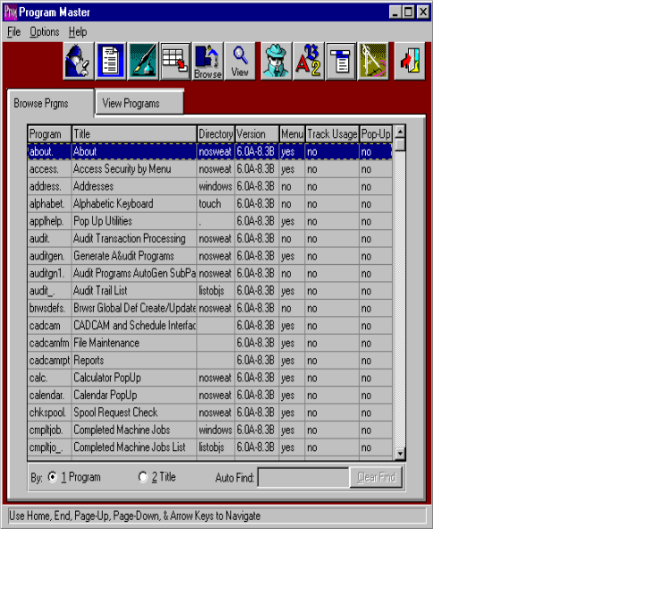

PROGRAM MASTER - BROWSER

This selection shows all the program names and menu title name for each menu option. The browser shows the program name, menu title, which is the menu name, directory, and version. This also shows if the selection appears on a menu, if it’s tracked for usage, and if it’s a pop up screen.

The best way to find a menu is to click the TITLE radio button on the bottom then type the menu name that appears on the Advantzware menu in the AUTOFIND box. Simply type and the box will begin searching for the menu. If you click inside the box and start typing, then you must press the ENTER key to begin the search. Alternatively, the progam name is listed by pressing the F3 key while running a program. Write down the program name, then access the program master and type the program name.

To view a program, you may double click on the selected file or click the View Program tab. The icons at the top of the browser provide additional capabilities. The icon with the fountain pen allows you to view the notes for each program. Each note, records the users initials, date, description of the note and a full-page of text for each note. Unlimited notes may be defined for each program. The browse icon will provide immediate access to the browser by program name. The icon with the corner of a page folded over allows you to print a list of the program files. The icon of the man will provide immediate access to the security by menu screen. The icon of the letters will provide immediate access to the set font and colors screen. The icon of the drop-down menu will provide immediate access to the users menu structure screen.
ADVANCED SOFTWARE SERVICES, INC
SYSTEM – PROGRAM MASTER
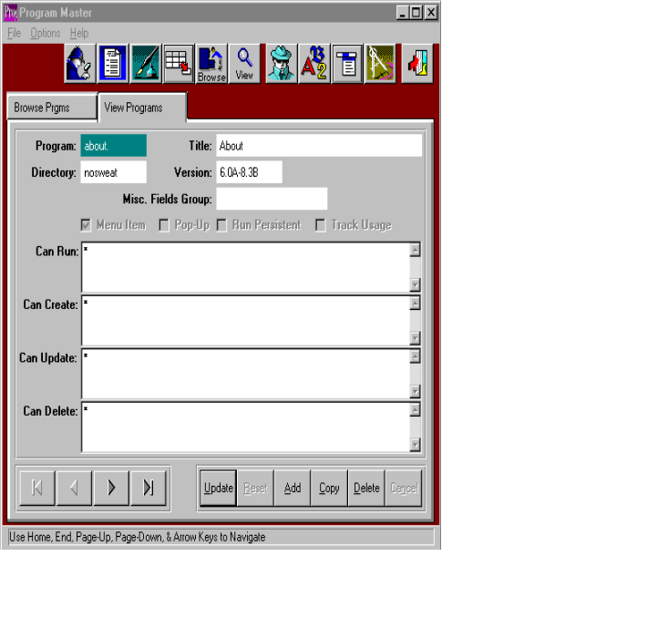

PROGRAM MASTER – VIEW

The VIEW Program screen allows you to view the security and menu title of each program. You may change the menu title, but ASI does not recommend this. To change the security for each program through this screen, press the UPDATE button and simply add the user ID’s and / or group names to each block called Can Run, Can Create, Can Update and Can Delete, then press SAVE. Use the arrow keys at the bottom of the screen to view the next or previous program file. You should not copy, change, add or delete any program from this screen.

The icons at the top of the screen provide additional capabilities. The browse icon will provide immediate access to the browser by program name. The icon with the fountain pen allows you to view any notes for the program selected. The icon with the corner of a page folded over allows you to print a list of the program files. The icon of the man will provide immediate access to the security by menu screen. The icon of the letters will provide immediate access to the set font and colors screen. The icon of the drop-down menu will provide immediate access to the users menu structure screen.

ADVANCED SOFTWARE SERVICES, INC
SYSTEM – USER GROUPS

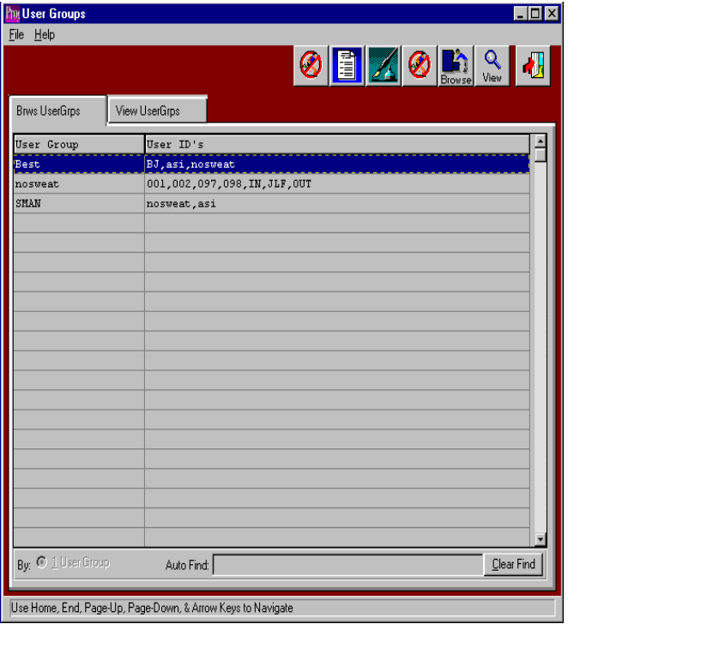

USER GROUPS – BROWSER

This selection shows all the user groups. The browser shows the user group, and user ID’s. To view a program, you may double click on the selected file or click the View Program tab. The icons at the top of the browser provide additional capabilities. The icon with the fountain pen allows you to view the notes for each user group. Each note records the users initials, date, description of the note and a full-page of text for each note. Unlimited notes may be defined for each user group. The browse icon will provide immediate access to the browser by user group. The icon with the corner of a page folded over allows you to print a list of the user groups.
ADVANCED SOFTWARE SERVICES, INC
SYSTEM – USER GROUPS
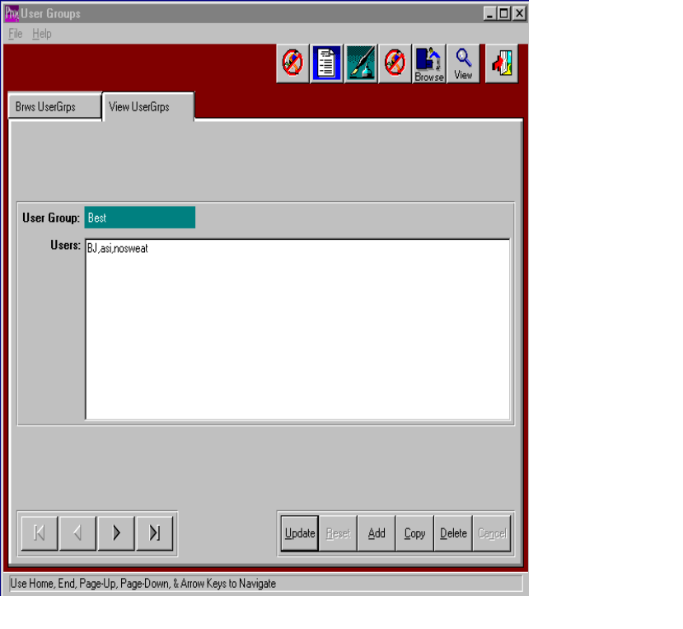

USER GROUPS – VIEW

The view UserGrps screen allows you to view the information of each user group. You may copy, change, add or delete any user group from this screen. Use the arrow keys at the bottom of the screen to view the next or previous user group. The icons at the top of the screen provide additional capabilities. The browse icon will provide immediate access to the browser by user group. The icon with the fountain pen allows you to view any notes for the user group selected. The icon with the corner of a page folded over allows you to print a list of the user groups.

ADVANCED SOFTWARE SERVICES, INC
SYSTEM – USERS
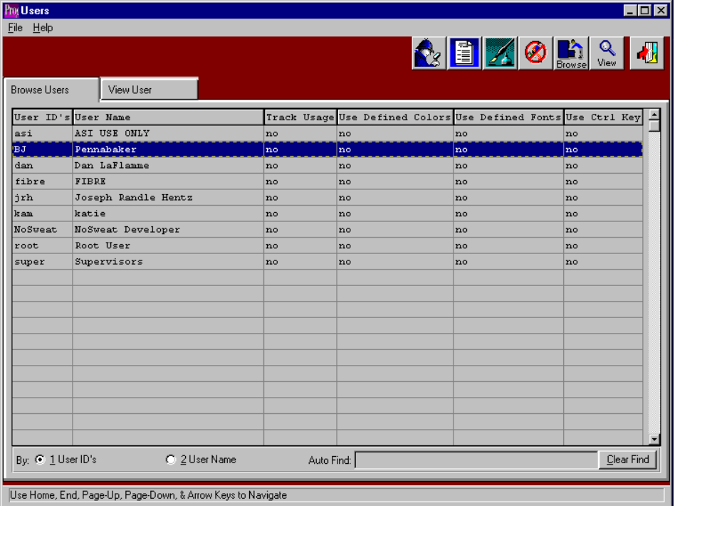

USERS – BROWSER

This selection shows all the users. The browser shows the user ID’s and user name. The browser also shows if the users usage is tracked, if the user is using defined colors, defined fonts, and control keys. To view a program, you may double click on the selected file or click the View User tab. The icons at the top of the browser provide additional capabilities. The icon with the fountain pen allows you to view the notes for each user. Each note records the users initials, date, description of the note and a full-page of text for each note. Unlimited notes may be defined for each user. The browse icon will provide immediate access to the browser by user. The icon with the corner of a page folded over allows you to print a list of the users.
ADVANCED SOFTWARE SERVICES, INC
SYSTEM – USERS
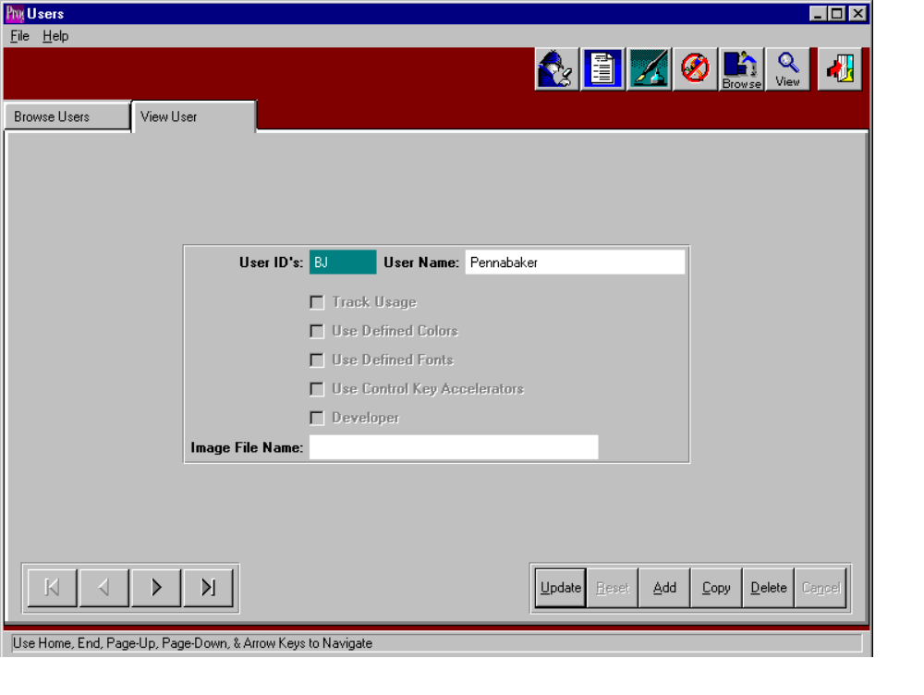

USERS – VIEW

The View User screen allows you to view the information of each user. You may copy, change, add or delete any user from this screen. Use the arrow keys at the bottom of the screen to view the next or previous user. The icons at the top of the screen provide additional capabilities. The browse icon will provide immediate access to the browser by user. The icon with the fountain pen allows you to view any notes for the user selected. The icon with the corner of a page folded over allows you to print a list of the users.

