ASSEMBLED SETS AND INVENTORY CONTROL

The following documentation will explain how Advanced Software’s Advantzware Packaging software creates assembled sets and controls the finished goods inventory for each component. In our example, we will create package to support a 12 pack of your favorite beverage. This set will consist of a box and two partitions that will look as follows:

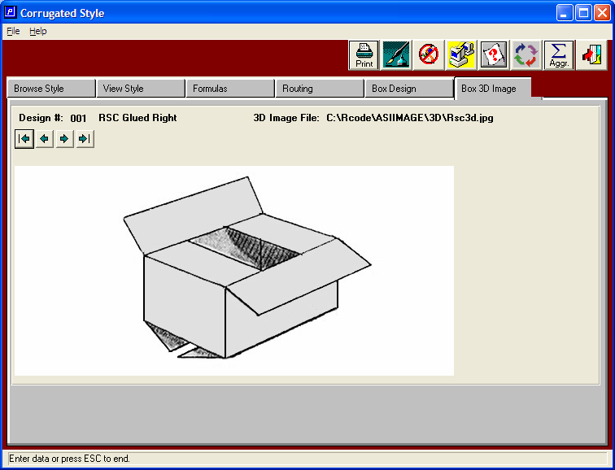

Both Partitions are Assembled, packed into RSC and Shipped as Set

The two length partitions will require 3 slots whereas the width partition will require just 2 slots. To make one assembled set, will require two length partitions or quantity per set equal to 2, three width partitions with quantity per set equal to 3 and one regular slotted container box with quantity per set equal to 1.

Length and Width Partitions

The two length partitions will require 3 slots whereas the width partition will require just 2 slots. They will be packed inside the box.

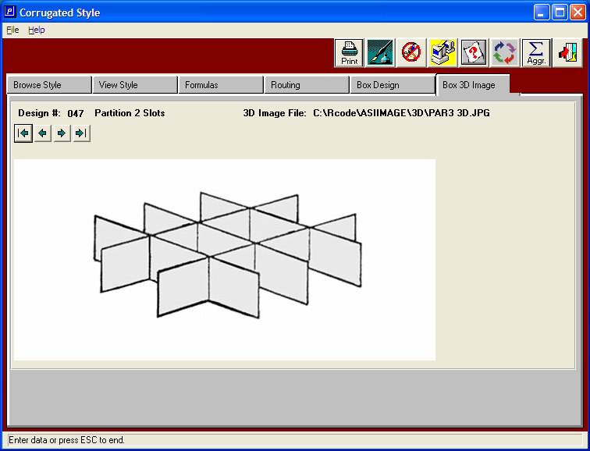

Cost Estimate Box Design Folder Shows Plant Specs
For Producing the RSC

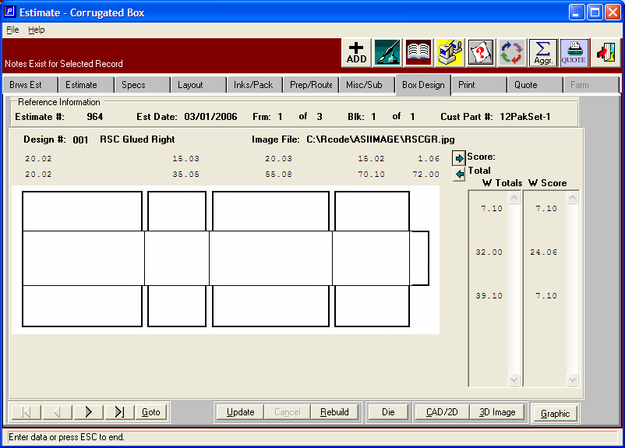

Box Design Folder Shows Plant Specs for Length & Width Partition

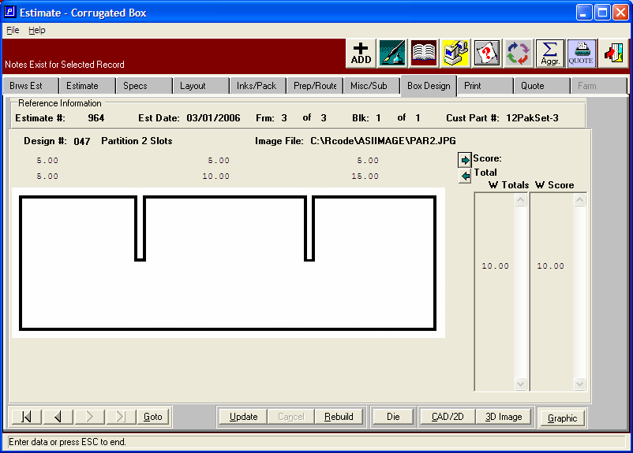

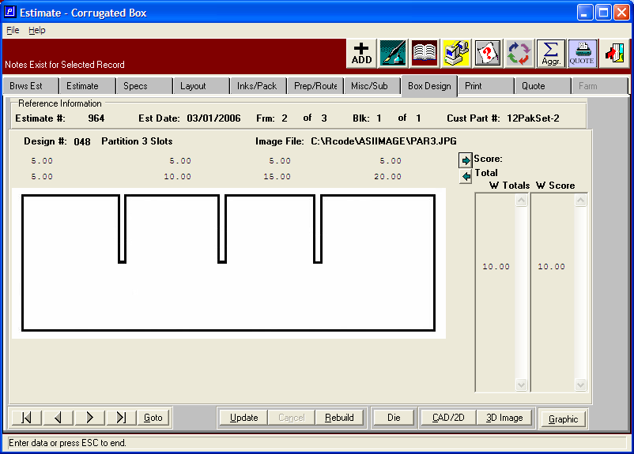

HOW DO WE ESTIMATE?
Cost Estimate Folder with Set Button

When clicking the + ADD button on the estimate, the user can create the estimate as assembled, unassembled or assembled with part received automatically when the set is received. The components may be unitized a single package or packed and shipped separately. Each component defined on the estimate folder will have a unique finished goods part number when a order is created.

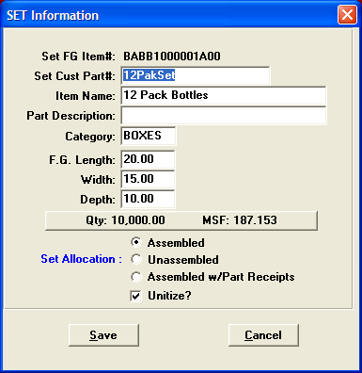

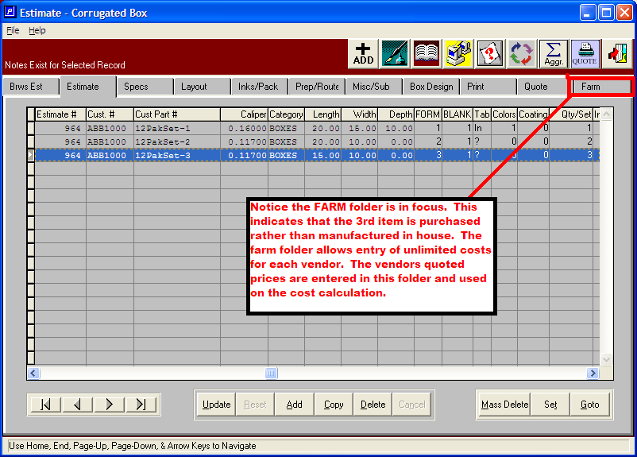

ORDER ENTRY
Creates Finished Goods and Updates the On Order Inventory Balances

When an order is added for a set, the system automatically creates the item that will be invoiced know as the parent or set item. The system also automatically creates a finished goods item for each component and simultaneously updates the estimate, updates the inventory balances and downloads the materials and machine operations to the job file which print on the factory ticket. The system also have switch settings to prompt to create the purchase order for board material complete with scoring allowances as well as placing a purchase order for the purchased partition while automatically selecting the vendors with the best price and delivery.

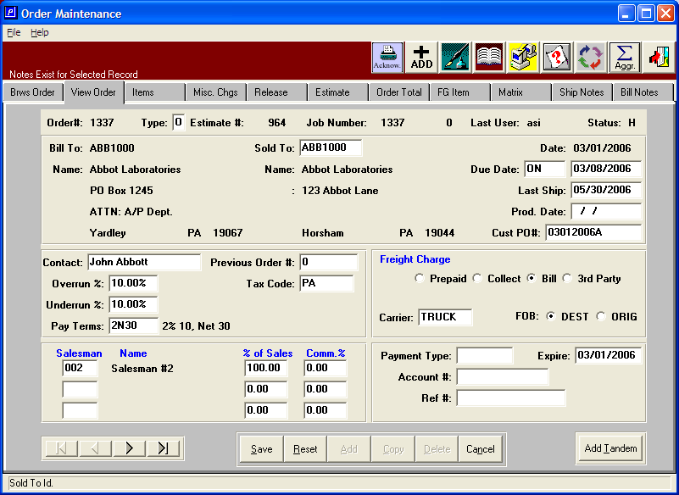

Creates Finished Goods and Updates the On Order Inventory Balances
In minutes, Advantzware creates an order, job ticket, purchase order for both board and purchased items, prints an order acknowledgment and can print the pallet tags.

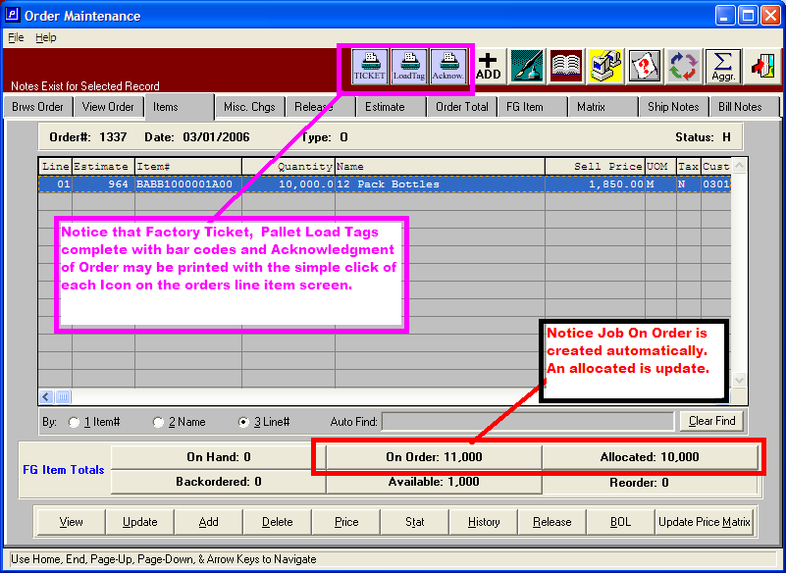

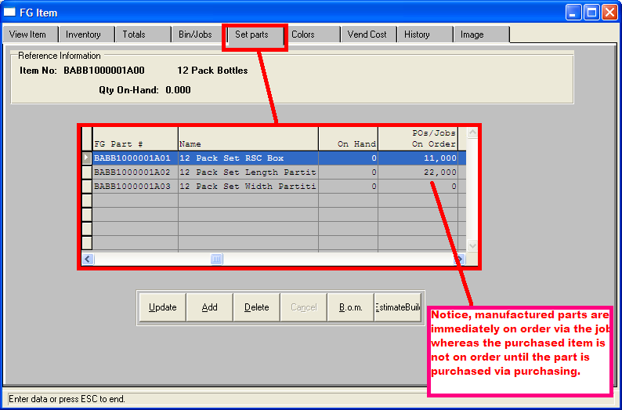

Click and Load Tags & FG Receipts are Created

Once finished goods are produced, pallet load tags complete with bar codes that identify each pallet are produced and added to the finished goods data entry screen for validation. Scanning the bar code allows the warehouse clerk to stock the pallets in specific bin locations or directly onto the truck.

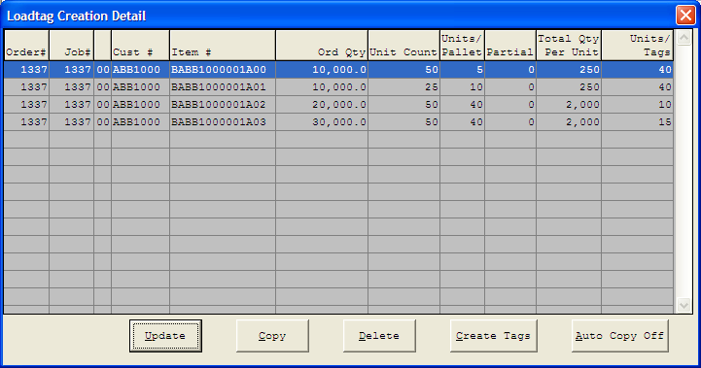

Unassembled Sets May Ship Components Separately

Components of Set may also be packed and shipped separately. Each component may ship on different dates or times, however when the final component is shipped, the parent or set item is automatically invoiced.

