ADVANCED SOFTWARE SERVICES, INC.
ADVANCED SOFTWARE FUNCTION KEYS

The following describes the standard function keys:

BRWS = The browser which is a list of records in the file. This is functionally equivalent
to the find option of our standard package.

VIEW = View record provides the ability to ADD, CHANGE, DELETE and UPDATE
an individual record.

SORT BY = The selections at the bottom of the browser which will sort the list in alphabetic order.

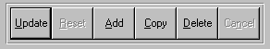

Update = Updating the current record.
Reset = Reset the current record.
Add = Add a record.
Copy = This will copy the existing record.
Delete = Delete the current record displayed on the screen.
Cancel = Canceling the information that was entered.
Save = Save the record



Takes you to the first record. | Takes you back one record at a time. | Moves forward one record. | Last current record.

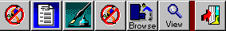

Search F2 | List F3 | Notes F4 | Misc. Fields F5 | Brows F6 | Viewer F7 | Exit F12

