Evaluation Warning: The document was created with Spire.Doc for Python.

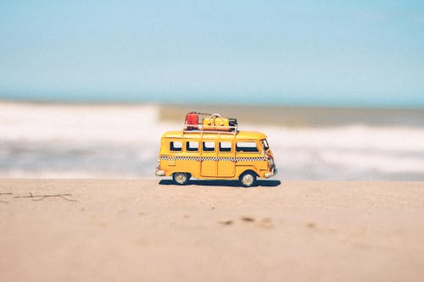



**Ultimate Amazon Adventure**



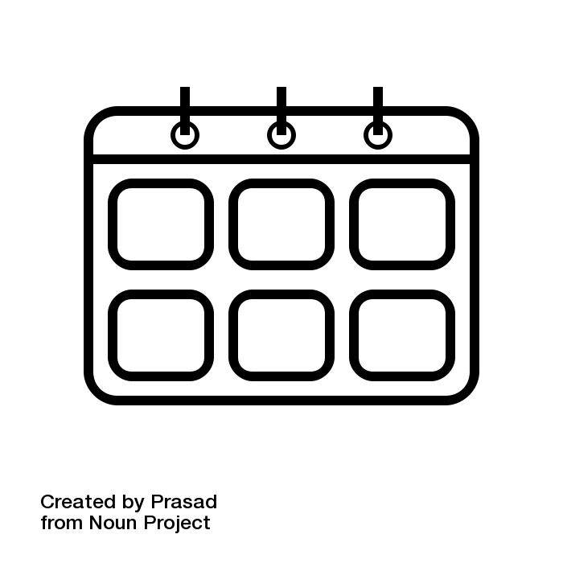Number of Days : 7

Budget Per Person : Rs. 100000.0

Cities : Manaus, Iguazu Falls, Salvador, Rio de Janeiro

* Number of Days : 7
* Budget Per Person : Rs. 100000.0
* Cities : Manaus, Iguazu Falls, Salvador, Rio de Janeiro
* Number of Days : 7
* Budget Per Person : Rs. 100000.0
* Cities : Manaus, Iguazu Falls, Salvador, Rio de Janeiro









Travel Distance: Pune to Manaus  
  
Today, you will depart from Pune to start your epic journey to Brazil. Upon arrival in Manaus, take some time to settle in and explore the city. You can visit the famous Amazon Theatre, take a boat tour on the Rio Negro, or simply relax and soak in the vibrant atmosphere of this bustling city.

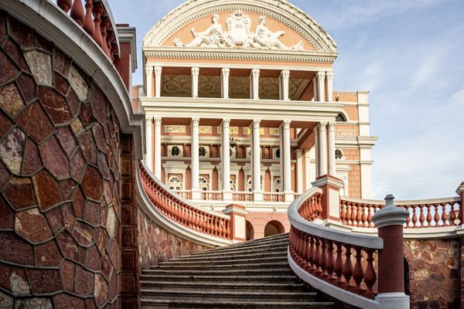

Day 1: Arrive in Manaus





Travel Distance: Manaus to Iguazu Falls  
  
Embark on a flight to Iguazu Falls, one of the most awe-inspiring natural wonders in the world. Spend the day exploring the falls from both the Brazilian and Argentinian sides, taking in the breathtaking views and experiencing the power of nature up close.

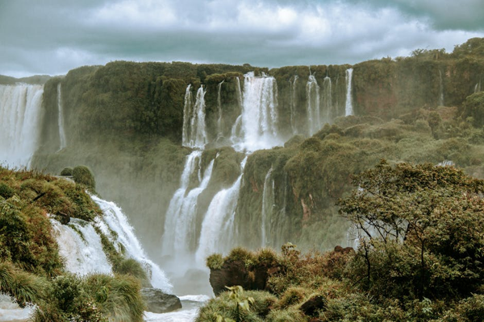

Day 2: Iguazu Falls Expedition





Travel Distance: Iguazu Falls to Salvador  
  
Head to Salvador, known for its rich Afro-Brazilian culture and lively music scene. Explore the historic Pelourinho district, visit the colorful Mercado Modelo, and indulge in delicious Bahian cuisine. Take a sunset stroll along the beautiful beaches of Salvador and immerse yourself in the local culture.

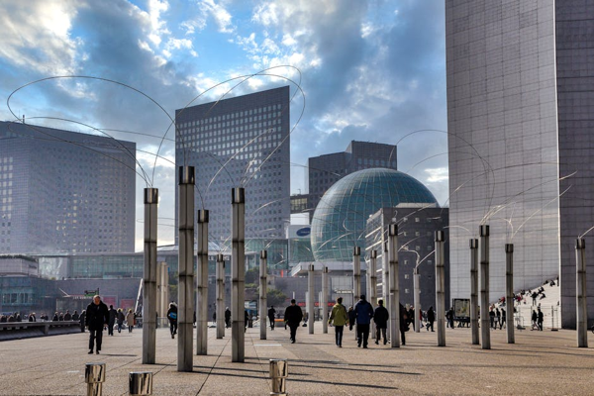

Day 3: Discovering Salvador





Travel Distance: Salvador to Rio de Janeiro  
  
Fly to Rio de Janeiro, the iconic city known for its stunning beaches, vibrant Carnival celebrations, and dramatic landscapes. Visit the famous Christ the Redeemer statue, stroll along Copacabana Beach, and explore the charming neighborhoods of Santa Teresa and Lapa. Enjoy a traditional Brazilian churrasco dinner and soak in the energetic nightlife of Rio.

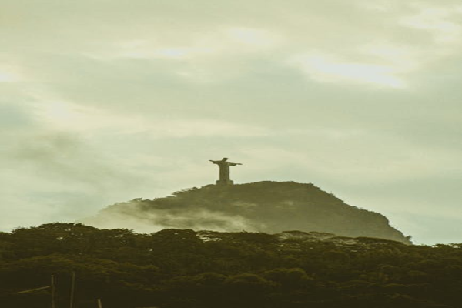

Day 4: Rio de Janeiro Adventure





Travel Distance: Rio de Janeiro  
  
Embark on a jungle adventure in the Tijuca Rainforest, the largest urban rainforest in the world. Hike to beautiful waterfalls, encounter exotic wildlife, and enjoy panoramic views of the city from the mountain peaks. Learn about the unique ecosystem of the rainforest and its importance for biodiversity conservation.

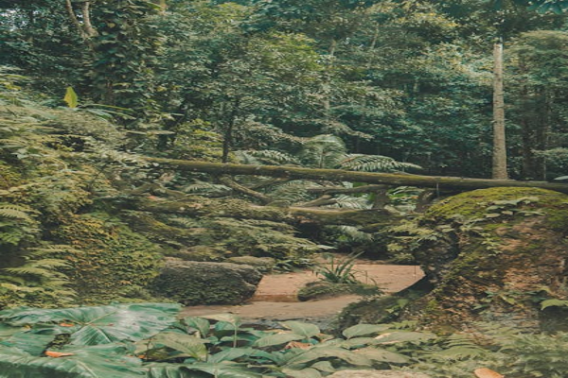

Day 5: Rainforest Exploration





Day 6: Beach

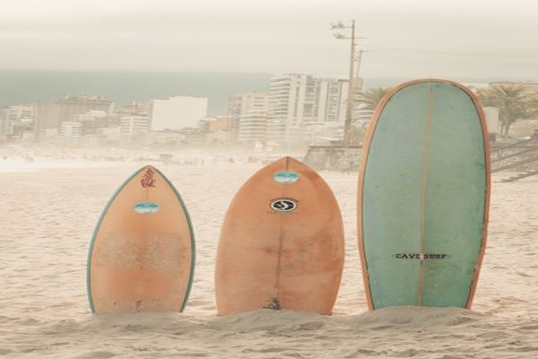

Day 6: Beach





Travel Distance: Buzios to Pune  
  
On your last day in Brazil, savor a final Brazilian breakfast before heading back to Pune. Reflect on your incredible journey filled with unforgettable experiences, cultural encounters, and natural wonders. Cherish the memories made with your friends and start planning your next adventure together.



Day 7: Farewell Brazil