



Travel Time: 0 hours  
Travel Distance: 0 km  
  
Welcome to the bustling city of New York! Upon arrival, check into your hotel and take some time to relax after your journey. You can explore the nearby areas and maybe grab a bite to eat at a local restaurant. Get ready for an exciting week ahead!

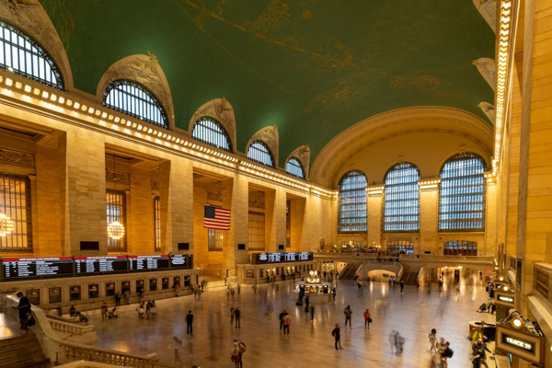

Day 1: Arrival in New York