



Travel Distance: Manaus to Iguazu Falls  
  
Embark on a flight to Iguazu Falls, one of the most awe-inspiring natural wonders in the world. Spend the day exploring the falls from both the Brazilian and Argentinian sides, taking in the breathtaking views and experiencing the power of nature up close.

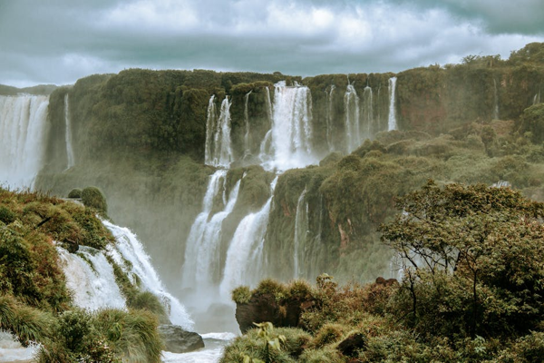

Day 2: Iguazu Falls Expedition