



Travel Distance: Iguazu Falls to Salvador  
  
Head to Salvador, known for its rich Afro-Brazilian culture and lively music scene. Explore the historic Pelourinho district, visit the colorful Mercado Modelo, and indulge in delicious Bahian cuisine. Take a sunset stroll along the beautiful beaches of Salvador and immerse yourself in the local culture.

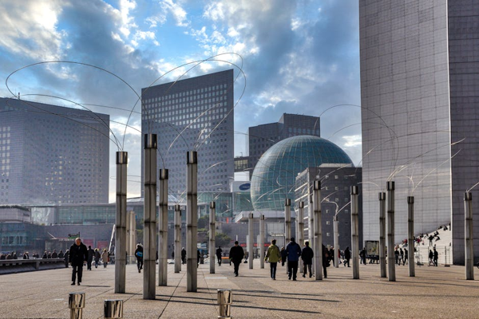

Day 3: Discovering Salvador