



Travel Distance: Rio de Janeiro  
  
Embark on a jungle adventure in the Tijuca Rainforest, the largest urban rainforest in the world. Hike to beautiful waterfalls, encounter exotic wildlife, and enjoy panoramic views of the city from the mountain peaks. Learn about the unique ecosystem of the rainforest and its importance for biodiversity conservation.

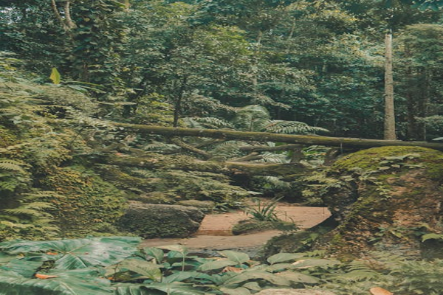

Day 5: Rainforest Exploration