



Travel Distance: Buzios to Pune  
  
On your last day in Brazil, savor a final Brazilian breakfast before heading back to Pune. Reflect on your incredible journey filled with unforgettable experiences, cultural encounters, and natural wonders. Cherish the memories made with your friends and start planning your next adventure together.

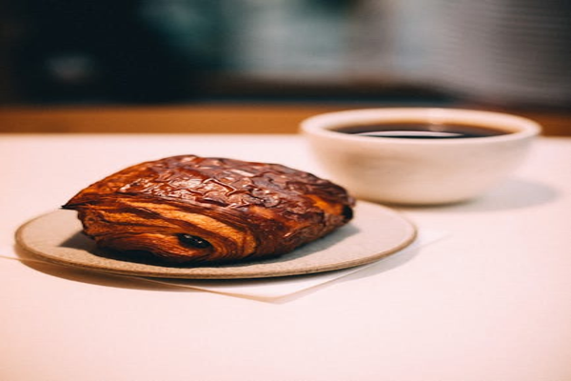

Day 7: Farewell Brazil