**Computing the determinant via cofactors**

Finding the determinant using cofactors is not really the best way of getting it. It performs in O(n!) time, for example, 3x3 matrix can be counted in near 200 steps. Actually, we tried to use algorithms Cramer’s rule and LU factorization, but these ways caused problems that we couldn’t tackle. So, let’s return to cofactors.

General solution looks like this:

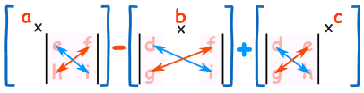

For matrices more than 4x4, we use the equivalent recursive method to reduce the dimension of the matrice.

Talking about our mistakes:

* We created too buggy code: int restricted values, poor data preparation, slow server and etc…
* The algorithm is the slowest one

To crown it all, there is a huge amount of work to be done that could improve our algorithm and code. We hope that in the future we will be much more confident in solving linear algebra problems and system architecture.

Dubovyk Serhii, Pryhoda Oleksandr, Kharysh Ostap, Petryshak Bohdan.