Redesign of a Functional Layout into a
Group Technology-Based Cellular Manufacturing System
A Production & Industrial Engineering Project
Prepared by: [Saurabh Kumar Singh]
Department of Production / Industrial Engineering
[NIT JAMSHEDPUR]
August 2025

Table of Contents
Table of Contents 2
1. Executive Summary 3
2. Introduction & Objective 3
2.1 Objectives 3
3. Theoretical Background 3
3.1 Group Technology and Cellular Manufacturing 3
3.2 Part Family Formation Methods 4
3.3 Rank Order Clustering (ROC) Algorithm 4
3.4 Exceptional Elements 4
4. Methodology 4
4.1 Dataset 4
Part List & Routings 4
Machine List 5
4.2 Machine-Component Incidence Matrix 5
4.3 Applying Rank Order Clustering 5
Row Pass Result (Sheet 3 of workbook) 5
5. Results 5
5.1 Final Clustered Matrix 5
5.2 Exceptional Element 6
6. Proposed Layout Redesign 6
7. Impact Quantification 7
8. Exceptional Element: Cost-Benefit Analysis 7
9. Conclusion & Recommendations 8
10. Limitations & Future Scope 8
References 9

1. Executive Summary
This project redesigns a functional (process-type) machine shop layout into a Group Technology (GT) based cellular manufacturing system. Using Rank Order Clustering (ROC) applied to a machine-component incidence matrix covering 8 machines and 10 parts, three natural manufacturing cells were identified: a Turning cell, a Milling cell, and a Drilling/Grinding cell. One exceptional element was found (Part P6 requiring an operation on a machine outside its natural cell), and a cost-based comparison was used to select the most economical resolution.
Converting the layout from functional to cellular form reduced total weekly material-handling effort by approximately 53.8%, based on a floor-distance model applied to actual part routings and volumes. The exceptional element is most economically resolved by duplicating the affected machine into the new cell, at roughly half the annual cost of the next-best alternative.
The methodology, calculations, and layout diagrams presented here are directly reusable on real plant data — only the input matrix, coordinates, and cost figures need to be replaced.

2. Introduction & Objective
Functional (process) layouts group machines by process type — all lathes together, all mills together, and so on. While intuitive, this arrangement forces parts to travel long, often criss-crossing distances between sections whenever their process sequence spans multiple machine types. This increases material handling cost, work-in-process (WIP) inventory, and overall lead time.
Group Technology (GT) addresses this by exploiting similarities among parts — in shape, size, or more commonly, processing route — to form part families, and by regrouping the machines that serve each family into dedicated manufacturing cells. This project applies GT principles, specifically Production Flow Analysis (PFA) via the Rank Order Clustering algorithm, to redesign a representative machine shop layout.

2.1 Objectives
- Identify natural part families and corresponding machine cells from process-routing data using Rank Order Clustering.
- Detect and resolve any exceptional elements (parts whose routing does not fit cleanly into a single cell).
- Design a cellular floor layout and quantify its impact on material handling distance relative to the existing functional layout.
- Perform a cost-benefit comparison to select the most economical way of resolving the exceptional element.

3. Theoretical Background

3.1 Group Technology and Cellular Manufacturing
Group Technology is a manufacturing philosophy that identifies and exploits the underlying sameness of parts and processes. When applied to shop-floor layout, it leads to Cellular Manufacturing (CM): physically grouping dissimilar machines into cells, each dedicated to producing a family of parts with similar processing requirements. Benefits typically include reduced material handling, lower WIP, shorter lead times, simplified scheduling, and improved quality feedback due to smaller, more visible production loops.

3.2 Part Family Formation Methods
- Visual inspection — grouping by shape/size similarity; fast but subjective.
- Classification and Coding (e.g., Opitz system) — assigns a multi-digit code capturing shape, dimensions, material, and tolerance.
- Production Flow Analysis (PFA) — uses the actual machine-component incidence matrix (which machines each part visits) rather than part geometry. This project uses PFA.

3.3 Rank Order Clustering (ROC) Algorithm
ROC, proposed by King, is an efficient algorithm for grouping machines and parts into cells directly from a binary machine-component incidence matrix. Each row (machine) and column (part) is converted to a binary number and ranked in decreasing order; rows and columns are repeatedly reordered until the matrix converges into a block-diagonal form. Each diagonal block represents one machine cell and its associated part family.

3.4 Exceptional Elements
In real production data, the matrix rarely converges into perfectly separated blocks. Some parts require an operation on a machine belonging to a different cell — these are termed exceptional elements. Standard resolution options include duplicating the machine into the second cell, subcontracting the operation, accepting the intercell material movement, or redesigning the part/process to remove the dependency.

4. Methodology

4.1 Dataset
A representative machine shop dataset was constructed, comprising 8 machines (3 lathes, 2 milling machines, 3 drilling/grinding machines) and 10 parts, each with a defined process routing and weekly production volume. This mirrors the structure of route-sheet data collected from a real shop floor.

Part List & Routings
Part | Description | Machine Routing | Weekly Volume
P1 | Shaft - Type A | M1, M2, M3 | 50
P2 | Bracket - Type A | M4, M5 | 60
P3 | Housing - Type A | M6, M7, M8 | 55
P4 | Shaft - Type B | M1, M2, M3 | 40
P5 | Bracket - Type B | M4, M5 | 35
P6 | Housing - Type B (mixed route) | M2, M6, M7, M8 | 20
P7 | Shaft - Type C | M1, M2, M3 | 30
P8 | Bracket - Type C | M4, M5 | 25
P9 | Shaft - Type D | M1, M2, M3 | 45
P10 | Housing - Type C | M6, M7, M8 | 40

Machine List
Machine | Description | Process Type
M1 | Lathe 1 | Turning
M2 | Lathe 2 | Turning
M3 | Lathe 3 | Turning
M4 | Milling Machine 1 | Milling
M5 | Milling Machine 2 | Milling
M6 | Drilling Machine 1 | Drilling/Grinding
M7 | Drilling Machine 2 | Drilling/Grinding
M8 | Grinding Machine 1 | Drilling/Grinding

4.2 Machine-Component Incidence Matrix
From the routings above, a binary incidence matrix was built (1 = part visits that machine). This is the starting matrix for Rank Order Clustering, and is intentionally unsorted — reflecting how a functional layout's process routes appear before any GT analysis.

4.3 Applying Rank Order Clustering
Rows (machines) were converted to binary numbers using part-position weights (leftmost part = most significant bit) and ranked in decreasing order. Columns (parts) were then ranked the same way using the reordered matrix. This row/column pass was repeated until the matrix stabilised. Ties were broken by order of appearance, per standard ROC convention.
Full row-by-row and column-by-column calculations, with live formulas, are provided in the accompanying workbook (Cellular_Manufacturing_GT_Project.xlsx, Sheets 3-4). The converged result is summarised below.

Row Pass Result (Sheet 3 of workbook)
Machine | Decimal Value | Rank
M1 | 586 | 2
M2 | 602 | 1
M3 | 586 | 3
M4 | 292 | 4
M5 | 292 | 5
M6 | 145 | 6
M7 | 145 | 7
M8 | 145 | 8

5. Results

5.1 Final Clustered Matrix
Rank Order Clustering converged after 2 row/column passes into three clean block-diagonal groups, with one exceptional element bridging two of them.
Cell | Machines | Part Family
Cell 1 (Turning) | M1, M2, M3 | P1, P4, P7, P9
Cell 2 (Milling) | M4, M5 | P2, P5, P8
Cell 3 (Drilling/Grinding) | M6, M7, M8 | P3, P6, P10

5.2 Exceptional Element
Part P6 belongs to Cell 3's part family by majority of its routing, but also requires an operation on Machine M2, which physically belongs to Cell 1. This is the single exceptional element identified in this dataset, and is addressed quantitatively in Section 7.

6. Proposed Layout Redesign
The existing functional layout groups machines strictly by process type across three separate shop sections (Turning, Milling, Drilling/Grinding). Parts whose routing spans multiple sections — such as P6 — must travel across the entire shop floor, and even within-family parts travel farther than necessary because machines belonging to the same eventual cell are not physically adjacent.
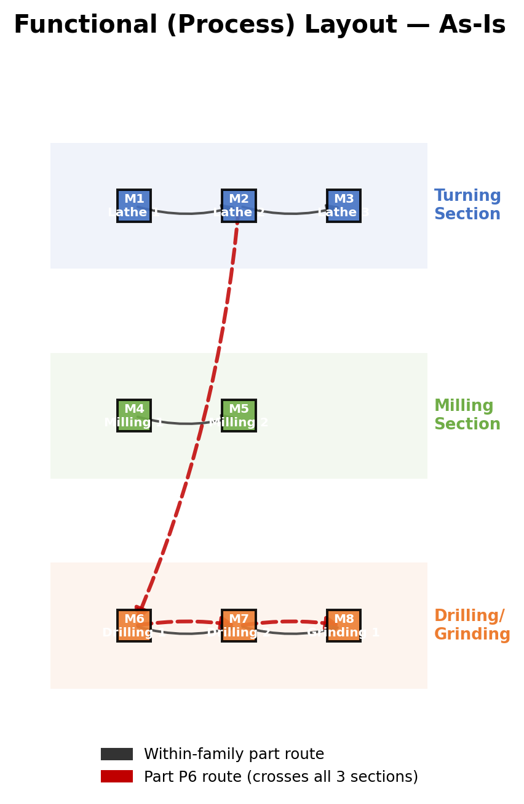
Figure 1: Existing functional (process) layout. Machines are grouped by process type; Part P6's route (red) crosses all three sections.
Based on the cell composition derived in Section 5, machines were physically regrouped into three compact, U-shaped cells. Within-cell travel distances shrink substantially since cell members are now adjacent. The one remaining long-distance route is the exceptional element (P6 to M2), which is now the clear, isolated exception rather than a routine occurrence.
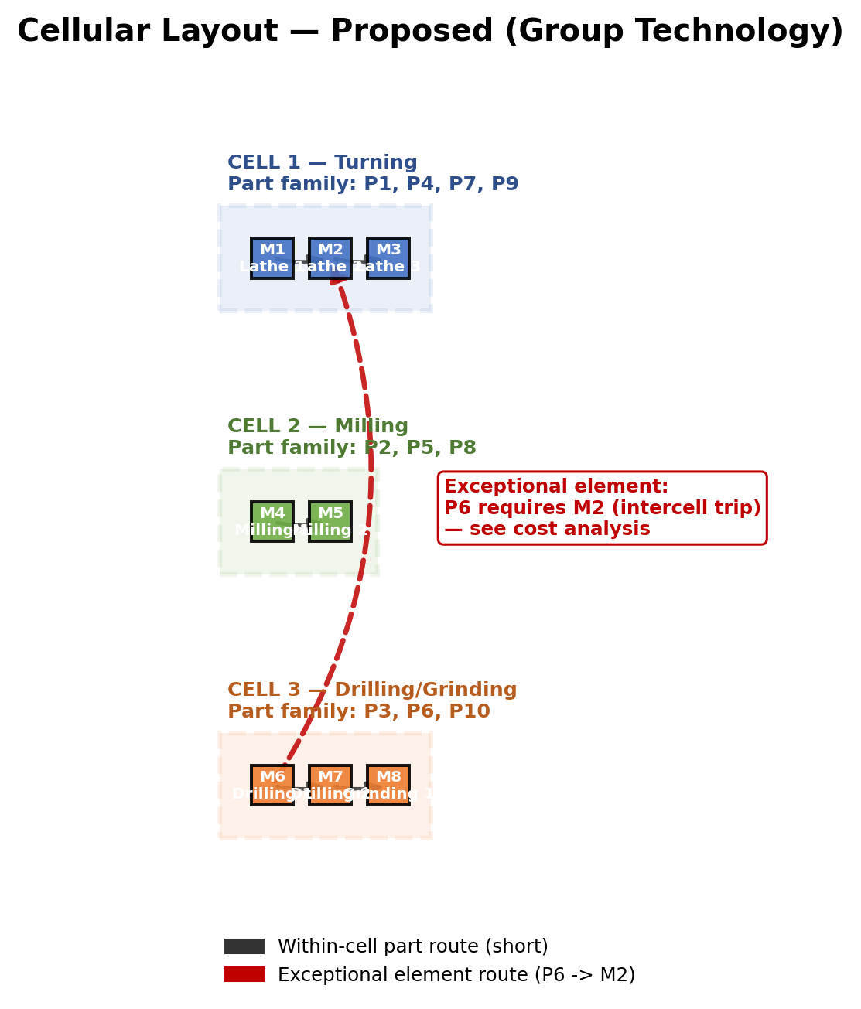
Figure 2: Proposed cellular layout. Each cell is compact and self-contained; the exceptional element route (red) is now the only intercell trip in the system.

7. Impact Quantification
Material handling effort was computed as the sum, over all parts, of (weekly volume x total route distance), where route distance is the sum of straight-line distances between consecutive machines in each part's process routing, based on the coordinates in Figures 1 and 2. Full calculations are in the accompanying workbook (Sheet 6: Layout & Distance).
Metric | Functional Layout (Before) | Cellular Layout (After) | % Improvement
Total weekly material handling effort (unit-metres/week) | 3,812.3 | 1,762.0 | 53.8% reduction
Number of manufacturing cells | 1 (undifferentiated) | 3 | -
Part families identified | 1 (undifferentiated) | 3 | -
Exceptional elements requiring resolution | 0 (not applicable) | 1 | -

8. Exceptional Element: Cost-Benefit Analysis
Three standard options exist for resolving the P6/M2 exceptional element. Annualised costs were estimated as follows (full inputs and formulas in workbook Sheet 7):
Option | Basis | Annual Cost (Rs.)
A: Accept intercell trips | Weekly volume x round-trip distance x weeks/year x handling cost/metre | 3,21,596
B: Duplicate Machine M2 into Cell 3 | One-time capital cost annualised over 5 years | 30,000
C: Subcontract the M2 operation for P6 | Fixed annual subcontracting rate | 60,000

Recommendation: Duplicating Machine M2 into Cell 3 (Option B) is the most economical resolution, at roughly half the annual cost of subcontracting and less than one-tenth the cost of accepting ongoing intercell trips.
This result should be re-checked against real machine costs and actual intercell distances if this methodology is applied to an actual plant, since the conclusion is sensitive to both the capital cost of the duplicated machine and the material handling cost per metre-trip.

9. Conclusion & Recommendations
Applying Rank Order Clustering to the machine-component incidence matrix successfully identified three coherent manufacturing cells, reducing modelled material handling effort by approximately 53.8% relative to the existing functional layout. A single exceptional element was identified and, under the cost assumptions used here, is best resolved by machine duplication rather than subcontracting or accepting recurring intercell material movement.
For an actual plant implementation, the following steps are recommended:
- Validate the machine-component matrix against real, current route sheets rather than historical or assumed routings.
- Re-run the cost-benefit analysis in Section 8 using actual machine costs, floor distances, and material handling rates.
- Pilot the cellular layout on a subset of the floor before full conversion, to validate WIP and lead-time improvements empirically.
- Periodically re-run the ROC analysis as the part mix changes, since GT cell assignments can become stale as new parts are introduced.

10. Limitations & Future Scope
- The dataset used here is illustrative and constructed to demonstrate the methodology; results should be re-validated on real plant data before implementation.
- Material handling distance is modelled using straight-line (Euclidean) distance; actual aisle-constrained travel distance may differ and can be substituted directly into the workbook.
- The analysis does not model queueing, machine breakdowns, or setup-time reduction explicitly; a discrete-event simulation could be a natural extension to validate WIP and lead-time claims empirically.
- Only one exceptional element was present in this dataset; larger, real matrices often contain several, each requiring its own resolution analysis.

References
King, J.R. (1980). Machine-component group formation in production flow analysis: an approach using a rank order clustering algorithm. International Journal of Production Research.
Groover, M.P. Automation, Production Systems, and Computer-Integrated Manufacturing. Pearson Education.
Askin, R.G. and Standridge, C.R. Modeling and Analysis of Manufacturing Systems. John Wiley & Sons.
Accompanying files: Cellular_Manufacturing_GT_Project.xlsx (full formula-driven ROC calculations and cost model); roc_algorithm.py (standalone, reusable ROC implementation in Python).

