# Software Requirements

Version 1.1, last updated by Hong Yue at 2020-09-18

# Software Requirements Specification (SRS)

Revision History:

|  |  |  |
| --- | --- | --- |
| Date | Author | Description |
| 9-18-20 | Hong Yue | Adding/Editing Use Cases, and Gantt graph |
| 9-18-20 | Guangpeng Li | Update Gautt graph |

Contents

Software Requirements 1

Software Requirements Specification (SRS) 1

1.  Introduction 3

1.1    Intended Audience and Purpose 3

1.2    How to use the document 3

2.  Concept of Operations 4

2.1    System Context 4

2.2 System capabilities 5

3.  Use Cases 5

Case 1: User wants to scan the X-Ray photograph 5

Case 2: User wants to do an angle calculation 5

Case 3: User wants to classify the case of scoliosis. 6

Case 4: User wants to migrate the model. 6

Case 5: User wants to compare the results with other algorithms. 6

**3.1 System Inputs and Outputs** 7

**3.1.1 Inputs** 7

**3.1.2 Outputs** 7

**3.2 Detailed Output Behavior** 7

4   Quality Requirements 7

5.    Fundamental Assumptions 7

6.    Expected Changes 7

7    References 8

## 1.  Introduction

### 1.1    Intended Audience and Purpose

This document is intended to provided information guiding the installation and development process, ensuring that all system requirements are met. The following entities may find the document useful:

Primary Customer (mainly orthopedists, or potential patients who need self-diagnosis) - This page will detail all of the application requirements as understood by the production team. The customer should be able to determine that their requirements will be correctly reflected in the final product through the information found on this page.

User - A prospective user will be able to use this document to identify the main functionality included in the application. Furthermore, the application will have a set of system requirements before the application can be run. Details regarding these requirements can be found here.

Coders - Details of specific requirements that the final software build must include will be located here. Coders can use this document to ensure the software addresses each of these requirements.

Testers - By developing testing procedures founded in the system requirements, testers can create a comprehensive testing regimen that will guarantee requirements are met.

Estimated Gantt Graph:

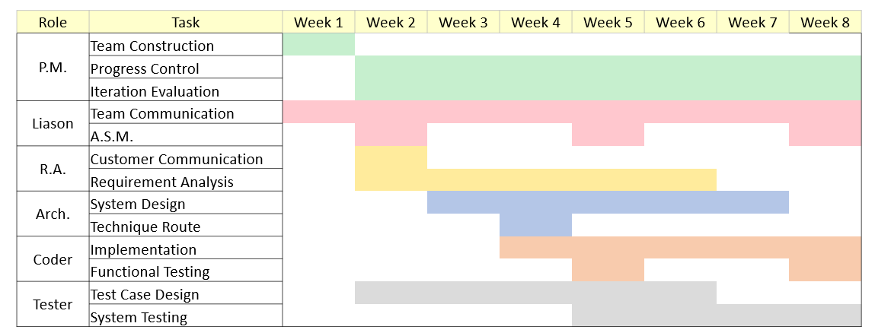

### 1.2    How to use the document

Table of Contents:

1. Introduction  
2. Concept of Operations - broad description of the purpose of the application  
  2.1 System Context - details any specific system requirements the application will require to run  
  2.2 System Capabilities - description in prose of all capabilities available to the user in the address book  
3.Use cases - A detailed look at each functional requirement, describing the application context both before and after an action is taken  
4. Quality Requirements - Requirements not pertaining to the function of the application will be listed here  
5. Fundamental Assumptions - Some specifics about input, output, or behavior upon which other requirements are founded will be listed here  
6. Expected Changes - Future features and directions the project is expected to take  
7. References - any external references necessary or helpful to understanding this document will be listed here

## 2.  Concept of Operations

The goal is to create an effective algorithm to diagnose scoliosis using artificial intelligence. Through the process of ct images analysis, the algorithm will calculate the cobb angel and provide a valid diagnosis of high accuracy. There are strict requirements on the format of the input.

### 2.1    System Context

**System Requirements:**  
Requires a system with a GUI display because all of the operations are performed through a GUI. The application is in Java so users must have an updated version of Java installed on their machine to use the application.

Windows:

* Windows 10 (8u51 and above)
* Windows 8.x (Desktop)
* Windows 7 SP1
* Windows Vista SP2
* Windows Server 2008 R2 SP1 (64-bit)
* Windows Server 2012 and 2012 R2 (64-bit)
* RAM: 1G (Minimum)
* Disk space: 4G (Minimum, for data and others)
* Processor: Minimum Pentium 2 266 MHz processor

Android:

* SDK: API 4 (Minimum)

### 2.2 System capabilities

Call this program, one can get the diagnose results of the ct image. This program will provide suggestions on whether the patient’s condition belongs to scoliosis, and the calcification of it, the angle of scoliosis, and other useful information.

## 3.  Use Cases

### Case 1: User wants to scan the X-Ray photograph

**Players**: End User

**Goals**: The end user wants to scan the X-Ray photograph.

**Preconditions**: The application is working.

**Case**:

1.1 From the File menu, the end user selects the “Scan X-Ray photograph”.

1.2 The application instructs the user to put X-Ray photograph in the scanner.

1.3 The application gets the image of X-Ray photograph in digital version from the scanner.

**Alternative Flows:**

1.2.1 The scanner is currently unavailable.

1.2.1.1 The application returns with error and report it to the user.

1.3.1 The scanner returns no image.

1.3.1.1 The application returns with error and report it to the user.

**Postconditions:**

The application now opens a digital image corresponding to the X-Ray photograph. And it is ready for further operations.

### Case 2: User wants to do an angle calculation

**Players**: End User

**Goals**: The end user wants to do an angle calculation.

**Preconditions**: The application is working and a digital X-Ray image is available.

**Case**:

2.1 From the Operation menu, the end user selects the “Angle Calculation”.

2.2 The application extracts lines of bones from the image.

2.3 User selects two of the bones.

2.4 The application calculates the angle of them and return the value to the user.

**Alternative Flows**:

2.1.1 The user does the operation without available digital image.

2.1.1.1 The application returns with error and report it to the user.

2.2.1 The application cannot identify any bones from the image.

2.2.1.1 The application returns with error and report it to the user.

2.4.1 Fewer or more than two bones are selected.

2.4.1.1 The application returns with error and report it to the user.

**Postconditions:**

The user gets the angle of two selected bones from the X-Ray image.

### Case 3: User wants to classify the case of scoliosis.

**Players**: End User

**Goals**: The end user wants to classify the case of scoliosis.

**Preconditions**: The application is working and a digital X-Ray image is available.

**Case**:

3.1 From the Operation menu, the end user selects the “Scoliosis Classification”.

3.2 The application processes the image with implemented algorithms, including calculates angle of every two bones.

3.3 The application tells the user whether this case is “C”, “S” or normal shape.

**Alternative Flows**:

3.1.1 The user does the operation without available digital image.\

3.1.1.1 The application returns with error and report it to the user.

**Postconditions**:

The user is now aware of the classification of scoliosis in this case.

### Case 4: User wants to migrate the model.

**Players**: End User

**Goals**: The end user wants to migrate the model.

**Preconditions**: The application is working, and a digital X-Ray image is available.

**Case**:

4.1 From the Operation menu, the end user selects the “Model Migration”.

4.2 The application extracts the model of this case and output to a file.

**Alternative Flows**:

4.1.1 The user does the operation without available digital image.

4.1.1.1 The application returns with error and report it to the user.

**Postconditions**:

The user gets the model file of this case.

### Case 5: User wants to compare the results with other algorithms.

**Players**: End User

**Goals**: The end user wants to compare the results with other algorithms.

**Preconditions**: The application is working, and a digital X-Ray image is available.

**Case**:

5.1 From the Operation menu, the end user toggle at least of one algorithm to compare with.

5.2 The application apply the operation using selected algorithms and return their result to the user.

**Alternative Flows:**

5.1.1 The user does the operation without available digital image.

5.1.1.1 The application returns with error and report it to the user.

**Postconditions:**

The user gets the results from other algorithms.

### 4   Quality Requirements

The product will fill a gap in the market, therefore there is no competition exists.

The algorithm must be competitive with Team A1 and Team A2’s algorithms in terms of performance, reliability, consistency, and scalability.

Since the problems involved in this program are relatively new, the requirements of this program are mainly for reference.

Performance: Responsiveness to user input

 * Standard actions that should not exceed 9000ms execution time.

## 5.    Fundamental Assumptions

There are strict requirements on the format of the input image.

The training set of this program is known.

The caller of this program will meet all the hardware requirements of this program.

The caller of this program uses the same token and semantic system as this program.

## 6.    Expected Changes

   Features to Add:

   Future Platforms:  
     Port Application to iOS

### 7    References