# Software Requirements

Version 3, last updated by Chase at 2020-10-02

# Software Requirements Specification (SRS)

Revision History:

|  |  |  |
| --- | --- | --- |
| Date | Author | Description |
| 20-09-25 | Chase | Revising entire document |
| 20-10-02 | Chase | Revising entire document |
|  |  |  |
|  |  |  |

Contents

Software Requirements 1

Software Requirements Specification (SRS) 1

1.  Introduction 1

1.1    Intended Audience and Purpose 1

1.2    How to use the document 2

2.  Concept of Operations 3

2.1    System Context 3

2.2.  Use Cases 4

3.    Behavioral Requirements 10

3.1 System Inputs and Outputs 10

4.   Quality Requirements 10

5.    Fundamental Assumptions 11

6.    Expected Changes 11

7.    Appendices 11

7.1    Definitions and acronyms 11

7.2    References 12

## 1.  Introduction

### 1.1    Intended Audience and Purpose

This document is intended to provided service to the patients who need scoliosis detect via x-ray photo recognition and doctors who need upload new data to train our algorithm engines, ensuring that all system requirements are met. And our work is web client - one part of project “Scoliosis Detection via X-ray Photo Recognition”.

The following entities may find the document useful:

* Primary Customer - This page will detail all of the application requirements as understood by the production team. The customer should be able to determine that their requirements will be correctly reflected in the final product through the information found on this page.
* User - A prospective user will be able to use this document to identify the main function included in the application. Furthermore, the application will have a set of system requirements before the application can be run. Details regarding these requirements can be found here.
* Development Team - Details of specific requirements that the final software build must include will be located here. Developers can use this document to ensure the software addresses each of these requirements.
* QA Team - By developing testing procedures founded in the system requirements, the QA Team can create a comprehensive testing regimen that will guarantee requirements are met.

### 1.2    How to use the document

Table of Contents:  
1. Introduction  
2. Concept of Operations - broad description of the purpose of the application  
  2.1 System Context - details any specific system requirements the application will require to run  
  2.2 Use cases - A detailed look at each functional requirement, describing the application context both before and after an action is taken  
3. Behavioral Requirements - How the application will interact with a user  
  3.1 Input and output requirments - A description of allowed inputs and generated outputs  
    3.1.1 Input - Describes any restrictions that will be placed on allowed input  
    3.1.2 Output - Describes the range of outputs that can be generated  
  3.2 Detailed Output Behavior - Output descriptions in prose  
4. Quality Requirements - Requirements not pertaining to the function of the application will be listed here  
5. Fundamental Assumptions - Some specifics about input, output, or behavior upon which other requirements are founded will be listed here  
6. Expected Changes - Future features and directions the project is expected to take  
7. Appendicies - Details aiding the understanding of this document  
  7.1 Definitions and acronyms - Any technical terms or abbreviations will be spelled out here for ease of use of the document  
    7.1.1 Definitions - Definitions of technical or unusual terminology  
    7.1.2 Acronyms and Abreviations - Any abreviated terms will be expanded here  
  7.2 References - any external references necessary or helpful to understanding this document will be listed here

## 

## 2.  Concept of Operations

The goal is to create a user friendly application. It will allow its users to use our algorithm engine to scoliosis detect via x-ray photo recognition, and also allow doctors to upload a dozen of new data to train our algorithm engine.

A user just need a browser installed on their machine. The application uses drop down menus, text boxes, and file system navigation windows to interact with the user.

### 2.1    System Context

**System Requirements:**  
 Requires a system with a browser because all of the operations are performed through a HTML. The application is in web so users must have an updated version of browser installed on their machine to use the application.

Browsers :

* Internet Explorer (8 and above)
* Opera 31.0
* Chrome
* Firefox
* Safari
* maxthon
* qqbrowser
* se 2.x
* lbbrowser
* bidubrowser
* ubrowser
* metasr
* tencenttraveler

### 2.2.  Use Cases

Use case diagram1:

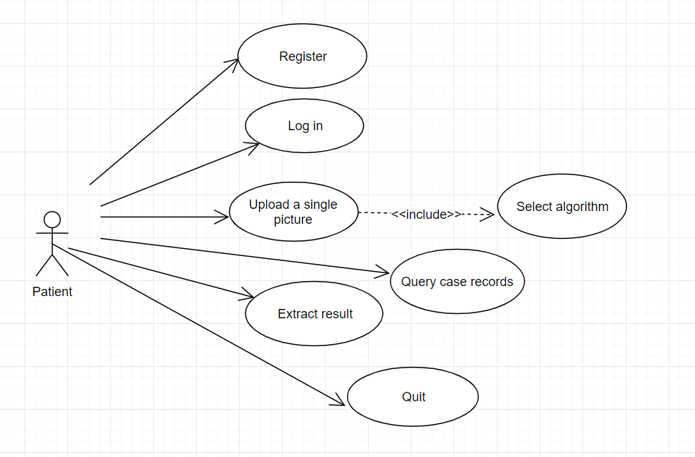

Use case diagram2:

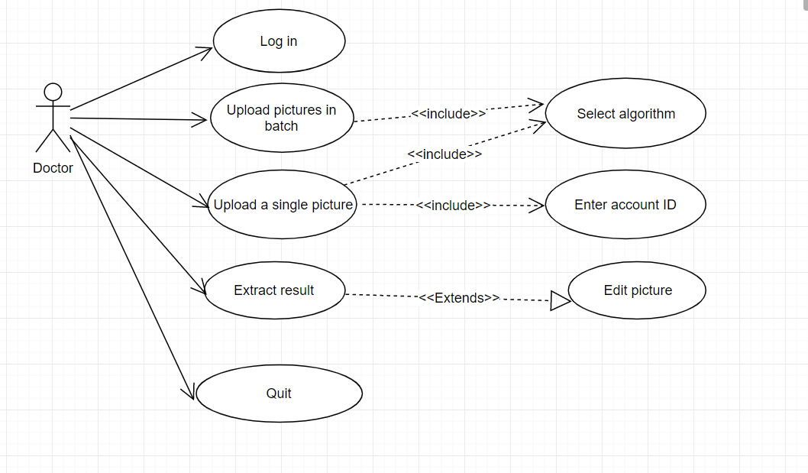

#### Case 1: User Wants to register

**Players:** Patients  
**Goal:** The user would like to register an account on the website.

**Preconditions:** The web client is open and login.  
**Case**:

1.1 The user opens the browser and opens the web site.

1.2 The user clicks register button.

1.3 The user input personal information.

1.4 The user clicks submit button.

1.5 The web client displays result.

**Alternate Flows**:  
**Exception Flows:**  
1.5.1 The web client shows a warning message that user registration failed.

**Postconditions:**The web client can display result which from server.

#### Case 2: User Wants to Login

**Players:**User (including patients and doctors)  
**Goals:**The user would like to use the website so that they can choose service they needed.  
**Preconditions:**The qualified browser is installed on the user's machine.  
**Case:**  
2.1 The user opens the browser

2.2 The user input the Uniform Resource Locator(URL) in the URL input area of the browser.

2.3 The user choose and clock login button.

2.4 The user input his or her own user id and password, then click enter button.  
**Alternate Flows:**  
**Exception Flows:**  
2.1.1 The browser is not qualified.  
         The web client does not display correctly.

2.4.1 The user id doesn’t exist or wrong password.

The user can’t login success.  
**Postconditions:**The web client is open and running, waiting for its next instruction from the user.

#### Case 3: User Wants to Upload a single picture and Use Scoliosis Detect Algorithm Engine to extract result

**Players:** End User (Patients and Doctors)  
**Goal:** The user would like to use scoliosis detect algorithm engine and acquire a true answer.  

**Preconditions:** The web client is open and login.  
**Case**:

3.1 The user chooses which scoliosis detect algorithm engine they want to use.

3.2 If users are doctors, users must enter an account ID (ID can be empty).

3.3 The user clicks upload image button.

3.4 The user uploads correct x-ray photo when file select window has opened.  
3.5 The user clicks submit button.

3.6 The web client displays result and user acquire information the need.

**Alternate Flows**:  
**Exception Flows:**  
3.3.1The image user upload isn’t qualified x-ray photo.

      The web client shows a warning message and user can upload photo again.

**Postconditions:**The web client can display result which from server.

#### Case 4: Doctors Wants to Upload a New Set of Data

**Players:** End User (Doctors)  
**Goal:** The user would like to upload a new set of data to train our scoliosis detect algorithm engine.    
**Preconditions:** The web client is open and login.  
**Case**:

4.1 The user chooses the correct page which is only opened to doctors.

4.2 The user clicks upload data button.

4.3 The user uploads a zip of new data.

4.4 The user clicks submit button.

4.5 The web client displays success message and user acknowledge.

**Alternate Flows**:  
**Exception Flows:**

**Postconditions:**The new set of data can be sent to the server.

#### Case 5: User Wants to query case records

**Players**: End User(patients)  
**Goals:**The user wants to see previous scoliosis detect result, it should be open in a blank window.  
**Preconditions:** The web client is open and running.

**Case:**   
5.1 From the result records menu, the end user selects the which record he or she want to see.   
5.2 The web client display correspondingly scoliosis detect result.  
**Alternate Flows:**  
**Exception Flows:**  
**Postconditions:**

#### Case 6: User Wants to edit results

**Players:**Doctors  
**Goals:**The end user wants to extract and edit results.

**Preconditions:**The web client is open and login.  
**Case:**  
6.1 After users submit the picture, the web page displays the result.

6.2 Users click the Edit button to edit the image results.

6.3 Users click the Save button after editing.

6.4 Users click the download button to download the image results.

**Alternate Flows:**  
**Exception Flows:**  
**Postconditons:**

#### Case 7: User Wants to Quit and Close the Web Client

**Players:**End User (patients and doctors)  
**Goals:**The end user wants to quit and close the web client.

**Preconditions:**The web client is open and login.  
**Case:**  
5.1 From the File menu, the end user selects the "Close all and Quit" option.  
5.2 The application terminates itself.  
**Alternate Flows:**  
**Exception Flows:**  
**Postconditons:**

## 3.    Behavioral Requirements

### 3.1 System Inputs and Outputs

#### 3.1.1 Inputs

Inputs to the web client come from the user. The user can select the following options: “register”.”login”.”quit”,”upload”,”view previous results”. Mainly input is X-ray photo or zip of new data.

#### 3.1.2 Outputs

Mainly result is Marked X-ray chart and angle of scoliosis.

## 4.   Quality Requirements

The application must be competitive with similar applications in regards to performance, reliability, consistency, and scalability.

## 

## 5.    Fundamental Assumptions

The application can run on any system that is capable of running qualified browser.  
The application will not terminate when all windows are closed.

## 

## 6.    Expected Changes

   Features to Add:

User Defined Fields

Doctors verify detect results  
      Links to Social Media

   Future Platforms:  
    Write Front End For Andriod  
      Port Application to iOS

## 

## Appendices

### 7.1    Definitions and acronyms

#### 7.1.1    Definitions

|  |  |
| --- | --- |
| **Keyword** | **Definitions** |
|  |  |
|  |  |
|  |  |
|  |  |

#### 7.1.2    Acronyms and abbreviations

|  |  |
| --- | --- |
| **Acronym or**  **Abbreviation** | **Definitions** |
| HTML | Hyper Text Markup Language |
| WWW | world wide web |
| URL | Uniform Resource Locator |

### 

### 7.2    References